Module 1

Lecture 1

1) Synopsis: O.S. Objectives and functions, evolution of O.S, Basic concepts and terminology

2) Target: At the completion of this lecture you should be able to answer questions like (a) what is an operating system.
(b)Objectives of OS
(c) Services provided by OS
(d) How OS evolved over the years.

3) Introduction
As stated above, in this lecture, we plan to explore OS, its objectives and evolution

4) Revision / Prerequisites
Please refer to pages 54 to 68 of the text book OS by William Stallings

5.1) Concept #1 OS objectives and functions

OS is a program that controls the execution of application programs and acts as an interface between applications and hardware. Its objectives are
(i) Convenience
-Makes the computer more convenient to use
(ii) Efficiency
-Allows computer system resources to be used in an efficient manner
(iii) Ability to evolve
-Permit effective development, testing, and introduction of new system functions without interfering with service

(i) OS as a user/Computer interface
The OS masks the details of the hardware from the programmer and provides the programmer with a convenient interface for using the system. It acts as a mediator, making it easier for the programmer and for application programs to access and use those facilities and services. The OS provides the following services:
(a) Program development
- Editors and debuggers help in creating programs.
(b) Program execution
-The system must be able to load a program into memory and to run that program, end execution, either normally or abnormally (indicating error)
- (c) I/O operations
- -A running program may require I/O, which may involve a file or an I/O device.
- (d) File-system manipulation
- -The file system is of particular interest. Obviously, programs need to read and write files and directories, create and delete them, search them, list file Information, permission management.
- (e) System Access
- OS controls access to system as a whole and to specific resources. The access function also provides the protection to data and resources and resolves conflicts during contention of resources.
- (f) Error detection and recovery
–OS needs to be constantly aware of possible errors. The errors can be of
(1) Internal and external hardware errors
    - memory error
    - device failure
- software errors
    - arithmetic overflow
    - access forbidden memory locations
- For each type of error, OS should take the appropriate action to ensure correct and consistent computing. Debugging facilities can greatly enhance the user’s and programmer’s abilities to efficiently use the system.
- (g) Accounting
-To keep track of which users use how much and what kinds of computer resources. This information is used to anticipate future enhancements and used for billing users.

(ii) OS as resource manager
- Operating system manages all the resources of the computer system. The
system resources include the processors, memories, timers, network interfaces and the various input output devices. Operating system allocates these resources to the processes and thereby ensures optimum utilization of the system resources.

(iii) Ease of evolution of an OS
- OS will evolve over time for a number of reasons:
1. Hardware upgrades and new type of hardware. For e.g. early UNIX systems did not support paging.
2. New services
3. Fixes – When faults are detected fixes need to be made

5.2) Concept #2 The evolution of OS

The evolution of OS over the years is as follows
- Serial processing

Here the programmer interacted directly with the hardware and there was no OS. Machines run from a console with display lights and toggle switches, input device, and printer. Programs were in machine language and loaded via input devices. Error condition was indicated by lights. For the correct program, the output appeared on the printer. The main problems are
(a) Scheduling – A sign up sheet was used to reserve computer time. A user could sign up for a block of time. Sometimes this may result in wasted computer idle time if the user finishes his job before time. Otherwise the user may not finish his work in the allotted time and will have to reserve some other slot to complete his job.

(b) Setup time - A single job involves loading the operating system, mounting the tapes and disk packs, placing the appropriate forms in the printer, punching in the time cards etc. When the job is completed, the tapes and disk packs were removed, time cards were “punched out” etc. Thus considerable amount of time was wasted for setting up the job.

6.0) Summary
In this class, we have gone through the OS, its objectives and function. Also the evolution of OS, in which serial processing and its drawbacks were discussed.

7.0) Exercise questions
(a) What is OS? (b) Its objectives? (c) Its functions (d) Drawbacks of serial processing?

Lecture 2

1) Synopsis: evolution of O.S

2) Target: At the completion of this lecture you should be able to answer questions like (a) Simple Batch system
(b)Multi programmed batch system
(c) Time sharing system

3) Introduction
In the last class we started the evolution of OS and discussed Serial processing as the first stage in this evolution. Can be continued
4) Revision / Prerequisites
Please refer to pages 59 to 68 of the text book OS by William Stallings

5.1) Concept #1 Simple Bath System

To overcome the following drawbacks of the earlier machines, batch OS was developed
(a) Expensiveness (b) minimum machine utilization

The simple batch processing scheme used software called monitor. The user did not have any direct interaction with the computer system. Instead the users submitted their jobs either on cards or tapes to a computer operator. A job consisted of the program, data and control information (control cards). The operator batched the jobs and placed the entire batch on an input device. Each program when it completes processing will branch back to the monitor and the monitor will automatically begin loading the next program. It is the monitor that controls the sequence of events. So much of the monitor should always be in the memory and should be available for execution. That part of the monitor which resides in the memory is called Resident Monitor

Job control language (JCL)

It is a special type of programming language used to provide instructions to the monitor. These job control instructions set up the job by telling the computer whether the cards following it contain data or programs, what programming language is used, the approximate execution time, etc. When the current job terminated, the job stream reader automatically reads in the control language statements for the next job. The format of a job looks like this:
$JOB
$FTN
.
.
$LOAD
$RUN
.
.
$END

Hardware Features

- Memory protection
do not allow the memory area containing the monitor to be altered
- Timer
prevents a job from monopolizing the system
- Privileged instructions
Certain instructions are privileged and can be executed only by monitor.
- Interrupts
Gives the OS more flexibility in relinquishing control to and regaining control
from user programs.

Drawbacks
In the batch OS the user don’t have any interaction with the system while the job is executing. The user submits his job and obtains the output at some later time. This might take minutes, hours or even days. The output consisted of the result of the program and the final memory and register contents for debugging. The turnaround time was very high.

5.2) Concept #2 Multiprogrammed Batch Systems

If more than one job could be held in the memory, when one job waits for I/O, the processor can switch to some other job that is not waiting for I/O. This concept which the modern operating System follows is called multiprogramming or multitasking.

In uniprogramming, Processor must wait for I/O instruction to complete before proceeding.

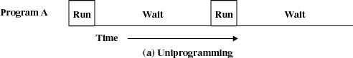

But in multiprogramming, when one job needs to wait for I/O, the processor can switch to the other job.

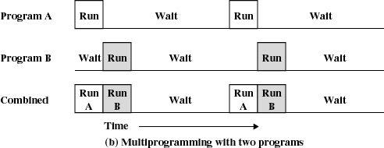

Yet another major feature in this operating system was the technique called spooling (simultaneous peripheral operations on line). In spooling, a high-speed device like a disk is used in between a running program and a low-speed device involved with the input/output. Instead of writing directly to a printer outputs are written to the disk. Programs can run to completion faster, and other programs can be initiated sooner when the printer becomes available, the outputs may be printed.
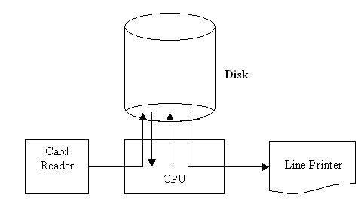

5.3) Concept #3 Time Sharing Systems

In these systems multiprogramming is used to handle multiple interactive jobs. Here the processors time is shared among multiple users. Multiple users simultaneously access the system through different terminals.
The difference of time sharing system from a multiprogrammed system is that in multiprogramming, the computer works on one program until it reaches a logical stopping point, such as an input/output event, while for timesharing system, every job is allocated a specific small time period after which the system switches to the next job.

The problems here are
- Since multiple jobs reside in memory at a time they must be protected from interfering with each other.
- The file system must be protected so that only authorized users will access a particular file.
- The contention of resources such as printers and storage devices must be handled.

6.0) Summary
In this class, we understand the evolution of OS in detail. From serial processing it advances through simple batch systems, multiprogramming and time shared systems.

7.0) Exercise questions

- What is resident monitor? (b) How does uniprogramming different from multiprogramming environments? (c) What is spooling? (d) Time shared system?

Lecture 3

1) Synopsis: Basic concepts and terminology, O.S. Hierarchy

2) Target: At the completion of this lecture you should be able to answer questions like (a) what is a process.
(b)Multi programmed batch system
(c) Time sharing system

3) Introduction
In this class we can discuss the main concepts related with OS. The main concepts are (1) process (2) Memory management (3) Information protection and security (4) Scheduling and resource management (5) System structure.

4) Revision / Prerequisites
Please refer to pages 69 to 80 of the text book OS by William Stallings

5.1) Concept #1 Process

A process can be defines as
- A program in execution
- An instance of a program running on a computer
- The entity that can be assigned to and executed on a processor
- A unit of activity characterized by a single sequential thread of execution, a current state, and an associated set of system resources
A process is composed of 3 components (1) An executable program (2) the associated data needed by the program (3) the execution context of the program.

OS manages the processes and it performs the following activities
- Creates and deletes user and system processes
- Suspends and resumes processes
- Provides mechanisms for process synchronization
- Provides mechanisms for process communication
- Provides mechanisms for deadlock handling

5.2) Concept #2 Memory management

The OS has 5 storage management responsibilities
- Process isolation: OS must prevent independent processes from interfering with the data and memory of each other.
- Automatic allocation and Management: Programs should be dynamically allocated
- Support for modular programming
- Protection and access control
- Long term storage

Concept 2.1 File management
It Implements long-term storage. In connection with file management the OS is responsible for the following activities
- Creating and deleting files
- Creating and deleting directories
- Supporting primitives for manipulating files and directories
- Mapping files into secondary storage
- Backing up files on storage media
5.3) Concept #3 Information protection and security

Here we are dealing with
(i) Access control
To regulate user access to the system
(ii) Information flow control
To regulate flow of data within the system and its delivery to users
(iii) Certification
To prove that access and flow control perform according to specifications
5.4) Concept #4 Scheduling and resource management

Resource allocation and scheduling policy must consider the following 3 factors:
(i) Fairness
To give equal and fair access to all processes
(ii) Differential responsiveness
To discriminate between different classes of jobs/users
(iii) Efficiency
To maximize throughput, minimize response time, and accommodate as many uses as possible
5.5) Concept #5 System structure (O.S. Hierarchy)

We can view the system as a series of levels. Each level performs a related subset of functions. Each level relies on the next lower level to perform more primitive functions. This decomposes a problem into a number of more manageable sub problems.
The hierarchy can be defines as follows.
Level Name Objects Example

Operations
13 Shell User programming Statements in
shell language
environment

12 User processes User processes Quit, kill,
suspend, resume

11 Directories Directories Create,
destroy, attach, detach,
search, list

10 Devices External devices, such Open, close,
as printer, displays read, write
and keyboards

9 File system Files Create,
destroy, open, close
read, write

8 Communications Pipes Create,
destroy, open. close,
read, write

7 Virtual Memory Segments, pages Read, write,
Fetch

6 Local secondary Blocks of data, device Read, write,
allocate, free
store channels

5 Primitive processes Primitive process, Suspend,
resume, wait, signal
semaphores, ready
list

4 Interrupts Interrupt-handling Invoke,
mask, unmask, retry
programs

- Procedures Procedures, call stack, Mark
stack, call, return
display

2 Instruction Set Evaluation stack, micro- Load,
store, add, subtract
program interpreter, branch
scalar and array data

1 Electronic circuits Registers, gates, buses, Clear,
transfer, activate,
etc. complement

6.0) Summary
In this class, we discussed different concepts related with OS. We have seen the hierarchical structure of OS

7.0) Exercise questions

(a) Define process? (b) Discuss different file operations performed by OS (c) Different process manipulation (d) Briefly describe the OS design hierarchy

Lecture 4

1) Synopsis: Different types of O.S – multiprogramming, time sharing, real time,
Microkernel, multithreading, multiprocessing, distributed O.S etc. (basic idea only)

2) Target: At the completion of this lecture you should be able to answer questions like
Explain the following:
(a) Multiprogramming
(b) Time sharing OS
(c) Real time OS
(d) Microkernel Architecture
(e) Multithreading OS
(f) Multiprocessing OS
(g) Distributed O.S

3) Introduction
In this section we will discuss different types of OS targeted above.

4) Revision / Prerequisites
Please refer to pages 54 to 68 of the text book OS by William Stallings

5.1) Concept #1 Multiprogramming

Multiprogramming is needed for efficiency. Single user cannot keep CPU and I/O devices busy at all times. Multiprogramming organizes jobs (code and data) so CPU always has one to execute. A subset of total jobs in system is kept in memory. One job selected and run via job scheduling. When it has to wait (for I/O for example), OS switches to another job. For diagram, refer the previous class notes.

5.2) Concept #2 Time sharing OS

Timesharing (multitasking) is logical extension in which CPU switches jobs so frequently that users can interact with each job while it is running, creating interactive computing. Its main features are
  - Response time should be < 1 second
  - Each user has at least one program executing in memory [process
  - If several jobs ready to run at the same time [ CPU scheduling
  - If processes don’t fit in memory, swapping moves them in and out to run
  - Virtual memory allows execution of processes not completely in memory

5.3) Concept #3 Multiprocessor Systems (Parallel systems or Tightly coupled systems)
These systems have more than one processor sharing the other resources such as computer bus, clock, memory and peripheral devices.
Advantages of multiprocessor systems are
- Increased throughput – Throughput is the amount of work done in unit time. By increasing the number of processors more work can be done than with a single processor.
- Economy of sale – Multiprocessor systems save more money than multiple single processor systems because the processors in the multiprocessor systems share the system resources.
- Increased reliability – The failure of one processor will not halt the system if the work id distributed properly among several processors.
Multiprocessing can be symmetric multiprocessing or asymmetric multiprocessing.

Symmetric multiprocessing – each processor runs an identical copy of the OS and these copies communicate with one another as needed.
Asymmetric Multiprocessing – one of the processor is assigned as the master. The master schedules and allocates work to the slave processors.

5.4) Concept #4 Distributed Systems

In distributed processors the computation is distributed among multiple processors. But to its users it appears as a uniprocessor system. Users need not bother about where their files are located or where their programs are run. The processors do not share memory, peripheral devices or a clock. Each processor has its own local memory and clock. The processors communicate with one another through various communications lines, such as high-speed buses or telephone lines. Distributed systems requires a networking interface either a LAN or WAN. The systems can be either peer to peer or client server model.
Client Server Systems
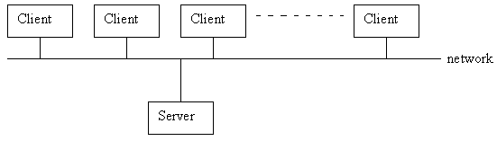
Terminals connected to centralized systems are supplanted by small PCs. Centralized systems ct as server to satisfy requested generated by clients. 2 types of server systems.
(i) Compute-server provides an interface to client to request services (i.e. database)
(ii) File-server provides interface for clients to store and retrieve files

Peer-to-peer Systems
The systems connected to the web can be considered as peer-to-peer systems. These systems do not share memory or clock. These systems are also called loosely coupled systems.

5.5) Concept #5 Clustered Systems
Like multiprocessor systems clustered machine gather multiple CPUs to perform computation. The difference is that it is composed of two or more individual systems coupled together. They share storage and is linked by LAN. There are two types of clustering, asymmetric clustering and symmetric clustering.

Asymmetric clustering – One machine is in hot standby mode and other machine runs the applications. The hot standby machine just monitors the active server. If the active server fails the hot standby machine becomes the active server.
Symmetric clustering – two or more machines runs applications and at the same time they monitors each other.

5.6) Concept #6 Real-Time Systems
A real time system has well defined fixed time constraints. Processing should be done within the defined constraints. Real time operating systems are used as a control device in a dedicated application such as controlling scientific experiments, medical imaging systems, industrial control systems, and some display systems. Real-Time systems are classified as hard or soft real-time.

Hard real-time
- Guarantees critical task completion on time.
- Secondary storage limited or absent, data stored in short term memory, or read-only memory (ROM)
- Conflicts with time-sharing systems, not supported by general-purpose operating systems.
- Advanced OS features are absent (e.g. virtual memory is absent).

Soft real-time
- Less restrictive.
- A critical real time task gets priority over other tasks and it retains its priority until it completes.
- Limited utility in industrial control of robotics
Useful in applications (multimedia, virtual reality, under sea explorations etc.) requiring advanced operating-system features.

5.7) Concept #7 Microkernel architecture

It assigns only a few essential functions to the kernel, including address spaces, IPC, and basic scheduling. Other services are provided by processes that run in user mode. Other features are
- client-server model, IPC between clients and servers
- the micro-kernel provides protected communication
- OS functions implemented as user-level servers
- flexible but efficiency is the problem
- easy to extend for distributed systems

Multithreading will be discussed in the next module.

6.0) Summary
In this class, we studied different types of OS and its features, advantages in general.

7.0) Exercise questions
Briefly explain the features of the following (a) multiprogramming, (b) time sharing, (c) real time, (d) Microkernel, (e) multiprocessing, (f) distributed O.S

Lecture 5

1) Synopsis: Windows – 2000 overview, UNIX overview

2) Target: At the completion of this lecture you should be able to answer questions like (a) Architecture and Organization of Windows 2000 and UNIX

3) Introduction
You are already familiar with Windows and Unix OS. Today we can discuss their architecture and organization

4) Revision / Prerequisites
Please refer to pages 83 to 93 of the text book OS by William Stallings

5.1) Concept #1 Windows 2000

- Windows 2000 is a single user multitasking OS.
- Windows 2000 is highly modular – each system function is managed by just one component of the OS. Any module can be upgraded or removed without affecting the rest of the system.
- In Windows 2000 many functions outside the microkernel runs in kernel mode.
- Windows 2000 can be run on a variety of platforms.
The architecture of windows 2000 is shown below.
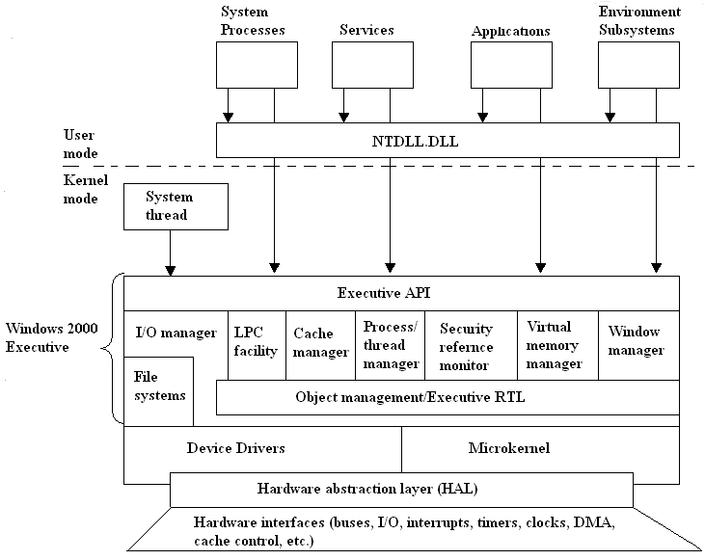
Architecture of Windows 2000
Hardware abstraction layer (HAL):
- HAL isolates the OS from platform specific hardware differences. This is done by mapping between the generic hardware commands and those specific to certain platforms.
- It makes each machines hardware look the same to the kernel.
- It gives the support needed for symmetric multiprocessing.
Microkernel:
- Most used and most fundamental components of the OS forms the microkernel.
- Kernel constitutes thread scheduling, process switching, exception and interrupt handling and multiprocessor synchronization.
- Microkernel is the only part of OS that is not preemptive or pageable.
Device Drivers:
- This includes file system and hardware device drivers.
- It translates I/O function calls into specific hardware device I/O requests.
Windows 2000 Executive:
The windows 2000 executive includes modules for specific system functions. It also provides an API for user mode software. The executive consists of the following modules:
I/O manager:
- Provides a framework through which I/O devices are accessible to applications.
- Implements all the Windows 2000 I/O APIs.
- Enforces security and naming for devices and file systems.
Object manager:
- It is responsible for the creation and deletion of Windows 2000 executive objects and ADT used to represent processes, threads and synchronization objects.
- It enforces uniform rules for naming and setting the security of objects.
- It creates object handles (object handles consists of the access control information and a pointer to the object).
Local Procedure Call facility:
- It enforces a client server relationship between the applications and executive subsystems. (The services of executive subsystems include memory services, process creation services, processor scheduling services etc.)
Cache manager:
- It causes the recently accessed disk data to reside in main memory for quick access thus improves the performance of file based I/O.
Process/thread manager:
- It tracks the process and thread objects.
Security reference monitor:
- It enforces access validation and audit generation rules for files, processes, address spaces and I/O devices.
Virtual memory manager:
- It maps virtual addresses in the process’s address space to physical addresses in the memory.
Window manager:
- It creates the windows oriented screen interface. Manages the graphics devices.
User Processes:
Windows 2000 supports four types of user processes.
Special system support processes:
This includes services not provided as part of Windows 2000 OS. Examples are logon process, session manager etc.
Server Processes:
This includes Windows 2000 services such as event logger.
Environment subsystems:
This system is responsible for exposing the Windows 2000 services to user applications. It includes DLLs that converts the user application calls to Windows 2000 calls.
User applications:
This includes the application programs.

5.2) Concept #2 UNIX

- Here the underlying hardware is surrounded by the OS software.
- OS is often called kernel to emphasize its isolation from the user and applications.
- OS is equipped with a number of user services and interfaces that are considered part of the system.
- These can be grouped into shell, other interface s/w and the components of C compiler.

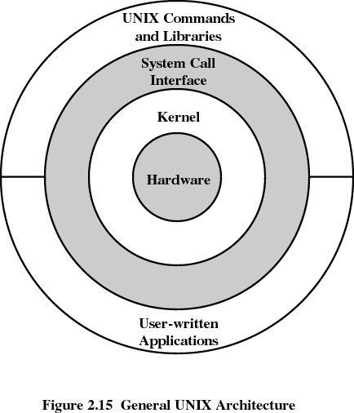

Shell
Shell is the interface between the user and the operating system.
Three types of shells are available
- Bourne shell
Stephen Bourne of AT&T Bell laboratories wrote bourne shell. This is the most primitive and the standard shell used in UNIX OS.
- C shell
William Joy at the University of California at Berkeley wrote C shell. Many of its programming features resemble the syntax of C programming language, so the name C shell. Apart from Bourne shell it has got the following features,
History facility – user can call previously used commands and edit them for reuse.
Alias facility – user can give shorthand names for long command sequences.
- Korn shell
David Korn of AT&T Bell laboratories wrote Korn shell. Most popular shell. Its format and usage is same as that of Bourne shell but it has got the history and alias facilities.

Modern UNIX Systems
- System V Release 4 (SVR4)
- Solaris 2.x
- 4.4BSD
- Linux

6.0) Summary
In this class, we studied the architecture and components of windows 2000 and UNIX. Also we discussed different types of shells.

7.0) Exercise questions
(a) Explain the architecture of Windows 2000 (b) Unix (c) What is shell? Different types of shells?

