Module 2

Lecture 6

1) Synopsis: Process – states, model, description

2) Target: At the completion of this lecture you should be able to answer questions like (a) Explain 2 state process model (b) 5 state model (c) How a process is described?
(d) What is PCB?

3) Introduction
We have come across the process in the previous classes. Here we can examine the states of process and how it is described.

4) Revision / Prerequisites
Please refer to pages 108 to 130 of the text book OS by William Stallings

5.1) Concept #1 Process

Process – a program in execution; process execution must progress in sequential fashion
A process includes:
  - program counter
  - stack
  - data section
Process states
- As a process executes, it changes state. The state of a process is defined in part by the current activity of that process.

A two state process model

- Process may be in one of two states
  - Running
  - Not-running

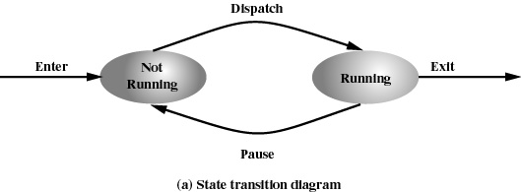

Process Creation

When a new process is to be added to those currently being managed, the OS builds DS that are used to manage the process and allocates address space in main memory to the process. Processes are created
- In batch environment, during the submission of a batch job
- In interactive environment, when user logs on
Process Termination
Processes are terminated
- In batch systems, when job issues Halt instruction
- In interactive systems, User logs off
- When Quit an application
- During Error and fault conditions
Reasons for Process Termination

- Normal completion
- Time limit exceeded
- Memory unavailable
- Bounds violation
- Protection error
  - example write to read-only file
- Arithmetic error
- Time overrun
  - process waited longer than a specified maximum for an event
- I/O failure
- Invalid instruction
  - happens when try to execute data
- Privileged instruction
- Data misuse
- Operating system intervention
  - such as when deadlock occurs
- Parent terminates so child processes terminate
- Parent request

A five state process model
Five states are as follows
- new: The process is being created
- running: Instructions are being executed
- waiting: The process is waiting for some event to occur
- ready: The process is waiting to be assigned to a processor
- terminated: The process has finished execution

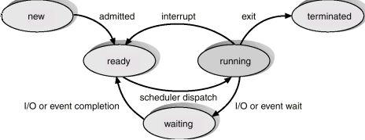

Process description

OS Control structures

- Information about the current status of each process and resource
- Tables are constructed for each entity the operating system manages

(a) Memory Tables

- Allocation of main memory to processes
- Allocation of secondary memory to processes
- Protection attributes for access to shared memory regions
- Information needed to manage virtual memory

(b) I/O Tables

- I/O device is available or assigned
- Status of I/O operation
- Location in main memory being used as the source or destination of the I/O transfer
(c) File Tables
- Existence of files
- Location on secondary memory
- Current Status
- Attributes
- Sometimes this information is maintained by a file-management system

(d) Process Tables

- It is crated where process is located
- Attributes necessary for its management
  - Process ID
  - Process state
  - Location in memory
(e) Process Location
- Process includes set of programs to be executed
  - Data locations for local and global variables
  - Any defined constants
  - Stack
- Process control block
  - Collection of attributes
- Process image
  - Collection of program, data, stack, and attributes

process control block (PCB)

A process is represented in the OS by a process control block (PCB)
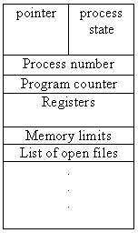

- Process state: The state may be any one of the five discussed earlier.
- Program counter: Holds the address of the next instruction to be executed for the process.
- CPU registers: The registers may vary depending on the architecture. The registers should be saved if an interrupt occurs. This will help the process to continue correctly afterwards.
- CPU-scheduling information: This includes process priority, pointers to scheduling queues etc.
- Memory-management information: This includes the value of the base and limit registers and the page tables or segment tables.
- Accounting information: This includes the amount of CPU and real time used, time limits, process numbers etc.
- I/O status information: This includes the list of I/O devices allocated to the process, a list of open files etc.

6.0) Summary
In this class, discussed about the process, its states and how a process is described in terms of various tables.

7.0) Exercise questions
(a) Explain 2 state process model (b) 5 state model (c) How a process is described?
(d) What is PCB?

Lecture 7

1) Synopsis: scheduling, scheduler organization, scheduling strategies

2) Target: At the completion of this lecture you should be able to answer questions like (a) what is scheduling?
(b) Explain different types of scheduling?
(c) What are the different scheduling criteria?

3) Introduction
In this class we will be discussing about scheduling, criteria of good scheduler and different scheduling algorithms.

4) Revision / Prerequisites
Please refer to pages 394 to 415 of the text book

5.1) Concept #1 scheduling

It is to assign processes to be executed by the processor or processors over time.
It is broken into 3 – long, medium and short term scheduling.

(i) Long term Scheduling
    - It decides which programs are admitted to the system for processing.
- It controls the degree of multiprogramming
- More processes, smaller percentage of time each process is being executed.

(ii) Medium term Scheduling

It is part of the swapping function.
(iii) Short term Scheduling
Also known as CPU scheduler
Selects which process should be executed next and allocates CPU

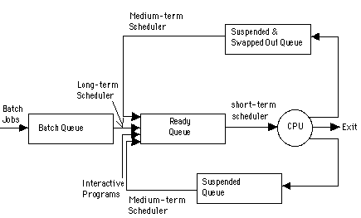

  - Context Switch
- Switching the CPU from one process to another is called context switch.
- It involves saving the state of the old process and loading the saved state of the new process.
- The state of a process includes the value of the CPU registers, the process state and memory management information. This information is saved in the PCB of the process.
- The processor does no useful work during this process, so the time for context switch is an overhead.
5.3 Scheduling Criteria
The different criteria used to compare the performance of the scheduling algorithms are the following:
- CPU Utilization: It is the percentage of time the CPU is kept busy.
- Throughput: It is the number of processes completed per unit time.
- Turnaround time: It is time from the submission of a job to the completion of the job. It is the sum of waiting time and time for which the process uses the CPU.
- Waiting time: It is the amount of time the process spends in the ready queue waiting for the processor.
- Response time: It is time from the submission of a job to the time the first response is obtained.
  - Preemptive Scheduling and Non preemptive Scheduling
In non-preemptive scheduling, once the CPU is allocated to a process, it is released only when the process terminates or when the process switches from the running state to waiting state. Used in Macintosh and Windows 3.1.
In preemptive scheduling, the scheduling takes place when a process switches from running state to ready state or from waiting state to ready state. This scheduling is costly and requires special hardware to implement it.
  - Scheduling Algorithms
(I) First Come First Serve (FCFS)
- The process that request first for the processor is allotted the processor first.
- The ready queue is maintained as a FIFO queue.
- When the processor becomes free it is allotted to the process at the head of the queue and when a new process arrives it is entered at the tail of the queue.
It is the simplest algorithm and easy to implement.
(II) Shortest Job First Scheduling (SJF)
- Here among the processes in the ready queue, the one with the least CPU burst time will be allotted the processor first.
- If two processes have their burst time equal, then FCFS scheduling is used.
- The average waiting time is small when compared to FCFS scheduling.
- SJF is optimal algorithm.
- It is difficult to implement because knowing the length of the next CPU burst is difficult.
- SJF can be non preemptive or preemptive.
The preemptive version of SJF is called Shortest Remaining Time First scheduling. Here when a new job arrives in the ready queue, its CPU burst is compared with the remaining CPU burst of the currently running process. If the newly arrived process has got the smaller burst then the currently running process will be preempted and the new process will be allotted to the processor. The preempted process will enter the ready queue and wait for its turn to get the processor.

(III) Priority Scheduling
- Each process is assigned a priority number (integer).
- The CPU is allocated to the process with the highest priority (smallest integer may be considered as highest priority).
- Priority scheduling can be preemptive or non preemptive.
- In preemptive priority scheduling, while a process is executing, if a new process with high priority than the currently running process arrives, the process is preempted and the processor is allocated to the new process. SJF is a priority scheduling where priority is the predicted next CPU burst time.

The problem with priority scheduling is that a low priority processes may have to wait indefinitely to get the processor to execute. This is called starvation. The solution is to increase the priority of the process as time progresses. This is called aging.

(IV) Round Robin Scheduling
- Each process gets a small amount of CPU time known as time quantum.
- When the time elapses process is preempted and the processor is allocated to the next process at the head of the ready queue.
- When the time quantum is very high this scheduling behaves as FCFS and when the time quantum is very small overhead will be high. It should be large with respect to context switch.
(V) Multilevel Queue Scheduling
Ready queue is partitioned into separate queues, for example, foreground (interactive) and background (batch).
Each queue has its own scheduling algorithm, foreground – RR, background – FCFS
Scheduling must be done between the queues. Any scheduling algorithm can be used for this purpose. If fixed priority scheduling is used for this purpose (i.e., serve all from foreground then from background). There is possibility of starvation. If RR is used each queue gets a certain amount of CPU time which it can schedule amongst its processes; i.e., 80% to foreground in RR and 20% to background in FCFS

(VI)Multilevel Feedback Queue Scheduling
In multilevel queue scheduling once a process enters a queue, it remains there. But in multilevel feedback queue scheduling a process can move between the various queues. Thus aging can be implemented.
Multilevel-feedback-queue scheduler defined by the following parameters:
- Number of queues
- Scheduling algorithms for each queue
- Method used to determine when to upgrade a process
- Method used to determine when to demote a process
- Method used to determine which queue a process will enter when that process needs service

6.0) Summary
In this class, we have gone through the Scheduling, different types of scheduling and algorithms for this. .

7.0) Exercise questions
(a) What is Scheduling? (b) Distinguish between preemptive and non preemptive algorithms? (c) Different types of schedulers (d) Scheduling algorithms?

Lecture 8

1) Synopsis: Process synchronization – interacting processes, co-coordinating processes, critical section

2) Target: At the completion of this lecture you should be able to answer questions like (a) what is synchronization. Why is it important?
(b) What is process coordination? How is it possible?
(c) What is critical section problem?

3) Introduction
In this class the concept of process synchronization is introduced. We will discuss why it is needed and how it can be achieved.
4) Revision / Prerequisites
Please refer to pages 394 to 415 of the text book.

5.1) Concept #1 Why synchronization required?

- Concurrent access to shared data may result in data inconsistency
- Maintaining data consistency requires mechanisms to ensure the orderly execution of cooperating processes
Example

- Suppose that we wanted to provide a solution to the consumer-producer problem that fills all the buffers. We can do so by having an integer count that keeps track of the number of full buffers. Initially, count is set to 0. It is incremented by the producer after it produces a new buffer and is decremented by the consumer after it consumes a buffer.

Producer

while (true) {

/* produce an item and put in nextProduced */
while (count == BUFFER_SIZE)
; // do nothing
buffer [in] = nextProduced;
in = (in + 1) % BUFFER_SIZE;
count++;
}

Customer
while (true) {
while (count == 0)
; // do nothing
nextConsumed = buffer[out];
out = (out + 1) % BUFFER_SIZE;
count--;

/* consume the item in nextConsumed
}

- A situation where several processes access and manipulate the same data concurrently and the outcome of the execution depends on the particular order in which the access takes place is called race condition

Critical Section problem

Each process has a segment of code called critical section, where it can change common variables, updating table etc. While one process is executing in this section, others are not allowed. The critical section problem is to design a protocol that processes can use to cooperate.

Solutions to Critical Section problem

1. Mutual Exclusion - If process Pi is executing in its critical section, then no other processes can be executing in their critical sections

2. Progress - If no process is executing in its critical section and there exist some processes that wish to enter their critical section, then the selection of the processes that will enter the critical section next cannot be postponed indefinitely

3. Bounded Waiting - A bound must exist on the number of times that other processes are allowed to enter their critical sections after a process has made a request to enter its critical section and before that request is granted
  - Assume that each process executes at a nonzero speed
  - No assumption concerning relative speed of the N processes
Two process solution

- Assume that the LOAD and STORE instructions are atomic; that is, cannot be interrupted.
- The two processes share two variables:
  - int turn;
  - Boolean flag[2]
- The variable turn indicates whose turn it is to enter the critical section.
- The flag array is used to indicate if a process is ready to enter the critical section. flag[i] = true implies that process Pi is ready!

Algorithm for process P

while (true) {
flag[i] = TRUE;
turn = j;
while ( flag[j] && turn == j);

CRITICAL SECTION

flag[i] = FALSE;

REMAINDER SECTION
}

Synchronization hardware

- Many systems provide hardware support for critical section code
- Uniprocessors – could disable interrupts
  - Currently running code would execute without preemption
  - Generally too inefficient on multiprocessor systems
    - Operating systems using this not broadly scalable
- Modern machines provide special atomic hardware instructions
    - Atomic = non-interruptable
  - Either test memory word and set value
  - Or swap contents of two memory words

Test and set instruction

Definition

boolean TestAndSet (boolean *target)
{
boolean rv = *target;
*target = TRUE;
return rv:
}

Solution using TestAndSet

- Shared boolean variable lock., initialized to false.
- Solution:

while (true) {
while ( TestAndSet (&lock ))
; /* do nothing

// critical section

lock = FALSE;

// remainder section

}

SWAP instruction

- Definition:

void Swap (boolean *a, boolean *b)
{
boolean temp = *a;
*a = *b;
*b = temp:
}

Solution using swap instruction

- Shared Boolean variable lock initialized to FALSE; Each process has a local Boolean variable key.
- Solution:
while (true) {
key = TRUE;
while ( key == TRUE)
Swap (&lock, &key );

// critical section

lock = FALSE;

// remainder section

}

Cooperating process
- Independent process cannot affect or be affected by the execution of another process
- Cooperating process can affect or be affected by the execution of another process
- Advantages of process cooperation
  - Information sharing
  - Computation speed-up
  - Modularity
  - Convenience

6.0) Summary
In this class, we have gone through the need of synchronization, and the critical section problem. We also discussed the solution to this problem using hardware methods.

7.0) Exercise questions
(a) What is Synchronization? Why is it important?
(b) What is process coordination? How is it possible?
(c) How can process synchronization be done using hardwares?
(d) What is critical section problem? How can it be solved?

Lecture 9

1) Synopsis: semaphores, deadlock

2) Target: At the completion of this lecture you should be able to answer questions like (a) What is deadlock? Its essential conditions?
(b) How it can be represented?
(c) How it can be avoided?
d) What is semaphore? Binary semaphore?

3) Introduction
In the last class we studied about synchronization. Now we can go through another synchronization tool called semaphore and its applications. Also we will come across the important term deadlock and more about it.

4) Revision / Prerequisites
Please refer to pages 420 to 442 of the text book.

5.1) Concept #1 Semaphore

- Synchronization tool that does not require busy waiting
- A semaphore is a protected variable whose value can be accessed and altered only by the operations P and V and initialization operation called 'Semaphoiinitislize'.
- Two standard operations modify S: wait() and signal()
  - Originally called P() and V()
- Less complicated
- Can only be accessed via two indivisible (atomic) operations
wait (S) {
while S <= 0
; // no-op
S--;
}

signal (S) {
S++;
}
- Binary Semaphores can assume only the value 0 or the value 1 counting semaphores also called general semaphores can assume only nonnegative values.
The P (or wait or sleep or down) operation on semaphores S, written as P(S) or wait (S), operates as follows: P(S): IF S > 0
THEN S := S - 1
ELSE (wait on S)
The V (or signal or wakeup or up) operation on semaphore S, written as V(S) or signal (S), operates as follows: V(S): IF (one or more process are waiting on S)
THEN (let one of these processes proceed)
ELSE S := S +1
Implementation of binary semaphore
- Can implement a counting semaphore S as a binary semaphore
- Provides mutual exclusion
- Must guarantee that no two processes can execute wait () and signal () on the same semaphore at the same time
- Thus, implementation becomes the critical section problem where the wait and signal code are placed in the crtical section.
  - Could now have busy waiting in critical section implementation
    - But implementation code is short
    - Little busy waiting if critical section rarely occupied
- Note that applications may spend lots of time in critical sections and therefore this is not a good solution.
- Implementation of wait:
wait (S){
value--;
if (value < 0) {
add this process to waiting queue
block(); }
}
- Implementation of signal:
Signal (S){
value++;
if (value <= 0) {
remove a process P from the waiting queue
wakeup(P); }
}
5.2) Concept #2 Deadlock
- two or more processes are waiting indefinitely for an event that can be caused by only one of the waiting processes
Example----The simplest example of deadlock is where process 1 has been allocated non-shareable resources A, say, a tap drive, and process 2 has be allocated non-sharable resource B, say, a printer. Now, if it turns out that process 1 needs resource B (printer) to proceed and process 2 needs resource A (the tape drive) to proceed and these are the only two processes in the system, each is blocked the other and all useful work in the system stops. This situation ifs termed deadlock. The system is in deadlock state because each process holds a resource being requested by the other process neither process is willing to release the resource it holds.
Necessary and Sufficient Deadlock Conditions
1. Mutual Exclusion Condition
The resources involved are non-shareable.
Explanation: At least one resource (thread) must be held in a non-shareable mode, that is, only one process at a time claims exclusive control of the resource. If another process requests that resource, the requesting process must be delayed until the resource has been released.
2. Hold and Wait Condition

Requesting process hold already, resources while waiting for requested resources.
Explanation: There must exist a process that is holding a resource already allocated to it while waiting for additional resource that are currently being held by other processes.
3. No-Preemptive Condition

Resources already allocated to a process cannot be preempted.
Explanation: Resources cannot be removed from the processes are used to completion or released voluntarily by the process holding it.
4. Circular Wait Condition

The processes in the system form a circular list or chain where each process in the list is waiting for a resource held by the next process in the list.

Dealing with Deadlock Problem
  - Deadlock Prevention
    - Deadlock might be prevented by denying any one of the conditions.
- Elimination of “Mutual Exclusion” Condition
The mutual exclusion condition must hold for non-sharable resources. That is, several processes cannot simultaneously share a single resource. This condition is difficult to eliminate because some resources, such as the tap drive and printer, are inherently non-shareable. Note that shareable resources like read-only-file do not require mutually exclusive access and thus cannot be involved in deadlock.
- Elimination of “Hold and Wait” Condition
There are two possibilities for elimination of the second condition. The first alternative is that a process request be granted all of the resources it needs at once, prior to execution. The second alternative is to disallow a process from requesting resources whenever it has previously allocated resources. This strategy requires that all of the resources a process will need must be requested at once. The system must grant resources on “all or none” basis. If the complete set of resources needed by a process is not currently available, then the process must wait until the complete set is available. While the process waits, however, it may not hold any resources. Thus the “wait for” condition is denied and deadlocks simply cannot occur. This strategy can lead to serious waste of resources. For example, a program requiring ten tap drives must request and receive all ten derives before it begins executing. If the program needs only one tap drive to begin execution and then does not need the remaining tap drives for several hours. Then substantial computer resources (9 tape drives) will sit idle for several hours. This strategy can cause indefinite postponement (starvation). Since not all the required resources may become available at once.
- Elimination of “No-preemption” Condition
The nonpreemption condition can be alleviated by forcing a process waiting for a resource that cannot immediately be allocated to relinquish all of its currently held resources, so that other processes may use them to finish. Suppose a system does allow processes to hold resources while requesting additional resources. Consider what happens when a request cannot be satisfied. A process holds resources a second process may need in order to proceed while second process may hold the resources needed by the first process. This is a deadlock. This strategy require that when a process that is holding some resources is denied a request for additional resources. The process must release its held resources and, if necessary, request them again together with additional resources. Implementation of this strategy denies the “no-preemptive” condition effectively.
High Cost When a process release resources the process may lose all its work to that point. One serious consequence of this strategy is the possibility of indefinite postponement (starvation). A process might be held off indefinitely as it repeatedly requests and releases the same resources.
- Elimination of “Circular Wait” Condition
The last condition, the circular wait, can be denied by imposing a total ordering on all of the resource types and than forcing, all processes to request the resources in order (increasing or decreasing). This strategy impose a total ordering of all resources types, and to require that each process requests resources in a numerical order (increasing or decreasing) of enumeration. With this rule, the resource allocation graph can never have a cycle
  - Deadlock Avoidance
This approach to the deadlock problem anticipates deadlock before it actually occurs. This approach employs an algorithm to access the possibility that deadlock could occur and acting accordingly. This method differs from deadlock prevention, which guarantees that deadlock cannot occur by denying one of the necessary conditions of deadlock.
If the necessary conditions for a deadlock are in place, it is still possible to avoid deadlock by being careful when resources are allocated. Perhaps the most famous deadlock avoidance algorithm, due to Dijkstra [1965], is the Banker’s algorithm. So named because the process is analogous to that used by a banker in deciding if a loan can be safely made.

Banker’s Algorithm
In this analogy
Customers | ≡ | processes
Units | ≡ | resources, say, tape drive
Banker | ≡ | Operating System

Customers | Used | Max
A  B  C  D | 0  0  0  0 | 6  5  4  7 | Available Units = 10
 | Fig. 1
In the above figure, we see four customers each of whom has been granted a number of credit nits. The banker reserved only 10 units rather than 22 units to service them. At certain moment, the situation becomes
Customers | Used | Max
A  B  C  D | 1  1  2  4 | 6  5  4  7 | Available Units = 2
 | Fig. 2
Safe State The key to a state being safe is that there is at least one way for all users to finish. In other analogy, the state of figure 2 is safe because with 2 units left, the banker can delay any request except C's, thus letting C finish and release all four resources. With four units in hand, the banker can let either D or B have the necessary units and so on.
Unsafe State Consider what would happen if a request from B for one more unit were granted in above figure 2.
We would have following situation
Customers | Used | Max
A  B  C  D | 1  2  2  4 | 6  5  4  7 | Available Units = 1
 | Fig. 3
This is an unsafe state.
If all the customers namely A, B, C, and D asked for their maximum loans, then banker could not satisfy any of them and we would have a deadlock.
3. Deadlock Detection
Deadlock detection is the process of actually determining that a deadlock exists and identifying the processes and resources involved in the deadlock.
The basic idea is to check allocation against resource availability for all possible allocation sequences to determine if the system is in deadlocked state a. Of course, the deadlock detection algorithm is only half of this strategy. Once a deadlock is detected, there needs to be a way to recover several alternatives exists:
- Temporarily prevent resources from deadlocked processes.
- Back off a process to some check point allowing preemption of a needed resource and restarting the process at the checkpoint later.
- Successively kill processes until the system is deadlock free.
These methods are expensive in the sense that each iteration calls the detection algorithm until the system proves to be deadlock free. The complexity of algorithm is O(N²) where N is the number of proceeds. Another potential problem is starvation; same process killed repeatedly.
6.0) Summary
In this class, discussed about how semaphore can be used for synchronization. And also discussed deadlock and various methods for its elimination

7.0) Exercise questions
(a) What is deadlock? Its essential conditions?
(b) How it can be represented?
(c) How it can be avoided?
d) What is semaphore? Binary semaphore?

Lecture 10

1) Synopsis: Processes and Threads, Multithreading, Multiprocessing

2) Target: At the completion of this lecture you should be able to answer questions like (a) What is thread?
(b) Distinguish between thread and process?
(c) Discuss thread states?
(d) Different multithreading models?
3) Introduction
We will discuss thread, its state. Also a comparative study between thread and process will be done. We can go through the multithreading concept and its different model.

4) Revision / Prerequisites
Please refer to pages 318 to 330 of the text book.

5.1) Concept #1 Thread
- Processes are used to group resources together and threads are the entities scheduled for execution on the CPU.
- A thread is a single sequence stream within in a process. Because threads have some of the properties of processes, they are sometimes called lightweight processes.
- In a process, threads allow multiple executions of streams. In many respect, threads are popular way to improve application through parallelism. The CPU switches rapidly back and forth among the threads giving illusion that the threads are running in parallel.
- Like a traditional process i.e., process with one thread, a thread can be in any of several states (Running, Blocked, Ready or Terminated). Each thread has its own stack. Since thread will generally call different procedures and thus a different execution history. This is why thread needs its own stack. An operating system that has thread facility, the basic unit of CPU utilization is a thread.
- A thread has or consists of a program counter (PC), a register set, and a stack space. Threads are not independent of one other like processes as a result threads shares with other threads their code section, data section, OS resources also known as task, such as open files and signals.
Processes Vs Threads

Similarities
- Like processes threads share CPU and only one thread active (running) at a time.
- Like processes, threads within a processes, threads within a processes execute sequentially.
- Like processes, thread can create children.
- And like process, if one thread is blocked, another thread can run
Differences
- Unlike processes, threads are not independent of one another.
- Unlike processes, all threads can access every address in the task .
- Unlike processes, thread are design to assist one other. Note that processes might or might not assist one another because processes may originate from different users.
Thread states
- States associated with a change in thread state
  - Spawn
    - Spawn another thread
  - Block
  - Unblock
  - Finish
    - Deallocate register context and stacks

User-Level Threads
User-level threads implement in user-level libraries, rather than via systems calls, so thread switching does not need to call operating system and to cause interrupt to the kernel. In fact, the kernel knows nothing about user-level threads and manages them as if they were single-threaded processes.
Advantages:
The most obvious advantage of this technique is that a user-level threads package can be implemented on an Operating System that does not support threads. Some other advantages are
- A user-level thread does not require modification to operating systems.
- Simple Representation:
Each thread is represented simply by a PC, registers, stack and a small control block, all stored in the user process address space.
- Simple Management:
This simply means that creating a thread, switching between threads and synchronization between threads can all be done without intervention of the kernel.
- Fast and Efficient:
Thread switching is not much more expensive than a procedure call.
Disadvantages:
- There is a lack of coordination between threads and operating system kernel. Therefore, process as whole gets one time slice irrespect of whether process has one thread or 1000 threads within. It is up to each thread to relinquish control to other threads.
- User-level threads require non-blocking systems call i.e., a multithreaded kernel. Otherwise, entire process will blocked in the kernel, even if there are runable threads left in the processes. For example, if one thread causes a page fault, the process blocks.
Kernel-Level Threads
In this method, the kernel knows about and manages the threads. No runtime system is needed in this case. Instead of thread table in each process, the kernel has a thread table that keeps track of all threads in the system. In addition, the kernel also maintains the traditional process table to keep track of processes. Operating Systems kernel provides system call to create and manage threads.
Advantages:
- Because kernel has full knowledge of all threads, Scheduler may decide to give more time to a process having large number of threads than process having small number of threads.
- Kernel-level threads are especially good for applications that frequently block.
Disadvantages:
- The kernel-level threads are slow and inefficient. For instance, threads operations are hundreds of times slower than that of user-level threads.
- Since kernel must manage and schedule threads as well as processes. It require a full thread control block (TCB) for each thread to maintain information about threads. As a result there is significant overhead and increased in kernel complexity.
Single and Multithreaded threads
- Operating system supports multiple threads of execution within a single process
- MS-DOS supports a single thread
- UNIX supports multiple user processes but only supports one thread per process
- Windows 2000, Solaris, Linux, Mach, and OS/2 support multiple threads
- 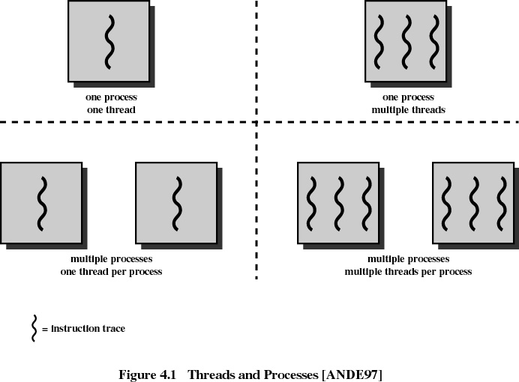
Advantages
- Responsiveness
- Resource Sharing
- Economy
- Utilization of MP Architectures
Multithreading model
1. Many to one
- Many user-level threads mapped to single kernel thread
- Examples:
  - Solaris Green Threads
  - GNU Portable Threads
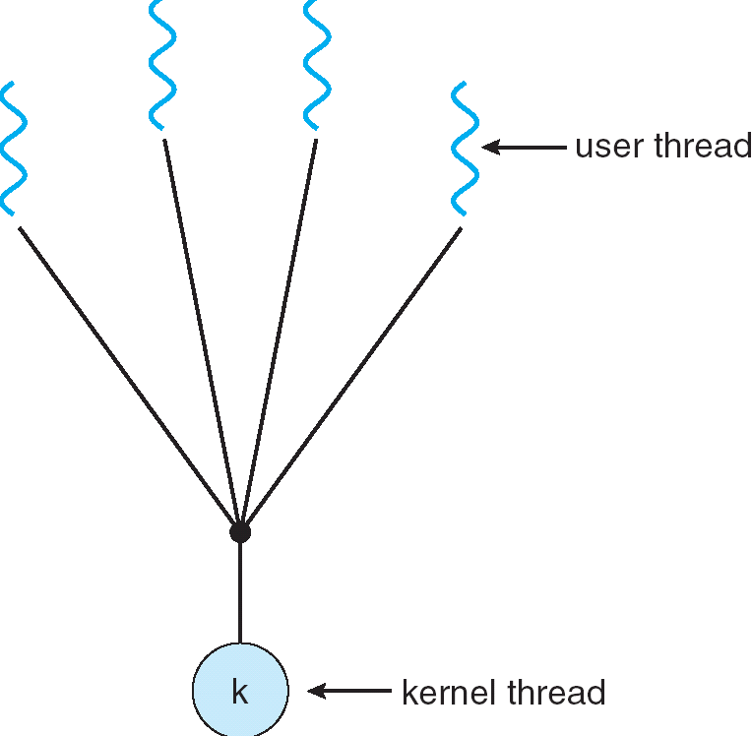
2. One to one
- Each user-level thread maps to kernel thread
- Examples
  - Windows NT/XP/2000
  - Linux
  - Solaris 9 and later
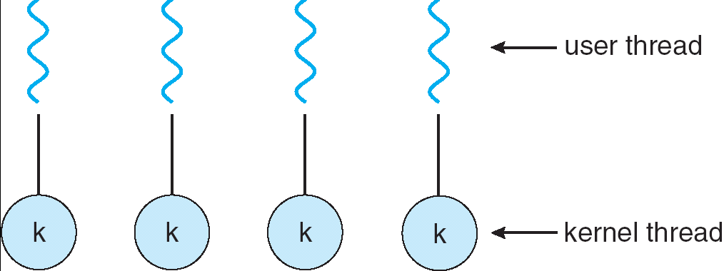
3. Many to many model
- Allows many user level threads to be mapped to many kernel threads
- Allows the operating system to create a sufficient number of kernel threads
- Solaris prior to version 9
- Windows NT/2000 with the ThreadFiber package
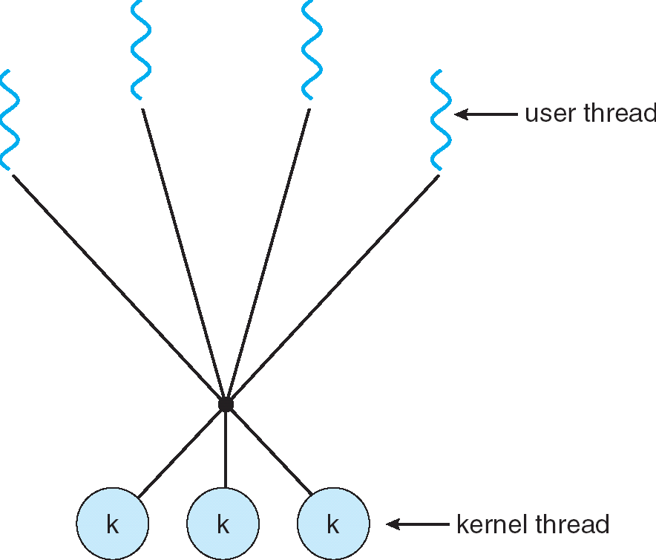

Categories of Computer systems
- Single Instruction Single Data (SISD)
  - single processor executes a single instruction stream to operate on data stored in a single memory
- Single Instruction Multiple Data (SIMD)
  - each instruction is executed on a different set of data by the different processors
- Multiple Instruction Single Data (MISD)
  - a sequence of data is transmitted to a set of processors, each of which executes a different instruction sequence. Never implemented
- Multiple Instruction Multiple Data (MIMD)
  - a set of processors simultaneously execute different instruction sequences on different data sets
6.0) Summary
In this class, discussed thread, its states. A Comparison between thread and process is also done.

7.0) Exercise questions
(a) What is thread?
(b) Distinguish between thread and process?
(c) Discuss thread states?
(d) Different multithreading models?

