MODULE-5

Storage Management

Dynamic Memory Management:

- data is arranged in memory using a data structure such as lists. We usually use a linked implementation of lists called linked lists.
:

-each node in the list have a data part and a pointer part. There can be internal pointers and external pointers for a particular node.
-In static memory the node have 2 characteristics:
- each node is of a given type and have a fixed size
- size of each node is fairly small
-But in some applications they do not apply.
For eg: a particular program might require a large amount of contiguous storage.
-A program may require storage blocks in large variety of sizes ie. variable length blocks are required.

-There are three essential things for efficient memory management:
- Keep track of available space.
- Allocate portion of that space when allocation requests are given
- To combine contiguous free spaces when a block is freed.

Compaction of blocks of storage:
Initially memory is one large block of available storage .as requests for storage arrive ,blocks of memory are allocated sequentially starting from the first location in memory.

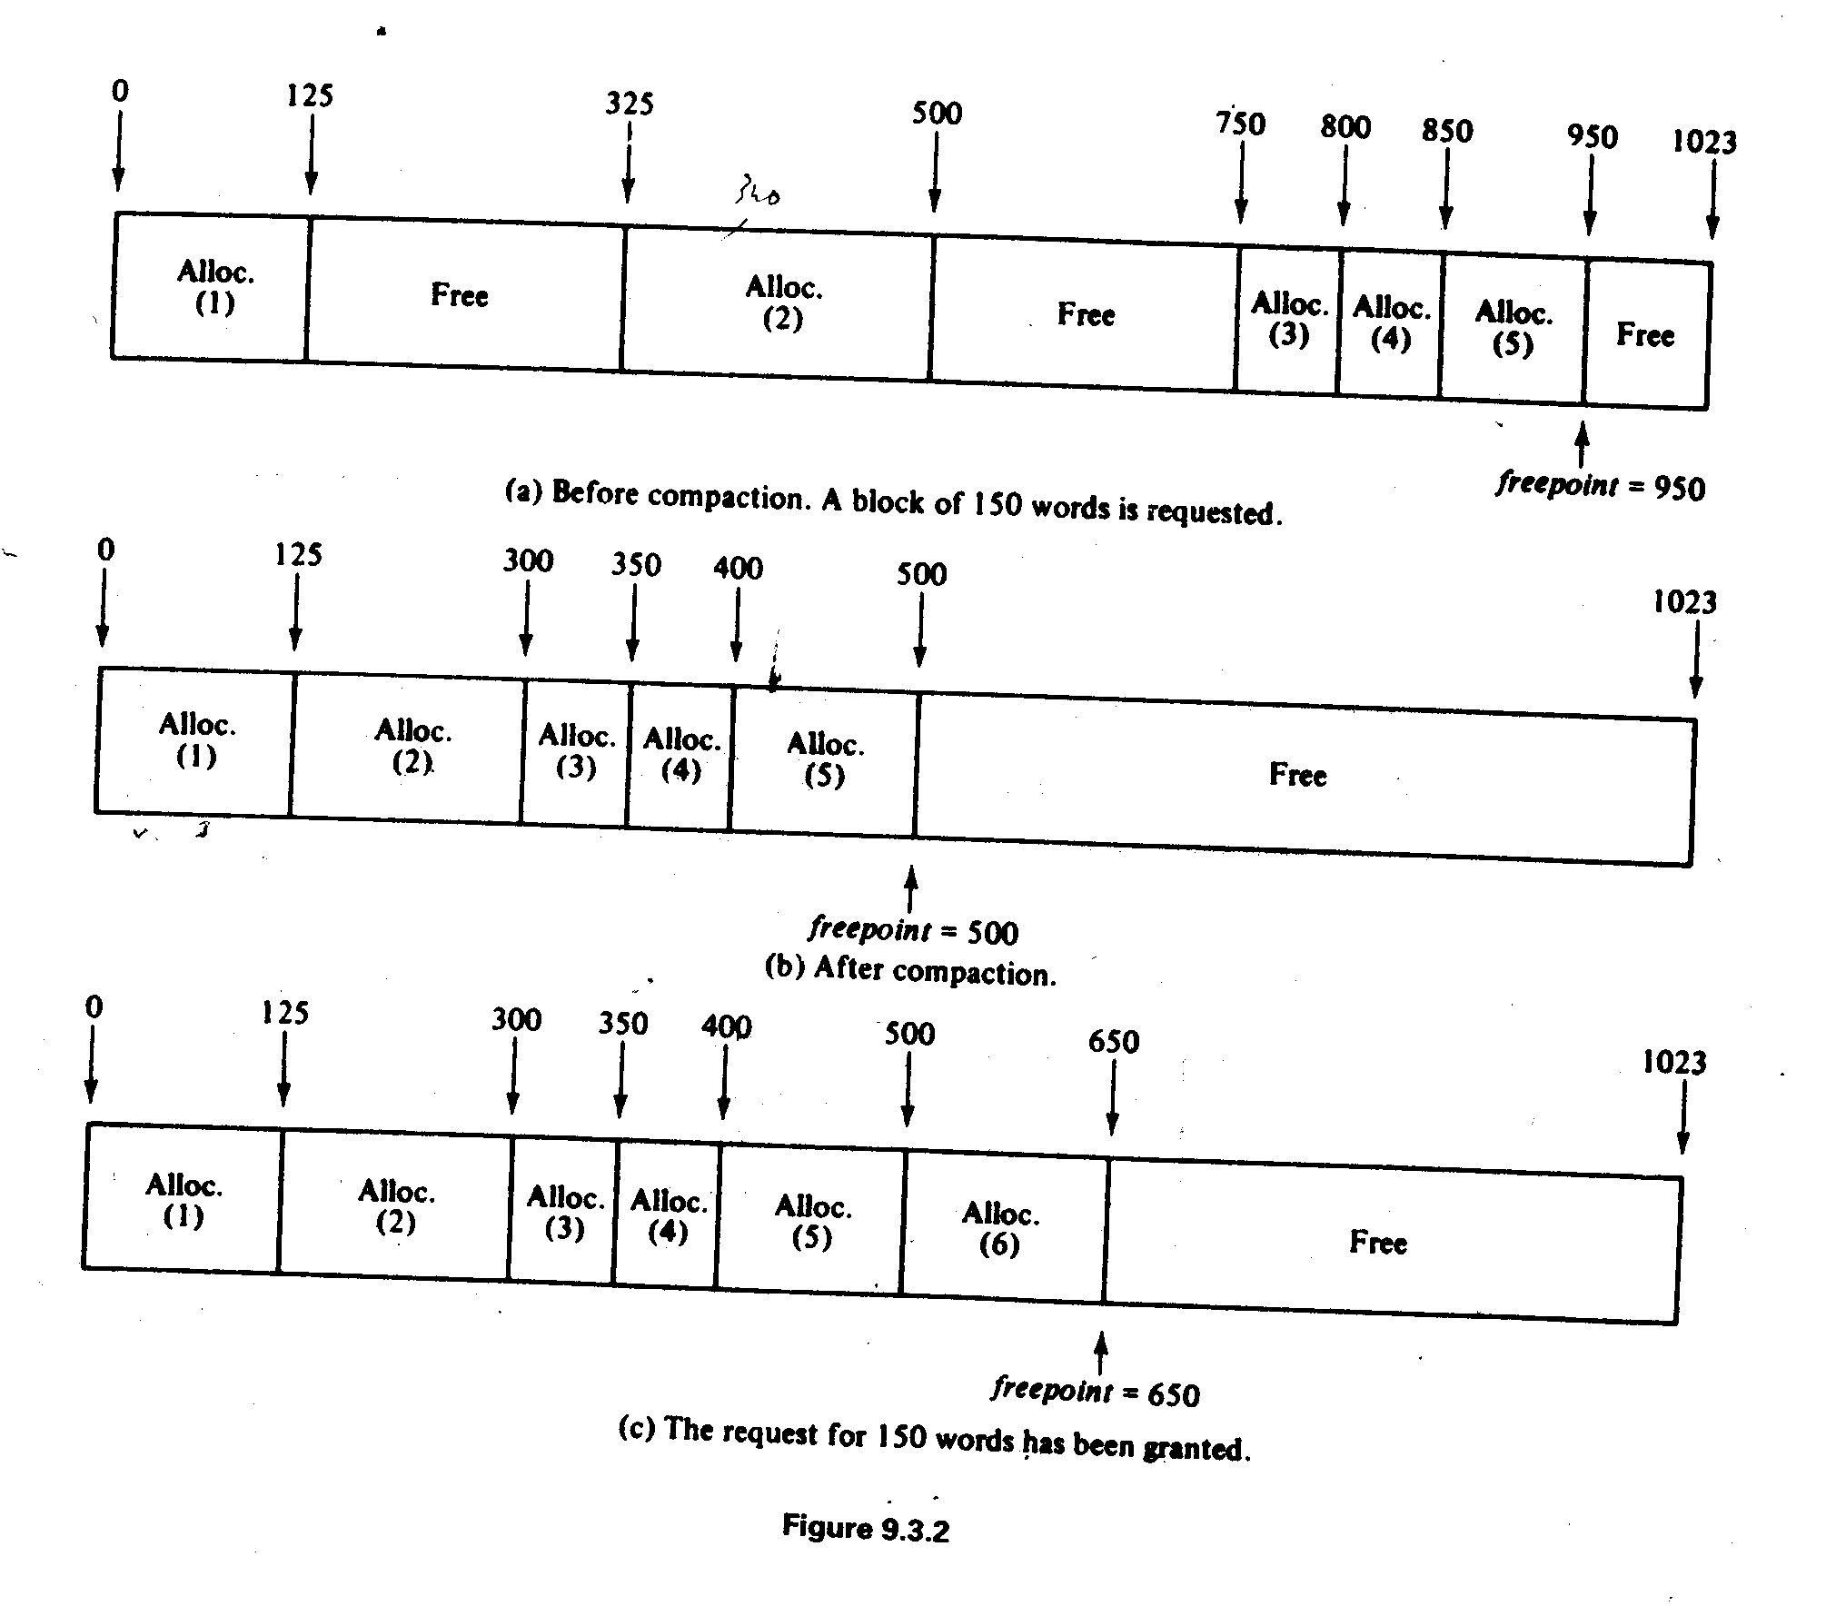

After compaction all allocated blocks are copied into the sequential memory locations starting from the lowest address in memory.

Thus all free blocks are eliminated and grouped as a contiguous free block.

First Fit, Best Fit and Worst Fit

-It is difficult to move blocks of allocated storage from one area of memory to another. So it must be possible to reallocate memory blocks that have been freed dynamically.
-each time that a request is made for storage, a free area large enough to accommodate the size requested must be located.
-There are several methods of selecting the free block to use when requesting storage.

First Fit allocation Method:
- In the first-fit method, the free list is traversed sequentially to find the first free block whose size is larger than or equal to the amount requested.
- If p is the address of a free block, the expressions size(p) refers to size of the free block and next(p) refers to pointer to the next free block.
- Once the block is found it is removed from the list or is split into two portions(if it is greater than the amount requested)
- The first of these portions remain on the list and the second is allocated.
- The reason for allocating second portion rather than the first is that the free list next pointer is at the beginning of each free block.
- By leaving the first portion of the block on the free list, this portion of the block on the free list, this pointer need not be copied into some other location and next field of the previous block in the list need not be changed.

- The following first fit allocation algorithm returns the address of a free block of storage of size n in the variable alloc if one is available and sets alloc to the null address if no such block is available

First Fit Allocation Algorithm

Assume: freeblock is a global pointer points to first free block on list
p- pointer used to store the starting address of first free block
q- pointer stores address of block behind p
alloc-variable that stores the address of the freeblock allocated
n-size of freeblock requested
size (p) =stores size of freeblock where p stores the address of a free block

Procedure: /*Initially we assign p with address of the first free block
and alloc as null and q to null*/.

p= freeblock;
alloc =null;
q =null;

/*Next we traverse through the whole free list so as to find a block having size
greater than or equal to the requested size n .*/

While (p!=null && size(p)<n)
{
q = p;
p = next (p)
/*When we contradict the condition (size(p)<n) we enters the next loop where we check two conditions ie:
Either size(p)>n or size(p)==n*/.
If (p!= null)
{
s =size (p);
alloc = p+ s-n;
/*Above we assume that size(p)>n then we have to split the block to two portions and we take the second portion(reason mentioned at initial part) and it is allocated to variable alloc as the starting address of the allocated block. Since we require second portion we have to decrement from the ending address location of the block. For that we add the size of p with starting address stored in variable p and then decrement the requested size from that*/

If(s==n)
/*Here we check the condition size(p)==n. If so we check if q is null ie. the free block jus before p is null. If so we set the starting address of first free block as next block to p*/

if (q==null)
freeblock = next(p);
/*else if q exists we set the next pointer of q to next pointer of p since in between block ie. p is allocated.*/
else
next (q) = next(p);
else
/*after allocation we have to resize the block from which the portion was allocated and it is done by decrementing allocated size from size of the block allocated.*/
size (p)=s-n;
}

Best Fit Allocation Algorithm :

p = freeblock /*p is used to traverse the free list
q = null /*q is one block behind p
r = null /*r points to the desired block
rq = null /*rq is one block behind r
alloc = null /* alloc will point to the block selected.
rsize=memsize+1 ; /* rsize is the size of the block at r and memsize is referred to the total number of words in memory

while (p!=null){
if (size(p)>=n && size(p)<rsize)
{/* we have found a free block closer in size*/
r = p;
rq = q;
rsize =size(p);
} /*end if*/

/* continue traversing*/

q = p;
p = next (p);
}/* end while*/

If(r! =null)
/* there is a block of sufficient size*/
alloc = r + rsize –n;
if(rsize==n)
/*remove the block from the free list*/
If(rq==null)
freeblock = next(r);
else
next(rq) = next(r);
else
size( r) = rsize-n;
}

Yet another method of allocating blocks of storage is the worst fit method.
-In this method the system always allocates a portion of the largest free block in the memory
-The idea behind this is by using small number of very large blocks repeatedly to satisfy the majority of reqests; many moderately sized blocks will be left unfragmented.
- The major reason for choosing one method over the other is efficiency.1n.each the methods, the search can be made more efficient:
- first-fit method (which allocates the block at the lowest memory address first, will be most efficient if available list is maintained in the order of increasing memory address
- If the available list is maintained in the order of increasing size, a best-fit search for a block becomes more efficient
- If the list is maintained in the order of decreasing size, a worst-fit requires no searching, as the largest size block is always the first on the list.
Improvements in the First-Fit Method
  - If the size of a free block is only slightly larger than the size of the block to be allocated, the portion of the free block that remains free is very small. Often this is so small that it can’t be used.
  - The solution to these problems is to insist that no block may remain free if its size is below some reasonable minimum, If a free block exist below this minimum size, the block is not split. Instead, the entire block is allocated as though it were exactly the same size.
  - The phenomenon in which there are many small noncontiguous free blocks is called external fragmentation because free space is wasted outside allocated blocks. This contrasts with internal fragmentation, in which free space is wasted within allocated blocks.
Freeing Storage Blocks
- How allocated blocks of storage are freed and how they are combined with contiguous free blocks to form larger blocks of free storage. Specifically, three questions arise:
1. When a block of storage is freed, where is it placed on the free list?
2. When a block of storage is freed, how can it be determined whether the blocks of storage on either side of it are free (in which case the newly freed block should be combined with an already existing free block)?
3. What is the mechanism for combining a newly freed block with a previously free contiguous block?

Here we introduce a new concept

Liberation:

- The term liberation used for the process of freeing an allocated block of storage; an algorithm to implement this process is called a liberation algorithm.
- Suppose that the free list is organized arbitrarily, so that when a block is freed, it is placed at the front of the list.
- It may be that the block just freed is adjacent to a previously free block.
- To create a single large free block, the newly freed block should be combined with the adjacent free block
- To find a adjacent freeblock there is other way than traversing the while block
- when a block is freed, the free list is traversed in a search for the first free block fb whose starting address is greater than the starting address of the block being freed.
- If a contiguous free block is not found in this search, no such contiguous block exists and the newly freed block can be inserted into the free list immediately before fb.
- If fb or the free block immediately preceding fb on the free list is contiguous to the newly freed block, it can be combined with that newly freed block.
- Search is only half of the list on average.

Algorithm of Liberation

The following liberation algorithm implements this scheme, assuming that the
free list is linear (not circular) and that freeblock points to the free block with the smallest address. The algorithm frees a block of size n beginning at address alloc.
q = nu11;
p = freeb1ock;
/* p 'traverses the free list. q remains one step behind p */

whi1e (p != nu11 && p < a11oc) {
q = p;
P = next(p);
} /* end while */

/* At this point, either q = nu11 or q < a11oc and either */
/* p = nu11 or a11oc < p. Thus if p and q are not null, */
/* the block must be combined with the blocks beginning at */
/* p or q or both, or must be inserted in the list between */
/* the two blocks. */

if (q == nu11)

freeb1ock = a11oc;
--- else
if (q + size(q) == a1loc) {
j.. /* combine with previous block */
alloc = q;
n = size(q) + n; }
else
next(q) = a11oc;
if (p != nu11 && a11oc + n == p) {
/* combine with subsequent block */
size(a11oc) = n + size(p);
next(a11oc) = next(p); }
else {
size(a11oc) = n;
next(al1oc) = p;

} /* end if */

Buddy System:

-Alterative method of handling the storage management problem without frequent list traversals.
-here we keep separate free lists for blocks of different sizes.
-each list contains free blocks of any one specific size.
-in the previous allocations where there are blocks of different sizes .In such case there are many drawbacks:
- First space is wasted due internal fragmentation ie .if there are block pf very small size, it won’t be of any use.
- Second is if request greater than the largest block in that memory is made it can’t be satisfied.
- The main demerit is free space can ever be combined

So Buddy system was introduced

-Here several free lists consisting of various sized blocks are maintained.

-Adjacent free blocks f smaller sizes may be removed from their lists, combined into free blocks of larger size and placed on the larger size free lists.

-larger blocks-used to satisfy request of large amount of memory or split once more into smaller constituent blocks to satisfy smaller request.

The first buddy system we consider is binary buddy system:

Binary Buddy System:
-works best on the binary computers in which the memory size is an integral power of 2 and in which multiplication and division by 2 can be performed very efficiently by shifting.
-Initially the entire memory of size 2^{m} is viewed as a single free block.
-For each power between 1 and 2^{m}- a free list containing blocks of that size is maintained.
-A block of size 2^{i} is called i-block and free list containing i-blocks is called i-list.
-Usually we avoid sizes 1, 2, 4 and 8 is consider as smallest free block.
-Initially all lists except m-list is empty.
-Blocks may be allocated only in sizes 2^{k} for some integer k between 0 and m. If a request for a block of size n is made, an i-block is reserved where i is the smallest integer such that n < = 2^{i}.
-If no i-block is available (the i-list is empty), an (i +1)-block is removed from the (i + 1)-list and is split into two equal size buddies. Each of these buddies is an i-block. One of the buddies is allocated, and the other remains free and is placed on the i-list.
- If an (i +1)-.block is also unavailable, an (i + 2)-block is split into two (i +1 )-block buddies, one of which is placed on the (i + 1)-list and the other of which is split into two i-blocks. One of these i-blocks is allocated and the other is placed onto the i-list. If no
(i + 2)-block is free, this process continues until either an i-block has been allocated or an m-block is found to be unavailable.
- The buddy system allocation process can best be described as a recursive function getblock(n) that returns the address of the block to be allocated, or the null pointer if no, block of size n is available. An outline of this function follows:

find the smallest integer i such that 2i >= n; if (the i-list is not empty) {
p = the address of the first block on the i-list;
remove the first block from the i-list;
return(p);
} /* end if */
e1se /*the i-list is empty*/
if (i == m)
return(null);
else {
p = getblock(2i+l);
if (p == null)
return(null);
e1se {
put the i-block starting at location p on the i-list; return(p + 2i); } /* end if */
} /* end if */

-Here when the block is split into two:The first of these remains on the free list, and the second is allocated.
-Each block is created by splitting a -block of one size higher. If an (i + 1 )-block is split into two i-blocks b1 and b2, b 1 and b2 are buddies of each other. The buddy of an i-block at location p is called the i-buddy of p.
- If an i-block is freed and its i-buddy is already free, the two buddies are combined into the (i +1)-block from which they were initially created.

Other Buddy Systems:

Fibonacci buddy system :
- The sizes of the blocks in this system are based on the Fibonacci numbers .Instead of blocks of size 1, 2, 4, 8, 16, ... as in the case of the binary buddy system, the Fibonacci buddy system uses blocks of size 1, 2, 3, 5, 8, 13, ... when an i-block (the size of an i-block in this system is the ith Fibonacci number) is split into two blocks, one of the blocks is an (i - 1)-block, and the other is an (i - 2)-block.

Weighted buddy system :
-In this scheme a block of size 2k is split into two blocks, one of size 2k-2 and the other of size 3 * 2k-2. For example, a block of size 64 splits into two buddies of sizes 16 and 48. Rules for recombination are similar.

-Here blocks are split into unequal subblocks, ie. requests for storage are usually not for sizes that match those of the blocks in the system.

- Thus, the next larger size block must be used, with the result that space is wasted within the block.

-For example, in the binary buddy system, when a request is made for a block of size 10, a block of size 16 will be allocated (resulting in 6 wasted bytes); in the Fibonacci buddy system, how- ever, a block of size 13 may be allocated (resulting in only 3 wasted bytes); in the weighted buddy system, a block of size 12 will be sufficient (resulting in only 2 wasted bytes). It is not always the case that the Fibonacci system results in less wasted space than the binary system (for example, a request for a block of size 15), but in general, allowing blocks of varying sizes will more likely produce a closer fit than will requiring groups of blocks to be of uniform size.

Recombination delaying buddy system:
- An alternative to the foregoing approach is to combine smaller blocks into larger ones only when necessary.
- In such a scheme, called a recombination delaying buddy system, when a block is freed it is returned to the list of blocks of its size.
- When a block of a particular size is required, the list of blocks of that size is searched. If a block of the required size is found, the search halts successfully; otherwise a search is made for a pair of blocks of the next smaller size that are buddies. If such a pair exists, the two blocks are combined to form a single block of the required size. If no such pair exists, this process is repeated recursively with successively smaller blocks until either a block of the required size can be formed from smaller blocks, so that the search is successful, or until it.is determined that the required block cannot be formed from smaller blocks

Garbage Collection and Compaction:
Garbage collection is the procedure of collecting all unused nodes and returning them to the available space list
This is done in 2 phases

Phase 1(marking phase)
All nodes in use are marked .We need a mark filed in each node .marking algorithm marks all directly accessible nodes ( ie nodes accessible through program variables referred to as pointer variables )and also indirectly accessible nodes (nodes accessible through link fields of nodes in accessible list) .It is assumed that a certain set of variables has been specified as pointer variables and that these variables are at all times valid or null pointers .Knowing which variables are pointer variables ,it is easy to mark all directly accessible nodes. The indirectly accessible nodes are marked by systematically examining all nodes reachable from these nodes.

Each node has 2 Boolean fields
- mark (mark= true ;node is used; mark= false; node is free)
- tag ( tag =false ;node has no link fields ;contains only atomic information)

They are called atomic nodes. All other nodes are list nodes.

We assume that all the nodes will be initially unmarked
(ie x .mark= false for every node x)
A procedure driver will repeatedly call the marking algorithm to mark all nodes accessible from each of the pointer variable being used
Procedure driver
Begin
For each pointer variable x such that
x! = null do
Begin
x.mark = true;
if x.tag then mark1(x)
end;
end;
The mark1 algorithm will examine all rlinks and dlinks .mark1 will move to the dlink at the same time will place the rlink on a stack in case the rlink is a list node not yet marked.
The type definition of a node is

Type list pointer = list node;
List node = record
mark:Boolean;
case tag : Boolean of
true (dlink :list pointer : rlink :list pointer);
false (data:char)
end;
Procedure mark1( x:list pointer)
Var p, q: list pointer;
Begin
Top = 0; push(x)
While (top> 0) do
begin
pop (p);
Repeat
q= p.rlink
if q!= null
then begin
if q. tag and not q.mark then push (q);
q.mark= true;
end;
p=p.dlink;
if p== null then go to 10;
if p.mark or ! p.tag then go to 10;
p.mark= true;
until false;
10. p.mark= true;
end;
end;

A I J

f | t
f | t | nil
f | t | Nil | nil

B H
f | t
f | t | nil | nil

C
f | t |  | nil

D F G
f | t
f | t | nil
f | t | nil | nil
f | t | abc

E

The initial list
A I J

t | t
t | t | nil
f | t | Nil | nil

B
H
t | t
t | t | nil | nil

C
t | t |  | nil

D F G
t | t
t | t | nil
t | t | nil | nil
t | t | abc

E

The final list after applying the mark1 algorithm
Storage compaction
All the unmarked nodes (free) are combined together to form an available space list.We will compact storage so that all the free space forms are contiguous blocks.

Consider the following memory configuration

1 2 3 4 5 6 7 8
f n1 | t n2 | f n3 | t n4 | f n5 | t n6 | t n7 | f n8

Memory configuration after applying the marking algorithm.Free nodes are marked f

n1
av
n3
n5
n8

While the total memory available is n1+n3+n5+n8 a request of this much memory cannot be met since the memory is fragmented in to 4 non adjacent nodes. So the memory needs to be relocated. This reallocation of storage resulting in a partitioning of memory in to 2 contiguous blocks (one used and other free) is referred to as storage comp action.

Storage compaction has 3 tasks:-
1) Determine the new addresses for nodes in use
2) Update all links in nodes in use.
3) Relocate nodes to new addresses

Procedure compact;
/* The array memory is memory [1…m] .Every node has mark =true;
a new address field and 2 link fields. Size (i) = number of words in the node*/
Var i, j, k: integer;
Begin
/* Phase 1: Scan memory left to right assigning new addresses to nodes in use.
av points to the next available word*/

av:= 1; i=1;
While i<=m do
begin
if mark(i)
then begin
newaddr(i):= av;
av:= av + size(i);
end;
i:=i+ size(i);
end;

/* Phase II Update all links .assume that newaddr(0)= 0*/
i=1;
While i<= m do
begin
if mark(i)
then begin
link1 (i) = newaddr(link1(i));
link2 (i) = newaddr(link2(i));
end;
i = i+ size(i);
end;

/* Phase III Relocate nodes */

i:= 1;
While i<= m do
If mark(i)
Then begin
K= i-newaddr(i) ;
L:= newaddr(i);
For j:= i to i+ size(i) -1 do
memory [j-k]:= memory [j];
i:= i+ size(L);
end;
else
i:= i+size(i);
end;/* end of compact*/

