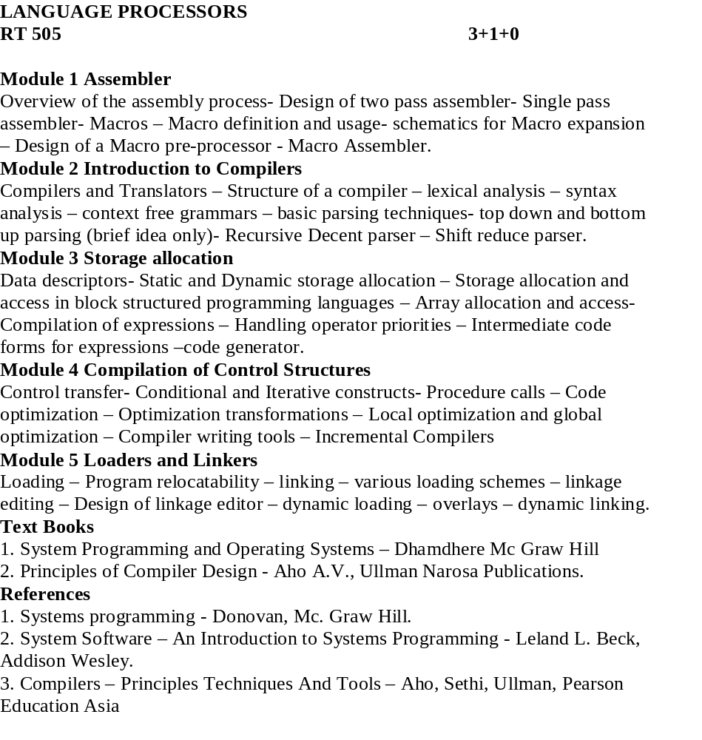

Lecture 1
- Synopsis-Language processors
- Target :- At the end of this lecture you will be able to answer questions like
  - What is semantics?
  - What is a semantic gap?
  - Define a language processor
  - What are the different types of language processors?
- Introduction:-A software designer expresses his ideas related to the software in terms of the application domain. To implement the ideas, their description has to be interpreted in terms of the computer system .The rules of meaning of a domain is called semantics. A semantic gap is the difference between the semantics of two domains
- Reference:- Refer the text book System programming and operating system by Dhamdhere
5.1)Semantics & Semantic gap
A semantic gap is the difference between the semantics of two domains
Semantic gap

Application Execution domain
domain

A semantic gap is tackled using software engineering steps like
1) Specification, design and coding
2) PL implementation steps .
The software implementation using the PL domain introduces the new domain called the Pl domain which comes between the application domain and the execution domain.
Specification gap Execution gap

Application PL domain Execution domain
domain
Specification gap: - It is the semantic gap between the two specifications of the same task.
Execution gap: - The gap between the semantics of programs written in the different programming languages.
Language processors: - It is a software which bridges a specification or execution gap. The input program of a language processor is a source program and the output program is the target program.The different types of language processors are
- Language translators:- Bridges an execution gap to the machine language
- assemblers- A language translator whose source language is assembly language
- compiler- A language translator whose source language is a high level language
- Detranslator:-converts machine language to assembly level language.
- Preprocessor:- Which bridges an execution gap and is not a language translator.
Eg:- Macro preprocessor
- Language migratory- bridges the specification gap between two PLs
- Interpreter:-Bridges an execution gap without generating a machine language .there is an absence of a target program. Interpreter executes each line as and when it is interpreted. Actually interpreter executes a program written in a PL .So execution gap vanishes totally.

PL domain execution
Application domain
domain
If the specification gap is more then that software system will be poor in quality and require large amount of time and effort to develop .A solution is to develop a PL which is close to the application.

5.2) Problem oriented languages
PLs used for specific application are called problem oriented languages .They are more close to the application domain.They have more execution gap and it is bridged by a translator or interpreter.
5.3) Procedure oriented languages
Provides general purpose facilities required in most application domains .Such a language is independent of specific application domains and result in large specification gap which has to be bridged by an application designer.

5.4) Language processing activities
a) Program generation activities (bridges specification gap)

Program Program in target
Program generator

specification PL

- Program execution- includes program translation and program execution
The translated program can be saved in a file, the saved program can be executed repeatedly .The program can be retranslated following modifications. During program interpretations it takes the source statements, determines its meaning and performs the actions which implement it.
6.0) Summary
So far we got a general idea regarding working of a language processor .Now
we will see the working of assembler.

Lecture 2

1) Synopsis:-Assemblers

2) Target: - At end of this lecture you will be able to answer questions like
a) What is an assembler?
b) What are the different types of statements in an assembly language?
c) What are the different types of tables which participate in the assembly process?

3) Introduction:-
Assembler is a language processor which converts assembly level language to machine level language .It is specific to a certain computer or a family of computer systems.
An assembly level statement has the following format:
[label]<opcode><operand spec>[<operand spec>…]
4) Reference:-Please refer the text book System programming and operating system by Dhamdhere
5.1)
opcode
-called mnemonic operation codes. They specify the operation.
eg: STOP stop execution

ADD Arithmetic operation
SUB
MULT

MOVER register memory
MOVEM memory register.

COMP sets condition codes
BC Branch on condition
READ
PRINT Reading and printing.

Operand specification:-
Syntax
<symbolic name>[+<displacement>][(<index register>]
a)AREA
b) AREA+5
C) AREA(4)
d)AREA+5(4)
An assembly program consists of three kinds of statements.
1. Imperative statements:-specifies an operation to be performed.
2. Declarative:-Syntax
[label]DS<constant>
[label]DC<value>
DS is declared storage reserves areas of memory and associates name with them.
AREA DS 1
This statement reserves a memory area of 1 word and associates name AREA with it.
DC is declare constant-constructs memory word containing constants.
3.Assembler directives-a)START
b)END
c)ORIGIN
d)EQU
e)LTORG

5.2)Design of a two pass assembler:-
Pass I-1.separate the symbol,mnemonic opcodes and operand fields
2.Build the symbol table.
3.Perform LC processing
4.Construct intermediate representation
Pass II-Synthesize target program.

LC processing
Location counter is always incremented to contain the address of the next memory word in the target program.LC is initialized to the constant specified in the START statement.

Data structures used in pass I are
I -OPTAB (operation table)
Fields-
a)mnemonic opcode-shows the name of the instruction
b)class-shows whether instruction is imperative(IS),declarative(DL)and assembler directive(AD)
c)mnemonic info-shows the machine code and instruction length. For DL,AD statement this field contains the address of the routine which finds the length of the statement

Mnemonic opcode | Class | Mnemonic info
MOVER | IS | (04,1)
DS | DL | R#7
START | AD | R#11
STOP | AD | 00
MOVEM | IS | (05,1)
ADD | IS | (01,1)
SUB | IS | (02,1)
MULT | IS | 03
COMP | IS | 06
BC | IS | 07
DIV | IS | 08
READ | IS | 09
PRINT | IS | 10
END | AD | 02
ORIGIN | AD | 03
EQU | AD | 04
LTORG | AD | 05

II SYMTAB (symbol table)
-fields are
a) symbol-specifies the label
b) address-address of the label
c) length-length of the label
Symbol | Address | Length
LOOP | 202 | 1
NEXT | 214 | 1
LAST | 216 | 1
A | 217 | 1
BACK | 202 | 1
B | 218 | 1

III LITTAB (literal table)
-fields are
a) literals-constants
b) address-address of the literal
LITTAB collects all the literals used in the program address field will be later filled in on encountering LTORG statement

Literal | address
=’5’ | 211
=’1’ | 212
=’1’ | 219

IV POOLTAB-contains literal number of the starting literal of each literal pool. A literal pool is defined as the literals encountered since the start of the program or since the last LTORG statement.

Literal no
#1
#3
-

6.0) Summary:-So far we have seen various tables used by the assember.In the coming class we will see how these tables participate in the assembly process.

Lecture 3
- Synopsis:- Pass 1 of the 2 pass assembler
- Target :- At the end of this lecture we will be able to answer questions like
  - Write the algorithm for pass 1 of a 2 pass assembler
  - With the help of an example show the Intermediate code generated for Pass 1 of a 2 pass assembler
- Introduction:- The various tables used by the assembler are filled during the pass1 and the output is the intermediate code .
- Reference:- Please refer the text book System programming and operating system
by Dhamdhere
- Algorithm for Pass1

Pass I

1.loc_cntr=0

Pooltab_ptr:=1;

POOLTAB[1]:=1;

Littab_ptr=1

2.while next statement is not an END statement

a)if label is present then

this_label:=symbol in label field

Enter(this_label,loc_cntr) in SYMTAB.

b)if an LTORG statement then

i)process literals LITTAB[POOLTAB[pooltab_ptr]]….LITTAB[littab_ptr-1] to allocate memory and put the address in the address field

Update loc_cntr

ii)pooltab_ptr=pooltab_ptr+1

iii)POOLTAB[pooltab_ptr]:=littab_ptr;

Generate IC(AD,code)( R )(C,literal)

c)if a START or ORIGIN statement then

Loc_cntr:=value specified in the operand field;

d)if an EQU statement then

i)this_addr:=value of <address spec>

ii)correct the symtab entry for this_label to(this_label,this_addr)

e)if a declarative statement then

i)code:=code of the declaration statement;

ii)size:=size of memory area required by DS/DC

iii)loc_cntr:=loc_cntr+size;

Generate IC(DL,code)(r )(C,constant/value)

f)if an imperative statement then

i)code:=machine opcode from OPTAB

ii)loc_cntr:=loc_cntr+instruction length from OPTAB;

iii)If operand is a literal then

This_literal:=literal in the operand field;

LITTAB[littab_ptr]:=this_literal;

Littab_ptr=littab_ptr+1;

This_entry=LITTAB entry no of the operand.

Generate IC(IS,code)(L,this_entry)

Else(ie operand is a symbol)

This_entry=SYMTAB entry no of the operand;

Generate IC(IS,code)(S,this_entry);

3.processing of END statement

A)perform step 2 b

B)generate IC(AD,02)

C)go to pass II

The IC generated after pass I will be of the form
(IS.04)(1)(L,01)
(IS,05)(1)(S,A)
(IS,04)(1)(S,A)
(IS,04)(3)(S,B)
(IS,01)(3)(L,02)
.
.
(IS,07)(6)(S,NEXT)
(AD,05)(C,5)
(AD,05)(C,1)
.
.
(IS,02)(1)(L,01)
(IS,07)(1)(S,BACK)
(AD,00)
(IS,03)(3)(S,B)
(DL,02)(C,1)
(DL,02)(C,1)

6.0) Summary
We have seen the algorithm for the pass 1 of a 2 pass assembler .The result of pass1 is the intermediate code .This code is then passed to pass 2 of the assembler which gives the machine language as the output. we will see the algorithm for pass 2 in the next class.

Lecture 4
1) Synopsis: - Pass 2 of the 2 pass assembler
2) Target: - At the end of this lecture we will be able to answer the following
- Write the algorithm for pass 2 of a 2-pass assembler
- With an example show the creation of machine language from pass 2
3) Introduction:-The intermediate code which is the output of pass 1 is taken to pass 2 and the target code is generated.
4) Reference:- Please refer the text Systems programming and operating system by Dhamdhere

5.1)Pass II

1.code_area_addr:=address of code_area;

Pooltab_ptr:=1;

Loc_cntr=0;

2.while next statement is not an END statement

A)clear machine_code_buffer

B)if an LTORG statement

i)process literals in

LITTAB[POOLTAB[pooltab_ptr]]…LITTAB[POOLTAB[pooltab_ptr+1]]-1

similar to processing of constants in a DC statement
ie,assemble the literals in the machine_code_ buffer.

ii)size :=size of memory area required for literals

iii)pooltab_ptr=pooltab_ptr+1;

C)if a START or ORIGIN statement then

i)loc_cntr:=value specified in the operand field

Ii)size=0;

D)if a declarative statement

I)if a DC statement then Assemble the constant in machine_code_buffer

Ii)size =size of memory area required by

DS/DC

E) if an imperative statement

i)get operand address from SYMTAB or LITTAB

ii)assemble instruction in machine code buffer

iii)size:=size of instruction

F) if size!=0 then

i)move contents of machine_code_buffer to the address code_area_address+loc_cntr

ii)loc_cntr=loc_cntr+size

3.processing of END statement

A)perform steps 2b and 2f

B)write code_area in to the output file.

Let the code_area_addr be equal to 2000

The machine code after pass II will be of the form
- 04 1 211
- 05 1 217
- 04 1 217
- 04 3 218
- 01 3 212
-----
-----
2210) 07 6 214
2211) 05 0 005
2212) 05 0 001
-----
2214) 02 1 219
2215) 07 1 202
2216) 00 0 000
2204) 03 3 218
2217) 02 0 001
2218) 02 0 001
- 00 0 001

5.2)Single pass translation

The problem of forward reference is tackled using a process called backpatching. The operand field of an instruction containing a forward reference is left blank initially. The address of the forward reference symbol is put in to this field when its defenition is encountered.
Consider the statements
MOVER BREG,TWO
TWO DC ‘2’.
First statement can only be partially synthesized,since TWO is a forward reference.Hence the instruction opcode and address of BREG will be assembled to reside in a location<instruction address>
The need for inserting the second operands address can be indicated by creating a table of Incomplete Instructions(TII).It contains an entry of the form
(<instruction address>,<symbol>)
eg:- ( 101,TWO)
When the END statement is processed the entries from the TII are taken and address is taken from the symbol table and filled.
6.0) Summary
We have seen the algorithm for pass2 of a two pass assembler. The output of the pass2 is the machine language.We have also seen the single pass translation process.

Lecture 5

- Synopsis : Macros
- Target : At the end of this lecture we will be able to answer questions like
  - What is a macro?
  - What is conditional macro expansion?
  - What is macro calls within macro?
3) Introduction

MACROS

There can be situations where the same set of instructions get repeatedly used. Programmer can use the macro facility. Macro instructions are single line abbreviations of the group of statements .For every occurrence of the macro call the macro processor will substitute the entire block.
4) Reference:-Please refer the text book Systems programming and operating system by D M Dhamdhere and Systems Programming by Donovan

5.1) A macro consists of a name ,a set of formal parameters and a body of code .Consider the following set of statements

Eg:-A 1,DATA->Add the contents of DATA to register 1
A 2,DATA->Add the contents of DATA to register 2
A 3,DATA->Add the contents of DATA to register 3

.
.
.
A 1,DATA->Add the contents of DATA to register 1
A 2,DATA->Add the contents of DATA to register 2
A 3,DATA->Add the contents of DATA to register 3

Macro definition
A macro definition is formed in the following manner
MACRO<macro name><formal parameters>
macro instruction
MEND

Syntax of formal parameters:-
&<parameter name>[<parameter kind>]

Syntax of macro call
<macro name><actual parameters>

For the above program macro definition can be written as
MACRO
INCR &ARG
A 1,&ARG
A 2,&ARG
A 3,&ARG
MEND
5.2) Positional parameters
They are written in the form &< parameter name>
The value of positional formal parameter XYZ is determined by the rule of positional association as follows.
a) Find the ordinal position of XYZ in the list of formal parameter in the macro prototype statement.
b) Find the actual parameter specification occupying the same ordinal position in the list of actual parameters in the macro call statement.
Eg:-
Consider the following macro
MACRO
INCR &MEM_VAL, &INCR_VAL, &REG
MOVER &REG ,&MEM_VAL
ADD &REG ,&INCR_VAL
MOVEM &REG ,&MEM_VAL
MEND
For the macro call
INCR A, B, AREG according to the rule of positional association the values of formal parameters (actual) are
Formal parameter value
MEM_VAL A
INCR_VAL B
REG AREG

5.3) Keyword parameters
It is of the form < formal parameter name > =< ordinary string>
The value of the formal parameter XYZ is determined by the rule of keyword association as follows
1) Find the actual parameter specification which has to the form XYZ= < ordinary string>
2) Let the <ordinary string > in the specification be the string ABC.
The value of the formal parameter XYZ is ABC.
Eg:-
MACRO
INCR_M & MEM_VAL=, &INCR_VAL=, &REG=
MOVER &REG,&MEM_VAL
ADD &REG ,&INCR_VAL
MOVEM &REG,&MEM_VAL
MEND
The following calls are now equivalent
- INCR_M MEM_VAL=A, INCR_VAL=B, REG=AREG.
- INCR_M INCR_VAL=B, MEM_VAL= A, REG= AREG
5.4) Default specification of parameters
A default is a standard assumption in the absence of an explicit specification by the programmer.
Consider the call
INCR-D MEM_VAL =A, INCR_VAL=B
Here the 3rd argument is not given. So the default value AREG is used.
5.5) Macros with mixed parameter list
A macro may be defined to use both positional and keyword parameters .In such a case all the positional parameter must precede all keyword parameters
Eg:-
SUMUP A,B,G=20,H=X
A,B are positional parameters
G,H are keyword parameters.

5.6)Conditional macro expansion:-

AIF and AGO
Consider the example
A 1,DATA 1
A 2,DATA 2
A 3,DATA 3;
.
;
;
A 1,DATA 3
A 2,DATA 2
.
.
.
A 1,DATA1
DATA1 DC ‘5’
DATA2 DC ‘10’
DATA3 DC ‘15’
Here the operands and the no of arguments change
So this can be written as
MACRO
VARY &COUNT,&ARG1,&ARG2,&ARG3
A 1,&ARG1
AIF(&COUNT EQ 1).FINI
A 2,&ARG2
AIF(&COUNT EQ 2).FINI
A 3,&ARG3
.FINI MEND
VARY 3,DATA1,DATA2,DATA3
.
.
.
VARY 2,DATA3,DATA2
.
.
VARY 1,DATA1
DATA1 DC ‘5’
DATA2 DC ‘10’
DATA3 DC ‘15’
The statement AIF(&COUNT EQ 1).FINI directs the macroprocessor to skip to the statement labeled .FINI if the parameter corresponding to the COUNT is 1,otherwise the macroprocessor will continue with the statement following the AIF psuedo-op.
AGO is an unconditional goto statement.labels are starting with a period( . )

5.7)Macro calls within macros:-

Consider the eg:-
MACRO
ADD1 &ARG
L 1,&ARG
A 1,=’1’
ST 1,&ARG
MEND
MACRO
ADDS & ARG1,&ARG2,&ARG3
ADD1 &ARG1
ADD1 &ARG2
ADD1 &ARG3
MEND
.
;
;
ADDS DATA1,DATA2,DATA3
Macro ADDS contains calls to the macro ADD1.
6.0) Summary: - We have seen various types of macros and the working of a macro preprocessor.

Lecture 6
- Synopsis : Design of a macro preprocessor
- Target : At the end of this lecture you will be able to answer questions like
- What is a macro preprocessor
- Explain the design of a macro preprocessor.

3) Introduction

Macro Preprocessor
-accepts an assembly level program containing definitions and calls and translate it into an assembly program which does not contain any macro definition and macro call

Macro
preprocessor
Assembler

Macro with macro
Definitions and Target program
Macro calls

Program without macros
4)Reference:- Please refer the text book Systems programming and operating system by D M Dhamdhere

5.1)Macro expansion consists of
- Identify the macr calls in the program
- Determine the values of formal parameters
- Maintain the values of the expansion time variables declared in a macro
- Organize the expansion time control flow.
- Determine the values of sequencing symbols
- Perform expansion of model statement
I)Identify macro calls
A table named macro name table (MNT) is designed to hold the names of all macros defined in the program.Macro name is entered while processing the macro definition
MNT
Macroname | #PP | #KP | #EV | MDTP | KPDTP | SSTP

II)Determine the values of formal parameters.
There are 3 tables associated with parameters.
Parameter name table(PNTAB)-hold the parameter names
Parameter name

Keyword parameter default table(KPDTAB)-holds the keyword parameters and their values
Parameter name | Default value

Actual parameter table-holds the actual parameters.
APTAB
value
III) maintain the expansion time control variable.
There are two tables
EVNTAB-hold the EV variable names
EVname
EVTAB-holds the EV variable values
value

IV) Organize expansion time control flow
The body of the macro is stored in the table MDT ( macro definition table)
The counter named MEC is initialized to the first entry in MDT. It is updated after expanding a model statement.
V) Determine the values of sequencing symbols
Two tables are associated
SSNTAB
SSname
SSTAB
MDT entry

5.2)Algorithm
Initialization part of the macro definition
KPDTAB_ptr=1;
SSTAB_PTR=1;
MDT_PTR=1;
Algorithm is invoked for every macro defined in the program
Algorithm
- SSTAB_ptr=1;
PNTAB_ptr=1;
- Process the macro prototype statement and form the MNT entry
  - name = macroname;
  - For each positional parameters
  - enter parameter name in PNTAB(PNTAB-ptr)
  - PNTAB_ptr =PNTAB_ptr + 1;
  - #PP = # PP +1;
c) KPDTP = KPDTAB_ptr ;
d) For each keyword parameter name
I) Enter parameter name and default value (if any ) in the
KPDTAB[KPDTAB_ptr]
ii) Enter parameter name in PNTAB[PNTAB_ptr]
iii)KPDTAB_ptr= KPDTAB_ptr + 1
  - PNTAB_ptr = PNTAB_ptr + 1;
  - #KP = #KP + 1;
e) MDTP = MDT_ptr;
f) #EV=0;
g) SSTP := SSTAB_ptr;
3.While not the MEND statement
a) if an LCL statement then
i) Enter expansion time variable name in EVNTAB
II) #EV = #EV+1;
B) If a model statement then
i) If label field contains a sequencing symbol then
if symbol is present in SSNTAB then
q= entry number in SSNTAB;
ELSE
Enter symbol in SSNTAB[SSNTAB_ptr] + 1;

q= SSNTAB_ptr;
SSNTAB_ptr= SSNTAB_ptr + 1;
SSTAB[SSTP +q-1]:-MDT_ptr;
ii) for a parameter generate the specification (P, # n)
iii) For an expansion variable ,generate the specification (E, # m)
iv) Record the IC in MDT[MDT_ptr];
v)MDT_ ptr = MDT_ptr + 1;
c) if a preprocessor statement
i) if a SET statement
search each expansion time variable name used in the statement in
EVNTAB and generate the spec (E,#m).
ii) if an AIF or AGO statement then
if sequencing symbol used in the statement is present in SSNTAB then
q= entry number in SSNTAB;
else
enter symbol in SSNTAB[SSNTAB_ptr];
q= SSNTAB_ ptr;
SSNTAB_PTR=SSNTAB_ptr + 1;
Replace the symbol by(S,SSTP+ q-1)
iii) Record the IC in MDT[MDT_ptr];
iv) MDT_ptr = MDT_ptr + 1;
4.MEND statement
If SSNTAB_ptr = 1 ( SSNTAB is empty ) then
SSTP = 0;
Else
SSTAB_ptr = SSTAB_ ptr + SSNTAB_ ptr -1;
If #KP = 0 then KPDTP =0;
6.0) Summary :- we have seen the tables used in macro definition processing and the algorithm for that.

Lecture 7
- Synopsis: - processing a macro call
- Target :- At the end of this lecture you will be able to answer questions like
  - Write the algorithm for the processing of a macro call

- Introduction: Two tables named APTAB and EVTAB are used in this algorithm .A counter named MEC is also used.
4) Reference :- Please refer the text book Systems programming and operating system by D M Dhamdhere

5.1) Algorithm
1. Perform initializations for the expansion of a macro
a) MEC= MDTP field of MNT entry.
b) Create EVTAB with #EV entries and set EVTAB_ptr;
c) Create APTAB with #PP + # KP entries and set APTAB_ptr.
d) Copy keyword parameter defaults fron the entries
KPDTAB[KPDTP ]…..KPDTAB[KPDTP + #KP -1] in to
APTAB[#PP +1]……APTAB[#PP +#KP].
e)Process positional parameters in the actual parameter list and copy them in to APTAB[1]…..APTAB[#PP];
f) for keyword parameters in the actual parameter list search keyword name in parameter name field of KPDTAB [KPDTP]……KPDTAB[KPDTP+#KP-1] .
Let the KPDTAB[q] contains a matching entry .Enter value of the keyword parameter in the call (if any ) in APTAB[#PP +q –KPDTP +1];
2. While statement pointed by the MEC is not an MEND statement
a) if a model statement then
i) replace operand of the form
P( #n) and (E,#m) by values in APTAB[n] and EVTAB[m] resp.
ii) output the generated statement
iii) MEC:= MEC + 1;
b)if a SET statement with the spec (E,#m) in the label filed then
- evaluate the expression in the operand field and set an appropriate value in EVTAB[m]
ii) MEC = MEC+ 1;
  - if an AGO statement with (S,#s) in the operand filed then
MEC:= SSTAB[SSTP + s-1 ];
  - if an AIF statement with (S,#s) in the operand field then
if condition in the AIF statement is true then
MEC:+ SSTAB[SSTP +s -1];
3. Exit from macro expansion
6.0) Summary :- We have seen the algorithm for processing the macro call and seen how a macro is being expanded while encountering a macro call

Lecture 8
- Synopsis:- Compilation
- Target :- At the end of this lecture you will be able to answer questions like
  - What are the different phases of compilation? Explain each phase in detail.
- Introduction :- A compiler converts the program written in high level language to machine language. There are 5 phases in compilation. Symbol table entries are also made during the compilation process.

Target language
High level language

compiler

4)Reference:- Please refer the text book Principles of compiler design by Aho &
Ullman

5.1)Phases of compilation
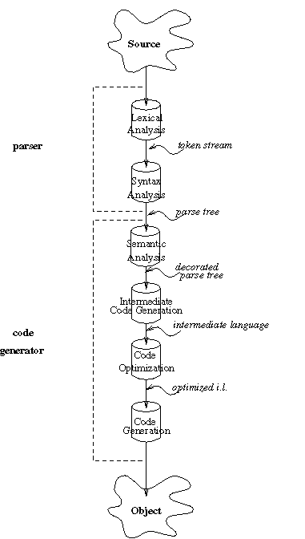

- Lexical analysis phase of a compiler reads the input language and returns Lexicaltokens to Parser for syntax analysis. It can also do additional functions such as keeping track of new line characters in source code so that it can provide line number for error messages.

Lexical analyzer separates the charactyers of the source language in ti groups that logically belong together called tokens.Lexical analysis phase of a compiler reads the input language and returns tokens to Parser for syntax analysis.Identifiers ,keywords ,constants,operators and punctuation marks are tokens. It can also do additional functions such as keeping track of new line characters in source code so that it can provide line number for error messages.

Consider the statement
If(a<b) goto 100
Here the tokens are
If,(,a,<,b,) ,goto,100
A token has token type and token value.
Token if has token type (identifier)
Token a has both type and value.
Parser asks the lexical analyzer for the next token whenever the parser needs one.Lexical analyzer then passes two components of the token to the parser –the code for the token type and the value of the token; a pointer to the place in the Symbol table where identifier is stored

341 constant ,integer, value =5

554 label,value=100
729 variable ,integer,value=MAX
Syntax analysis
Checks the syntax of expressions statements. It checks whether the token occur in pattern that are permitted by the specification of the source language .Consider A+/B .Syntax analyser produces id+/id. Seeing / the parser will detect an error, because the presence of two adjacent operators violate the rules of the language.ntax
Syntax analyzer creates a syntax tree.Consider the expression A/B*C .This can be interpreted in two ways.
- divide A by B and then multiply by C
- multiply B by C and then use the result to divide A

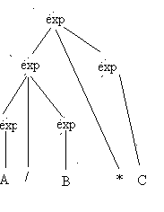Fig 1
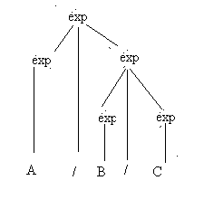
Fig 2
The language specification must tell which of the interpretation must be used and which hierarchical structure each program should use.
The parse tree for an if statement is as follows
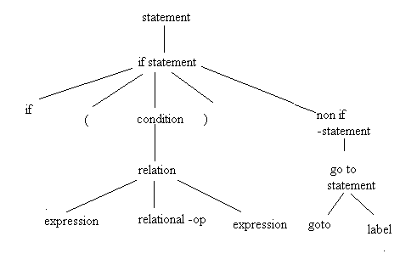
The intermediate code generation
This phase transforms the parse tree in to an intermediate language representation of the source program
Three address code
It’s a popular type of representation
Its of the form A:= Bop C where A,B,C are the operands and op is a binary operator.
The parse tree for A/B*C is shown in Fig 1

Consider the while statement
While A>B & A<= 2* B-5 do
A:= A+b
The intermediate code can be as follows
L1: if A> B go to L2
goto L3
L2: T1 := 2*b
T2 := T1-5
If A<= T2 go to L4
go to L3
L4: A := A+B
Goto L1
L3:
The reason for the name three address code is that each statement usually contains three addresses two for the operands and one for the result .Note that no complicated arithmetic expressions are permitted as there is only one operator per statement.
Additional 3 address statements
There are a number of types of 3 address statements that involve fewer than 3 addresses
1)Assignment statements of the form A:= B op C
where op is a binary arithmetic or logical operation
2) Assignment instructions of the form A:B op C where op is a unary operation .It include unary minus ,logical negation ,shift operators and conversion operators
3) Unconditional jump goto L meaning is to execute the next Lth 3 –address statement.
4) Conditional jumps such as if A relop B goto L.If the relation is true The Lth three address statement is executed .If not the 3-address statement after the above statement is executed.
Loop optimization
Another source of optimization speeds up loops. One loop improvement is to move a computation that produces the same result each time around the loop to a point in the program just before the loop is entered .Then this computation is done only once each time the loop is entered rather than once for each iteration of the loop.Such a computation is called loop invariant.
Loop jamming
A method of loop optimization merge the bodies of two loops.
Eg:- Initialize a matrix to be an identity matrix.
Begin
For i= 1 to 10 do
For j= 1 to 10 do
A[i,j]= 0;
For i:= 1 to 10 do
A[I,j]:= 1
End
This can be jammed by concatenating the bodies of 2 loops on I to form
For i:= 1 to do
Begin
For j:= 1 to 10 do
A[I,j]:= 0;
A[I,i] := 1;
End
Optimization
It is done to increase the speed of execution
Local optimization
Consider the ststement
If A>B goto L2
Goto L3
L2:
This sequence could be replaced by the single statement.
If A<= B goto L3;
The first sequence need machine instructions which does the following
- compare A and B to set the condition codes
- Jump to L2 if the code for > is set and
- Jump to L3
The second sequence need the machine instructions
- compare A and B to set the condition codes
- jump to L3 if the code for < or = is set
This sequence requires less space if we assume that all instructions require the same space.
Code generation
This phase converts the intermediate code in to a sequence of machine instructions
Code generator might map the statement A: = B+ C in to machine code sequence
LOAD B
Add C
Store A

A good code generator will try to use the registers as efficiently as possible.
Book keeping

Compiler needs to collect the information about all data objects that appear in the source program
E.g.:- Compiler needs to know whether a variable represents an integer or real number.
Error handling:-
Detection & reporting of errors in the source program.
Error message should allow its programmers to determine exactly where the error has occurred. Error can be encountered by all the phases of the compiler.
- The lexical analyzer finds that the next token in the source program is misspelled
- Syntax analyzer finds that a parenthesis is missing
- Intermediate code generator may detect an operator whose operands have incompatible types
- Code optimizer may detect that certain statements can never be reached
- Code generator may find a compiler created constant that is too large to fit in a word of the target machine.
- While entering information in to symbol table the bookkeeping routine may discover an identifier that has been declared with contradictory attributes.
6.0) Summary: - We have seen the different phases of compilation in detail.

Lecture 9
- Synopsis:- Parsing
- Target :- At the end of this lecture you will be able to answer questions like
  - What is parsing ?
  - Explain shift reduce parsing with an example.
  - Show the stack implementation of shift reduce parsing
3) Introduction:-
Parsing:-
Syntax analysis constructs a parse tree for the string
Two common forms of parsers
a) Shift reduce parsing (bottom up)
b) Top down parsing.
4) Reference:-Please refer the text book Principles of compiler design by Aho &
Ullmann
5.1)Shift reduce parsing
Bottom up parsing attempts to construct a parse tree for an input string beginning at the leaves (the bottom) and working up towards the root( the top).It reduces the string w to the start symbol of a grammar. At each step a string matching the right of the production is replaced by the symbol on the left.
Consider the grammar
S-> aAcBe.
A-> Ab/b
B->d
And the string abbcde .we want to reduce the string to S. Scan abbcde looking for the substring which match the right side of some production b and d finds a match. So replace b with A. now we get aAbcde .Again scan the string .Now we find Ab , b and d. Now replace Ab by A.We get aAcde .Now again scan the string .d is found matching .So replace d by B .we get aAcBe. Now replace the entire string with S.
Each replacement of the right side of the production by the left side in the above process is called reduction. Thus by a sequence of 4 reduction we are able to reduce the string to S.The substring on the right hand side which get replaced by the left is called a handle.
So bottom up parsing is finding and reducing handles.
Consider the following grammar
- E→ E + E
- E→ E * E
- E→( E)
- E→ id
The input string id₁ + id₂ * id₃ can be reduced as follows.
Right –sentential form handle Reducing production
id₁ + id₂ * id₃ id₁ E→id
E + id₂ * id₃ id₂ E→id
E + E * id₃ id₃ E→id
E + E * E E * E E→ E * E
E + E E + E E→ E + E
E
5.2)Stack implementation of shift reduce parsing.
Use a stack and an input buffer .Use the $ to mark the bottom of the stack and right end of the input. Zero or more input symbols are moved on to the stack until a handle is on the top of the stack.
Stack input Action

1) $ id₁ + id₂ * id₃ $ shift

2) $ id₁ + id₂ * id₃ $ reduce by E →id

3) $ E + id₂ * id₃ $ shift

4) $E+ id₂ * id₃ $ shift

5) $E+ id₂ * id₃ $ reduce by E→id

6) $ E +E * id₃ $ shift

7) $ E +E * id₃ $ shift

8) $ E +E * id₃ $ reduce by E→id

9) $ E +E * E $ reduce by E→E * E

10) $ E + E $ reduce by E→E + E

11) $ E $ accept

There are 4 actions
- In a shift action the next input symbol is shifted to the top of the stack
- In a reduce action, the parser knows the right end of the handle is at the top of the stack. It should decide with what non terminal to replace the handle.
- In an accept action the parser announces successful completion of parsing
- In an error action the parser discovers that syntax has occurred and calls an error recovery routine.
Constructing a parse tree
Parse tree can be created as we perform a shift reduce parsing .With each symbol on the stack we associate a pointer whose root is that symbol and whose yield is the string of terminals which have been reduced to that symbol .At the end of the shift reduce parse, the start symbol remaining on the stack will have the entire parse tree associated with that.
1) Stack: $ id₁ 2) Stack: $ E

.id₁ E
|
After shifting id₁ id₁
After reducing id₁ to E

3) Stack: $ E + 4) Stack: $ E + id₂
E + E + id₂
| |
id₁ id₁
After shifting+ After shifting id₂
- Stack $ E + E 6) Stack $ E + E *
E + E E + E
| | | |
id₁ id₂ id₁ id₂
After reducing id₂ After shifting *
- Stack $ E + E * id₃ 8) Stack $ E + E * E
E + E * id₃ E + E * E
| | | | |
id₁ id₂ id₁ id₂ id₃
After shifting id₃ After reducing id₃
- Stack: $ E + E 10) Stack $ E
E
E + E
E + E

id₁ E * E id₁ E * E

id₂ id₃ id₂ id₃

After reducing E * E After reducing E + E

6.0) Summary:- Shift reduce parsing is a bottom up parsing.We have seen how a stack is being used in the bottom up parsing method.

Lecture 10
- Synopsis:- Top down parsing
- Target :- At the end of this lecture you will be able to answer questions like
  - What is top down parsing?
  - What are the disadvantages of top down parsing?
  - What is recursive descent parsing?
3) Introduction:- We will see topdown parsing method with an example and the disadvantages of that.
4) Reference:- Please refre the text book Principles of compiler design by Aho & Ullman
5.1) Consider the grammar
S→ cAd
A→ ab/a and the input w=cad
To construct a parse tree for this sentence we initially create a tree consisting of a single node labeled S An input pointer points to the c the first symbol of w.
Input
cad

we then use the first production for S to expand the tree and obtain.
S

c A d
The left most leaf labeled c ,matches the first symbol of w .We advance the input pointer to a ,the second symbol of w and consider the next leaf A .we then expand A using the first alternate for A to obtain the tree

S

c A d

a b

Now we have match for the second input symbol a .Now move the pointer to d.
c a d

There is no match with the next leaf which is to b.So a failure is reported .So we backtrack ie,we move back to node A to see whether there is an alternate for A.In going back to A we must reset the input pointer to position 2 ie,c
c a d

Now try the second alternate A→a to get
S

c A d

a
The left a matches the second symbol of w .Then move the input pointer forward.
c a d

Now leaf d matches with input symbol d
Now we produce a parse tree for w,we halt and announce successful completeion of parsing

5.2)Disadvantages of top down parsing
- Left recursion:-
A grammar G is said to be left recursive if it has a non terminal A such that there is a derivation A➔Aα/β for some α .A left recursive grammar can cause a top down parser to go in to an infinite loop ie,when we try to expand A without consuming any input. So to use top down parsing we must eliminate all left recursion from the grammar.
2) Backtracking:-
Suppose we make a sequence of erroneous expansion and discover a mismatch we may have to undo the semantic effects of making these erroneous expansions .Since this create more overhead we go for top down parsing without backtracking.
3) The order in which alternates are tried can affect the language accepted .In the above example if we used a and then ab as the order of alternates for A. we could fail to accept cabd.
Ie,with parse tree
S

c A d

a
here the ca already matched .The failure of the next input symbol b to match
would imply that the alternate cAd for S was wrong leading to rejection of cabd.
4)If failure is reported we cannot identify where the error actually occurred.
Elimination of left recursion
A➔Aα/β where β doesn’t begin with an A then we can eliminate left recursion by
replacing this pair of production with
A→ βA’
A’→A’/ε
5.3) Recursive descent parsing:_
Inorder to avoid backtacking we must know with which right hand side we have to replace the non terminal .The proper alternate is found out by looking at the first symbol
A parser that uses a set of mutually recursive procedures to recognize its input with no backtracking is called a recursive –descent parser.
Procedure E( );
begin
T ();
EPRIME ( )
end;
procedure EPRIME ( );
if input-symbol = ‘+’ then
begin
ADVANCE ( );
T( );
EPRIME ( );
end;
procedure T( );
begin
F( );
TPRIME ( )
End;
Procedure TPRIME ( ) ;
If input symbol = ‘id ‘ then
ADVANCE ( );
F ( );
TPRIME ( )
end;
Procedure F ( );
if input symbol = ‘id’ then
ADVANCE ( )
else if input-symbol =’(‘ then
begin
ADVANCE ( );
E( );
if input-symbol =’)‘ then
ADVANCE ( );
else ERROR ( )
end
else ERROR ( )
6.0) Summary
We have see the algorithm for recursive descent parsing.A useful method for manipulating grammars in to a form suitable for recursive descent parsing is left factoring ,the process of factoring out the common prefixes of alternatives.

