Module 5
Terminal Handling – Point to point and Multidrop lines
Refer : Data Communication and networking – Behrouz A.Forouzan – Page 8 – 12 & 295 – 297

Transmission Media – Guided - Refer : Data Communication and networking – Behrouz A.Forouzan – Page 173 – 184

GSM Architecture – Refer Mobile Communications – Schiller Page 116 – 126

Components Of Computer Communication

1) Data concentrator: A functional unit that permits a common transmission medium to serve more data sources than there are channels currently available within the transmission medium.
Data Concentrator acts as a Data Hub providing convenient connection points for external interfaces to the system. This is particularly important in the case where the RTUs are distributed around the substation and a central connection point is necessary to facilitate interfacing.
The Data Concentrator provides the following functionality:
- Interfaces
- Modularity & Expansion
- Redundancy
- Time Synchronisation
- Remote Communications

Interfaces
The main interfaces that may be implemented in the Data Concentrator are:
· Local Operator Workstation
· Communication links to Control Centre
· Communication link to the Power Systems Management Centre
· GPS Clock for time synchronization
· Interlocking Units
· OEM RTU Interface
· Hardwired I/O
In addition to these interfaces, the Data Concentrator also includes Control Authorization (Command Arbitration), Redundant Communication links and local I/O for controlling and monitoring substation common equipment.

Modularity & Expansion
The Data Concentrator comprises several external interfaces. Each interface is assigned to a separate processor module. Each processor module operates independently and maintains its own protocol database.
This independent and modular approach ensures that any single processor failure will affect only the interface to which it is connected. All other modules continue to operate with no adverse affect on their operation.
Future expansion is as simple as adding extra modules, i.e. processors for communications or processors and I/O modules for additional monitoring and control.

Redundancy
The modularity outlined in the previous section is ideally suited to redundancy. Two separate processors can be used to provide redundant communications to any location. Redundant links provide a continuity of communications in the event of a failure on either link.
Time Synchronisation
In order to have accurately time stamped data all clocks in the system must be synchronized. As each processor is responsible for the time-stamping of local events, all processors must therefore be synchronized.
synchronization maintains all processor clocks to within 1ms of each other. In addition, the RTU can also be referenced to a master clock.

Remote Communications
The Data Concentrator provides an interface to remote hosts. The interface to the host is a redundant interface for increased availability as it uses two independent processor modules for communications over dedicated lines.
Advantages :
- All the data channels can be used with any type of equipment.
- The system does not need any configuration. Even computer illiterates can use the system without any difficulty.

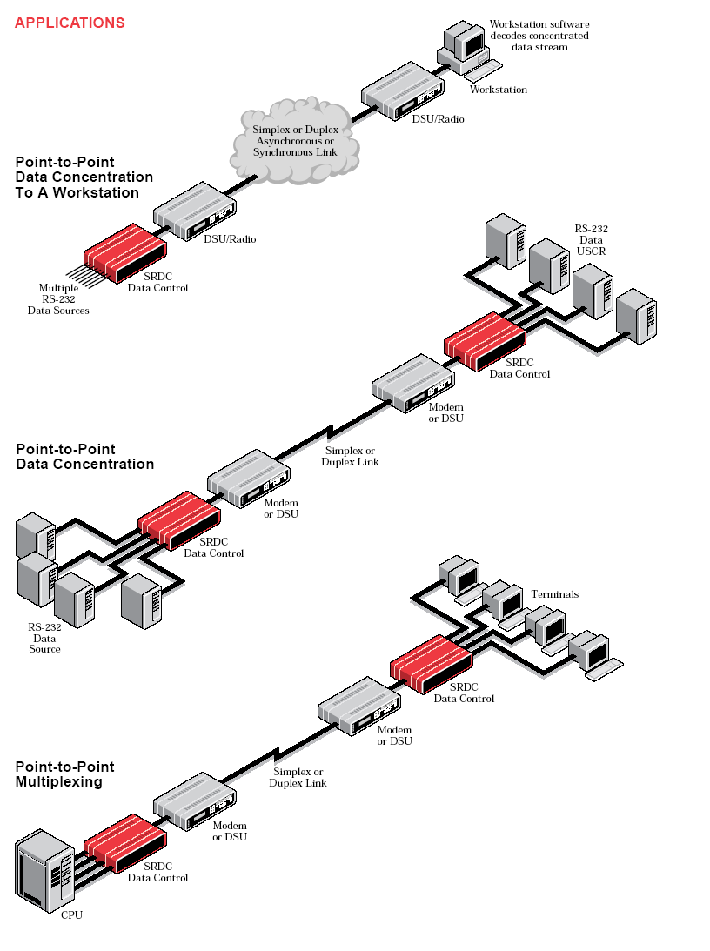

2) Front end processor (FEP)
: A computer used to process data before it is sent to a mainframe computer for analysis or further processing.
A front end processor (FEP), or a communications processor, is a small-sized computer which interfaces to the host computer a number of networks, such as SNA, or a number of peripheral devices, such as terminals, disk units, printers and tape units. Data is transferred between the host computer and the front end processor using a high-speed parallel interface. The front end processor communicates with peripheral devices using slower serial interfaces, usually also through communication networks. The purpose is to off-load from the host computer the work of managing the peripheral devices, transmiting and receiving messages, packet assembly and disassembly, error detection, and error correction. ^{[1]} Two examples are the IBM 3705 Communications Controller and the Burroughs Data Communications Processor.
Sometimes FEP is synonymous with a communications controller, although the latter is usually not as flexible.
Front end processor is also used in a more general sense in asymmetric multi-processor systems. The FEP is a processing device (usually a computer) which is closer to the input source than is the main processor. It performs some task such as telemetry control, data collection, reduction of raw sensor data, analysis of keyboard input, etc.
Communications FEPs in IP era
FEPs are responsible for linking client applications and their associated networks to host computer based applications. With the advent of the Internet and of IP as a universal protocol, it is often assumed that there is no longer any need for FEPs ^{[2]}, which traditionally handled SNA traffic. This may be true where FEPs provide only straight connectivity (and assuming IP address never changes). However, FEPs also perform other vital functions, that are closely linked to transaction applications, including message and transaction switching, multiplexing, transaction security, QoS guarantors, and end-to-end transaction management and reporting. The need for these functions is especially important in mission critical transaction environments such as banking, government, point-of-sale, security, and health care applications. In these environments, FEP functionality is more necessary than ever before.
Although the IBM Corporation withdrew its 3745/3746 Communications Front End Processors from marketing in 2003, the company continues to maintain the estimated 20,000 installed front end processors. IBM also provides microcode enhancement features. Smaller companies have filled the void created by IBM's action, providing machines, features, parts and services worldwide.

GSM – Global System for mobile Communication

Introduction:
Short for Global System for Mobile Communications, GSM is a digital cellular communications system. It was developed in order to create a common European mobile telephone standard but it has been rapidly accepted worldwide. GSM is designed to provide a comprehensive range of services and features to the users not available on analogue cellular networks and in many cases very much in advance of the old public switched telephone network (PSTN). In addition to digital transmission, GSM incorporates many advanced services and features like worldwide roaming in other GSM networks.

History of GSM and cellular mobile Radio:
The idea of cell-based mobile radio systems appeared at Bell Laboratories (in USA) in the early 1970s. However, mobile cellular systems were not introduced for commercial use until the 1980s. During the early 1980s, analog cellular telephone systems experienced a very rapid growth in Europe, particularly in Scandinavia and the United Kingdom, but also in France and Germany. Each country developed its own system, which was incompatible with everyone else's in equipment and operation. But in the beginnings of cellular systems, each country developed its own system, which was an undesirable situation for the following reasons:
- The equipment was limited to operate only within the boundaries of each country, which in a unified Europe were increasingly unimportant.
- The market for each mobile equipment was limited, so economies of scale, and the subsequent savings, could not be realized.
In order to overcome these problems, the Conference of European Posts and Telecommunications (CEPT) formed, in 1982, the Groupe Spécial Mobile (GSM) in order to develop a pan-European mobile cellular radio system (the GSM acronym became later the acronym for Global System for Mobile communications). The standardized system had to meet certain criterias:
- Good subjective speech quality
- Support for international roaming
- Ability to support handheld terminals
- Support for range of new services and facilities
- Spectral efficiency
- Low mobile and base stations costs
- Compatibility with other systems such as Integrated Services Digital Network (ISDN)
In 1989 the responsibility for the GSM specifications passed from the CEPT to the European Telecommunications Standards Institute (ETSI). The commercial use of GSM started around mid-1991. By the beginning of 1994, there were 1.3 million subscribers worldwide. By the beginning of 1995, there were 60 countries with operational or planned GSM networks in Europe, the Middle East, the Far East, Australia, Africa, and South America, with a total of over 5.4 million subscribers. As of the end of 1997, GSM service was available in more than 100 countries and has become the de facto standard in Europe and Asia. Presently, GSM networks are operational or planned in over 80 countries around the world.
GSM Services

GSM has much more to offer than voice telephony. Additional services allow you greater flexibility in where and when you use your phone. You should contact your local GSM network operator for information on the specific services available to you.
But there are three basic types of services offered through GSM which you can ask for:
- Telephony (also referred to as teleservices) Services
- Data (also referred to as bearer services) Services.
- Supplementary Services

Teleservices or Telephony Services:
A Teleservice utilises the capabilities of a Bearer Service to transport data, defining which capabilities are required and how they should be set up.

Voice Calls:
The most basic Teleservice supported by GSM is telephony. This includes Full-rate speech at 13 Kbps.
emergency calls : service provider is notified by dialing three digits. A very basic example of emergency service is 911 service available in USA.

Short Text Messages:
SMS (Short Messaging Service) service is a text messaging which allow you to send and receive text messages on your GSM Mobile phone. Services available from many of the world's GSM networks today - in addition to simple user generated text message services - include news, sport, financial, language and location based services, as well as many early examples of mobile commerce such as stocks and share prices, mobile banking facilities and leisure booking services. Supports up to 160 characters in one message
EMS – Enhanced Messaging Service - A text messaging which allow you to send and receive text messages on your GSM Mobile phone up to a size of 760 characters
MMS – Multimedia Messaging Service - A messaging which allow you to send and receive images in the form of JPG , BMP etc and also short videos on your GSM Mobile phone

Bearer Services or Data Services
Teleservice utilises the capabilities of a Bearer Service to transport data, defining which capabilities are required and how they should be set up. The bearer services are parted into nine groups of transparent and non-transparent data-transmission services.
Also this has synchronous and asynchronous modes of transmission

Supplementary Services
Supplementary services are provided on top of teleservices or bearer services, and include features such as caller identification, call forwarding, call waiting, multi?party conversations, and barring of outgoing (international) calls, among others. A brief description of supplementary services is given here:
- Multiparty Service or conferencing: The multiparty service allows a mobile subscriber to establish a multiparty conversation.that is, a simultaneous conversation between three or more subscribers to setup a conference call. This service is only applicable to normal telephony.
- Call Waiting: This service allows a mobile subscriber to be notified of an incoming call during a conversation. The subscriber can answer, reject, or ignore the incoming call. Call waiting is applicable to all GSM telecommunications services using a circuit-switched connection.
- Call Hold: This service allows a subscriber to put an incoming call on hold and then resume this call. The call hold service is only applicable to normal telephony.
- Call Forwarding: The Call Forwarding Supplementary Service is used to divert calls from the original recipient to another number, and is normally set up by the subscriber himself. It can be used by the subscriber to divert calls from the Mobile Station when the subscriber is not available, and so to ensure that calls are not lost. A typical scenario would be a salesperson turns off his mobile phone during a meeting with customers, but does not with to lose potential sales leads while he is unavailable.
- Call Barring: The concept of barring certain types of calls might seem to be a supplementary disservice rather than service. However, there are times when the subscriber is not the actual user of the Mobile Station, and as a consequence may wish to limit its functionality, so as to limit the charges incurred. Alternatively, if the subscriber and user are one and the same, the Call Barring may be useful to stop calls being routed to international destinations when they are routed. The reason for this is because it is expected that the roaming subscriber will pay the charges incurred for international re-routing of calls. So, GSM devised some flexible services that enable the subscriber to conditionally bar calls.
- Number Identification: There are following supplementary services related to number identification:
  - Calling Line Identification Presentation: This service deals with the presentation of the calling party's telephone number. The concept is for this number to be presented, at the start of the phone ringing, so that the called person can determine who is ringing prior to answering. The person subscribing to the service receives the telephone number of the calling party.
  - Calling Line Identification Restriction: A person not wishing their number to be presented to others subscribes to this service. In the normal course of event, the restriction service overrides the presentation service.
  - Connected Line Identification Presentation: This service is provided to give the calling party the telephone number of the person to whom they are connected. This may seem strange since the person making the call should know the number they dialled, but there are situations (such as forwardings) where the number connected is not the number dialled. The person subscribing to the service is the calling party.
  - Connected Line Identification Restriction: There are times when the person called does not wish to have their number presented and so they would subscribe to this person. Normally, this overrides the presentation service.
  - Malicious Call Identification: The malicious call identification service was provided to combat the spread of obscene or annoying calls. The victim should subscribe to this service, and then they could cause known malicious calls to be identified in the GSM network, using a simple command. This identified number could then be passed to the appropriate authority for action. The definition for this service is not stable.
- Advice of Charge (AoC): This service was designed to give the subscriber an indication of the cost of the services as they are used. Furthermore, those Service Providers who wish to offer rental services to subscribers without their own Subscriber Identity Module (SIM) can also utilize this service in a slightly different form. AoC for data calls is provided on the basis of time measurements.
- Closed User Groups (CUGs): This service is provided on GSM to enable groups of subscribers to only call each other. This type of services are being offered with special discount and is limited only to those members who wish to talk to each other.
- Unstructured supplementary services data (USSD): This allows operator-defined individual services.

