Module 1
Evolution of 8086 family of microprocessors – 8088 to Itanium, Internal architecture of 8086, block diagram, Registers, flags, Programming model, 8086 and 8088, 8086 memory organization, segmented memory, Physical address calculation, Memory Addressing, Addressing modes.

Lecture #1

1. Synopsis
- Overview of 8085 microprocessor
- Evolution of 8086 family of microprocessors

2. Target
By this lecture, you should be aware of the following topics:
- The internal architecture of 8085
- The generation of x86 microprocessors.

3. Introduction
The 8085 was an 8-bit microprocessor made by Intel in the mid-1970s. It was binary
compatible with the more-famous Intel 8080 but required less supporting hardware,
thus allowing simpler and less expensive microcomputer systems to be built.

4. Revision/Prerequisites
Please refer to the text Microprocesor architecture of Remesh Gaonkar-Fifth Edition and Advanced microprocessors and peripherals, A K Ray & K M Chaudhari.
5. Concepts
CPU Architecture
The 8085 Architecture follows the von Neumann architecture, with a 16bit address bus, and an 8bit data bus. But it is actually based on Harvard concept.

Registers:
The 8085 can access 2¹⁶ (= 65,536) individual 8-bit memory locations, or in other words, its address space is 64 KB. Unlike some other microprocessors of its era, it has a separate address space for up to 2⁸ (=256) I/O ports. It also has a built in register array which are usually labeled A(Accumulator), B, C, D, E, H, and L. Further special-purpose registers are the 16-bit Program Counter (PC), Stack Pointer (SP), and 8-bit flag register F. The microprocessor has three maskable interrupts (RST 7.5, RST 6.5 and RST 5.5), one Non-Maskable interrupt (TRAP), and one externally serviced interrupt (INTR). The RST n.5 interrupts refer to actual pins on the processor-a feature which permitted simple systems to avoid the cost of a separate interrupt controller chip.

Buses:
Address bus - 16 line bus accessing 2¹⁶ memory locations (64 KB) of memory.
Data bus - 8 line bus accessing one 8-bit byte of data in one operation. Data bus width is the traditional measure of processor bit designations, as opposed to address bus width, resulting in the 8-bit microprocessor designation.
Control buses - Carries the essential signals for various operations.

Evolution of 8086 family of microprocessors – 8088 to Itanium

The x86 architecture first appeared as the Intel 8086 CPU in 1978. The 8086 was a development of the Intel 8085 processor, and was created such that programs written in assembly for the 8085 could be mechanically translated to equivalent programs in 8086 assembler language.
This made the 8086 a tempting migration path for 8085 software vendors, but not without significant redesign of the system hardware due to the 8086's 16-bit data bus. To address this Intel introduced the externally 8-bit 8088 processor. The 8088 could run 8086 software, but reduction in data pins (from 16 to 8) it was feasible to interface it with existing 8-bit system chips.
From their fifth-generation chips onwards, Intel adopted the Pentium name for their x86 CPUs. The architecture has twice been extended to a larger word size. In 1985, Intel released the 32-bit 386 to replace the 16-bit 286. This extension to the x86 architecture is commonly called IA-32 (an abbreviation for Intel Architecture, 32-bit), but is also referred to as i386, x86-32, or simply Intel Architecture.
In 2003, AMD further extended the architecture to 64 bits, variously called x86-64, AMD64 (AMD's branding, formerly AA-64 (an abbreviation for AMD Architecture, 64-bit)), Intel 64 (Intel's branding, formerly EM64T or IA-32e) and x64 (Microsoft and Sun Microsystems' vendor-neutral naming convention). Intel 64 should not be confused with the unrelated IA-64 architecture.
The table below lists historically significant x86 desktop processors grouped by generation. Note that the definition of a CPU generation is somewhat ambiguous; each manufacturer has their own timeline progression and release schedules, as well as marketing spin. In the public eye, generations are roughly marked by significantly improved and commercially successful designs.
Itanium is the brand name for 64-bit Microprocessors that implement the Itanium architecture. Intel has released two processor families using the brand: Itanium and Itanium 2.

Generation | Years | Prominent CPUs
1 | 1978-1982 | Intel 8086, Intel 8088
2 | 1982-1986 | Intel 80286
3 | 1986-1989 | Intel 80386
4 | 1989-1993 | Intel 80486
5 | 1993-1997 | Pentium, AMD K5, Cyrix 6x86
5 | 1997-1999 | AMD K6
6 | 1997-1999 | Pentium II, AMD K6-2
6 | 1999-2001 | Pentium III
7 | 1999-2001 | Athlon
7 | 2001-2003 | Athlon XP, Pentium 4
8 | 2003-2007 | Core 2, Athlon 64

6. Summary
Today we have discussed the overview of 8085 and the generation of x86 microprocessors.

Lecture #2

1. Synopsis
- Introduce the architecture of 8086

2. Target
By this lecture, you should be able to answer the following questions
- Give the internal architecture of 8086?
- What is the advantage of 8086 over 8085?

3. Introduction
The 8086 introduced the reign of the Intel 80x86 microprocessor family. Despite its design based on the previous 8-bit processors (e.g. the 8080 and the 8085), the 8086 is not entirely compatible with its predecessors. The 8086, the first widely used 16-bit microprocessor has been used to power the first IBM PCs.

4. Revision/Prerequisites
Please refer to the text Microprocesor architecture of Remesh Gaonkar-Fifth Edition and the pages 1-7 of Advanced microprocessors and peripherals, A K Ray & K M Chaudhari.
5. Concepts
Architecture
The 8086 have a microprogrammed sequencer, but have also many wired functionalities such as to optimise the size of the microcode. The vertical microinstructions are 21-bit wide. The microprogram ROM contains 504 microinstructions. The 8086 have two functional units aimed to work in parallel: the BIU (Bus Interface Unit) and the EU (Execution Unit)
Execution Unit
The arithmetic and logic unit may be loaded from three temporary registers (TMPA, TMPB, TMPC) and execute operations on bytes or 16-bit words. The result of an operation may be stored into one the temporary registers, or into any one of the 16-bit registers connected to the internal data bus. These registers consist in four general registers called AX, BX, CX and DX, two stack pointers (SP and BP), and two index registers (SI and DI).
Bus Interface Unit
The bus interface unit is intended to compute the addresses. This unit is made of two temporary registers used by indirect addressing, four segment registers (DS, CS, SS and ES), a program counter (IP - Instruction Pointer), and a 6-byte stack to store the pre-fetched opcodes and data.

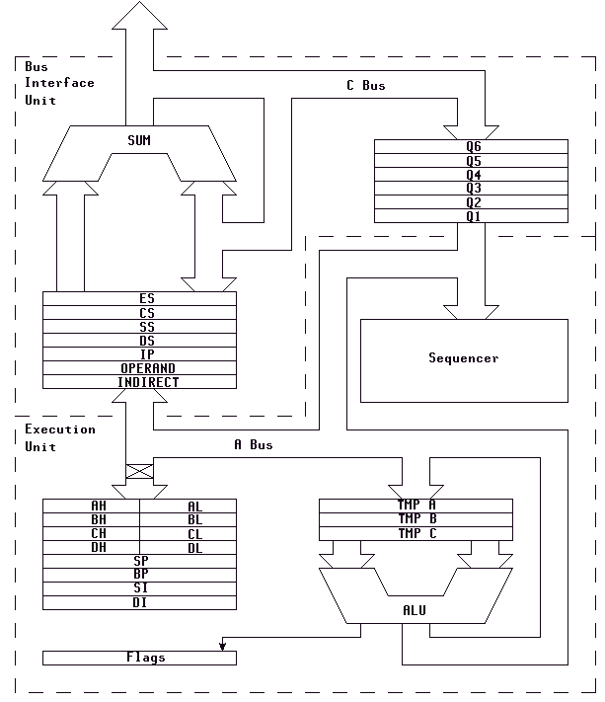

6. Summary
Today we have discussed the overview of 8085 and a detailed description of 8086 architecture. 8086 has two functional units BIU and EU. BIU performs address computation while the EU execute the operation.
7. Exercise Questions
1. The 8086 processor addresses --------- bytes of memory.
2. Memory above 1M byte is called --------- memory.
3. What are program visible registers?

Lecture #3

1. Synopsis
- Detailed study of 8086 microprocessor
- BIU and EU

2. Target
By this lecture, you should be able to answer the following questions
- Explain the segment registers of 8086?
- What is the necessity of instruction queues?
- What is a stack register? How it can be initialized?

3. Introduction
Today we are going to see the details of 8086 microprocessor. It includes the components of EU and BIU and also have to see the function of flag register.

4. Revision/Prerequisites
Please refer to the pages 1-7 of Advanced microprocessors and peripherals, A K Ray & K M Chaudhari.

5. Concepts
Execution Unit
Segment Registers
Within the 1 MB of memory space the 8086 defines four 64K-byte memory blocks called the code segment, stack segment, data segment, and extra segment. Each of these blocks of memory is used differently by the processor.
The code segment holds the program instruction codes. The data segment stores data for the program. The extra segment is an extra data segment (often used for shared data). The stack segment is used to store interrupt and subroutine return addresses.
The concept of the segmented memory is a unique one. Older-generation microprocessors such as the 8-bit 8086 or Z-80 could access only one 64K-byte segment. This mean that the programs instruction, data and subroutine stack all had to share the same memory. This limited the amount of memory available for the program itself and led to disaster if the stack should happen to overwrite the data or program areas.
The four segment registers (CS, DS, ES, and SS) are used to "point" at location 0 (the base address) of each segment. The segment registers are only 16 bits wide, but the memory address is 20 bits wide. The BIU takes care of this problem by appending four 0's to the low-order bits of the segment register. In effect, this multiplies the segment register contents by 16.
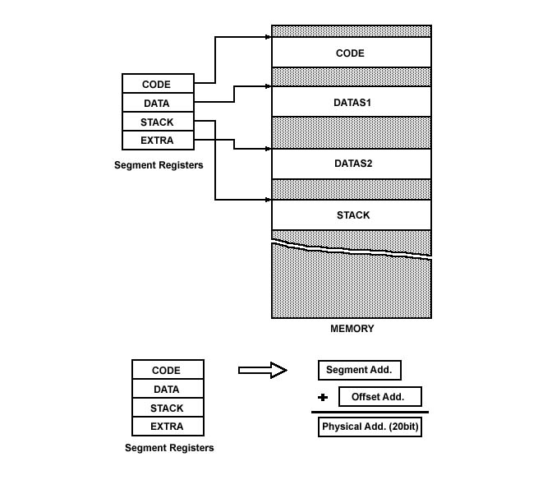
The point to note is that the beginning segment address is not arbitrary -it must begin at an address divisible by 16. Another way if saying this is that the low-order hex digit must be 0.
Also note that the four segments need not be defined separately. Indeed, it is allowable for all four segments to completely overlap (CS = DS = ES = SS).
Memory locations not defined to be within one of the current segments cannot be accessed by the 8086 without first redefining one of the segment registers to include that location. Thus at any given instant a maximum of 256 K (64K * 4) bytes of memory can be utilized. As we will see, the contents of the segment registers can only be specified via S/W. As you might imagine, instructions to load these registers should be among the first given in any 8086/88 program.
An immediate advantage of having separate data and code segments is that one program can work on several different sets of data. This is done by reloading register DS to point to the new data. Perhaps the greatest advantage of segmented memory is that programs that reference logical addresses only can be loaded and run anywhere in memory. This is because the logical addresses always range from 00000h to 0FFFFh, independent of the code segment base. Such programs are said to be relocatable, meaning that they will run at any location in memory. The requirements for writing relocatable programs are that no references be made to physical addresses, and no changes to the segment registers are allowed

Instruction Byte Queue
Instruction queue is 6 bytes long, FIFO structure. The instructions from the queue are taken for decoding sequentially. Once a byte is decoded, the queue is rearranged by pushing it out and the queue status is checked for the possibility of the next opcode fetch cycle. While the opcode is fetched bus interface unit, the execution unit executes the previously decoded instruction concurrently. The microprocessor does not perform the next fetch instruction till at least two bytes of the instruction queue are emptied.By prefetching the instruction there is a considerable speeding up in instruction execution in 8086. This scheme is known as instruction pipelining.
Bus Interface Unit
Buses and operation
Address Bus - 20-bit address bus. Can access 220 memory locations i.e 1 MB of memory.
Data Bus - 16 bit data bus. Can access 16 bit data in one operation. (All registers of the 8086 are 16 bits wide, further contributing to the moniker of "16-bit microprocessor".)
Control buses - Carries the essential signals for various operations.
8086 instructions varied from 1 to 6 bytes. However, fetch and execution were concurrent; the Bus Interface Unit fed the instruction stream to the Execution Unit through a 6 byte prefetch queue, a form of loosely coupled pipelining.
6. Summary
Today we have discussed the overview of 8085 and a detailed description of 8086 architecture. 8086 has two functional units BIU and EU. BIU performs address computation while the EU execute the operation.

7. Exercise Questions
a) Which register holds the count for some instructions?
b) Which segment register is used to store the interrupt and subroutine return address registers?

Lecture #4

1. Synopsis
- Detailed study of 8086 microprocessor
- Registers

2. Target
By this lecture, you should be able to answer the following questions
- Explain the General purpose registers of 8086?
- What is a flag register?
- What is a stack register? How it can be initialized?

3. Introduction
Today we are going to see the general purpose registers and other special purpose registers available in 8086 processor.

4. Revision/Prerequisites
Please refer to the pages 1-7 of Advanced microprocessors and peripherals, A K Ray & K M Chaudhari.

5. Concepts

General Purpose Registers
All general registers of the 8086 microprocessor can be used for arithmetic and logic operations. The general registers are:
a) Accumulator
Accumulator register consists of 2 8-bit registers AL and AH, which can be combined together and used as a 16-bit register AX. AL in this case contains the low-order byte of the word, and AH contains the high-order byte. Accumulator can be used for I/O operations and string manipulation.
b) Base register
Base register consists of 2 8-bit registers BL and BH, which can be combined together and used as a 16-bit register BX. BL in this case contains the low-order byte of the word, and BH contains the high-order byte. BX register usually contains a data pointer used for based, based indexed or register indirect addressing.
c) Count register
Count register consists of 2 8-bit registers CL and CH, which can be combined together and used as a 16-bit register CX. When combined, CL register contains the low-order byte of the word, and CH contains the high-order byte. Count register can be used as a counter in string manipulation and shift/rotate instructions.
d) Data register
Data register consists of 2 8-bit registers DL and DH, which can be combined together and used as a 16-bit register DX. When combined, DL register contains the low-order byte of the word, and DH contains the high-order byte. Data register can be used as a port number in I/O operations. In integer 32-bit multiply and divide instruction the DX register contains high-order word of the initial or resulting number.
The following registers are both general and index registers:
- Stack Pointer (SP) is a 16-bit register pointing to program stack.
- Base Pointer (BP) is a 16-bit register pointing to data in stack segment. BP register is usually used for based, based indexed or register indirect addressing.
- Source Index (SI) is a 16-bit register. SI is used for indexed, based indexed and register indirect addressing, as well as a source data address in string manipulation instructions.
- Destination Index (DI) is a 16-bit register. DI is used for indexed, based indexed and register indirect addressing, as well as a destination data address in string manipulation instructions.

Other registers:
- Instruction Pointer (IP) is a 16-bit register.
- Flags is a 16-bit register containing 9 1-bit flags:
Overflow Flag (OF) - set if the result is too large positive number, or is too small negative number to fit into destination operand.
Direction Flag (DF) - if set then string manipulation instructions will auto-decrement index registers. If cleared then the index registers will be auto-incremented.
Interrupt-enable Flag (IF) - setting this bit enables maskable interrupts.
Single-step Flag (TF) - if set then single-step interrupt will occur after the next instruction.
Sign Flag (SF) - set if the most significant bit of the result is set.
Zero Flag (ZF) - set if the result is zero.
Auxiliary carry Flag (AF) - set if there was a carry from or borrow to bits 0-3 in the AL register.
Parity Flag (PF) - set if parity (the number of "1" bits) in the low-order byte of the result is even.
Carry Flag (CF) - set if there was a carry from or borrow to the most significant bit during last result calculation.
6. Summary
Thus the 8086 processor consist of four 16 bit general-purpose registers and index registers. It also provides a 16 bit flag register to keep up the status of operation.
- Exercise Questions
- What is the purpose of segment register in real mode addressing mode?
- The stack memory is addressed by combination of the -------- segment plus ------- offset.
- If the base pointer (BP) addresses memory, the --------- segment contains the data.

Lecture #5

1. Synopsis
- Detailed study of 8086 microprocessor
- Difference between 8086 and 8088

2. Target
By this lecture, you should be able to answer the following questions
- What are main differences between 8086 and 8088 microprocessors?

3. Introduction
The first x86 processor was developed in 1979 by Intel and was called the 8088. This processor then went through six different generations.

4. Revision/Prerequisites
Please refer to the pages 1-7 of Advanced microprocessors and peripherals, A K Ray & K M Chaudhari.

5. Concepts

8086 and 8088

The main difference between 8086 and 8088 microprocessors are:

The BIU in 8088 is 8-bit data bus & 16- bit in 8086.Instruction queue is 4 byte long in 8088and 6 byte in 8086.

The 8088 and the 8086 could run the same programs but one couldn't fit into the other's socket. The 8086 got its success mainly from the IBM-PC although IBM preferred implementing the 8088 into its computers because it was less expensive and less complex. Depending on the manufacturer, the 8086 and 8088 processors would run at a speed ranging from 4MHz to 16MHz.

8086

Clock speeds: 5 MHz (0.33 MIPS)
8 MHz (0.66 MIPS)
10 MHz (0.75 MIPS)

Bus width: 16 bits
Addressable memory: 1 Megabyte
Typical use: Portable computing
Ten times the performance of the 8080

8088

Clock speeds: 5 MHz (0.33 MIPS)
8 MHz (0.75 MIPS)
Internal architecture: 16 bits
External bus width: 8 bits

Typical use: Standard microprocessor for all IBM PCs and PC clones
Identical to 8086 except for its 8 bit external bus

6. Summary
Thus we have seen the main difference between 8086 and 8088 microprocessors.

Lecture #6

1. Synopsis
- Addressing modes of 8086

2. Target
By this lecture, you should be able to answer the following questions
- How the physical address can be generated from effective address?
- What are the logical instructions available for 8086? Explain.

3. Introduction
The last day we completed the registers available in 8086. Today we are going to see the instruction sets and addressing modes of 8086.

4. Revision/Prerequisites
Please refer to the Advanced microprocessors and peripherals, A K Ray & K M Chaudhari.
5. Concepts
Instruction Set
8086 instruction set consists of the following instructions:
- Data moving instructions.
Arithmetic - add, subtract, increment, decrement, convert byte/word and compare.
Logic - AND, OR, exclusive OR, shift/rotate and test.
String manipulation - load, store, move, compare and scan for byte/word.
Control transfer - conditional, unconditional, call subroutine and return from subroutine.
2. Input/Output instructions.
3. Other - setting/clearing flag bits, stack operations, software interrupts, etc.
Addressing modes
Addressing modes indicate a way of locating data or operands. An addressing mode specifies how to calculate the effective memory address of an operand by using information held in registers and/or constants contained within a machine instruction. It describes the type of operands and the way they are accessed for execution of an instruction.

1) Direct (Displacement only) Addressing Mode
The most common addressing mode is the displacement-only (or direct) addressing mode. In this addressing mode, a 16-bit memory address (offset) is directly specified as part of the instruction..

The instruction MOV AL, DS:[8088H] loads the AL register with a copy of the byte at memory location 8088H. Likewise, the instruction MOV [1234H], DS:DL stores the value in the DL register to memory location 1234H.
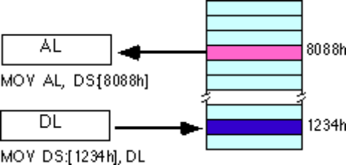
The displacement-only addressing mode is perfect for accessing simple variables.
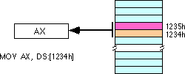
By default, all displacement-only values provide offsets into the data segment. If we want to provide an offset into a different segment, we must use a segment override prefix before the address. For example, to access location 1234H in the extra segment (ES) we would use an instruction of the form MOV AX, ES:[1234H]. Likewise, to access this location in the code segment we would use the instruction MOV AX, CS:[1234H]. The DS: prefix in the previous examples is not a segment override.

Immediate addressing mode
In this type of addressing, immediate data is a part of instruction, and appears in the form of successive byte or bytes.
Eg: MOV AX,0005H
Here 0005H is an immediate data. The data can be 8 bit or 16 bit.

Register addressing mode
In register addressing mode, the data is stored in a register and it is referred using the particular register. All the registers, except IP can be used for this purpose.
Eg: MOV AX, BX

4) The Register Indirect Addressing Modes
Sometimes, the address of the memory location that contains data or operand is determined by in an indirect way using the offset registers. This mode of addressing mode is known as register indirect addressing mode. Here, the offset address of data is in either BX or SI or DI

There are four forms of this addressing mode on the 8086, best demonstrated by the following instructions:
mov al, [bx]
mov al, [bp]
mov al, [si]
mov al, [di]

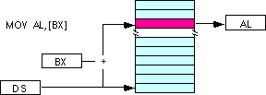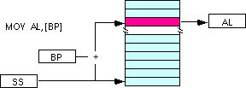
Note: the [si] and [di] addressing modes work exactly the same way, just substitute si and di for bx above.
6. Summary
Thus the 8086 processor mainly consist of 8 addressing modes. By this lecture we know how to use the memory and we will continue the rest of this section in the next class.
- Exercise Questions
- What special symbol is sometimes used to represent immediate data?
- Suppose that DS= 0200H, BX= 0300H, and DI=400H. Determine the memory address accessed by each of the following instruction.
  - MOV AL, [1234H]
  - MOV [DI], AL
- Which base register addresses data in stack segment?
- What are the three program memory addressing modes?

Lecture #7

1. Synopsis
- Continuation of Addressing modes of 8086

2. Target
By this lecture, you should be able to answer the following questions
- Explain the difference between Register-indirect and indexed addressing modes?
- How the effective address is calculated in Based indexed addressing mode?

3. Introduction
The last day we started the addressing modes of 8086. Today we will see the rest of the addressing modes of 8086.

4. Revision/Prerequisites
Please refer to the Advanced microprocessors and peripherals, A K Ray & K M Chaudhari.
5. Concepts
Addressing modes

Indexed Addressing Modes
In this mode of addressing, offset of the operand is stored in one of the index registers. DS and ES are the default segments for index registers SI and DI respectively.
The indexed addressing modes use the following syntax:
mov al, disp[bx]
mov al, disp[bp]
mov al, disp[si]
mov al, disp[di]
If bx contains 1000h, then the instruction mov cl,20h[bx] will load cl from memory location ds:1020h. Likewise, if bp contains 2020h, mov dh,1000h[bp] will load dh from location ss:3020.
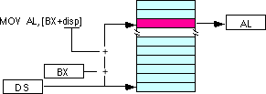

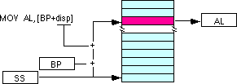
We may substitute si or di in the figure above to obtain the [si+disp] and [di+disp] addressing modes.
6) Register Relative
In this addressing mode, the data is available at an effective address formed by adding an 8-bit or 16-bit displacement with the content of any one of the registers BX, BP, SI and DI. in the default segment.
Eg: MOV AX, 50H[BX]
The effective address is given as 10H * DS + 50H + [BX]
7) Based Indexed Addressing Modes
The based indexed addressing modes are simply combinations of the register indirect addressing modes. The effective address is calculated by adding the content of base register (bx or bp) to the content of an index register (si or di).
Eg: MOV AX, [BX] [SI]
Effective address is computed as 10H * DS + [BX] + [SI]
The allowable forms for these addressing modes are
mov al, [bx][si]
mov al, [bx][di]
mov al, [bp][si]
mov al, [bp][di]
Suppose that bx contains 1000h and si contains 880h. Then the instruction
mov al,[bx][si]
would load al from location DS:1880h. Likewise, if bp contains 1598h and di contains 1004, mov ax,[bp+di] will load the 16 bits in ax from locations SS:259C and SS:259D.
The addressing modes that do not involve bp use the data segment by default. Those that have bp as an operand use the stack segment by default.
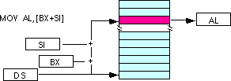
By substituting di in the figure above, we can obtain the [bx+di] addressing mode.
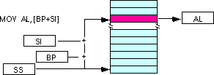
We substitute di in the figure above for the [bp+di] addressing mode.

8) Based Indexed Plus Displacement Addressing Mode
These addressing modes are a slight modification of the base/indexed addressing modes with the addition of an eight bit or sixteen bit constant. The following are some examples of these addressing modes:
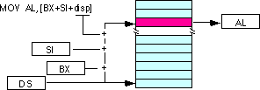
mov al, disp[bx][si]
mov al, disp[bx+di]
mov al, [bp+si+disp]
mov al, [bp][di][disp]
di may be substituted in the figure above to produce the [bx+di+disp] addressing mode.
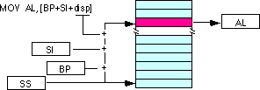
Suppose bp contains 1000h, bx contains 2000h, si contains 120h, and di contains 5. Then mov al,10h[bx+si] loads al from address DS:2130; mov ch,125h[bp+di] loads ch from location SS:112A; and mov bx,cs:2[bx][di] loads bx from location CS:2007.
6. Summary
Today we have completed all addressing modes used in 8086 programming.
- Exercise Questions
1. Logic calculations are done in which type of registers?
- Suppose that DS= 1200H, BX= 0100H, and DI=0400H. Determine the memory address accessed by each of the following instruction.
  - MOV [100H], DL
  - MOV DL, [BX + 100H]
  - MOV [SI + 100H], EAX

Lecture #8

Synopsis
  - Program addressing modes
  - Program, Data and Stack memory

2. Target
By this lecture, you should be able to answer the following questions
a) How the addressing modes are differentiated?

3. Introduction
There are two addressing modes for the control transfer instructions, intra segment and inter segment-addressing modes. These addressing modes depend upon whether the destination location is within the same segment or a different one the method of passing the destination address to the processor.

4. Revision/Prerequisites
Please refer to the text Microprocesor architecture of Remesh Gaonkar-Fifth Edition and the pages 38-40 of Advanced microprocessors and peripherals, A K Ray & K M Chaudhari.
5. Concepts
Program addressing modes
Program memory address can be of the following three types
- Direct Program Memory addressing modes (JMP instructions- intersegment jump)
- Relative Program Memory Addressing modes (JMP instructions-intrasegment jumps)
- Indirect program memory accessing modes (CALL instructions)
Program, data and stack memories occupy the same memory space. The total addressable memory size is 1MB KB. As the most of the processor instructions use 16-bit pointers the processor can effectively address only 64 KB of memory. To access memory outside of 64 KB the CPU uses special segment registers to specify where the code, stack and data 64 KB segments are positioned within 1 MB of memory.
Program memory - program can be located anywhere in memory. Jump and call instructions can be used for short jumps within currently selected 64 KB code segment, as well as for far jumps anywhere within 1 MB of memory. All conditional jump instructions can be used to jump within approximately +127 - -127 bytes from current instruction.
Data memory - the processor can access data in any one out of 4 available segments, which limits the size of accessible memory to 256 KB (if all four segments point to different 64 KB blocks). Accessing data from the Data, Code, Stack or Extra segments can be usually done by prefixing instructions with the DS:, CS:, SS: or ES: (some registers and instructions by default may use the ES or SS segments instead of DS segment).
Word data can be located at odd or even byte boundaries. The processor uses two memory accesses to read 16-bit word located at odd byte boundaries. Reading word data from even byte boundaries requires only one memory access.
Stack memory can be placed anywhere in memory. The stack can be located at odd memory addresses, but it is not recommended for performance reasons.
Intersegment code
If the location to which control is to be transferred lies in a different segment other than the current one, the mode is called intersegment mode.
Intrasegment mode
If the destination location lies in the same segment, the mode is called intrasegment mode.

Intrasegment direct

Intrasegment
Modes for control Intrasegment Indirect
Transfer instructions Intersegment Direct
Intersegment

Intersegment Direct

Intrasegment Direct Mode
In this mode, the address to which the control is to be transferred lies in the same segment in which the control transfer instruction lies and appears directly in the instruction as an immediate displacement value. In this mode, the displacement is computed relative to the content of the instruction pointer IP.
The effective address to which control is transferred is given by the sum of 8 or 16 bit displacement and current content of IP. In case of jump instruction, if the signed displacement (d) is of 8 bits (-128<d<+128), we term it as short jump and if it is of 16 bits, it is termed as long jump.
Intra segment Direct Mode
In this mode the displacement to which the control is to be transferred is in the same segment in which the control transfer instruction lies, but it is passed to the instruction indirectly. Here, the branch instruction is found as the content of register or a memory location. This addressing mode may be used in unconditional branch instructions.
Intersegment Direct Mode
In this mode, the address to which the control is to be transferred is in a different segment. The addressing mode provides a means of branching from one code segment to another code segment. Here the CS and IP of the destination address are specified directly in the instruction.

Intersegment Indirect Mode
In this mode, the address to which the control is to be transferred is in a different segment and it is passed to the instruction indirectly, i.e contents of a memory block containing four bytes, i.e IP(LSB), IP(MSB), CS(LSB) and CS(MSB).The starting address of the memory block may be referred using any of the addressing mode, except immediate..

6. Summary
Today we have discussed the other addressing modes.
7. Exercise Questions
- Which addressing mode is used in unconditional branch instructions?
- What is the addressing mode used in which the destination location is in a different segment?
- What is the difference between intrasegment and intersegment addressing modes?

Lecture #9

Synopsis
  - Segmented Memory
  - Physical address calculation

2. Target
By this lecture, you should be able to answer the following questions
a) What linear address is corresponding to a particular segment/offset address?

3. Introduction
A processor requires a minimum of 20 address lines to have the ability to access 1MB of memory. But the problem is 20 bit addresses are too big to fit in 16 bit registers. And the solution to this problem is Memory Segment.

Revision/Prerequisites

Please refer to the text Microprocessors architecture of Remesh Gaonkar-Fifth Edition and Advanced microprocessors and peripherals, A K Ray & K M Chaudhari.

- Concepts

Memory Organization

Address Bus:

The address bus is multiplexed with data bus.
20-bit memory address ---> Access 1 MiB of segmented memory space. (2²⁰ = 1,048,576)
16-bit I/O address ----------> Access 64 KiB of separate I/O space. (2¹⁶ = 65,536)

Data Bus:

The data bus is multiplexed with address bus. The 16 bit data bus, transfers 16 bits of data in a single operation. All internal registers are also 16 bits wide.

The 8086 is therefore a TRUE 16-bit processor.

The Total address space is theoretically 1 MiB + 64 KiBs, but the maximum linear address space is only 64 KiBs, because of internal address segmentation , also each physical address location can be addressed by 4096 distinct segment: offset combinations.

Segmented Memory Architecture (Real Mode)

As you already know, a processor requires a minimum of 20 address lines to have the ability to access 1MB of memory. Each byte in memory has a 20 bit address starting with 0 to 220-1 or 1 meg of addressable memory. So the addresses are expressed as 5 hex digits from 00000 – FFFFF.

But the problem is: 20 bit addresses are TOO BIG to fit in 16 bit registers. And the solution to this problem is Memory Segment. That is dividing the address space into 64KB segments and coordinates memory access through the use of two 16 bit values - a Segment and an Offset.

The segment numbers range from 0000 to FFFF. Within a segment, a particular memory location is specified with an offset. An offset also ranges from 0000 to FFFF.

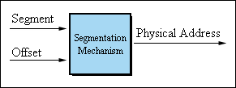
Figure 1: Real Mode Translation Process

Four dedicated Segment Registers were created in order to hold the segment portion of the processor generated addresses. Each of these registers was designated to serve as a base pointer to a unique segment in the processor physical address space.

Segment Register | Designated Role
CS | Code Segment Register This register points to the currently active code segment. Used in conjunction with the IP register to point to the next instruction to be fetched and executed by the processor.
DS | Data Segment Register This register usually points to the default data segment which contains the global and static variables of the active application.
ES | Extra Segment Register General purpose segment register used mostly for data transfers between different segments.
SS | Stack Segment Register  This register points to the segment containing the active stack. The top of stack is located at address SS:SP.
FS  GS | General Purpose Segment Registers  First introduced on the 80386, these segment registers can be used for any purpose in your application code.
Table 1 - Segment registers on the 80x86 processors
The value set into a segment register identifies a specific 64KB region of memory, whereas the offset part points to an exact location within that region. To calculate a physical address, the processor shifts the content of the segment register four bits to the left (thus multiplying its value by 16) and adds the offset.
physical address = segment×16 + offset
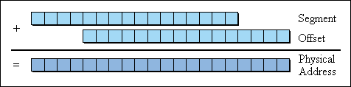
Figure 2: Physical Memory Calculation

Since the content of a segment register forms the 16 high-order bits of a physical address, it is always divisible by 16 and has its lowest four bits set to zero. It can be depicted as in the following figure:

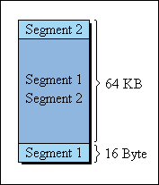
Figure 3: Consecutive segments

For years, the world of personal computing was dominated by real-mode MS-DOS. The arrival of the Windows operating system which dispensed with real-mode in favor of the much advanced protected-mode, marked a new era in the computing industry.

6. Summary
Today we have discussed the memory organization of 8086 microprocessor.

