MODULE 4

Error Detection and Correction

Data can be corrupted during transmission. For reliable communication, errors must be detected and corrected

Types of Error

Single-Bit Error
Burst Error

In a single-bit error, only one bit in the data unit has changed
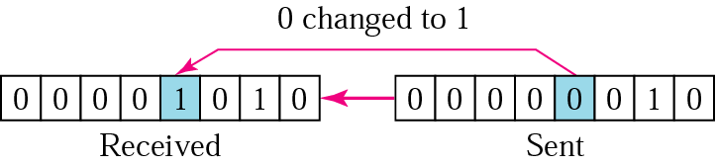

A burst error means that 2 or more bits in the data unit have changed.

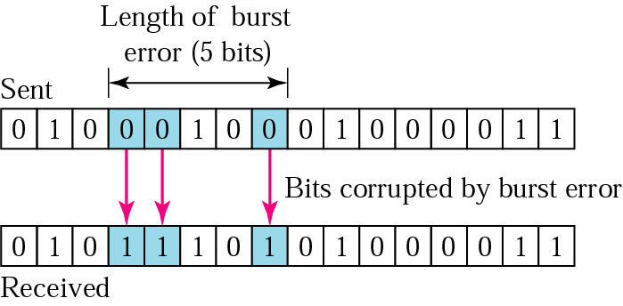

Detection

Redundancy

Parity Check

Cyclic Redundancy Check (CRC)

Checksum

Error detection uses the concept of redundancy, which means adding extra bits for detecting errors at the destination.

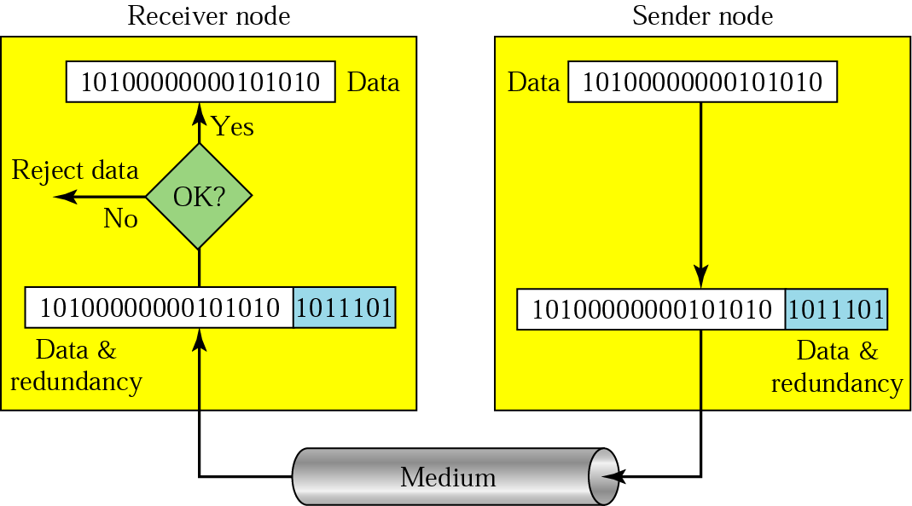

Detection methods

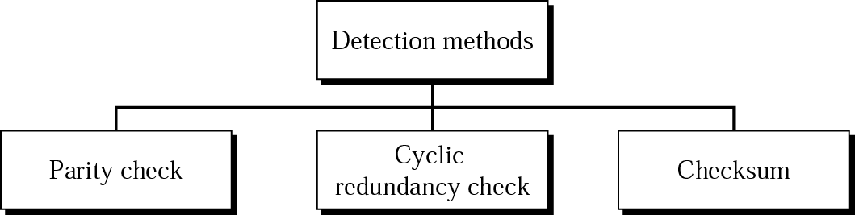

Even-parity concept

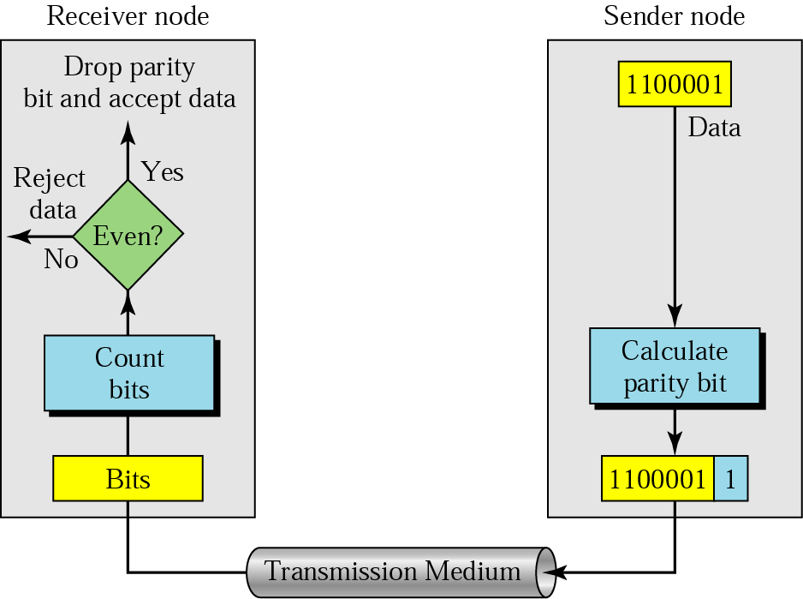

In parity check, a parity bit is added to every data unit so that the total number of 1s is even
(or odd for odd-parity).

Example 1
Suppose the sender wants to send the word world. In ASCII the five characters are coded as
1110111 1101111 1110010 1101100 1100100
The following shows the actual bits sent
11101110 11011110 11100100 11011000 11001001

Example 2

Now suppose the word world in Example 1 is received by the receiver without being corrupted in transmission.
11101110 11011110 11100100 11011000 11001001
The receiver counts the 1s in each character and comes up with even numbers (6, 6, 4, 4, 4). The data are accepted.

Now suppose the word world in Example 1 is corrupted during transmission.
11111110 11011110 11101100 11011000 11001001
The receiver counts the 1s in each character and comes up with even and odd numbers (7, 6, 5, 4, 4). The receiver knows that the data are corrupted, discards them, and asks for retransmission.

Two-dimensional parity

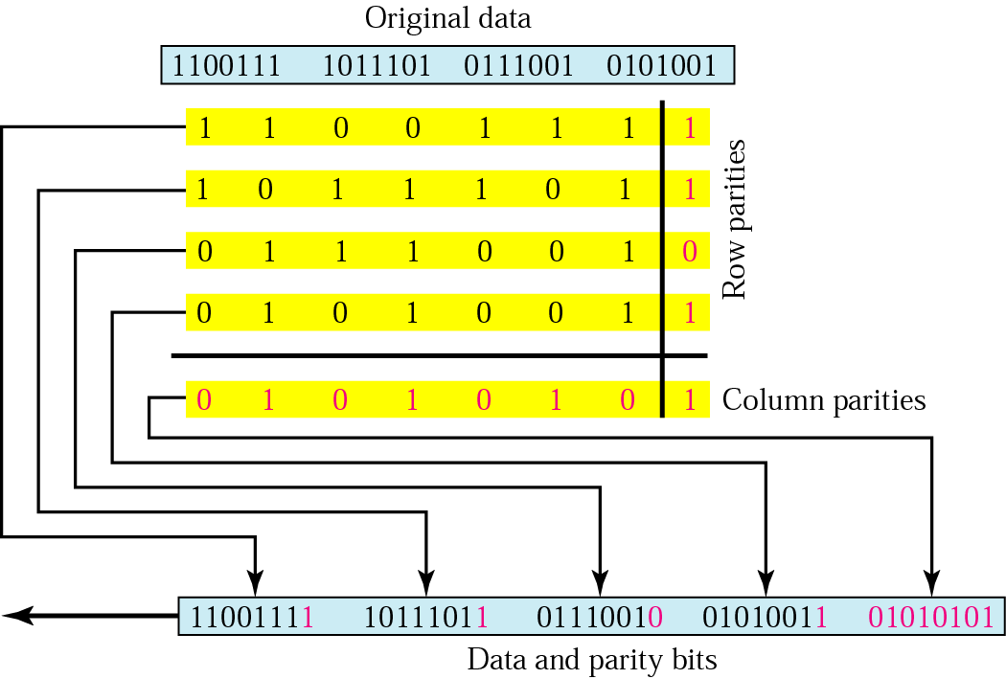

Suppose the following block is sent:
10101001 00111001 11011101 11100111 10101010
However, it is hit by a burst noise of length 8, and some bits are corrupted.
10100011 10001001 11011101 11100111 10101010
When the receiver checks the parity bits, some of the bits do not follow the even-parity rule and the whole block is discarded.
10100011 10001001 11011101 11100111 10101010

In two-dimensional parity check, a block of bits is divided into rows and a redundant row of bits is added to the whole block.

CRC generator and checker

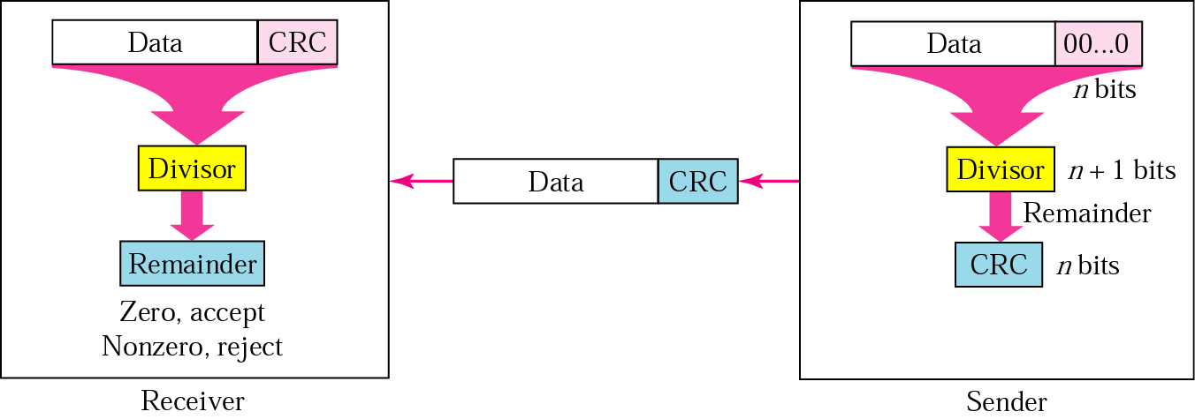

Binary division in a CRC generator

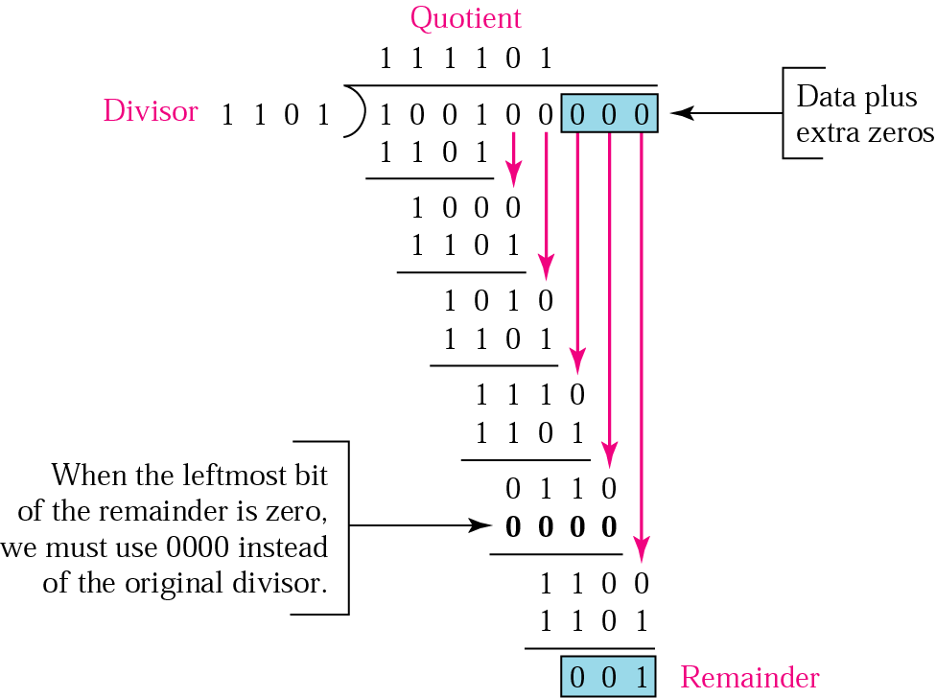

Binary division in CRC checker

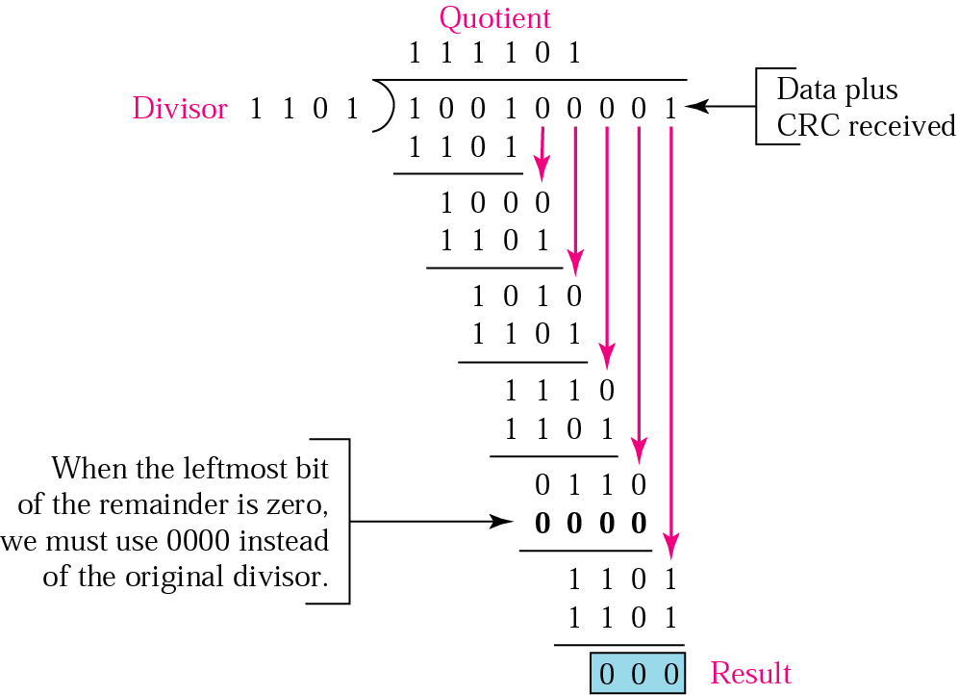

A polynomial

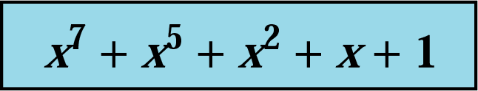

A polynomial representing a divisor
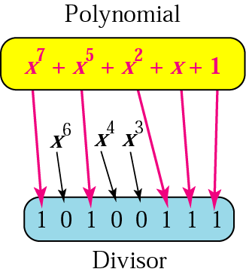

Standard polynomials

Name | Polynomial | Application
CRC-8 | x8 + x2 + x + 1 | ATM header
CRC-10 | x10 + x9 + x5 + x4 + x 2 + 1 | ATM AAL
ITU-16 | x16 + x12 + x5 + 1 | HDLC
ITU-32 | x32 + x26 + x23 + x22 + x16 + x12 + x11 + x10 + x8 + x7 + x5 + x4 + x2 + x + 1 | LANs

It is obvious that we cannot choose x (binary 10) or x2 + x (binary 110) as the polynomial because both are divisible by x. However, we can choose x + 1 (binary 11) because it is not divisible by x, but is divisible by x + 1. We can also choose x2 + 1 (binary 101) because it is divisible by x + 1 (binary division).

Checksum
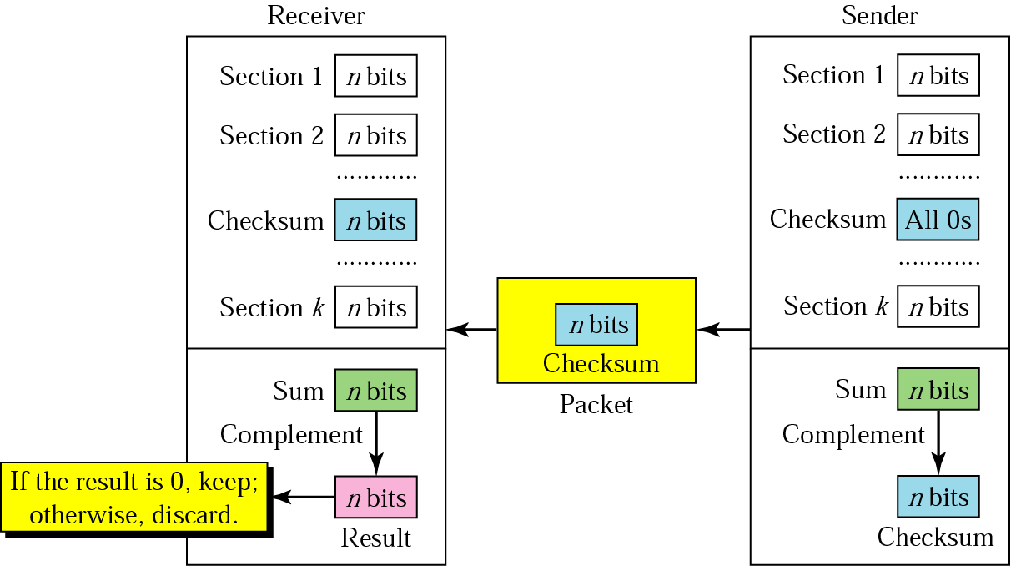

The sender follows these steps:
- The unit is divided into k sections, each of n bits.
- All sections are added using one’s complement to get the sum.
- The sum is complemented and becomes the checksum.
- The checksum is sent with the data.

The receiver follows these steps:
- The unit is divided into k sections, each of n bits.
- All sections are added using one’s complement to get the sum.
- The sum is complemented.
- If the result is zero, the data are accepted: otherwise, rejected

Correction

Retransmission

Forward Error Correction

Burst Error Correction

Data and redundancy bits

Number of  data bits  m | Number of  redundancy bits  r | Total  bits  m + r
1 | 2 | 3
2 | 3 | 5
3 | 3 | 6
4 | 3 | 7
5 | 4 | 9
6 | 4 | 10
7 | 4 | 11

Positions of redundancy bits in Hamming code

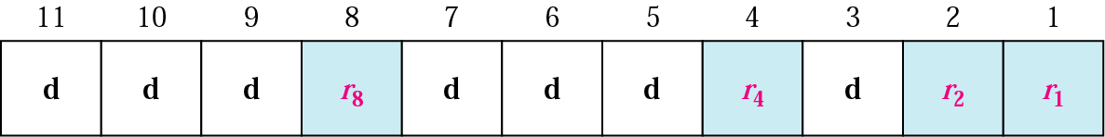

Redundancy bits calculation

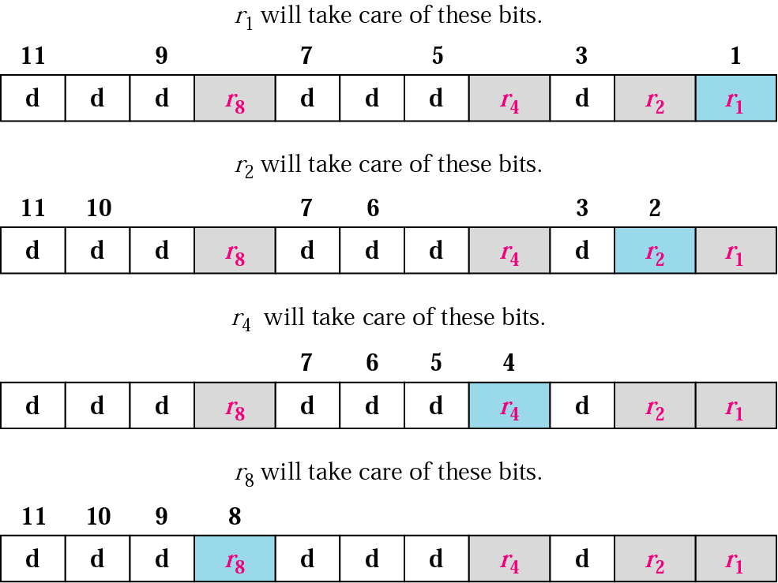

Example of redundancy bit calculation

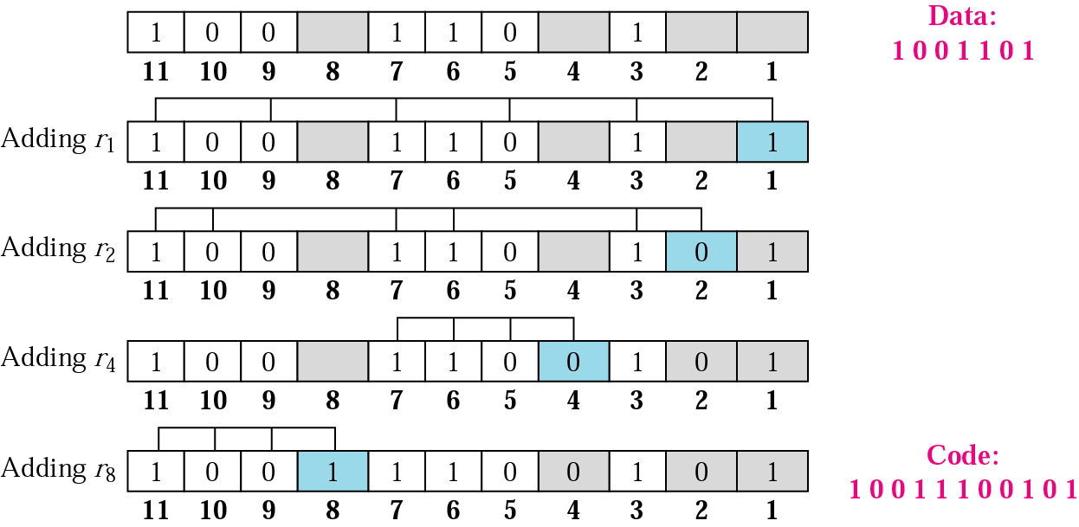

Error detection using Hamming code

