OS Assignment 2 (S5 IT)
Consider the following processes,
Processes CPU Burst time (ms) Priority Arrival time
P1 5 3 0
P2 7 1 1
P3 4 2 2
P4 2 0 3
P5 5 4 4
Compare the following. Draw the Gantt chart and find average waiting time for the above given data
1.1) Shortest remaining time scheduling with round robin scheduling (time Slice is 2ms)
1.2) Preemptive priority scheduling with round robin scheduling (time slice is 1 ms)
1.3) Shortest remaining time scheduling with Preemptive priority scheduling.
1.4) FCFS with Non preemptive SJF (ignore the arrival time)
1.5) Non preemptive priority scheduling with FCFS (ignore the arrival time)
1.6) Non preemptive SJF with Non preemptive priority scheduling (ignore the arrival time)
The preemptive version of SJF is called Shortest Remaining Time First scheduling. Here when a new job arrives in the ready queue, its CPU burst is compared with the remaining CPU burst of the currently running process. If the newly arrived process has got the smaller burst then the currently running process will be preempted and the new process will be allotted to the processor. The preempted process will enter the ready queue and wait for its turn to get the processor.

Round Robin Scheduling
- Each process gets a small amount of CPU time known as time quantum.
- When the time elapses process is preempted and the processor is allocated to the next process at the head of the ready queue.
- When the time quantum is very high this scheduling behaves as FCFS and when the time quantum is very small overhead will be high. It should be large with respect to context switch.
First Come First Serve (FCFS)
- The process that request first for the processor is allotted the processor first.
- The ready queue is maintained as a FIFO queue.
- When the processor becomes free it is allotted to the process at the head of the queue and when a new process arrives it is entered at the tail of the queue.
It is the simplest algorithm and easy to implement.
Shortest Job First Scheduling (SJF)
- Here among the processes in the ready queue, the one with the least CPU burst time will be allotted the processor first.
- If two processes have their burst time equal, then FCFS scheduling is used.
- The average waiting time is small when compared to FCFS scheduling.
- SJF is optimal algorithm.
- It is difficult to implement because knowing the length of the next CPU burst is difficult.
- SJF can be non preemptive or preemptive.
Priority Scheduling
- Each process is assigned a priority number (integer).
- The CPU is allocated to the process with the highest priority (smallest integer may be considered as highest priority).
- Priority scheduling can be preemptive or non preemptive.
In preemptive priority scheduling, while a process is executing, if a new process with high priority than the currently running process arrives, the process is preempted and the processor is allocated to the new process. SJF is a priority scheduling where priority is the predicted next CPU burst time

2. Compare the multilevel Queue and multilevel feedback queue scheduling with example.
Multilevel Queue Scheduling
Ready queue is partitioned into separate queues, for example, foreground (interactive) and background (batch).
Each queue has its own scheduling algorithm, foreground – RR, background – FCFS
Scheduling must be done between the queues. Any scheduling algorithm can be used for this purpose. If fixed priority scheduling is used for this purpose (i.e., serve all from foreground then from background). There is possibility of starvation. If RR is used each queue gets a certain amount of CPU time which it can schedule amongst its processes; i.e., 80% to foreground in RR and 20% to background in FCFS

Multilevel Feedback Queue Scheduling
In multilevel queue scheduling once a process enters a queue, it remains there. But in multilevel feedback queue scheduling a process can move between the various queues. Thus aging can be implemented.
Multilevel-feedback-queue scheduler defined by the following parameters:
- Number of queues
- Scheduling algorithms for each queue
- Method used to determine when to upgrade a process
- Method used to determine when to demote a process
- Method used to determine which queue a process will enter when that process needs service

3. Discuss the real time scheduling strategies and issues in detail.
Hard real time system --- Resource reservation
Soft real time system--- Priority base
Issues---** Priority cannot be changed---- disable aging
----** reduce dispatch latency----Make System call preemptible---Kernel preemptible---priority inversion
4. Explain the structure of process image in detail

Refer PCB
5. Discuss the structure of PCB in detail
A process is represented in the OS by a process control block (PCB)
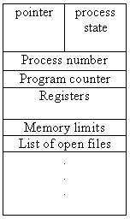

- Process state: The state may be any one of the five discussed earlier.
- Program counter: Holds the address of the next instruction to be executed for the process.
- CPU registers: The registers may vary depending on the architecture. The registers should be saved if an interrupt occurs. This will help the process to continue correctly afterwards.
- CPU-scheduling information: This includes process priority, pointers to scheduling queues etc.
- Memory-management information: This includes the value of the base and limit registers and the page tables or segment tables.
- Accounting information: This includes the amount of CPU and real time used, time limits, process numbers etc.
- I/O status information: This includes the list of I/O devices allocated to the process, a list of open files etc.

6. Discuss the process state diagram with suspended states and different transitions.
Five states are as follows
- new: The process is being created
- running: Instructions are being executed
- waiting: The process is waiting for some event to occur
- ready: The process is waiting to be assigned to a processor
- terminated: The process has finished execution

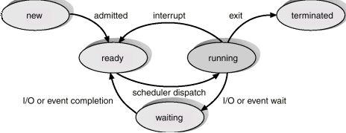
7. What is thread? How does it differ from a process? Distinguish between user and kernel threads.
- Processes are used to group resources together and threads are the entities scheduled for execution on the CPU.
- A thread is a single sequence stream within in a process. Because threads have some of the properties of processes, they are sometimes called lightweight processes.
- In a process, threads allow multiple executions of streams. In many respect, threads are popular way to improve application through parallelism. The CPU switches rapidly back and forth among the threads giving illusion that the threads are running in parallel.
- Like a traditional process i.e., process with one thread, a thread can be in any of several states (Running, Blocked, Ready or Terminated). Each thread has its own stack. Since thread will generally call different procedures and thus a different execution history. This is why thread needs its own stack. An operating system that has thread facility, the basic unit of CPU utilization is a thread.
- A thread has or consists of a program counter (PC), a register set, and a stack space. Threads are not independent of one other like processes as a result threads shares with other threads their code section, data section, OS resources also known as task, such as open files and signals.
Processes Vs Threads

Similarities
- Like processes threads share CPU and only one thread active (running) at a time.
- Like processes, threads within a processes, threads within a processes execute sequentially.
- Like processes, thread can create children.
- And like process, if one thread is blocked, another thread can run
Differences
- Unlike processes, threads are not independent of one another.
- Unlike processes, all threads can access every address in the task .
- Unlike processes, thread are design to assist one other. Note that processes might or might not assist one another because processes may originate from different users.

8. Discuss multithreading with diagram, example and advantages.
- Operating system supports multiple threads of execution within a single process
- MS-DOS supports a single thread
- UNIX supports multiple user processes but only supports one thread per process
- Windows 2000, Solaris, Linux, Mach, and OS/2 support multiple threads
- 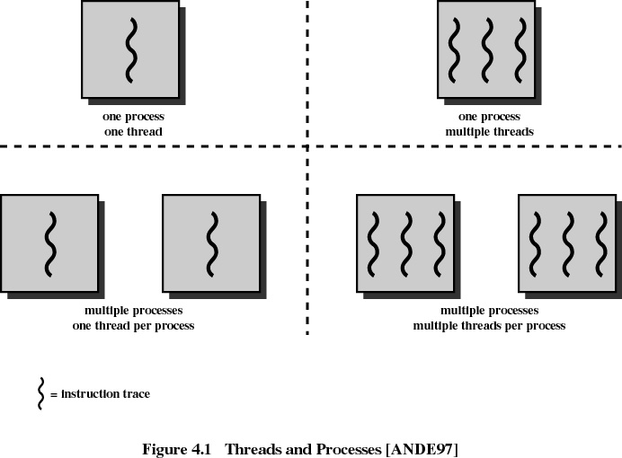
Advantages
- Responsiveness
- Resource Sharing
- Economy
- Utilization of MP Architectures

9. Discuss different multithreading mapping models.

Multithreading model
1. Many to one
- Many user-level threads mapped to single kernel thread
- Examples:
  - Solaris Green Threads
  - GNU Portable Threads
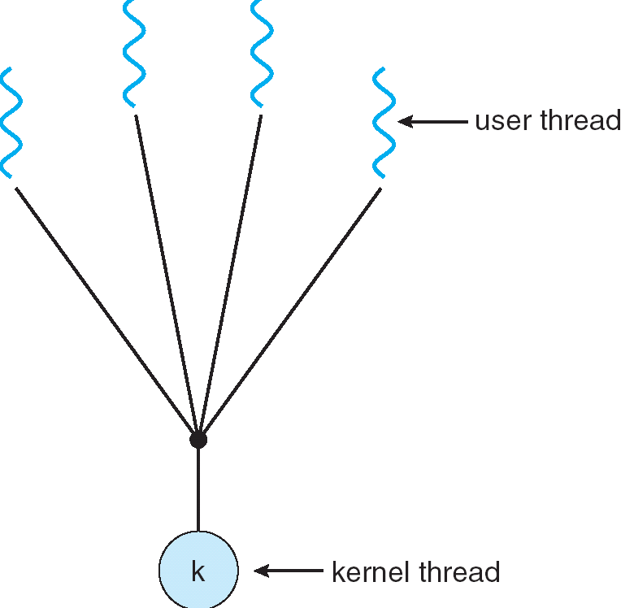
2. One to one
- Each user-level thread maps to kernel thread
- Examples
  - Windows NT/XP/2000
  - Linux
  - Solaris 9 and later
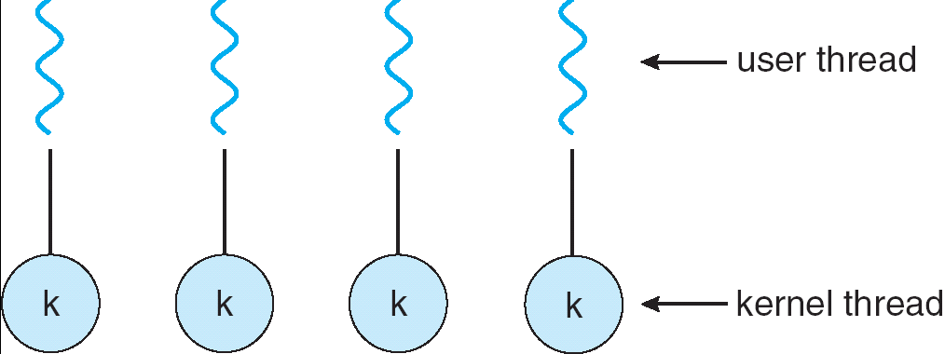
3. Many to many model
- Allows many user level threads to be mapped to many kernel threads
- Allows the operating system to create a sufficient number of kernel threads
- Solaris prior to version 9
- Windows NT/2000 with the ThreadFiber package
