T502 Register No:…………………

RAJAGIRI SCHOOL OF ENGINEERING AND TECHNOLOGY

B.TECH DEGREE FIRST INTERNAL EXAMINATION, Oct 2007

Fifth Semester Information Technology
Operating System Concepts

Time:2 hours Maximum Marks:50

Answer all questions

Part A

- Discuss main objectives and functions of operating system.

OS is a program that controls the execution of application programs and acts as an interface between applications and hardware. Its objectives are
(i) Convenience
-Makes the computer more convenient to use
(ii) Efficiency
-Allows computer system resources to be used in an efficient manner
(iii) Ability to evolve
-Permit effective development, testing, and introduction of new system functions without interfering with service
(a) Program development
- Editors and debuggers help in creating programs.
(b) Program execution
-The system must be able to load a program into memory and to run that program, end execution, either normally or abnormally (indicating error)
- (c) I/O operations
- -A running program may require I/O, which may involve a file or an I/O device.
- (d) File-system manipulation
- -The file system is of particular interest. Obviously, programs need to read and write files and directories, create and delete them, search them, list file Information, permission management.
- (e) System Access
- OS controls access to system as a whole and to specific resources. The access function also provides the protection to data and resources and resolves conflicts during contention of resources.
(f) Error detection and recovery

- Define deadlock. Explain the essential conditions for deadlock.

- two or more processes are waiting indefinitely for an event that can be caused by only one of the waiting processes
Necessary and Sufficient Deadlock Conditions
1. Mutual Exclusion Condition
The resources involved are non-shareable.
Explanation: At least one resource (thread) must be held in a non-shareable mode, that is, only one process at a time claims exclusive control of the resource. If another process requests that resource, the requesting process must be delayed until the resource has been released.
2. Hold and Wait Condition

Requesting process hold already, resources while waiting for requested resources.
Explanation: There must exist a process that is holding a resource already allocated to it while waiting for additional resource that are currently being held by other processes.
3. No-Preemptive Condition

Resources already allocated to a process cannot be preempted.
Explanation: Resources cannot be removed from the processes are used to completion or released voluntarily by the process holding it.
4. Circular Wait Condition

The processes in the system form a circular list or chain where each process in the list is waiting for a resource held by the next process in the list.

- Describe five state transition diagram of a process? Under what circumstances, a process will be suspended?

Five states are as follows
- new: The process is being created
- running: Instructions are being executed
- waiting: The process is waiting for some event to occur
- ready: The process is waiting to be assigned to a processor
- terminated: The process has finished execution

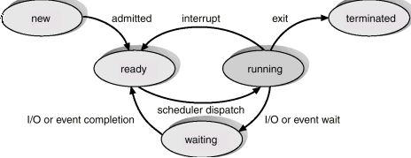

- How does a process differ from thread? What is process spawning?

Similarities
- Like processes threads share CPU and only one thread active (running) at a time.
- Like processes, threads within a processes, threads within a processes execute sequentially.
- Like processes, thread can create children.
- And like process, if one thread is blocked, another thread can run
Differences
- Unlike processes, threads are not independent of one another.
- Unlike processes, all threads can access every address in the task .
- Unlike processes, thread are design to assist one other. Note that processes might or might not assist one another because processes may originate from different users.

- Explain the role of PCB in process management.

A process is represented in the OS by a process control block (PCB)
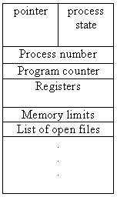

- Process state: The state may be any one of the five discussed earlier.
- Program counter: Holds the address of the next instruction to be executed for the process.
- CPU registers: The registers may vary depending on the architecture. The registers should be saved if an interrupt occurs. This will help the process to continue correctly afterwards.
- CPU-scheduling information: This includes process priority, pointers to scheduling queues etc.
- Memory-management information: This includes the value of the base and limit registers and the page tables or segment tables.
- Accounting information: This includes the amount of CPU and real time used, time limits, process numbers etc.
- I/O status information: This includes the list of I/O devices allocated to the process, a list of open files etc.

(5 x 4 = 20 marks)

Part B

- Discuss different types of operating systems with its features.

Simple Bath System

To overcome the following drawbacks of the earlier machines, batch OS was developed
(a) Expensiveness (b) minimum machine utilization

The simple batch processing scheme used software called monitor. The user did not have any direct interaction with the computer system. Instead the users submitted their jobs either on cards or tapes to a computer operator. A job consisted of the program, data and control information (control cards). The operator batched the jobs and placed the entire batch on an input device. Each program when it completes processing will branch back to the monitor and the monitor will automatically begin loading the next program. It is the monitor that controls the sequence of events. So much of the monitor should always be in the memory and should be available for execution. That part of the monitor which resides in the memory is called Resident Monitor

Multiprogrammed Batch Systems

If more than one job could be held in the memory, when one job waits for I/O, the processor can switch to some other job that is not waiting for I/O. This concept which the modern operating System follows is called multiprogramming or multitasking.

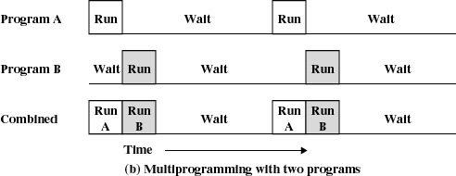

Time Sharing Systems

In these systems multiprogramming is used to handle multiple interactive jobs. Here the processors time is shared among multiple users. Multiple users simultaneously access the system through different terminals.
The difference of time sharing system from a multiprogrammed system is that in multiprogramming, the computer works on one program until it reaches a logical stopping point, such as an input/output event, while for timesharing system, every job is allocated a specific small time period after which the system switches to the next job.

The problems here are
- Since multiple jobs reside in memory at a time they must be protected from interfering with each other.
- The file system must be protected so that only authorized users will access a particular file.
- The contention of resources such as printers and storage devices must be handled.

Distributed Systems

In distributed processors the computation is distributed among multiple processors. But to its users it appears as a uniprocessor system. Users need not bother about where their files are located or where their programs are run. The processors do not share memory, peripheral devices or a clock. Each processor has its own local memory and clock. The processors communicate with one another through various communications lines, such as high-speed buses or telephone lines. Distributed systems requires a networking interface either a LAN or WAN. The systems can be either peer to peer or client server model.
Clustered Systems
Like multiprocessor systems clustered machine gather multiple CPUs to perform computation. The difference is that it is composed of two or more individual systems coupled together. They share storage and is linked by LAN. There are two types of clustering, asymmetric clustering and symmetric clustering.

- What is scheduler? What are different scheduling criteria? Discuss different CPU scheduling algorithms with example.

It is to assign processes to be executed by the processor or processors over time.
It is broken into 3 – long, medium and short term scheduling.

(i) Long term Scheduling
    - It decides which programs are admitted to the system for processing.
- It controls the degree of multiprogramming
- More processes, smaller percentage of time each process is being executed.

(ii) Medium term Scheduling

It is part of the swapping function.
(iii) Short term Scheduling
Also known as CPU scheduler
Selects which process should be executed next and allocates CPU

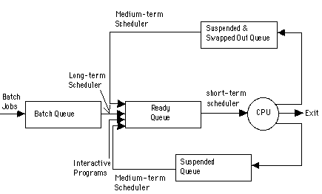

Scheduling Criteria
The different criteria used to compare the performance of the scheduling algorithms are the following:
- CPU Utilization: It is the percentage of time the CPU is kept busy.
- Throughput: It is the number of processes completed per unit time.
- Turnaround time: It is time from the submission of a job to the completion of the job. It is the sum of waiting time and time for which the process uses the CPU.
- Waiting time: It is the amount of time the process spends in the ready queue waiting for the processor.
- Response time: It is time from the submission of a job to the time the first response is obtained.
  - Preemptive Scheduling and Non preemptive Scheduling
In non-preemptive scheduling, once the CPU is allocated to a process, it is released only when the process terminates or when the process switches from the running state to waiting state. Used in Macintosh and Windows 3.1.
In preemptive scheduling, the scheduling takes place when a process switches from running state to ready state or from waiting state to ready state. This scheduling is costly and requires special hardware to implement it.
  - Scheduling Algorithms
(I) First Come First Serve (FCFS)
- The process that request first for the processor is allotted the processor first.
- The ready queue is maintained as a FIFO queue.
- When the processor becomes free it is allotted to the process at the head of the queue and when a new process arrives it is entered at the tail of the queue.
It is the simplest algorithm and easy to implement.
(II) Shortest Job First Scheduling (SJF)
- Here among the processes in the ready queue, the one with the least CPU burst time will be allotted the processor first.
- If two processes have their burst time equal, then FCFS scheduling is used.
- The average waiting time is small when compared to FCFS scheduling.
- SJF is optimal algorithm.
- It is difficult to implement because knowing the length of the next CPU burst is difficult.
- SJF can be non preemptive or preemptive.
The preemptive version of SJF is called Shortest Remaining Time First scheduling. Here when a new job arrives in the ready queue, its CPU burst is compared with the remaining CPU burst of the currently running process. If the newly arrived process has got the smaller burst then the currently running process will be preempted and the new process will be allotted to the processor. The preempted process will enter the ready queue and wait for its turn to get the processor.

(III) Priority Scheduling
- Each process is assigned a priority number (integer).
- The CPU is allocated to the process with the highest priority (smallest integer may be considered as highest priority).
- Priority scheduling can be preemptive or non preemptive.
- In preemptive priority scheduling, while a process is executing, if a new process with high priority than the currently running process arrives, the process is preempted and the processor is allocated to the new process. SJF is a priority scheduling where priority is the predicted next CPU burst time.

The problem with priority scheduling is that a low priority processes may have to wait indefinitely to get the processor to execute. This is called starvation. The solution is to increase the priority of the process as time progresses. This is called aging.

(IV) Round Robin Scheduling
- Each process gets a small amount of CPU time known as time quantum.
- When the time elapses process is preempted and the processor is allocated to the next process at the head of the ready queue.
- When the time quantum is very high this scheduling behaves as FCFS and when the time quantum is very small overhead will be high. It should be large with respect to context switch.
(V) Multilevel Queue Scheduling
Ready queue is partitioned into separate queues, for example, foreground (interactive) and background (batch).
Each queue has its own scheduling algorithm, foreground – RR, background – FCFS
Scheduling must be done between the queues. Any scheduling algorithm can be used for this purpose. If fixed priority scheduling is used for this purpose (i.e., serve all from foreground then from background). There is possibility of starvation. If RR is used each queue gets a certain amount of CPU time which it can schedule amongst its processes; i.e., 80% to foreground in RR and 20% to background in FCFS

(VI)Multilevel Feedback Queue Scheduling
In multilevel queue scheduling once a process enters a queue, it remains there. But in multilevel feedback queue scheduling a process can move between the various queues. Thus aging can be implemented.
Multilevel-feedback-queue scheduler defined by the following parameters:
- Number of queues
- Scheduling algorithms for each queue
- Method used to determine when to upgrade a process
- Method used to determine when to demote a process
- Method used to determine which queue a process will enter when that process needs service

- Explain in brief the features of windows 2000 operating system with its architecture diagram.

- Windows 2000 is a single user multitasking OS.
- Windows 2000 is highly modular – each system function is managed by just one component of the OS. Any module can be upgraded or removed without affecting the rest of the system.
- In Windows 2000 many functions outside the microkernel runs in kernel mode.
- Windows 2000 can be run on a variety of platforms.
The architecture of windows 2000 is shown below.
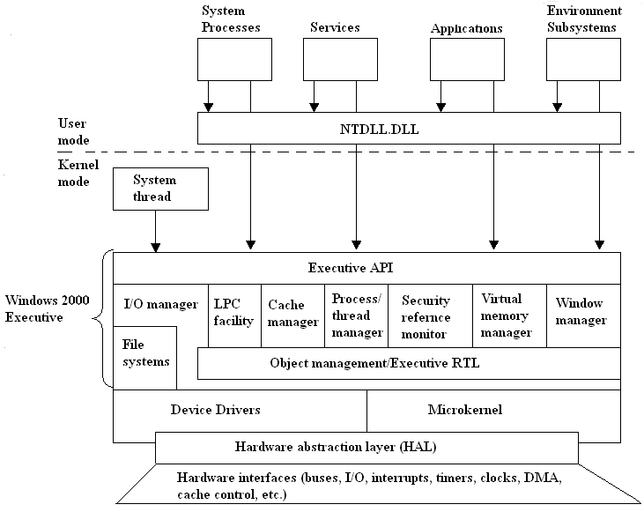
Architecture of Windows 2000
Hardware abstraction layer (HAL):
- HAL isolates the OS from platform specific hardware differences. This is done by mapping between the generic hardware commands and those specific to certain platforms.
- It makes each machines hardware look the same to the kernel.
- It gives the support needed for symmetric multiprocessing.
Microkernel:
- Most used and most fundamental components of the OS forms the microkernel.
- Kernel constitutes thread scheduling, process switching, exception and interrupt handling and multiprocessor synchronization.
- Microkernel is the only part of OS that is not preemptive or pageable.
Device Drivers:
- This includes file system and hardware device drivers.
- It translates I/O function calls into specific hardware device I/O requests.
Windows 2000 Executive:
The windows 2000 executive includes modules for specific system functions. It also provides an API for user mode software. The executive consists of the following modules:
I/O manager:
- Provides a framework through which I/O devices are accessible to applications.
- Implements all the Windows 2000 I/O APIs.
- Enforces security and naming for devices and file systems.
Object manager:
- It is responsible for the creation and deletion of Windows 2000 executive objects and ADT used to represent processes, threads and synchronization objects.
- It enforces uniform rules for naming and setting the security of objects.
- It creates object handles (object handles consists of the access control information and a pointer to the object).
Local Procedure Call facility:
- It enforces a client server relationship between the applications and executive subsystems. (The services of executive subsystems include memory services, process creation services, processor scheduling services etc.)
Cache manager:
- It causes the recently accessed disk data to reside in main memory for quick access thus improves the performance of file based I/O.
Process/thread manager:
- It tracks the process and thread objects.
Security reference monitor:
- It enforces access validation and audit generation rules for files, processes, address spaces and I/O devices.
Virtual memory manager:
- It maps virtual addresses in the process’s address space to physical addresses in the memory.
Window manager:
- It creates the windows oriented screen interface. Manages the graphics devices.
User Processes:
Windows 2000 supports four types of user processes.
Special system support processes:
This includes services not provided as part of Windows 2000 OS. Examples are logon process, session manager etc.
Server Processes:
This includes Windows 2000 services such as event logger.
Environment subsystems:
This system is responsible for exposing the Windows 2000 services to user applications. It includes DLLs that converts the user application calls to Windows 2000 calls.
User applications:
This includes the application programs.

(3 x 10 = 30 marks)

.
.
.

