OS Assignment (S5 IT)

  - Define OS. Mention its functions.
OS is a program that controls the execution of application programs and acts as an interface between applications and hardware. Its objectives are
(i) Convenience
-Makes the computer more convenient to use
(ii) Efficiency
-Allows computer system resources to be used in an efficient manner
(iii) Ability to evolve
-Permit effective development, testing, and introduction of new system functions without interfering with service
The OS provides the following services:
(a) Program development
- Editors and debuggers help in creating programs.
(b) Program execution
-The system must be able to load a program into memory and to run that program, end execution, either normally or abnormally (indicating error)
- (c) I/O operations
- -A running program may require I/O, which may involve a file or an I/O device.
- (d) File-system manipulation
- -The file system is of particular interest. Obviously, programs need to read and write files and directories, create and delete them, search them, list file Information, permission management.
- System Access
- OS controls access to system as a whole and to specific resources. The access function also provides the protection to data and resources and resolves conflicts during contention of resources.
- (f) Error detection and recovery
–OS needs to be constantly aware of possible errors. The errors can be of
(1) Internal and external hardware errors
    - memory error
    - device failure
- software errors
    - arithmetic overflow
    - access forbidden memory locations
- For each type of error, OS should take the appropriate action to ensure correct and consistent computing. Debugging facilities can greatly enhance the user’s and programmer’s abilities to efficiently use the system.
- (g) Accounting
-To keep track of which users use how much and what kinds of computer resources. This information is used to anticipate future enhancements and used for billing users.

OS as resource manager
- Operating system manages all the resources of the computer system. The
system resources include the processors, memories, timers, network interfaces and the various input output devices. Operating system allocates these resources to the processes and thereby ensures optimum utilization of the system resources.

3. Discuss the operating system design hierarchy.
Level Name Objects Example

Operations
13 Shell User programming Statements in
shell language
environment

12 User processes User processes Quit, kill,
suspend, resume

11 Directories Directories Create,
destroy, attach, detach,
search, list

10 Devices External devices, such Open, close,
as printer, displays read, write
and keyboards

9 File system Files Create,
destroy, open, close
read, write

8 Communications Pipes Create,
destroy, open. close,
read, write

7 Virtual Memory Segments, pages Read, write,
Fetch

6 Local secondary Blocks of data, device Read, write,
allocate, free
store channels

5 Primitive processes Primitive process, Suspend,
resume, wait, signal
semaphores, ready
list

4 Interrupts Interrupt-handling Invoke,
mask, unmask, retry
programs

- Procedures Procedures, call stack, Mark
stack, call, return
display

2 Instruction Set Evaluation stack, micro- Load,
store, add, subtract
program interpreter, branch
scalar and array data

1 Electronic circuits Registers, gates, buses, Clear,
transfer, activate,
etc. complement

4. Explain multiprocessor systems. Mention advantages.
These systems have more than one processor sharing the other resources such as computer bus, clock, memory and peripheral devices.
Advantages of multiprocessor systems are
- Increased throughput – Throughput is the amount of work done in unit time. By increasing the number of processors more work can be done than with a single processor.
- Economy of sale – Multiprocessor systems save more money than multiple single processor systems because the processors in the multiprocessor systems share the system resources.
- Increased reliability – The failure of one processor will not halt the system if the work id distributed properly among several processors.
Multiprocessing can be symmetric multiprocessing or asymmetric multiprocessing.

Symmetric multiprocessing – each processor runs an identical copy of the OS and these copies communicate with one another as needed.
Asymmetric Multiprocessing – one of the processor is assigned as the master. The master schedules and allocates work to the slave processors.

5. Define multiprogrammed system. How does it differ from uniprogrammed system?
If more than one job could be held in the memory, when one job waits for I/O, the processor can switch to some other job that is not waiting for I/O. This concept which the modern operating System follows is called multiprogramming or multitasking.

In uniprogramming, Processor must wait for I/O instruction to complete before proceeding.

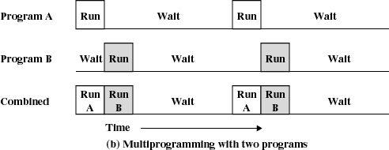
6. What is multitasking system? Explain the disadvantages of such systems.
In these systems multiprogramming is used to handle multiple interactive jobs. Here the processors time is shared among multiple users. Multiple users simultaneously access the system through different terminals.
The difference of time sharing system from a multiprogrammed system is that in multiprogramming, the computer works on one program until it reaches a logical stopping point, such as an input/output event, while for timesharing system, every job is allocated a specific small time period after which the system switches to the next job.

The problems here are
- Since multiple jobs reside in memory at a time they must be protected from interfering with each other.
- The file system must be protected so that only authorized users will access a particular file.
- The contention of resources such as printers and storage devices must be handled.

7. What are real time systems and its classifications.
A real time system has well defined fixed time constraints. Processing should be done within the defined constraints. Real time operating systems are used as a control device in a dedicated application such as controlling scientific experiments, medical imaging systems, industrial control systems, and some display systems. Real-Time systems are classified as hard or soft real-time.

Hard real-time
- Guarantees critical task completion on time.
- Secondary storage limited or absent, data stored in short term memory, or read-only memory (ROM)
- Conflicts with time-sharing systems, not supported by general-purpose operating systems.
- Advanced OS features are absent (e.g. virtual memory is absent).

Soft real-time
- Less restrictive.
- A critical real time task gets priority over other tasks and it retains its priority until it completes.
- Limited utility in industrial control of robotics
Useful in applications (multimedia, virtual reality, under sea explorations etc.) requiring advanced operating-system features.

- Distinguish between clustered and distributed systems
In distributed processors the computation is distributed among multiple processors. But to its users it appears as a uniprocessor system. Users need not bother about where their files are located or where their programs are run. The processors do not share memory, peripheral devices or a clock. Each processor has its own local memory and clock. The processors communicate with one another through various communications lines, such as high-speed buses or telephone lines. Distributed systems requires a networking interface either a LAN or WAN. The systems can be either peer to peer or client server model
Like multiprocessor systems clustered machine gather multiple CPUs to perform computation. The difference is that it is composed of two or more individual systems coupled together. They share storage and is linked by LAN. There are two types of clustering, asymmetric clustering and symmetric clustering.

9. Explain windows 2000 architecture with diagrams.
- Windows 2000 is a single user multitasking OS.
- Windows 2000 is highly modular – each system function is managed by just one component of the OS. Any module can be upgraded or removed without affecting the rest of the system.
- In Windows 2000 many functions outside the microkernel runs in kernel mode.
- Windows 2000 can be run on a variety of platforms.
The architecture of windows 2000 is shown below.
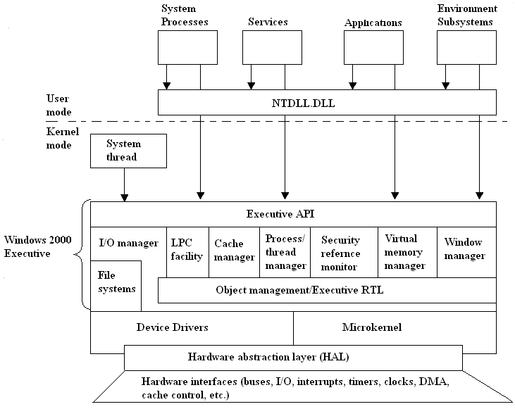
Architecture of Windows 2000
Hardware abstraction layer (HAL):
- HAL isolates the OS from platform specific hardware differences. This is done by mapping between the generic hardware commands and those specific to certain platforms.
- It makes each machines hardware look the same to the kernel.
- It gives the support needed for symmetric multiprocessing.
Microkernel:
- Most used and most fundamental components of the OS forms the microkernel.
- Kernel constitutes thread scheduling, process switching, exception and interrupt handling and multiprocessor synchronization.
- Microkernel is the only part of OS that is not preemptive or pageable.
Device Drivers:
- This includes file system and hardware device drivers.
- It translates I/O function calls into specific hardware device I/O requests.
Windows 2000 Executive:
The windows 2000 executive includes modules for specific system functions. It also provides an API for user mode software. The executive consists of the following modules:
I/O manager:
- Provides a framework through which I/O devices are accessible to applications.
- Implements all the Windows 2000 I/O APIs.
- Enforces security and naming for devices and file systems.
Object manager:
- It is responsible for the creation and deletion of Windows 2000 executive objects and ADT used to represent processes, threads and synchronization objects.
- It enforces uniform rules for naming and setting the security of objects.
- It creates object handles (object handles consists of the access control information and a pointer to the object).
Local Procedure Call facility:
- It enforces a client server relationship between the applications and executive subsystems. (The services of executive subsystems include memory services, process creation services, processor scheduling services etc.)
Cache manager:
- It causes the recently accessed disk data to reside in main memory for quick access thus improves the performance of file based I/O.
Process/thread manager:
- It tracks the process and thread objects.
Security reference monitor:
- It enforces access validation and audit generation rules for files, processes, address spaces and I/O devices.
Virtual memory manager:
- It maps virtual addresses in the process’s address space to physical addresses in the memory.
Window manager:
- It creates the windows oriented screen interface. Manages the graphics devices.
User Processes:
Windows 2000 supports four types of user processes.
Special system support processes:
This includes services not provided as part of Windows 2000 OS. Examples are logon process, session manager etc.
Server Processes:
This includes Windows 2000 services such as event logger.
Environment subsystems:
This system is responsible for exposing the Windows 2000 services to user applications. It includes DLLs that converts the user application calls to Windows 2000 calls.
User applications:
This includes the application programs.

10. Unix architecture
- Here the underlying hardware is surrounded by the OS software.
- OS is often called kernel to emphasize its isolation from the user and applications.
- OS is equipped with a number of user services and interfaces that are considered part of the system.
- These can be grouped into shell, other interface s/w and the components of C compiler.

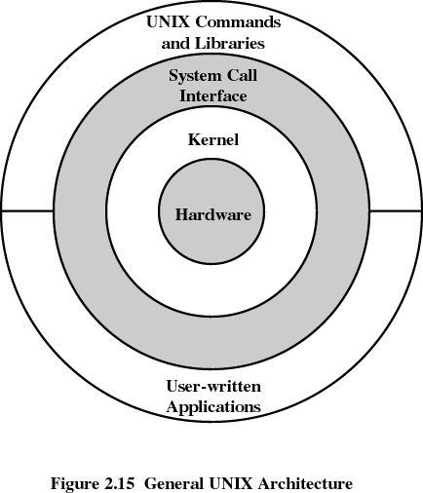

Shell
Shell is the interface between the user and the operating system.
Three types of shells are available
- Bourne shell
Stephen Bourne of AT&T Bell laboratories wrote bourne shell. This is the most primitive and the standard shell used in UNIX OS.
- C shell
William Joy at the University of California at Berkeley wrote C shell. Many of its programming features resemble the syntax of C programming language, so the name C shell. Apart from Bourne shell it has got the following features,
History facility – user can call previously used commands and edit them for reuse.
Alias facility – user can give shorthand names for long command sequences.
- Korn shell
David Korn of AT&T Bell laboratories wrote Korn shell. Most popular shell. Its format and usage is same as that of Bourne shell but it has got the history and alias facilities.

11. Discuss the structure of job in batch system.
It is a special type of programming language used to provide instructions to the monitor. These job control instructions set up the job by telling the computer whether the cards following it contain data or programs, what programming language is used, the approximate execution time, etc. When the current job terminated, the job stream reader automatically reads in the control language statements for the next job. The format of a job looks like this:
$JOB
$FTN
.
.
$LOAD
$RUN
.
.
$END

