July/August 2007

- What are the features of time sharing system and batch system?

The simple batch processing scheme used software called monitor. The user did not have any direct interaction with the computer system. Instead the users submitted their jobs either on cards or tapes to a computer operator. A job consisted of the program, data and control information (control cards). The operator batched the jobs and placed the entire batch on an input device. Each program when it completes processing will branch back to the monitor and the monitor will automatically begin loading the next program. It is the monitor that controls the sequence of events.
In time sharing systems multiprogramming is used to handle multiple interactive jobs.
Here the processors time is shared among multiple users. Multiple users
simultaneously access the system through different terminals

- What are the system calls in windows API related to process?
. end, abort
Load,execute
Create process, terminate
Get and set process attributes
Wait for time
Wait event,signal event
Allocate and free memory

3. What are the use of fork() SYSTEM CALL?
A new process is created by this. The new process is called child process and the other one parent process. The new process consists of copy of the address space of the original. It allows the parent to communicate easily with its child process. The return code for the child is zero, whereas the process identifier is returned to the parent.

4. What is Zombie process? When is it created?
On Unix and Unix-like computer operating systems, a zombie process or defunct process is a process that has completed execution but still has an entry in the process table, this entry being still needed to allow the process that started the zombie process to read its exit status. A zombie process doesn't react to signals because it's not really a process at all- it's just what's left over after it died. What's supposed to happen is that its parent process was to issue a "wait()" to collect the information about its exit. If the parent doesn't (programming error or just bad programming), you get a zombie. The zombie will go away if its parent dies- it will be "adopted" by init which will do the wait()- so if you see one hanging about, check its parent; if it is init, it will be gone soon, if not the only recourse is to kill the parent which you may or may not want to do.

5. What is PTBR?
It is the page table base register and points to the page table. It contains the base address of the page and helps address calculation

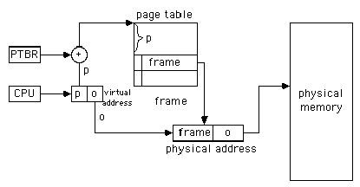

6. Why does UNIX treat all devices as files?
Computer systems usually have peripheral devices attached to them. These devices may be involved with I/O (terminals, printers, modems); they may involve mass storage (disks, tapes); and they may have other specialized functions. The UNIX paradigm for devices is to treat each one as a file, some with special characteristics. UNIX devices are represented as inodes, identical to files. The inodes represent either a character device or a block device (described in the sidebar). Each device is also designated by a major device number, indicating the type of device, and a minor device number, indicating which one of many similar devices the inode represents. For instance, the partitions of a physical disk will all have the same major device number, but different minor device numbers. For a serial card, the minor device number may represent which port number is in use. When a program reads from or writes to a device file, the kernel turns the request into an I/O operation with the appropriate device, using the major/minor device numbers as parameters to indicate which device to access.

7. What essential feature operates the C SCAN and FSCAN from SCAN?

SCAN
The disk arm starts at one end of the disk, and moves toward the other end, servicing requests until it gets to the other end of the disk, where the head movement is reversed and servicing continues.
CSCAN
- Provides a more uniform wait time than SCAN.
- The head moves from one end of the disk to the other. servicing requests as it goes. When it reaches the other end, however, it immediately returns to the beginning of the disk, without servicing any requests on the return trip.
- Treats the cylinders as a circular list that wraps around from the last cylinder to the first one.
FSCAN
FScan is a disk scheduling algorithm to determine the motion of the disk's arm and head in servicing read and write requests. It uses two subqueues. During the scan, all of the requests are in the first queue and all new requests are put into the second queue. Thus, service of new requests is deferred until all of the old requests have been processed. When the scan ends, the arm is taken to the first queue entries and is started all over again.

8. What is the use of stub?
The stub is application-specific code, but it is not directly generated by the application writer and therefore appears as a separate layer from the programmer's point of view. The function of the stub is to provide transparency to the programmer-written application code. On the client side, the stub handles the interface between the client's local procedure call and the run-time system, marshaling and unmarshaling data, invoking the RPC run-time protocol, and if requested, carrying out some of the binding steps. On the server side, the stub provides a similar interface between the run-time system and the local manager procedures that are executed by the server.
RPC transparency to the application programmer is provided by the interface specification mechanism. The programmer specifies interfaces using an Interface Definition Language (IDL), and the IDL compiler generates stubs automatically from the specification. Thus, the actual operations performed by the stub are largely invisible to the programmer, although they form part of the application-specific program code
9. Explain inode in file sysem?
For each object in the filesystem, UNIX stores administrative information in a structure known as an inode. Inodes reside on disk and do not have names. Instead, they have indices (numbers) indicating their positions in the array of inodes.
Each inode generally contains:
- The location of the item's contents on the disk, if any
- The item's type (e.g., file, directory, symbolic link)
- The item's size, in bytes, if applicable
- The time the file's inode was last modified (the ctime)
- The time the file's contents were last modified (the mtime)
- The time the file was last accessed (the atime) for read ( ), exec ( ), etc
- A reference count: the number of names the file has
- The file's owner (a UID)
- The file's group (a GID)
- The file's mode bits (also called file permissions or permission bits)
10. Features of Windows 2000 cluster server.
A computer cluster is a group of tightly coupled computers that work together closely so that in many respects they can be viewed as though they are a single computer. The components of a cluster are commonly, but not always, connected to each other through fast local area networks. Clusters are usually deployed to improve performance and/or availability over that provided by a single computer, while typically being much more cost-effective than single computers of comparable speed or availability. Unlike other clusters which are made for better performance, Windows clusters have historically only presented the option of failover services, which means that if a failure occurs on a server that is a member of the cluster (Cluster node) the services that the failing server was hosting will automatically restart themselves on another server that is a member of the same cluster. The process of a service moving from one server to another is called Failover.
11. What are the basic functions of OS?
OS is a program that controls the execution of application programs and acts as an interface between applications and hardware. Its objectives are
(i) Convenience
-Makes the computer more convenient to use
(ii) Efficiency
-Allows computer system resources to be used in an efficient manner
(iii) Ability to evolve
-Permit effective development, testing, and introduction of new system functions without interfering with service

(i) OS as a user/Computer interface
The OS masks the details of the hardware from the programmer and provides the programmer with a convenient interface for using the system. It acts as a mediator, making it easier for the programmer and for application programs to access and use those facilities and services. The OS provides the following services:
(a) Program development
- Editors and debuggers help in creating programs.
(b) Program execution
-The system must be able to load a program into memory and to run that program, end execution, either normally or abnormally (indicating error)
- (c) I/O operations
- -A running program may require I/O, which may involve a file or an I/O device.
- (d) File-system manipulation
- -The file system is of particular interest. Obviously, programs need to read and write files and directories, create and delete them, search them, list file Information, permission management.
- (e) System Access
- OS controls access to system as a whole and to specific resources. The access function also provides the protection to data and resources and resolves conflicts during contention of resources.
- (f) Error detection and recovery
–OS needs to be constantly aware of possible errors. The errors can be of
(1) Internal and external hardware errors
    - memory error
    - device failure
- software errors
    - arithmetic overflow
    - access forbidden memory locations
- For each type of error, OS should take the appropriate action to ensure correct and consistent computing. Debugging facilities can greatly enhance the user’s and programmer’s abilities to efficiently use the system.
- (g) Accounting
-To keep track of which users use how much and what kinds of computer resources. This information is used to anticipate future enhancements and used for billing users.

(ii) OS as resource manager
- Operating system manages all the resources of the computer system. The
system resources include the processors, memories, timers, network interfaces and the various input output devices. Operating system allocates these resources to the processes and thereby ensures optimum utilization of the system resources.

(iii) Ease of evolution of an OS
- OS will evolve over time for a number of reasons:
1. Hardware upgrades and new type of hardware. For e.g. early UNIX systems did not support paging.
2. New services
3. Fixes – When faults are detected fixes need to be made
Memory management

The OS has 5 storage management responsibilities
- Process isolation: OS must prevent independent processes from interfering with the data and memory of each other.
- Automatic allocation and Management: Programs should be dynamically allocated
- Support for modular programming
- Protection and access control
- Long term storage
File management
It Implements long-term storage. In connection with file management the OS is responsible for the following activities
- Creating and deleting files
- Creating and deleting directories
- Supporting primitives for manipulating files and directories
- Mapping files into secondary storage
- Backing up files on storage media
Information protection and security

Here we are dealing with
(i) Access control
To regulate user access to the system
(ii) Information flow control
To regulate flow of data within the system and its delivery to users
(iii) Certification
To prove that access and flow control perform according to specifications
Scheduling and resource management

Resource allocation and scheduling policy must consider the following 3 factors:
(i) Fairness
To give equal and fair access to all processes
(ii) Differential responsiveness
To discriminate between different classes of jobs/users
(iii) Efficiency
To maximize throughput, minimize response time, and accommodate as many uses as possible

12. Explain the features of UNIX?

- Here the underlying hardware is surrounded by the OS software.
- OS is often called kernel to emphasize its isolation from the user and applications.
- OS is equipped with a number of user services and interfaces that are considered part of the system.
- These can be grouped into shell, other interface s/w and the components of C compiler.

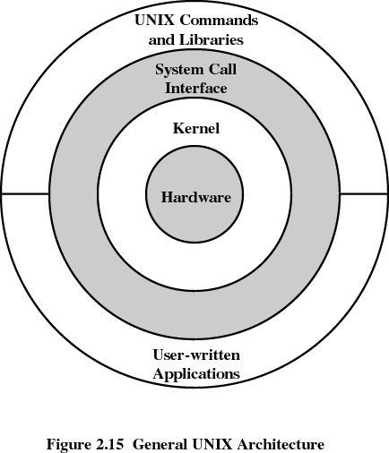

Shell
Shell is the interface between the user and the operating system.
Three types of shells are available
- Bourne shell
Stephen Bourne of AT&T Bell laboratories wrote bourne shell. This is the most primitive and the standard shell used in UNIX OS.
- C shell
William Joy at the University of California at Berkeley wrote C shell. Many of its programming features resemble the syntax of C programming language, so the name C shell. Apart from Bourne shell it has got the following features,
History facility – user can call previously used commands and edit them for reuse.
Alias facility – user can give shorthand names for long command sequences.
- Korn shell
David Korn of AT&T Bell laboratories wrote Korn shell. Most popular shell. Its format and usage is same as that of Bourne shell but it has got the history and alias facilities.

Modern UNIX Systems
- System V Release 4 (SVR4)
- Solaris 2.x
- 4.4BSD
- Linux

13. What are binary semaphore? What type of problems can be solved using them?

It is a synchronization tool that does not require busy waiting. Semaphore S – integer variable. Two standard operations modify S: wait() and signal()
Originally called P() and V()
Can only be accessed via two indivisible (atomic) operations
wait (S) {
while S <= 0
; // no-op
S--;
}
signal (S) {
S++;
}

Binary semaphore – integer value can range only between 0
and 1; It can be simpler to implement, also known as mutex locks
Can implement a counting semaphore S as a binary semaphore
Provides mutual exclusion
Semaphore S; // initialized to 1
wait (S);
Critical Section
signal (S);
It must guarantee that no two processes can execute wait () and signal () on the same semaphore at the same time.Thus, implementation becomes the critical section problem where the wait and signal code are placed in the crtical section.
Could now have busy waiting in critical section implementation
    - But implementation code is short
    - Little busy waiting if critical section rarely occupied
Note that applications may spend lots of time in critical sections and therefore this is not a good solution.

Eg: Readers Writer problem
A data set is shared among a number of concurrent processes
Readers – only read the data set; they do not perform any updates
Writers – can both read and write.
Problem – allow multiple readers to read at the same time. Only one single writer can access the shared data at the same time.

The structure of a writer process

while (true) {
wait (wrt) ;

// writing is performed

signal (wrt) ;
}
The structure of a reader process

while (true) {
wait (mutex) ;
readcount ++ ;
if (readcount == 1) wait (wrt) ;
signal (mutex)

// reading is performed

wait (mutex) ;
readcount - - ;
if (readcount == 0) signal (wrt) ;
signal (mutex) ;
}

14. Scheduler? Its role?
It is to assign processes to be executed by the processor or processors over time.
It is broken into 3 – long, medium and short term scheduling.

(i) Long term Scheduling
    - It decides which programs are admitted to the system for processing.
- It controls the degree of multiprogramming
- More processes, smaller percentage of time each process is being executed.

(ii) Medium term Scheduling

It is part of the swapping function.
(iii) Short term Scheduling
Also known as CPU scheduler
Selects which process should be executed next and allocates CPU

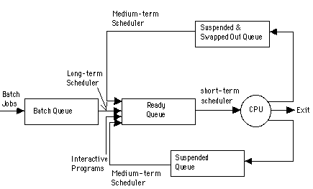

Scheduling Criteria
The different criteria used to compare the performance of the scheduling algorithms are the following:
- CPU Utilization: It is the percentage of time the CPU is kept busy.
- Throughput: It is the number of processes completed per unit time.
- Turnaround time: It is time from the submission of a job to the completion of the job. It is the sum of waiting time and time for which the process uses the CPU.
- Waiting time: It is the amount of time the process spends in the ready queue waiting for the processor.
- Response time: It is time from the submission of a job to the time the first response is obtained.
Preemptive Scheduling and Non preemptive Scheduling
In non-preemptive scheduling, once the CPU is allocated to a process, it is released only when the process terminates or when the process switches from the running state to waiting state. Used in Macintosh and Windows 3.1.
In preemptive scheduling, the scheduling takes place when a process switches from running state to ready state or from waiting state to ready state. This scheduling is costly and requires special hardware to implement it.
Scheduling Algorithms
(I) First Come First Serve (FCFS)
- The process that request first for the processor is allotted the processor first.
- The ready queue is maintained as a FIFO queue.
- When the processor becomes free it is allotted to the process at the head of the queue and when a new process arrives it is entered at the tail of the queue.
It is the simplest algorithm and easy to implement.
(II) Shortest Job First Scheduling (SJF)
- Here among the processes in the ready queue, the one with the least CPU burst time will be allotted the processor first.
- If two processes have their burst time equal, then FCFS scheduling is used.
- The average waiting time is small when compared to FCFS scheduling.
- SJF is optimal algorithm.
- It is difficult to implement because knowing the length of the next CPU burst is difficult.
- SJF can be non preemptive or preemptive.
The preemptive version of SJF is called Shortest Remaining Time First scheduling. Here when a new job arrives in the ready queue, its CPU burst is compared with the remaining CPU burst of the currently running process. If the newly arrived process has got the smaller burst then the currently running process will be preempted and the new process will be allotted to the processor. The preempted process will enter the ready queue and wait for its turn to get the processor.

(III) Priority Scheduling
- Each process is assigned a priority number (integer).
- The CPU is allocated to the process with the highest priority (smallest integer may be considered as highest priority).
- Priority scheduling can be preemptive or non preemptive.
- In preemptive priority scheduling, while a process is executing, if a new process with high priority than the currently running process arrives, the process is preempted and the processor is allocated to the new process. SJF is a priority scheduling where priority is the predicted next CPU burst time.

The problem with priority scheduling is that a low priority processes may have to wait indefinitely to get the processor to execute. This is called starvation. The solution is to increase the priority of the process as time progresses. This is called aging.

(IV) Round Robin Scheduling
- Each process gets a small amount of CPU time known as time quantum.
- When the time elapses process is preempted and the processor is allocated to the next process at the head of the ready queue.
- When the time quantum is very high this scheduling behaves as FCFS and when the time quantum is very small overhead will be high. It should be large with respect to context switch.
(V) Multilevel Queue Scheduling
Ready queue is partitioned into separate queues, for example, foreground (interactive) and background (batch).
Each queue has its own scheduling algorithm, foreground – RR, background – FCFS
Scheduling must be done between the queues. Any scheduling algorithm can be used for this purpose. If fixed priority scheduling is used for this purpose (i.e., serve all from foreground then from background). There is possibility of starvation. If RR is used each queue gets a certain amount of CPU time which it can schedule amongst its processes; i.e., 80% to foreground in RR and 20% to background in FCFS

(VI)Multilevel Feedback Queue Scheduling
In multilevel queue scheduling once a process enters a queue, it remains there. But in multilevel feedback queue scheduling a process can move between the various queues. Thus aging can be implemented.
Multilevel-feedback-queue scheduler defined by the following parameters:
- Number of queues
- Scheduling algorithms for each queue
- Method used to determine when to upgrade a process
- Method used to determine when to demote a process
- Method used to determine which queue a process will enter when that process needs service

15. What is paging?
Virtual memory is a mapping from a name space (or virtual address space) to a physical address space. Its impact on the design of the instruction set architecture is felt in two areas, mostly in supervisor state. First, there are the tables that hold the virtual memory mappings, and which must be accessible. Second, the virtual mapping may have an effect on the size of address fields in the instruction set, especially if page-relative addressing is one of the supported modes.
There are three common approaches to the mapping: paging, segmentation, and paged segmentation. A fourth approach has recently become popular in some designs such as the Alpha and UltraSPARC: multiple page sizes.
Paging
In a paged system, there are fixed-size blocks of memory called pages that are allocated to a process. A memory reference consists of a page number and an offset within the page. The memory management unit (MMU) uses the virtual page number to look up the physical page number. Because the virtual address space can be quite large, the look-up usually involves hashing, and possibly additional search. However, only one piece of an address is needed as the look-up key.
With a paged system, there is one address space and every reference must be checked to ensure that it refers to a page that has been allocated to the current process. The operating system allocates pages from this one address space as needed. The operating system can swap out a subset of the pages that are allocated to a process and bring them into memory when they are needed again. The down side is that a process can get into a pattern of access where it is frequently page-faulting and starts to operate at disk access speeds.
Because the pages are fixed in size, they may be only partially used. This internal fragmentation was a significant problem when machine memories were tiny, but is now negligible. However, it lead to the notion of segmentation as an alternative that avoids internal fragmentation.
Memory is divided into fixed-size blocks called pages. Main memory contains some number of pages (memory size / page size), which is smaller than the number of pages in the virtual address space (virtual address range / page size).
For example, if the page size is 4K and the physical memory is 256M (64K pages) and the virtual memory is 4G (1 M pages) then there is a factor of 16 to 1 mapping.
In order to perform the mapping function, a table lookup is employed. A page table is kept with one entry per virtual page. (In reality, a 1M entry table would not be used -- parts of it would also be mapped in virtual memory, and in may cases those pages would never be stored anywhere because they would never be accessed.)
A page table entry might have the following form:
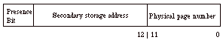
The Presence Bit indicates whether the physical page is in main memory or must be fetched from secondary storage (a page fault). The secondary storage address is used to locate the data on disk. Physical page address is substituted for the virtual page address as a result of the lookup.
A virtual address takes the following form for a page of 4K words:
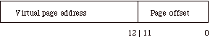
The page offset (low order 12 bits) is the location of the desired word within a page. The Presence Bit indicates whether the physical page is in main memory or must be fetched from secondary storage (a page fault).
Thus, the virtual address translation hardware appears as follows:
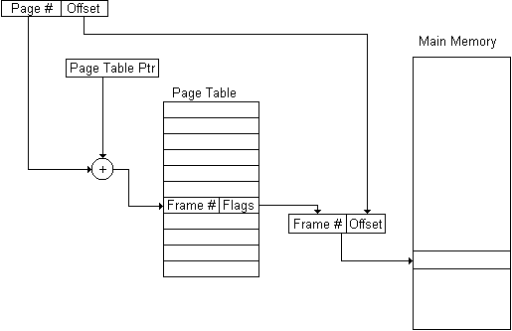

The virtual address from the CPU is split into the offset and page number. The page number becomes the index into the table (requiring a shift and an add of the base address of the table to get a proper address).The table entry is fetched, starting with the presence bit and the physical page. When the presence bit indicates that the page is in main memory, it simply substitutes the physical page from the table for the virtual page portion of the address. When the presence bit indicates that the page is not in main memory, it triggers a page fault exception, and the OS must initiate the disk transfer that brings the page into memory.
While a disk transfer is in progress, the OS my cause another task to execute or it may simply stall the current task and sit idle. In either case, once the transfer is complete, the OS stores the new physical page number into the page table and jumps back to the instruction causing the page fault so that the access can be reissued.
Thus, any virtual page may be stored at any physical page location and the addressing hardware performs the translation automatically.
A page table can also contain privilege information consisting of an owner process ID and level of access. On any access, the current process ID in the program status word is checked against the owner process ID portion of the page table entry and if there is a match and the type of access (read vs. write) is allowed, then the access proceeds. Otherwise an access privilege violation exception is signaled.
Pages are usually loaded in this manner, which is called "on demand". However, schemes have also been devised in which the historical behavior of a task is recorded, and when the task is suspended, its working set of pages is reloaded before it restarts.

Segmentation
In a segmented system, the blocks of memory are variable in size. Each process may have one or more segments. The segments may be visible to the process, that is, it may be aware that there are code, data, stack, and heap segments (whereas pages are usually transparent). A segment table is used that specifies the base of the physical addresses associated with a segment and the valid range. The combination of this base and the offset specified by the address means that two words must be used by the MMU to identify the physical address.
One advantage to the operating system is that once a segment has been allocated, there won't be any access faults from the process except those that actually try to access beyond the segment boundaries. Thus, once a process has started, it can run at memory rates until it returns control to the OS. Of course, this leads to the problem that if a segment is large, the time for a context switch can be excessive.
An access outside of the segment is detected as exceeding the valid range, and is trapped. Segmented virtual addressing is otherwise similar to paging. One problem with pure segmentation is external fragmentation (holes in the address map following a series of allocations and deallocations) that can lead to low memory utilization. External fragmentation is also called checkerboarding, and its correction requires a phase of memory compaction that reduces processing efficiency.
Paged Segmentation
Paged segmentation combines the two techniques by segmenting the address space and having fixed size pages within a segment. Thus, a segment can be physically split into pages that are logically contiguous. External fragmentation is reduced because the variability in size is in terms of pages that can be freely rearranged. Swapping at a context switch does not require that an entire segment be stored or loaded. The swap can occur incrementally as pages are replaced or demanded.
The segementation aspect of the scheme contributes the ability to assign multiple address spaces to a process, which it can then manage explicitly. As virtual address spaces grow large, this has the advantage that we can often avoid having to specify a full virtual address (which can be 64 bits long) in a program and thus we save memory. It also makes it easier to distinguish between access violations and simple page faults, because the segment tables carry the access range information.
The drawback of paged segmentation is that it requires a two-stage translation process in which a segment table is first accessed to retrieve a pointer to a page table for the segment (in the Intel Pentium architecture, a third "Page Directory Table" must also be accessed). Thus, the translation time is increased significantly.
Variable Size Pages
Pure paging is attractive in that it requires just one lookup with a single word of address. It is thus the fastest scheme. However, as virtual address spaces have grown large, it has become difficult to deal with so many small chunks of memory. One problem is that the page tables become huge. If we limit the size of the page tables, then we may not be able to access all of the physical memory that we want to have.
In addition, programs tend to have patchy locality in virtual memory. In some cases, small pages are needed to avoid internal fragmentation and to allow flexibility in the use of memory. On the other hand, if we have a large data structure that is being used heavily, it hardly makes sense to break it into many small pages and allow parts of it to be swapped. A more sensible approach would be to assign a larger block of memory and only have to use a single page table entry to translate for it.
Variable size pages are, of course, more difficult to manage than are fixed size pages. They can also reintroduce the problem of external fragmentation, although in a more limited manner than for a segmented system.
Modern 64-bit architectures have addressed this problem by allowing a small number of choices for the page sizes. These ÒsuperpagesÓ are typically a power-of-2 multiple of the smallest page size. So we might see 4K, 16K, 64K, and 1 MB pages supported in a system. If we can use a 1 MB page, then we avoid having to keep 255 table entries that would be necessary in a system that supports only 4K-byte pages.
Translation Lookaside Buffer
As noted previously, virtual address translation can require multiple memory references and calculations, resulting in a large time penalty. One way to save time is to cache the most recently used page translations in a small, fully associative cache so that the translation can be retrieved in a cycle. This is called a translation lookaside buffer (TLB). In case the TLB misses, the virtual address will already have started through the translation process, which eventually succeeds and updates the TLB. If the TLB hits, then the translation is cancelled.
It would seem that making the TLB large would be advantageous, so that fewer TLB misses would occur. However, keep in mind that the TLB also has to interact with the cache. At whatever level the virtual address translation takes place, the time to access the TLB must be inserted. Before first level caches became as fast as they are now, it was possible to have a physically mapped primary cache. Even a tiny TLB, however, may now slow access too much. Thus, it is more common to have the first level cache be virtually mapped and the TLB sits between the first and second level caches. Even then, it must be very fast, and hence small. Full associativity is used to make up for the small size by allowing full utilization of the small number of entries.
16. Memory management in Solaris?
Variable Size Pages
Pure paging is attractive in that it requires just one lookup with a single word of address. It is thus the fastest scheme. However, as virtual address spaces have grown large, it has become difficult to deal with so many small chunks of memory. One problem is that the page tables become huge. If we limit the size of the page tables, then we may not be able to access all of the physical memory that we want to have.
In addition, programs tend to have patchy locality in virtual memory. In some cases, small pages are needed to avoid internal fragmentation and to allow flexibility in the use of memory. On the other hand, if we have a large data structure that is being used heavily, it hardly makes sense to break it into many small pages and allow parts of it to be swapped. A more sensible approach would be to assign a larger block of memory and only have to use a single page table entry to translate for it.
Variable size pages are, of course, more difficult to manage than are fixed size pages. They can also reintroduce the problem of external fragmentation, although in a more limited manner than for a segmented system.
Modern 64-bit architectures have addressed this problem by allowing a small number of choices for the page sizes. These ÒsuperpagesÓ are typically a power-of-2 multiple of the smallest page size. So we might see 4K, 16K, 64K, and 1 MB pages supported in a system. If we can use a 1 MB page, then we avoid having to keep 255 table entries that would be necessary in a system that supports only 4K-byte pages.
Translation Lookaside Buffer
As noted previously, virtual address translation can require multiple memory references and calculations, resulting in a large time penalty. One way to save time is to cache the most recently used page translations in a small, fully associative cache so that the translation can be retrieved in a cycle. This is called a translation lookaside buffer (TLB). In case the TLB misses, the virtual address will already have started through the translation process, which eventually succeeds and updates the TLB. If the TLB hits, then the translation is cancelled.
It would seem that making the TLB large would be advantageous, so that fewer TLB misses would occur. However, keep in mind that the TLB also has to interact with the cache. At whatever level the virtual address translation takes place, the time to access the TLB must be inserted. Before first level caches became as fast as they are now, it was possible to have a physically mapped primary cache. Even a tiny TLB, however, may now slow access too much. Thus, it is more common to have the first level cache be virtually mapped and the TLB sits between the first and second level caches. Even then, it must be very fast, and hence small. Full associativity is used to make up for the small size by allowing full utilization of the small number of entries.
17. Explain SCAN scheduling algorithms? Is SCAN better than SSTF?
The operating system is responsible for using hardware efficiently — for the disk drives, this means having a fast access time and disk bandwidth.
Access time has two major components
Seek time is the time for the disk are to move the heads to the cylinder containing the desired sector.
Rotational latency is the additional time waiting for the disk to rotate the desired sector to the disk head.
Minimize seek time. Disk bandwidth is the total number of bytes transferred, divided by the total time between the first request for service and the completion of the last transfer.
In SCAN, The disk arm starts at one end of the disk, and moves toward the other end, servicing requests until it gets to the other end of the disk, where the head movement is reversed and servicing continues. Sometimes called the elevator algorithm.
This algorithm is named after the behavior of a building elevator, where the elevator continues to travel in its current direction (up or down) until empty, stopping only to let individuals off or to pick up new individuals heading in the same direction.
From an implementation perspective, the drive maintains a buffer of pending read/write requests, along with the associated cylinder number of the request. Lower cylinder numbers indicate that the cylinder is closest to the spindle, and higher numbers indicate the cylinder is further away.
When a new request arrives while the drive is idle, the initial arm/head movement will be in the direction of the cylinder where the data is stored, either in or out. As additional requests arrive, requests are serviced only in the current direction of arm movement until there are no further requests in that direction. When this happens, the direction of the arm reverses, and the requests that were remaining in the opposite direction are serviced, and so on.
One variation of this method ensures all requests are serviced in only one direction, that is, once the head has arrived at the outer edge of the disk, it returns to the beginning and services the new requests in this one direction only (or vice versa). This is known as the "Circular Elevator Algorithm" or C-SCAN. This results in more equal performance for all head positions, as the expected distance from the head is always half the maximum distance, unlike in the standard elevator algorithm where cylinders in the middle will be serviced as much as twice as often as the innermost or outermost cylinders.
Example
The following is an example of how to calculate average disk seek times for both the SCAN and C-SCAN algorithms.
- Example list of pending disk requests (listed by track number): 100, 50, 10, 20, 75.
- The starting track number for the examples will be 35.
- The list will need to be sorted in ascending order: 10, 20, 50, 75, 100.
Both SCAN and C-SCAN behave in the same manner until they reach the last track queued. For the sake of this example let us assume that the SCAN algorithm is currently going from a lower track number to a higher track number (like the C-SCAN is doing). For both methods, one takes the difference in magnitude (i.e. absolute value) between the next track request and the current track.
- Seek 1 : 50 - 35 = 15
- Seek 2 : 75 - 50 = 25
- Seek 3 : 100 - 75 = 25
At this point both have reached the highest (end) track request. SCAN will just reverse direction and service the next closest disk request (in this example, 20) and C-SCAN will always go back to track 0 and start going to higher track requests.
- Seek 4 (SCAN) : 20 - 100 = 80
- Seek 5 (SCAN) : 10 - 20 = 10
- Total (SCAN) : 155
- Average (SCAN) : 155 / 5 = 31
- Seek 4 (C-SCAN) : 0 - 100 = 100 // c-scan always goes back to the first track
- Seek 5 (C-SCAN) : 10 - 0 = 10
- Seek 6 (C-SCAN) : 20 - 10 = 10
- Total (C-SCAN) : 185
- Average (C-SCAN) : 185 / 5 = 37

18. Describe the makeup of Process control block?
PCB is collection of attributes. It includes the following information.
- Process identification
  - Identifiers
    - Numeric identifiers that may be stored with the process control block include
    - Identifier of this process
    - Identifier of the process that created this process (parent process)
    - User identifier

- Processor State Information
  - Control and Status Registers
These are a variety of processor registers that are employed to control the operation of the processor. These include
•Program counter: Contains the address of the next instruction to be fetched
•Condition codes: Result of the most recent arithmetic or logical operation (e.g., sign, zero, carry, equal, and overflow)
•Status information: Includes interrupt enabled/disabled flags, execution mode

- Processor State Information
  - Stack Pointers
    - Each process has one or more last-in-first-out (LIFO) system stacks associated with it. A stack is used to store parameters and calling addresses for procedure and system calls. The stack pointer points to the top of the stack.

    - Process Control Information
  - Scheduling and State Information
This is information that is needed by the operating system to perform its scheduling function. Typical items of information:
•Process state: defines the readiness of the process to be scheduled for execution (e.g., running, ready, waiting, halted).
•Priority: One or more fields may be used to describe the scheduling priority of the process. In some systems, several values are required (e.g., default, current, highest-allowable)
•Scheduling-related information: This will depend on the scheduling algorithm used. Examples are the amount of time that the process has been waiting and the amount of time that the process executed the last time it was running.
•Event: Identity of event the process is awaiting before it can be resumed
  - Data Structuring
• A process may be linked to other process in a queue, ring, or some other structure. For example, all processes in a waiting state for a particular priority level may be linked in a queue. A process may exhibit a parent-child (creator-created) relationship with another process. The process control block may contain pointers to other processes to support these structures.

  - Memory Management
    - This section may include pointers to segment and/or page tables that describe the virtual memory assigned to this process.
  - Resource Ownership and Utilization
    - Resources controlled by the process may be indicated, such as opened files. A history of utilization of the processor or other resources may also be included; this information may be needed by the scheduler.

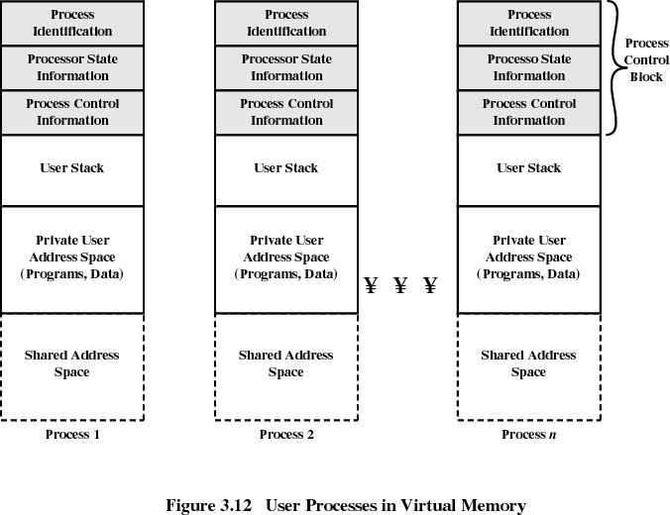

19. Client server architecture and features.
The parts of a client/server system are the client, server, and the network. The client can be a personnel computer (PC) or the soon to be released network computer (NC.) The server can be anything from a mainframe to a PC but is usually a platform suited for a specific application or task. The network could be as simple as two computers connected by modem or as complicated as several thousand computers linked by a combination of fiber optics, coaxial cable, and wireless communications. The client and server might be in the same room (possibly even the same physical machine) or half a world apart. The difference between client/server computing and the mainframe computing that it often supersedes is that the client is not a dumb terminal. The client has its own operating system and can manage inputs (keyboard, mouse, etc..) and outputs (display, local printer, sound, etc..) without the server. The server's role is to wait passively for a client to request a service. This distribution of processing allows the client to offer a more user friendly environment (graphical user interface, local applications, mouse, etc..) than a dumb terminal and allows the servers to be less complex and expensive than current mainframe systems. Overall client/server computing leads to a flexible and dynamic computing environment
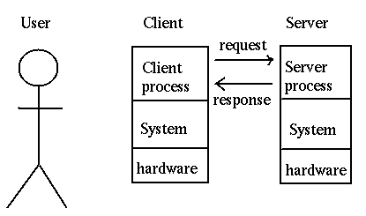

Characteristics
- Common application – Users accessing a shared database
- Differences from distributed processing:
  - User-friendly applications running on each client
    - Users have control over usage
  - Databases and network management often centralized
    - Helps maintain interoperability
    - Individual departments don’t have to worry about sophisticated servers
  - Open and modular products
    - Flexibility in mixing equipment from various vendors
  - Networking is fundamental
    - Management and security is vital

Sustainability
Client/server computing is often advertised as a low maintenance alternative to mainframe computing. This is not necessarily true. Everyone who has a PC in their home and has spent hours waiting on hold with their manufacturer's technical support knows that a PC is not as simple as taking it out of the box and plugging in the parts. Today's PC's and the software they use are very complicated. Client application errors are not repairable from a remote console, instead they require a visit from desk side support and could be caused by anything from a virus to a conflict with the screen saver program the end user brought from home. This adds a new complexity to trouble shooting that is not present in mainframe computing .
Client/server maintenance also takes on a more prominent role. Client/server computing places part or all of an applications software on the client. This means that when a change needs to be made or software updated it has to happen on every client, not just on the server. These updates are labor intensive and difficult to manage on large sites. In some cases updates can be automated such as with IBM's Netdoor software, but these innovations tend to be complicated and touchy at best. There is some hope with the anticipated network computer (NC) that this problem could be alleviated or at least diminished. This is because the NC downloads new software every time you run an application therefore the application code only has to be maintained on the server.
Client/server computing requires a change in the way a company thinks of application maintenance and technical support for the end user.
User Productivity
Productivity Client/server computing has the potential to raise the productivity of the end user. However, there are several issues that must be faced before this will happen.
The end users must be educated to use a client/server system. Client/server offers the end user the potential for high quality work and increased productivity. However, this is not possible unless the user is educated on how to increase their productivity and use the system. Users changing from mainframe to client/server have to make a significant mental paradigm shift and face a considerable learning curve. Also human nature tends to resist change and a switch to client/server is often a notable change in the way a user performs his or her job. This can lead to a resistance in learning the new system and an exaggeration of any problems that occur. This requires that the client/server system have strong management support that will help to persuade end users to adopt and learn the new system.
A client/server system must have solid education for the end users and management support to insure that it increases rather than decreases user productivity
Reliability and Security
Reliability and security is a concern for any corporate computer system. These issues require special attention when considering a change from mainframe to client/server technologies.
Security in a computing environment is also a consideration in the decisions to switch to client/server computing. Mainframes are very secure because they are generally placed in 'glass rooms' with hardened infrastructure and controlled access. Client/server systems are distributed and therefore more difficult to secure
20. What is RPC? How is it implemented?
RPC allows processes to interact using standard procedure call/return. Advantages of this scheme Procedure call widely understood, Remote interfaces can be represented as named operations with designated types – compiler can type-check, Standardized interface is more portable
Sample syntax:
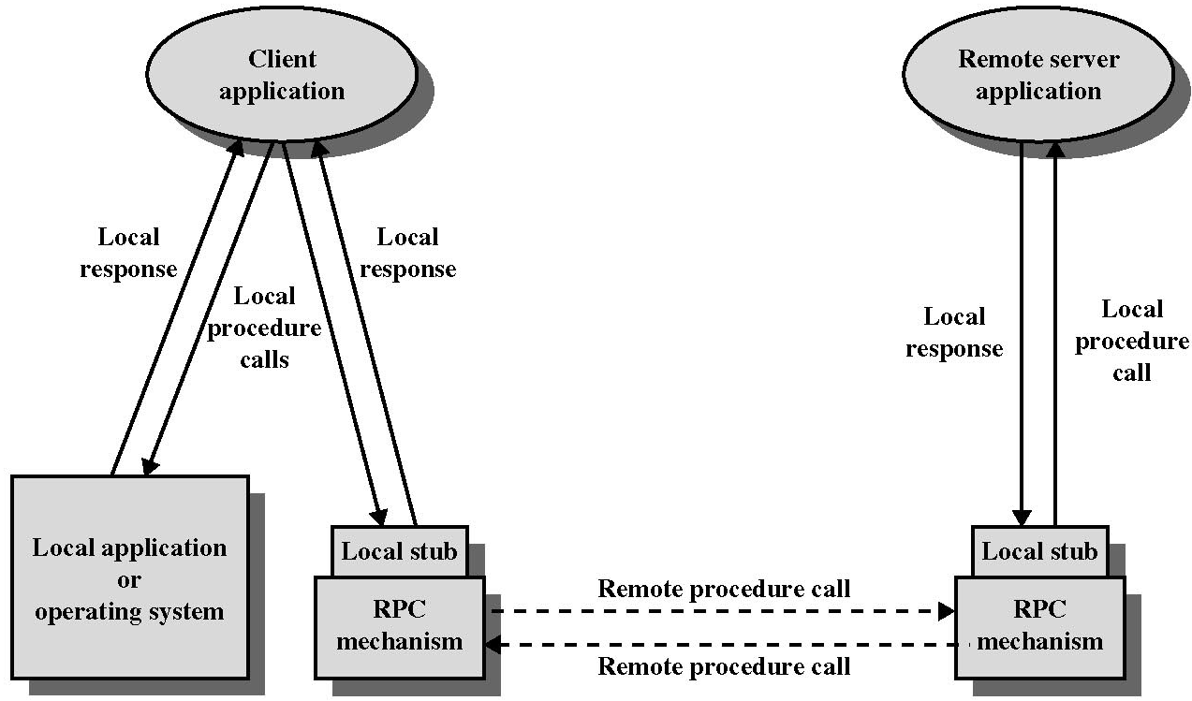Proc_name(Send_Args,Recv_Args)

Arguments are sent by value. Parameter Representation -Number/String formats may differ-Send values across network in a standard form-Each node converts to/from local form.
In order to access the remote server portion of an application, special function calls, RPCs, are embedded within the client portion of the client/server application program. Because they are embedded, RPCs do not stand alone as a discreet middleware layer. When the client program is compiled, the compiler creates a local stub for the client portion and another stub for the server portion of the application. These stubs are invoked when the application requires a remote function and typically support synchronous calls between clients and servers.
By using RPC, the complexity involved in the development of distributed processing is reduced by keeping the semantics of a remote call the same whether or not the client and server are collocated on the same system. However, RPC increases the involvement of an application developer with the complexity of the master-slave nature of the client/server mechanism.
RPC increases the flexibility of architecture by allowing a client component of an application to employ a function call to access a server on a remote system. RPC allows the remote component to be accessed without knowledge of the network address or any other lower-level information. Most RPCs use a synchronous, request-reply (sometimes referred to as "call/wait") protocol which involves blocking of the client until the server fulfills its request. Asynchronous ("call/nowait") implementations are available but are currently the exception. RPC is typically implemented in one of two ways:
- within a broader, more encompassing propriety product
- by a programmer using a proprietary tool to create client/server RPC stubs
Advantages
Remote Procedure Call (RPC) is a client/server infrastructure that increases the interoperability, portability, and flexibility of an application by allowing the application to be distributed over multiple heterogeneous platforms. It reduces the complexity of developing applications that span multiple operating systems and network protocols by insulating the application developer from the details of the various operating system and network interfaces--function calls are the programmer's interface when using RPC

