- What is real time OS?
A real time system has well defined fixed time constraints. Processing should be done within the defined constraints. Real time operating systems are used as a control device in a dedicated application such as controlling scientific experiments, medical imaging systems, industrial control systems, and some display systems. Real-Time systems are classified as hard or soft real-time.

Hard real-time
- Guarantees critical task completion on time.
- Secondary storage limited or absent, data stored in short term memory, or read-only memory (ROM)
- Conflicts with time-sharing systems, not supported by general-purpose operating systems.
- Advanced OS features are absent (e.g. virtual memory is absent).

Soft real-time
- Less restrictive.
- A critical real time task gets priority over other tasks and it retains its priority until it completes.
- Limited utility in industrial control of robotics
Useful in applications (multimedia, virtual reality, under sea explorations etc.) requiring advanced operating-system features.

- What is deadlock?
A group of processes permanently stuck waiting for each other. Essential conditions are
- Mutual Exclusion
  - Only one process can hold the resource at any given time
- Hold and Wait
  - A process may hold resources while requesting others
- No Preemption
  - No resource may be forcibly removed from a process
- Circular Wait (event)
  - A closed chain of process exists, each waiting for a resource held by the next process in the chain

3. What are threads?
A thread is a single sequence stream within in a process. Because threads have some of the properties of processes, they are sometimes called lightweight processes. In a process, threads allow multiple executions of streams. In many respect, threads are popular way to improve application through parallelism. The CPU switches rapidly back and forth among the threads giving illusion that the threads are running in parallel. Like a traditional process i.e., process with one thread, a thread can be in any of several states (Running, Blocked, Ready or Terminated). Each thread has its own stack. Since thread will generally call different procedures and thus a different execution history. This is why thread needs its own stack. An operating system that has thread facility, the basic unit of CPU utilization is a thread.
A thread has or consists of a program counter (PC), a register set, and a stack space. Threads are not independent of one other like processes as a result threads shares with other threads their code section, data section, OS resources also known as task, such as open files and signals

4. Draw the process state diagram and explain?
Five states are as follows
- new: The process is being created
- running: Instructions are being executed
- waiting: The process is waiting for some event to occur
- ready: The process is waiting to be assigned to a processor
- terminated: The process has finished execution

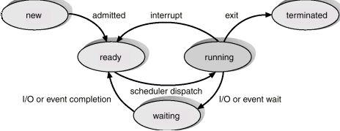
5. Difference between memory mapped I/O and I/O mapped I/O?
Memory-mapped I/O (not to be confused with memory-mapped file I/O) uses the same bus to address both memory and I/O devices, and the CPU instructions used to read and write to memory are also used in accessing I/O devices. In order to accommodate the I/O devices, areas of CPU addressable space must be reserved for I/O rather than memory. This does not have to be permanent, for example the Commodore 64 could bank switch between its I/O devices and regular memory. The I/O devices monitor the CPU's address bus and respond to any CPU access of their assigned address space, mapping the address to their hardware registers.
Port-mapped I/O uses a special class of CPU instructions specifically for performing I/O. This is generally found on Intel microprocessors, specifically the IN and OUT instructions which can read and write a single byte to an I/O device. I/O devices have a separate address space from general memory, either accomplished by an extra "I/O" pin on the CPU's physical interface, or an entire bus dedicated to I/O

6. fork() system call?
A new process is created by this. The new process is called child process and the other one parent process. The new process consists of copy of the address space of the original. It allows the parent to communicate easily with its child process. The return code for the child is zero, whereas the process identifier is returned to the parent

7. Disk cache?
Similar concept to memory cache, Use main memory to hold frequently used disk blocks. It can afford more complex algorithms due to the time factors involved. Handling a request is done as-If the data is in cache, pass it to the user (copy or use shared memory). If it is not in cache, read the disk and add it to the cache. Replacement algorithms: LRU – Can keep a list and determine the one not used for most time and LFU (least frequently used)-Account for how often it is used -Watch out for burst of uses, then idle.

8. Stub in RPC?
In order to access the remote server portion of an application, special function calls, RPCs, are embedded within the client portion of the client/server application program. Because they are embedded, RPCs do not stand alone as a discreet middleware layer. When the client program is compiled, the compiler creates a local stub for the client portion and another stub for the server portion of the application. These stubs are invoked when the application requires a remote function and typically support synchronous calls between clients and servers.

9.Distributed OS?
In distributed processors the computation is distributed among multiple processors. But to its users it appears as a uniprocessor system. Users need not bother about where their files are located or where their programs are run. The processors do not share memory, peripheral devices or a clock. Each processor has its own local memory and clock. The processors communicate with one another through various communications lines, such as high-speed buses or telephone lines. Distributed systems requires a networking interface either a LAN or WAN. The systems can be either peer to peer or client server model.

11. Features of Windows 2000 OS?
- Windows 2000 is a single user multitasking OS. Windows 2000 is highly modular – each system function is managed by just one component of the OS. Any module can be upgraded or removed without affecting the rest of the system. In Windows 2000 many functions outside the microkernel runs in kernel mode. Windows 2000 can be run on a variety of platforms.
The architecture of windows 2000 is shown below.
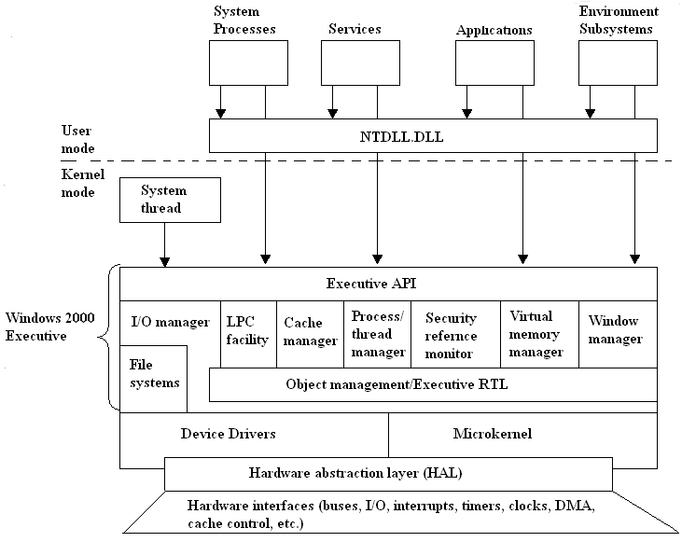
Architecture of Windows 2000
Hardware abstraction layer (HAL):
- HAL isolates the OS from platform specific hardware differences. This is done by mapping between the generic hardware commands and those specific to certain platforms.
- It makes each machines hardware look the same to the kernel.
- It gives the support needed for symmetric multiprocessing.
Microkernel:
- Most used and most fundamental components of the OS forms the microkernel.
- Kernel constitutes thread scheduling, process switching, exception and interrupt handling and multiprocessor synchronization.
- Microkernel is the only part of OS that is not preemptive or pageable.
Device Drivers:
- This includes file system and hardware device drivers.
- It translates I/O function calls into specific hardware device I/O requests.
Windows 2000 Executive:
The windows 2000 executive includes modules for specific system functions. It also provides an API for user mode software. The executive consists of the following modules:
I/O manager:
- Provides a framework through which I/O devices are accessible to applications.
- Implements all the Windows 2000 I/O APIs.
- Enforces security and naming for devices and file systems.
Object manager:
- It is responsible for the creation and deletion of Windows 2000 executive objects and ADT used to represent processes, threads and synchronization objects.
- It enforces uniform rules for naming and setting the security of objects.
- It creates object handles (object handles consists of the access control information and a pointer to the object).
Local Procedure Call facility:
- It enforces a client server relationship between the applications and executive subsystems. (The services of executive subsystems include memory services, process creation services, processor scheduling services etc.)
Cache manager:
- It causes the recently accessed disk data to reside in main memory for quick access thus improves the performance of file based I/O.
Process/thread manager:
- It tracks the process and thread objects.
Security reference monitor:
- It enforces access validation and audit generation rules for files, processes, address spaces and I/O devices.
Virtual memory manager:
- It maps virtual addresses in the process’s address space to physical addresses in the memory.
Window manager:
- It creates the windows oriented screen interface. Manages the graphics devices.
User Processes:
Windows 2000 supports four types of user processes.
Special system support processes:
This includes services not provided as part of Windows 2000 OS. Examples are logon process, session manager etc.
Server Processes:
This includes Windows 2000 services such as event logger.
Environment subsystems:
This system is responsible for exposing the Windows 2000 services to user applications. It includes DLLs that converts the user application calls to Windows 2000 calls.
User applications:
This includes the application programs.

12. What are critical section problem?
Each process has a segment of code called critical section, where it can change common variables, updating table etc. While one process is executing in this section, others are not allowed. The critical section problem is to design a protocol that processes can use to cooperate.

Solutions to Critical Section problem

1. Mutual Exclusion - If process Pi is executing in its critical section, then no other processes can be executing in their critical sections

2. Progress - If no process is executing in its critical section and there exist some processes that wish to enter their critical section, then the selection of the processes that will enter the critical section next cannot be postponed indefinitely

3. Bounded Waiting - A bound must exist on the number of times that other processes are allowed to enter their critical sections after a process has made a request to enter its critical section and before that request is granted
  - Assume that each process executes at a nonzero speed
  - No assumption concerning relative speed of the N processes
Two process solution

- Assume that the LOAD and STORE instructions are atomic; that is, cannot be interrupted.
- The two processes share two variables:
  - int turn;
  - Boolean flag[2]
- The variable turn indicates whose turn it is to enter the critical section.
- The flag array is used to indicate if a process is ready to enter the critical section. flag[i] = true implies that process Pi is ready!

Algorithm for process P

while (true) {
flag[i] = TRUE;
turn = j;
while ( flag[j] && turn == j);

CRITICAL SECTION

flag[i] = FALSE;

REMAINDER SECTION
}

Synchronization hardware

- Many systems provide hardware support for critical section code
- Uniprocessors – could disable interrupts
  - Currently running code would execute without preemption
  - Generally too inefficient on multiprocessor systems
    - Operating systems using this not broadly scalable
- Modern machines provide special atomic hardware instructions
    - Atomic = non-interruptable
  - Either test memory word and set value
  - Or swap contents of two memory words

Test and set instruction

Definition

boolean TestAndSet (boolean *target)
{
boolean rv = *target;
*target = TRUE;
return rv:
}

Solution using TestAndSet

- Shared boolean variable lock., initialized to false.
- Solution:

while (true) {
while ( TestAndSet (&lock ))
; /* do nothing

// critical section

lock = FALSE;

// remainder section

}

SWAP instruction

- Definition:

void Swap (boolean *a, boolean *b)
{
boolean temp = *a;
*a = *b;
*b = temp:
}

Solution using swap instruction

- Shared Boolean variable lock initialized to FALSE; Each process has a local Boolean variable key.
- Solution:
while (true) {
key = TRUE;
while ( key == TRUE)
Swap (&lock, &key );

// critical section

lock = FALSE;

// remainder section

}

13. Memory management in windows?
In a paged system, there are fixed-size blocks of memory called pages that are allocated to a process. A memory reference consists of a page number and an offset within the page. The memory management unit (MMU) uses the virtual page number to look up the physical page number. Because the virtual address space can be quite large, the look-up usually involves hashing, and possibly additional search. However, only one piece of an address is needed as the look-up key.
With a paged system, there is one address space and every reference must be checked to ensure that it refers to a page that has been allocated to the current process. The operating system allocates pages from this one address space as needed. The operating system can swap out a subset of the pages that are allocated to a process and bring them into memory when they are needed again. The down side is that a process can get into a pattern of access where it is frequently page-faulting and starts to operate at disk access speeds.
Because the pages are fixed in size, they may be only partially used. This internal fragmentation was a significant problem when machine memories were tiny, but is now negligible. However, it lead to the notion of segmentation as an alternative that avoids internal fragmentation.
Memory is divided into fixed-size blocks called pages. Main memory contains some number of pages (memory size / page size), which is smaller than the number of pages in the virtual address space (virtual address range / page size).
For example, if the page size is 4K and the physical memory is 256M (64K pages) and the virtual memory is 4G (1 M pages) then there is a factor of 16 to 1 mapping.
In order to perform the mapping function, a table lookup is employed. A page table is kept with one entry per virtual page. (In reality, a 1M entry table would not be used -- parts of it would also be mapped in virtual memory, and in may cases those pages would never be stored anywhere because they would never be accessed.)
A page table entry might have the following form:
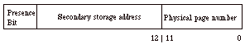
The Presence Bit indicates whether the physical page is in main memory or must be fetched from secondary storage (a page fault). The secondary storage address is used to locate the data on disk. Physical page address is substituted for the virtual page address as a result of the lookup.
A virtual address takes the following form for a page of 4K words:
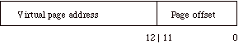
The page offset (low order 12 bits) is the location of the desired word within a page. The Presence Bit indicates whether the physical page is in main memory or must be fetched from secondary storage (a page fault).
Thus, the virtual address translation hardware appears as follows:
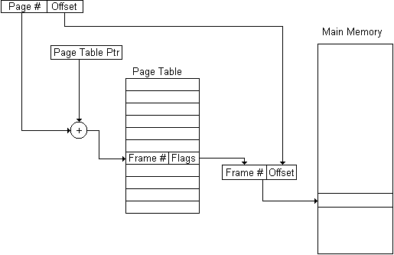

The virtual address from the CPU is split into the offset and page number. The page number becomes the index into the table (requiring a shift and an add of the base address of the table to get a proper address).The table entry is fetched, starting with the presence bit and the physical page. When the presence bit indicates that the page is in main memory, it simply substitutes the physical page from the table for the virtual page portion of the address. When the presence bit indicates that the page is not in main memory, it triggers a page fault exception, and the OS must initiate the disk transfer that brings the page into memory.
While a disk transfer is in progress, the OS my cause another task to execute or it may simply stall the current task and sit idle. In either case, once the transfer is complete, the OS stores the new physical page number into the page table and jumps back to the instruction causing the page fault so that the access can be reissued.
Thus, any virtual page may be stored at any physical page location and the addressing hardware performs the translation automatically.
A page table can also contain privilege information consisting of an owner process ID and level of access. On any access, the current process ID in the program status word is checked against the owner process ID portion of the page table entry and if there is a match and the type of access (read vs. write) is allowed, then the access proceeds. Otherwise an access privilege violation exception is signaled.
Pages are usually loaded in this manner, which is called "on demand". However, schemes have also been devised in which the historical behavior of a task is recorded, and when the task is suspended, its working set of pages is reloaded before it restarts.

14. What is an inode? Unix file structure?
- Four types distinguished:
  - Ordinary
  - Directory
  - Special (devices, etc.)
  - Named Pipes

For each object in the filesystem, UNIX stores administrative information in a structure known as an inode. Inodes reside on disk and do not have names. Instead, they have indices (numbers) indicating their positions in the array of inodes.
Each inode generally contains:
- The location of the item's contents on the disk, if any
- The item's type (e.g., file, directory, symbolic link)
- The item's size, in bytes, if applicable
- The time the file's inode was last modified (the ctime)
- The time the file's contents were last modified (the mtime)
- The time the file was last accessed (the atime) for read ( ), exec ( ), etc
- A reference count: the number of names the file has
- The file's owner (a UID)
- The file's group (a GID)
The file's mode bits (also called file permissions or permission bits)

15. Classify disk scheduling algorithms?

If we have a number of requests, what order do we do them is determined by the following algorithms
- Random
  - Select a random request to do next
  - Useful for comparisons
- FIFO
  - Do in the order they arrive. Fair in that all requests are honored. Poor performance if requests are not clustered. Especially true in multiprogramming systems
- Priority
  - Do operations for high-priority processes first. Disk utilization not the top goal. Users may try to exploit priorities
- LIFO (Last-In First-Out)
  - Always take the most recent request. Hope to catch a sequence of reads at one time. Runs risk of starvation
- SSTF (Shortest Service Time First)
  - Select the read closest to the current track next. Requires knowledge of arm position. Also has risk of starvation
- SCAN
  - Arm moves in one direction, meeting all requests en route. If no more requests, switch directions. Bias against track just traversed will miss locality in the wrong direction
- CSCAN
  - Always scan in one direction. If no more requests, move to far end and start over. Reduces time for requests on edges
- N-step Scan
  - Prevent one track from monopolizing disk. Have subqueues of size N
  - Use SCAN for each subqueue.
- FSCAN
  - When one scan begins, only existing requests are handled. New requests are put on a secondary queue. When a scan ends, take the queue entries and start a new scan
16. Client server architecture
The parts of a client/server system are the client, server, and the network. The client can be a personnel computer (PC) or the soon to be released network computer (NC.) The server can be anything from a mainframe to a PC but is usually a platform suited for a specific application or task. The network could be as simple as two computers connected by modem or as complicated as several thousand computers linked by a combination of fiber optics, coaxial cable, and wireless communications. The client and server might be in the same room (possibly even the same physical machine) or half a world apart. The difference between client/server computing and the mainframe computing that it often supersedes is that the client is not a dumb terminal. The client has its own operating system and can manage inputs (keyboard, mouse, etc..) and outputs (display, local printer, sound, etc..) without the server. The server's role is to wait passively for a client to request a service. This distribution of processing allows the client to offer a more user friendly environment (graphical user interface, local applications, mouse, etc..) than a dumb terminal and allows the servers to be less complex and expensive than current mainframe systems. Overall client/server computing leads to a flexible and dynamic computing environment
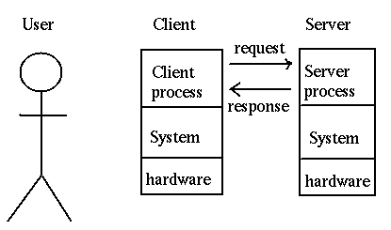

Characteristics
- Common application – Users accessing a shared database
- Differences from distributed processing:
  - User-friendly applications running on each client
    - Users have control over usage
  - Databases and network management often centralized
    - Helps maintain interoperability
    - Individual departments don’t have to worry about sophisticated servers
  - Open and modular products
    - Flexibility in mixing equipment from various vendors
  - Networking is fundamental
    - Management and security is vital

Sustainability
Client/server computing is often advertised as a low maintenance alternative to mainframe computing. This is not necessarily true. Everyone who has a PC in their home and has spent hours waiting on hold with their manufacturer's technical support knows that a PC is not as simple as taking it out of the box and plugging in the parts. Today's PC's and the software they use are very complicated. Client application errors are not repairable from a remote console, instead they require a visit from desk side support and could be caused by anything from a virus to a conflict with the screen saver program the end user brought from home. This adds a new complexity to trouble shooting that is not present in mainframe computing .
Client/server maintenance also takes on a more prominent role. Client/server computing places part or all of an applications software on the client. This means that when a change needs to be made or software updated it has to happen on every client, not just on the server. These updates are labor intensive and difficult to manage on large sites. In some cases updates can be automated such as with IBM's Netdoor software, but these innovations tend to be complicated and touchy at best. There is some hope with the anticipated network computer (NC) that this problem could be alleviated or at least diminished. This is because the NC downloads new software every time you run an application therefore the application code only has to be maintained on the server.
Client/server computing requires a change in the way a company thinks of application maintenance and technical support for the end user.
User Productivity
Productivity Client/server computing has the potential to raise the productivity of the end user. However, there are several issues that must be faced before this will happen.
The end users must be educated to use a client/server system. Client/server offers the end user the potential for high quality work and increased productivity. However, this is not possible unless the user is educated on how to increase their productivity and use the system. Users changing from mainframe to client/server have to make a significant mental paradigm shift and face a considerable learning curve. Also human nature tends to resist change and a switch to client/server is often a notable change in the way a user performs his or her job. This can lead to a resistance in learning the new system and an exaggeration of any problems that occur. This requires that the client/server system have strong management support that will help to persuade end users to adopt and learn the new system.
A client/server system must have solid education for the end users and management support to insure that it increases rather than decreases user productivity
Reliability and Security
Reliability and security is a concern for any corporate computer system. These issues require special attention when considering a change from mainframe to client/server technologies.
Security in a computing environment is also a consideration in the decisions to switch to client/server computing. Mainframes are very secure because they are generally placed in 'glass rooms' with hardened infrastructure and controlled

17. RPC?
18. PCB?

Refer the previous question paper

