VIRTUAL MEMORY
Memory management strategies like paging and segmentation help implement the concept of multiprogramming. But they have a few disadvantages. One problem with the above strategies is that they require the entire process to be in main memory before execution can begin. Another disadvantage is the limitation on the size of the process. Processes whose memory requirement is larger than the maximum size of the memory available will never be able to be run that is users are desirous of executing processes whose logical address space is larger than the available physical address space.
Virtual memory is a technique that allows execution of processes that may not be entirely in memory. Also virtual memory allows mapping of a large virtual address space onto a smaller physical memory. It also raises the degree of multiprogramming and increases CPU utilization. Because of the above features, users are freed from worrying about memory requirements and availability.

WHY WE NEED VIRTUAL MEMORY?
Every process needs to be loaded into physical memory for execution. One brute force approach to this is to map the entire logical space of the process to physical memory as in the case of paging and segmentation.
Many a time the entire process need not be in memory during execution. The following are some of the instances to substantiate the above statement:
- Code used to handle error and exceptional cases are executed only in case errors and exceptional conditions occur which is usually a rare occurrence may be one or no occurrences in an execution.
- Static declarations of arrays lists and tables declared with a large upper bound but used with no greater than 10% of the limit.
- Certain features and options provided in the program as a future enhancement, never used, as enhancements are never implemented.
- Even though entire program is needed, all its parts may not be needed at the same time because of overlays.
All the examples show that a program can be executed even though it is partially in memory. This scheme also has the following benefits:
- Physical memory is no longer a constraint for programs and therefore users can write large programs and execute them
- Physical memory required for a program is less. Hence degree of multiprogramming can be increased because of which utilization and throughput increase.
- I/O time needed for load / swap is less.

Virtual memory is the separation of logical memory from physical memory. This separation provides a large logical / virtual memory to be mapped on to a small physical memory (Figure 1).
Page 1
Page 2
Page 4
Page n
Frame
Frame 2
Frame 3
Frame m

Page 3

Memory map Physical Memory
Virtual memory
Figure 1: Virtual to physical memory mapping (n >> m)

Virtual memory is implemented using demand paging. Also demand segmentation could be used. A combined approach using a paged segmentation scheme is also available. Here user view is segmentation but the operating system implements this view with demand paging.

DEMAND PAGING
Demand paging is similar to paging with swapping (Figure 2).
1
2
3
4
5
6
7
8
9

Swap out

Swap in

Figure 2: Paging with swapping

When a process is to be executed then only that page of the process, which needs to be currently executed, is swapped into memory. Thus only necessary pages of the process are swapped into memory thereby decreasing swap time and physical memory requirement. The protection valid-invalid bit which is used in paging to determine valid / invalid pages corresponding to a process is used here also (Figure 3).
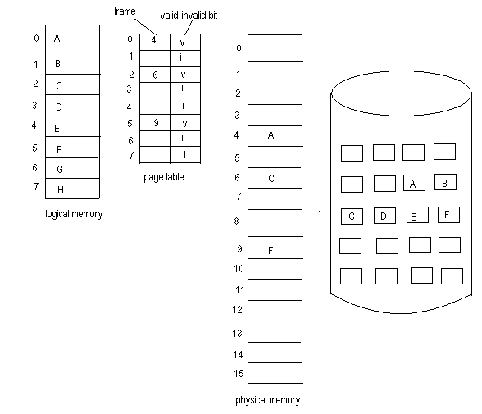Figure 3: Demand paging with protection
If the valid-invalid bit is set then the corresponding page is valid and also in physical memory. If the bit is not set then any of the following can occur:
- Process is accessing a page not belonging to it; i.e. an illegal memory access.
- Process is accessing a legal page but the page is currently not in memory.
If the same protection scheme as in paging is used, then in both the above cases a page fault error occurs. The error is valid in the first case but not in the second because in the latter a legal memory access failed due to non-availability of the page in memory which is an operating system fault. Page faults can thus be handled as follows (Figure 4):

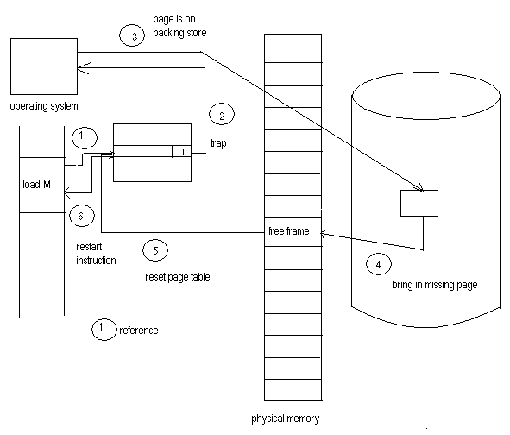
Figure 4: Handling a page fault
- Check the valid-invalid bit for validity.
- If valid then the referenced page is in memory and the corresponding physical address is generated.
- If not valid then an addressing fault occurs.
- The operating system checks to see if the page is in the backing store. If present then the addressing error was only due to non-availability of page in main memory and is a valid page reference.
- Search for a free frame.
- Bring in the page into the free frame.
- Update the page table to reflect the change.
- Restart the execution of the instruction stalled by an addressing fault.
In the initial case, a process starts executing with no pages in memory. The very first instruction generates a page fault and a page is brought into memory. After a while all pages required by the process are in memory with a reference to each page generating a page fault and getting a page into memory. This is known as pure demand paging. The concept never brings in a page into memory until it is required.
Hardware required to implement demand paging is the same as that for paging and swapping.
- Page table with valid-invalid bit
- Secondary memory to hold pages not currently in memory, usually a high speed disk known as a swap space or backing store.
A page fault at any point in the fetch-execute cycle of an instruction causes the cycle to be repeated.

