RAJAGIRI SCHOOL OF ENGINEERING
AND TECHNOLOGY
Rajagiri Valley, Kochi -39



R606 –Algorithm Analysis & design
MODULE II

Prepared by
Preetha K G

INDEX

Introduction to Divide and Conquer
  - Control Abstraction
  - Binary Search
  - Merge Sort
  - Quick Sort
  - Finding Maximum and Minimum
  - Divide and Conquer Matrix Multiplication
  - Strassen’s Matrix Multiplication

Introduction to Divide and Conquer
It works by recursively breaking down a problem into two or more sub-problems of the same (or related) type, until these become simple enough to be solved directly.
  - Divide the problem into sub-problems that are similar to the original but smaller in size
  - Conquer the sub-problems by solving them recursively. If they are small enough, just solve them in a straightforward manner.
  - Combine the solutions to create a solution to the original problem
  - Control Abstraction
Control abstraction is a procedure whose flow of control is clear but primary operations are specified by other functions whose precise meaning is undefined. This gives a way an algorithm based on divide and conquer will look.
DAndC (P)
{
if Small(P) return S(P);
else
{
divide P into smaller instances P₁, P₂,…,P_{k} k1;
apply DandC to each of these sub problems;
retun Combine(DandC(P₁), DandC(P₂),…,DandC(P_{k}));
}
}

Small(p) is a boolean valued function that determines whether the size of the problem is small enough to solve without splitting. If so function S is invoked otherwise problem is divided into sub problems p1,p2,……pk and are solved by recursive applications of D AndC. Combine is a function that determines the solution to p using the solution to the k subproblems. If the size of p=n divide into k subproblems n1,n2,……nk respectively then the computing time of DandC is described by the recurrence relation
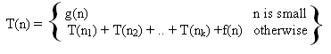
g(n) – time to computer answer directly from small inputs.
f(n) – time for dividing P and combining solution to sub problems

Time complexity of many divide and conquer algorithm is given by recurrence of the form
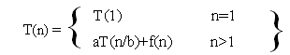
a and b are constatnts, T(1) is known and n is the power of 2.

2.2 Binary Search
Problem: Given a list of n sorted elements a_{i}, 1≤ i ≤ n sorted in ascending order. Check whether an element x is present in the list or not. If present, find the position of x in the list else return zero.
P(n, a_{i},….,a_{l}, x) denote an instance of the problem.
where n : no of elements
a_{i},….,a_{l}: elements in the list
x : number to be searched

Divide and conquer can be used for solving this problem. Let Small(p) is true if n=1.
S(P) will take the value of I if x=ai. Otherwise 0. Then g(1)=O(1).
If P has more than one element divided into sub problems. If P has more than one element, divide the problem into sub problems as given below
- Pick an index 1 in the range [i, l]
- Compare x with a_{q}
- x = a_{q}, solved
- x < a_{q}, search x in sub list a_{i}, a_{i+1}, … , a_{q-1} . Then P = (q-i, a_{i},….,a_{q-1}, x)
- x > a_{q}, search x in sub list a_{q+1}, a_{q+2}, … , a_{l} . Then P = (l-q, a_{q+1},….,a_{l}, x)
This division takes O(1) time. After comparing remaining can be solved by using the same method. q is selected such that
q = .Answer to new sub problem is the answer to the original problem P. So no need for combine function.
Program
int BinSearch (int a[], int n, int x)
{
int low=1, high=n, mid;
while (low <= high)
{
mid = (low + high)/2;
if (x < a[mid])
high = mid – 1;
else if (x > a[mid])
low = mid + 1;
else
return (mid);
}
return (0);
}

Simulation

Consider 10 elements 10, 20, 30, 40, 50, 60, 70, 80, 90, 100
Number of comparison needed to search element is as per the table given below
Position | 1 | 2 | 3 | 4 | 5 | 6 | 7 | 8 | 9 | 10
Element | 10 | 20 | 30 | 40 | 50 | 60 | 70 | 80 | 90 | 100
No. of comparisons required | 3 | 2 | 3 | 4 | 1 | 3 | 4 | 2 | 3 | 4

No element requires more than 4 comparisons.
Average comparison=29/10=2.9 (for successful search)

The binary decision tree for the above list of elements will be as given below.
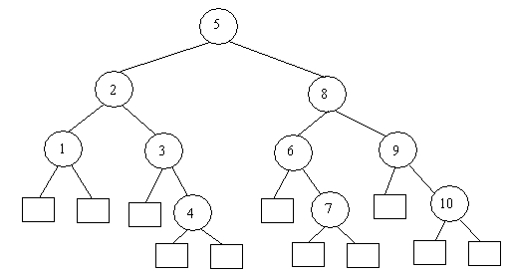
If the element is present, then search end in a circular node (inner node), if the element is not present, then it end up in a square node (leaf node)
There are 11 possible ways that an unsuccessful search may terminate depends on value of x.
If element is present, search ends at circular node and if the element is not present search ends at square node.

Average comparison= (3x5+6x4)/11=3.6(Unsuccessful search)
Now we will consider the worse case, average case and best case complexities of the algorithm for a successful and an unsuccessful search.
Worse Case
If 2^{k-1} <= n <= 2^{k} then all circular nodes at level1,2,….k and all square nodes at levels k and k+1. Root at level 1.
Then for a successful search, it will end up in either of the k inner nodes. Hence the complexity is O(k), which is equal to O(log₂n).
For an unsuccessful search, it need either k-1 or k comparisons. Hence complexity is Θ (k), which is equal to Θ(log₂n).
Average Case
Let I (Internal path length) and E ( External path length) represent the sum of distance of all internal nodes from root and sum of distance of all external nodes from the root respectively.
E = I + 2n
Number of element comparison to terminate at circular node at level i is i.
Number of element comparison to terminate at square node at level i is i-1.
Let A_{s}(n) and A_{u}(n) represents average case complexity of a successful and unsuccessful search respectively. Then
Let A_{s}(n) is the number of comparisons needed to find an element represented by an internal node is more than the distance of the node from the root.
A_{s}(n) = 1 + I/n
Let A_{u}(n) is the number of comparisons needed to find an element represented by an external node.
A_{u}(n) = E / (n+1)
A_{s}(n) = 1 + I/n
= 1 + (E-2n)/n
= 1 + (A_{u}(n)(n+1) – 2n)/n
= (n + (A_{u}(n)(n+1) – 2n))/n
= (n(A_{u}(n) -1) + A_{u}(n))/n
= A_{u}(n) – 1 + A_{u}(n)/n
A_{s}(n) = A_{u}(n)(1+1/n) - 1
A_{s}(n) and A_{u}(n) are directly related and are proportional to log₂n.
Hence the average case complexity for a successful and unsuccessful search is O(log₂n)
Best Case
Best case for a successful search - there is only one comparison (element at middle)
Hence complexity is Θ(1)
Best case for an unsuccessful search is O(log₂n)
 | Best Case | Average Case | Worse Case
Successful Search | Θ(1) | O(log₂n) | O(log₂n)
Unsuccessful Search | O(log₂n) | O(log₂n) | O(log₂n)

2.3 Merge Sort
Problem: Given a sequence of n elements a[1],...,a[n]. Sort this list in ascending order.
Spilt into two sets
Each set is individually sorted, resultant is merged to form sorted list of n elements
Program
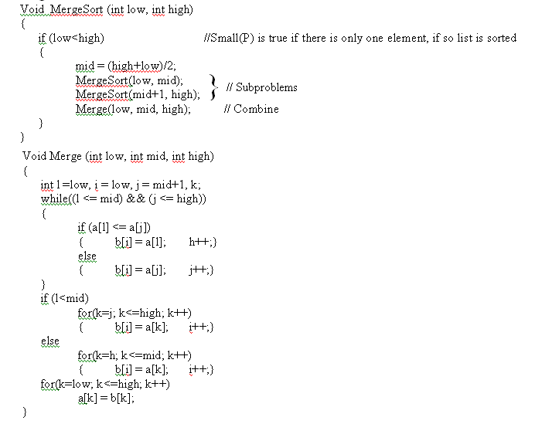

Consider 10 elements 310, 285, 179, 652, 351, 423, 861, 254, 450 and 520. The recursive call can be represented using a tree as given below.
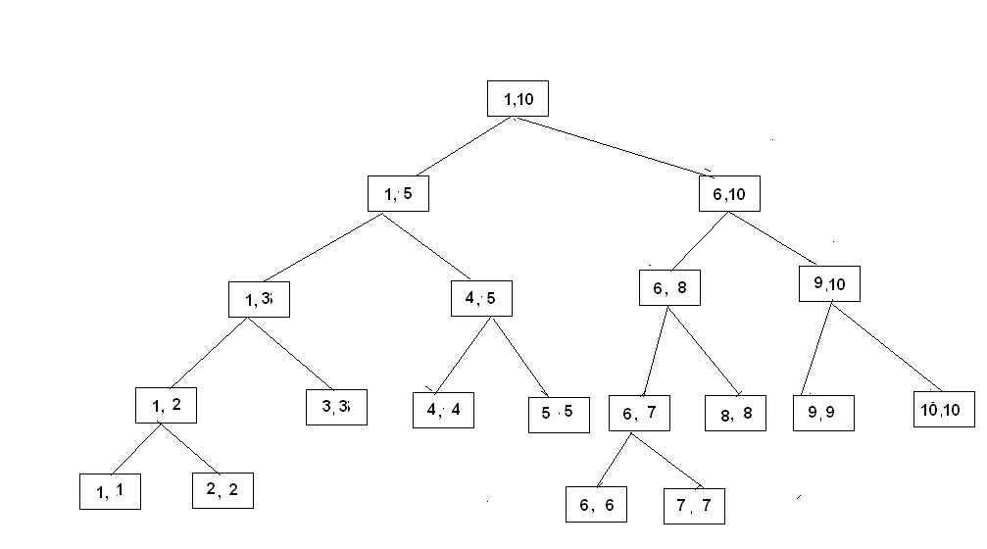
The recurrence relation for the algorithm can be written as
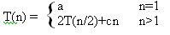
When n is power of 2, we can write n = 2^{k}
T(n) = 2(T(n/4) + cn/2) + cn
= 4T(n/4) + 2cn
= 4(2T(n/8) + cn/4) + 2cn
= …
= 2^{k}T(1) + kcn
T(n) = an + cnlogn
If 2^{k}<n≤2^{k+1} , T(n)≤T(2^{k+1})
T(n) = O(nlogn)

2.4 Quick Sort
Problem: Given a sequence of n elements a[1],...,a[n]. Sort this list in ascending order.
Divide the list into two sub arrays and sorted so that the sorted sub arrays need not be merged later. This is done by rearranging elements in the array such that a[i]<=a[j] for 1≤i≤m and m+1≤j≤n, 1≤m≤n.
This rearrangement is done by picking an element, m=a[s], reorder other elements so that all elements appearing before t is less than or equal to m, all elements after m is greater than or equal to m. This rearranging is called partitioning.
Program
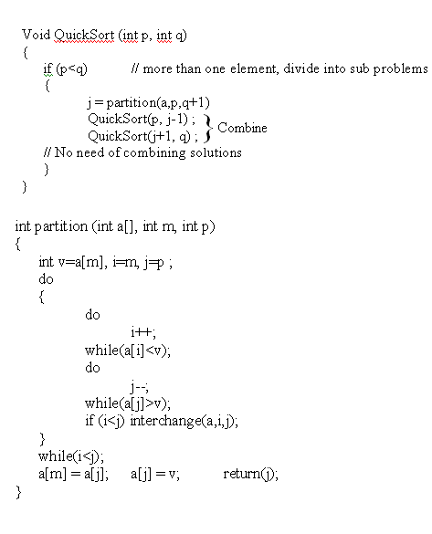

Example:

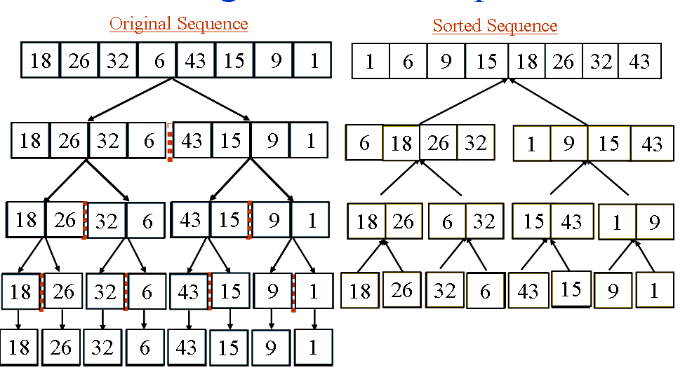
In analyzing quick sort we count only element comparisons. Assume that n elements are distinct and the distribution is such that there is equal probability for any element to get selected for partitioning.
Worse case complexity
Assume that each time after fixing an element the file is divided into a smaller partition and a bigger partition. Say, during i^{th} partition it is divided into 1 and (i-1).
No. of comparison = n + (n-1) + (n-2) + … + 2
= n(n+1)/2 – 1
= O(n²)
Average case complexity
The partitioning element has equal probability of becoming the i^{th} smallest element, 1≤ i≤ p-m in the array a[m:p-1].
Hence probability for sub arrays being sorted, a[m:j], a[j+1:p-1]is 1/(p-m), m≤j<p.
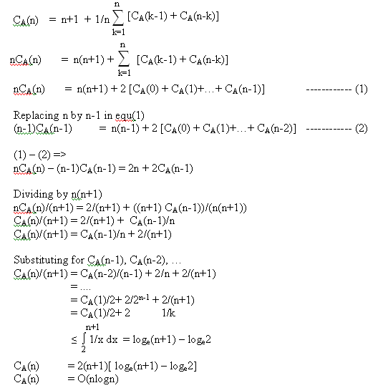

2.5 Finding Maximum and Minimum
Problem: Given a list of n elements a_{i}, 1≤ i ≤ n, find the maximum and the minimum element from the list.
Given below is a straight forward method to calculate the maximum and minimum from the list of n elements.

Void StraightMinMax (int a[], int n, int *max, int *min)
{
int i;
*max = a[0];
*min = a[0];
for (i=1; i<n; i++)
{
if (a[i] > *max) *max = a[i];
if (a[i] < *min) *min = a[i];
}
}
In analyzing the time complexity of the algorithm, only element comparisons are considered, because the frequency counts of other operations are same as that of element comparison.
2(n-1) comparisons are required for worse, average and best case.
But if we modify the code as
if(a[i] > *max) *max = a[i];
else if (a[i]<min) *min = a[i];
Then Best case complexity is (n-1), it happens when elements are sorted in increasing order.
Worse case complexity is 2(n-1), when elements are sorted in decreasing order
Average case complexity is (2(n-1)+ (n-1))/2 = 3(n-1)/2
Divide and conquer algorithm can be used for this problem.
P = (n, a[i],….,a[j])
where n : no of elements
a[i],….,a[j]: elements in the list
Small(P) is true when n<=2.
When n=1, max = min = a[1].
When n=2, the problem can be solved in one comparison
If there are more elements, then we have to divide the problem into sub problems. So divide the problem into two instances,
To solve the problem, invoke Divide and Conquer algorithm recursively. Combine solution for P₁ and P₂.
Set Max(P) as larger among Max(P₁) and Max(P₂) and Min(P) as smaller among Min(P₁) and Min(P₂).
Program
Void MaxMin (int i, int j, int *max, int *min)
{
if (i==j)
{
*max = a[i];
*min = a[i];
}
else if (i == j-1)
{
if (a[i] < a[j])
{
*max = a[j];
*min = a[i];

}
else
{
*max = a[i];
*min = a[j];

}
}
else
{
mid = (i+j)/2;
MaxMin (i, mid, *max, *min);
MaxMin (mid+1, j, *max1, *min1);
if (*max < *max1) *max = *max1;
if (*min > *min1) *min = *min1;
}
}
Example:
a[1] a[2] a[3] a[4] a[5] a[6] a[7] a[8] a[9]
22 13 -5 -8 15 60 17 31 47
The recursive call can be represented using a tree as given below
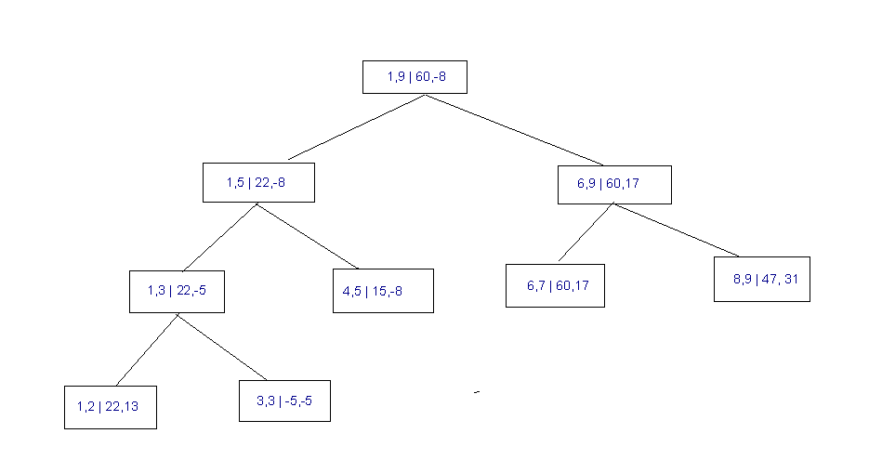
The maximum and minimum of a[1] and a[2] is 22 and 13. The maximum and minimum of a[3] and a[3] is -5 and -5. Thus the maximum and minimum of a[1], a[2] and a[3] is 22 and -5 and so on. Finally we get the maximum and minimum of the given array as 60 and -8
Time complexity can be represented by the recurrence
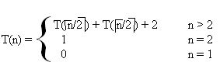
If n is a power of two, n = 2^{k}
T(n) = 2T(n/2) + 2
= 2 (2T(n/4) + 2) + 2
= 4T(n/4) + 4 + 2
= ...
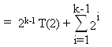
= 2^{k-1}+ 2^{k} -2
= 2^{k-1}+ n -2
= n/2 + n – 2
T(n) = 3n/2 – 2 (Best, average, Worst)
Comparing with the Straight forward method, Divide and Conquer is 50% more faster. But additional stack space is required for recursion.
If we include position comparison also, while calculating complexity. For this rewrite Small(P) as
if (i >= j-1) (Small(P)}
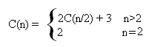
C(n) = 2C(n/2) + 3
= 4C(n/4) + 6 + 3
= 4C(n/4) + 3(1+2)
= ...
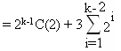
= 2^{k-1.}2 + 3[2^{k-1}-2]
= 2^{k} + 3.2^{k-1}-3
= n + 3.n/2 – 3
C(n) = 5n/2 – 3
While using StraightMinMax, the comparison is 3(n-1) which is greater than 5n/2–3. Even though the element comparison is less for MaxMin, it is slower than normal method because of the stack.
Both algorithm having the complexity O(n).
If element comparison is costlier than the index comparison divide and conquer is good else otherwise is good.
  - Divide and Conquer Matrix Multiplication
Let A and B are two nxn matrices. Suppose we want to multiply these two matrices A x B = C.
Algorithm
void matrix_mult (){
for (i = 1; i <= N; i++) {
for (j = 1; j <= N; j++) {
compute Ci,j;
}
}}
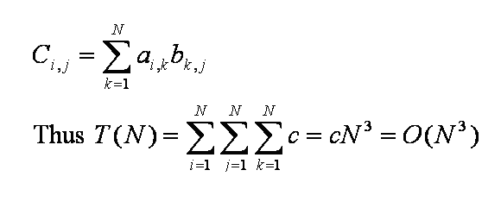
For this matrix multiplication divide and conquer method can be used. Assume n is the power of 2. If not add enough zeros to make power of two.
Given two matrices A and B of size nXn.
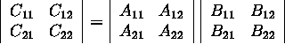
C11 = a11b11 + a12b21
C12 = a11b12 + a12b22
C21 = a21b11 + a22b21
C22 = a21b12 + a22b22
If n=2 we can use the above formula. If n>2 calculate product by recursively using the same formula. Multiplication, addition operation applied to matrices of size n/2Xn/2. This algorithm will continue applying itself to smaller- sized sub matrices until n becomes small (n=2). So the product is computed directly.
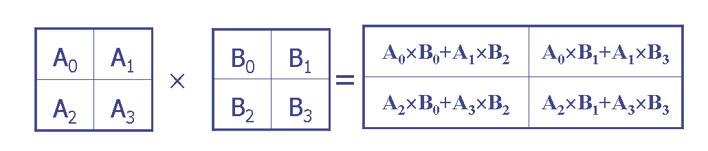
2x2 matrix multiplication can be accomplished in 8 multiplications and 4 additions.
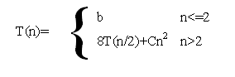
Where a and b are constants.
T(n)= O(n³)
In the above method no improvement has been made.
  - Strassen's Matrix Multiplication
Volkar Strassen discovered a way to compute 2x2 matrix multiplication can be accomplished in 7 multiplication and 18 additions or subtractions.
Consider the follwing example.
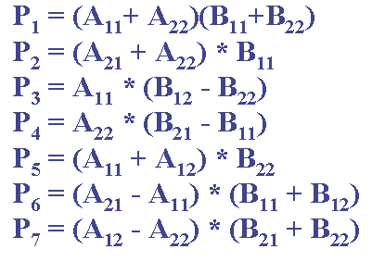
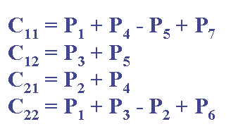
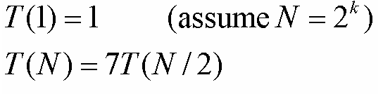
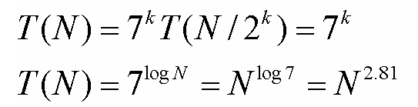
So T(n)=O(n^{2.81})

