RT604 Name …………………
Register No ………….

RAJAGIRI SCHOOL OF ENGINEERING AND TECHNOLOGY
B.TECH DEGREE FIRST INTERNAL EXAMINATION, FEB 2009

S6 CS (α, β), IT
COMPUTER NETWORKS

Time: 2 hours Maximum Marks: 50

Answer all questions

PART A
(All questions carry 3 marks each)
- Draw the block diagram of TCP/IP reference model and explain the functions of each block.

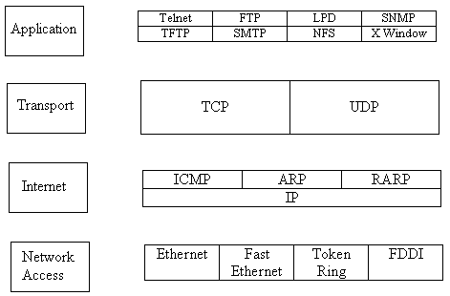

Layers of the TCP/IP model are defined as follows:
Application layer
In TCP/IP the Application Layer also includes the OSI Presentation Layer and Session Layer. This includes all of the processes that involve user interaction. The application determines the presentation of the data and controls the session. In TCP/IP the terms socket and port are used to describe the path over which applications communicate. There are numerous application level protocols in TCP/IP, including Simple Mail Transfer Protocol (SMTP) and Post Office Protocol (POP) used for e-mail, Hyper Text Transfer Protocol (HTTP) used for the World-Wide-Web, and File Transfer Protocol (FTP). Most application level protocols are associated with one or more port number.
Transport layer
Between the Internet layer and Application layer of the TCP/IP architecture model is the Transport Layer. This layer has two primary protocols, the Transmission Control Protocol (TCP) and the User Datagram Protocol (UDP). TCP is a connection based protocol that provides error detection and correction with reliable delivery of data packets. UDP is a connectionless protocol with low overhead. When writing application software a developer normally chooses TCP or UDP based on whether it is more important to have a reliable connection with bi-directional communication and error management, or if it is more important to develop a low overhead, streamlined application.
Internet Layer
The Internet Layer of the TCP/IP architecture model resides just above the Network Access Layer and below the Transport Layer. The primary concern of the protocol at this layer is to manage the connections across networks as information is passed from source to destination. The Internet Protocol (IP) is the primary protocol at this layer of the TCP/IP architecture model. IP is a connectionless protocol. This means it does not use a handshake to provide end-to-end control of communications flow. It relies on other layers to provide this function if it is required. IP also relies on other layers to provide error detection and correction. Because of this IP is sometimes referred to as an unreliable protocol since it does not perform the error checking and correcting functions.
The functions that IP performs include:
- Defining a datagram and an addressing scheme
- Moving data between transport layer and network access layer protocols
- Routing datagram to remote hosts
- The fragmentation and reassembly of datagram
The only other protocol that is generally described as being at the Internet Layer of the TCP/IP model is the Internet Control Message Protocol (ICMP), a protocol used to communicate control messages between IP systems.

Network Access Layer (Host to Network Layer)
The Network Access layer is the lowest level of the TCP/IP protocol hierarchy. It is often ignored by users as it is well hidden by the mid-level protocols such as IP, TCP, and UDP, and higher level protocols such as SMTP, HTTP, and FTP. Functions performed at the network access layer include encapsulation of IP datagram into frames to be transmitted by the network, and mapping IP addresses to physical hardware addresses.
Much of the work that takes place at the network access layer is handled by software applications and drivers that are unique to individual pieces of hardware. Configuration often consists of simply selecting the appropriate driver for loading, and selecting TCP/IP as the protocol for use. Many computers come with this driver software pre-loaded and configured, or can automatically configure themselves via "plug-and-play" applications.

- Explain in detail about any three transmission media used by the physical layer of a computer network.

Coaxial Cable
Coaxial cable consists of two conductors. The inner conductor is held inside an insulator with the other conductor woven around it providing a shield. An insulating protective coating called a jacket covers the outer conductor.

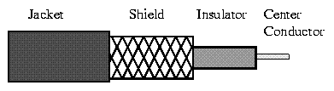
Coaxial Cable
The outer shield protects the inner conductor from outside electrical signals. The distance between the outer conductor (shield) and inner conductor plus the type of material used for insulating the inner conductor determine the cable properties or impedance. Typical impedances for coaxial cables are 75 ohms for Cable TV, 50 ohms for Ethernet. The excellent control of the impedance characteristics of the cable allow higher data rates to be transferred than with twisted pair cable.

- Used extensively in LANs
- Single central conductor surrounded by a circular insulation layer and a conductive shield
- High bandwidth: Upto 400 MHz
- High quality of data transmission
- Max. Used data rates: 100 Mbits/s
- Problems: Signal loss at high frequencies

Twisted Pair Cable
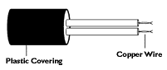

Twisted Pair Cable
It is extensively used in telephone circuits, where several wires are insulated and put together.
The bandwidth is of 250 KHz. It is having a low signal to noise ratio (cross talk). Good for short-distance communications and are used in LAN (UTP or 10baseT).

Optical Fiber
Fiber optic cable has the ability to transmit more information, more quickly and over longer distances. Fiber optic cable offers almost unlimited bandwidth and unique advantages over all previously developed transmission media. The basic point-to-point fiber optic transmission system consists of three basic elements: the optical transmitter, the fiber optic cable and the optical receiver.
The Optical Transmitter: The transmitter converts an electrical analog or digital signal into a corresponding optical signal. The source of the optical signal can be either a light emitting diode, or a solid-state laser diode. The most popular wavelengths of operation for optical transmitters are 850, 1300, or 1550 nanometers.
The Fiber Optic Cable: The cable consists of one or more glass fibers, which act as wave guides for the optical signal. Fiber optic cable is similar to electrical cable in its construction, but provides special protection for the optical fiber within. For systems requiring transmission over distances of many kilometers, or where two or more fiber optic cables must be joined together, an optical splice is commonly used.
The Optical Receiver: The receiver converts the optical signal back into a replica of the original electrical signal. The detector of the optical signal is either a PIN-type photodiode or avalanche-type photodiode.
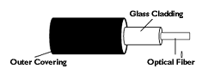

Fiber Optic Cable
- Compare Geostationary, Medium earth orbit and Low earth orbit satellites on their utility as communication elements.
LEO, or Low Earth Orbit
A satellite in low earth orbit circles the earth 100 to 300 miles above the earth’s surface. Because it is close to the earth, it must travel very fast to avoid being pulled out of orbit by gravity and crashing into the earth. Satellites in low earth orbit travel about 17,500 miles per hour. These satellites can circle the whole earth in about an hour and a half.
MEO, or Medium Earth Orbit
Satellites circling 6,000 to 12,000 miles above the earth are in medium altitude orbit. In these larger orbits they stay in sight of a ground receiving station for 2 hours or more, compared to about 10 minutes for LEOs. It takes MEO satellites from 4 to 8 hours to go around the earth.
GEO, or Geostationary Earth Orbit
A satellite in geosynchronous orbit circles the earth in 24 hours—the same time it takes the earth to rotate one time. If these satellites are positioned over the equator and travel in the same direction as the earth rotates, they appear "fixed" with respect to a given spot on earth; that is, they hang like lanterns over the same spot on the earth all the time. Satellites in GEO orbit 22,282 miles above the earth. In this high orbit, GEO satellites are always able to "see" the receiving stations below, and their signals can cover a large part of the planet. Three GEO satellites can cover the globe, except for the parts at the North and South poles.

- Explain any 2 sliding window protocols.
Go back n
In Go back n protocol if there is one frame k missing, the receiver simply discard all subsequent frames k+1, k+2, ..., sending no acknowledgments. So the sender will retransmit frames from k onwards. This effectively sets the receiver window size to be 1. This can be a waste of bandwidth.
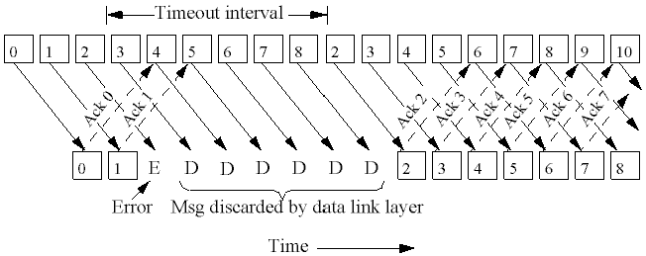

Selective Repeat
Another strategy is to re-send only the ones that are actually lost or damaged. The receiver buffers all the frames after the lost one. When the sender finally noticed the problem (e.g. no acknowledgment for the lost frame is received within time-out limit), the sender retransmits the frame in question.
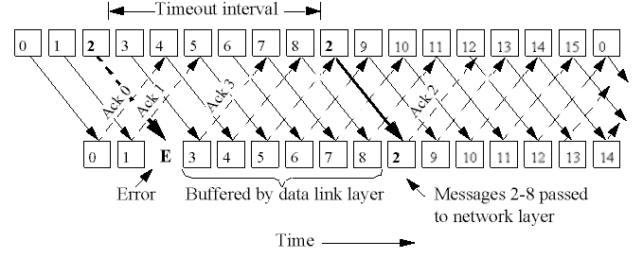
- What is ISDN?
ISDN stands for Integrated Services Digital Network. It is a design for a completely digital telephone/telecommunications network. It is designed to carry voice, data, images, and video, everything you could ever need. ISDN components include terminals, terminal adapters (TA), network-termination devices, line-termination equipment and exchange-termination equipment.
- ISDN terminals come in two types:
- Specialized ISDN terminals are referred to as terminal equipment type 1 (TE1).
- Non - ISDN terminals such as DTE that predate the ISDN standards are referred to as terminal equipment type 2 (TE2).
TE1 are connected to the ISDN network through a four-wired twisted-pair digital link.
TE2 are connected to the ISDN network through a terminal adapter.
The ISDN TA can either be a stand-alone device or a board inside TE2. If implemented as a stand-alone device, the TE2 is connected to the TA via a standard physical layer interface.
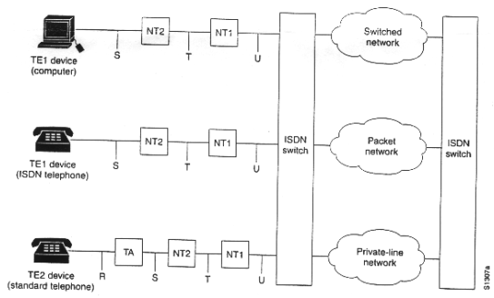

- Compare OSI Reference Model with TCP/IP Reference Model.
- Both are based on the concept of a stack of independent protocols.
- Functionality of the layers is similar.
- The layers up through and including transport layer are providing an end-to-end transport service.
- Concepts, Interfaces, Protocols are the three concepts central to the OSI model. Each layer provides some service for the layer above to it. A layer’s interface tells the process above it how to access it.
- The TCP/IP model did not originally clearly distinguish between service, interface, and protocol.
- The OSI reference model was devised before the protocols were invented.
- With the TCP/IP, protocol came first, and the model was really the description of the existing protocol.
- Distinguish clearly between Hubs, Bridges and Routers.
A bridge is a simple device that split the physical network being shared by many computers into smaller segments. A bridge generally has only two ports; bridges with more than two ports are usually called switches. Bridges are normally used to connect LAN segments within a limited geographic area (local bridges), like a building or a campus. Bridges can be programmed to reject packets from particular networks.
Hubs can also be called either Multi port Repeaters or Concentrators. They are physical hardware devices. Hubs are used to provide a Physical Star Topology. At the center of the star is the Hub, with the network nodes located on the tips of the star. Hubs are a crucial element to all star topology LANs. Hubs serve as a central device through which data bound for a workstation travels. Hubs do not read any of the data passing through them and are not aware of their source or destination. Essentially, a hub simply receives incoming packets, possibly amplifies the electrical signal, and broadcasts these packets out to all devices on the network - including the one that originally sent the packet. The data may be distributed, amplified, regenerated, screened or cut off. The hierarchical use of hubs removes the length limitation of the cables. Hub joins multiple computers (or other network devices) together to form a single network segment. A hub includes a series of ports that each accepts a network cable. Small hubs network four computers.
A router is a box or a regular computer with at least two ports, used to connect also dissimilar networks. A router is used to route data packets between two networks. It reads the information in each packet to tell where it is going. It differs from bridges since it operates at the network level. It will also use different addresses. For example a bridge may use Ethernet addresses while a router uses IP addresses. Routers work at the network layer - they actually understand the protocols being used to carry the data over the network. And since they understand the protocols, they can use rules to decide what to do with a specific piece of data. Because of this, routers are useful in linking networks that are used for different purposes or by different organizations. One can apply rules or filters to let certain data in, but keep other data out. Also to route data serving one purpose over a certain set of network connections, while routing other data over other connections.
- What are the design issues of the data link layer?
- Services provided to network layer
- Framing
- Error Control
- Flow Control

- What are CSMA protocols?
Ethernet uses a refinement of ALOHA, known as Carrier Sense Multiple Access (CSMA), which improves performance when there is a higher medium utilization. When a Station has data to transmit, the station first listens to the cable (using a transceiver) to see if a carrier (signal) is being transmitted by another node. This may be achieved by monitoring whether a current is flowing in the cable (each bit corresponds to 18-20 milliamps (mA)). If a sender does not receive an acknowledgment after some period, it assumes that a collision has occurred. After a collision a station backs off for a certain (random) time and retransmits.
There are a number of variations of CSMA protocols:
- Non-Persistent CSMA
- 1-Persistent CSMA
- p-Persistent CSMA
- Compare Pure ALOHA with Slotted ALOHA.
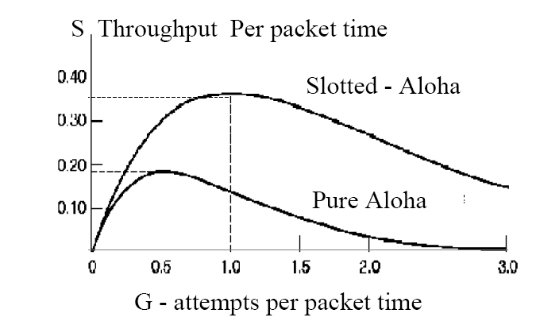

PART B
(Each question carries 10 marks)
- Explain the algorithm for Cyclic Redundancy Code generation.
The most popular error detection codes are based on polynomial codes or cyclic redundancy codes. Idea:
- Represent a k-bit frame as coefficients of a polynomial expansion ranging from to , with the high-order bit corresponding to the coefficient of .
For example, represent the string ``11011'' as the polynomial:
- Perform modulo 2 arithmetic (e.g. XOR of the bits)
- Sender and receiver agree on a generator polynomial: G(x). (G(x) must be smaller than the number of bits in the message.)
- Append a checksum to message; let's call the message M(x), and the combination T(x). The checksum is computed as follows:
  - Let r be the degree of G(x), append r zeros to M(x). Our new polynomial becomes x^{r}M(x).
  - Divide x^{r}M(x) by G(x) using modulo 2 arithmetic.
  - Subtract the remainder from x^{r}M(x) giving us T(x).
- When receiver gets T(x), it divides T(x) by G(x); if T(x) divides cleanly (e.g., no remainder), no error has occurred.
The presence of a remainder indicates an error.
Assume:
- The receiver gets T(x) + E(x), where each bit in E(x) corresponds to an error bit.
- k 1 bits indicate k single-bit errors.
- Receiver computes [T(x) + E(x)]/G(x) = E(x)/G(x).
Will detect:
- Single bit errors. If a single-bit error occurs, G(x) will detect it if it contains more than one term. If it contains only one term, it may or may not detect the error, depending on the E(x) and G(x).
- Two isolated single-bit errors. Consider two single-bit errors:

Example:
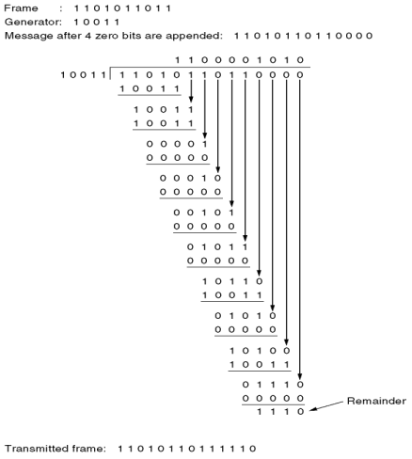

- Explain IEEE 802.3 specifications for LANs.
IEEE 802.3 standard for LAN (Ethernet)
Introduction
Ethernet is a frame-based computer networking technology for local area networks (LANs). The name comes from the physical concept of ether. It defines wiring and signaling for the physical layer, and frame formats and protocols for the media access control (MAC)/data link layer of the OSI model. Ethernet is mostly standardized as IEEEs 802.3.

History
Ethernet was originally developed in mid 1970s, as one of the many pioneering projects at Xerox PARC. Digital Equipment Corporation and Intel Corporation joined Xerox to define a 10 Mbps Ethernet standard in 1978. Later 100 Mbps version (Fast Ethernet) & 1000 Mbps version (Gigabit Ethernet) came into existence. In 1983, the specification was formalized by the IEEE as the 802.3 specification. At first, the technology only used coaxial cable in a bus topology, however it has changed with the times to take into advantage of new technologies such as twisted pair cabling (10 Base-T), fiber optics (10 Base-FL), and 100 Mbps operation (100 Base-X or Fast Ethernet). The current standard is known as IEEE 802.3u.

Ethernet Cabling
Ethernet has several different variations, each of which uses different cable types, topologies, and distance limitations. However, all variations use the same CSMA/CD protocol. The different types are:
Name | Media Type | Max. Segment Length | Max. Nodes/Segment
10Base5 | Thick coaxial | 500 meters | 100
10Base2 | RG58 (thin) coaxial | 185 meters | 30
10BaseT | UTP | 100 meters | 1024
10BaseF (FOIRL) | Fiber-optic | 2,000 meters | 1024k

1. 10 Base-5 (Thick Ethernet)
This is the original version of Ethernet. It consists of a coaxial cable about 10mm (0.4") thick with transceivers connecting the individual devices on the network to the cable. It allows up to 255 physical connections to a cable segment, and an overall cable length of 500 meters (1650 feet).
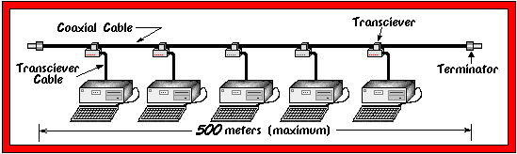

2. 10 Base-2 (Thin Ethernet)
This is the second variation of Ethernet. Here, we dispense with the external transceivers and simply daisy-chain all of the devices on the network together with a thinner version of the cable used in 10 Base-5. Each device on the network is connected to the bus through a BNC "T" adapter, and each end of the bus must have a 50 Ohm terminator attached. Each node on the bus must be a minimum of 0.5 meters (1.5 feet) apart, and the overall length of the bus must be less than 185 meters (606 feet).
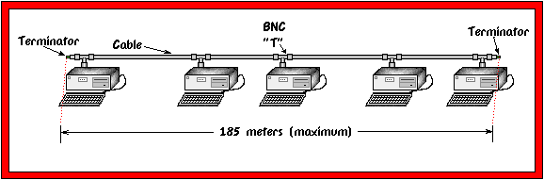

3. 10 Base-T
This is the most popular version of Ethernet. It uses Unshielded Twisted Pair (UTP) cable. Each device has its own cable run of up to 100 meters (330 feet) back to a common hub.
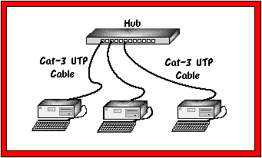

4. 10 Base-FL
This is basically a version of Ethernet which runs over fiber optic cable. It is set up in much the same manner as 10 Base-T, except that it uses fiber optic cable. This allows it to support very long distances of up to 2000 meters (6600 feet) per run. 10 Base-FL is wired in a star topology with all of the fiber optic runs originating from a central hub. It is also acceptable to connect a pair of 10 Base-FL devices directly together with a point to point link.

FRAME FORMAT
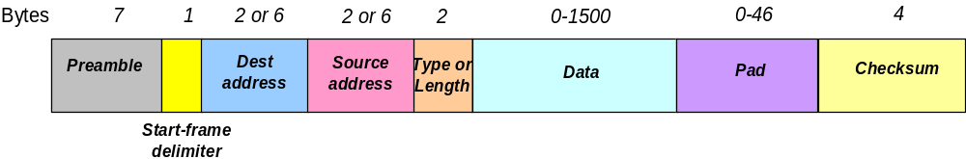
The Preamble consists of seven bytes all of the form 10101010, and is used by the receiver to allow it to establish bit synchronisation (there is no clocking information on the Ether when nothing is being sent).
The Start frame delimiter is a single byte, 10101011, which is a frame flag, indicating the start of a frame.
The MAC addresses used in 802.3 are always 48 bits (6 bytes) long, although older versions of Ethernet used 16 bits. The high-order bit of the destination address is a 0 for ordinary address and 1 for group addresses. Group addresses allow multiple stations to listen to a single address. The address consisting of all 1 bits is reserved for broadcast.
The Length/Ether Type field is the only one which differs between 802.3 and Ethernet II. The Type field tells the receiver what to do with the frame. It specifies which process to give the frame to.
Frames must be at least 64 bytes long, not including the preamble, so, if the data field is shorter than 46 bytes, it must be compensated by the Pad field. The reason for specifying a minimum length lies with the collision-detect mechanism. In CSMA/CD a station must never be allowed to believe it has transmitted a frame successfully if that frame has, in fact, experienced a collision. In the worst case it takes twice the maximum propagation delay across the network before a station can be sure that a transmission has been successful. If a station sends a really short frame, it may actually finish sending and release the Ether without realising that a collision has occurred. The 802.3 design rules specify an upper limit on the maximum propagation delay in any Ethernet installation, and the minimum frame size is set to be more than twice this figure (64 bytes takes 51.2μs to send at 10Mbps).
The Checksum field uses a CRC-32 polynomial code.
Transmission Algorithm
Ethernet uses 1-persistent carrier sense multiple access with collision detection (CSMA/CD) for channel allocation.
When one station wants to send some information, it obeys the following algorithm:
Step 1: Start - If the wire is idle, starts transmitting, else go to step 4
Step 2: Transmitting - If detecting a collision, continue transmitting until the minimum packet time is reached (to ensure that all other transmitters and receivers detect the collision) then go to step 4.
Step 3: End successful transmission - Report success to higher network layers; exit transmit mode.
Step 4: Wire is busy - Wait until wire becomes idle
Step 5: Wire just became idle - Wait a random time, then go to step 1, unless maximum number of transmission attempts has been exceeded
Step 6: Maximum number of transmission attempt exceeded - Report failure to higher network layers; exit transmit mode.

Manchester Encoding
Ethernet uses Manchester Encoding to encode the clock and data of a synchronous bit stream. In the Manchester encoding, logic 0 is indicated by a 0 to 1 transition at the center of the bit and logic 1 is indicated by a 1 to 0 transition at the center of the bit. The signal transitions do not always occur at the ‘bit boundaries’ (the division between one bit and another), but that there is always a transition at the center of each bit. The Manchester encoding rules are summarized below:
Original Data | Value Sent
Logic 0 | 0 to 1 (upward transition at bit center)
Logic 1 | 1 to 0 (downward transition at bit center)

