What is a computer network?
Computer network is a collection of autonomous computers interconnected by a single technology. Two computers are said to be interconnected if they are able to exchange information. It is not necessary that the connection should be via a copper wire. Fiber optics, microwaves, infrared, and communication satellites can also be used to establish the connection.

Why Networks?
- Distribute computation among nodes
- Coordination between processes running on different nodes
- Remote I/O Devices
- Remote Data/File Access
- Personal communications (e-mail, chat, A/V)
- World Wide Web

Applications of networks

Business applications
Resource sharing by using client server model
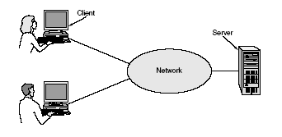

In this model the data are stored on powerful computers called servers. Users have simpler machines, called clients, on their desks, with which they access remote data.
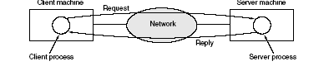
A computer network can provide a powerful communication medium among employees. Virtually every company that has two or more computers now has e-mail (electronic mail), which employees generally use for a great deal of daily communication.

Home Applications
- Access to remote information.
- Person-to-person communication.
- Interactive entertainment.
- Electronic commerce.

Why Do We Need A Standard?
- Many types of connection media: telephone lines, optical fibers, cables, radios, etc.
- Many different types of machines and operating systems
- Many different network applications
To reduce their design complexity, most networks are organized as a stack of layers or levels, each one built upon the one below it. The number of layers, the name of each layer, the contents of each layer, and the function of each layer differ from network to network. The purpose of each layer is to offer certain services to the higher layers, shielding those layers from the details of how the offered services are actually implemented. In a sense, each layer is a kind of virtual machine, offering certain services to the layer above it.

ISO - OSI Model
One of the most important concepts in networking is the open-systems interconnection (OSI) reference model. It serves as a framework within which communication protocol standards are developed.
In 1977, International Standards Organization (ISO) began an ambitious project to develop a single international standard set of communications protocols. By 1984, ISO had defined an overall model of computer communications called the Reference Model for Open Systems Interconnection, or OSI Model.
ISO also developed a comprehensive set of standards for the various layers of the OSI model. The standards making up the OSI architecture were not widely implemented in commercial products for computer networking. However, the OSI model is still important. The concepts and terminology associated with the OSI model have become widely accepted as a basis for discussing and describing network architectures. The OSI model is often used in categorizing the various communications protocols that are in common use today and also used for comparing one network architecture to another.
- Model: It means that it is only theory. In fact the OSI model is not yet fully implemented in real networks.
- Open System: It can communicate with any other system that follows the specified standards, formats, and semantics.
- Protocols give rules that specify how the communication parties may communicate.
- Supports two general types of protocols. They are
  - Connection-Oriented:
    - Sender and receiver first establish a connection, possibly negotiate on a protocol (virtual circuit)
    - Transmit the stream of data
    - Release the connection when done
    - e.g. Telephone connection
  - Connectionless
- No advance setup is needed.
- Transmit the message (datagram) when sender is ready. e.g. surface mail

The Seven Layers
- The OSI model defines the seven functional layers. Each layer performs a different set of functions, and the intent was to make each layer as independent as possible from all others.
- Each layer deals with a specific aspect of communication.
- Each layer provides an interface to the layer above. The set of operations define the service provided by that layer.
- As a message sent by the top layer is passed on to the next lower layer until the most bottom layer.
- At each level a header may be appended to the message. Some layers add both a header and a trailer.
- The lowest layer transmits the message over the network to the receiving machine. It communicates with the most bottom layer of the receiver.
- Each layer then strips the header (trailer), handles the message using the protocol provided by the layer and passes it on to the next higher layer. Finally to the highest layer in the receiver.
Layer 7 | Application Layer
Layer 6 | Presentation Layer
Layer 5 | Session Layer
Layer 4 | Transport Layer
Layer 3 | Network Layer
Layer 2 | Data-Link Layer
Layer 1 | Physical Layer

Layer-1: Physical Layer

The physical layer defines the physical characteristics of the interface, such as mechanical components and connectors, electrical aspects such as voltage levels representing binary values, and functional aspects such as setting up, maintaining, and taking down the physical link. Well-known physical layer interfaces for local area networks (LANs) include Ethernet, Token-Ring, and Fiber Distributed Data Interface (FDDI). Physical Layer
- Concerned with the transmission of bits.
- How many volts for 0, how many for 1?
- Number of bits of second to be transmitted.
- Two way or one-way transmission
- Standardized protocol dealing with electrical, mechanical and signaling interfaces.
- Many standards have been developed, e.g. RS-232 (for serial communication lines).
- Example: X.21

Layer-2: Data-Link Layer
The data link layer defines the rules for sending and receiving information across the physical connection between two systems. This layer encodes and frames data for transmission, in addition to providing error detection and control. Because the data link layer can provide error control, higher layers may not need to handle such services. However, when reliable media is used, there is a performance advantage by not handling error control in this layer, but in higher layers. Bridges operate at this layer in the protocol stack.
- Handles errors in the physical layer.
- Groups bits into frames and ensures their correct delivery.
- Adds some bits at the beginning and end of each frame plus the checksum.
- Receiver verifies the checksum.
- If the checksum is not correct, it asks for retransmission. (Send a control message).
- Consists of two sub layers:
  - Logical Link Control (LLC) defines how data is transferred over the cable and provides data link service to the higher layers.
  - Medium Access Control (MAC) defines who can use the network when multiple computers are trying to access it simultaneously (i.e. Token passing, Ethernet [CSMA/CD]).

Layer-3: Network Layer
The network layer defines protocols for opening and maintaining a path on the network between systems. It is concerned with data transmission and switching procedures, and hides such procedures from upper layers. Routers operate at the network layer. The network layer can look at packet addresses to determine routing methods. If a packet is addressed to a workstation on the local network, it is sent directly there. If it is addressed to a network on another segment, the packet is sent to a routing device, which forwards it on the network.
- Concerned with the transmission of packets.
- Choose the best path to send a packet (routing).
- It may be complex in a large network (e.g. Internet).
- Shortest (distance) route vs. route with least delay.
- Static (long term average) vs. dynamic (current load) routing.
- Two protocols are most widely used.
- X.25
  - Connection Oriented
  - Public networks, telephone, European PTT
  - Send a call request at the outset to the destination
  - If destination accepts the connection, it sends an connection identifier
- IP (Internet Protocol)
  - Connectionless
  - Part of Internet protocol suite.
  - An IP packet can be sent without a connection being established.
  - Each packet is routed to its destination independently.

Layer-4: Transport Layer
The transport layer provides a high level of control for moving information between systems, including more sophisticated error handling, prioritization, and security features. The transport layer provides quality service and accurate delivery by providing connection-oriented services between two end systems. It controls the sequence of packets, regulates traffic flow, and recognizes duplicate packets. The transport layer assigns pocketsize information a traffic number that is checked at the destination. If data is missing from the packet, the transport layer protocol at the receiving end arranges with the transport layer of the sending system to have packets re-transmitted. This layer ensures that all data is received and in the proper order.
- Network layer does not deal with lost messages.
- Transport layer ensures reliable service.
- Breaks the message (from sessions layer) into smaller packets, assigns sequence number and sends them.
- Reliable transport connections are built on top of X.25 or IP.
- In case IP, lost packets arriving out of order must be reordered.
- TCP: (Transport Control Protocol) Internet transport protocol.
- TCP/IP Widely used for network/transport layer (UNIX).
- UDP (Universal Datagram Protocol): Internet connectionless transport layer protocol.
- Application programs that do not need connection-oriented protocol generally use UDP.

Layer-5: Session Layer
The session layer coordinates the exchange of information between systems by using conversational techniques, or dialogues. Dialogues are not always required, but some applications may require a way of knowing where to restart the transmission of data if a connection is temporarily lost, or may require a periodic dialog to indicate the end of one data set and the start of a new one.
- Enhanced version of transport layer.
- Dialog control, synchronization facilities.
- Rarely supported (Internet suite does not).

Layer-6: Presentation Layer
Protocols at the presentation layer are part of the operating system and application the user runs in a workstation. Information is formatted for display or printing in this layer. Codes within the data, such as tabs or special graphics sequences, are interpreted. Data encryption and the translation of other character sets are also handled in this layer.
- Concerned with the semantics of the bits.
- Define records and fields in them.
- Sender can tell the receiver of the format.
- Makes machines with different internal representations to communicate.
- If implemented, the best layer for cryptography.

Layer-7: Application Layer
Applications access the underlying network services using defined procedures in this layer. The application layer is used to define a range of applications that handle file transfers, terminal sessions, network management, and message exchange.
- Collection of miscellaneous protocols for high level applications
- Electronic mail, file transfer, connecting remote terminals, etc.
- E.g. SMTP, FTP, Telnet, HTTP, etc.
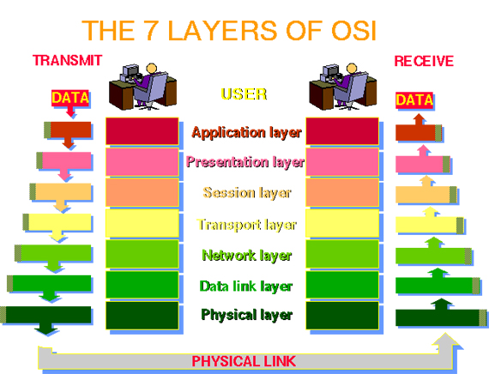

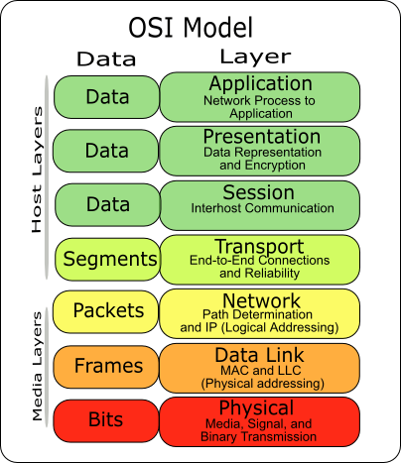

Performance Parameters
Latency: Time required for transferring an empty message between relevant computers.
Sum total of
  - Delay introduced by the sender software.
  - Delay introduced by the receiver software.
  - Delay in accessing the network.
  - Delay introduced by the network.
Data transfer rate: is the speed at which data can be transferred between sender and receiver in a network, once transmission has begun. (bit/sec)
Message transfer time = latency + (length of message) / (Data transfer rate).
Bandwidth: is the total volume of traffic that can be transferred across the network.
Max. Data rate (bit/sec) = carrier BW · log₂ (1 + (signal/noise))
e.g. phone line BW = 3 kHz, S/N = 30 dB = 1000 Max. Data rate = 30 kbit/sec

TCP/IP Reference Model
The TCP/IP reference model is the network model used in the current Internet architecture. It has its origins back in the 1960's with the grandfather of the Internet, the ARPANET. The TCP/IP model does not exactly match the OSI model. There is no universal agreement regarding how to describe TCP/IP with a layered model but it is generally agreed that there are fewer levels than the seven layers of the OSI model.
Layers of the TCP/IP model are defined as follows:

Application layer
Like OSI Model, it contains all the higher-level protocols. In TCP/IP the Application Layer also includes the OSI Presentation Layer and Session Layer. This includes all of the processes that involve user interaction. The application determines the presentation of the data and controls the session. In TCP/IP the terms socket and port are used to describe the path over which applications communicate. There are numerous application level protocols in TCP/IP, including Simple Mail Transfer Protocol (SMTP) and Post Office Protocol (POP) used for e-mail, Hyper Text Transfer Protocol (HTTP) used for the World-Wide-Web, and File Transfer Protocol (FTP). Most application level protocols are associated with one or more port number.
The most widely known and implemented Application Layer protocols are:
Network Terminal Protocol (Telnet): Provides text communication for remote login and communication across the network
File Transfer Protocol (FTP): Used to download and upload files across the network
Simple Mail Transfer Protocol (SMTP): Delivers electronic mail messages across the network
Post Office Protocol, Version 3 (POP-3): Allows users to pick up e-mail across the network from a central server
Domain Name Service (DNS): Maps IP addresses to Internet domain names
Hyper Text Transfer Protocol (HTTP): The protocol used by the World-Wide-Web to exchange text, pictures, sounds, and other multi-media information via a graphical user interface (GUI)
Routing Information Protocol (RIP): Used by network devices to exchange routing information
Some protocols are used directly by users as applications, such as FTP and Telnet. Other protocols are directly behind applications, such as SMTP and HTTP. Others, such as RIP and DNS, happen indirectly or are used by the programs and operating system routines. A system administrator must be aware of all of the protocols and how they interact with each other and the lower TCP/IP layers.
Most of the application level protocols in TCP/IP are implemented as 7-bit ASCII stream conversations. This means that the communication that takes place across the network is formatted using upper and lower case alphabetic characters, numeric digits, and standard punctuation. This was partly done because, historically, as a packet of information passed across the Internet there was no predicting what type of system it would pass through. 7-bit ASCII was chosen as a coding scheme that almost any computer or piece of equipment would be able to handle. Any information that is not actually 7-bit ASCII is first converted to ASCII, then transmitted across the network, and converted back to its original form at the destination.
To really understand the rest of the reasons behind why application protocols are simple text conversations it is important to understand a little of the history of TCP/IP, the Internet, and UNIX.
The Internet and TCP/IP originally grew up on networks of UNIX computer systems. On a classic UNIX system there was one central computer system with a number of "Dumb", text display terminals connected to it. A user on one of the terminals typed in text commands to run programs, which displayed text as output.
One of the first real network applications allowed a user on one UNIX computer to communicate across a connection to a remote UNIX computer and run programs as if directly connected to the remote system. This type of connection used Network Terminal Protocol, which is now commonly called Telnet. The local system that the user is connected to is called the client, and the remote computer is called the server. This was one of the original Client-Server applications.
When a user wanted to communicate from their computer to a remote system, they would Telnet to the remote and run a program on the remote system. For example, if they wanted to send mail to someone on a remote computer, they could Telnet to the remote system, run the mail receiving program, and type in a message to a particular user. If they wanted to send a file from computer to computer, they would Telnet to the remote system, start a Receive program running, then drop back to the local computer and start a Send program to transmit the file.
Eventually there were certain programs that were left running all the time on the server computers, E-Mail, File Transfer, and other common applications, so that a remote user did not have to log onto the remote system and start them each time they wanted to use them. These programs were left running in the background, using only a small amount of resources, while they waited to be contacted. These are what is known in the UNIX world as Daemons, and in the Windows world as Services. Just so that people could find the correct Daemon to talk to, each common or well known program was given a specific Port on the computer that it listened to while it was waiting for someone to contact it.
Programmers, being the basically lazy people they are, grew tired of all the Telnetting from system to system. They began writing programs to do the Telnetting about for them. These programs at first were barely more than a modified Telnet program that followed a script to talk to a remote server. But these client applications grew in complexity and sophistication, becoming much more popular than the manual method of Telnetting around and typing in long text messages. Eventually there were mostly computers talking to computers, but the conversations were still the original text messages developed when it was people doing the conversing.
Now, the above description is not exactly the order of events, or exactly the way it all happened, but it does give a rough idea of how the application protocols ended up the way they are. The important thing to remember is that most application protocols are text conversations that can be manually operated using a Telnet client program.
The text conversation aspect of application level protocols comes in very handy when setting up, testing, and troubleshooting TCP/IP applications. It is usually possible, and often quite easy, to use a simple Telnet client to contact a remote TCP/IP application and send it commands and test data. For example, if you are having trouble sending an E-Mail message to a particular person, it is quite easy to Telnet directly to the recipients mail server and manually compose a message for delivery. Then the responses of the remote system to each step of the procedure can be observed. This usually makes it much easier to identify where and how a problem is occurring.
One downside of the text conversation aspect of TCP/IP application level protocols is that it is fairly easy to eavesdrop on a conversation or to write a program to generate the correct text messages so that one program can impersonate another. There have been many solutions developed to address this problem. Pretty Good Privacy (PGP) is a publicly available application that encrypts text messages before they are passed across unsecured channels, and then un encrypts them at the destination. Secure Hyper Text Transfer Protocol (SHTTP) and the Secure Sockets Layer (SSL) are designed to verify the identities of computer systems at both ends of a World Wide Web conversation and to encrypt information in transit between them. These are just a few of a broad range of available applications that address the security issues.
Secure communications across TCP/IP is a broad topic and is beyond the scope of this technical reference. Usually it is best to approach it on an application by application basis, or as an individual solution such as a Firewall system.

Transport layer
In TCP/IP there are two Transport Layer protocols. The Transmission Control Protocol (TCP) guarantees that information is received as it was sent. The User Datagram Protocol (UDP) performs no end-to-end reliability checks.
Between the Internet layer and Application layer of the TCP/IP architecture model is the Transport Layer. This layer has two primary protocols, the Transmission Control Protocol (TCP) and the User Datagram Protocol (UDP).
TCP is a connection based protocol that provides error detection and correction with reliable delivery of data packets. UDP is a connectionless protocol with low overhead.
When writing application software a developer normally chooses TCP or UDP based on whether it is more important to have a reliable connection with bi-directional communication and error management, or if it is more important to develop a low overhead, streamlined application.

Internet Layer
In the OSI Reference Model the Network Layer isolates the upper layer protocols from the details of the underlying network and manages the connections across the network. The Internet Protocol (IP) is normally described as the TCP/IP Network Layer. Because of the Inter-Networking emphasis of TCP/IP this is commonly referred to as the Internet Layer. All upper and lower layer communications travel through IP as they are passed through the TCP/IP protocol stack.
The Internet Layer of the TCP/IP architecture model resides just above the Network Access Layer and below the Transport Layer. The primary concern of the protocol at this layer is to manage the connections across networks as information is passed from source to destination. The Internet Protocol (IP) is the primary protocol at this layer of the TCP/IP architecture model.
IP is a connectionless protocol. This means it does not use a handshake to provide end-to-end control of communications flow. It relies on other layers to provide this function if it is required. IP also relies on other layers to provide error detection and correction. Because of this IP is sometimes referred to as an unreliable protocol. This does not mean that IP cannot be relied upon to accurately deliver data across a network; it simply means that IP itself does not perform the error checking and correcting functions.
The functions that IP performs include:
- Defining a datagram and an addressing scheme
- Moving data between transport layer and network access layer protocols
- Routing datagram to remote hosts
- The fragmentation and reassembly of datagram
The only other protocol that is generally described as being at the Internet Layer of the TCP/IP model is the Internet Control Message Protocol (ICMP), a protocol used to communicate control messages between IP systems.

Network Access Layer (Host to Network Layer)
In TCP/IP the Data Link Layer and Physical Layer are normally grouped together. TCP/IP makes use of existing Data Link and Physical Layer standards rather than defining its own. Most RFCs that refer to the Data Link Layer describe how IP utilizes existing data link protocols such as Ethernet, Token Ring, FDDI, HSSI, and ATM. The characteristics of the hardware that carries the communication signal are typically defined by the Physical Layer. This describes attributes such as pin configurations, voltage levels, and cable requirements. Examples of Physical Layer standards are RS-232C, V.35, and IEEE 802.3.
The Network Access layer is the lowest level of the TCP/IP protocol hierarchy. It is often ignored by users as it is well hidden by the mid-level protocols such as IP, TCP, and UDP, and higher level protocols such as SMTP, HTTP, and FTP. Functions performed at the network access layer include encapsulation of IP datagram into frames to be transmitted by the network, and mapping IP addresses to physical hardware addresses.
Much of the work that takes place at the network access layer is handled by software applications and drivers that are unique to individual pieces of hardware. Configuration often consists of simply selecting the appropriate driver for loading, and selecting TCP/IP as the protocol for use. Many computers come with this driver software pre-loaded and configured, or can automatically configure themselves via "plug-and-play" applications.

5.2. Comparison of the OSI and TCP/IP reference models
- Both are based on the concept of a stack of independent protocols.
- Functionality of the layers is similar.
- The layers up through and including transport layer are providing an end-to-end transport service.
- Concepts, Interfaces, Protocols are the three concepts central to the OSI model. Each layer provides some service for the layer above to it. A layer’s interface tells the process above it how to access it.
- The TCP/IP model did not originally clearly distinguish between service, interface, and protocol.
- The OSI reference model was devised before the protocols were invented.
- With the TCP/IP, protocol came first, and the model was really the description of the existing protocol.
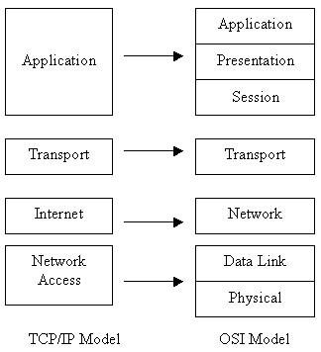

Figure: 3.1 TCP/IP and OSI Models

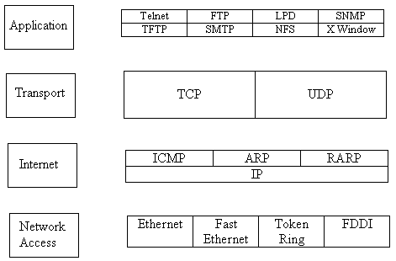

Figure 3.2. TCP/IP Protocol Suite

Transmission Technology
There are two types of transmission technology.
- Broadcast links (Multiple Access)
- Point-to-point links

Broadcast networks have a single communication channel that is shared by all the machines on the network. Short messages, called packets in certain contexts, sent by any machine are received by all the others. An address field within the packet specifies the intended recipient. Upon receiving a packet, a machine checks the address field. If the packet is intended for the receiving machine, that machine processes the packet; if the packet is intended for some other machine, it is just ignored. Broadcast systems generally also allow the possibility of addressing a packet to all destinations by using a special code in the address field. When a packet with this code is transmitted, it is received and processed by every machine on the network. This mode of operation is called broadcasting. Some broadcast systems also support transmission to a subset of the machines, something known as multicasting.

Point-to-point networks consist of many connections between individual pairs of machines. To go from the source to the destination, a packet on this type of network may have to first visit one or more intermediate machines. Often multiple routes, of different lengths, are possible, so finding good ones is important in point-to-point networks. As a general rule (although there are many exceptions), smaller, geographically localized networks tend to use broadcasting, whereas larger networks usually are point-to-point. Point-to-point transmission with one sender and one receiver is sometimes called unicasting.

Types of Networks

Networks can be divided into three types based on geographical areas covered:

LAN

MAN

WAN

LAN (Local Area Networks): LANs may use a transmission technology consisting of a cable, to which all the machines are attached,
- Typically connects computer in a single building or campus.
- Developed in 1970s.
- Medium: optical fibers, coaxial cables, twisted pair, wireless.
- Low latency (except in high traffic periods).
- High-speed networks (10 to 100 Mb/sec).
- Speeds adequate for most distributed systems

Problems:
- Multi media based applications
- Typically buses or rings.
- Ethernet, Token Ring

BUS Ring
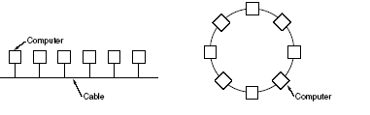
MAN (Metropolitan Area Networks): The best-known example of a MAN is the cable television network available in many cities.
- Generally covers towns and cities (50 kms)
- Developed in 1980s.
- Medium: optical fibers, cables.
- Data rates adequate for distributed computing applications.
- A typical standard is DQDB (Distributed Queue Dual Bus).
- Typical latencies < 1 msec.
- Message routing is fast.

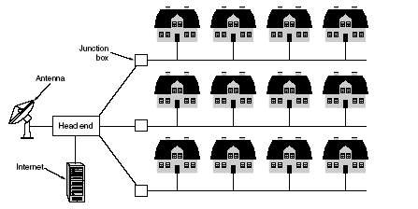
Figure 4.4.2. Man based on Cable TV

WAN (Wide Area Networks): It contains a collection of machines intended for running
user (i.e., application) programs. In most wide area networks, the subnet consists of two distinct components: transmission lines and switching elements. Transmission lines move bits between machines. They can be made of copper wire, optical fiber, or even radio links. Switching elements are specialized computers that connect three or more transmission lines. When data arrive on an incoming line, the switching element must choose an outgoing line on which to forward them. These switching computers have been called by various names in the past; the name router is now most commonly used.

- Developed in 1960s.
- Generally covers large distances (states, countries, continents).
- Medium: communication circuits connected by routers.
- Routers forward packets from one to another following a route from the sender to the receiver. Store-and-Forward
- Hosts are typically connected (or close to) the routers.
- Typical latencies: 100ms - 500ms.
- Problems with delays if using satellites.
- Typical speed: 20 - 2000 Kbits/s.
- Not (yet) suitable for distributed computing.
- New standards are changing the landscape.
In this model, each host is frequently connected to a LAN on which a router is present, although in some cases a host can be connected directly to a router. The collection of communication lines and routers (but not the hosts) form the subnet.
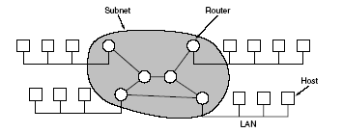
Figure 4.2.3. Network Components

Common requirements are:
- Connect networks of different types, different vendors.
- Provide common communication facilities and hide different hardware and protocols of constituent networks.
- Needed for extensible open distributed systems

Network Topology

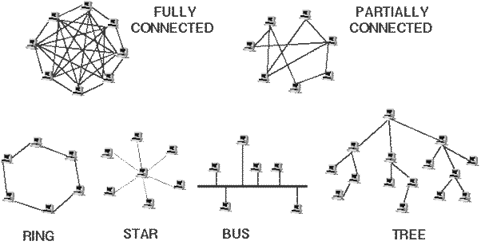
Figure 4.5.1. Network Topology

BUS Network: Bus network is a network architecture in which a set of clients is connected via a shared communications line, called a bus. Bus networks are the simplest way to connect multiple clients, but often have problems when two clients want to communicate at the same time on the same bus.

Advantages
Easy to implement and extend
Well suited for temporary networks (quick setup)
Typically the cheapest topology to implement
Failure of one station does not affect others

Disadvantages
Difficult to administer/troubleshoot
Limited cable length and number of stations
A cable break can disable the entire network
Maintenance costs may be higher in the long run
Performance degrades as additional computers are added
Low security (all computers on the bus can see all data transmissions on the bus)
One virus in the network will affect all of them (but not as badly as a star or ring network)

Star network: In its simplest form, star network consists of one central or hub computer which acts as a router to transmit messages.

Advantages
Easy to implement and extend
Well suited for temporary networks
The failure of a non-central node will not affect the functionality of the network

Disadvantages
Limited cable length and number of stations
Maintenance costs may be higher in the long run
Failure of the central node can disable the entire network
One virus in the network will affect them all

Ring network: Ring network is a topology where each user is connected to two other users. Popular example for such a network is the token ring network.

Advantages
All stations have equal access
Each node on the ring acts as a repeater, allowing ring networks to span greater distances than other topologies
When a coaxial cable is used to create the ring network the service becomes much faster

Disadvantages
The most expensive topology

Mesh Network: Mesh network is a way to route data, voice and instructions between nodes. It allows for continous connections and reconfiguration around blocked paths by hopping from node to node until a connection can be established.
Mesh networks are self healing, i.e. the network can still operate even when a node breaks down or a connection goes bad. Thus it a very reliable network. This is applicable to wireless networks, wired networks and software interaction.
This network allows inexpensive peer network nodes to supply services to other nodes in the same network.

Star-Bus Network: It is a combination of a star network and a bus network. A hub is used to connect the nodes to the network.

Network Hardware
1. Network adapter: Interfaces a computer board with the network medium.

2. Repeaters
A repeater connects two segments of your network cable. It retimes and regenerates the signals to proper amplitudes and sends them to the other segments. When talking about, Ethernet topology, you are probably talking about using a hub as a repeater. Repeaters require a small amount of time to regenerate the signal. This can cause a propagation delay, which can affect network communication when there are several repeaters in a row. Many network architectures limit the number of repeaters that can be used in a row. Repeaters work only at the physical layer of the OSI network model.

Figure 4.5.2. Repeater

3. Bridges
A bridge is a simple device that split the physical network being shared by many computers into smaller segments. A bridge generally has only two ports; bridges with more than two ports are usually called switches. Bridges are normally used to connect LAN segments within a limited geographic area (local bridges), like a building or a campus. Bridges can be programmed to reject packets from particular networks.
Ethernet is the most commonly used physical network. On an Ethernet network, all the connected computers share the same piece of "wire" (it's not physically the same piece, but it is electrically). When two computers attempt to talk at the same time, they drown each other out and create what's called a collision. The more computers you have on one Ethernet, the bigger chance you'll have a collision.
Bridges split an Ethernet into multiple collision-domains. All the data on one side of the bridge stays there, unless it's destined for a computer on the other side of the bridge, lessening the overall load on each segment. Bridges forward all broadcast messages. Only a special bridge called a translation bridge will allow two networks of different architectures to be connected. Bridges do not normally allow connection of networks with different architectures. It does not propagate noise signals and defective frames as it was the case for repeaters (at the physical layer). It adaptively recognizes which machines are reachable from a port. It reduces traffic on each port and it improves security since each port will only transmit frames directed to nodes reachable from that port. All the nodes reachable from a node through segments and bridges will receive broadcast messages sent by that node.
Bridges don't care what protocol is being used on the network (TCP/IP, IPX, AppleTalk, etc.) since they operate at the data-link level. This is both a benefit and a curse; since they work at such a simple level, bridges are able to operate at blindingly fast speeds, but since they will indiscriminately forward data, one has little control over their operation. This is where routers come in.

4. HUB
Hubs can also be called either Multi port Repeaters or Concentrators. They are physical hardware devices. Hubs are used to provide a Physical Star Topology. At the center of the star is the Hub, with the network nodes located on the tips of the star. Hubs are a crucial element to all star topology LANs. Hubs serve as a central device through which data bound for a workstation travels. Hubs do not read any of the data passing through them and are not aware of their source or destination. Essentially, a hub simply receives incoming packets, possibly amplifies the electrical signal, and broadcasts these packets out to all devices on the network - including the one that originally sent the packet. The data may be distributed, amplified, regenerated, screened or cut off. The hierarchical use of hubs removes the length limitation of the cables.
Hub joins multiple computers (or other network devices) together to form a single network segment. On this network segment, all computers can communicate directly with each other.
A hub includes a series of ports that each accepts a network cable. Small hubs network four computers.
Hubs classify as Layer 1 devices in the OSI model. (Physical layer)
Three different types of hubs exist:
- Passive
- Active
- Intelligent
Passive hubs do not amplify the electrical signal of incoming packets before broadcasting them out to the network. Active hubs, on the other hand, do perform this amplification, as does a different type of dedicated network device called a repeater. They can also be treated as concentrator when referring to a passive hub and multiport repeater when referring to an active hub.
Intelligent hubs add extra features to an active hub that are of particular importance to businesses. An intelligent hub typically is stackable (built in such a way that multiple units can be placed one on top of the other to conserve space). It also typically includes remote management capabilities

5. Router
A router is a box or a regular computer with at least two ports, used to connect also dissimilar networks. A router is used to route data packets between two networks. It reads the information in each packet to tell where it is going. It differs from bridges since it operates at the network level. It will also use different addresses. For example a bridge may use Ethernet addresses while a router uses IP addresses. Routers work at the network layer - they actually understand the protocols being used to carry the data over the network. And since they understand the protocols, they can use rules to decide what to do with a specific piece of data. Because of this, routers are useful in linking networks that are used for different purposes or by different organizations. One can apply rules or filters to let certain data in, but keep other data out. Also to route data serving one purpose over a certain set of network connections, while routing other data over other connections. This convenience comes at a price. The more detail a router must acquire about a specific piece of data before forwarding it on, the longer that piece of data is delayed before being sent on to its destination. Also, the greater configurability of routers requires faster, more expensive hardware.
It does all the transformations that may be required by the transfer of packets across the networks it connects. Routing involves two basic activities: running routing algorithms to determine routes, as expressed by routing tables, and using the routing tables to move packets across the network. The latter activity is easier and it is called switching. Routing tables contain information that will indicate for each packet on the basis of its final destination (usually an IP address) where to go next (next-hop forwarding) as to the port to be used and the physical address of the next router.

6. Gateways

A gateway can translate information between different network data formats or network architectures. It can translate TCP/IP to AppleTalk so computers supporting TCP/IP can communicate with Apple brand computers. Most gateways operate at the application layer, but can operate at the network or session layer of the OSI model. Gateways will start at the lower level and strip information until it gets to the required level and repackage the information and work its way back toward the hardware layer of the OSI model.

7. Cable Modem
The cable television companies have the high speed bandwidth to the homes. Cable modems use the existing cable TV line to provide the high speed bandwidth. It is an asymmetrical transfer rates with the upstream data transfer rate at 2 Mbps. The downstream data transfer rate is a maximum of 30 Mbps. Most users connect the cable modem to their 10 Mbps Ethernet NIC, and don't utilize the cable modems full bandwidth. Switching to a 100 Mbps Ethernet NIC would give them full bandwidth. Most cable companies use dynamic IP addressing: each time the user connects; they are assigned a new IP address. Most cable TV companies are placing high performance web proxy servers at the head end. These servers store the most commonly accessed web pages and files locally at the head end. The user's web browser first checks the proxy server to see if the file has been downloaded there. If it hasn't, then it goes out on the Internet to download it. The storing of the web pages and files on the local proxy server reduces the load on the communication servers (to the Internet), and gives the impression of extremely fast Internet access.
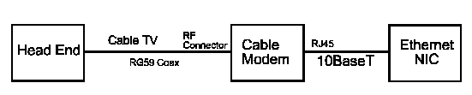
Figure 4.5.3.
The cable modem is connected to the existing cable TV RG59 coax line, using a standard RF connector. The output of the cable modem is a 10BaseT or 100BaseT Ethernet connection to your NIC.

Cable Modem Advantages
- Fast data transfers, up to 30 Mbps if using a 100BaseT NIC
- Competitive pricing against competing technologies
- Easy to install - home prewired

Cable Modem Disadvantages
- The available bandwidth depends on the number of users on the local cable TV line segment.
- There is an asymmetrical transfer rate. Upstream is slower than downstream.
- There can be a bottleneck at the communication server at the head end.

Transmission Media
The media for transmission can be classified as
- Bound Media
- Unbound Media
- Wireless Media

1. Bound Media
Media is the path used for transferring data in a network. Bound Media consists of physical substances used to transfer data. The following is a list of the types of bound media and their susceptibility to EMI - (Electrical Magnetic Interference).
- Coaxial Cable - copper core, shielding, used in LANs, EMI
- Fiber Optic - light signal, glass core, no shielding (not required) No EMI
- Unshielded Twisted Pair (UTP) - No shielding, high EMI, very common, cheap
- Shielded Twisted Pair (STP) - Shielding, less EMI than UTP, IBM networks

Coaxial Cable
Coaxial cable consists of two conductors. The inner conductor is held inside an insulator with the other conductor woven around it providing a shield. An insulating protective coating called a jacket covers the outer conductor.

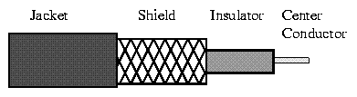
Figure 5.5.1 Coaxial Cable
The outer shield protects the inner conductor from outside electrical signals. The distance between the outer conductor (shield) and inner conductor plus the type of material used for insulating the inner conductor determine the cable properties or impedance. Typical impedances for coaxial cables are 75 ohms for Cable TV, 50 ohms for Ethernet. The excellent control of the impedance characteristics of the cable allow higher data rates to be transferred than with twisted pair cable.

- Used extensively in LANs
- Single central conductor surrounded by a circular insulation layer and a conductive shield
- High bandwidth: Upto 400 MHz
- High quality of data transmission
- Max. Used data rates: 100 Mbits/s
- Signal loss at high frequencies
Twisted Pair Cable
Twisted-pair cable is a type of cabling that is used for telephone communications and most modern Ethernet networks. A pair of wires forms a circuit that can transmit data. The pairs are twisted to provide protection against crosstalk, the noise generated by adjacent pairs. When electrical current flows through a wire, it creates a small, circular magnetic field around the wire. When two wires in an electrical circuit are placed close together, their magnetic fields are the exact opposite of each other. Thus, the two magnetic fields cancel each other out. They also cancel out any outside magnetic fields. Twisting the wires can enhance this cancellation effect. Using cancellation together with twisting the wires, cable designers can effectively provide self-shielding for wire pairs within the network media.
Two basic types of twisted-pair cable exist: unshielded twisted pair (UTP) and shielded twisted pair (STP).

UTP Cable
UTP cable is a medium that is composed of pairs of wires UTP cable is used in a variety of networks. Each of the eight individual copper wires in UTP cable \is covered by an insulating material. In addition, the wires in each pair are twisted around each other.
UTP cable relies solely on the cancellation effect produced by the twisted wire pairs to limit signal degradation caused by electromagnetic interference (EMI) and radio frequency interference (RFI). To further reduce crosstalk between the pairs in UTP cable, the number of twists in the wire pairs varies. UTP cable must follow precise specifications governing how many twists or braids are permitted per meter (3.28 feet) of cable.
UTP cable often is installed using a Registered Jack 45 (RJ-45) connector. The RJ-45 is an eight-wire connector used commonly to connect computers onto a local-area network (LAN), especially Ethernets.
When used as a networking medium, UTP cable has four pairs of either 22- or 24-gauge copper wire. UTP used as a networking medium has an impedance of 100 ohms; this differentiates it from other types of twisted-pair wiring such as that used for telephone wiring, which has impedance of 600 ohms.
UTP cable offers many advantages. Because UTP has an external diameter of approximately 0.43 cm (0.17 inches), its small size can be advantageous during installation. Because it has such a small external diameter, UTP does not fill up wiring ducts as rapidly as other types of cable. This can be an extremely important factor to consider, particularly when installing a network in an older building. UTP cable is easy to install and is less expensive than other types of networking media. In fact, UTP costs less per meter than any other type of LAN cabling. And because UTP can be used with most of the major networking architectures, it continues to grow in popularity.
Disadvantages also are involved in using twisted-pair cabling, however. UTP cable is more prone to electrical noise and interference than other types of networking media, and the distance between signal boosts is shorter for UTP than it is for coaxial and fiber-optic cables.
Although UTP was once considered to be slower at transmitting data than other types of cable, this is no longer true. In fact, UTP is considered the fastest copper-based medium today. The following summarizes the features of UTP cable:
- Speed and throughput—10 to 1000 Mbps
- Average cost per node—Least expensive
- Media and connector size—Small
- Maximum cable length—100 m (short)
Commonly used types of UTP cabling are as follows:
- Category 1—Used for telephone communications. Not suitable for transmitting data.
- Category 2—Capable of transmitting data at speeds up to 4 megabits per second (Mbps).
- Category 3—Used in 10BASE-T networks. Can transmit data at speeds up to 10 Mbps.
- Category 4—Used in Token Ring networks. Can transmit data at speeds up to 16 Mbps.
- Category 5—Can transmit data at speeds up to 100 Mbps.
- Category 5e —Used in networks running at speeds up to 1000 Mbps (1 gigabit per second [Gbps]).
- Category 6—Typically, Category 6 cable consists of four pairs of 24 American Wire Gauge (AWG) copper wires. Category 6 cable is currently the fastest standard for UTP.

Shielded Twisted-Pair Cable
Shielded twisted-pair (STP) cable combines the techniques of shielding, cancellation, and wire twisting. Each pair of wires is wrapped in a metallic foil. The four pairs of wires then are wrapped in an overall metallic braid or foil, usually 150-ohm cable. As specified for use in Ethernet network installations, STP reduces electrical noise both within the cable (pair-to-pair coupling, or crosstalk) and from outside the cable (EMI and RFI). STP usually is installed with STP data connector, which is created especially for the STP cable. However, STP cabling also can use the same RJ connectors that UTP uses.
Although STP prevents interference better than UTP, it is more expensive and difficult to install. In addition, the metallic shielding must be grounded at both ends. If it is improperly grounded, the shield acts like an antenna and picks up unwanted signals. Because of its cost and difficulty with termination, STP is rarely used in Ethernet networks. STP is primarily used in Europe.
The following summarizes the features of STP cable:
- Speed and throughput—10 to 100 Mbps
- Average cost per node—Moderately expensive
- Media and connector size—Medium to large
- Maximum cable length—100 m (short)
When comparing UTP and STP, keep the following points in mind:
- The speed of both types of cable is usually satisfactory for local-area distances.
- These are the least-expensive media for data communication. UTP is less expensive than STP.
- Because most buildings are already wired with UTP, many transmission standards are adapted to use it, to avoid costly rewiring with an alternative cable type.

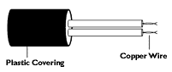

Figure 5.5.2 Twisted Pair Cable
- Extensively used in telephone circuits, where several wires are insulated and put together.
- Bandwidth: 250 KHz.
- Low signal to noise ratio (cross talk) -> Low data rate.
- Good for short-distance communications.
- Used in LAN (UTP or 10baseT).

Optical Fiber
Fiber optic cable has the ability to transmit more information, more quickly and over longer distances. Fiber optic cable offers almost unlimited bandwidth and unique advantages over all previously developed transmission media. The basic point-to-point fiber optic transmission system consists of three basic elements: the optical transmitter, the fiber optic cable and the optical receiver.
The Optical Transmitter: The transmitter converts an electrical analog or digital signal into a corresponding optical signal. The source of the optical signal can be either a light emitting diode, or a solid-state laser diode. The most popular wavelengths of operation for optical transmitters are 850, 1300, or 1550 nanometers.
The Fiber Optic Cable: The cable consists of one or more glass fibers, which act as waveguides for the optical signal. Fiber optic cable is similar to electrical cable in its construction, but provides special protection for the optical fiber within. For systems requiring transmission over distances of many kilometers, or where two or more fiber optic cables must be joined together, an optical splice is commonly used.
The Optical Receiver: The receiver converts the optical signal back into a replica of the original electrical signal. The detector of the optical signal is either a PIN-type photodiode or avalanche-type photodiode.
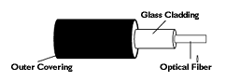

Figure 5.5.3 Fiber Optic Cable

- High quality and high bandwidth data transmission applications.
- Use light instead of electric pulses for message transmission.
- Very high frequency ranges (20,000 MHz).
- Single fiber can support over 30,000 telephone lines.
- Data transmission rates of 400 Mbits/s and more.
- Becoming very popular for MAN and LAN, also used for intercontinental links.
- High signal to noise ratio, difficulty in tapping (security).
- Cost is the single biggest drawback (currently).

Advantages of Fiber Optic communication
Fiber optic transmission systems – a fiber optic transmitter and receiver, connected by fiber optic cable – offer a wide range of benefits not offered by traditional copper wire or coaxial cable. These include:
1. The ability to carry much more information and deliver it with greater fidelity than either copper wire or coaxial cable.
2. Fiber optic cable can support much higher data rates, and at greater distances, than coaxial cable, making it ideal for transmission of serial digital data.
3. The fiber is totally immune to virtually all kinds of interference, including lightning, and will not conduct electricity. It can therefore come in direct contact with high voltage electrical equipment and power lines. It will also not create ground loops of any kind.
4. As the basic fiber is made of glass, it will not corrode and is unaffected by most chemicals. It can be buried directly in most kinds of soil or exposed to most corrosive atmospheres in chemical plants without significant concern.
5. Since the only carrier in the fiber is light, there is no possibility of a spark from a broken fiber. Even in the most explosive of atmospheres, there is no fire hazard, and no danger of electrical shock to personnel repairing broken fibers.
6. Fiber optic cables are virtually unaffected by outdoor atmospheric conditions, allowing them to be lashed directly to telephone poles or existing electrical cables without concern for extraneous signal pickup.
7. A fiber optic cable, even one that contains many fibers, is usually much smaller and lighter in weight than a wire or coaxial cable with similar information carrying capacity. It is easier to handle and install, and uses less duct space. (It can frequently be installed without ducts.)
8. Fiber optic cable is ideal for secure communications systems because it is very difficult to tap but very easy to monitor. In addition, there is absolutely no electrical radiation from a fiber

2. Unbound Media
Media is the path used for transferring data in a network. Unbound Media consists of the wireless path used to transfer data. The following is a list of the types of unbound media and their susceptibility to EMI - (Electrical Magnetic Interference).
- Radio Waves
- Micro Waves - Terrestrial and Satellite
- Infrared

Microwave Transmission
Another popular transmission medium is microwave. This is a popular way of transmitting data since it does not require the expense of laying cables. Microwave systems use very high frequency radio signals to transmit data through space. However, at microwave frequencies the electromagnetic waves cannot bend or pass through obstacles like hills, etc. Hence microwave transmission is a line-of-sight method of communication. In other words, the transmitter and receiver of a microwave system, which are mounted on very high towers, should be in a line-of-sight. This may
not be possible for very long distance transmission due to physical constraints. Moreover, the signals become weak after traveling a certain distance and require power amplification.
In order to overcome the problems of line-of-sight and power amplification of weak signals, microwave systems use repeaters at intervals of about 25 to 30 km in between the transmitting and receiving stations. The first repeater is placed in line-of-sight of the transmitting station and the last repeater is placed in line-of-sight of the receiving station. Two consecutive repeaters are also placed in line-of-sight of each other. The data signals are received, amplified, and re-transmitted by each of these stations.

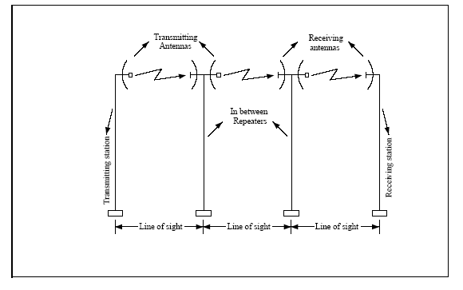
Figure 5.5.4. Microwave Transmission
Advantages and Limitations of Microwave Transmission
Microwave systems permit data transmission rates of about 16 Giga (1 giga = 109) bits per second. At such high frequency, a microwave system can carry 250,000 voice channels at the same time.
However, the capital investment needed to install microwave links is very high and hence they are mostly used to link big metropolitan cities that have heavy telephone traffic between them.

3. Wireless Media

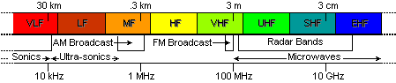
Figure 5.5.5.

- For WANs satellites provide global communication over the world, receiving signals from transmitters and relaying them back to the receivers.
- With geostationary satellites senders and receivers always points the same direction.
- High communication capacity. Big latency: 0.25 secs.
- For MANs microwave radio technology is widely used (2 to 24 Mbit/s).
- For LANs Spread Spectrum radio technology is becoming very popular (up to 2 Mbit/s).
- Infrared: Line of sight limitation.

Communication Satellite
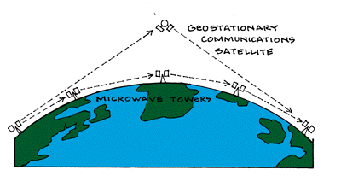
Figure 5.5.6.
The main problem with microwave communications is that the curvature of the earth, mountains, and other structures often block the line-of-sight. Due to this reason, several repeater stations are normally required for long distance transmission, which increases the cost of data transmission between two points. This problem is overcome by using satellites which are relatively newer and more promising data transmission media.
A communication satellite is basically a microwave relay station placed precisely at 36,000 km above the equator where its orbit speed exactly matches the earth’s rotation speed. Since a satellite is positioned in a geo-synchronous orbit, (i.e. the orbit where the speed of the satellite matches the earth’s rotation speed), it appears to be stationary relative to earth and always stays over the same point with respect to earth. This allows a ground station to aim its antenna at a fixed point in the sky. The Indian satellite, INSAT-1B, is positioned in such a way that it is accessible from any place in India.
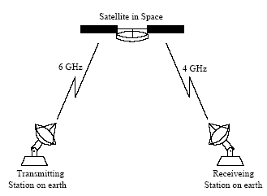
Figure 5.5.7.

Communications through satellites are either passive or active. The first communications satellites were passive. Signals from Earth were merely reflected from the orbiting metallic sphere. Later types of satellites are active. Active communication satellites receive signals from Earth, electronically strengthen the signals, and transmit the signals to Earth.

This relaying of signals from one Earth Station to another is done through the satellite's transponder. Most communications satellites have more than one transponder and antenna so that they can relay several users of radio waves or signals at the same time.
Advantages and Limitations
The main advantage of satellite communication is that it is a single microwave relay station visible from any point of a very large area on the earth. For example, satellites used for national transmission are visible from all parts of the country. Thus transmission and reception can be between any two randomly chosen places in that area. Moreover, transmission and reception costs are independent of the distance between the two points. In addition to this, a transmitting station can receive back its own transmission and check whether the satellite has transmitted the information correctly. If an error is detected, the data would be retransmitted.
A major drawback of satellite communications has been the high cost of placing the satellite into its orbit. Moreover, a signal sent to a satellite is broadcasted to all receivers within the satellite’s range. Hence necessary security measures need to be taken to prevent unauthorized tampering of information.
Communications satellites are launched by rockets or carried into space by the Space Shuttle. Once in space, small engines on the satellites guide the satellite into orbit and help keep them there. Most communications satellites are placed in orbit at an altitude of 22,300 miles above the Earth. This is known as a geostationary or synchronous orbit. This allows the satellite to orbit the Earth at the same speed as the rotation of the Earth. As a result, the satellite appears to be stationary above the same location on Earth.
Communications satellites will be used to link all the regions and people of the world.
This is a giant step from the early uses of communication satellites. This global system will consist of many satellites, positioned in geostationary orbit, providing high bandwidth capacity; interconnect many highly specialized Earth Stations operating in more than thirty countries. This network, already in progress by consortiums headed by Motorola (Iridium) will provide the framework and capability for anyone in the world to communicate with anyone else, regardless of location.

ISDN
ISDN stands for Integrated Services Digital Network. It is a design for a completely digital telephone/telecommunications network. It is designed to carry voice, data, images, and video, everything you could ever need. It is also designed to provide a single interface (in terms of both hardware and communication protocols) for hooking up your phone, your fax machine, your computer, your videophone, your video-on-demand system (someday), and your microwave.
B-ISDN is Broadband ISDN. (The older ISDN is often called Narrowband ISDN.) This is not simply faster ISDN, or ISDN with the copper to your home finally upgraded to fiber. B-ISDN is a complete redesign. It is still capable of providing all the integrated services (voice, data, video, etc.) through a single interface just like ISDN was supposed to.

ISDN Architecture
ISDN components include terminals, terminal adapters (TA), network-termination devices, line-termination equipment and exchange-termination equipment.
- ISDN terminals come in two types:
- Specialized ISDN terminals are referred to as terminal equipment type 1 (TE1).
- Non - ISDN terminals such as DTE that predate the ISDN standards are referred to as terminal equipment type 2 (TE2).
TE1 are connected to the ISDN network through a four-wired twisted-pair digital link.
TE2 are connected to the ISDN network through a terminal adapter.
The ISDN TA can either be a stand-alone device or a board inside TE2. If implemented as a stand-alone device, the TE2 is connected to the TA via a standard physical layer interface.
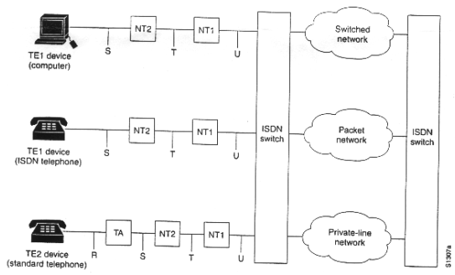

Figure 5.5.8. Sample ISDN Configuration

