MODULE III
NETWORK LAYER

NETWORK LAYER DESIGN ISSUES
The network layer has been designed with the following goals:
- The services provided should be independent of the routing technology. Users of the service need not be aware of the physical implementation of the network. This design goal has great importance when we consider the great variety of networks in operation. In the area of public networks, networks in underdeveloped countries are nowhere near that in the countries like the US or Ireland. The design of the layer must not disable us from connecting to networks of different technologies.
- The transport layer (that is the host computer) should be shielded from the number, type and different topologies of the routers present. That is, all that the transport layer wants is a communication link; it need not know how that link is made.
- Finally, there is a need for some uniform addressing scheme for network addresses.

Services provided to the Transport Layer
The network layer provides two different types of service,
- Connection oriented
- Connectionless.
A connection-oriented service is one in which the user is given a "reliable" end to end connection. In a connection-less service, the user simply bundles his information together, puts an address on it, and then sends it off, in the hope that it will reach its destination. There is no guarantee that the bundle will arrive. So - a connection less service is somewhat identical to the postal system. A letter sent, is then in the "postal network" where it gets bounced around and hopefully will leave the network in the correct place, that is, in the addressee's letter box. We can never be totally sure that the letter will arrive, but we know that there is a high probability that it will, and so we place our trust in the postal network.
With a connection oriented service, the user must pay for the length (i.e. the duration) of his connection. Usually this will involve a fixed start up fee. Now, if the user intends to send a constant stream of data down the line, he is given a reliable service for as long as he wants. However, say the user wished to send only a packet or two of data - now the cost of setting up the connection greatly overpowers the cost of sending. A telephone call is the classic example of a connection oriented service.

Internal organization of the network layer
The subnet is organized in two different ways
- Virtual circuits: used in subnets whose primary service is connection-oriented.
- Datagrams correspond to the independent packets of the connectionless organization.

Datagrams
Each datagram must contain the full destination address. The routers have a table telling which outgoing line to use for each possible destination router. (These tables are also needed in virtual circuit subnets for determining the route for a SETUP packet). Routes are not worked out in advance. Successive packets may follow different routes.
Virtual Circuits
- Each router must maintain a table with one entry per open virtual circuit passing through it.
- Each packet traveling through the subnet must contain a virtual circuit number field in its header, in addition to sequence numbers, checksums, and the like.
- Whenever a host wants to create a new outbound virtual circuit, it chooses the lowest circuit number not currently in use (locally), and put this number in the header of a SETUP packet.
- The router does not forward this SETUP packet to the next router as is. Instead, router chooses the lowest free VC number and substitutes that number for the one chosen by the host, and then forwards the SETUP packet to router.
- Similarly, router chooses the lowest free number between it and the next router, substitutes that number for the one chosen by router, and then forwards the setup packet to the next router.
- When this SETUP packet finally arrives at the destination, the router there chooses the lowest free inbound circuit number, substitutes that number for the one in the packet, and pass it to the host.

Comparison between datagrams and virtual circuits

Issue | Datagram | Virtual Circuit
Addressing | Each packet contains the full source and destination addresses | Each packet contains a virtual circuit number
Circuit Setup | Not needed | Required
Routing | Each packet is routed independently | Route is chosen when the virtual circuit is setup, all packets follow this route
State Information | Routers do not hold information about connections | Each VC requires router table space per connection
Quality of Service | Difficult | Easy if enough resources can be allocated in advance for each VC
Congestion Control | Difficult | Easy if enough resources can be allocated in advance for each VC
Effect of router failures | None, except for packets lost during the crash | All virtual circuits that are passed through the failed router are terminated

ROUTING ALGORITHMS
Routing is the act of moving information across an internetwork from a source to a destination. Along the way, at least one intermediate node typically is encountered. Routing is often contrasted with bridging, which might seem to accomplish precisely the same thing to the casual observer. The primary difference between the two is that bridging occurs at Layer 2 (the datalink layer) of the OSI reference model, whereas routing occurs at Layer 3 (the network layer).
Routing involves two basic activities: determining optimal routing paths and transporting information groups (typically called packets) through an internetwork. In the context of the routing process, the latter of these is referred to as packet switching.
The routing algorithm is that part of the network layer software responsible for deciding which output line an incoming packet should be transmitted on.
Routing algorithms often have one or more of the following design goals:
- Correctness – are the packets getting to the right destination?
- Simplicity – the simpler the algorithm and steps, the easier to understand, to extend, modify and improve. Routing algorithms also are designed to be as simple as possible.
- Robustness – If something happens to the network (e.g. some lines go down, some user in a machine starts sending out a huge amount of data, etc), does the algorithm cater for that? This is good if a network is very dynamic and changes occur frequently, which means that they should perform correctly in the face of unusual or unforeseen circumstances, such as hardware failures, high load conditions, and incorrect implementations. Because routers are located at network junction points, they can cause considerable problems when they fail. The best routing algorithms are often those that have withstood the test of time and that have proven stable under a variety of network conditions.
- Stability – Does the routes change all the time? If the routes are unstable, even when there are little changes to the network, the routers will incur the overhead of having to keep changing their routing tables. This must be balanced with robustness of the algorithm.
- Fairness – How well does the algorithm ensure all routers have the same share of network utilization, and the same consideration when finding routes for them?
- Optimality – How well does the algorithm ensure that the cost (time, hops, distance, etc) is kept to a minimal? This is balanced against fairness

Optimality principle: Optimality refers to the capability of the routing algorithm to select the best route, which depends on the metrics and metric weightings used to make the calculation. If a router k is on the optimal path from router i to router j, then the optimal path from k to j is also falls along the same route.
The set of optimal routes from all sources to a given destination form a tree (called sink tree) rooted at the destination.

In addition, routing algorithms must converge rapidly. Convergence is the process of agreement, by all routers, on optimal routes. When a network event causes routes to either go down or become available, routers distribute routing update messages, stimulating recalculation of optimal routes and eventually causing all routers to agree on these routes. Routing algorithms that converge slowly can cause routing loops.

Routing algorithms can be divided into two major classes:
- Nonadaptive algorithms or Static Routing algorithms
- Adaptive algorithms or Dynamic Routing algorithms

Static Routing Algorithms
Nonadaptive algorithms do not base their routing decisions on measurements or estimates of the current traffic and topology. The choice of the route to use is computed in advance, off-line, and downloaded to the routers when the network is booted (Static Routing).

1. Shortest Path Routing

This is the simplest and widely used technique. The basic idea:
- Build a graph of the subnet, with each node of the graph representing a router and each arc of the graph representing a communication line.
- To choose a route between a given pair of routers, the algorithm finds the shortest path between them.
Metrics for measuring the shortest path can be any one of the following,
- The number of hops.
- The geographic distance in kilometers.
- The mean queuing and transmission delay.
- A function of the distance, bandwidth, average traffic, communication cost, mean queue length, measured delay, etc.
The Dijkstra’s algorithm is used to find the shortest path. The following steps are performed:
  - The router builds a status record set for every node on the network. The record contains three fields:
  - Predecessor field - This field shows the previous node.
  - Length field - This field shows the sum of the weights from the source to that node.
  - Label field - This field shows the status of node. Each node can have one status mode: "permanent" or "tentative."
  - The router initializes the parameters of the status record set (for all nodes) and sets their length to "infinity" and their label to "tentative."
  - The router sets a T-node. For example, if V1 is to be the source T-node, the router changes V1's label to "permanent." When a label changes to "permanent," it never changes again. A T-node is an agent and nothing more.
  - The router updates the status record set for all tentative nodes that are directly linked to the T-node.
  - The router looks at all of the tentative nodes in the entire network and chooses the one whose weight to V1 is lowest. That node is then the destination T-node.
  - If this node is not V2 (the intended destination), the router goes back to step 4.
  - If this node is V2, the router extracts its previous node from the status record set and does this until it arrives at V1. This list of nodes shows the best route from V1 to V2.

Example: Dijkstra Algorithm
Here we want to find the best route between A and E (see below). You can see that there are six possible routes between A and E (ABE, ACE, ABDE, ACDE, ABDCE, ACDBE), and it's obvious that ABDE is the best route because its weight is the lowest. But life is not always so easy, and there are some complicated cases in which we have to use algorithms to find the best route.
- As you see in the image below, the source node (A) has been chosen as T-node, and so its label is permanent (we show permanent nodes with filled circles and T-nodes with the --> symbol).
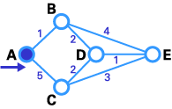
- In this step, you see that the status record set of tentative nodes directly linked to T-node (B, C) has been changed. Also, since B has less weight, it has been chosen as T-node and its label has changed to permanent (see below).
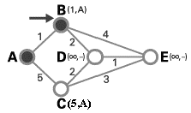
- In this step, like in step 2, the status record set of tentative nodes that have a direct link to T-node (D, E), has been changed. Also, since D has less weight, it has been chosen as T-node and its label has changed to permanent (see below).
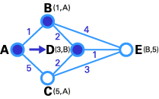
- In this step, we don't have any tentative nodes, so we just identify the next T-node. Since E has the least weight, it has been chosen as T-node.
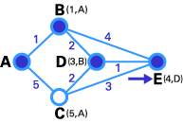
- E is the destination, so we stop here.
Now we have to identify the route. The previous node of E is D, and the previous node of D is B, and B's previous node is A. So the best route is ABDE. In this case, the total weight is 4 (1+2+1).

2. Flooding
Another static routing algorithm is flooding. In flooding every incoming packet is sent out on every outgoing line except the one it arrived on.
Measures for damming the flood:
- A hop counter is included in the header of each packet, which is decremented at each hop. A packet is discarded when the counter reaches zero.
- A sequence number is included in each packet. Each router maintains a list per source router telling which sequence numbers originating at that source have already been seen. A packet is discarded when it contains a sequence number that is in the list.

Selective flooding - an incoming packet is sent on those lines that are going approximately in the right direction.
Possible applications of flooding:
- In military applications, to withstand large numbers of routers crashes at any instant.
- As a metric (always choose the shortest path) against which other routing algorithms can be compared.
- In distributed database flooding used to update the databases concurrently.

Flow Based Routing
It takes into account of the load. It is suitable in some networks (e.g., a corporate network for a retail store chain), in which the mean data flow between each pair of nodes is relatively stable (approximately constant in time) and predictable.
Information known in advance:
- The subnet topology.
- The capacity for each line in the subnet.
- The average traffic (pkts/sec) between any pair of nodes.
Main calculations involved:
- Tentatively choose a routing algorithm.
- Apply the tentatively chosen routing algorithm to the known subnet topology to select a path from each node to all other nodes.
- For each line, calculate the average flow according to the selected path and the known average traffic between any pair of nodes.
- For each line, compute the mean packet delay on that line from queuing theory (assuming a mean packet delay)
- For each line, calculate the flow-weight - the fraction of the total traffic using that line.
- For the whole subnet, calculate mean packet delay according to the flow-weight and the mean packet delay for each line.
The routing problem reduces to finding the routing algorithm (from a collection of known single path routing algorithms) that produces the minimum average delay for the entire subnet. Since the calculations can be done off-line, the fact that it may be time consuming is not necessarily a serious problem.

Dynamic Routing Algorithms
Adaptive algorithms attempt to change their routing decisions to reflect changes in topology and the current traffic. (Dynamic Routing).
1. Distance Vector Routing
A distance vector routing protocol advertises the number of hops to a network destination (the distance) and the direction in which a packet can reach a network destination (the vector). The distance vector algorithm, also known as the Bellman-Ford algorithm, enables a router to pass route updates to its neighbors at regularly scheduled intervals. Each neighbor then adds its own distance value and forwards the routing information on to its immediate neighbors. The result of this process is a table containing the cumulative distance to each network destination.
Distance vector routing protocols, the earliest dynamic routing protocols, are an improvement over static routing, but have some limitations. When the topology of the internetwork changes, distance vector routing protocols can take several minutes to detect the change and make the appropriate corrections.
One advantage of distance vector routing protocols is simplicity. Distance vector routing protocols are easy to configure and administer. They are well suited for small networks with relatively low performance requirements. Most distance vector routing protocols use a hop count as a routing metric. A routing metric is a number associated with a route that a router uses to select the best of several matching routes in the IP routing table. The hop count is the number of routers that a packet must cross to reach a destination.
Consider the following subnet
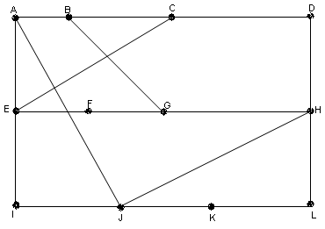

Router J receives the following delay vectors from its neighboring routers A, I, H and K. Router J has calculated its delay to A, I, H and K as 8, 10, 12 and 6 respectively. This is done by sending an ECHO packet to its neighbors and finding the round trip time.

 | A | I | H | K
A | 0 | 24 | 20 | 21
B | 12 | 36 | 31 | 28
C | 25 | 18 | 19 | 36
D | 40 | 27 | 8 | 24
E | 14 | 7 | 30 | 22
F | 23 | 20 | 19 | 40
G | 18 | 31 | 6 | 31
H | 17 | 20 | 0 | 19
I | 21 | 0 | 14 | 22
J | 9 | 11 | 7 | 10
K | 24 | 22 | 22 | 0
L | 29 | 33 | 9 | 9

From this information, router J computes its new routing table by finding the path with the shortest delay to each router in the subnet.
For example:
For router B, if J takes the path through A the delay is 8+12 = 20
If J takes the path through I the delay is 10+36 = 46
If J takes the path through H the delay is 12+31 = 43
If J takes the path through K the delay is 6+28 = 34
The path with shortest delay for J to reach B is through its neighbor A. Similarly for the other routers also J calculates the path with minimum delay and updates its routing table with the delay and the path to reach each router.
Now the routing table for J is

 | Delay | Path
A | 8 | A
B | 20 | A
C | 28 | I
D | 20 | H
E | 17 | I
F | 30 | I
G | 18 | H
H | 12 | H
I | 10 | I
J | 0 | -
K | 6 | K
L | 15 | K

Routing Information Protocol (RIP) is the best known and most widely used of the distance vector routing protocols. RIP version 1 (RIP v1), which is now outmoded, was the first routing protocol accepted as a standard for TCP/IP. RIP version 2 (RIP v2) provides authentication support, multicast announcing, and better support for classless networks. The Windows Server 2003 Routing and Remote Access service supports both RIP v1 and RIP v2 (for IPv4 only).
Using RIP, the maximum hop count from the first router to the destination is 15. Any destination greater than 15 hops away are considered unreachable. This limits the diameter of a RIP internetwork to 15. However, if you place your routers in a hierarchical structure, 15 hops can cover a large number of destinations.

Link State Routing
- To replace Distance Vector Routing
- Problem with Distance Vector Routing – uses only delay at a node – doesn't consider line capacity
Each router
- Discover its neighbors and addresses – this is done by sending out HELLO packets on start-up and receiving replies from neighbors.
- Measure the cost to each neighbor – measure the round-trip time taken to send an ECHO packet and to receive a reply.
- Construct link state packets and send it to all routers – these link state packets contains what each router knows about the cost to each of its neighbors.
- Compute the shortest path to each router based on received link state packets from other routers.

HIERARCHICAL ROUTING
In both link state and distance vector algorithms, every router has to save some information about other routers. When the network size grows, the number of routers in the network increases. Consequently, the size of routing table increases, and routers can't handle network traffic efficiently. Hierarchical routing solves this problem.
In hierarchical routing network is divided into regions. Each region has a main router.
All routers need to know only about the routers in their region and the main routers in the other regions. So routers just save one record in their table for every other region.
Suppose we use distance vector algorithms to find best routes between nodes. In the situation depicted below, every node of the network has to save a routing table with 17 records. Here is a typical graph and routing table for router A.
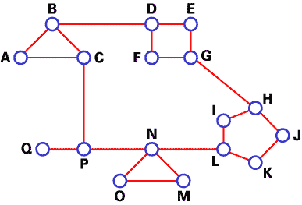

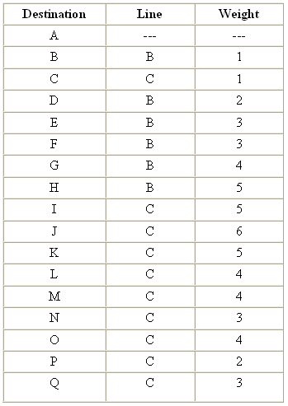
Routing Table for Router A
In this example, we have classified our network into five regions.
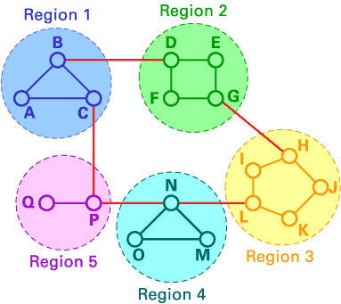
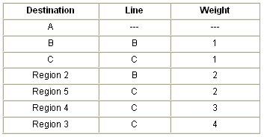
Routing table for A in Hierarchical Routing
If A wants to send packets to any router in region 2 (D, E, F or G), it sends them to B. As you can see, in this type of routing, the tables can be summarized, so network efficiency improves. The above example shows two-level hierarchical routing. We can also use three- or four-level hierarchical routing.
In three-level hierarchical routing, the network is classified into a number of clusters. Each cluster is made up of a number of regions, and each region contains a number or routers. Hierarchical routing is widely used in Internet routing and makes use of several routing protocols.

ROUTING FOR MOBILE HOSTS
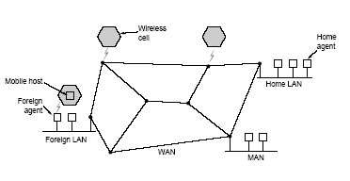
In this routing, nodes can move amongst regions or areas.
There are three kinds of nodes
- Stationary
- Migratory
- Mobile
The challenge is how to find a portable host that could potentially be anywhere. Each mobile host has a home location, with a home agent. When the mobile host moves to a new location, it registers with a foreign agent. The foreign agent lets home agent know when a sender sends a packet to the mobile host. Home agent forwards packet to foreign agent to pass to mobile host. Home agent also notifies sender to send subsequent packets to mobile host's foreign agent.

BROADCAST ROUTING
Broadcasting is sending packets to more than one host in the subnet. The possible ways are,
- Sender sends one packet to each possible destination
- Flooding
- Multi-destination Routing
- Reverse path forwarding – router will forward the packet to its outgoing links only if the packet arrived on the shortest path back to the source.
- Using spanning tree (sink tree) – a node will forward the packet to all its neighbors in the spanning tree.
MULTICAST ROUTING
Some hosts spread over a large network can be put into "multicast" groups – packets sent out to a group is sent to every member of a group. E.g. news updates service where news is sent to every user who subscribes. It can't use broadcast since some machines are not meant to receive the packets. In a LAN, we are less security conscious and assume that the supporting protocols for each machine will ignore all packets not meant for it. Here we have a set of routers from very different networks. We can't trust that all routers (or their administrators) will not illegally read the packets.
One way of doing multi-cast routing to a particular group:
- Compute a spanning tree joining all nodes – there may be more than one.
- Delete the links that do not lead to members of the group.
- Using this pruned spanning tree forward the packet to all the neighbors in the pruned spanning tree.

CONGESTION CONTROL
What happens when there are more packets in a path than the routers can handle? This situation is called congestion. At very high traffic, performance collapses completely and almost no packets are delivered.
When too much traffic is offered, congestion sets in and performance degrades sharply
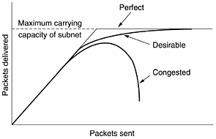
Congestion can be brought on by several factors. If all of a sudden, streams of packets begin arriving on three or four input lines and all need the same output line, a queue will build up. If there is insufficient memory to hold all of them, packets will be lost. Regulating the average rate of data transmission is called traffic shaping.

Causes of congestion
- The input traffic rate exceeds the capacity of the output lines (Routers receiving packets from multiple incoming lines, all meant for the same outgoing line).
- Slow processors for the routers - in this case, the packets from the multiple incoming lines are coming in faster than the routers can process them and send them back out.
- Low bandwidth lines
- The routers' buffer is too limited.

Difference between congestion control and flow control
Flow control is between sender and receiver. In flow control, it is about not having a fast sender flood a slow receiver, when the slow receiver is not able to process the packets. An example when we have a flow control problem but no congestion is a fast supercomputer sends packets to a slow workstation. The packets are not delayed at any of the routers, and so get to the workstation very quickly. Unfortunately, the workstation can’t process the packets fast enough. In this case, there is no congestion (in the network), but there is a flow problem (between the sender and receiver).
Congestion control makes sure that the subnet is able to carry the offered traffic. It is a global issue that involves the behavior of all hosts, all routers, store and forwarding processing within the routers etc.

CONGESTION CONTROL ALGORITHMS
Congestion control algorithms can be classified as

Open loop
  - Attempts to solve the problem by good design
  - Makes sure that congestion does not occur
  - Once the system is up and running, midcourse corrections are not made

Closed loop
Have feedback on congestion in real-time, and respond. The different steps are:
1. Monitor for congestion - Explicit monitors detects congestions by having the congested nodes send packets to notify others. Implicit monitors detect congestion by inferring from local data, such as how long acknowledgments take to get back. Chief metrics for monitoring the subnet for congestion are:
- percentage of all packets discarded for lack of buffer space
- average queue lengths
- number of packets that time out and are retransmitted
- average packet delay
- standard deviation of packet delay
  - Pass the information to appropriate places where actions can be taken. Usually the best place to pass congestion information to is the source of the packets. The source is most able to adjust to congestion (by re-routing, slowing down, etc). The different methods to propagate the monitored congestion information are
- The router detecting the congestion sends a separate warning packet to the traffic source.
- A bit or field can be reserved in each packet. When a router detects a congested state, it fills in the field in all outgoing packets to warn the neighbors.
- Hosts or routers send probe packets out periodically to explicitly ask about congestion and to route traffic around problem areas.
  - Adjust the system operations to correct the problem. The different methods to correct congestion problem are:
- Increase the resource:
  - Using an additional line to temporarily increase the bandwidth between certain points.
  - Splitting traffic over multiple routes.
  - Using spare routers.
- Decrease the load:
  - denying service to some users,
  - degrading service to some or all users
  - having users schedule their demands in a more predictable way.
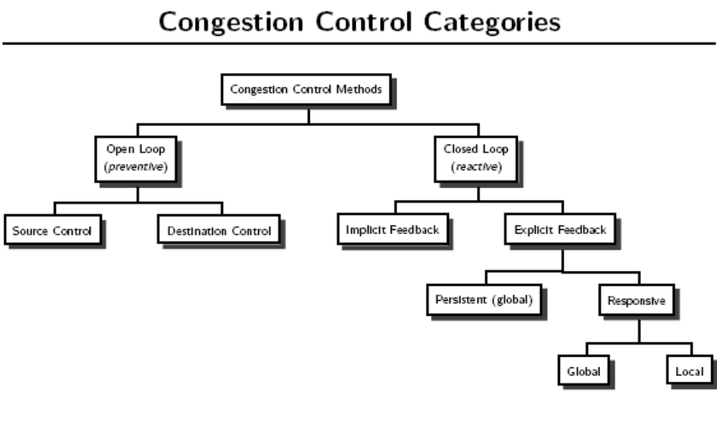

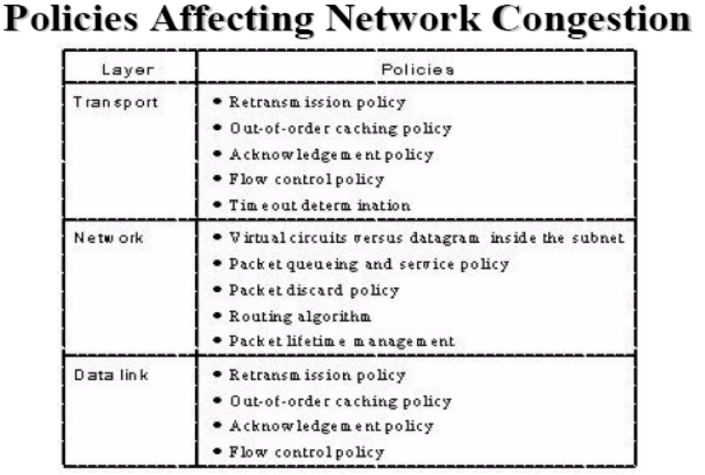
Open Loop Solutions
Traffic Shaping
- Controlling congestion by controlling the rate of data transmission mainly at the source of the packets.
- Having host transmit at uniform rate usually cause less congestion – network less affected by bursts of packets.
- Requires an agreement between all senders, receivers and subnet on how the network flow should be like - if for example, most hosts agrees to transmit at a slow rate, but one decides it will transmit at the fast rate, then the fast host will end up hogging the lines it uses.
Algorithms used for traffic shaping are
- Leaky Bucket Algorithm
- Token Bucket Algorithm

Leaky Bucket Algorithm
The leaky bucket algorithm is similar to how a leaky bucket behaves under a tap. The drip from the leak is always constant regardless of how fast water is coming from a tap, and if the bucket is full, then water will overflow and be discarded.
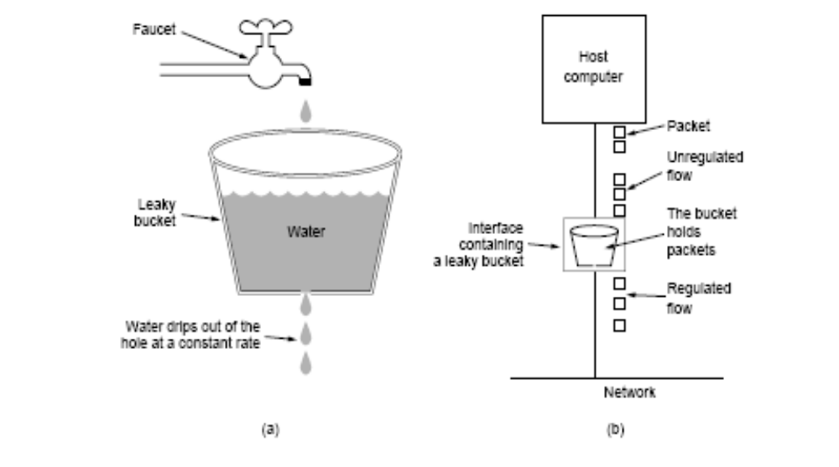
In a network using the leaky bucket algorithm, data coming from a host goes through an interface. The interface stores up the packets from the source in memory and sends them out in a constant rate. If the memory fills up, the packets will be discarded (the host will re-transmit at a later time when it times out).
To handle variable size packets, instead of sending one packet per clock tick, a fixed number of bytes are transmitted.

Token Bucket Algorithm
Here also we use an interface (bucket) to regulate the flow, but we want to allow a slightly faster rate when the bucket is relatively full and slower when relatively empty. We do this by having the interface generate tokens. A packet being sent through the interface must consume a token. If there are no tokens, the packets must wait. By having the interface generate the tokens at a regular interval, we can have the tokens saved up at idle times, to be used for a burst when the packets come. And at busy times, the rate of transmission is still constant since the tokens are generated at a constant rate.
Token bucket algorithm design
– Leaky bucket holds tokens
– Tokens generated by a clock, one token every ΔT seconds
– Bucket has a maximum size (capacity) of c tokens
– For a cell to be transmitted, it must remove one token from the bucket

Performance of the token bucket algorithm
Let s = burst length (seconds)
c = bucket capacity (bytes)
ρ = token arrival rate (bytes/second)
m = maximum source rate (bytes/second)
Then the maximum bytes sent from the token bucket during a burst is c + ρ × s
Maximum bytes the source can send during a burst is m × s
Setting the two equal and solving for s
s = c ÷ (m − ρ)

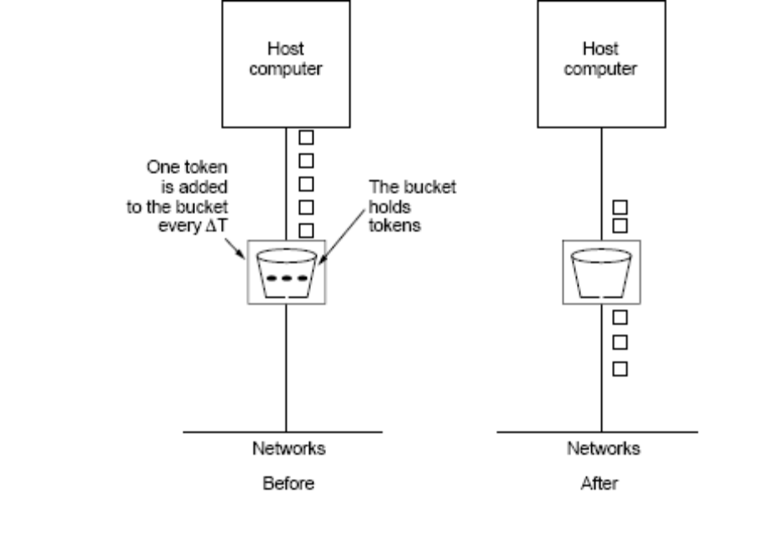

Closed Loop Solutions
The different closed loop solutions are
- Congestion control in virtual circuit subnets
- Choke packets
- Load shedding

Congestion Control in Virtual Circuit Subnets
- Admission control: once congestion has been signaled, no more virtual circuits are set up until the problem has gone away.
- Allow new VC, but choose an alternate path: Suppose that a host attached to router A wants to set up a connection to a host attached to router B. Normally, this connection would pass through one of the congested routers. To avoid this situation, we can redraw the subnet omitting the congested routers and all of their lines. The dashed line shows a possible route for the virtual circuit that avoids the congested routers.

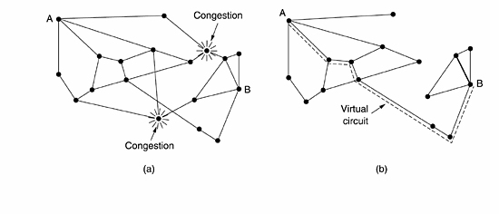
- Negotiate an agreement between the host and subnet when a virtual circuit is set up: This agreement specifies the volume and shape of the traffic, quality of service required, and other parameters. The subnet will reserve resources along the path when the circuit is set up. These resources can include table and buffer space in the routers and bandwidth on the lines. In this way, congestion is unlikely to occur on the new virtual circuits because all the necessary resources are guaranteed to be available.

Choke Packets
This method can be used in either VCs or datagram subnets. Every router maintains a variable for every outgoing line. The variable indicates how often the line is used. The router will obviously know how often a particular outgoing line is being used. If the variable goes above a threshold value, the line goes into a warning state. If an incoming packet requires an outgoing line that is in warning state, a choke packet is sent back to the source and the packet is till forwarded as normal. Source receiving choke packets adjust their sending patterns by either slow down, or re-route through somewhere else.

Load Shedding
The strategy adopted is that, when routers can’t handle the load, just dump incoming packets. But decision has to be made on which packets to dump, new or old packets. This depends on what type the packets are. In some applications, it is better that new packets get dumped. E.g. in interlaced image packets, packets sent out first (old packets) contain the coarse-grain image, and then the later packets (new packets) fill in the details. So getting the coarse-grain image without the details may still be usable, but having the details without the coarse-grain image to work with is not. On the other hand, in some applications, it is better that old packets get dumped. E.g. in file transfers, if any packets are to be discarded, it would be better that the one sent out earlier (old packets). This is so that the sender gets time out a lot sooner and re-transmits the file, rather than falsely believing that since the earlier packets are getting acknowledged, that everything is OK.
Another strategy is to dump packets with low priority. Source label the priority of the packets and put them in priority fields in the packet headers and routers can use these priority fields and dump the low priority packets first.

Jitter Control
In some audio and video transmission, speed for each packet is not as important as having a constant rate for all the packets. Routers can calculate if these packets are ahead or behind the scheduled rate, and during congestion hold off packets currently ahead of the schedule. This involves the packets having a time-stamp, and the routers using this time-stamp to determine if the packet is ahead of the schedule or not.

INTERNET PROTOCOL
The Internet is a collection of many different networks. The central protocol, which holds all the different networks together, is the Internet Protocol (or IP). The aim of IP is to transport datagrams from source to destination inside and outside the same network.
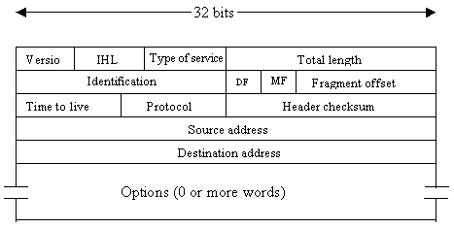

The IPv4 (Internet Protocol) header

Fields in an IPv4 header:
- Version: specifies which version of IP.
- IHL: this header's length - minimum 160 bits.
- Type of Service: what type of service this packet requires (e.g. reliability, speed, etc). Each router can try and satisfy this.
- Total length: this header's length - maximum 64Kb.
- Identification, DF, MF, Fragment Offset: for fragmenting packets that are too large.
- Time to live: value to limit packet lifetime, so that it doesn't float around forever - set by host and decreased by each router.
- Protocol: the protocol, which pass IP the data (e.g. TCP).
- Checksum: checksum for the header, to ensure there are no errors.
- Source and Destination Addresses: sender and receiver of the data.
- Options: other useful header fields not included above.

