MODULE V
APPLICATION LAYER
4.1. DOMAIN NAME SYSTEM
The Domain Name System (DNS) is the method by which Internet addresses in mnemonic form such as cse.cusat.ac.in are converted into the equivalent numeric IP address such as 134.220.4.1. To the user and application process this translation is a service provided either by the local host or from a remote host via the Internet. The DNS server (or resolver) may communicate with other Internet DNS servers if it cannot translate the address itself.
The system accesses the DNS through a resolver. The resolver gets the hostname and returns the IP address or gets an IP address and looks up a hostname. The resolver returns the IP address before asking the TCP to open a connection or sending a datagram using UDP.
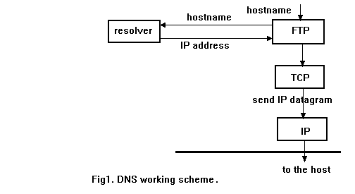
4.1.1. DNS Name Structure
DNS names are constructed hierarchically. The highest level of the hierarchy being the last component or label of the DNS address. Labels can be up to 63 characters long and are case insensitive. A maximum length of 255 characters is allowed. Labels must start with a letter and can only consist of letters, digits and hyphens. The root of the DNS tree is a special node with a null label. In the DNS we start from the leaf and "go up" till the root.
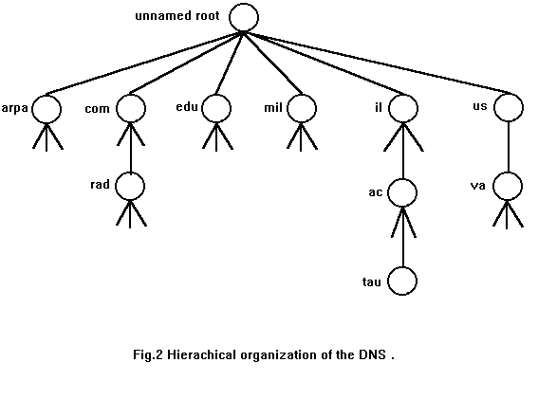
Top-level domains can be classified as
- Generic
- Country
The seven 3-character generic domain names.
code | meaning
com | Commercial. Now international.
edu | Educational.
gov | Government.
int | International Organization.
mil | Military.
net | Network related.
org | Miscellaneous Organization.

The Internet scheme can accommodate a wide variety of organizations, and allows each group to choose between geographical or organizational naming hierarchies. Most sites follow the Internet scheme so they can attach their TCP/IP installations to the connected Internet without changing names. The zone is a sub tree of the DNS that is administered separately. A common zone is a second-level domain, "ac.il" for example. Thus a lot of second-level domains divide their zone into smaller zones.
Whenever a new system is installed in a zone, the DNS administrator for the zone allocates a name and an IP address for the new system and enters these into the name server's database. A name server is said to have authority for one zone or multiple zones. Often, server software executes on a dedicated processor, and this computing machine is called the name Server.
The person responsible for a zone must provide a primary name server for that zone and one or more secondary name servers. The main difference between a primary and a secondary is that the primary loads all the information for the zone from disk files, while the secondary obtain all the information from the primary. When a secondary obtains the information from its primary it is called a zone transfer.
When a new host is added to the zone, the administrator adds the appropriate information (name and IP address) to a disk file on the system running the primary. The primary name server is then notified to reread its configuration files. The secondary query the primary on regular basis (normally every 3 hours) and if the primary contains newer data, the secondary obtains the new data using a zone transfer.
If the name server doesn't contain the information requested, it must contact another name server. The root servers then know the name and location (i.e. IP address) of each authoritative name servers for all the second-level domains. There are six root servers in the world and every primary name server has to know the address of one of root server.
The country domains are of three characters. The country domain for India is in, United Kingdom is uk etc. Every country in the world has a two letter domain name.
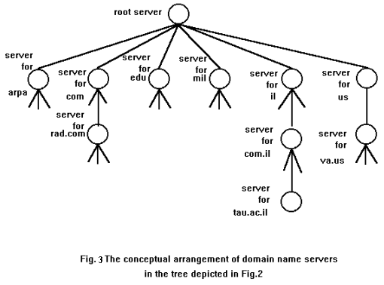
4.1.2. Resource Records
The Domain Name System provides a consistent name space that is used for referring to resources. It is a distributed hierarchical system that can be used in many applications and across multiple communications systems. It consists of three kinds of entities: name servers, name resolvers, and resource records. Name servers answer queries using data available to them. Name resolvers serve as an interface between user programs and the Domain Name System. Resource records are the data associated with the names. Resource records are used to store data about domain names and IP addresses.
Every domain has a set of resource records. Resource record is a five tuple. Format is
<domain_name> <time_to_live> <class> <type> <value>
If the domain name is only a host name, the default domain is appended. If it is left empty, then the last specific name is used. If it is the @ symbol, the domain name of the DNS server is used.
Time to live is an optional entry that specifies how long the record can be cached.
Class is the class of the record, and it is IN for Internet.
Type is the type of the record.
Value is the resource record data.

Some common resource record type
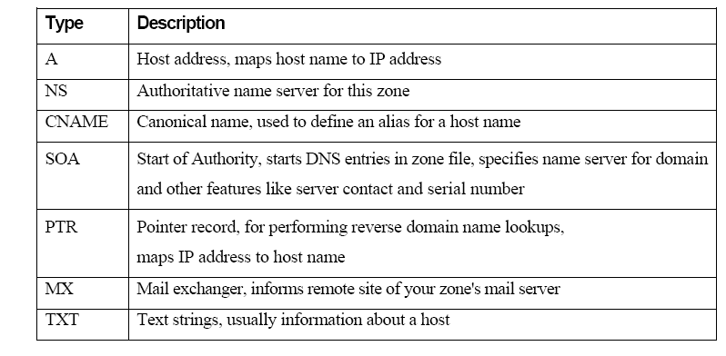
4.2. ELECTRONIC MAIL
Email is the most widely used Internet application. For some people, it is their most frequent form of communication. Electronic mail is a natural use of networked communication technology that developed along with the evolution of the Internet. Message exchange in one form or another has existed from the early days of timesharing computers. Network email was developed for the ARPANET shortly after it's creation, and has now evolved into the powerful email technology that is the most used application on the Internet today.
Email servers exchange messages using the SMTP protocol. Client applications log into the servers to send and receive user's email with one of several protocols, including the leading POP3, IMAP, and MAPI protocols.
Each internet domain has an associated email server that manages all addresses at that domain. Each email address is expressed in the form "name@domain", and is unique at that domain, as in " jane@twenty.net".
The key to this elegant architecture is its simple structure, where each domain has an associated mail server that maintains the accounts for all users with addresses at that domain. Therefore, any email server can easily use the Internet's domain name system to find the IP address of any other mail server, connect to that server, and transfer email to recipients at that domain using the standard SMTP protocol.

4.3. MIME
In the early days of the ARPANET, e-mail consisted exclusively of text messages written in English and expressed in ASCII. For this environment, RFC 822 did the job completely: it specified the headers but left the content entirely up to the users. Nowadays, on the worldwide Internet, this approach is no longer adequate. The problems include sending and receiving
- Messages in languages with accents (e.g., French and German).
- Messages in non-Latin alphabets (e.g., Hebrew and Russian).
- Messages in languages without alphabets (e.g., Chinese and Japanese).
- Messages not containing text at all (e.g., audio or images).
A solution was proposed in RFC 1341 and updated in RFCs 2045–2049. This solution, called MIME (Multipurpose Internet Mail Extensions) is now widely used.
The basic idea of MIME is to continue to use the RFC 822 format, but to add structure to the message body and define encoding rules for non-ASCII messages. By not deviating from RFC 822, MIME messages can be sent using the existing mail programs and protocols. All that has to be changed are the sending and receiving programs, which users can do for themselves.
MIME is an Internet Standard for the format of e-mail. Virtually all human written Internet e-mail and a fairly large proportion of automated e-mail is transmitted via SMTP in MIME format. Internet e-mail is so closely associated with the SMTP and MIME standards that it is sometimes called SMTP/MIME e-mail.
To insure that email messages containing images or other non-text information will be delivered with maximum protection against corruption, MIME provides a way for non-text information to be encoded as text. This encoding is known as base64, and appears to be a source of frustration for many email users.
MIME defines five new message headers, as shown in figure. The first of these simply tells the user agent receiving the message that it is dealing with a MIME message, and which version of MIME it uses. Any message not containing a MIME-Version: header is assumed to be an English plaintext message and is processed as such.
Header | Meaning
MIME version | Identifies the MIME version
Content description | Human readable string telling what is in the message
Content-Id | Unique identifier
Content-Transfer-Encoding: | How the body is wrapped for transmission
Content-Type | Type and format of the content

The Content-Description: header is an ASCII string telling what is in the message. This header is needed so the recipient will know whether it is worth decoding and reading the message. If the string says: “Photo of Barbara’s hamster” and the person getting the message is not a big hamster fan, the message will probably be discarded rather than decoded into a high-resolution color photograph.
The Content-Id: header identifies the content. It uses the same format as the standard Message-Id: header.
The Content-Transfer-Encoding: tells how the body is wrapped for transmission through a network that may object to most characters other than letters, numbers, and punctuation marks. Five schemes (plus an escape to new schemes) are provided. The simplest scheme is just ASCII text. ASCII characters use 7 bits and can be carried directly by the e-mail protocol provided that no line exceeds 1000 characters.
The Content-Type: It specifies the nature of the message body.
4.4. MOBILE TELEPHONE SYSTEMS
4.4.1. Evolution of mobile telephone systems
Cellular is one of the fastest growing and most demanding telecommunications applications. Today, it represents a continuously increasing percentage of all new telephone subscriptions around the world. Currently there are more than 45 million cellular subscribers worldwide, and nearly 50 percent of those subscribers are located in the United States. It is forecasted that cellular systems using a digital technology will become the universal method of telecommunications.
The concept of cellular service is the use of low-power transmitters where frequencies can be reused within a geographic area. The idea of cell-based mobile radio service was formulated in the United States at Bell Labs in the early 1970s. However, the Nordic countries were the first to introduce cellular services for commercial use with the introduction of the Nordic Mobile Telephone (NMT) in 1981.
Cellular systems began in the United States with the release of the advanced mobile phone service (AMPS) system in 1983. The AMPS standard was adopted by Asia, Latin America, and Oceanic countries, creating the largest potential market in the world for cellular.
In the early 1980s, most mobile telephone systems were analog rather than digital, like today's newer systems. One challenge facing analog systems was the inability to handle the growing capacity needs in a cost-efficient manner. As a result, digital technology was welcomed. The advantages of digital systems over analog systems include ease of signaling, lower levels of interference, integration of transmission and switching, and increased ability to meet capacity demands.
4.4.2. Global System for Mobile Communication (GSM)
Throughout the evolution of cellular telecommunications, various systems have been developed without the benefit of standardized specifications. This presented many problems directly related to compatibility, especially with the development of digital radio technology. The GSM standard is intended to address these problems.
From 1982 to 1985 discussions were held to decide between building an analog or digital system. After multiple field tests, a digital system was adopted for GSM. The next task was to decide between a narrow or broadband solution. In May 1987, the narrowband time division multiple access (TDMA) solution was chosen.
The GSM Network
GSM provides recommendations, not requirements. The GSM specifications define the functions and interface requirements in detail but do not address the hardware. The reason for this is to limit the designers as little as possible but still to make it possible for the operators to buy equipment from different suppliers. The GSM network is divided into three major systems: the switching system (SS), the base station system (BSS), and the operation and support system (OSS).
The basic GSM network is given below.
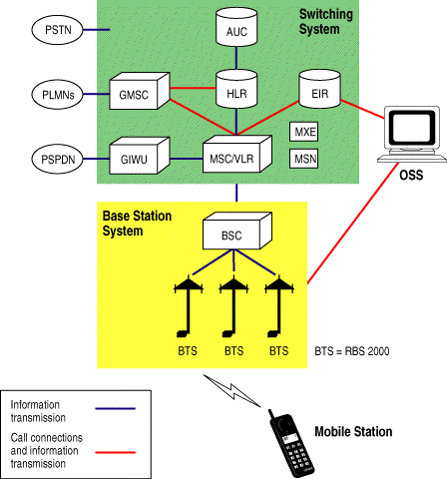

The Switching System
The switching system (SS) is responsible for performing call processing and subscriber-related functions. The switching system includes the following functional units.
Home Location Register (HLR)—The HLR is a database used for storage and management of subscriptions. The HLR is considered the most important database, as it stores permanent data about subscribers, including a subscriber's service profile, location information, and activity status. When an individual buys a subscription from one of the PCS operators, he or she is registered in the HLR of that operator.
Mobile Services Switching Center (MSC)—The MSC performs the telephony switching functions of the system. It controls calls to and from other telephone and data systems. It also performs such functions as toll ticketing, network interfacing, common channel signaling, and others.
Visitor Location Register (VLR)—The VLR is a database that contains temporary information about subscribers that is needed by the MSC in order to service visiting subscribers. The VLR is always integrated with the MSC. When a mobile station roams into a new MSC area, the VLR connected to that MSC will request data about the mobile station from the HLR. Later, if the mobile station makes a call, the VLR will have the information needed for call setup without having to interrogate the HLR each time.
Authentication Center (AUC)—A unit called the AUC provides authentication and encryption parameters that verify the user's identity and ensure the confidentiality of each call. The AUC protects network operators from different types of fraud found in today's cellular world.
Equipment Identity Register (EIR)—The EIR is a database that contains information about the identity of mobile equipment that prevents calls from stolen, unauthorized, or defective mobile stations. The AUC and EIR are implemented as stand-alone nodes or as a combined AUC/EIR node.
The Base Station System (BSS)
All radio-related functions are performed in the BSS, which consists of base station controllers (BSCs) and the base transceiver stations (BTSs).
BSC—The BSC provides all the control functions and physical links between the MSC and BTS. It is a high-capacity switch that provides functions such as handover, cell configuration data, and control of radio frequency (RF) power levels in base transceiver stations. A number of BSCs are served by an MSC.
BTS—The BTS handles the radio interface to the mobile station. The BTS is the radio equipment (transceivers and antennas) needed to service each cell in the network. A group of BTSs are controlled by a BSC.

The Operation and Support System
The operations and maintenance center (OMC) is connected to all equipment in the switching system and to the BSC. The implementation of OMC is called the operation and support system (OSS). The OSS is the functional entity from which the network operator monitors and controls the system. The purpose of OSS is to offer the customer cost-effective support for centralized, regional and local operational and maintenance activities that are required for a GSM network. An important function of OSS is to provide a network overview and support the maintenance activities of different operation and maintenance organizations.
- Message Center (MXE)—The MXE is a node that provides integrated voice, fax, and data messaging. Specifically, the MXE handles short message service, cell broadcast, voice mail, fax mail, e-mail, and notification.
- Mobile Service Node (MSN)—The MSN is the node that handles the mobile intelligent network (IN) services.
- Gateway Mobile Services Switching Center (GMSC)—A gateway is a node used to interconnect two networks. The gateway is often implemented in an MSC. The MSC is then referred to as the GMSC.
- GSM Interworking Unit (GIWU)—The GIWU consists of both hardware and software that provides an interface to various networks for data communications. Through the GIWU, users can alternate between speech and data during the same call. The GIWU hardware equipment is physically located at the MSC/VLR.
4.5. BLUETOOTH
Bluetooth is a global standard for wireless connectivity. Bluetooth technology facilitates the replacement of the cables used to connect one device to another, with one universal short-range radio link operating in the unlicensed 2.45 GHz ISM band. The main objectives of Bluetooth technology can be described as follows,
- Cable replacement: Getting rid of the various types of cables and wires required for interconnectivity between various devices would enable the lay man to use all electronic devices without wasting time and money.
- Small size: the Bluetooth device is very small so that it can be attached to any device required like the cell phones without adding much to the weight of the system.
- Low cost: Bluetooth is aimed to be a low cost device approximately $5 in the near future.
- Low power: The utilization of power is very less (within 100 mW) as it is short range equipment and so it facilitates the use of small batteries for its usage.
4.5.1. Working of BLUETOOTH
Basically, Bluetooth is the term used to describe the protocol of a short range (10 meter) frequency-hopping radio link between devices. These devices implementing the Bluetooth technology are termed Bluetooth - enabled. Bluetooth can imitate a universal bridge to attach the existing data networks, and also as a mechanism for forming ad-hoc networks. Designed to operate in noisy frequency environments, the Bluetooth radio uses a fast acknowledgement and frequency hopping scheme to make the link robust.

4.5.2. Bluetooth Architecture
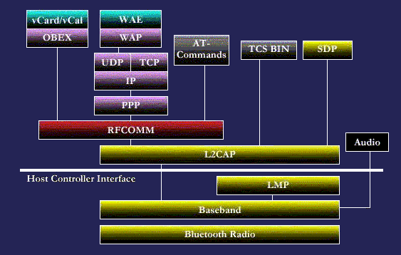
Different layers are:
Bluetooth Radio: The Bluetooth Radio (layer) is the lowest defined layer of the Bluetooth specification. It defines the requirements of the Bluetooth transceiver device operating in the 2.4GHz ISM band. The Bluetooth air interface is based on three power classes,
- Power Class 1: designed for long range (~100m), max output power of 20 dBm.
- Power Class 2: ordinary range devices (~10m), max output power of 4 dBm.
- Power Class 3 short range devices (~10cm), with a max output power of 0 dBm.
Baseband: The Base band is the physical layer of the Bluetooth. It manages physical channels and links apart from other services like error correction, data whitening, hop selection and Bluetooth security. As mentioned previously, the basic radio is a hybrid spread spectrum radio. Typically, the radio operates in a frequency-hopping manner in which the 2.4GHz ISM band is broken into 79 1MHz channels that the radio randomly hops through while transmitting and receiving data. A Pico net is formed when one Bluetooth radio connects to another Bluetooth radio.
LMP: The Link Manager Protocol is used by the Link Managers (on either side) for link set-up and control.
HCI: The Host Controller Interface provides a command interface to the Baseband Link Controller and Link Manager, and access to hardware status and control registers.
L2CAP: Logical Link Control and Adaptation Protocol supports higher level protocol multiplexing, packet segmentation and reassembly, and the conveying of quality of service information.
RFCOMM: The RFCOMM protocol provides emulation of serial ports over the L2CAPprotocol. The protocol is based on the ETSI standard TS 07.10.
SDP: The Service Discovery Protocol provides a means for applications to discover which services are provided by or available through a Bluetooth device. It also allows applications to determine the characteristics of those available services.

