MODULE II

Data link Layer
The main task of the data link layer is to take a raw transmission facility and transform it into a line that appears free of transmission errors in the network layer. It accomplishes this task by having the sender break the input data up into data frames (typically a few hundred bytes), transmit the frames sequentially, and process the acknowledgment frames sent back by the receiver. Since the physical layer merely accepts and transmits a stream of bits without any regard to meaning of structure, it is up to the data link layer to create and recognize frame boundaries. This can be accomplished by attaching special bit patterns to the beginning and end of the frame.

The data link layer should provide error control between adjacent nodes. The data link layer provides the functional and procedural means to transfer data between network entities and to detect and possibly correct errors that may occur in the Physical layer. Examples of data link protocols are Ethernet for local area networks and PPP, HDLC and ADCCP for point-to-point connections.

This layer is made up of two components. The first component is Logical Link Control. This component determines where one frame of data ends and the next one starts.
The second component is Media Access Control. This component determines who is allowed to access the media at any one time. There are generally two forms of media access control: distributed and centralized.

Data Link Layer Design Issues
1. Services provided to the network layer
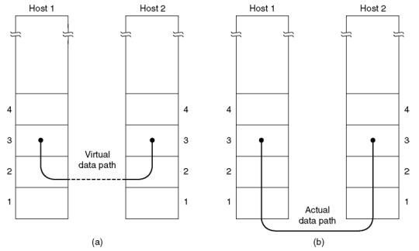
Figure 1. (a) Virtual Communication (b) Actual Communication

Functions of DLL
- Group the physical layer bit stream into units called frames
- Sender checksums the frame and sends checksum together with data. The checksum allows the receiver to determine when a frame has been damaged in transit
- Receiver recomputes the checksum and compares it with the received value. If they differ, an error has occurred and the frame is discarded
- Perhaps return a positive or negative acknowledgment to the sender. A positive acknowledgment indicates that the frame was received without errors, while a negative acknowledgment indicates the opposite
- Flow control. Prevent a fast sender from overwhelming a slower receiver. For example, a supercomputer can easily generate data faster than a PC can consume it
- Provide service to the network layer
2. Framing
The DLL translates the physical layer's raw bit stream into discrete units (messages) called frames.

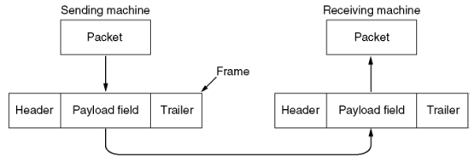
Figure 2 Relationship between packets and frames

Breaking the bit stream up to frame is difficult. One way to achieve this framing is to insert the time gap between frames. Network rarely make any guarantee about timing, so it is possible to these time gap might be squeezed out, or other time gap can be inserted during transmission. Different methods are used to mark the start and end of the frame.

Framing Methods
a) Length Count (Character Count):
Make the first field in the frame's header be the length of the frame. That way the receiver knows how big the current frame is and can determine where the next frame ends.
Disadvantage: Receiver loses synchronization when bits become garbled. If the bits in the count become corrupted during transmission, the receiver will think that the frame contains fewer (or more) bits than it actually does. Although checksum will detect the incorrect frames, the receiver will have difficulty resynchronizing to the start of a new frame. This technique is not used anymore, since better techniques are available.
b) Bit Stuffing:
Use reserved bit patterns to indicate the start and end of a frame. For instance, use the 4-bit sequence of 0111 to delimit consecutive frames. A frame consists of everything between two delimiters.
Problem: What happens if the reserved delimiter happens to appear in the frame itself? If we don't remove it from the data, the receiver will think that the incoming frame is actually two smaller frames!
Solution: Use bit stuffing. Within the frame, replace every occurrence of two consecutive 1's with 110. E.g., append a zero bit after each pair of 1's in the data. This prevents 3 consecutive 1's from ever appearing in the frame.
Likewise, the receiver converts two consecutive 1's followed by a 0 into two 1's, but recognizes the 0111 sequence as the end of the frame.
Example1: The frame ``1011101'' would be transmitted over the physical layer as ``0111101101010111''.
Example2:
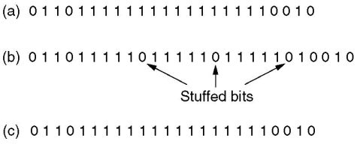

Note: When using bit stuffing, locating the start/end of a frame is easy, even when frames are damaged. The receiver simply scans arriving data for the reserved patterns. Moreover, the receiver will resynchronize quickly with the sender as to where frames begin and end, even when bits in the frame get garbled.
The main disadvantage with bit stuffing is the insertion of additional bits into the data stream, wasting bandwidth. How much expansion? The precise amount depends on the frequency in which the reserved patterns appear as user data.

c) Character stuffing:
Same idea as bit-stuffing, but operates on bytes instead of bits.
Use reserved characters to indicate the start and end of a frame. For instance, use the two-character sequence DLE STX (Data-Link Escape, Start of Text) to signal the beginning of a frame, and the sequence DLE ETX (End of Text) to flag the frame's end.
Problem: What happens if the two-character sequence DLE ETX happens to appear in the frame itself?
Solution: Use character stuffing. Within the frame, replace every occurrence of DLE with the two-character sequence DLE DLE. The receiver reverses the processes, replacing every occurrence of DLE DLE with a single DLE.
Example: If the frame contained ``A B DLE D E DLE'', the characters transmitted over the channel would be ``DLE STX A B DLE DLE D E DLE DLE DLE ETX''.
Disadvantage: character is the smallest unit that can be operated on; not all architectures are byte oriented.
d) Encoding Violations:
Send a signal that doesn't conform to any legal bit representation. In Manchester encoding, for instance, 1-bits are represented by a high-low sequence, and 0-bits by low-high sequences. The start/end of a frame could be represented by the signal low-low or high-high.
The advantage of encoding violations is that no extra bandwidth is required as in bit-stuffing. The IEEE 802.4 standard uses this approach.

3. Error Control
Error control is concerned with insuring that all frames are eventually delivered (possibly in order) to a destination.
Three Items are required for this.
Acknowledgements:
Typically, reliable delivery is achieved using the ``acknowledgments with retransmission'' paradigm, whereby the receiver returns a special acknowledgment (ACK) frame to the sender indicating the correct receipt of a frame.
In some systems, the receiver also returns a negative acknowledgment (NACK) for incorrectly-received frames. This is nothing more than a hint to the sender so that it can retransmit a frame right away without waiting for a timer to expire.

Timers:
One problem that simple ACK/NACK schemes fail to address is recovering from a frame that is lost, and as a result, fails to solicit an ACK or NACK. What happens if an ACK or NACK becomes lost?
Retransmission timers are used to resend frames that don't produce an ACK. When sending a frame, schedule a timer to expire at some time after the ACK should have been returned. If the timer goes off, retransmit the frame.

Sequence Numbers:
Retransmissions introduce the possibility of duplicate frames. To suppress duplicates, add sequence numbers to each frame, so that a receiver can distinguish between new frames and old copies.

4. Flow Control
Flow control deals with throttling the speed of the sender to match that of the receiver. Usually, this is a dynamic process, as the receiving speed depends on such changing factors as the load, and availability of buffer space.
One solution is to have the receiver extend credits to the sender. For each credit, the sender may send one frame. Thus, the receiver controls the transmission rate by handing out credits.

Error Detection and Correction
In data communication, line noise is a fact of life (e.g., signal attenuation, natural phenomenon such as lightning, and the telephone repairman). Moreover, noise usually occurs as bursts rather than independent, single bit errors. For example, a burst of lightning will affect a set of bits for a short time after the lightning strike.
There are two types of attacks against errors:
Error Detecting Codes:
Include enough redundancy bits to detect errors and use ACKs and retransmissions to recover from the errors.

Error Correcting Codes:
Include enough redundancy to detect and correct errors.
To understand errors, consider the following:
- Messages (frames) consist of m data (message) bits and r redundancy bits, yielding an n = (m+r)-bit codeword.
- Hamming Distance. Given any two codeword, we can determine how many of the bits differ. Simply exclusive or (XOR) the two words, and count the number of 1 bit in the result.
- If two codewords are d bits apart, d errors are required to convert one to the other.
- A code's Hamming Distance is defined as the minimum Hamming Distance between any two of its legal codeword (from all possible codewords).
- In general, all possible data words are legal. However, by choosing check bits carefully, the resulting codeword will have a large Hamming Distance. The larger the Hamming distance, the better able the code can detect errors.
To detect d 1-bit errors requires having a Hamming Distance of at least d+1 bits.
To correct d errors requires 2d+1 bits. Intuitively, after d errors, the garbled messages are still closer to the original message than any other legal codeword.

Parity Bits
A single parity bit is appended to each data block (e.g. each character in ASCII systems) so that the number of 1 bits always adds up to an even (odd) number. 1000000(1) 1111101(0). The Hamming Distance for parity is 2, and it cannot correct even single-bit errors (but can detect single-bit errors). As another example, consider a 10-bit code used to represent 4 possible values: ``00000 00000'', ``00000 11111'', ``11111 00000'', and ``11111 11111''. Its Hamming distance is 5, and we can correct 2 single-bit errors:
For instance, ``10111 00010'' becomes ``11111 00000'' by changing only two bits.
However, if the sender transmits ``11111 00000'' and the receiver sees ``00011 00000'', the receiver will not correct the error properly. Finally, in this example we are guaranteed to catch all 2-bit errors, but we might do better: if ``00111 00111'' contains 4 single-bit errors, we will reconstruct the block correctly.
Error correction is most useful in three contexts:
- Simplex links (e.g., those that provide only one-way communication).
- Long delay paths, where retransmitting data leads to long delays (e.g., satellites).
- Links with very high error rates, where there is often one or two errors in each frame. Without forward error correction, most frames would be damaged, and retransmitting them would result in the frames becoming garbled again.

Error Correction using Hamming Code
Using Hamming code provides 100% certainty of detecting a single bit error in a code. Additionally, the use of Hamming code allows the erroneous bit to be identified. Hamming code has 11-bits comprising 7-bits of an ASCII code and an additional 4-bits which are parity bits.
A 7-bit ASCII character may be represented by an 11-bit Hamming code in which the additional 4 parity bits take the positions 1, 2, 4 and 8 in the binary sequence and are 0 or 1 according to specified criteria which allow not only a single error to be detected, but also identified.
As an example take the ASCII code for the $ sign. This is 0100100. In an 11-bit Hamming code sequence this bits fill the following positions:
0 1 0 0 1 0 0
Bit #: 1 2 3 4 5 6 7 8 9 10 11
The additional bits are filled according to the following criteria
- bit 1, 0 or 1 so that the total number of 1s in bits 1,3,5,7,9,11 is even
- bit 2, 0 or 1, so that the total number of 1s in bits 2,3,6,7,10,11 is even
- bit 4, 0 or 1, so that the total number of 1s in bits 4,5,6,7 is even
- bit 8, 0 or 1, so that the total number of 1s in bits 8,9,10,11 is even
The Hamming code for the $ sign is therefore: 00011001100
If a bit is changed during communication then checking if the conditions above are met allows identification of the erroneous bit. For example, suppose the 6th bit is changed from 0 to 1 so that the received code is 00011101100. Checking the parity bits:
- bit 1 - total number of 1s in bits 1,3,5,7,9,11 is even - passes test
- bit 2 - total number of 1s in bits 2,3,6,7,10,11 is odd - fails test
- bit 4 - total number of 1s in bits 4,5,6,7 is odd - fails test
- bit 8 - total number of 1s in bits 8,9,10,11 is even - passes test
Adding up the bit numbers of the failed tests gives 2 + 4 = 6 - correctly identifies the erroneous bit.

Error Detection
Error correction is relatively expensive (computationally and in bandwidth). For example, 10 redundancy bits are required to correct 1 single-bit error in a 1000-bit message. Detection? In contrast, detecting a single bit error requires only a single-bit, no matter how large the message. The most popular error detection codes are based on polynomial codes or cyclic redundancy codes (CRCs). Allows us to acknowledge correctly received frames and to discard incorrect ones.

CRC (Cyclic Redundancy Code)Checksums
The most popular error detection codes are based on polynomial codes or cyclic redundancy codes. Idea:
- Represent a k-bit frame as coefficients of a polynomial expansion ranging from to , with the high-order bit corresponding to the coefficient of .
For example, represent the string ``11011'' as the polynomial:
- Perform modulo 2 arithmetic (e.g. XOR of the bits)
- Sender and receiver agree on a generator polynomial: G(x). (G(x) must be smaller than the number of bits in the message.)
- Append a checksum to message; let's call the message M(x), and the combination T(x). The checksum is computed as follows:
  - Let r be the degree of G(x), append r zeros to M(x). Our new polynomial becomes
  - Divide by G(x) using modulo 2 arithmetic.
  - Subtract the remainder from giving us T(x).
- When receiver gets T(x), it divides T(x) by G(x); if T(x) divides cleanly (e.g., no remainder), no error has occurred.
The presence of a remainder indicates an error.
Assume:
- the receiver gets T(x) + E(x), where each bit in E(x) corresponds to an error bit.
- k 1 bits indicate k single-bit errors.
- Receiver computes [T(x) + E(x)]/G(x) = E(x)/G(x).
Will detect:
- single bit errors. If a single-bit error occurs, G(x) will detect it if it contains more than one term. If it contains only one term, it may or may not detect the error, depending on the E(x) and G(x).
- two isolated single-bit errors. Consider two single-bit errors:
Example:
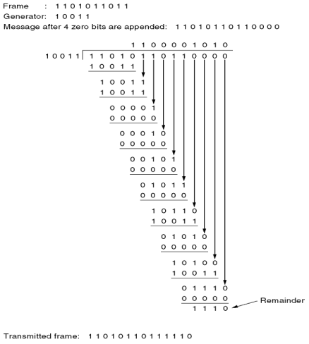

CRC Standards
There are currently three international standards:
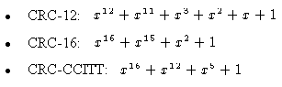

Elementary Data Link Protocols

As far as the data link layer concerned, the packet passed across the interface to it from the network layer. While the DLL accepts a packet, it encapsulates the packet into frame by adding header and trailer to it. Thus frame consists of an embedded packet and some control (header) information. The frame is then transmitted to the other DLL.
Assumptions:
- The physical layer, data link layer, and network layer are independent processes.
- The network layer contacts the data link layer by generating proper events. There exist suitable library procedures for the data link layer to deliver a packet, and to fetch a packet.
- The data link layer provides a reliable, connection-oriented service to the network layer.
- The physical layer computes/checks checksums in outgoing/incoming frames, and contacts the data link layer by generating proper events.
There exist suitable library procedures for the data link layer to send a frame, and to receive a frame.

#define MAX_PKT 4 /* determines packet size in bytes */
typedef enum {false, true} boolean; /* boolean type */
typedef unsigned int seq_nr; /* sequence or ack numbers */
typedef struct {unsigned char data [MAX_PKT] ;} packet; /* packet definition */
typedef enum {data, ack, nak} frame_kind; /* frame_kind definition */

typedef struct
{ /* frames are transported in this layer */
frame_kind kind; /* what kind of a frame is it? */
seq_nr seq; /* sequence number */
seq_nr ack; /* acknowledgement number */
packet info; /* the network layer packet */
} frame;

/* Wait for an event to happen; return its type in event. */
void wait_for_event (event_type *event);

/* Fetch a packet from the network layer for transmission on the channel. */
void from_network_layer (packet *p);

/* Deliver information from an inbound frame to the network layer. */
void to_network_layer (packet *p);

/* Go get an inbound frame from the physical layer and copy it to r. */
void from_physical_layer (frame *r);

/* Pass the frame to the physical layer for transmission. */
void to_physical_layer (frame *s);

/* Start the clock running and enable the timeout event. */
void start_timer (seq_nr k);

/* Stop the clock and disable the timeout event. */
void stop_timer (seq_nr k);

/* Start an auxiliary timer and enable the ack_timeout event. */
void start_ack_timer (void);

/* Stop the auxiliary timer and disable the ack_timeout event. */
void stop_ack_timer (void);

/* Allow the network layer to cause a network_layer_ready event. */
void enable_network_layer (void);

/* Forbid the network layer from causing a network_layer_ready event */
void disable_network_layer (void);

/* Macro inc is expanded in-line: Increment k circularly. */
#define inc (k) if (k < MAX_SEQ) k = k + 1; else k = 0

1. An Unrestricted Simplex Protocol
This is the simplest protocol in which data are transmitted in one direction only. Both the transmitting and receiving network layers are always ready. Processing time is ignored and infinite buffer space is available. Also it is assumed that the communication channel between the data link layers never loses or damages frames.
The protocol consists of two distinct procedures a sender and a receiver. The sender runs in the data link layer of the source machine and the receiver runs in the data link layer of the destination machine.
/* Protocol 1 provides for data transmission in one direction only, from sender to receiver. The communication channel is assumed to be error free, and the receiver is assumed to be able to process all the input infinitely fast. Consequently, the sender just sits in a loop pumping data out onto the line as fast as it can. */

typedef enum {frame_arrival} event_type;
#include "protocol.h"
void sender1(void)
{
frame s; /* buffer for an outbound frame */
packet buffer; /* buffer for an outbound packet */
while (true)
{
from_network_layer(&buffer); /* go get something to send */
s.info = buffer; /* copy it into s for transmission */
to_physical_layer(&s); /* send it on its way */
}
}

void receiver1(void)
{
frame r;
event_type event; /* filled in by wait, but not used here */
while (true)
{
wait_for_event(&event); /*only possibility is frame_arrival*/
from_physical_layer(&r); /* go get the inbound frame */
to_network_layer(&r.info); /* pass the data to the network layer */
}
}

2. A Simplex Stop-and-Wait Protocol
Stop-and-wait protocol provides for a one-directional flow of data from sender to receiver. The communication channel is once again assumed to be error free, as in protocol 1. However, this time, the receiver has only a finite buffer capacity and a finite processing speed, so the protocol must explicitly prevent the sender from flooding the receiver with data faster than it can be handled.
/* Protocol 2 (stop-and-wait) also provides for a one-directional flow of data from sender to receiver. The communication channel is once again assumed to be error free, as in protocol 1. However, this time, the receiver has only a finite buffer capacity and a finite procesing speed, so the protocol must explicitly prevent the sender from flooding the receiver with data faster than it can be handled. */

typedef enum {frame_arrival} event_type;
#include "protocol.h"

void sender2(void)
{
frame s; /* buffer for an outbound frame */
packet buffer; /* buffer for an outbound packet */
event_type event; /* frame_arrival is the only possibility */

while (true)
{
from_network_layer(&buffer); /* go get something to send */
s.info = buffer; /* copy it into s for transmission */
to_physical_layer(&s); /* bye bye little frame */
wait_for_event(&event); /* do not proceed until given the go ahead */
}
}

void receiver2(void)
{
frame r, s; /* buffers for frames */
event_type event; /* frame_arrival is the only possibility */
while (true)
{
wait_for_event(&event); /* only possibility is frame_arrival */
from_physical_layer(&r); /* go get the inbound frame */
to_network_layer(&r.info);/* pass the data to the network layer */
to_physical_layer(&s); /* send a dummy frame to awaken sender */
}
}

3. A Simplex Protocol for a Noisy Channel
This protocol allows unidirectional data flow over an unreliable channel.
/* Protocol 3 (par) allows unidirectional data flow over an unreliable channel. */

#define MAX_SEQ 1 /* must be 1 for protocol 3 */
typedef enum {frame_arrival, cksum_err, timeout} event_type;
#include "protocol.h"

void sender3(void)
{
seq_nr next_frame_to_send; /* seq number of next outgoing frame */
frame s; /* scratch variable */
packet buffer; /* buffer for an outbound packet */
event_type event;

next_frame_to_send = 0; /* initialize outbound sequence numbers */
from_network_layer(&buffer); /* fetch first packet */
while (true)
{
s.info = buffer; /* construct a frame for transmission */
s.seq = next_frame_to_send; /*insert sequence number in frame*/
to_physical_layer(&s); /* send it on its way */
start_timer(s.seq); /* if answer takes too long, time out */
wait_for_event(&event); /* frame_arrival, cksum_err, timeout */
if(event == frame_arrival)
{
from_physical_layer(&s); /* get the acknowledgement */
if (s.ack == next_frame_to_send)
{
from_network_layer(&buffer); /*get the next one to send*/
inc(next_frame_to_send); /* invert next_frame_to_send */
}
}
}
}

void receiver3(void)
{
seq_nr frame_expected;
frame r, s;
event_type event;
frame_expected = 0;
while (true)
{
wait_for_event(&event); /* possibilities: frame_arrival,cksum_err */
if (event == frame_arrival)
{
/* A valid frame has arrived. */
from_physical_layer(&r); /* go get the newly arrived frame */
if (r.seq == frame_expected)
{
/* This is what we have been waiting for. */
to_network_layer(&r.info); /* pass the data to the network layer */
inc(frame_expected); /* next time expect the other sequence nr */
}
s.ack = 1 - frame_expected; /* tell which frame is being acked */
to_physical_layer(&s); /*only the ack field is use*/
}
}
}

Sliding Window Protocols
Sliding window is used by most connection oriented network protocol, among others, the Point-to-Point protocol (PPP) which many people use to establish their home PC as temporary Internet node via a phone-line connection to an existing node. Sliding Window Protocol assumes two-way communication (full duplex). It uses two types of frames:
  - Data
  - Ack (sequence number of last correctly received frame)
The basic idea of sliding window protocol is that both sender and receiver keep a ``window'' of acknowledgment. The sender keeps the value of expected acknowledgment; while the receiver keeps the value of expected receiving frame. When it receives an acknowledgment from the receiver, the sender advances the window. When it receives the expected frame, the receiver advances the window. When communication links are noisy and loss rate high, ACK schemes are preferred: a sender has to receive an acknowledgment from each receiver of a message. If ACKs are not received, the message is resent until an ACK has been received.
The idea of sliding windows is to keep track of the acknowledgements for each ID. However, a scheme in which a sender send a single message (e.g. to multiple receivers in a group) and then waits for all ACKs is to slow: a sender should be able to send a number of messages and a separate thread should receive ACKs, and resend messages with ACKs missing.
The senders and receivers each maintain a window of messages for which no ACKs have been received: a window is essentially a sequence of message IDs, starting with a low water mark and bounded by a high water mark. Whenever an ACK is received, the low and high water marks are advanced by 1, this allows 1 more ACK to be received, therefore sliding the window 1 to the right. When the window is full, an ACK is either discarded, or some kind of flow control is used to throttle the sender until there is more space available.
Sliding windows usually start out with a given size, however, more sophisticated protocols will dynamically adapt the window size, trying to find an agreed-upon size between sender and receiver.
The characteristics of sliding windows used at the sender and receiver usually involve
- Error correction (by retransmission)
- Flow control
- Message ordering by sender (FIFO).
Example:
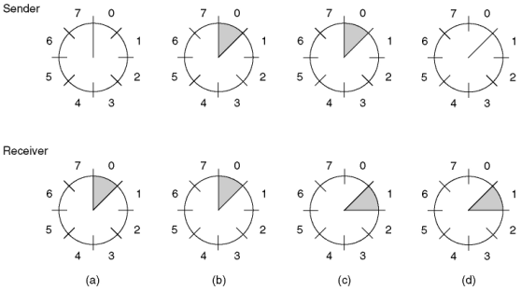

Figure 1. A sliding window of size 1, with a 3-bit sequence number (a) Initially
(b) After the first frame has been sent (c) After the first frame has been received (d) After the first acknowledgement has been received

2. Protocol 4: One Bit Sliding Window Protocol (Stop And Wait)
One bit sliding window protocol is also called Stop-And-Wait protocol. In this protocol, the sender sends out one frame, waits for acknowledgment before sending next frame, thus the name Stop-And-Wait.
Problem with Stop-And-Wait protocol is that it is very inefficient. At any one moment, only in frame is in transition. The sender will have to wait at least one round trip time before sending next. The waiting can be long for a slow network such as satellite link.
/* Protocol 4 (sliding window) is bidirectional and is more robust than protocol 3. */

#define MAX_SEQ 1 /* must be 1 for protocol 4 */
typedef enum {frame_arrival, cksum_err, timeout} event_type;
#include "protocol.h"

void protocol4 (void)
{
seq_nr next_frame_to_send; /* 0 or 1 only */
seq_nr frame_expected; /* 0 or 1 only */
frame r, s; /* scratch variables */
packet buffer; /* current packet being sent */
event_type event;
next_frame_to_send = 0; /* next frame on the outbound stream */
frame_expected = 0; /* number of frame arriving frame expected */
from_network_layer(&buffer); /* fetch a packet from the network layer */
s.info = buffer; /* prepare to send the initial frame */
s.seq = next_frame_to_send; /* insert sequence number into frame */
s.ack = 1 - frame_expected; /* piggybacked ack */
to_physical_layer(&s); /* transmit the frame */
start_timer(s.seq); /* start the timer running */
while (true)
{
wait_for_event(&event); /* could be: frame_arrival, cksum_err, timeout */
if (event == frame_arrival)
{ /* a frame has arrived undamaged. */
from_physical_layer(&r); /* go get it */

if (r.seq == frame_expected)
{ /* Handle inbound frame stream. */
to_network_layer(&r.info); /* pass packet to network layer */
inc(frame_expected); /* invert sequence number expected next */
}
if (r.ack == next_frame_to_send)
{ /* handle outbound frame stream. */
from_network_layer(&buffer); /* fetch new packet from network layer */
inc(next_frame_to_send); /* invert sender's sequence number */
}
}
s.info = buffer; /* construct outbound frame */
s.seq = next_frame_to_send; /*insert sequence number into it */
s.ack = 1 - frame_expected; /* seq number of last received frame */
to_physical_layer(&s); /* transmit a frame */
start_timer(s.seq); /* start the timer running */
}
}

3. Protocol 5: Go back n
In Go back n protocol if there is one frame k missing, the receiver simply discard all subsequent frames k+1, k+2, ..., sending no acknowledgments. So the sender will retransmit frames from k onwards. Figure 3-15(a) on page 208. This effectively sets the receiver window size to be 1. This can be a waste of bandwidth.
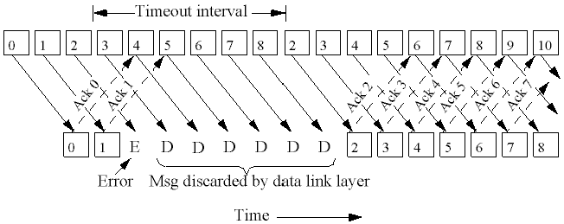
/* Protocol 5 (pipelining) allows multiple outstanding frames. The sender may transmit up to MAX_SEQ frames without waiting for an ack. In addition, unlike the previous protocols, the network layer is not assumed to have a new packet all the time. Instead, the network layer causes a network_layer_ready event when there is a packet to send. */

#define MAX_SEQ 7 /* should be 2^n - 1 */
typedef enum {frame_arrival, cksum_err, timeout, network_layer_ready} event_type;
#include "protocol.h"

static boolean between(seq_nr a, seq_nr b, seq_nr c)
{
/* Return true if (a <=b < c circularly; false otherwise. */
if (((a <= b) && (b < c)) || ((c < a) && (a <= b)) || ((b < c) && (c < a)))
return(true);
else
return(false);
}
static void send_data(seq_nr frame_nr, seq_nr frame_expected, packet buffer[])
{
/* Construct and send a data frame. */
frame s; /* scratch variable */

s.info = buffer[frame_nr]; /* insert packet into frame */
s.seq = frame_nr; /* insert sequence number into frame */
s.ack = (frame_expected + MAX_SEQ) % (MAX_SEQ + 1); /*piggyback ack*/
to_physical_layer(&s); /* transmit the frame */
start_timer(frame_nr); /* start the timer running */
}

void protocol5(void)
{
seq_nr next_frame_to_send; /*MAX_SEQ > 1; used for outbound stream*/
seq_nr ack_expected; /* oldest frame as yet unacknowledged */
seq_nr frame_expected; /* next frame expected on inbound stream */
frame r; /* scratch variable */
packet buffer[MAX_SEQ+1]; /* buffers for the outbound stream */
seq_nr nbuffered; /* # output buffers currently in use */
seq_nr i; /* used to index into the buffer array */
event_type event;

enable_network_layer(); /* allow network_layer_ready events */
ack_expected = 0; /* next ack expected inbound */
next_frame_to_send = 0; /* next frame going out */
frame_expected = 0; /* number of frame expected inbound */
nbuffered = 0; /* initially no packets are buffered */
while (true)
{
wait_for_event(&event); /* four possibilities: see event_type above */

switch(event)
{
case network_layer_ready: /* the network layer has a packet to send */
/* Accept, save, and transmit a new frame. */
from_network_layer(&buffer[next_frame_to_send]); /* fetch new packet */
nbuffered = nbuffered + 1; /* expand the sender's window */
send_data(next_frame_to_send, frame_expected, buffer);
/* transmit the frame */
inc(next_frame_to_send); /* advance sender's upper window edge */
break;
case frame_arrival: /* a data or control frame has arrived */
from_physical_layer(&r); /* get incoming frame from physical layer */

if (r.seq == frame_expected)
{ /* Frames are accepted only in order. */
to_network_layer(&r.info); /* pass packet to network layer */
inc(frame_expected); /* advance lower edge of receiver's window */
}
/* Ack n implies n - 1, n - 2, etc. Check for this. */
while (between(ack_expected, r.ack, next_frame_to_send))
{ /* Handle piggybacked ack. */
nbuffered = nbuffered - 1; /*one frame fewer buffered */
stop_timer(ack_expected); /* frame arrived intact; stop timer */
inc(ack_expected); /* contract sender's window */
}
break;
case cksum_err: ; /* just ignore bad frames */
break;
case timeout: /*trouble; retransmit all outstanding frames */
next_frame_to_send = ack_expected; /* start retransmitting here */
for (i = 1; i <= nbuffered; i++)
{
send_data(next_frame_to_send, frame_expected, buffer); /* resend 1 frame */
inc(next_frame_to_send); /* prepare to send the next one */
}
}
if (nbuffered < MAX_SEQ)
enable_network_layer();
else
disable_network_layer();
}
}

4. Protocol 6: Selective Repeat
Another strategy is to re-send only the ones that are actually lost or damaged. The receiver buffers all the frames after the lost one. When the sender finally noticed the problem (e.g. no ack for the lost frame is received within time-out limit), the sender retransmits the frame in question.
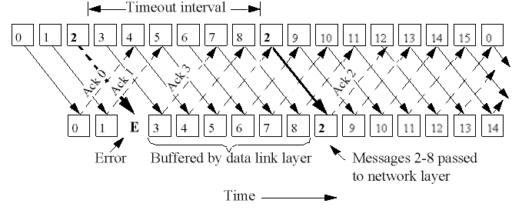
/* Protocol 6 (nonsequential receive) accepts frames out of order, but passes packets to the network layer in order. Associated with each outstanding frame is a timer. When the timer goes off, only that frame is retransmitted, not all the outstanding frames, as in protocol 5. */

#define MAX_SEQ 7 /* should be 2^n - 1 */
#define NR_BUFS ((MAX_SEQ + 1)/2)
typedef enum {frame_arrival, cksum_err, timeout, network_layer_ready, ack_timeout} event_type;
#include "protocol.h"
boolean no_nak = true; /* no nak has been sent yet */
seq_nr oldest_frame = MAX_SEQ+1; /* init value is for the simulator */

static boolean between(seq_nr a, seq_nr b, seq_nr c)
{
/* Same as between in protocol5, but shorter and more obscure. */
return ((a <= b) && (b < c)) || ((c < a) && (a <= b)) || ((b < c) && (c < a));
}

static void send_frame(frame_kind fk, seq_nr frame_nr, seq_nr frame_expected, packet buffer[])
{
/* Construct and send a data, ack, or nak frame. */
frame s; /* scratch variable */

s.kind = fk; /* kind == data, ack, or nak */
if (fk == data) s.info = buffer[frame_nr % NR_BUFS];
s.seq = frame_nr; /* only meaningful for data frames */
s.ack = (frame_expected + MAX_SEQ) % (MAX_SEQ + 1);
if (fk == nak) no_nak = false; /* one nak per frame, please */
to_physical_layer(&s); /* transmit the frame */
if (fk == data) start_timer(frame_nr % NR_BUFS);
stop_ack_timer(); /*no need for separate ack frame */
}

void protocol6(void)
{
seq_nr ack_expected; /* lower edge of sender's window */
seq_nr next_frame_to_send; /* upper edge of sender's window + 1 */
seq_nr frame_expected; /* lower edge of receiver's window */
seq_nr too_far; /* upper edge of receiver's window + 1 */
int i; /* index into buffer pool */
frame r; /* scratch variable */
packet out_buf[NR_BUFS]; /* buffers for the outbound stream */
packet in_buf[NR_BUFS]; /* buffers for the inbound stream */
boolean arrived[NR_BUFS]; /* inbound bit map */
seq_nr nbuffered; /*how many output buffers currently used*/
event_type event;

enable_network_layer(); /* initialize */
ack_expected = 0; /*next ack expected on the inbound stream*/
next_frame_to_send = 0; /* number of next outgoing frame */
frame_expected = 0; /* frame number expected */
too_far = NR_BUFS; /* receiver's upper window + 1 */
nbuffered = 0; /* initially no packets are buffered */

for (i = 0; i < NR_BUFS; i++) arrived[i] = false;
while (true)
{
wait_for_event(&event); /* five possibilities: see event_type above */
switch(event)
{
case network_layer_ready: /* accept, save, and transmit a new frame */
nbuffered = nbuffered + 1; /* expand the window */
from_network_layer(&out_buf[next_frame_to_send % NR_BUFS]);
/*fetch new packet */
send_frame(data, next_frame_to_send, frame_expected, out_buf); /* transmit the frame */
inc(next_frame_to_send); /* advance upper window edge */
break;

case frame_arrival: /* a data or control frame has arrived */
from_physical_layer(&r); /* fetch incoming frame from physical layer */
if (r.kind == data)
{
/* An undamaged frame has arrived. */
if ((r.seq != frame_expected) && no_nak)
send_frame(nak, 0, frame_expected, out_buf);
else
start_ack_timer();
if (between(frame_expected, r.seq, too_far) && (arrived[r.seq%NR_BUFS] == false))
{
/* Frames may be accepted in any order. */
arrived[r.seq % NR_BUFS] = true; /*mark buffer as full*/
in_buf[r.seq % NR_BUFS] = r.info; /* insert data into buffer */
while (arrived[frame_expected % NR_BUFS])
{
/* Pass frames and advance window. */
to_network_layer(&in_buf[frame_expected % NR_BUFS]);
no_nak = true;
arrived[frame_expected % NR_BUFS] = false;
inc(frame_expected); /* advance lower edge of receiver's window */
inc(too_far); /* advance upper edge of receiver's window */
start_ack_timer(); /* to see if (a separate ack is needed */
}
}
}
if((r.kind==nak) && etween(ack_expected,(r.ack+1)%(MAX_SEQ+1),next_frame_to_send))
send_frame(data, (r.ack+1) % (MAX_SEQ + 1), frame_expected, out_buf);

while (between(ack_expected, r.ack, next_frame_to_send))
{
nbuffered = nbuffered – 1;/*handle piggybacked ack*/
stop_timer(ack_expected % NR_BUFS); /* frame arrived intact */
inc(ack_expected); /* advance lower edge of sender's window */
}
break;

case cksum_err: if (no_nak) send_frame(nak, 0, frame_expected,out_buf); break; /* damaged frame */
case timeout: send_frame(data, oldest_frame, frame_expected, out_buf); break; /* we timed out */
case ack_timeout: send_frame(ack,0,frame_expected, out_buf); /* ack timer expired; send ack */
}

if (nbuffered < NR_BUFS) enable_network_layer(); else disable_network_layer();
}
}

Multiplexing
Multiplexing is a transmission of multiple signals over a single communications or computer channel. The multiplexer brings together several low speed communications lines, transforms them into one high speed channel and reverses the operation at the other end. The multiplexers also perform the concentration functions. Multiplexers are less expensive than concentrators, but many of the earlier versions were not programmable and thus did not have the flexibility of concentrators.
However today’s microprocessor equipped multiplexers perform much like concentrators.
There are many applications in which several terminals are connected to a computer. If each terminal is operating at 300 bits per second over a communications line (channel) that can operate at 9600 bits per second, then we see a very inefficient operation. It has been found that the capacity of a channel exceeds that required for a single signal. A channel is an expensive resource. Hence, for its optimal utilization, the channel can be shared in such a way so as to simultaneously transmit multiple signals over it. The method of dividing a physical channel into many logical channels so
that a number of independent signals may be simultaneously transmitted on it is known as multiplexing.
The electronic device that performs this task is known as a multiplexer.
A multiplexer takes several data communications lines or signals and converts them into one data communications line or signal at the sending location. For example, as shown in figure there may be 4 terminals connected to a multiplexer. The multiplexer takes the signals from the 4 terminals and converts them into 1 large signal, which can be transmitted over 1 communications line. Then, at the receiving location, a multiplexer takes the 1 large signal and breaks it into the original 4 signals. Without multiplexers, you would have to have 4 separate communications lines.

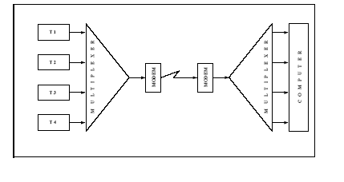
Figure 10.4.1
Thus, with multiplexing it is possible for a single transmission medium to concurrently
transmit data between several transmitters and receivers. There are two basic methods of multiplexing channels. They are frequency division multiplexing and time division multiplexing.
Frequency Division Multiple Access (FDMA)
With Frequency Division Multiple Access (FDMA) the entire available frequency band is divided into bands each of which serves a single user. Every user is therefore equipped with a transmitter for a given, predetermined, frequency band, and a receiver for each band. The main advantage of FDMA is its simplicity--it does not require any coordination or synchronization among the users since each can use its own frequency band without interference. This, however, is also the cause of waste especially when the load is momentarily uneven, since when one user is idle his share of the bandwidth cannot be used by other users. It should be noted that if the users have uneven long term demands, it is possible to divide the frequency range unevenly, i.e., proportional to the demands. FDMA is also not flexible; adding a new user to the network requires equipment modification (in every other user. The best example of FDM is the way we receive various stations in a radio. Each radio station is assigned a frequency range within a bandwidth of radio frequencies. Several radio stations may be transmitting speech signals simultaneously over the physical channel that is "ether" in this case. A radio receiver’s antenna receives signals transmitted by all the stations. Finally, the tuning dial in the radio is used to isolate the speech signal of the station tuned. In FDM, the signals to be transmitted must be analog signals. Thus, digital signals must be converted to analog form if they are to use FDM.

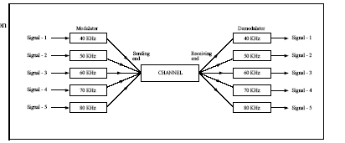
Figure 10.4.2
Time Division Multiple Access (TDMA)
In the time division multiple access (TDMA) scheme the time axis is divided into time
slots, pre assigned to the different users. Every user is allowed to transmit freely during the slot assigned to it, that is, during the assigned slot the entire system resources are devoted to that user. The slot assignments follow a predetermined pattern that repeats itself periodically; each such period is called a cycle or a frame. Whenever a node has a frame to send, it transmits the frame's bits during its assigned time slot in the revolving TDM frame.
In the most basic TDMA scheme every user has exactly one slot in every frame.
Moreover, communication between computers occurs in short, fast bursts. Each burst would thus need the full channel bandwidth, which is available to a signal in TDM. Besides this, TDM is generally more efficient as more subchannels can be derived because it is upto the network designers to allocate time slots to different channels. It is common to have 32 low speed terminals connected to one high speed line.
Whether or not to use multiplexing usually depends upon economics. The cost of high-speed modems and multiplexers is very high compared to the cost of low-speed modems. However, if line costs are high due to long distances, then multiplexing is cost effective. One serious disadvantage with multiplexing relates to transmission line failure. If the line goes out, everything is dead. With individual lines only one terminal is likely to be lost.

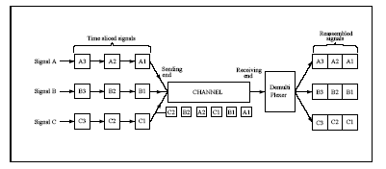

Figure 10.4.3.
Problems with FDMA & TDMA
Static conflict-free protocols such as the FDMA and TDMA protocols do not utilize the
shared channel very efficiently, especially when the system is lightly loaded or when the
loads of different users are asymmetric. The static and fixed assignment in these protocols, cause the channel (or part of it) to be idle even though some users have data to transmit. Dynamic channel allocation protocols are designed to overcome this drawback.

1. The Medium Access Sub layer
There are two types of network links: point-to-point links, and broadcast links. A point-to-point link consists of a single sender on one end of the link, and a single receiver at the other end of the link. Second type of link, a broadcast link, can have multiple sending and receiving nodes all connected to the same, single, shared broadcast channel.
Traditional networks make use of point-to-point channels, that is, channels that are dedicated to a (ordered) pair of users. These channels, beyond being very economical, are advantageous due to their noninterference feature namely, that transmission between a pair of nodes has no effect on the transmission between another pair of nodes even if these two pairs have a common node. Point-to-point channels, however, require the topology to be fixed, mostly determined at network design time. Subsequent topological changes are quite hard (and costly) to implement.
When point-to-point channels are not economical, not available, or when dynamic topologies are required broadcast channels can be used. Informally stated, a broadcast channel is one in which more than a single receiver can potentially receive every transmitted message.
Broadcast channels appear naturally in radio, satellite, and some local area networks.
This basic property has its advantages and disadvantages. If, indeed, a message is destined to a large number of destinations then a broadcast channel is clearly superior. However, in a typical case a message is destined to a single or a very small number of destinations and wasteful processing results in all those switches for whom the message is not intended. The transmissions over a broadcast channel interfere, in the sense that one transmission coinciding in time with another may cause none of them to be received.
To make a transmission successful interference must be avoided or at least controlled.
The channel then becomes the shared resource whose allocation is critical for proper operation of the network. This is done by Multiple Access Protocols. These protocols are nothing but channel allocation schemes that posses desirable performance characteristics. In terms of known networking models, such as the OSI reference model, these protocols reside mostly within a special layer called the Medium Access Control (MAC) layer. The MAC layer is between the Data Link Control (DLC) layer and the Physical Layer.

2. Static Channel Allocation in LANs and MANs
The different methods for static channel allocation are
- Frequency Division Multiplexing
- Time Division Multiplexing

3. Dynamic Channel Allocation in LANs and MANs
Dynamic allocation strategies, the channel allocation changes with time and is based on
current (and possibly changing) demands of the various users.

4. Multi access Protocols
Protocols that solve the resolution problem dynamically are called Multiple Access (Multi access) Protocols.

Different types of multi-access protocols:
- Contention protocols resolve a collision after it occurs. These protocols execute a collision resolution protocol after each collision
- Collision-free protocols ensure that a collision can never occur.

5. Contention Protocols
5.1. ALOHA
Aloha, also called the Aloha method refers to a simple communications scheme in which each source (transmitter) in a network sends data whenever there is a frame to send. If the frame successfully reaches the destination (receiver), the next frame is sent. If the frame fails to be received at the destination, it is sent again. This protocol was originally developed at the University of Hawaii for use with satellite communication systems in the Pacific.
In a wireless broadcast system or a half-duplex two-way link, Aloha works perfectly. But as networks become more complex, for example in an Ethernet system involving multiple sources and destinations in which data travels many paths at once, trouble occurs because data frames collide (conflict). The heavier the communications volume, the worse the collision problems become. The result is degradation of system efficiency, because when two frames collide, the data contained in both frames is lost.
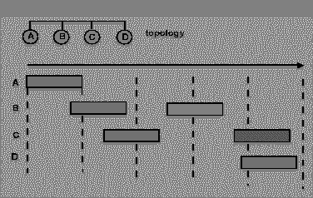
Figure 10.5.1

5.2. Pure ALOHA
With Pure Aloha, stations are allowed access to the channel whenever they have data to transmit. Because the threat of data collision exists, each station must either monitor its transmission on the rebroadcast or await an acknowledgment from the destination station. By comparing the transmitted packet with the received packet or by the lack of an acknowledgement, the transmitting station can determine the success of the transmitted packet. If the transmission was unsuccessful it is resent after a random amount of time to reduce the probability of re-collision.
- Whenever a station has data, it transmits
- Sender finds out whether transmission was successful or experienced a collision by listening to the broadcast from the central node
- Sender retransmits after some random time if there is a collision
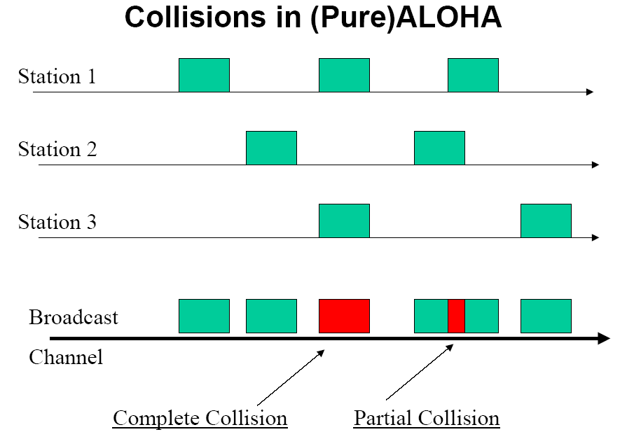
Figure 10.5.2
Advantages:
- Superior to fixed assignment when there are a large number of bursty stations.
- Adapts to varying number of stations.
Disadvantages:
- Theoretically proven throughput maximum of 18.4%.
- Requires queuing buffers for retransmission of packets.
Performance of Pure ALOHA
Let S –Throughput: Expected number of successful transmissions per time unit
Normalization: Frame transmission time is 1
Maximum throughput is 1
G -Offered Load: Expected number of transmission and retransmission attempts (from all users) per time unit
- Frames have fixed length of one time unit normalized
- Infinite user population
Prob [k frames generated in 1 frame time] = (G^{k}e^{-G})/k!

Prob [frame suffers no collision]=
= Prob [no other frame is generated during the vulnerable period for this frame]
= Prob [no frame is generated during a 2-frame period]
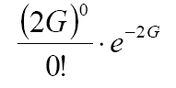
Throughput in ALOHA
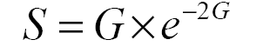
Throughput will be maximum for G=0.5. So Effiency of Pure ALOHA is 18%.

5.3. Slotted ALOHA
- Aloha with an additional constraint
- Time is divided into discrete time intervals (=slot)
- Slot size equals fixed packet transmission time
- A station can transmit only at the beginning of a slot.
- When Packet ready for transmission, wait until start of next slot
- Packets overlap completely or not at all
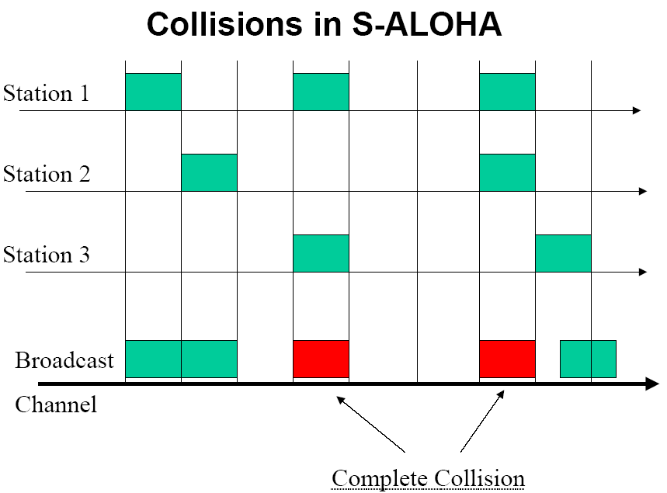
Figure 10.5.3
Advantages:
- Doubles the efficiency of Aloha
- Adaptable to a changing station population
Disadvantages:
- Theoretically proven throughput maximum of 36.8%
- Requires queuing buffers for retransmission of packets
Performance of Slotted ALOHA
Prob [frame suffers no collision] = Prob [no other frame is generated during the vulnerable period for this frame]
= Prob [no frame is generated during a 1-frame period]
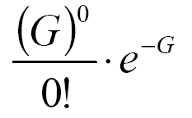
Throughput in S-ALOHA:
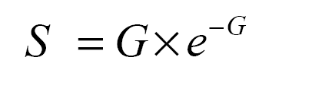
Throughput will be maximum for G=1.0. So Effiency of Slotted ALOHA is 36%.

5.4. Comparison between Pure ALOHA & Slotted ALOHA.
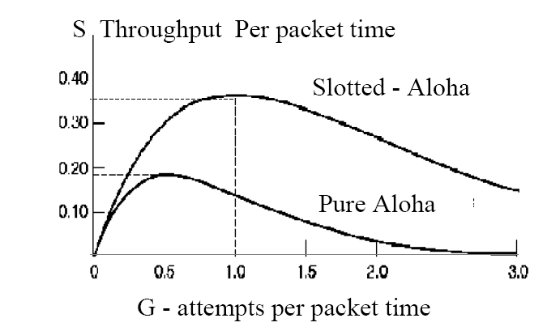
Figure 10.5.4

Carrier Sense Multiple Access Protocol (CSMA)
In both slotted and pure ALOHA, a node's decision to transmit is made independently of the activity of the other nodes attached to the broadcast channel. Ethernet uses a refinement of ALOHA, known as Carrier Sense Multiple Access (CSMA), which improves performance when there is a higher medium utilization. When a Station has data to transmit, the station first listens to the cable (using a transceiver) to see if a carrier (signal) is being transmitted by another node. This may be achieved by monitoring whether a current is flowing in the cable (each bit corresponds to 18-20 milliamps (mA)). If a sender does not receive an acknowledgment after some period, it assumes that a collision has occurred. After a collision a station backs off for a certain (random) time and retransmits.
There are a number of variations of CSMA protocols:
- Non-Persistent CSMA
- 1-Persistent CSMA
- p-Persistent CSMA

Non-Persistent CSMA Protocol:
1. If the medium is idle, transmit immediately
2. If the medium is busy, wait a random amount of time and repeat Step 1
- Random back-off reduces probability of collisions
- Wasted idle time if the back-off time is too long
- May result in long access delays
- Better Channel utilization than 1 persistent.

1-persistent CSMA Protocol:
When a station has to send data it first listens to the channel to see if anyone else is transmitting. If the channel is busy the station waits until it becomes idle, When the station detects an idle channel, it transmits a frame. If a collision occurs, the station waits a random amount of time and starts all over again.
1. Check the medium.
2. if idle, send
3. else, wait until idle (continuously sense), then send
4. if collision, wait random amount of time, goto 1
There will always be a collision if two stations want to transmit simultaneously.
1-persistent CSMA transmits with probability 1 when it finds channel idle.

p-Persistent CSMA Protocol:
This protocol applies to slotted channels. When a station becomes ready to send it sends the channel. If it is idle it transmits with a probability p.
1. If the medium is idle, transmit with probability p, and delay for one time unit with probability (1 - p) (time unit = length of propagation delay).
2. If the medium is busy, continue to listen until medium becomes idle, then go to Step 1
3. If transmission is delayed by one time unit, continue with Step 1
- If p=1, station can transmit the frame whenever the channel is idle. If p=0 station always wait.
If a collision has occurred, the channel is unstable until colliding packets have been fully transmitted. CSMA/CD overcome this difficulty.

Carrier Sense Multiple Access with Collision Detection (CSMA/CD)

While transmitting, the sender is listening to medium for collisions.

Sender stops if collision has occurred.

Use one of the CDMA persistence algorithm (non-persistent, 1-persistent, p-persistent) for transmission.

If a collision is detected during transmission, cease transmission and transmit a jam signal to notify other stations of collision.

After sending the jam signal, back off for a random amount of time, then start to transmit again.
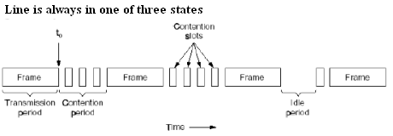
Figure 12.5.1 CSMA/CD can be in one of three states: contention, transmission, or idle

IEEE 802.3 standard for LAN (Ethernet)
Ethernet is a frame-based computer networking technology for local area networks (LANs). The name comes from the physical concept of ether. It defines wiring and signaling for the physical layer, and frame formats and protocols for the media access control (MAC)/data link layer of the OSI model. Ethernet is mostly standardized as IEEEs 802.3. Ethernet was originally developed as one of the many pioneering projects at Xerox PARC.
Ethernet uses 1-persistent carrier sense multiple access with collision detection (CSMA/CD) for channel allocation. Originally developed in the 1960s for the ALOHAnet in Hawaii using radio, the scheme is relatively simple compared to token ring or master controlled networks. When one station wants to send some information, it obeys the following algorithm:
Step 1: Start - If the wire is idle, starts transmitting, else go to step 4
Step 2: Transmitting - If detecting a collision, continue transmitting until the minimum packet time is reached (to ensure that all other transmitters and receivers detect the collision) then go to step 4.
Step 3: End successful transmission - Report success to higher network layers; exit transmit mode.
Step 4: Wire is busy - Wait until wire becomes idle
Step 5: Wire just became idle - Wait a random time, then go to step 1, unless maximum number of transmission attempts has been exceeded
Step 6: Maximum number of transmission attempt exceeded - Report failure to higher network layers; exit transmit mode.

