EXTREME PROGRAMMING

Software life cycle models describe phases of the software cycle and the order in which those phases are executed. There are tonnes of models, and many companies adopt their own, but all have very similar patterns. Each phase produces deliverables required by the next phase in the life cycle.
One of the software life cycle models is the XP model or Extreme Programming model.It is categorised as an agile process,meaning,it is based on fundamental changes to what was considered to be an accepted convention in the past. Extreme Programming (XP) is a software development methodology which is intended to improve software quality and responsiveness to changing customer requirements.It was created by Kent Beck during his work on the Chrysler Comprehensive Compensation System (C3) payroll project.This methodology takes best practices to extreme levels.
In traditional system development methods (such the waterfall model) the requirements for the system are determined at the beginning of the development project and often fixed from that point on. This means that the cost of changing the requirements at a later stage will be high. XP attempts to reduce the cost of change by having multiple short development cycles, rather than one long one. In this doctrine changes are a natural, inescapable and desirable aspect of software development projects, and should be planned for instead of attempting to define a stable set of requirements.
Following is the diagramatic representation of the phases in the XP model.
The software developed based on XP model is open to changes and modifications.So most features are such that required changes can be made in the future.Daily communication helps in obtaining feedback and review of the deiverd software as well as gives knowledge regarding the user requirements.The planning phase is iterative,that is,it takes place more than once and frequently as the software is open to incorporate changes and each time a change is to be made,adequate planning is required.

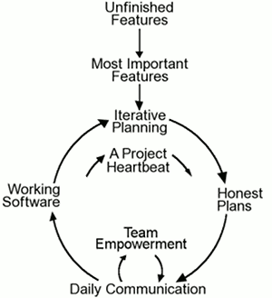

The 12 core practices of XP are:
- The Planning Game: Business and development cooperate to produce the maximum business value as rapidly as possible. The planning game happens at various scales, but the basic rules are always the same:
  - Business comes up with a list of desired features for the system. Each feature is written out as a User Story, which gives the feature a name, and describes in broad strokes what is required. User stories are typically written on 4x6 cards.
  - Development estimates how much effort each story will take, and how much effort the team can produce in a given time interval (the iteration).
  - Business then decides which stories to implement in what order, as well as when and how often to produce a production releases of the system.
- Small Releases: Start with the smallest useful feature set. Release early and often, adding a few features each time.
- System Metaphor: Each project has an organizing metaphor, which provides an easy to remember naming convention.
- Simple Design: Always use the simplest possible design that gets the job done. The requirements will change tomorrow, so only do what's needed to meet today's requirements.
- Continuous Testing: Before programmers add a feature, they write a test for it. When the suite runs, the job is done. Tests in XP come in two basic flavors.
- Unit Tests are automated tests written by the developers to test functionality as they write it. Each unit test typically tests only a single class, or a small cluster of classes. Unit tests are typically written using a unit testing framework, such as JUnit.
- Acceptance Tests (also known as Functional Tests) are specified by the customer to test that the overall system is functioning as specified. Acceptance tests typically test the entire system, or some large chunk of it. When all the acceptance tests pass for a given user story, that story is considered complete. At the very least, an acceptance test could consist of a script of user interface actions and expected results that a human can run. Ideally acceptance tests should be automated, either using the unit testing framework, or a separate acceptance testing framework.
- Refactoring: Refactor out any duplicate code generated in a coding session. You can do this with confidence that you didn't break anything because you have the tests.
- Pair Programming: All production code is written by two programmers sitting at one machine. Essentially, all code is reviewed as it is written.
- Collective Code Ownership: No single person "owns" a module. Any developer is expect to be able to work on any part of the codebase at any time.
- Continuous Integration: All changes are integrated into the codebase at least daily. The tests have to run 100% both before and after integration.
- 40-Hour Work Week: Programmers go home on time. In crunch mode, up to one week of overtime is allowed. But multiple consecutive weeks of overtime are treated as a sign that something is very wrong with the process.
- On-site Customer: Development team has continuous access to a real live customer, that is, someone who will actually be using the system. For commercial software with lots of customers, a customer proxy (usually the product manager) is used instead.
- Coding Standards: Everyone codes to the same standards. Ideally, you shouldn't be able to tell by looking at it who on the team has touched a specific piece of code.

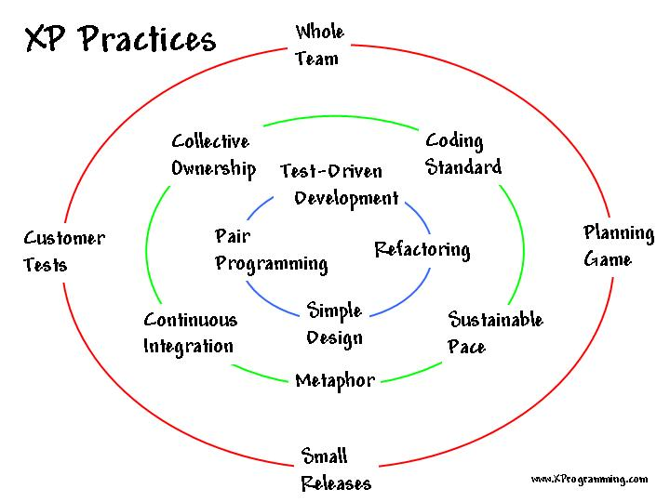

XP describes four basic activities that are performed within the software development process.

1.Coding: figure out the most suitable solution and help to communicate thoughts about programming problems.

2.Testing: Extreme Programming's approach is that if a little testing can eliminate a few flaws, a lot of testing can eliminate many more flaws.
- Unit tests determine whether a given feature works as intended. A programmer writes as many automated tests as they can think of that might "break" the code; if all tests run successfully, then the coding is complete. Every piece of code that is written is tested before moving on to the next feature.
- Acceptance tests verify that the requirements as understood by the programmers satisfy the customer's actual requirements. These occur in the exploration phase of release planning.

3.Listening:Programmers must listen to what the customers need the system to do, what "business logic" is needed

4. Designing: One can come a long way without designing but at a given time one will get stuck. The system becomes too complex and the dependencies within the system cease to be clear. One can avoid this by creating a design structure that organizes the logic in the system. Good design will avoid lots of dependencies within a system; this means that changing one part of the system will not affect other parts of the system.

5. Values:The 5 values recognized by XP model are as follows:

i)Communication
Building software systems requires communicating system requirements to the developers of the system. In formal software development methodologies, this task is accomplished through documentation.

ii)Simplicity
Extreme Programming encourages starting with the simplest solution. Extra functionality can then be added later

iii)Feedback
Within Extreme Programming, feedback relates to different dimensions of the system development:
- Feedback from the system
- Feedback from the customer
- Feedback from the team

iv)Courage
Several practices embody courage. One is the commandment to always design and code for today and not for tomorrow..

v)Respect
The respect value manifests in several ways. In Extreme Programming, team members respect each other because programmers should never commit changes that break compilation, that make existing unit-tests fail, or that otherwise delay the work of their peers. Members respect their work by always striving for high quality and seeking for the best design for the solution at hand through refactoring.

XP incorporates within it certain rules.
-"Rules of Engagement" which dictate the environment in which software development can take place effectively, and
-"Rules of Play" which define the minute-by-minute activities and rules within the framework of the Rules of Engagement.

Extreme Programming sees feedback as most useful if it is done rapidly and expresses that the time between an action and its feedback is critical to learning and making changes. Unlike traditional system development methods, contact with the customer occurs in more frequent iterations. The customer has clear insight into the system that is being developed. He or she can give feedback and steer the development as needed.
A number of criticsims have risen against XP model some of which are as follows:
- Requirements are defined incrementally, rather than trying to get them all in advance.
- Software developers are usually required to work in pairs.
- There is no Big Design Up Front. Most of the design activity takes place on the fly and incrementally.
- A customer representative is attached to the project. This role can become a single-point-of-failure for the project, and some people have found it to be a source of stress.
- Lack of structure and necessary documentation
- Only works with senior-level developers
- Incorporates insufficient software design
- Requires meetings at frequent intervals at enormous expense to customers
- Requires too much cultural change to adopt
- Can lead to more difficult contractual negotiations
- Can be very inefficient—if the requirements for one area of code change through various iterations, the same programming may need to be done several times over

