ITERATIVE MODEL
Submitted by,

Lakshmi V
Prajul P T
Priya Sekhar
Rahul Joseph
Rahul Manoharan
Rajesh Paul
Riya Elizabeth Sunny

Introduction

A software life cycle model is either a descriptive or prescriptive characterization of how software is or should be developed. A descriptive model describes the history of how a particular software system was developed. Descriptive models may be used as the basis for understanding and improving software development processes.

Iterative model is a cyclic software development process model developed in response to the weaknesses of another model called waterfall model which has no concept of feedback or reexamination of previous stages anymore. It starts with an initial planning and ends with deployment with the cyclic interaction in between.

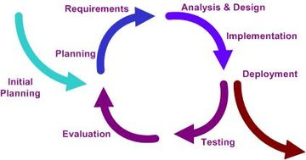

(fig) The flow of operations in an iterative model

Without mapping out iterations, you have very little idea when the project will be finished, what resources will be needed to complete the project, or when these resources will be needed. Without estimates to help judge the cost of the project, it is difficult to get the customer and sponsor to commit resources for all but the most trivial project, and there will be little to indicate how the project is progressing toward the goal of delivering a solution.

Principle

The basic idea behind iterative enhancement is to develop a software system incrementally, allowing the developer to take advantage of what was being learned during the development of earlier, incremental, deliverable versions of the system. Learning comes from both the development and use of the system, where possible key steps in the process are to start with a simple implementation of a subset of the software requirements and iteratively enhance the evolving sequence of versions until the full system is implemented. At each iteration, design modifications are made and new functional capabilities are added.

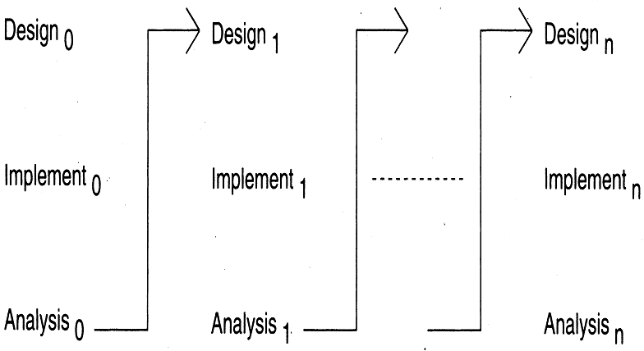

(fig) The iterative model
Procedure

The procedure itself consists of the following steps:
- initialization step
- Iteration step, and
- Project Control List.

The initialization step creates a base version of the system. The goal for this initial implementation is to create a product to which the user can react. It should offer a sampling of the key aspects of the problem and provide a solution that is simple enough to understand and implement easily. To guide the iteration process, a project control list is created that contains a record of all tasks that need to be performed. It includes such items as new features to be implemented and areas of redesign of the existing solution. The control list is constantly being revised as a result of the analysis phase.

The iteration involves the redesign and implementation of a task from the project control list, and the analysis of the current version of the system. The goal for the design and implementation of any iteration is to be simple, straightforward, and modular, supporting redesign at that stage or as a task added to the project control list. The level of design detail is not dictated by the interactive approach. In a light-weight iterative project the code may represent the major source of documentation of the system; however, in a mission-critical iterative project a formal Software Design Document may be used. The analysis of iteration is based upon user feedback, and the program analysis facilities available. It involves analysis of the structure, modularity, usability, reliability, efficiency, & achievement of goals. The project control list is modified in light of the analysis results.

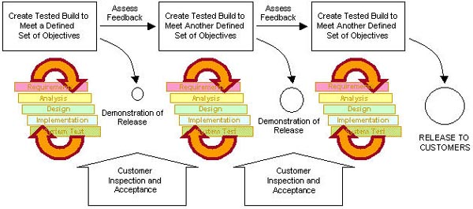

(fig.) Iterative model from perspective of a project manager

Benefits

- Get-as-you-pay: As the user pay for each module of the software he gets a finished product worth the money he has paid.

- Obtain feedback for improvement: At each stage the user provide the feedback after inspection and acceptance of the section of the software that is demonstrated in front of him.

- No risk of all-or-nothing: If due to any reason the company that develops the software for the user fails to provide the user with the final finished product or software, the user is not to worry much since only a section after the last finished state is missing.

Drawbacks

- Architecture/design may not be optimal: Since sections of project are already delivered to the clients the final architecture may not be exact and accurate.

- Amendments may increase: The user gives feedback after demonstration of each section of the developed software. This may increase the number of changes that are to be made to the so far developed software.

- Total cost of the project may be more: Since the work load may increase as the stages of development progresses, the final cost of the project may increase. And the final cost may exceed the initially estimated cost.

The iterative approach has proven itself superior to the waterfall approach for a number of reasons:

- It accommodates changing requirements. Changes in requirements and "feature creep" -- the addition of features that are technology- or customer-driven -- have always been primary sources of project trouble, leading to late delivery, dissatisfied customers, and frustrated developers. To address these problems, teams who use an iterative approach focus on producing and demonstrating executable software in the first few weeks, which forces a review of requirements and helps to pare them down to essentials.

- Integration is not one "big bang" at the end of a project. Leaving integration to the end almost always results in time-consuming rework -- sometimes up to 40 percent of the total project effort. To avoid this, each iteration ends by integrating building blocks; this happens progressively and continuously, minimizing later rework.

- Early iterations expose risks. An iterative approach helps the team mitigate risks in early iterations, which include testing for all process components. As each iteration engages many aspects of the project -- tools, off-the-shelf software, team members' skills, and so on -- teams can quickly discover whether perceived risks are real and uncover new risks they did not suspect, at a time when these problems are relatively easy and less costly to address.

- Management can make tactical changes to the product. Iterative development quickly produces an executable architecture (albeit of limited functionality) that can be readily translated into a "modified" product for quick release to counter a competitor's move.

- It facilitates reuse. It is easier to identify common parts as you partially design or implement them in iterations than to recognize them during planning. Design reviews in early iterations allow architects to spot potential opportunities for reuse, and then develop and mature common code for these opportunities in subsequent iterations.

- You can find and correct defects over several iterations. This results in a robust architecture and a high-quality application. You can detect flaws even in early iterations rather than during a massive testing phase at the end. And you can discover performance bottlenecks when you can still address them without destroying your schedule -- or creating panic on the eve of delivery.

- It facilitates better use of project personnel. Many organizations match their waterfall approach with a pipeline organization: Analysts send the completed requirements to designers, who send a completed design to programmers, who send components to integrators, who send a system for test to testers. These multiple handoffs not only create errors and misunderstandings; they also make people feel less responsible for the final product. An iterative process encourages a wider scope of activities for team members, allowing them to play many roles. Project managers can better use available staff and eliminate risky handoffs.

- Team members learn along the way. Those working on iterative projects have many opportunities during the development lifecycle to learn from their mistakes and improve their skills from one iteration to another. By assessing each iteration, project managers can discover training opportunities for team members. In contrast, those working on waterfall projects are typically confined to narrow specialties and have only one shot at design, coding, or testing.

- You can refine the development process along the way. End-of-iteration assessments not only reveal the status of the project from a product or scheduling perspective; they also help managers analyze how to improve both the organization and the process in the next iteration.

Areas of application

- Businesses which require quick response for software
- Organizations which cannot afford the risk of all-or-nothing
- When all the requirements are not known beforehand.

Organizations which cannot afford the risk of long projects

Key points

An iterative model of software development thus:

- Develops and deliver software in increments
- Each increment of which is complete in itself
- Can be viewed as a sequence of waterfalls
- Feedback from iterations is used in the future iterations
- Combines benefit of prototyping and waterfall models.

The iterative approach tempts you to start coding too early. You should have a good idea of what the final program should look like before starting. Unless you're clear on what you want, it's likely that much extra iteration will be required.

