Submitted by
- Neelima.s
- Nidhiya Chiramel
- Nikita Sara Alexander
- Pearl Gregory
- Nithin Johnson
- Philip John
- Vishnu
INTRODUCTION

A prototype is a working model that is functionally equivalent to a component of the product. Software prototyping is an activity during software development where prototypes or incomplete versions of the actual software to be developed are created. A prototype typically simulates only a few aspects of the features of the final program and may be completely different from the actual program. It is a systems development method (SDM) in which a prototype (an early approximation of a final system or product) is built, tested, and then reworked as necessary until an acceptable prototype is finally achieved from which the complete system or product can now be developed. This model works best in scenarios where not all of the project requirements are known in detail ahead of time. It is an iterative, trial-and-error process that takes place between the developers and the users. This model reflects an attempt to increase the flexibility of the development process by allowing the client to interact and experiment with a working representation of the product. The developmental process only continues once the client is satisfied with the functioning of the prototype. At that stage the developer determines the specifications of the client’s real needs. Prototyping includes:
- Identify basic requirements
- Develop Initial Prototype
- Review
- Revise and Enhance the Prototype
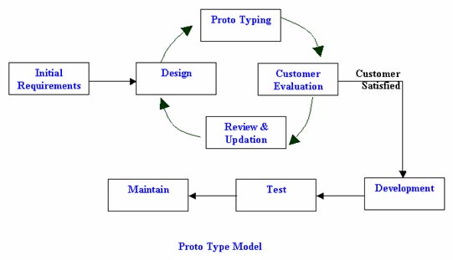
Steps in prototyping:
- The new system requirements are defined in as much detail as possible. This usually involves interviewing a number of users representing all the departments or aspects of the existing system.
- A preliminary design is created for the new system.
- A first prototype of the new system is constructed from the preliminary design. This is usually a scaled-down system, and represents an approximation of the characteristics of the final product.
- The users thoroughly evaluate the first prototype, noting its strengths and weaknesses, what needs to be added, and what should to be removed. The developer collects and analyzes the remarks from the users.
- The first prototype is modified, based on the comments supplied by the users, and a second prototype of the new system is constructed.
- The second prototype is evaluated in the same manner as was the first prototype.
- The preceding steps are iterated as many times as necessary, until the users are satisfied that the prototype represents the final product desired.
- The final system is constructed, based on the final prototype.
- The final system is thoroughly evaluated and tested. Routine maintenance is carried out on a continuing basis to prevent large-scale failures and to minimize downtime.

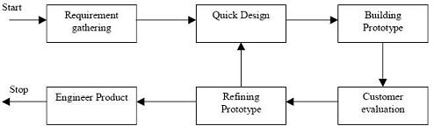
Prototyping Model

Advantages:
- Users are actively involved in the development
- It provides a better system to users, as users have natural tendency to change their mind in specifying requirements and this method of developing systems supports this user tendency.
- Since in this methodology a working model of the system is provided, the users get a better understanding of the system being developed.
- Errors can be detected much earlier as the system is mode side by side
- Quicker user feedback at an early stage is available leading to better solutions.
- Cost of testing and writing detailed documents are reduced and hence overall development cost is less
- Final system and results are more reliable and better designed.
- The client and the contractor can compare if the software made matches the software specification, according to which the software program is built.
- It also allows the software engineer some insight into the accuracy of initial project estimates and whether the deadlines and milestone proposed can be successfully met.

Disadvantages:
- Leads to implementing and then repairing way of building systems.
- Practically, this methodology may increase the complexity of the system as scope of the system may expand beyond original plans.
- Cost involved is greater due to built-it-twice approach.
- Insufficient analysis: The focus on a limited prototype can distract developers from properly analyzing the complete project. This can lead to overlooking better solutions, preparation of incomplete specifications or the conversion of limited prototypes into poorly engineered final projects that are hard to maintain. Further, since a prototype is limited in functionality it may not scale well if the prototype is used as the basis of a final deliverable, which may not be noticed if developers are too focused on building a prototype as a model.
5. User confusion of prototype and finished system: Users can begin to think that a prototype, intended to be thrown away, is actually a final system that merely needs to be finished or polished. (They are, for example, often unaware of the effort needed to add error-checking and security features which a prototype may not have.) This can lead them to expect the prototype to accurately model the performance of the final system when this is not the intent of the developers. Users can also become attached to features that were included in a prototype for consideration and then removed from the specification for a final system. If users are able to require all proposed features be included in the final system this can lead to conflict.
6. Developer misunderstanding of user objectives: Developers may assume that users share their objectives (e.g. to deliver core functionality on time and within budget), without understanding wider commercial issues. For example, user representatives attending Enterprise software (e.g.PeopleSoft) events may have seen demonstrations of "transaction auditing" (where changes are logged and displayed in a difference grid view) without being told that this feature demands additional coding and often requires more hardware to handle extra database accesses. Users might believe they can demand auditing on every field, whereas developers might think this is feature creep because they have made assumptions about the extent of user requirements. If the solution provider has committed delivery before the user requirements were reviewed, developers are between a rock and a hard place, particularly if user management derives some advantage from their failure to implement requirements.
7. Developer attachment to prototype: Developers can also become attached to prototypes they have spent a great deal of effort producing; this can lead to problems like attempting to convert a limited prototype into a final system when it does not have an appropriate underlying architecture. (This may suggest that throwaway prototyping, rather than evolutionary prototyping, should be used.)
8. Excessive development time of the prototype: A key property to prototyping is the fact that it is supposed to be done quickly. If the developers lose sight of this fact, they very well may try to develop a prototype that is too complex. When the prototype is thrown away the precisely developed requirements that it provides may not yield a sufficient increase in productivity to make up for the time spent developing the prototype. Users can become stuck in debates over details of the prototype, holding up the development team and delaying the final product.
9. Expense of implementing prototyping: the start up costs for building a development team focused on prototyping may be high. Many companies have development methodologies in place, and changing them can mean retraining, retooling, or both. Many companies tend to just jump into the prototyping without bothering to retrain their workers as much as they should.
10. A common problem with adopting prototyping technology is high expectations for productivity with insufficient effort behind the learning curve. In addition to training for the use of a prototyping technique, there is an often overlooked need for developing corporate and project specific underlying structure to support the technology. When this underlying structure is omitted, lower productivity can often result
Evolution of prototype model
In the traditional SDLC, software is created on a well planned pattern. There will be planning, consultation, creation, testing, documentation and launching. This pattern is seen in most development software. Since it’s planned right from the start, it is efficient as planned. However, it is important to note that this type of development is all focused on the developers and not the consumers.

To overcome this, another model for developing software is created Called the Prototype model, here the development of the program is not based on strict planning, but it is based on the response of the users instead.
As a type of SDLC, the Prototype Model slowly builds from a simple concept of what a program is. Little by little the software is updated and tested in a real time environment. Users will be able to test and improve the software as they are created.
Types of prototyping:
Software prototyping has many variants. However, all the methods are in some way based on two major types of prototyping: Throwaway Prototyping and Evolutionary Prototyping.
1. Throwaway protocol:
Also called close ended prototyping. Throwaway or Rapid Prototyping refers to the creation of a model that will eventually be discarded rather than becoming part of the final delivered software. After preliminary requirements gathering is accomplished, a simple working model of the system is constructed to visually show the users what their requirements may look like when they are implemented into a finished system.
Rapid Prototyping involved creating a working model of various parts of the system at a very early stage, after a relatively short investigation. The method used in building it is usually quite informal, the most important factor being the speed with which the model is provided. The model then becomes the starting point from which users can re-examine their expectations and clarify their requirements. When this has been achieved, the prototype model is 'thrown away', and the system is formally developed based on the identified requirements.
The most obvious reason for using Throwaway Prototyping is that it can be done quickly. If the users can get quick feedback on their requirements, they may be able to refine them early in the development of the software. Making changes early in the development lifecycle is extremely cost effective since there is nothing at that point to redo. If a project is changed after a considerable work has been done then small changes could require large efforts to implement since software systems have many dependencies. Speed is crucial in implementing a throwaway prototype, since with a limited budget of time and money little can be expended on a prototype that will be discarded.
Another strength of Throwaway Prototyping is its ability to construct interfaces that the users can test. The user interface is what the user sees as the system, and by seeing it in front of them, it is much easier to grasp how the system will work.
SUMMARY:-In this approach the prototype is constructed with the idea that it will be discarded and the final system will be built from scratch. The steps in this approach are:
- Write preliminary requirements
- Design the prototype
- User experiences/uses the prototype, specifies new requirements
- Repeat if necessary
- Write the final requirements
- Develop the real products
2. Evolutionary prototyping
Evolutionary Prototyping (also known as breadboard prototyping) is quite different from Throwaway Prototyping. The main goal when using Evolutionary Prototyping is to build a very robust prototype in a structured manner and constantly refine it. "The reason for this is that the Evolutionary prototype, when built, forms the heart of the new system, and the improvements and further requirements will be built.
When developing a system using Evolutionary Prototyping, the system is continually refined and rebuilt.
This technique allows the development team to add features, or make changes that couldn't be conceived during the requirements and design phase.For a system to be useful, it must evolve through use in its intended operational environment. We make assumptions about the way business will be conducted and the technology base on which the business will be implemented. A plan is enacted to develop the capability, and, sooner or later, something resembling the envisioned system is delivered.
Evolutionary Prototypes have an advantage over Throwaway Prototypes in that they are functional systems. Although they may not have all the features the users have planned, they may be used on an interim basis until the final system is delivered.
In Evolutionary Prototyping, developers can focus themselves to develop parts of the system that they understand instead of working on developing a whole system.
To minimize risk, the developer does not implement poorly understood features. The partial system is sent to customer sites. As users work with the system, they detect opportunities for new features and give requests for these features to developers. Developers then take these enhancement requests along with their own and use sound configuration-management practices to change the software-requirements specification, update the design, recode and retest.
3. Incremental prototyping:
The final product is built as separate prototypes. At the end the separate prototypes are merged in an overall design.
4. Extreme prototyping
Extreme Prototyping as a development process is used especially for developing web applications. Basically, it breaks down web development into three phases, each one based on the preceding one. The first phase is a static prototype that consists mainly of HTML pages. In the second phase, the screens are programmed and fully functional using a simulated services layer. In the third phase the services are implemented. The process is called Extreme Prototyping to draw attention to the second phase of the process, where a fully-functional UI is developed with very little regard to the services other than their contract.
5. Patch Up Prototype
This type of Prototype Model encourages cooperation of different developers. Each developer will work on a specific part of the program. After everyone has done their part, the program will be integrated with each other resulting in a whole new program. Since everyone is working on a different field, Patch Up Prototype is a fast development model. If each developer is highly skilled, there is no need to overlap in a specific function of work.
6.Non-Operational Prototype
A non-operational prototype model is used when only a certain part of the program should be updated. Although it’s not a fully operational program, the specific part of the program will work or could be tested as planned. The main software or prototype is not affected at all as the dummy program is applied with the application. Each developer who is assigned with different stages will have to work with the dummy prototype. This prototype is usually implemented when certain problems in a specific part of the program arises.
7. First of a Series Prototype
Known as a beta version, this Prototype Model could be very efficient if properly launched. In all beta versions, the software is launched and even introduced to the public for testing. It’s fully functional software but the aim of being in beta version is to as for feedbacks, suggestions or even practicing the firewall and security of the software
8. Selected Features Prototype
This is another form of releasing software in beta version. However, instead of giving the public the full version of the software in beta, only selected features or limited access to some important tools in the program is introduced. Selected Features Prototype is applied to software that are part of a bigger suite of programs.

Examples of projects where prototyping can be used:
- Transaction processing
- Batch processing(system with little user interaction)
- Designing human-computer interface

Tools:
Efficiently using prototyping requires that an organization have proper tools and a staff trained to use those tools. Tools used in prototyping can vary from individual tools like CASE tools. 4th generation programming languages like Visual Basic and Cold fusion are frequently used since they are cheap, well known and relatively easy and fast to use. CASE tools, like the Requirements engineering development are often developed or selected by the military or large organizations.

Screen generators, design tools & Software Factories
Also commonly used are screen generating programs that enable prototypes to show users systems that don't function, but show what the screens may look like
Software Factories are Code Generators that allow you to model the domain model and then drag and drop the UI. Also they enable us to run the prototype and use basic database functionality. This approach allows us to explore the domain model and make sure it is in sync with the GUI prototype.

PSDL
PSDL is a prototype description language to describe real-time software.
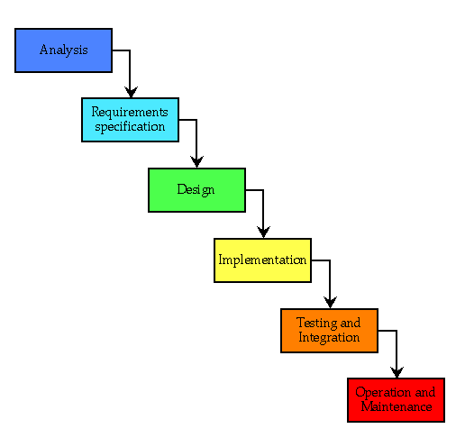

Prototyping in Software Development(QUESTIONS)
1. Why Prototype?
Prototyping is a means of exploring ideas before you invest in them. The best reason to prototype is to save time and resources. So, for a minimal investment, you can find usability and design problems and adjust your UI before you invest heavily in the final design and technologies.
On examining the needs of your particular project, you might come up with reasons for creating a prototype other than saving money. Is the goal to explore a new interface model? Make modifications to one part of the existing design? Investigate a new technology? It’s important to be clear about why you’re building what you’re building before you start. If you begin with clear goals, you can be direct and effective in your efforts. The reasons for creating prototypes fall into three basic categories:
Proof of concept.
Among some teams there are disagreements about the future direction of a project. You can use a prototype to prove that an idea or new approach has merit or value. A prototype can help illustrate that an idea works, express its qualities in a visual and interactive way, and/or motivate team members to think about the problem from another perspective.
Design exploration.
If you design interactive things, the only way to explore how something will be used is to create a mock-up and interact with it. Sometimes the mock-up is tied to a usability study, where parts of the prototype can be evaluated in a structured way. Sometimes it’s just a way to clearly express to a developer how something should work or look. In many cases, a designer might simply be experimenting, in an effort to get a sense for what approach might work. Anyone on the team can use prototypes to explore design issues, although designers are generally the most skilled. Design explorations should be directed at trying to solve specific problems that you’ve recognized in your product.
Technical exploration.
Developers investigating implementation approaches to a problem often try out different coding techniques to see if they work well. Using HTML, Jscript, SQL, DHTML, Win32, or specific coding approaches within each technology have different tradeoffs. Sometimes a prototype represents an exploration into what technology will work well to support a certain UI or web feature.
Sometimes prototypes are created for a combination of these reasons. If a team plans well enough, they can allot time for a developer and a designer or project manager to work together on a prototype. In such cases, it’s extremely important to clearly define the goals and the contributions each team member is expected to make. You want everyone to be clear on what the goals are, what’s at stake, and what the potential outcome will be.
2. Who is Involved?
Prototyping can be done informally by anyone, regardless of their background or role in the project. It’s easy to make a simple but effective prototype by taking a bitmap from Adobe Photoshop, putting it into the Microsoft FrontPage Web site creation and management tool, and adding active buttons or links. These lightweight prototypes only go so far, and can become unwieldy for complex interactions.
For more formal prototypes by larger teams, a developer or project manager will often collaborate with a designer and a usability engineer. Together they’ll generate ideas, build a prototype that represents the best ideas, and then go into the lab to see how effective it is in solving user problems. Developers might get involved if they can spare the time, or if their technical expertise is needed. Often the designer or project manager will do most of the scripting or coding to build the prototype.

