RAJAGIRI SCHOOL OF ENGINEERING AND TECHNOLOGY
Rajagiri Valley, Kochi -39


TEACHING NOTES
RT602 – SOFTWARE ENGINEERING
MODULE 1 – Introduction to Software Engineering

for

B.TECH. COMPUTER SCIENCE & ENGINEERING BRANCH
SIXTH SEMESTER
January 2010

Prepared By

K. S. Mathew,
Professor, Dept. of CSE

Table of Contents

1. Introduction to Software Engineering 3
1.1 What is Software? 3
1.1.1 History of Software 4
1.1.2 Software Characteristics 5
1.1.3 Software Applications - Classification 5
1.1.4 What is a project? 7
1.1.5 What is Management? 8
1.2 Software Engineering 13
1.3 Software Development Process Models 20
1.4 Software Requirements Analysis and Specification 26

Introduction to Software Engineering

What is Software?
Software can be described as consisting of:
- Computer instructions (or computer programs) that when executed provide desired function and performance or solve some business problem.
- Data structures that enable the programs to adequately manipulate information, and
- Documents that describe the operation and use of the programs.

Software is a product and at the same time, the vehicle for delivering a product. As a product, it delivers the computing potential embodied by computer hardware or a network of computers. Software is an information transformer – producing, managing, acquiring, modifying, displaying, or transmitting information. As the vehicle used to deliver the product, software acts as the basis for the control of the computer (operating systems), communication of information (networks), and the creation and control of other programs (software tools and environments). Software delivers the most important product of our time – information. Software transforms personal data (e.g., an individual’s financial transactions) so that the data can be more useful in a local context; it manages business information to enhance competitiveness; it provides a gateway to worldwide information networks (eg. Internet) and provides the means for acquiring information in all of its forms.

Software has undergone significant changes over the past 60 years with dramatic improvements in hardware performance, profound changes in computing architectures, vast increases in memory and storage capacity, and a wide variety of exotic input and output options. However, even now the success rate of software projects is only around 32%. Following were the major concerns all along the software history:
- Why does it take so long to get software finished?
- Why are development costs so high?
- Why can’t we find all the errors before we give the software to customers?
- Why do we continue to have difficulty in measuring progress as software is being developed?

These concerns are mainly due to the specific characteristics of software products in comparison with other products and also because of the way in which it is developed (compared to how other products are manufactured). These concerns led to the adoption of software engineering practices by the industry, which helped to improve the software projects success rate.

History of Software

Year | Event
1804 | First practical form of programming done by Jaquard, France. He designed a loom that performed a set of pre-defined tasks by feeding instructions punched in cards. Instructions were specific to the problem to be solved.
1843 | Ada Lovelace wrote the first rudimentary program for the analytical machine designed by Charles Babbage in 1827
1847 | George Boole proved the relationships between mathematics and logic and introduced Boolean algebra or binary logic.
1945 | John Von Neumann introduced two important concepts that directly affected the path of computer programming languages. The concepts were: (1) ‘shared-program technique’ which states that the actual computer hardware should be simple and need not be hard wired for each program. Instead complex instructions should be used to control the simple hardware, allowing it to be reprogrammed much faster (2) ‘conditional control transfer’ which gave rise to the notion of subroutines and libraries. Also, it stated that the computer code should be able to branch based on logical statements such as IF, and looped such as with a FOR statement.
1948 | Claude Shannon wrote a thesis on how binary logic could be used in computing to complete the software concept of modern computing.
1949 | The first computer language called Short Code appeared. It required the programmer to change its statements into 0’s and 1’s by hand.
1951 | Grace Hopper wrote the first compiler called A-0.
1957 | IBM designed the first of the major languages FORTRAN
1958 | John McCarthy of MIT designed the LISP language for Artificial Intelligence
1958 | Algol was created by a committee for scientific use. This led to the development of other languages such as Pascal, C, C++ and Java. Algol first implemented the novel concepts like recursive calling of functions etc.
1959 | COBOL was developed for business computing
1964 | IBM released PL/1
1964 | BASIC language was developed by John Kemeny and Thomas Kurtz
1968 | Niklaus Wirth developed Pascal as a good teaching tool for educational institutions. Introduced the CASE statement.
1970 | FORTH (the first fourth generation language) developed by Charles Moore
1972 | Dennis Ritchie of Bell Labs developed C language for their new Unix system
1975 | Prolog was released by Philippe Roussel
1979 | Smalltalk was designed by Xerox PARC
1979 | ADA was released by Department of Defense
1983 | Ashton Tate created dBase II
1984 | Clipper was developed by Nantucket Software
1986 | First version of “C with classes”, C++ was designed by Bjarne Stroustrup of Bell Labs
1987 | Perl was developed by Larry Wall
Early 1990 | Microsoft designed Visual BASIC
1994 | James Gosling of Sun Microsystems developed Java
2001 | C# developed by Anders Hejlsberg & team of Microsoft was released.

Software Characteristics

Software is more of a logical rather than a physical product. Therefore, software has the following specific characteristics that are considerably different than those of other physical/hardware products.

- Software is a logical rather than a physical product and is intangible
- Software is developed or engineered; it is not manufactured in the classical sense
- Software doesn’t wear out; but it does deteriorate (explain with “bathtub” curve)
- Software can be changed easily compared to other products
- Most software continues to be custom-built rather than component based assembly
- Software is expensive since software costs are concentrated in engineering / development which is labor intensive. Whereas, hardware costs are coming down with the advancement of technology. HW/SW cost ratio in mid 50’s were 85:15 whereas now it is around 10:90.

Software Applications - Classification

Software may be applied in any situation where pre-defined set of procedural steps has been defined. Software applications can be broadly classified into the following areas:

- Business Applications – Majority of software applications fall in this category, which accesses one or more large databases containing business information. Examples include Banking, Payroll, Inventory, Railway Reservation etc.
- System Software - System software is a collection of programs written to service other programs. Examples include compilers, editors, file management utilities, operating system components, drivers, telecommunication processors etc.
- Engineering and Scientific Applications – These are software applications that generally involves “number crunching” algorithms to process/manipulate data. Applications range from astronomy to volcanology, from automotive stress analysis to space shuttle orbital dynamics, and from molecular biology to automated manufacturing.
- Real-time Software – Software that monitors/analyzes/controls real-world events as they occur (responses ranging from milliseconds to one second) is called real time. Usually, a real time software will have following elements: (a) a data gathering component that collects and formats information from an external environment (b) an analysis component that transforms information as required by the application (c) a control or output component that responds to the external environment, and (d) a monitoring component that coordinates all other components so that real time response can be maintained. Examples include process control software, CNC machine control software, railway signaling system etc.
- Embedded Software – Software that resides in read-only memory within consumer/industrial systems and products and is used to control them. Examples include key pad control for a microwave oven, fuel control, dashboard displays and breaking systems.
- Personal Computer (PC) Software – Software that are installed in the home PCs for personal use. Examples include word processing, spreadsheets, computer graphics, multi media, entertainment, database management, personal and business financial applications,
- Artificial Intelligence Software – Artificial Intelligence (AI) software makes use of non-computational algorithms to solve complex problems that are not amenable to computation or straight forward analysis. Expert systems, also called knowledge based systems, pattern recognition (image and voice), artificial neural networks, theorem proving, and game playing are examples of applications within this category.
- Software Components - Though most of the software is custom built, component-based software engineering is evolving with the intention of developing software with reusable components. A software component is a standalone piece of software encapsulating both data and the processing applied to the data; providing a clearly defined service or function with clear interfaces to outside world. A software component should be designed and implemented so that it can be reused in many different programs. For example, today’s graphical user interfaces are built using reusable components that enable the creation of graphics windows, buttons, pull-down menus, and a wide variety of interaction mechanisms.

What is a project?

Different activities performed by an organization falls into two main categories called “Operations” and “Projects”. Operations are routine or day-to-day activities of the organization or a department within it. Projects are unique and temporary activities (rather a set of activities) executed to achieve a definite objective or goal.

- Common characteristics of Operations & Projects:
- Performed by people
- Constrained by limited resources
- Planned, executed and controlled

- Difference between Operations & Projects:
- Operations are ongoing & repetitive
- Projects are temporary & unique

Project Definition: A project is a temporary endeavor undertaken to create a unique product or service. Temporary means every project has a definite beginning and a definite end. Unique means that the product or service is different in some distinguishing way from all other products and services.

Project Examples:

- Building a bridge, building or a facility
- Preparing a company’s financial report
- Running a campaign for an environmental issue
- Writing a new operating system for a computer
- A programming assignment for a final year computer student

Project Characteristics

Key characteristics of a project:

- Large or complex
- Work is carried out in several phases
- Specific objectives are to be met
- Planning is required
- Predetermined time span
- Non-routine tasks are involved
- Multiple groups may be involved

Software Project

A project, whose objective is to design and develop a software component or application, is called a software project.

Software Projects vs Other Projects

The following three characteristics of products of software projects make them different from other projects:

Invisibility: The progress in the construction of a product is more visible in case of other projects. With software, progress is not immediately visible.

Complexity: Per dollar spent, software products contain more complexity than other engineered products.

Flexibility: The ease with which software can be changed is usually seen as one of its strengths. This means the software systems are likely to be subject to a high degree of change.

Problems with Software Projects

The following are some of the problems with software projects from the manager’s point of view:

- Unrealistic estimates and plans
- Lack of (or insufficient) trained resources
- Changing business requirements
- Lack of quality standards and measures
- Lack of guidance about making organizational decisions
- Lack of techniques to make progress visible
- Poor role definition – who does what?
- Incorrect success criteria

Given below is a list of problems with software projects in a developer’s perspective:

- Inadequate specification of work
- Lack of domain knowledge
- Lack of standards
- Lack of up-to-date documentation
- Changing system requirements
- Dynamic software environment
- Deadline pressure
- Lack of training

What is Management?

“Management” involves the following activities:

- Planning – deciding what is to be done
- Organizing – making arrangements
- Staffing – selecting the right people for the job
- Directing – giving instructions
- Monitoring – checking on progress
- Controlling – taking action to remedy hold-ups
- Innovating – coming up with new solutions
- Representing – liaising with users etc.

What is Project Management?

The applications of knowledge, skills, tools and techniques to project activities in order to meet or exceed stakeholders expectations. It involves all the above management activities of planning, organizing, staffing,…etc.

The Project Manager is concerned about three main constraints in a project, namely Time, Cost and Scope. Balancing SCOPE, COST and TIME within the framework of QUALITY, meeting customer expectations is the main responsibility of a Project Manager.

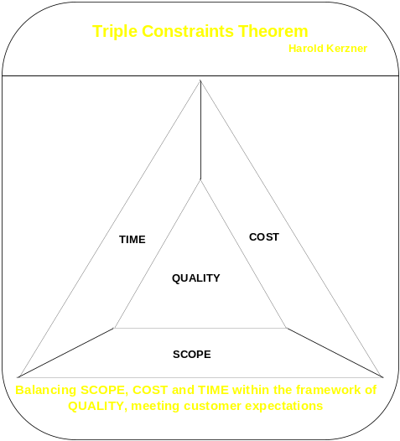

The project management processes could be broadly classified under:

- Project Initiation – Project Management processes for establishing the business need/objectives of the project and formally initiating a project.
- Project Planning – All planning activities in the project including planning the scope, time, cost, quality, risk, communication, human resources, procurement etc. of the project. A formal project plan document will be produced during the planning phase.
- Project Execution – Executing the plan to deliver the product or service.
- Project Monitoring and Control – During execution, we need to monitor the progress and status of various activities of the project and make sure that the project objectives will be met. In case of any deviation from the plan, corrective actions to be taken to control the deviation.
- Project Closure – Formally closing or terminating a project. This include the activities like documenting the lessons learned, archiving the project artifacts, updating the project repository, releasing the resources etc.

The PM processes are further segregated into 9 knowledge areas as follows. There may be initiating, planning, executing, controlling and closing processes under each of these knowledge areas:

- Project Scope Management – Processes required to ensure that the project includes all the work required, and only the work required, to complete the project successfully.
- Project Cost Management – Processes required to ensure that the project is completed within the approved budget.
- Project Time Management – Processes required to ensure timely completion of the project.
- Project Quality Management – Processes required to ensure that the project will satisfy the needs for which it was undertaken.
- Project Risk Management – Processes concerned with identifying, analyzing and responding to project risks.
- Project Human Resource Management – Processes required to make the most effective use of the people involved with the project.
- Project Communication Management – Processes required to ensure timely and appropriate generation, collection, dissemination, storage and ultimate disposition of project information.
- Project Procurement Management – Processes required to acquire goods and services from outside the performing organization.
- Project Integration Management – Processes required to ensure that the various elements of the project are properly coordinated.

Activities specific to software project management

There are usually three successive processes that bring a new software system into being:

The feasibility study: This is an investigation to decide whether a prospective project is worth starting. Information will be gathered about the general requirements of the proposed system. The probable developmental and operational costs, along with the value of the benefits of the new system are estimated. A preliminary study on the technical feasibility of the requirements is also done. This is done before initiating a project.

Planning: If the feasibility study produces results that indicate that the prospective project appears viable, then planning of the project can take place. This involves deciding on what is to be done, who to do, when to do and how to do. We would start with an outline plan for the whole project and a detailed one for the first stage. More detailed planning of the later stages would be done as the project progress.

Project execution: The project can now be executed. Individual projects are likely to differ considerably but a classic project life cycle is shown in figure below.

Requirement
analysis
specification
Design
Coding
Verification & Validation
Implementation & Installation
Maintenance & Support
A typical Software Project Life Cycle

Software Engineering

Engineering: The creative application of scientific principles to design or develop structures, machines, apparatus, or manufacturing processes, or works utilizing them singly or in combination; or to construct or operate the same with full cognizance of their design; or to forecast their behavior under specific operating conditions; all as respects an intended function, economics of operation and safety to life and property.

The primary reason for the high failure rate of software projects (software crisis) is that the software development is frequently ad-hoc and programming centered. The ad-hoc or programming centered approach (which considers software development essentially as a programming activity) may work for small projects, but for the large industrial-quality software, these approaches generally do not work. Some methodical approach is needed for software development in order to control this software crisis. This is what software engineering does.

Software Engineering is the application of a systematic, disciplined, quantifiable approach to the development, operation and maintenance of software and the study of these approaches; that is, the application of engineering to software. Software Engineering focuses on the scientific methods for developing software, so that software development becomes a repeatable and people-independent activity. The basic objective of software engineering is to develop methods and procedures for software development that can scale up for large systems and that can be used to consistently produce high quality software at low cost and with a small cycle time. That is, the key objectives are: consistency, low cost, high quality, small cycle time, and scalability. To better manage the development process and to achieve consistency, it is essential that the software development be done in phases. Hence, a phased development process is central to the software engineering approach.

    - Phases in Software Development

Software development process consist of various phases, each phase delivering a defined output. This phased process allows proper checking for quality and progress at some defined points during the development (end of phases). Various process models have been proposed for developing software. The details of few popular models are discussed in section 1.3 below. The phases are performed in an order specified by the process model being followed. The different processes can have different phases / activities. In general, software development must consist of these activities:

- Requirement Analysis
- Software Design
- Coding
- Verification & Validation
- Installation & Implementation
- Maintenance & Support

However, the above activities may not be done explicitly and may not have clear boundaries. In many cases, these activities may overlap.

Requirement Analysis

This is usually the first phase or activity in software development. Requirement analysis is done to understand the problem the software system is to solve. The problem could be automating an existing manual process, developing a new automated system to replace an existing old system or a combination of the two. This activity focuses on identifying and documenting “what” is needed from the system (and NOT on how the system is going to provide that).

Two major groups of people involved in software development are developers and users (or clients). The developers have to build the software system to satisfy users’ needs. The developers are usually technical people or engineers who do not understand users/client’s problem or business domain. Similarly, the users often do not understand the issues involved in software systems. This causes a communication gap and is a major reason for software project’s failure. This communication gap has to be adequately bridged during requirement analysis.

The requirement analysis is usually done by senior developers or analysts and is documented in Software Requirements Specification (SRS) document. Ie. The output from requirement analysis phase is SRS.

Several methods can be used to elicit the users requirements. These include interviews with key people of user community, observing the manual operation, collection of different documents and forms used in the manual process, asking the customer representatives to answer questionnaires, making a small prototype (model) of the system and showing that to user to collect users feedback etc.

Assignment Questions

- Study the following software development process models in details and give a presentation to the class:
  - Waterfall Model
  - V-Model
  - Spiral Model
  - Prototyping
  - Iterative (Incremental Delivery) Model
  - Rapid Application Development
  - Cleanroom Software Engineering
  - Adaptive Software Development
  - Scrum
  - Extreme Programming
- What are the different tools and techniques for requirement elicitation? Give a presentation to the class.
- Get standard templates including IEEE format for Software Requirement Specification document and explain the contents under various headings. Give a presentation to the class.
- Compare Waterfall and V-Model stating the similarities and differences between the two.
- Compare Iterative and Scrum process stating the similarities and differences between the two.
- Compare Scrum and Extreme Programming stating the similarities and differences between the two.
- Prepare an SRS for following software requirements using a standard template:
  - Development of an online examination web site
  - Development of a student attendance tracking system based on swipe / proximity card.
  - Development of an online assignment submission and evaluation system.
  - Development of a Library Management System
  - Development of an online job site
  - Development of an online personal music album
  - Development of an online video library
  - Development of an online course material repository
  - Development of a daily timesheet monitoring for a software development company
  - Development of an online common admission system

Software Design

The design phase converts the problem domain to solution domain. It focuses on ‘how’ to solve the problem or how to satisfy the client needs. The design is an important factor that affects subsequent phases and quality of software. The design activity is often divided into two separate phases – system design and detailed design or sometimes called as high level design and low level design.

During system design, various modules / components of the proposed system are identified. The specifications of identified modules and interfaces between various modules are defined during the system design. At the end of system design, all the major data structures, file formats, output formats, and the major modules in the system and their specifications are decided.

During detailed design, the internal logic of each of the modules specified in system design is decided. During this phase further details of the data structures and algorithmic design of each of the modules is specified. The logic of a module could be specified using a high level design description language or a pseudo-code using plain English, which is independent of the target language in which software will be implemented.

The module specifications, their interfaces and logic defined during the design phase will be documented in a design document. The design document could be a combined document for system design and detailed design together or can be separate documents for system design and detailed design.

A design methodology is a systematic approach to creating a design by application of a set of techniques and guidelines.

Coding

During the coding phase, the design is translated into programs in a given language. The aim of the coding phase is to implement a design in the best possible manner. The coding phase affects both testing and maintenance. A structured well-written program reduces testing and maintenance efforts and is easy to read and understand. Software organizations maintain coding standards for various programming languages, which guides the programmers to write well-written programs.

Verification and Validation

Careful verification of every deliverable (of all phases) will be needed to ensure that the proposed system meets its requirements. This includes document reviews, code reviews, unit testing, system testing etc.

Testing

Testing is the major quality control measure used during software development. The purpose of testing is to detect the errors in the software. The software errors could be due to errors in requirement, design or code. So, different levels of testing are used to detect these errors. Usually there are four levels of testing – unit testing, integration testing, system testing and acceptance testing.

Unit testing is often performed by the coder himself simultaneously along with coding of a unit or module. This will uncover coding errors in the software. After this, the modules are gradually integrated into subsystems, which are then integrated to eventually form the entire system. During integration of modules, integration testing is performed to detect design errors by focusing on testing the interconnection between modules. After the system is put together, system testing is performed. Here the system is tested against the system requirements to see if all the requirements are met and if the system performs as specified by the requirements. Finally, acceptance testing is performed to demonstrate to the client, on the real-life data of the client, the operation of the system.

Testing is an extremely critical and time-consuming activity. It requires proper planning of the overall testing process. A test plan is prepared as part of project plan. The test plan includes the following contents: test levels, different units to be tested, conditions to be tested, test environment, test timeline/schedule, test responsibility etc. Test plan is a sub plan of the overall project plan.

A test case specification document for different levels of testing is also prepared before each level of test starts. Eg. System test case specification is prepared after the requirement analysis phase, a unit test case specification is prepared after the design phase and an acceptance test case specification is prepared after the requirement analysis phase. During testing of the unit, specified by test cases are executed and actual result compared with the expected output. The final output of the testing phase is the test report and the error report. Each test report contains the set of test cases and the result of executing the code with these test cases. The error report describes the errors encountered and the action taken to remove the errors.

Installation and Implementation

This phase includes the installation of the system at user premises, training the user on how to use the system, setting up of the configuration parameters, and making the users to actually use the system.

Maintenance and Support

Once the system has been implemented there will be a continuing need for the correction of any errors that may have crept into the system and for extensions and improvements to the system. Maintenance and support activities may be seen as a series of minor software projects. In many environments, most software development is in fact maintenance.

    - Structured methods in Software Development

Software development process follows various structured methods. Structured methods are made up of sets of steps and rules which, when applied produce system products such as data flow diagrams. Each of these products is carefully documented. Such methods are often time consuming compared to more intuitive approaches and this implies some additional cost. The pay-off is a less error-prone and more maintainable final system. Examples of these structured methods include: SSADM (Structured System Analysis and Design Methodology), OOAD (Object Oriented Analysis and Design).

With SSADM method, there is considerable degree of choice about how it is to be applied; not all parts of SSADM are compulsory. Which parts or fragments of SSADM will be used in a project should be documented at the outset in the project plan. SSADM methodology consists of diagrams like Data Flow Diagrams (DFD), Entity Relationship Diagrams (ERD), Logical Data Structure Diagrams, Physical Database Designs etc.

In Object Oriented Analysis and Design approach, various objects that interact each other make up the entire system or product. OOAD methodology consists of diagrams such as Use Case Diagrams, Class Diagrams, Sequence Diagrams, Deployment Diagrams etc. A language / diagrammatic representation called Unified Modeling Language (UML) is used to draw these diagrams.

    - Role of Management in Software Development

A software development process defines the various phases & activities to be performed and the order in which they should be performed for production of software. This is the core of software engineering. However, it doesn’t specify how to allocate resources for various activities, schedule of activities, how to ensure that the activities are being done properly, risks in project etc. The success of a software development project depends on properly handling these issues as well. These types of issues generally fall under the domain of project management. So, effective project management plays a major role in software engineering to satisfy its objectives.

The management activities in a project are performed based on a project plan. A software project plan forms the baseline for monitoring and control of a software project. Without proper project planning, a software project is likely to fail (fail to meet its basic objectives of time, cost, scope and quality). So, project planning is one of the most important management activity in a project and will be discussed in detail in module 2.

    - Role of Metrics and Measurement in Software Development

Software metrics are quantifiable measures that could be used to measure different characteristics of a software system or the software development process (eg. actual time duration of various activities, effort in person days for various activities, number of defects in a program etc.). In order to monitor the progress / status of various software development activities and to control them, we need these metrics or measurements. These metrics could be compared with the baseline values in project plan to ascertain that the project is progressing as per the plan or not. A subjective information won’t help to ascertain the progress or status of projects. That is, the software metrics and measurements are very important for properly managing a software development project. Hence, we can say that metrics and measurements also play a major role in software development.

Software Development Process Models

What is a process?
One or more interrelated activities executed to achieve an outcome or to create a product is called a process.

What is a process model?

The processes or activities can be organized in different ways and these are called process models.

The term process means a particular method of doing something, generally involving a number of steps or operations. In software engineering, software process refers to the method of developing software. A software process is a set of software development and project management activities, together with ordering constraints among them, such that if the activities are performed properly and in accordance with the ordering constraints, the desired result is produced. Software process is used in a software project. Software project starts with some user needs and hopefully ends with some software products that satisfy those needs. Software products are outcomes of a software project.

The steps or activities in a software process generally follow a standard pattern or specification. Each step performs a well-defined activity producing a defined output which may become input of another process or activity. Such outputs from the development process, which are not the final output of the project, are frequently called the work products. In software, a work product can be the requirements document, design document, code, prototype etc. The phases in software development will have entry criteria and exit criteria. The entry criteria of a phase specify the conditions that the input to the phase should satisfy in order to initiate the activities of that phase. The exit (or output) criteria specifies the conditions that the work product of this phase should satisfy in order to terminate the activities of the phase. Similarly, at the end of each phase, there will be a verification and validation (V&V) activity to ensure that the output from the phase satisfy project goals.

Software Development Life Cycle (SDLC)

Software (or sometimes called System) Development Life Cycle (SDLC) is the overall process of developing information systems through a multistep process from investigation of initial requirements through analysis, design, implementation and maintenance. There are many different models and methodologies, but each generally consists of a series of defined steps or stages. Few popular models are:
- Waterfall Model
- V-Model
- Spiral Model
- Prototyping
- Iterative (Incremental Delivery)
- Rapid Application Development

The details of these models are given below:

Waterfall Model

This is the classical model for software development. An alternative name for this model is the one-shot approach. As can be seen from the example in figure below, there is a sequence of activities working from top to bottom. The activities include: (a) Feasibility Study (b) Requirement Analysis (c) System Design (d) Coding (e) Testing (f) Installation & Implementation and (g) Maintenance. The diagram shows some arrows pointing upwards and downwards. This indicates that a later stage might reveal the need for some extra work at an earlier stage; but this should definitely be an exception rather than a rule. The flow of a waterfall should be downwards with the possibility of just a little splashing back. The limited scope for iteration is in fact one of the strengths of this process model. This gives more control over schedule for the project manager. The primary reason being that each phase in this model will be of larger duration compared to that in other models. This gives sufficient time to control the schedule variation in case it goes out of control. The waterfall approach allows project completion dates to be forecast with more confidence than with iterative approaches. However, where there is uncertainty about how a system is to be implemented, and unfortunately there very often is, a more flexible, iterative, approach would be preferred.

Feasibility Study

Requirement Analysis

System Design

Coding

Testing

Waterfall Model

Installation & Implementation

Maintenance

V-Model

This is an elaboration of Waterfall model and emphasizes on validation activities corresponding to each of the activities that create the products of the project. It can be seen as expanding the testing activity in the waterfall model. Each step has a matching validation process that can give feedback (in case defects are found) to the corresponding development stage and a reworking of the succeeding steps. For example, the system designer might have written that a calculation be carried out in a certain way. The person who has written the program design might have misunderstood what was required and written the pseudo code in a different way. At system testing stage, the system designer would carry out checks to ensure that the software is doing what was specified in the design document and would discover the program designer’s misreading of that document. So, all the steps from program design has to be repeated for correcting this defect.
Feasibility Study
Review
Correction

User Acceptance Testing
User Requirements
Correction

System Design
System Testing
Correction

Program Design
Unit Testing

Code

V-Process Model

Spiral Model

In this approach, a greater level of detail is considered at each stage of the project and a greater degree of confidence about the probability of success for the project should be justified. This can be portrayed as a loop or a spiral where the system to be implemented is considered in more and more detail in each sweep and an evaluation process is undertaken before the next iteration is started.

For example, a feasibility study is conducted as the first stage by analyzing the initial requirements provided by the customer. A feasibility study report is produced at the end of this stage. Based on the review or evaluation of the feasibility study report the decision is taken to proceed with the Requirement Analysis stage or not. In the second stage, that is Requirement Analysis stage, the requirements are studied in more detail and a Requirement Specification is developed. Based on the review or evaluation of the Requirement Specification, a decision is taken to go ahead with the next stage, that is system design, stage. In the system design stage, details on how to implement the system is analyzed and a design document is produced. The system development process progresses in this manner. In this model, there is a possible exit at the end of every stage. Each stage goes through the same task regions (for example analysis, build and review); but the details get enhanced at each stage.

Prototyping Model

A prototype is a working model of one or more aspects of the projected system. It is constructed and tested quickly and inexpensively in order to test out assumptions. Prototypes can be classified as throwaway evolutionary or incremental.

Throw-away Prototypes: Here the prototype is used to test out some ideas and is then discarded when the development of the operational system is commenced. It could be developed even using a different language and technology than that of the actual product.

Evolutionary Prototypes: The prototype is developed and modified until it is finally in a state where it can become the operational system. In this case, the standards that are used to develop the software have to be considered.

Iterative (Incremental Delivery)

This approach involves breaking down the system into small components, which are then implemented and delivered in phases or iterations or increments.

Different functions or components to be delivered in each increment are decided. When an incremental model is used, the first increment is often a core product. That is basic requirements are addressed, but many supplementary features remain undelivered. The core product is used by the customer and a feedback is received. Subsequent increments are planned or modified based on this feedback. This process is repeated following the delivery of each increment, until the complete product is produced.

Analysis
Design
Code
Test
Analysis
Design
Code
Test
Increment 1
Increment 2
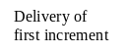
Delivery of second increment

Incremental Delivery Model

Rapid Application Development

The customers of IS/IT are concerned with getting working business applications delivered quickly and at less cost and often see structured methods as unnecessarily bureaucratic and slow. A response to this has been Rapid Application Development (RAD).

The RAD approach does not preclude the use of some elements of structured methods such as Logical Data Structure diagrams but also adopts tactics such as Joint Application Development (JAD) workshops. In these workshops, developers and users work together intensively for, say three to five days and identify and agree fully documented business requirements. Often, these workshops are conducted away from the normal business and development environments in clean rooms, that is, special conference rooms free from outside interruption and suitably furnished. This is based on the belief that communication and negotiation that might take several weeks or months via a conventional approach of formal reports and proposals and counter-proposals can be speeded up in these workshops.

Another practice associated with RAD is time-boxing where the scope of a project is rigidly constrained by a pre-agreed and relatively close absolute deadline. Requirements that have to be omitted in order to meet this deadline are considered in later time-boxes.

Also, RAD assumes the use of fourth generation techniques and languages. It also encourages the reuse of existing program components or create reusable components. Automated tools are also used to facilitate the construction of the software.

Software Requirements Analysis and Specification
The three important activities in the requirement analysis phase of a software project are: Problem Analysis, Requirements Specification and Requirements Validation.
    - Problem Analysis
The basic aim of problem analysis is to obtain a clear understanding of the needs of the clients and the users, what exactly is desired from the software, and what constraints on the solution are. People performing the analysis are often called requirement analysts or business analysts or just analysts. The basic source of information for the problem analysis are the end users or clients and the existing documents about the current mode of operation. Typically, analysts research a problem by interviewing or asking questions to end users and clients and by reading existing documents. Problem analysis activity focuses on identifying “what” is needed from the system (and NOT on how the system is going to provide that). The objectives or issues of problem analysis are:

- Obtain the necessary information
- Organize the information obtained so that the information can be effectively evaluated for completeness and consistency
- Resolving the contradictions in the information obtained from different parties
- Avoiding internal design (thinking on how to implement) during analysis

The process of obtaining or collecting the necessary information is often called as requirement elicitation. The common tools and techniques for requirement elicitation are:
- Interviewing the end users and clients
- Brainstorming between the end users/clients and the analysts
- Collecting and reading existing documents and forms
- Observing the existing manual or automated operation
- Asking end users and client to answer a set of questionnaires
- Showing a small prototype or model of the system to end users and clients and getting their feedback

There are three basic approaches to problem analysis: (a) informal approaches based on structured communication and interaction (b) conceptual modeling based approaches – structured analysis, object oriented modeling, ER-modeling etc. (c) prototyping.

Informal Approach

The informal approach to analysis doesn’t use any defined methodology and analysts relies on his experience. Analyst uses questionnaires, forms, interviews, study of existing documents, observation of current operations, brainstorming etc. to elicit information about the problem and client needs.

In this approach, analyst will have a series of meetings with the end users and clients. In the early meetings, end users and clients will explain to the analyst about their work, their environment, difficulties they face in their work, their needs as they perceive them etc. Analysts will be taking more of listener role in the initial meetings and noting down all the information and collecting existing documents, forms, reports etc. Once the analyst understands the system to some extent, he uses next few meetings to seek clarifications of the parts he does not understand or where he has some doubts. He may document the information in some manner (may be an initial draft SRS) or he may even build a model if he wishes. He may then do some brainstorming or thinking about what the system should do. In the final few meetings, the analyst essentially explains to the client what he understands the system should do and uses the meetings as a means of verifying the correctness and completeness of his understanding. An initial draft of the SRS may be used in the final meetings.

Structured Analysis

The basic principle used in structured analysis is the same as in any complex task: divide and conquer. That is, partition the problem or system into sub-problems or sub-systems and then try to understand each one and its relationship to other. The structured analysis technique uses function-based decomposition while modeling the problem. It focuses on the functions performed in the problem domain and the data consumed and produced/transformed by these functions. Data Flow Diagrams (DFDs) and Flow Charts are commonly used for problem analysis in the structured analysis methodology.

Data Flow Diagram (DFD)

A DFD shows the flow of data through a system. It views the system as a set of functions that transforms the inputs into desired outputs. Data Flow Diagram has four elements:
- Process represented by a circle (bubble) or a rounded edge rectangle
- External entity represented by rectangle
- Data store represented by parallel lines or open rectangle
- Data flow represented by an arrowed line

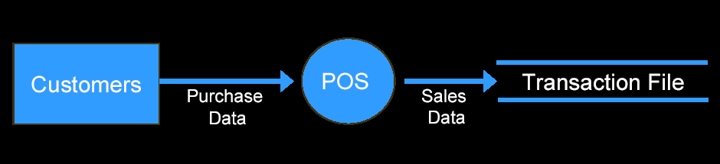
A Simple Data Flow Diagram

Rules of Data Flow Diagrams:
- All entities, processes and data stores should be numbered or named
- It is preferable to mention the information flowing on the arrows too
- DFD is always read from top-to-bottom and from left-to-right
- No more than 7 processes (5 is ideal) should be represented in the same page

Limitations of DFD:
- It is not possible to represent conditions and decisions as in flow charts in DFD
- DFDs do not show the time intervals or delays between processes

Flow Charts

Flow Chart is another tool to represent the flow of data & control across various processes in the system. It has four elements:

- Start and Stop represented by circle or rounded edge rectangle.
- Processing step represented by rectangle
- Condition / Decision represented by diamond
- Flow represented by arrowed line

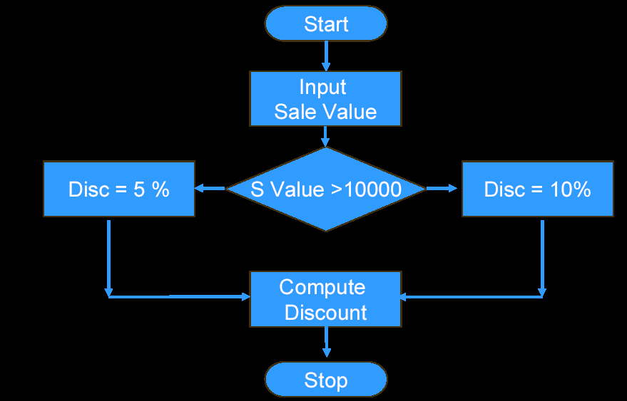

Object Oriented Modeling

In object oriented modeling, a system is viewed as a set of objects. The objects interact with each other through the services they provide. Some objects also interact with the users through their services such that the users get the desired services. Hence, the goal of modeling is to identify the objects that exist in the problem domain, define the objects by specifying what state information they encapsulate and what services they provide, and identify relationships that exist between objects. Such a model of a system is called its object model.

Each object has certain attributes, which together define the object. Attributes hold the state of an object. An object also provides some services or operations. These services are the only means by which the state of the object can be modified or viewed from outside. Objects of similar type are grouped together to form an object class (or just class). An object class is essentially a type definition, which defines the state space (or properties) of objects of its type and the operations (and their semantics) that can be applied to objects of that type. For operating a service or operation, a message is sent to the object for that service. Encapsulating services and attributes together in an object is one of the main features that distinguishes an object modeling approach from data modeling approaches, like the ER diagrams.

Object diagrams represent the object model graphically using a precise notation. In an object diagram, an object class is represented as a portrait style rectangle divided into three parts. The top part contains the name of the class. The middle part lists the attributes that objects of this class possess. And the third part lists the services provided by objects of this class.

The classes and entities are related in the real world. For example, a house object contains many room objects, or the house class is a special form of the general accommodation class, or an object of the class Employer may be related to many objects of the class Employee. So, in addition to defining the objects or classes, we need to model the relationships between classes and objects also to complete the object modeling. To model these, three types of structures are used: generalization – specialization, aggregation (also called assembly) and associations. The generalization – specialization structure can be used by a class to inherit all or some attributes and services of a general class and add more attributes and services. This structure is modeled in object oriented modeling through inheritance. By using a general class (called Super class or Base class) and inheriting some of its attributes and services and adding more, one can create a class that is a specialized version (called Sub class) of the general class. And many sub classes can be created from a base class, giving us class hierarchies. The inheritance is shown using a triangle symbol in object diagrams. The aggregation structure models the whole-part relationship. An object may be composed of many objects; this is modeled through the aggregation structure. The aggregation is shown using a diamond symbol in object diagrams. The association structure is used to represent the relationship of an object of a class with objects of other classes. The multiplicity of an association specifies how many instances of one class may relate to an instance of the other class through this association. An association between two classes can be one-to-one (ie. one instance of one class is related to exactly one instance of the other class), one-to-many, or some other special cases. Multiplicity is specified by having a solid ball on the line adjacent to the class representing zero or more instances of the class may be related to an instance of the other class. The relationship may be necessary, that is, an instance cannot exist without being related to another object by this relationship, or it may be optional. In the object diagram, a hollow circle on the line next to the class implies that the participation of an object of that class in the association is optional (ie. zero or one).

We now have the basic components for an object-oriented model: objects, classes (for classification), inheritance (for modeling generalization-specialization), aggregation (for modeling whole-part relationship), and associations (for modeling relationships between instances). Using these, a system can be modeled.

For example, suppose a system is being designed for a drug store that will compute the total sales of the drug store along with the total sales of different chemists that man the drug store. The medicines are of two major types – off-the-shelf and prescription drugs. The system is to provide help in procuring drugs when out of stock, removing them when expired, replenishing the off-the-shelf drugs when needed etc. An object model of the system is shown in figure below.
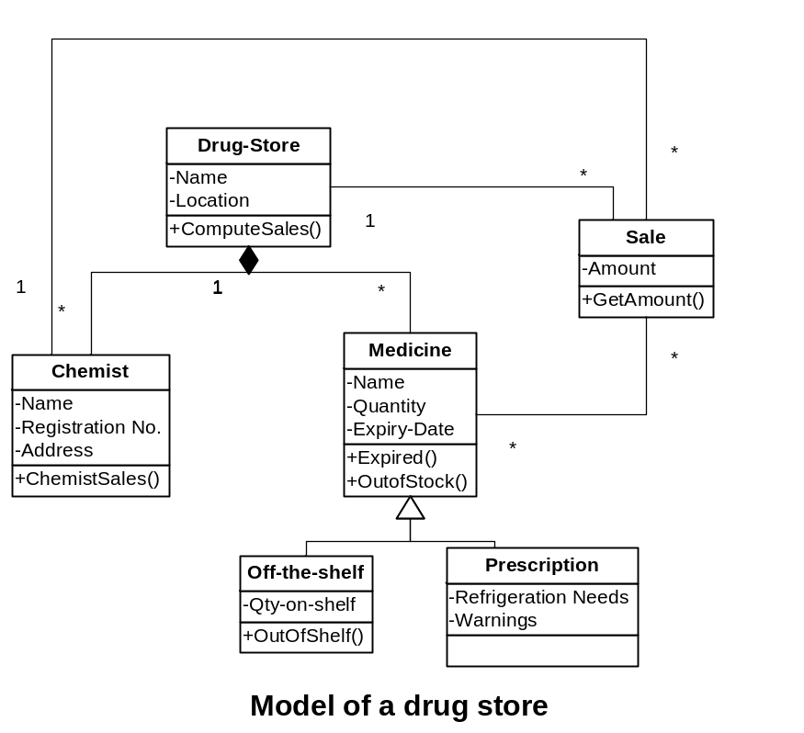

The above object diagram has 6 classes of objects, each with a defined name, some attributes and services. For example, an object of class ‘Chemist’ has the attributes Name, Registration No. and Address. It has one service ChemistSales(), which computes the total sales by this chemist. The Drug-Store class is an aggregation of the class Medicine and the class Chemist (representing that a drug store is composed of medicines and chemists). A medicine may either be Off-the-shelf or Prescription. The object class Medicine has some attributes like Name, Quantity, Expiry Date and has services like Expired() (to list the expired medicines), OutOfStock() (to list the medicines that are no longer in stock), etc. These attributes and services are inherited by the two specialized classes. In addition to these, the Off-the-shelf class has another attribute Qty-on-shelf, representing how many have been put on the shelf and have services related to shelf stock. Similarly, the Prescription class has Refrigeration Needs and Warnings as specialized attributes and services related to them. There are various associations in this model. For example, there is an association between Sale and Medicine. This association is many-to-many, that is, one sale could be of many medicines and one medicine could be in many sales. Similarly, Drug-Store is associated to Medicine and Chemist, and Chemist is associated with Sale.

The major steps in object oriented analysis to obtain the object model for a system are:
- Identifying objects
- Identifying attributes
- Defining services
- Identifying the relationship structures
  - Generalization-Specializations
  - Aggregations
  - Associations

To identify analysis objects, start by looking at the problem domain and its description. Obtain a brief summary of the problem domain. In the summary and other descriptions of the problem domain, consider the nouns. Frequently, nouns represent entities in the problem domain which will get modeled as objects. A noun may be a candidate for including as an object, if the system needs to remember something about that object and system needs some services from that object. If the system does not need to keep information about some real-world entity or does not need any services from the entity, it should not be considered as an object for modeling.

Advantages of Object Oriented Modeling:
- It makes systems easy to build and maintain
- Avoids duplication and facilitates re-usability
- Object model of the system doesn’t change even if there is some changes in the functionality (only the services or operations change; not the objects as such). Whereas, in the structured analysis (function oriented approach), the models change whenever there is a change in the functions or processes.

ER Modeling

This is based on the perception of the real world that consists of a collection of basic data entities and the relationship among entities. Relationship is the association among several entities. Each entity has its own properties called its attributes. The relationship between entity sets is represented by a named E-R relationship and is 1:1, 1:M or M:N, mapping from one entity set to another. The E-R model is usually shown pictorially using entity-relationship (ER) diagrams. The entities and the relationships between them are shown in figure using the following conventions:

- An entity set is shown as a rectangle.
- A diamond represents the relationship among a number of entities, which are connected to the entities by lines.
- The attributes, shown as ovals, are connected to the entities or relationships by lines.
- Diamonds, ovals, and rectangles are labeled. The type of relationship existing between the entities is represented by giving the cardinality of the relationship on the line joining the relationship to the entity.

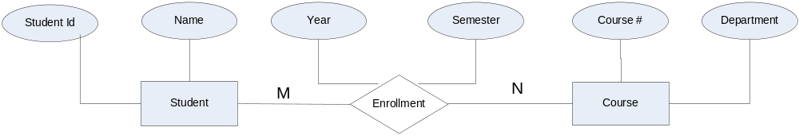
An ER-Diagram

Entities: An entity is a data object that is of interest to an organization. Objects of similar types are characterized by the same set of attributes or properties. Such similar objects form an entity set or entity type. For example, each of the students is an entity and the rectangle Student in the above diagram represents the Student entity set. An entity set in an ER-diagram will be represented by a table (called relation in relational model) in a database that contains a column for each of its attributes and a row for each instance of the entity (called tuple in relational model).

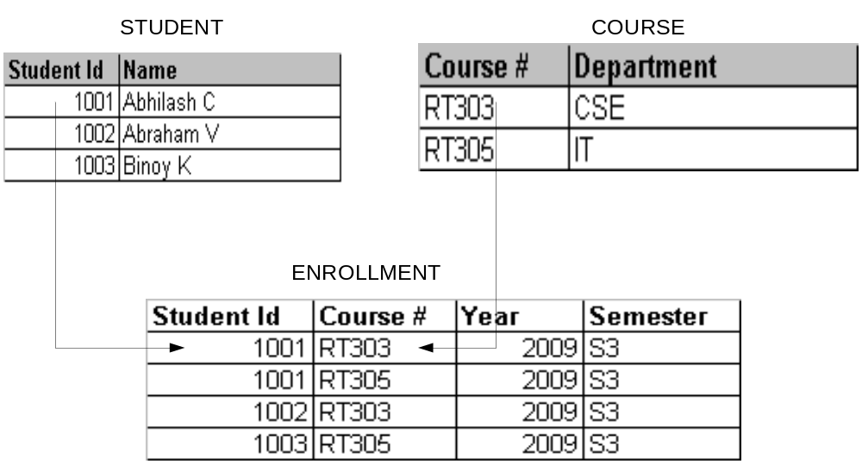 Representation of Relationship

The focus of ER modeling is on data in the problem domain and the relationships between data items. For this reason, it is suitable for modeling database applications. Using the ER model, the analyst can expect to get complete knowledge of all data that exist in the system and how the data are related. However, ER modeling does not help much in understanding the functional and processing requirements of the database system.

Use Case Modeling

In object oriented analysis and design approach, usually a use case model is developed first from the problem domain description before developing an object model of the system. System behavior (or testable functionality or activity of a system) is captured in use cases. Use case model describes the system, its environment and the relationship between the system and its environment. Use Case model describes a system’s functional requirements in terms of use cases. It is a model of the system’s intended functionality (use cases) and its environment (actors). Use case model of a system consists of (a) use case diagrams (a pictorial representation of various system functions and its environment), (b) activity diagrams and (c) use case specifications.

Use Case Diagram

A use case diagram has two basic elements: Actor and Use Case. An actor represents anything (usually a human user or an external system) that interacts with the system and is represented by a stick man as shown below. Similarly, a use case is a sequence of actions a system performs that yields an observable result of value to a particular actor. Use cases are represented using oval shape figures as shown below:
 | 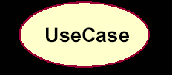

A sample use case diagram for a student online course registration and report module is given below:

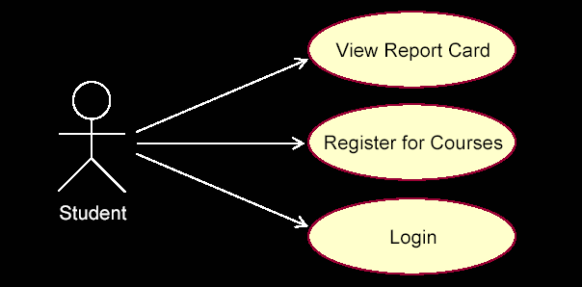

Activity Diagram

An activity diagram in the use case model can be used to capture the activities in a use case. It is essentially a flow chart, showing flow of control from activity to activity. A sample structure of activity diagram is given below:

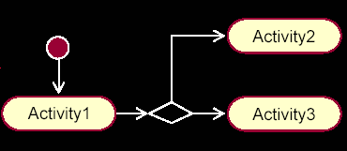

Use Case Specification

Use case model of a system is incomplete without a use case specification for each use case in the system. Use case specification is usually a word document including the following contents:

- Name: Name of use case
- Brief Description: Brief description of the use case
- Flow of Events: Sequence of activities (scenarios) in the use case. Usually, there will be one basic flow (success scenario) and several alternate flows (exceptional flows, failure scenarios etc.)
- Relationships: Relationship of this use case with other use cases
- Use case diagrams: Use case diagram of the use case
- Activity diagrams: Activity diagram of the use case
- Pre-conditions: Pre-requisites (or conditions) to be satisfied before this use case can be executed.
- Post-conditions: Condition (state) of the system after successful execution of this use case.

Prototyping
Prototyping is another approach that can be used for problem analysis, which takes a very different approach compared to conceptual modeling based approaches. In prototyping, a partial system is constructed which is then used by the client, users and developers to gain a better understanding of the problem and the needs. A software prototype can be defined as a partial implementation of a system whose purpose is to learn something about the problem being solved or the solution approach. The rational behind using prototyping for problem understanding and analysis is that the client and the users often find it difficult to visualize how the eventual software system will work in their environment just by reading a specification document. The clients and users can assess their needs much better if they can see the working of a system, even if the system is only a partial system.
There are two main approaches to prototyping: throwaway and evolutionary. In the throwaway approach, the prototype is constructed with the idea that it will be discarded after the analysis is complete, and final system will be built from scratch. In the evolutionary approach, the prototype is built with the idea that it will eventually be converted into the final system.
In throwaway prototyping, as the prototype is to be discarded, there is no point in implementing those parts of the requirements that are already well understood. Hence, the focus of the development is to include those features that are not properly understood. And the development approach is “quick and dirty” with the focus on quick development rather than quality. Experience with this prototype is used to determine if the understanding of requirements when building the prototype is correct. Determining missing requirements is a secondary benefit from this approach.
In contrast, in the evolutionary prototype approach, because the prototype is to be retained, those parts of the system that are well understood are implemented where it is clear they are needed. The development approach is more formal, as the prototype needs to be of the quality standards expected of the final system. The basic focus in this prototype is to elicit missing requirements. By working with a stable system having features that are definitely needed, the client and users can determine which other services and features are needed. This approach works well when the “core” of the system, comprising its critical functions, is well understood.
Whereas the throwaway prototype leads to the prototyping process model, evolutionary prototyping leads to the iterative enhancement process model. Though the evolutionary prototyping is also useful in the context, it is used more to build newer versions of the software rather than for requirements analysis. From the point of view of problem analysis and understanding, the throwaway prototypes are more suited.
The first question to be addressed when prototyping is being considered for a project is whether or not to prototype. The requirements of a system can be divided into three sets – those that are well understood, those that are poorly understood, and those that are not known. In a throwaway prototype, the poorly understood requirements are the ones that should be incorporated. Based on the experience with the prototype, these requirements then become well understood. Out of the poorly understood requirements, the throwaway prototype should focus mostly on the critical requirements. Overall, we can say that if the set of poorly understood requirements is substantial, then a throwaway prototype should be built. In addition, there are 10 criteria that may be considered when making a decision about whether or not to prototype. These criteria are:
- Developer’s application experience
- Maturity of application
- Problem complexity
- Usefulness of early partial functionality
- Frequency of changes
- Magnitude of changes
- Funds and staff profile
- Access to users
- Management compatibility
- Volume of fuzzy requirements
A throwaway prototype should be built if the application is new or not well established (criterion 2), the problem complexity is high (criterion 3), if low funding is available in the short term but high funding may be available in the long term (criterion 7), a high access to the users is there (criterion 8), the management is flexible (criterion 9), and there are substantial critical requirements that are fuzzy (criterion 10).
    - Requirements Specification

The final output from the requirements analysis phase is the software requirements specification document (SRS). It is more likely that the problem analysis and specification (documenting the analysis) are done concurrently. An analyst typically will analyze some parts of the problem and then write the requirements for that part. In practice, problem analysis and requirements specification activities overlap. However, as all the information for specification comes from analysis, we can conceptually view the specification activity as following the analysis activity.
A good SRS needs to specify many things in addition to the models developed as part of problem analysis. For example, user interfaces, design constraints, performance constraints, standards compliance, recovery etc. must be specified clearly in the SRS because the designer must know about these to properly design the system. The desirable characteristics of a good SRS are listed below:
- Correct: An SRS is correct if every requirement included in the SRS represents something required in the final system.
- Complete: An SRS is complete if everything the software is supposed to do and the responses of the software to all classes of input data are specified in the SRS.
- Unambiguous: An SRS is unambiguous if and only if every requirement stated has one and only one interpretation.
- Verifiable: An SRS is verifiable if and only if every stated requirement is verifiable. A requirement is verifiable if there exists some cost-effective process that can check whether the final software meets that requirement. Verification of requirements is often done through reviews and hence SRS should be understandable by the client, users and developers.
- Consistent: An SRS is consistent if there is no requirement that conflicts with another. Terminologies can cause inconsistencies; for example, different requirements may use different terms to refer to the same object. There may be logical or temporal conflict between requirements causing inconsistencies. For example, suppose a requirement states that an event e is to occur before another event f. But, then another set of requirements states (directly or indirectly by transitivity) that event f should occur before event e.
- Ranked for importance and/or stability: Generally, all the requirements for software are not of equal importance. Some are critical, others are important but not critical, and there are some which are desirable but not very important. Similarly, some requirements are “core” requirements which are not likely to change as time passes, while others are more dependent on time. An SRS is ranked for importance and/or stability if for each requirement the importance and the stability of the requirement are indicated. Stability of a requirement reflects the chances of it changing in future.
- Modifiable: An SRS should be easy to modify. Even when the requirements of a system are specified, they are later modified as the needs of the client change. Hence an SRS should be easy to modify. An SRS is modifiable if its structure and style are such that any necessary change can be made easily while preserving completeness and consistency. Presence of redundancy is a major hindrance to modifiability, as it can easily lead to errors.
- Traceable: An SRS is traceable if the origin of each of its requirements is clear and if it facilitates the referencing of each requirement in future development. Forward traceability means that each requirement should be traceable to some design and code elements. Backward traceability requires that it be possible to trace design and code elements to the requirements they support. Traceability aids verification and validation.
Off all these characteristics, completeness is perhaps the most important (and hardest to ensure). One of the most common problem in requirements specification is when some of the requirements of the client are not specified. This necessitates additions and modifications to the requirements later in the development cycle, which are often expensive to incorporate.
Components of an SRS
As mentioned in the above section, completeness is perhaps the single most important characteristics of an SRS that is difficult to achieve and verify. Hence, having a guideline on different things to specify in an SRS will help in completely specifying the requirements. The basic four requirements / properties of a software system that should be specified in a SRS are:
- Functional Requirements
- Performance Requirements
- Design Constraints
- External Interface Requirements
Functional Requirements:
This part of SRS usually will be obtained as an output from problem analysis and system modeling activity. So, the contents like DFDs, Object diagrams, ER diagrams, Use case specifications etc. could be include in functional requirements section of SRS. Functional requirements should also specify which outputs should be produced from the given inputs. They describe the relationship between the input and output of the system. For each functional requirement, a detailed description of all the data inputs and their source, the units of measure, and the range of valid inputs must be specified.
All the operations to be performed on the input data to obtain the output should be specified. This includes specifying the validity checks on the input and output data, parameters affected by the operation, and equations or other logical operations that must be used to transform the inputs into corresponding outputs. For example, if there is a formula for computing the output, it should be specified.
The specification should also include the system behavior in abnormal situations like invalid inputs and invalid outputs. In short, the functional requirements should specify the behavior of the system in valid and invalid inputs & outputs (or in successful and failure scenarios).
Performance Requirements:
This part of SRS should specify all the requirements relating to the performance characteristics of the system. There are two types of performance requirements: static and dynamic. Static requirements are those that do not impose constraint on the execution characteristics of the system. These include requirements like the number of terminals to be supported, the number of simultaneous users to be supported, and the number of files that the system has to process and their sizes. These are also called capacity requirements of the system.
Dynamic requirements specify constraints on the execution behavior of the system. These typically include response time and throughput constraints on the system. For example, the SRS of a telecom billing application may specify the time period before which the call should be rated after completing a call and the number of calls to be billed per second etc.
Design Constraints:
There may be many constraints in the client’s operating environment, which needs to be considered while designing the system. Such constraints include (a) specific standards / policies to be followed (b) hardware limitations (c) operating environment (d) reliability requirements (e) recovery requirements (f) security requirements etc. An SRS should identify and specify all such constraints.
Standards Compliance: Policies of the organization and government regulations may impose compliance of certain standards. These include report formats, accounting procedures, communication protocols, audit requirements etc.
Hardware Limitations: The software may have to operate on some existing or predetermined hardware, thus imposing restrictions on the design. Hardware limitations can include the types of machines to be used, operating system available on the machine, languages supported, and limits on primary and secondary storage etc.

Reliability and Recovery Requirements: There may be a requirement for critical applications to be fault tolerant, reliable and recoverable. That is, the software should be reliable, able to recover and continue to run even in case of unexpected errors. These are very important for critical applications.
Security Requirements: Security requirements are particularly significant in defense systems and many database systems. Security requirements place restrictions on the use of certain commands/functions, control access to data, provide different access rights for different people, use of passwords, encryption techniques, audit trails etc.
External Interface Requirements:
All the possible interactions of the software with people, hardware and other software should be clearly specified. The characteristics of each user interface (graphical or text based) of the software should be specified. A preliminary user manual should be created with all user commands, screen & report formats, an explanation of how the system will appear to the user and error messages.
For hardware interface requirements, the SRS should specify the logical characteristics of each interface between the software product and the hardware components. In addition, the current use and load characteristics of the hardware should be given. In case of interface with other software, the SRS should specify the message content and format of each interface.
Structure (typical contents) of an SRS
IEEE has suggested a general structure for Software Requirements Specification (SRS) considering various aspects of software requirements and projects. It also recognizes the fact that different projects may require different structure for SRS. Also, the structure might differ based on the approach followed in problem analysis. The general structure of an SRS is given below. The first two sections given in the general structure below could be same for all types of projects irrespective of the method used for problem analysis. The specific requirements section (section 3 of the SRS) describes all the details that the software developer needs to know for designing and developing the system. This is typically the largest and most important part of the document. This section can be customized based on the type of the project and the approach adapted for problem analysis.

- INTRODUCTION
  - Document Purpose
Identify the product whose software requirements are specified in this document, including the revision or release number. Describe the basic objective or purpose of this document.
  - Product Scope
Describe the scope of the product that is covered by this SRS. Provide a short description of the software being specified and its purpose, including relevant benefits, objectives, and goals.
  - Intended Audience and Document Overview
Describe the different types of reader that the document is intended for, such as developers, project managers, marketing staff, users, testers, and documentation writers Describe what the rest of this SRS contains and how it is organized. Suggest a sequence for reading the document, beginning with the overview sections and proceeding through the sections that are most pertinent to each reader type.
  - Definitions, Acronyms & Abbreviations
Define all the terms necessary to properly interpret the SRS, including acronyms and abbreviations. You may wish to build a separate glossary that spans multiple projects or the entire organization, and just include terms specific to a single project in each SRS.

  - References
List any other documents or Web addresses to which this SRS refers. These may include user interface style guides, contracts, standards, system requirements specifications, use case documents, or a vision and scope document.

- OVERALL DESCRIPTION
  - Product Perspective
Describe the context and origin of the product being specified in this SRS. For example, state whether this product is a follow-on member of a product family, a replacement for certain existing systems, or a new, self-contained product. If the SRS defines a component of a larger system, relate the requirements of the larger system to the functionality of this software and identify interfaces between the two. In this part, make sure to include a simple diagram that shows the major components of the overall system, subsystem interconnections, and external interface.

  - Product Functions
Summarize the major functions the product must perform or must let the user perform. Details will be provided in Section 3, so only a high level summary is needed here. Organize the functions to make them understandable to any reader of the SRS. A picture of the major groups of related requirements and how they relate, such as a top level data flow diagram or object class diagram, will be effective.

  - User Characteristics
Identify the various users that you anticipate will use this product. Users may be differentiated based on frequency of use, subset of product functions used, technical expertise, security or privilege levels, educational level, or experience.

  - Operating Environment
Describe the environment in which the software will operate, including the hardware platform, operating system and versions, and any other software components or applications with which it must peacefully coexist. In this part, make sure to include a simple diagram that shows the major components of the overall system, subsystem interconnections, and external interface.

  - General Constraints
Describe any general items or issues that will have some impact in the software development project like human resource constraint, schedule constraint, budget constraint, lack of expertise etc.

  - Assumptions and Dependencies
List any assumed factors (as opposed to known facts) that could affect the requirements stated in the SRS. These could include third-party or commercial components that you plan to use, issues around the development or operating environment, or constraints. The project could be affected if these assumptions are incorrect, are not shared, or changed. Also identify any dependencies the project has on external factors, such as software components that you intend to reuse from another project.

- SPECIFIC REQUIREMENTS
  - Functional Requirements
Functional requirements capture the intended behavior of the system. This behavior may be expressed as services, tasks or functions the system is required to perform. This section is the direct continuation of section 2.2 where we have specified the general functional requirements. Here, we should list in detail the different product functions with specific explanations regarding every function. This section could be customized to include various models & diagrams developed as part of problem analysis, based on the approach adapted for problem analysis.

  - Performance Requirements
If there are performance requirements for the product under various circumstances, state them here and explain their rationale, to help the developers understand the intent and make suitable design choices. Specify the timing relationships for real time systems. Make such requirements as specific as possible. You may need to state performance requirements for individual functional requirements or features.

  - Design Constraints
Describe any items or issues that will limit the options available to the developers. These might include: hardware limitations (timing requirements, memory requirements); interfaces to other applications; specific technologies, tools, and databases to be used; parallel operations; language requirements; communications protocols; security considerations; design conventions or programming standards (for example, if the customer’s organization will be responsible for maintaining the delivered software).

Also, specify those requirements that are concerned with possible loss, damage, or harm that could result from the use of the product. Define any safeguards or actions that must be taken, as well as actions that must be prevented. Refer to any external policies or regulations that state safety issues that affect the product’s design or use. Define any safety certifications that must be satisfied. Specify any requirements regarding security or privacy issues surrounding use of the product or protection of the data used or created by the product. Define any user identity authentication requirements.

  - External Interface Requirements

User Interfaces

Describe the logical characteristics of each interface between the software product and the users. This may include sample screen images, any GUI standards or product family style guides that are to be followed, screen layout constraints, standard buttons and functions (e.g., Cancel) that will appear on every screen, error message display standards, and so on. Define the software components for which a user interface is needed.

Hardware Interfaces

Describe the logical and physical characteristics of each interface between the software product and the hardware components of the system. This may include the supported device types, the nature of the data and control interactions between the software and the hardware. You are not required to specify what protocols you will be using to communicate with the hardware, but it will be usually included in this part as well.

Software Interfaces

Describe the connections between this product and other specific software components (name and version), including databases, operating systems (Windows? Linux? Etc…), tools, libraries, and integrated commercial components. Identify the data items or messages coming into the system and going out and describe the purpose of each. Describe the services needed and the nature of communications. Identify data that will be shared across software components. If the data sharing mechanism must be implemented in a specific way (for example, use of a global data area in a multitasking operating system), specify this as a design constraint.

Communication Interfaces

Describe the requirements associated with any communications functions required by this product, including e-mail, web browser, network server communications protocols, electronic forms, and so on. Define any pertinent message formatting. Identify any communication standards that will be used, such as FTP or HTTP. Specify any communication security or encryption issues, data transfer rates, and synchronization mechanisms.

- OTHER REQUIREMENTS
This section is optional. Define any other requirements not covered elsewhere in the SRS. This might include database requirements, internationalization requirements, legal requirements, reuse objectives for the project, and so on. Add any new sections that are pertinent to the project.

Validation
The development of software starts with the SRS document, which is also used to determine eventually whether or not the delivered software system is acceptable. It is therefore important that the requirements specification contains no errors and specifies the client’s requirements correctly. The basic objective of the requirements validation activity is to ensure that the SRS reflects the actual requirements accurately and clearly.
There are four common types of errors that are possible in an SRS. They are: Omission, Inconsistency, Incorrect Fact and Ambiguity. Omission is a common error in requirements where some user requirements are simply missed out from SRS. Inconsistency can be due to contradictions within the requirements themselves or to in-compatability of the stated requirements with the actual requirements of the client or with the environment in which the system will operate. The third common requirement error is incorrect fact. Errors of this type occur when some fact recorded in the SRS is not correct. The fourth common error type is ambiguity. Errors of this type occur when there are some requirements that have multiple meanings, that is, their interpretation is not unique.

Requirement Reviews: Requirement reviews are the most commonly used method for requirement validation. Requirements review is a review by a group of people to find errors and point out other matters of concern in the requirement specification of a system. The review group shall include the author of SRS, analyst, end users, a representative from business who understands the needs of the client, a person of the design team and a person from the quality assurance group.
One way to organize the review meeting is to circulate the SRS in advance to all members in the review group and ask them to go through the document and come to the meeting with their comments and list of items in which they have doubts and need clarifications. A review checklist could also be circulated which will help the members to easily identify all possible errors. A possible checklist that can be used for SRS reviews is given below (though it may usually depend on the project).
- Are all hardware resources defined?
- Have the response times of functions been specified?
- Have all the hardware, external software, and data interfaces been defined?
- Have all the functions required by the client been specified?
- Is each requirement testable?
- Is the initial state of the system defined?
- Are the responses to exceptional conditions specified?
- Does the requirement contain restrictions that can be controlled by the designer?
- Are possible future modifications specified?
In the meeting, each participant goes through the list of potential defects he has uncovered. As the member asks questions, the requirement analyst provides clarifications if there are no errors or agrees to the presence of errors. These discussions form a very important part of the review process.
Alternately, the meeting can start with the analyst explaining each of the requirements in the document. The participants ask questions, share doubts, or seek clarifications. Errors are uncovered by the participants during the discussion.
The requirement reviews are the most effective means for detecting requirement errors. However, only a very small percentage (33%) of errors are detected in review process, and majority of errors might get uncovered only in the design and subsequent phases.
Traceability Matrix:
Another tool used in requirement validation is the traceability matrix. This tool will help in ensuring the backward and forward traceability of requirements with the user needs, design, code, test cases, user manual etc. This is usually an excel based tool with separate columns for each work product from different phases of SDLC. The sections / portions of the work products are indicated against each requirement. This will help in finding out any requirements are not addressed in any phase/work product. Also, it will uncover functions or items that are added extra (without user asking for it). Such extra items should be avoided. The format of a typical traceability matrix is given below.

User Needs | SRS | Design Document | Code | Test Cases | User Manual
1. UserNeed1 | 3.1.1 | 2.1 | Abc.php | 1.1 | 1.1
2. User Need2 | 3.1.2 | 2.2 | Xyz.php | 1.2 | 1.2

