Experiment No:6
Date: 18/08/2010

BIDIRECTIONAL COMMUNICATION USING THREADS

PROBLEM DEFINITION

To develop a java networking program for client and server and to implement a bidirectional communication between client and server using threads.

THEORETICAL BACKGROUND

Java supports advanced programming concepts such as threads. A thread is a process that can run concurrently with other processes. Java is inherently multi-threaded. A single Java program can have many different threads executing independently and continuously. Three Java applets on the same page can run together with each getting equal time from the CPU with very little extra effort on the part of the programmer. This makes Java very responsive to user input. It also helps to contribute to Java's robustness. It also ensures that a malicious applet doesn’t steal all of the host's CPU cycles.

Socket (String host, int port) throws IOException

- This creates a Socket and connects to the specified host and port. Host can be a host name or IP address and port must be in a range of 1-65535.

Socket (InetAddress address, int port) throws IOException

- This creates a Socket and connects to the specified port of the host address. The port must be in a range of 1-65535.
- These methods allow the remote host address and local or remote port numbers to be identified. These methods also allow for the creation of input and output streams.

ALGORITHM

Server

Step 1: Start the server
Step 2: Create Socket with server IP and port 3110
Step 3: Create socket and bind the server socket to it.
Step4: Create two threads t1 and t2
Step 4: Create Buffer to Input string from client
Step 5: Accept the string from the buffer created & print it
Step 6: Input string from the user
Step 7: Send the user inputted string to the client.
Step 8: Stop

Client

Step 1: Start the Client
Step 2: Create Socket in port 3110
Step 3: Create buffer to input the string from the user
Step 5: Create two threads for reading and writing simultaneously.
Step 4: Send the string to the server.
Step 5: Accept the string from the client & Print it
Step 6: Stop

PROGRAM DEVELOPMENT
Server

import java.net.*;
import java.io.*;

class server
{
public static void main(String args[]) throws IOException
{
Socket s;
try
{
String str1,str2;
ServerSocket ss=new ServerSocket(3000);
System.out.println(ss);
s=ss.accept();
BufferedReader br1=new BufferedReader(new InputStreamReader(System.in));
BufferedReader br2=new BufferedReader(new InputStreamReader(s.getInputStream()));
PrintWriter pw=new PrintWriter(s.getOutputStream(),true);
System.out.println("Server Side");
while((str1=br2.readLine())!=null)
{
System.out.println("Data received from client:"+str1);
System.out.println("Enter data");
str2=br1.readLine();
if(str2.equals("exit"))
break;
pw.println(str2);
}
s.close();
}
catch(Exception e)
{ }
}
}

Client

import java.net.*;
import java.io.*;
class client
{
public static void main(String args[])throws IOException
{
try
{
String a;
Socket s=new Socket("Localhost",3000);
System.out.println("Enter the string");
BufferedReader r=new BufferedReader(new InputStreamReader(System.in));
BufferedReader r1=new BufferedReader(new InputStreamReader(s.getInputStream()));
String str=r.readLine();
while(!str.equals("exit"))
{
PrintWriter pw=new PrintWriter(s.getOutputStream(),true);
pw.println(str);
a=r1.readLine();
if(a.equals(null))
break;
System.out.println("Data received from server:"+a);
System.out.println("Enter data");
str=r.readLine();
}
s.close();
}
catch(Exception e)
{
System.out.println("Error");
}
}
}

TESTING STRATEGIES

Server

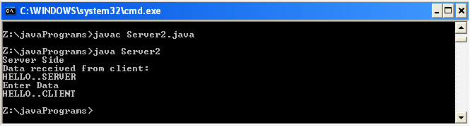

Client

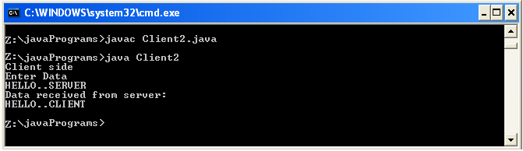

CONCLUSION

The program for implementing a bidirectional communication between client and server using threads was developed and the results were obtained successfully.

Experiment No: 7
Date: 18/08/2010

BROADCASTING MESSAGES

PROBLEM DEFINITION

Program to implement message broadcasting from server to clients using sockets and datagram.

THEORETICAL BACKGROUND

Broadcasting and Multicast Protocol

Broadcasting means sending data freely, for all receivers listening to receive the data simultaneously. Also called multicasting, it sends data from one host to many different hosts, the data goes only to clients that have expressed an interest in the data by joining particular multicast group. It needs a special protocol called Multicast protocol. With a multicast transport service a single node can send data to many destinations by making just a single call on the transport service.

Multicasting makes use of the UDP (User Datagram Protocol), which is an unreliable but high transmission speed protocol. Multicasting also uses special IP addresses in the range 224.0.0.0 - 239.255.255.255.

Datagram

A datagram is an independent, self-contained message sent over the network whose arrival, arrival time, and content are not guaranteed.

Clients and servers that communicate via a perfect channel have a dedicated point-to-point channel between themselves. To communicate, they must first establish the connection, transmit the data, and then close down the connection. All data sent over the channel is received in the same order that it was sent. This is guaranteed by the channel.

In contrast, clients and servers that communicate via datagrams send and receive completely independent packets. These clients and servers do not have a dedicated point-to-point channel. Rather the packets are sent on their way over the network on whatever route is available. A packet sent over a perfect channel does not contain any information about its source or its destination. The channel contains that information. In contrast, a datagram packet must contain the complete address of its source or destination depending on if the datagram is sent or received.
The java.net package contains two classes that use the datagram model to send and recieve packets over the network: DatagramSocket and DatagramPacket. A DatagramSocket is a communcation link used to send datagrams between applications. A DatagramPacket is a message sent between applications via a DatagramSocket.

The DatagramPacket Class

This class is used to create the datagram packets for transmission and receipt with data and address information.

Constructors and Methods

DatagramPacket(byte inbuf[], int buflength)
This statement constructs a datagram packet for receiving datagrams. Inbuff is a byte array that holds the data received and buflength is the maximum number of bytes to read. We are effectively ignoring the address and port information held within the packet

DatagramPacket(byte inbuf[], int buflength, InetAddress iaddr, int port)
This statement constructs a datagram packet for transmission. As above inbuff holds the data to be sent, buflength is the amount of data to be sent, iaddr is the address of the destination and port is the port number on the remote host.

InetAddress getAddress()

This method returns the IP address of the packet source or destination. If the datagram was received from the Internet the address returned is the address of the machine that sent it (source address). Otherwise if datagram was created locally to be sent to a remote host, then address returned is the address of the remote machine to which the datagram is addressed. This method is commonly used to determine the address of the host that sent a UDP datagram, so that the recipient can reply.

The DatagramSocket Class

The DatagramSocket class is used to create sockets through which the DatagramPackets are send and received. As with TCP, a UDP DatagramSocket must listen on a port number.

Constructors and Methods

DatagramSocket() throws SocketException
A DatagramSocket is created using the next available free port number.
DatagramSocket(int port) throws SocketException
A DatagramSocket is created using the specified port number.

void send(DatagramPacket p) throws IOException
This method sends the packet out onto the network.
syncronized void receive(DatagramPacket p) throws IOException
This method receives a packet into the specified DatagramPacket. This method blocks until a packet has been received successfully.

MulticastSocket is a subclass of DatagramSocket which has the extended ability to join and leave multicast groups. A multicast group consists of both a multicast address and a port number. The only difference between UDP and multicast in this respect is that multicast groups are represented by Class D internet addresses. Just as there are well-known ports for network services, there are reserved, well-known multicast groups for multicast network services.

When an application subscribes to a multicast group (host/port), it receives datagrams sent by other hosts to that group, as do all other members of the group. Multiple applications may subscribe to a multicast group and port concurrently, and they will all receive group datagrams.
When an application sends a message to a multicast group, all subscribing recipients to that host and port receive the message. The application needn't be a member of the multicast group to send messages to it.

ALGORITHM

Server

1. Start.
2. Create the object of server class that implements the Runnable interface.
3. Create a server socket at a port number 5739.
4. Create a client socket and accept the request from the client.
5. Create a two threads named key and str.
6. Start the two threads.
7. If the current thread in execution is key, then go to step 8, else go to step 12.
8. Read the data inputted from keyboard.
9. Store the data from buffer into a string.
10. Send the input data through the output stream to the client.
11. Repeat steps 8 to 10 until the data input is stop.
12. Read the data send from client side from the input stream.
13. Store the data from buffer into a string.
14. Print the data received from client.
15. Repeat steps 12 to 14 until the data input is stop.
16. Close the server socket.
17. Close the client socket.
18. Stop.

Client

1. Start.
2. Create the object of client class that implements the Runnable interface.
3. Create a client socket at a port number 5739.
4. Create a two threads named key and str.
5. Start the two threads.
6. If the current thread in execution is key, then go to step 7, else go to step 10.
7. Read the data inputted from keyboard.
8. Store the data from buffer into a string.
9. Send the input data through the output stream to the server.
10. Repeat steps 7 to 9 until the data input is stop.
11. Read the data send from server side from the input stream.
12. Store the data from buffer into a string.
13. Print the data received from server.
14. Repeat steps 11 to 13 until the data input is stop.
15. Close the client socket.
16. Stop.
PROGRAM DEVELOPMENT

bserver.java

import java.io.*;
import java.net.*;
class broadserver
{
DatagramSocket sock;
DatagramPacket p;
byte d[];
InetAddress addr;
String s1;
broadserver()
{
try
{
addr=InetAddress.getByName("233.6.9.2");
sock=new DatagramSocket(7500);
}
catch(Exception e)
{
System.out.println("error");
}
}
public void broadcast()
{
String s="start";
try
{
do
{
BufferedReader br= new BufferedReader(new InputStreamReader(System.in));
s1=br.readLine();
d=s1.getBytes();
p = new DatagramPacket(d,d.length,addr,6300);
sock.send(p);
}
while(!s1.equals("end"));
sock.close();
}
catch(Exception e)
{
System.out.println("error in broadcasting");
}
}
public static void main(String args[])
{
broadserver ser=new broadserver();
ser.broadcast();
}
}
bclient.java

import java.io.*;
import java.net.*;
class broadclient
{
MulticastSocket sock;
DatagramPacket pp;
InetAddress addr;
String x;
broadclient()
{
try
{
addr=InetAddress.getByName("233.6.9.2");
sock=new MulticastSocket(6300);
sock.joinGroup(addr);

}
catch(Exception e)
{
System.out.println("");
}
}
public void rcv()
{String str="start";
try
{do
{byte[] d=new byte[100];
pp=new DatagramPacket(d,d.length);
sock.receive(pp);
str=new String(d);
System.out.println(str);
x=str.substring(0,3);
}while(!x.equals("end"));
sock.leaveGroup(addr);
sock.close();
}
catch(Exception e)
{
System.out.println("");
}
}
public static void main(String args[])
{
broadclient cl = new broadclient();
cl.rcv();
}
}
TESTING STRATEGIES AND SUMMARY OF RESULTS

Server
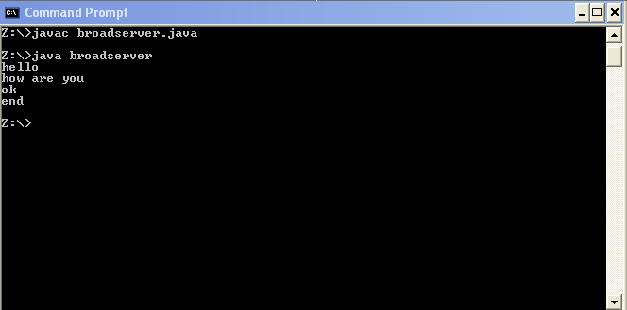

Client1
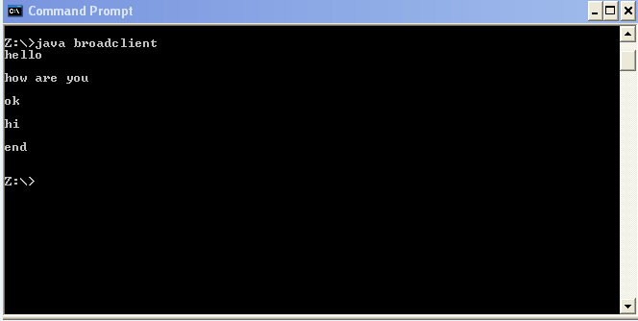

Client2

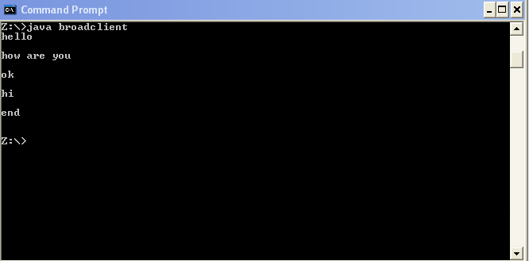

CONCLUSION

A program to implement broadcasting of messages was successfully executed and results were obtained.

Experiment No: 08
Date: 15/09/2010

CHAT USING A CENTRAL SERVER

PROBLEM DEFINITION

The program is to implement a chat using central server.

THEORETICAL BACKGROUND

Client-server is a computing architecture which separates a client from a server, and is almost always implemented over a computer network. Each client or server connected to a network can also be referred to as a node. The most basic type of client-server architecture employs only two types of nodes: clients and servers.
There are many different types of servers; some examples include: a file server, terminal server, or mail server.
Client-server architecture is intended to provide a scalable architecture, whereby each computer or process on the network is either a client or a server.

A socket is one end-point of a two-way communication link between two programs running on the network. Socket classes are used to represent the connection between a client program and a server program. Socket classes are used to represent the connection between a client program and a server program. The java.net package provides two classes, Socket and ServerSocket that implement the client side of the connection and the server side of the connection, respectively.

DatagramPacket defines several constructors. Four are described here. The first constructor specifies a buffer that will receive data, and the size of a packet. It is used for receiving data over a DatagramSocket. The second form allows you to specify an offset into the buffer at which data will be stored. The third form specifies a target address and port, which are used by a DatagramSocket to determine where the data in the packet will be sent. The fourth form transmits packets beginning at the specified offset into the data. Think of the first two forms as building an “in box,” and the second two forms as stuffing and addressing an envelope. Here are the four constructors:
DatagramPacket(byte data[ ], int size)
DatagramPacket(byte data[ ], int offset, int size)
DatagramPacket(byte data[ ], int size, InetAddress ipAddress, int port)
DatagramPacket(byte data[ ], int offset, int size, InetAddress ipAddress, int port)

ALGORITHM

Client
1. Start
2. Create the client class object that implements Runnable.
3. Read the address of the server and bind the socket to the server port.
4. Create two threads. One thread reads keyboard input and outputs it to the server. The
second thread reads input from other clients from the server and displays it.
5. Stop.

Server
1. Start
2. Create object for server class that implements Runnable.
3. Accept the client request and generate two threads for each client
4. Read input from the client through one thread and output the data to the client through
another thread.
5. Stop.

PROGRAM DEVELOPMENT

Server:
import java.io.*;
import java.net.*;

public class CentralServer {

ServerSocket ss;
Socket conn;
int i=0;
static ClientListener listener0;
static ClientListener listener1;
public CentralServer(){
try{
ss=new ServerSocket(8000);
conn=ss.accept();
System.out.println("Client 1 connected..");
listener0=new ClientListener(conn,0);
listener0.start();
conn=ss.accept();
System.out.println("Client 2 connected..");
listener1=new ClientListener(conn,1);
listener1.start();
}catch(Exception e){System.out.println("Client stopped:connection reset");}
}

public static void main(String[] args){

new CentralServer();
}
}

class ClientListener extends Thread{

Socket conn;
PrintWriter p;
BufferedReader b;
String s;
int i;

public ClientListener(Socket conn,int j){
this.conn=conn;
i=j;
}
public void run(){
try{
b=new BufferedReader(new InputStreamReader(conn.getInputStream()));
p=new PrintWriter(conn.getOutputStream(),true);
while(true){
s=b.readLine();
if(i==0)
{
System.out.println("Client 1:"+s );
CentralServer.listener1.p.println(s);
}
else
{
System.out.println("Client 2:"+s );
CentralServer.listener0.p.println(s);
}}
}
catch(Exception e)
{
}
}
}
Client

import java.io.*;
import java.net.*;

class CentralClient{

Socket conn;
PrintWriter p;
BufferedReader b1,b2;
String s;
public CentralClient(){
try{
conn=new Socket("localhost",8000);
System.out.println("Server started..");

b1=new BufferedReader(new InputStreamReader(System.in));
b2=new BufferedReader(new InputStreamReader(conn.getInputStream()));
p=new PrintWriter(conn.getOutputStream(),true);
new Thread(){
String ss;
public void run(){
try{
while(true){
ss=b2.readLine();
System.out.println(ss);
}}
catch(Exception e){}
}
}.start();

while(true){
s=b1.readLine();
if(!s.equals("stop"))
p.println(s);
if(s.equals("stop"))
System.exit(0);
}
}
catch(Exception e){}
}

public static void main(String[] args)
{
new CentralClient();

}
}

TESTING STRATEGIES AND SUMMARY OF RESULTS

Server
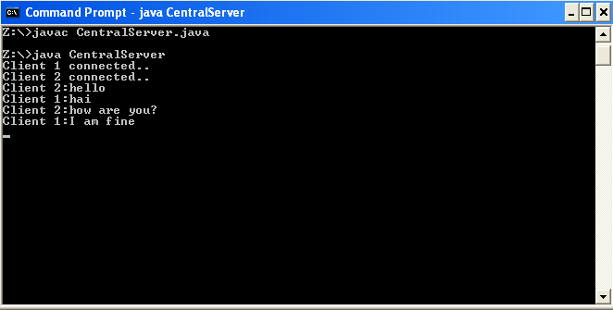

Client1
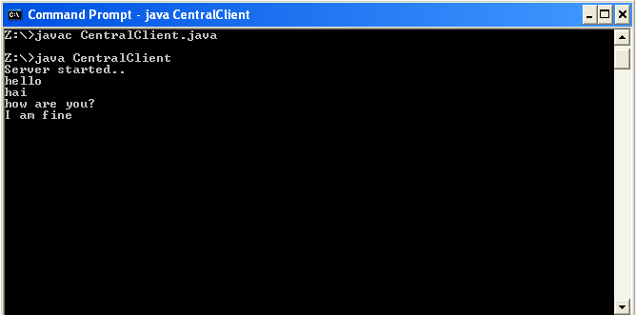

Client2

CONCLUSION

The program to implement chat using central server was execured and results were obtained successfully.

Experiment No: 09
Date: 22/09/2010
FILE SERVER

PROBLEM DEFINITION

The program is to implement a File server program.

THEORETICAL BACKGROUND

In the client/server model, a file server is a computer responsible for the central storage and management of data files so that other computers on the same network can access the files. A file server allows users to share information over a network without having to physically transfer files by floppy diskette or some other external storage device. Any computer can be configured to be a host and act as a file server. In its simplest form, a file server may be an ordinary PC that handles requests for files and sends them over the network.

In a more sophisticated network, a file server might be a dedicated network-attached storage (NAS) device that also serves as a remote hard disk drive for other computers, allowing anyone on the network to store files on it as if to their own hard drive. In common parlance, the term file server refers specifically to a computer on which a user can map or mount a disk drive or directory so that the directory appears to be on the machine at which the user is sitting.

Traditionally, file and print services have been combined on the same computers due to similar computing requirements for both functions. Usually, such computers are distinct from application and database servers, which have different, usually more processor-intensive, requirements. However, as computing power increases and file serving requirements remain relatively constant, it is more common to see these functions combined on the same machine.
A file output stream is an output stream for writing data to a File or to a FileDescriptor. Whether or not a file is available or may be created depends upon the underlying platform. Some platforms, in particular, allow a file to be opened for writing by only one FileOutputStream (or other file-writing object) at a time. In such situations the constructors in this class will fail if the file involved is already open.
FileOutputStream is meant for writing streams of raw bytes such as image data. For writing streams of characters, consider using FileWriter.

A FileInputStream obtains input bytes from a file in a file system. What files are available depends on the host environment. FileInputStream is meant for reading streams of raw bytes such as image data. For reading streams of characters, consider using FileReader

The FileInputStream class creates an InputStream that you can use to read bytes from
a file. Its two most common constructors are shown here:
FileInputStream(String filepath)
FileInputStream(File fileObj)
Either can throw a FileNotFoundException. Here, filepath is the full path name of a file,
and fileObj is a File object that describes the file.

ALGORITHM

Server
1. Start
2. Create buffered reader for reading from keyboard and from input stream.
3. Create printwriter pw to write to output stream.
4. Create server socket object and listen for client request at same port number.
5. Accept client request and establish connection.
6. Read from inputstream and store it in a strig.
7. Create a file inputstream and initialize it by passing file name stored in the string.
8. Read content of file and store to another string and write it to the outputstream.
9. Stop

Client
1. Start.
2. Create buffered reader for reading from keyboard and from input stream.
3. Create printwriter pw to write to output stream.
4. Create socket object and initialize port number.
5. Accept file name from keyboard.
6. Write string to the output string.
7. Read file content from the server and store it in a string.
8. Create new file name from keyboard and store in another string
9. Create the file output stream and initialize it.
10. Write string content in file.
11. Stop

PROGRAM DEVELOPMENT

Server
import java.io.*;
import java.net.*;

class fserver
{
public static void main(String args[])
{
try
{
ServerSocket ss = new ServerSocket(6767);
Socket s = ss.accept();
FileOutputStream fout = new FileOutputStream("C:/user/c.txt");

while(true)
{
int r;
DataInputStream d = new DataInputStream(s.getInputStream());
r = d.read();

if(r!=-1)
{
fout.write(r);
}
else
{
fout.close();
s.close();
ss.close();
System.out.println("File Transferred Successfully");
System.exit(0);
}
}
}
catch(Exception e)
{
System.out.println(e);
}
}
}

Client
import java.net.*;
import java.io.*;
import java.awt.*;
import javax.swing.*;

class fclient
{
public static void main(String args[])
{
try
{
int i;
String str;

Socket s = new Socket("localhost",6767);
BufferedReader br = new BufferedReader(new InputStreamReader(System.in));
PrintStream pw = new PrintStream(s.getOutputStream(),true);

do
{
System.out.println("Enter the file name:");
str = br.readLine();

if(!str.equals("stop"))
{
FileInputStream fin = new FileInputStream(str);

do
{
i = fin.read();
if(i!=-1)
{
pw.write(i);
}
}while(i!=-1);

fin.close();
}
}while(!str.equals("stop"));

s.close();
}
catch(IOException e)
{
System.out.println("ERROR"+e);
}
}
}

TESTING STRATEGIES AND SUMMARY OF RESULTS

Server 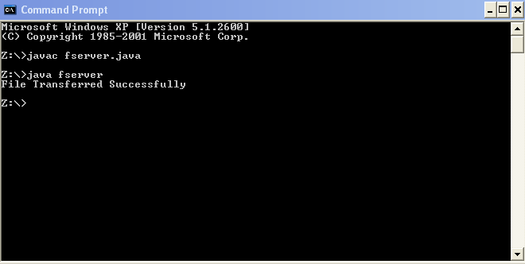

Client

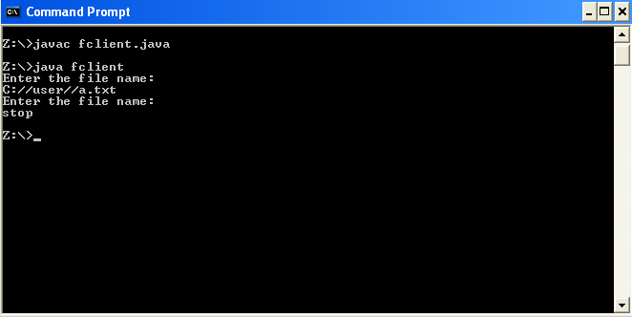

CONCLUSION

The program to implement a file server was executed and results were obtained successfully.

