M.G University
B. Tech Regular Examination May 2005
Computer Science and Engineering
Algorithm Analysis and Design

1) Explain the difference between algorithm, computational procedure and program? (4)

Sol) Algorithm

An algorithm is a type of effective method in which a definite list of well-defined instructions for completing a task; that given an initial state, will proceed through a well-defined series of successive states, eventually terminating in an end-state. The concept of an algorithm originated as a means of recording procedures for solving mathematical problems such as finding the common divisor of two numbers or multiplying two numbers.

Program

An organized set of instructions that, when executed, causes the computer to behave in a predetermined manner. Without programs, computers are useless.

A program is like a recipe. It contains a list of ingredients (called variables) and a list of directions (called statements) that tell the computer what to do with the variables. The variables can represent numeric data, text, or graphical images.

There are many programming languages -- C, C++, Pascal, BASIC, FORTRAN, COBOL, and LISP are just a few. These are all high-level languages. One can also write programs in low-level languages called assembly languages, although this is more difficult. Low-level languages are closer to the language used by a computer, while high-level languages are closer to human languages.

Computational Procedure

(1) Same as routine, subroutine, and function. A procedure is a section of a program that performs a specific task.

(2) An ordered set of tasks for performing some action.

2) Differentiate between time and space complexity? (4)

Ans. Space Complexity
Space complexity of an algorithm is the amount to memory needed by the program for its completion. Space needed by a program has the following components

Space complexity is measured by using polynomial amounts of memory, with an infinite amount of time. The difference between space complexity and time complexity is that space can be reused. Space complexity is not affected by determinism or nondeterminism. Savitch's theorem, which is a space complexity theorem, states that by using a small amount of space, deterministic machines can simulate nondeterministic machines, where as in time complexity, time increase exponentially in this case. Savitch's theorem explicitly demonstrates that a nondeterministic TM using Ĩn) space can be changed to a deterministic TM using only ļsup>2(n) space.

Instruction Space

2. Time Complexity

Time complexity of an algorithm is the amount of time needed by the program for its completion. Time taken is the sum of the compile time and the execution time. Compile time does not depend on instantaneous characteristics. Hence we can ignore it.

The total number of steps involved in a solution to solve a problem is the function of the size of the problem, which is the measure of that problem's time complexity. The rate of growth is what is most important for measuring time complexity for a computation. For instance, a function Ġis of order g, Ġ= O(g), such that g is an approximate growth rate. For instance, if Ĩn) = n² + 3n - 5, then g(n) = n², hence we have O(n²). So, the theoretical approach is that the most significant term of a polynomial is used to avoid the differences in the details regarding exactly how many steps are made between various computers. In practical terms, a programmer could be concerned with the details of efficiency to some degree. However, what is of more concern to the theoretical computer scientist is computational distinguishibility between polynomial bounded problems from exponentially bounded problems. The following are some general orders that we can consider, where the red < divides what is poly-efficient and not poly-efficient:
O(c) < O(log n) < O(n) < O(n log n) < O(nc) < O(cn) < O(n!), where c is some constant.

3. How many key comparisons are done by merge sort, if the keys are already in order when the sort begins? Justify your answer? (4)
Ans. The basic principle of merge sort is as follows:
- Select the size of the sub file as multiples of 2, starting from 2⁰.
- Sort two sub files into a single array.

This process continues till the whole input array is sorted. Hence whatever be the input n comparisons are done by merge sort where n is the number of elements. Even if the keys are in order, n comparisons have to be performed.

Time Complexity
There are log₂n passes, each with n comparisons. Hence the complexity is O(nlog₂n) for all cases.

Example

Consider the array of 8 elements 25,57,48,37,12,92,86,33

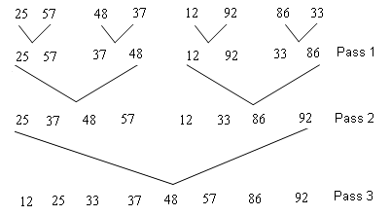

- Discuss optimal storage on tapes? (4)

Soln: -

Problem
n programs are to be stored on a computer tape of length l. Associated with each program t is a length l_{i}, 1≤i≤n. All programs can be stored on the tape iff the sum of length of programs is at most l. Whenever program is to be retrieved, tape is positioned at the front. If stored in the order I = i₁, i₂, … , i_{n} time to retrieve i_{j}, given by t_{j} is proportional to 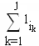. If all programs are equally often chosen, mean retrieval time 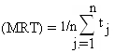. The problem is to find a permutation for n that minimizes MRT.

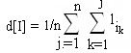

Example

n = 3 (l₁, l₂, l₃) = (5, 10, 3)

Ordering I | d[I]
1,2,3 | 5 + 5 + 10 + 5 + 10 + 3 = 38
1,3,2 | 5 + 5 + 3 + 5 + 3 + 10 = 31
2,1,3 | 10 + 10 + 5 +10 + 5 + 3 = 43
2,3,1 | 10 + 10 + 3 +10 + 3 + 5 = 41
3,1,2 | 3 + 3 + 5 + 3 + 5 + 10 = 29
3,2,1 | 3 + 3 + 10 + 3 +1 10 + 5 = 34

Greedy method chose the next program to be stored on tape as on that minimizes increase in d. Hence store in the non decreasing order of length.

6) Explain Knapsack Problem?

Problem: Given n inputs and a knapsack or bag. Each object i is associated with a weight w_{i} and profit p_{i}. If fraction of an object x_{i}, 0 ≤ x_{i} ≥ 1 is placed in knapsack earns profit p_{i}x_{i}. Fill the knapsack with maximum profit.

- If sum of all weights ≤ m, then all x_{i} =1, 0 ≤ x_{i} ≤ 1 , is an optimal solution
- If sum >m, all x_{i} cannot be equal to 1. Then optimal solution fills knapsack exactly

Example
Number of inputs n = 3
Size of the knapsack m = 20
(x₁, x₂, x₃) | ∑w_{i}x_{i} | ∑p_{i}x_{i}
(1, 2/15, 0) | 20 | 28.2
(0, 2/3, 1) | 20 | 31
(0, 1, 1/2) | 20 | 31.5

8) Explain Multistage Graph? (4)
A multistage graph is a directed graph in which the vertices are partitioned into k≥2 disjoint sets v_{i}, 1≤i≤k. If <u, v> is an edge in E, then u v_{i} and v v_{i+1} for some i, 1≤i≤k. Sets v_{i} and v_{k} is such that | v_{i} | = | v_{k} | = 1. Let s and t are vertices if v_{i} and v_{k} respectively such that s is the source and t is the sink. c(i,j) is the cost of edge <i,j>. Cost of the path from s to t is the sum of cost of all edges on the path. Multi stage graph problem is to find a minimum cost path from s to t. Every path from s to t starts at stage 1, goes to stage 2, etc. eventually terminates in stage k.

Every path from s to t is the result of a sequence of k-1 decisions.
i^{th} decision involves determining which vertex in v_{i+1} 1≤i≤k-2 is to be on the path.

Let p(i,j) is the minimum cost path from j in v_{i} to vertex t, and cost (i,j) be its cost.
According to forward approach
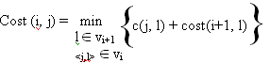

9) Explain LC search? (4)
Ans: Let t be the state space tree and c(.) be a cost function for nodes in t. If x is a node in t, c(x) is the minimum cost of any answer node in t with root x. Then c(t) is the minimum cost node in t. We use a heuristic function c’(t) to calculate c(t).
If x is an answer node or leaf node, then c(x) = c’(x).
Functions Least() and Add() deletes and adds from or to list of live nodes. Least() find nodes with least c’(x), delete the node from the list of live nodes and return the nodes. Live nodes are maintained as minheap. Path from answer node to t is printed.

struct listnode{
strunct listnode *next, *parent;
float cost;
}

LCSearch(struct listnode *t)
{
struct listnode *x, *E;
if (*t is an answer node)
output *t and return;
E = t; //E-node
Initialize list of live nodes to be empty;
do
{
for (each child x of E)
{
if x is an answer node, output the path from x to t and return;
Add(x);
x->parent = E;
}
if there are more love nodes
{
print(“no answer nodes”);
return;
}
E = Least();
}
while(1);
}

If the function Least() and Add() are Pop and Push function of a stack, then LC Search transforms to LIFO. If the function Least() and Add() are Delete and Insert function of a queue, then LC Search transforms to FIFO.

10) What is branch and bound notion? (4)
Ans: Branch and bound is a technique for exploring an implicit directed graph. This graph should be acyclic or even a tree. Branch and bound always looks for an optimal solution to the problem under consideration. At each node we calculate a bound on the possible value of any solution that may lie farther on in the solution. If the bound shows that any such solution must necessarily be worse than the best solution found so far, then we need not go on exploring that node and its children.

Calculation of this bound is combined with a breadth first search or a depth first search to prune certain branches of a tree or to close paths in a graph. The calculated bound is also used to choose which open paths looks the most promising so that it can be explored first.

It is a counter-part of the backtracking search algorithm which, in the absence of a cost criteria, the algorithm traverses a spanning tree of the solution space using the breadth-first approach. It is a state space search method in which all children of E-node is generated before any other love node can become the E-node. Here, a BFS like state space search in which the live nodes are maintained using a queue is called FIFO and a D-Search like state space search in which the live nodes are maintained using a stack is called LIFO. As in the case of backtracking, bounding functions are used to avoid the generation of sub trees that do not contain an answer node.

PART B
11) Explain asymptotic notation?

Asymptotic Notations
Step count is to compare time complexity of two programs that compute same function and also to predict the growth in run time as instance characteristics changes. Determining exact step count is difficult and not necessary also. Since the values are not exact quantities we need only comparative statements like c₁n² ≤ t_{p}(n) ≤ c₂n².

For example, consider two programs with complexities c₁n² + c₂n and c₃n respectively. For small values of n, complexity depend upon values of c₁, c₂ and c₃. But there will also be an n beyond which complexity of c₃n is better than that of c₁n² + c₂n.This value of n is called break-even point. If this point is zero, c₃n is always faster (or at least as fast). Common asymptotic functions are given below.

Function | Name
1 | Constant
log n | Logarithmic
n | Linear
n log n | n log n
n² | Quadratic
n³ | Cubic
2^{n} | Exponential
n! | Factorial

Big ‘Oh’ Notation (O)

O(g(n)) = { f(n) : there exist positive constants c and n₀ such that 0 ≤ f(n) ≤ cg(n) for all n ≥ n₀ }
It is the upper bound of any function. Hence it denotes the worse case complexity of any algorithm. We can represent it graphically as

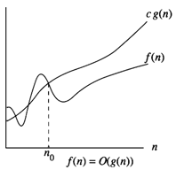
Fig 1.1

Find the Big ‘Oh’ for the following functions:

Linear Functions
Example f(n) = 3n + 2

General form is f(n) ≤ cg(n)

When n ≥ 2, 3n + 2 ≤ 3n + n = 4n
Hence f(n) = O(n), here c = 4 and n₀ = 2

When n ≥ 1, 3n + 2 ≤ 3n + 2n = 5n
Hence f(n) = O(n), here c = 5 and n₀ = 1

Hence we can have different c,n₀ pairs satisfying for a given function.

Example
f(n) = 3n + 3
When n ≥ 3, 3n + 3 ≤ 3n + n = 4n
Hence f(n) = O(n), here c = 4 and n₀ = 3

Example
f(n) = 100n + 6
When n ≥ 6, 100n + 6 ≤ 100n + n = 101n
Hence f(n) = O(n), here c = 101 and n₀ = 6

Quadratic Functions
Example
f(n) = 10n² + 4n + 2
When n ≥ 2, 10n² + 4n + 2 ≤ 10n² + 5n
When n ≥ 5, 5n ≤ n², 10n² + 4n + 2 ≤ 10n² + n² = 11n²
Hence f(n) = O(n²), here c = 11 and n₀ = 5

Example
f(n) = 1000n² + 100n - 6
f(n) ≤ 1000n² + 100n for all values of n.
When n ≥ 100, 5n ≤ n², f(n) ≤ 1000n² + n² = 1001n²
Hence f(n) = O(n²), here c = 1001 and n₀ = 100

Exponential Functions
Example f(n) = 6*2^{n} + n²
When n ≥ 4, n² ≤ 2^{n}
So f(n) ≤ 6*2^{n} + 2^{n} = 7*2^{n}
Hence f(n) = O(2^{n}), here c = 7 and n₀ = 4

Constant Functions
Example
f(n) = 10
f(n) = O(1), because f(n) ≤ 10*1

Omega Notation (Ω)
Ω (g(n)) = { f(n) : there exist positive constants c and n₀ such that 0 ≤ cg(n) ≤ f(n) for all n ≥ n₀ }
It is the lower bound of any function. Hence it denotes the best case complexity of any algorithm. We can represent it graphically as
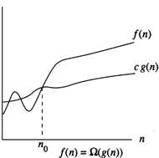
Fig 1.2
Example
f(n) = 3n + 2
3n + 2 > 3n for all n.
Hence f(n) = Ω(n)
Similarly we can solve all the examples specified under Big ‘Oh’.

Theta Notation (Θ)
Θ(g(n)) = {f(n) : there exist positive constants c₁,c₂ and n₀ such that c₁g(n) ≤f(n) ≤c₂g(n) for all n ≥ n₀ }
If f(n) = Θ(g(n)), all values of n right to n₀ f(n) lies on or above c₁g(n) and on or below c₂g(n). Hence it is asymptotic tight bound for f(n).
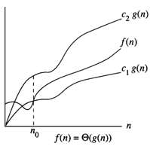
Fig 1.3
Example
f(n) = 3n + 2
f(n) = Θ(n) because f(n) = O(n) , n ≥ 2.

Similarly we can solve all examples specified under Big’Oh’.

Little ‘Oh’ Notation (o)
o(g(n)) = { f(n) : for any positive constants c > 0, there exists n₀>0, such that 0 ≤ f(n) < cg(n) for all n ≥ n₀ }
It defines the asymptotic tight upper bound. Main difference with Big Oh is that Big Oh defines for some constants c by Little Oh defines for all constants.
Little Omega (ω)
ω(g(n)) = { f(n) : for any positive constants c>0 and n₀>0 such that 0 ≤ cg(n) < f(n) for all n ≥ n₀ }
It defines the asymptotic tight lower bound. Main difference with Ω is that, ω defines for some constants c by ω defines for all constants
12) Explain various complexity classes of algorithm? (12)
Ans.
Complexity Classes
P | Deterministic Polynomial Time
P-complete | Hardest problems in P solvable on parallel computers
NP | Nondeterministic polynomial time and YES answers checkable in polynomial time
Co-NP | Nondeterministic polynomial time and NO answers checkable in polynomial time
NP-complete | Hardest problems in NP
Co-NP-complete | Hardest problems in CO-NP
NP-hard | At least as hard as NP-complete problems
NC | Solvable parallel computation efficiency
PSPACE | Polynomial memory with unlimited time
PSPACE-complete | Hardest problems in PSPACE
EXPTIME | Exponential time
EXPSPACE | Exponential memory with unlimited time
BQP | Polynomial time on a quantum computer
Complexity Classes
Determining if a problem is computable at all is interesting, but this distinction is not fine enough to determine if a problem can realistically be solved by a physical computer in a reasonable amount of time. If a computation will take billions of years to compute, it may as well be uncomputable from the perspective of the pragmatist. An algorithm can be characterized by the number of operations and amount of memory it requires to compute an answer given an input of size . These characterizations of the algorithm determine what is called the algorithms complexity. Specifically, the complexity of an algorithm is determined by looking at how the number of operations and memory usage required to complete the program scales with the size of the input of the program. Computer Scientists have grouped problems into the following complexity classes:
P:
Polynomial time, the running time of the given algorithm is in the worst case some polynomial function of the size of the input. For example if an algorithm with an input size of 10 bits which took 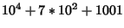operations to compute is a polynomial time algorithm.
NP:
Nondeterministic polynomial time, a candidate for an answer can be verified as a correct answer or not in polynomial time.
NP-complete:
A set of problems such that if any member is in P, the the set P equals the set NP. (Cormen, Leiserson, Rivest)
Problems which can be solved in polynomial time or less are generally deemed to be ``tractable.'' Problems which require more than polynomial time are usually considered to be ``intractable,'' for example an algorithm which would take operations for an input size of would be considered intractable, as the number of operations grows exponentially with the input size, not polynomially.
It should be noted at this point that in Shor's Algorithm, we will be given , a number to be factored. In 's most compact representation, it will take 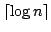bits to be encoded. When discussing the running time of algorithms, we must always speak in reference to the encoded input size. For Shor's algorithm (or any algorithm whose input is an integer), the ``input size'' grows logarithmically with the value of to be factored.
A stronger version of the Church-Turing Thesis has been phrased as:
Any physical computing device can be simulated by a Turing machine in a number of steps polynomial in the resources used by the computing device.
As an aside, whether or not P and NP describe the same set of problems is one of the most important open questions in computer science. Should a polynomial time algorithm for any NP-complete problem be discovered, then we would know that P and NP are the same set. Many NP-complete problems have known algorithms which can compute their solutions in exponential time, whether there exists any polynomial time algorithms is unknown.
When discussing the complexity of a problem it is important to distinguish between there being no known algorithm to compute it in polynomial time, and there being no algorithm to compute it in polynomial time. There are many problems whose best known algorithm requires an exponential number of steps to compute a solution. These problems are generally considered to be intractable. Determining the prime factors of a large number is one such problem, and its assumed intractability is the bases for most cryptography.
The interest in quantum computing is twofold. First it is of interest if a quantum computer can solve problems which are uncomputable on a classical computer, and second it is of interest if a quantum computer can make problems thought of as intractable, tractable.

13. Explain Stressen’s multiplication method. Find the time complexity of the algorithm? (12)

Ans: Let A and B be two N by N matrices. The product matrix c=AB is also an N by N Matrix whose i,j th element formed by taking elements in the ith row of a and the jth column of b and multiplying them to get C(I,j)=Sum A(I,k) B(k,j) 1<=k<=n
For all i and j between 1 and n. To compute C(I,J) using this formula, we need n multiplications. As the matrix C has N² elements, the time for the resulting matrix multiplication algorithm is O(n³ ).
For simplicity we assume that n is a power of 2 that is there exist a nonnegative integer K such that n=2^{k} .In case n is not a power of two, then enough rows and columns of zeros can be added to both A and B, So that the resulting dimensions are a power of two. In case n is not power of two, then enough rows and columns of zeros can be added to both A and B. So that the resulting dimensions are a power of two. Imagine that A and B are each portioned in to four square matrices, each submartix having dimension n/2 by n/2.Then the product AB can be computed by using the above formula for the product of 2 by 2 matrices.

A11 A12 B11 B12 = C11 C12
A21 A22 B21 B22 C21 C22

C11 =A11 B11+A12B21
C12 = A11B12 + A12B22
C21 = A21B11 +A22B21
C22 = A21B12+A22B22

For N>2,the elements of C can be computed using matrix multiplication and addition operation applied to matrices of size n/2 by n/2 .Since n is of power 2 these matrix products can be recursively computed by the same algorithm we are using for the n by n case. This algorithm will continue applying itself to smaller-sized sub matrices until n becomes suitably small n=2 so that the product is computed directly.
To compute AB we need to perform eight multiplications of n/2 by n/2 matrices and four additions of n/2 by n/2 matrices. Since two n/2 by n/2 matrices can be added in time CN² , for some constant C, the overall computing time T(n) of the resulting divide and conquer algorithm is given by the reference.

T(n)= b n<=2
8T(n/2)+cn2 N>2

Where b and c are constants.
Volker strassen has discovered a way to compute the Ci,j’s of 3.12 using only 7 multiplications and 18 additions or subtractions. His method involves first computing the seven n/2 by n/2 matrices P,Q,R,S,T,U and V. Then Cij’s are computed using the formulas in 3.14.As can be seen P,Q,R,S,T,U and V can be computed using 7 matrix multiplications and 10 matrix addition. The Ci,j’s require an additional 8 addition and subtractions. The resulting recurrence relation for T(n) is
T(n)= b n<=2
7T(n/2)+an² n>2
Working with this formula we get
T(n)=O(n^{log}₂⁷ )
Which is less than O(n³).The matrices P Q R S T U V are specified as follows.
P=(A11+A22)(B11+B22)
Q=(A21+A22)B11
R=A11(B12- B22)
S=A22(B21-B11)
T=(A11+A12)B22
U=(A21-A11)(B11+B12)
V=(A12-A22)(B21+B22)

C11=P+S-T+V
C12=R+T
C21=Q+S
C22=P+R-Q+U

15) Write Kruskal’s algorithm for finding minimum spanning tree. Analyse it. Illustrate with example. (12)

Soln: -

Kruskal's algorithm is an algorithm that finds a minimum spanning tree for a connected weighted graph. If the graph is not connected, then it finds a minimum spanning forest (a minimum spanning tree for each connected component).

Kruskal's Algorithm builds the MST in forest. Initially, each vertex is in its own tree in forest. Then, algorithm considers each edge in turn, order by increasing weight. If an edge (u, v) connects two different trees, then (u, v) is added to the set of edges of the MST, and two trees connected by an edge (u, v) are merged into a single tree on the other hand, if an edge (u, v) connects two vertices in the same tree, then edge (u, v) is discarded. The resultant may not be a tree in all stages. But can be completed into a tree at the end.

t = EMPTY;
while ((t has fewer than n-1 edges) && (E != EMPTY))
{
choose an edge(v, w) from E of lowest cost;
delete (v, w) from E;
if (v, w) does not create a cycle in t
add (v, w) to t;
else
discard (v, w);
}
To check whether there exist a cycle, place all vertices in the same connected component of t into a set. Then two vertices v and w are connected in t then they are in the same set.

Example
Consider the connected graph given below
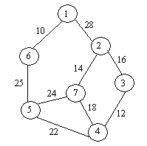

Minimum spanning tree for the above graph can be formed as given below: -

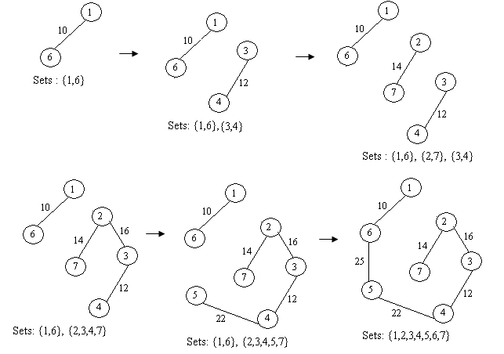
Algorithm

float kruskal (int E[][], float cost[][], int n, int t[][2])
{
int parent[w];
consider heap out of edge cost;
for (i=1; i<=n; i++)
parent[i] = -1; //Each vertex in different set
i=0;
mincost = 0;
while((i<n-1) && (heap not empty))
{
Delete a minimum cost edge (u,v) from the heap and reheapify;
j = Find(u); k = Find(v); // Find the set
if (j != k)
{
i++;
t[i][1] = u;
t[i][2] = v;
mincost += cost[u][v];
Union(j, k);
}
if (i != n-1) printf(“No spanning tree \n”);
else return(mincost);
}
}

Time complexity of the above algorithm is O(n log n)

16) Explain Job Sequencing Problem with algorithm? (12)

Job Sequencing with Deadlines
Problem: Given a set of n jobs. Associated with each job i is a profit p_{i} > 0 and deadline d_{i}≥0. Profit is earned if job is completed before deadline. To complete a job, it has to be process one unit time. Only one machine is available to process the jobs. Feasible solution is a subset J of jobs such that each job in the subset can be completed by its deadline. The value of feasible solution is the sum of profits of jobs in J,. An optimal solution is a feasible solution with maximum value.

Example
n = 4 (p₁, p₂, p₃, p₄) = (100, 10, 15, 27) (d₁, d₂, d₃, d₄) = (2, 1, 2, 1)

Jobs | Profit
(1, 2) | 110
(1, 3) | 115
(1, 4) | 127
(2, 3) | 25
(3, 4) | 42

Arrange jobs in the decreasing order of profit. Then start takings jobs one by one.
Arranging the jobs in decreasing order we have (J₁, J₄, p₃, J₂).
Consider J₁, since deadline for J₁ is 2, include J₁ in the resultant set {J₁}
Now consider J₄. Since deadline J₄ is 1, we can include J₄ also in the resultant set by interchanging the order as {J₄ , J₁}. We cannot include J₃ as the deadline for J₃ is 1.
Hence the sequence is J = {J₄ , J₁}.

Greedy Jobs (int d[], set J, int n)
{
//Jobs are arranged in the decreasing order of profit.
J = {1}; // J₁ is the job with maximum profit
for (int i; i<=n; i++)
if (all jobs in J U{i} can be completed by their deadlines) J = J U{i};
}

Algorithm
void JS (int d[], int j[], int n)
{
// d[i] ≥1, n ≥1, p[1] ≥ p[2] ≥...≥ p[n]. We the algorithm terminates d[j[i]] ≤ d[j[i+1]]
d[0] = j[0] = 0;
k = 1;
for ( int i=2; i<=n; i++)
{
r = k;
while (d[j[r] > max(d[i], r)) r = r – 1;
if (d[i] > r)
{
for (m=k; m>=r+1; m--) j[m+1] = j[m];
j[r+1] = i;
k = k+1;
}
}
return;
}
Time complexity of the program is Θ(sn), where s is the number of terms in the result set. Hence we can write the worse case complexity as O(n²).

18) Explain Travelling salesman problem? (12)

Problem: A salesman spends his time in visiting cities cyclically. In his tour he visits each city just once, and finishes up where he started. In which order should he visit to minimize the distance traveled.

The problem an be represented using a graph. Let G=(V,E) be a directed graph with cost c_{ij}, c_{ij} >0 for all <i j> E and c_{ij} = ∞ for all <j,t> E. |V| = n and n>1. We know that tour of a graph includes all vertices in V and cost of tour is the sum of the cost of all edges on the tour. Hence the traveling salesman problem is to minimize the cost.

Application
The traveling salesman problem can be correlated to many problems that we find in the day to day life. For example, consider a production environment with many commodities manufactured by same set of machines. Manufacturing occur in cycles. In each production cycle n different commodities are produced. When machine changes from product i to product j, a cost C_{ij} is incurred. Since products are manufactured cyclically, for the change from last commodity to the first a cost is incurred. The problem is to find the optimal sequence to manufacture the products so that the production cost is minimum.

We know that the tour of the simple graph starts and ends at vertex1. Every tour consist of an edge <i, k> for some k V-{1} and a path from k to 1. Path from k to 1 goes through each vertex in V- {1,k} exactly once. If tour is optimal, path from k to 1 muat be shortest k to 1 path going through all vertices in V-{1,k}. Hence the principle of optimality holds.
Let g(i, S) be length of shortest path starting at i, going through all vertices in S ending at 1. Function g(1, V-{1}) is the optimal salesman tour. From the principle of optimality
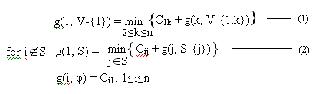
Use eq.(1) to get g(i, S) for |S| =1. Then find g(i, S) with |S|=2 and so on.

Example 4.3
Consider the directed graph with the cost adjacency matrix given below.
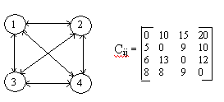

g(2, φ) = C₂₁ = 5
g(3, φ) = C₃₁ = 6
g(4, φ) = C₄₁ = 8

g(2, {3}) = C₂₃ + g(3, φ) = 15
g(2, {4}) = C₂₄ + g(4, φ) = 18
g(3, {2}) = C₃₂ + g(2, φ) = 18
g(3, {4}) = C₃₄ + g(4, φ) = 20
g(4, {2}) = C₄₂ + g(2, φ) = 13
g(4, {3}) = C₄₃ + g(3, φ) = 15

g(2, {3,4}) = min{C₂₃ + g(3, {4}) , C₂₄ + g(4, {3}) }= 25
g(3, {2,4}) = min{C₃₂ + g(2, {4}) , C₃₄ + g(4, {2}) }= 25
g(4, {2,3}) = min{C₄₂ + g(2, {3}) , C₄₃ + g(3, {2}) }= 23

g(1, {2,3,4}) = min{C₁₂ + g(2, {3,4}) , C₁₃ + g(3, {2,4}) , C₁₄ + g(4, {2,3}) }
= min{35, 40, 43} = 35

Let J(i, S) represent the value of j which is the value of g(i, S) that minimizes the right hand side of equ(2). Then J(1, {2,3,4}) =2, which infers that the tour starts from 1 goes to 2. Since J(2,{3,4}) = 4, we know that from 2 it goes to 4. J(4, {3}) = 3. Hence the next vertex is 3. Then we have the optimal sequence as 1,2,4,3,1.

19) Solve Travelling Salesman problem using Backtracking? (12)

Ans: Problem: A salesman spends his time in visiting cities cyclically. In his tour he visits each city just once, and finishes up where he started. In which order should he visit to minimize the distance traveled.

The problem an be represented using a graph. Let G=(V,E) be a directed graph with cost c_{ij}, c_{ij} >0 for all <i j> E and c_{ij} = ∞ for all <j,t> E. |V| = n and n>1. We know that tour of a graph includes all vertices in V and cost of tour is the sum of the cost of all edges on the tour. Hence the traveling salesman problem is to minimize the cost.

The solution space is given by S = {1,S,1 | S is a permutation of (2,3,…,n)}.
Hence |S| = (n-1)!. Size of S can be reduced by restricting S so that (1,i₁,…i_{n-1}, 1) S
iff < i_{j}, i_{j+1}> E, 0 ≤ j ≤ n-1 and i₀ = i_{n} = 1. The state space tree is given by
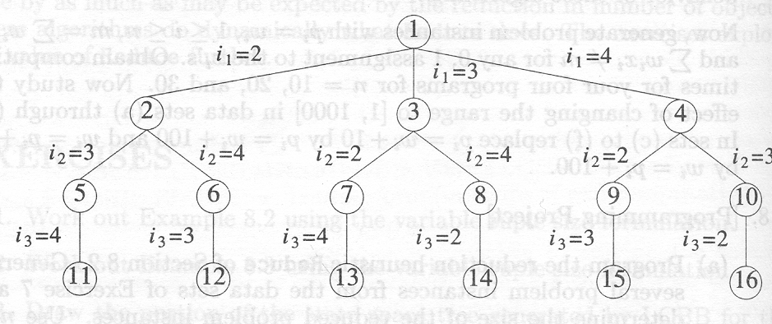

To use LCBB we need cost function c(.) such that c’(r) ≤ c(r) ≤ u(r) for all nodes r.
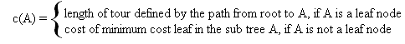
Since both these methods are not practical, choose c’( x) as
c’(x) = reduced cost matrix for G.

A row or column in a given matrix is said to be reduced iff it contains at least one zero and all remaining entries as non-negative numbers. A matrix is said to be reduced if all rows and all columns are reduced.

Consider a graph with 5 vertices. Given the cost matrix of the graph. Since every tour in the graph includes one edge <i, j> with 1 ≤ I ≤ 5 and exactly one edge <i, j> with 1≤j≤5. We know that subtracting a common value from all the elements in a row or column will not change the minimum cost tour, even though it chances the minimum distance traveled.

Now consider the cost matrix of the graph G.
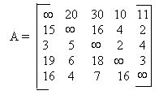

Reduced cost matrix of A is generated by
Subtracting 10, 2, 2, 3 and 4 from rows 1, 2, 3, 4 and 5 respectively. Let the resultant matrix be A’
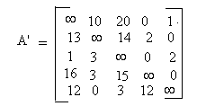
- And again subtract 1 and 3 from column 1 and column 3 respectively, we get the reduced cost matrix.
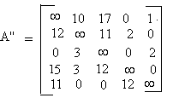
Find out the total value reduced from each row and column, which is 10+ 2+2+3+ 4+1+3 = 25.
Considering the state space tree, we are starting from node1, which means we started from vertex 1. Hence vertex 1 is the current E-node. Now generate children of node 1. Hence it generates nodes 2, 3 , 4 or 5 depending on whether we are selecting vertex 2, 3, 4 or 5. Calculate the reduced cost matrix for all the child nodes. The final state space tree will look like the one given below.
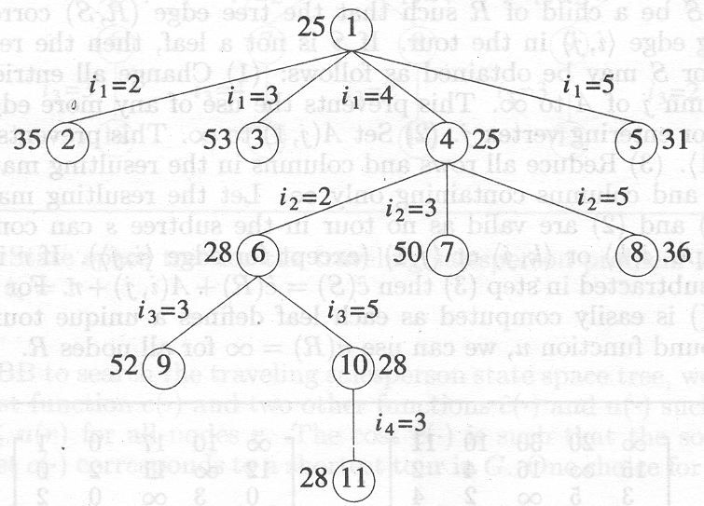

To calculate the reduced cost matrix of a child node C with parent P, if C corresponds to vertex j and P corresponds to vertex i, then reduced cost matrix is calcualted as per the following steps
- Change all entries in row i and column j to ∞ (Prevents the use of any more vertex leaving i or entering j)
- Set A(j,1) to ∞ (Prevents use of edge <j,1>)
- Reduce all rows and columns in the resulting matrix except the one with all ∞.
Let the resultant matrix be B. If r is the total amount subtracted in step 3,
c’(C) = c’(P) + A(i,j) + r.

Calculating the reduced cost matrix for node 2,3,4 and 5 we get
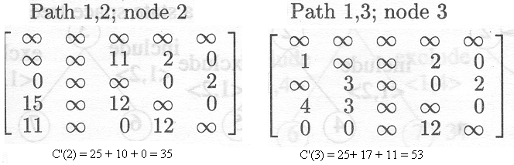
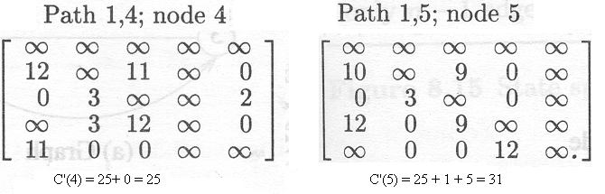
Since node 4 has got the least c’(.) value, select the next vertex as 4. Hence the current path is 1,4 and current E-node is node 4. Now generate the children of node 4. Then nodes 6, 7 and 8 are generated. Now the current live nodes are nodes 2,3,5,6,7 and8. Now find the c’(6), c’(7) and c’(9). Pick the next node as one with least c’(.) value.

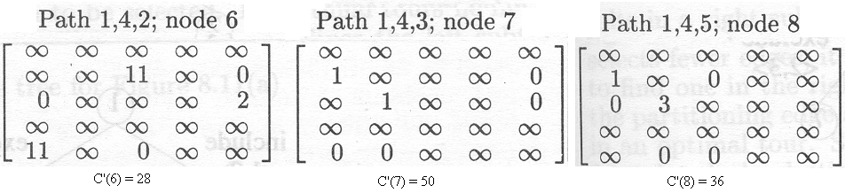Of the 6 live nodes, node 6 got the least C’(.) value, which means you selected vertex 2 as the next vertex. Hence the current path is 1,4,2. Now generate the children of node 6. So nodes 9 and 10 are generated. Calculate the C’() value of nodes 9 and 10.

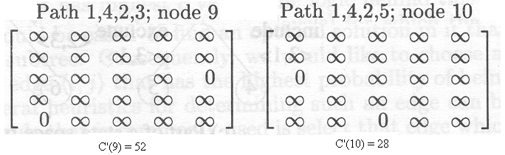
Since node 9 has the least cost, select node 9, means select vertex 5. Now the path is 1,4,2,5. Since only one more vertex remaining select that as the next vertex. Hence the path is 1,4,2,5,3,1.

20) Explain N-queens problem and solution using backtracking? (12)

Ans: Backtracking is a type of algorithm that is a refinement of brute force search. In backtracking, multiple solutions can be eliminated without being explicitly examined, by using specific properties of the problem. It systematically searches for a solution to a problem among all available options. It does so by assuming that the solutions are represented by vectors (x₁, ..., x_{n}) of values and by traversing, in a depth first manner, the domains of the vectors until the solutions are found.
The constraints are divided into implicit constraints and explicit constraints. Implicit constraints are rules which determine which of the tuples in solution space of I satisfy the criteria function. And explicit constraints restrict x_{i} take values from a given set. e.g., x_{i} ≥ 0, x_{i}{0,1} etc. Backtracking algorithm determine the problem solution by systematically searching the problem space with a tree representation.

N-Queens Problem: N queens are to be placed on an nxn chessboard so that no two of them are in attacking position. i.e., no two queens are in same row or same row or same diagonal.
Let us assume that queen i is placed in row i. So the problem can be represented as n-tuple (x₁, ..., x_{n}) where each x_{i} represents the column in which we have to place queen i.
Hence the explicit constraints is S_{i} ={1,2,..,n}. No two x_{i} can be same and no two queens can be in same diagonal is the implicit constraint. Since we fixed the row number the solution space reduce from n^{n} to n!.
To check whether they are on the same diagobal, let chessboard be represented by an array a[1..n][1..n]. Every element with same diagonal that runs from upper left to lower right has same “row-column” value. E.g., consider the element a[4][2]. Elements a[3][1], a[5][3], a[6][4], a[7][5] and a[8][6] have row-column value 2. Similarly every element from same diagonal that goes from upper right to lower left has same “row+column” value. The elements a[1][5], a[2][4], a[3][3], a[5][1] have same “row+column” value as that of element a[4][2] which is 6.

Hence two queens placed at (i,j) and (k,l) have same diagonal iff
i – j = k – l or i + j = k + l
i.e., j – l = i – k or j – l = k – i
|j – l| = |i – k|
Algorithm For N-Queens Problem.
Bool Place (int k, int i)
{
// Returns true if queen can be placed on kth row, ith column. Otherwise return false. // Assume that first k-1 elements of x is set.

for( int j=1; j<k; j++)
if ((x[j] == i) || (abs(x[j]-i) == abs(j-k))) //same column or same diagonal
return false;
return true;
}
Void NQueens (int k, int n)
{
// Prints all possible permutations to place n queens on an nxn chess board so that
// none of them are in attacking position.

for (int i=1; i<=n; i++)
{
if (Place(k,i))
{
x[k] = I;
if (k==n)
for(int j=1; j<=n; j++)
print(x[j]);
else
NQueens(k+1, n);

}
}

