CORBA OBJECT REFERENCE
A CORBA object is a virtual entity in the sense that it does not exist on its own, but rather is brought to life when, using the reference to that CORBA object, the client application requests an operation on that object. The reference to the CORBA object is called an object reference. When the client or server application issues a request on an object via an object reference, the server application instantiates the object specified by the object reference, if the object is not already active in memory. Instantiating an object typically involves the server application initializing the object's state, which may include having the object's state read from durable storage, such as a database.The object contains all the data necessary to do the following:
*Execute the object's operations. * Store the object's state in durable storage when the object is no longer needed.
Creating objects is simple.New operator can be used.Creating a distributed object instance requires more effort since object is usually created in a different process on a different machine.An abstraction is needed to redirect creation of a distributed object to a remote location.CORBA relys on factory to create distributed object instances.
* In C++ object is deleted using delete operator *Java uses garbage collection * Reference Counting is used * Server object is destroyed when no longer a client is using it. *Another method is to maintain a list of object references and timestamps all object instances The time stamp indicates the

Corba Object References

Introduction
Correct use of object references is an essential skill for CORBA developers. Object references are largely a client-side issue but there are server-side implications arising from the C++ language mapping that defines how object references are exchanged during CORBA request invocations. This is certainly not "news" but a periodic review of this topic is useful for most CORBA developers. This article, the first of two parts, discusses the C++ language mapping for object references, addresses memory management issues related to object references, and demonstrates the correct means of exchanging object references during CORBA request invocations. This article focuses on object references, the basic pointer (_ptr) type, and rules for exchanging object references during CORBA requests. The followup article will focus on the smart pointer helper (_var) type that assists with memory management and parameter passing.

Object Reference Defined
An object reference is a handle to a CORBA object. A CORBA object is a vague concept but two aspects of CORBA objects are clear. Every CORBA object realizes a specific interface and has a distinct identity. An object's interface defines the operations and attributes it offers to its clients. An object's identity informs an ORB where and how to dispatch its client's requests. An object reference embodies the corresponding CORBA object's identity and interface, and constitutes the primary means for invoking a CORBA object's operations. (Attributes in effect define operations so hereafter an object's interface will be described only in terms of operations.)
An object reference can take many forms. Some forms are language independent and some are language specific. A stringified IOR is a language independent form of object reference. The following is a stringified reference to a CORBA object incarnated on the author's laptop computer:
IOR:010000001900000049444c3a6f63697765622e636f6d2f48656c6c6f
3a312e3000000000010000000000000060000000010102cd050000006469
6e6f00cde12e1b00000014010f005253547fb8d63dd48809000000000001
00000001000000cd02000000000000000800000001cdcdcd004f41540100
00001400000001cdcdcd01000100000000000901010000000000
The CORBA object it refers to realizes the following interface:
#include "example_exceptions.idl"
interface Hello
{
void say_hello();
string ior_please();
void take_exception() raises (ExampleExceptions::SimpleException);
void shutdown();
};
A corbaloc URL is another language independent form of object reference. The following corbaloc URL is another reference to the object denoted by the preceding stringified IOR:
corbaloc:iiop:dino:12001/Hello
Language independent object references are essential to interoperability. They allow the exchange of object references between clients and servers deployed on heterogeneous platforms and implemented in different languages. Language specific forms are defined by formal language mappings to enable concrete development in the various languages supported by CORBA. An object reference in the C++ language is a pointer to an object that proxies for the target CORBA object and has the target object's interface. A client invokes a request by dereferencing the pointer using native C++ syntax. When a client invokes a CORBA request, the proxy forwards the request to the local ORB. The local ORB uses identity information held by the object reference to locate the target object and dispatches the request accordingly. A synchronous request's reply is returned to the proxy by the local ORB and the proxy returns the reply to the client.
For each interface, the IDL compiler generates the servant base class, the proxy object class, several helper types, and two pointer types, a basic pointer and a smart pointer. For the Hello interface presented earlier, servant based class is named POA_Hello, the proxy object class is named Hello, the basic pointer type is named Hello_ptr, and the smart pointer type is named Hello_var. The basic pointer is analogous to a native C++ pointer. The smart pointer has the same behavior as the basic pointer but provides additional features that simplify memory management and parameter passing. One of the generated helper classes assists with passing object references as out mode parameters. For the Hello interface, this helper type is named Hello_out. It is common practice to refer to these types in a general sense, e.g. the "pointer type," the "var type," and the "out type." These phrases refer respectively to generated _ptr, _var, and _out types.

Creating and Obtaining Object References
An object reference is created when the corresponding CORBA object is created. CORBA objects are commonly created when servants are activated via PortableServer::POA::activate_object(). However, CORBA objects can be created without activating servants via other operations. CORBA servers often export object references, in different forms using a variety of mechanisms, to provide clients with access to their CORBA objects. However, object references can be exposed to clients without the server's direct participation using forms such as corbaloc URLs.
An object reference can be introduced into a client's address space in many ways. Clients frequently employ ORB operations such as CORBA::ORB::resolve_initial_references() and CORBA::ORB::string_to_object() to obtain object references. Clients often use a Naming Service and obtain object references via CosNaming::NamingContext::resolve(). Clients may also obtain object references by invoking requests on known CORBA objects, i.e. objects already accessible in their address space, that act as factories for other CORBA objects.
When an object reference is introduced into a client's address space, regardless of the mechanism, the local ORB creates a proxy object and returns a basic pointer to that proxy. An ORB chooses a proxy object class based on the interface type information at hand when a reference is introduced. This allows ORBs to produce object references in a type-safe manner. Often, the available type information is sufficient only to return a CORBA::Object reference. This is the case with operations such as CORBA::ORB::resolve_initial_references(), CORBA::ORB::string_to_object(), and CosNaming::NamingContext::resolve(). When the ORB returns a CORBA::Object reference, the client is then obligated to narrow the reference to a more specific type. Factory object interfaces typically return specific object types, which allow an ORB to create a type specific reference in a safe manner.
Clients are specifically prohibited from directly creating object references with the exception of a nil reference. Clients are permitted to copy object references, to narrow and widen object references to other related types, and to pass object references as parameters during CORBA request invocations. Clients are also obligated to collaborate with the ORB in managing resources allocated to object references. This includes informing the ORB when object references are copied (duplicated) and destroyed (released). Most ORBs employ reference counting as a memory management technique but this is not required. The memory management interfaces and a client's obligations are independent of the ORB's implementation.

Basic Pointer: The _ptr Type
This section demonstrates use of the basic pointer, the _ptr type. The examples are based in part on the Hello interface shown previously. All references are initially introduced into the client's address space using CORBA::ORB::string_to_object() but there are some examples that demonstrate factory object behavior.
CORBA::ORB::string_to_object() returns CORBA::Object_ptr types, i.e. CORBA::Object references, because there isn't sufficient type information to return a more specific type, e.g.:
CORBA::Object_ptr obj = orb->string_to_object("file://server.ior");
The caller should always verify that the object reference returned is not nil:
if(CORBA::is_nil (obj))
{
// error: nil object reference returned
}
The client now has a reference to a CORBA::Object, a basic pointer to a proxy having the CORBA::Object interface:
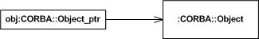
To gain access to something more useful than a CORBA::Object, the client must narrow the object reference:
Hello_ptr Hello_obj = Hello::_narrow(obj);
This operation returns an object reference having the Hotel interface or a nil reference. A nil reference will be returned if the target object's interface is not Hotel. Consequently, clients should always verify that the object reference returned from a _narrow() operation is not nil:
if(CORBA::is_nil (Hello_obj))
{
// error: nil object reference returned
}
The client now has a reference to a Hello object:
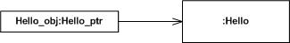
(For the remainder of this article, checks for nil object references are omitted for brevity.)
A consequence of the preceding two operations is that the ORB has allocated resources for two distinct proxy objects, a proxy for a CORBA::Object and a proxy for a Hello object. Although both proxies are associated with the same target object, their interfaces are different and therefore they are separate proxy objects. The client has access to these objects, via pointers provided by the ORB, but the ORB retains ownership so it can manage resources in a coherent manner. Because clients have access to resources owned by the ORB, clients must collaborate with the ORB to protect their interests in the use object references and to assist the ORB in the recovery of its resources.
To inform the ORB that an object reference is no longer in use and may be destroyed, a client calls CORBA::release():
CORBA::release(obj);
The ORB may destroy the obj reference and recover its resources upon the call to CORBA::release() or anytime thereafter. The client must assume, however, that the object reference is destroyed immediately upon the call to CORBA::release() and treat it accordingly:
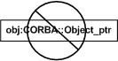
The obj variable can be re-used to refer to other CORBA::Objects but it must not be used to invoke requests until it has been associated with another CORBA object.
The release of obj has no effect on Hello_obj because they are distinct references so the following sequence is valid:
CORBA::Object_ptr obj = orb->string_to_object("file://server.ior");
Hello_ptr Hello_obj = Hello::_narrow(obj);
CORBA::release(obj);
Hello_obj->say_hello();
Similarly, the release of Hello_obj has no effect on obj. The following sequence, although nonsensical, demonstrates the point:
CORBA::Object_ptr obj = orb->string_to_object("file://server.ior");
for(int i = 0; i < 10; ++i)
{
Hello_ptr Hello_obj = Hello::_narrow(obj);
Hello_obj->say_hello();
CORBA::release(Hello_obj);
}
To copy an object reference, a client calls _duplicate() using the appropriate proxy class. For example, to copy a Hello object reference:
Hello_ptr Hello_obj2 = Hello::_duplicate(Hello_obj);
Hello_obj2 is a reference to target object referred to by Hello_obj.
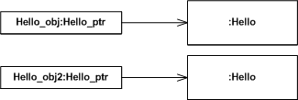
Other object references, including CORBA::Objects are also be copied in this manner:
CORBA::Object_ptr obj2 = CORBA::Object::_duplicate(obj);
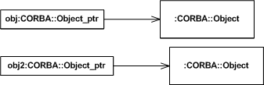
Conceptually, the ORB performs a deep copy when object references are duplicated. Most ORBs employ reference counting so this operation usually amounts to incrementing a proxy object's reference count. Similarly, a release operation usually amounts to decrementing a proxy object's reference count. A proxy object continues to exist until its reference count reaches 0 at which time the object is destroyed and associated resources recovered. However, it is important to treat different object references, e.g. Hello_obj and Hello_obj2, as distinct references each having dedicated resources managed by the ORB.
CORBA Object references in C++ and java
C++ : -

When we use CORBA with C++ , reference counting directly affects how object references are declared .An object reference type that is appended with _ptr never implicitly affects the reference count of the object that it references. An object reference type that is appended with _var implicitly decrements the reference count of any object it currently references when it is destroyed or assigned to a new object.
The Checking account wrapper class uses both _var and _ptr types.

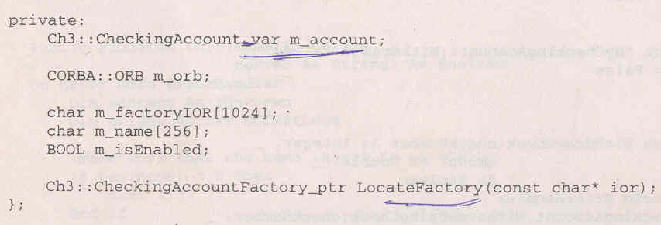

m_account is declared as an _var type so it will automatically be released when the Mycheckingccount instance is destroyed. If we had declared it as a _ptr type variable , we would have needed to explicitly release it in the destructor.
Java : -
Java provides many advantages compared to C++ , of those , the most important is garbage collection .java based CORBA products rely on the java runtime system to manage CORBA object reference counting rather than forcing the user to correctly use explicit constructors like those used in C++.
The IDL to java mapping supports implicit widening .Downward navigation of the hierarchy is made possible by means of a narrow() method that is defined in a helper class for each CORBA interface .The init method in the mMyCheckingAccount wrapper class illustrates the narrowing of a CORBA object reference to a Checking Account Factory reference;.

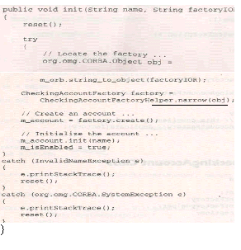
How Are Object References Obtained By Applications?
Object references allow applications to issue distributed requests. They basically fall into two categories, mechanisms to obtain initial object references and mechanisms to obtain subsequent object references. CORBA provides two standard ways to obtain an initial object reference:
- ORB::resolve_initial_references(string): CORBA defines a vendor specific mechanism for obtaining an initial set of object references. While CORBA defines the interface for the mechanism, internals required to drive the functionality are not standardized. CORBA specifies that an application can obtain an object reference by calling resolve_initial_references(), but vendor specific configurations files, command line arguments, of environmental variable might be required for the call to succeed. Object references obtained in this way can most likely be implemented only within the same vendors ORB.
- ORB::string_to_object(string): CORBA provides a vendor independent mechanism for obtaining an object reference. The string_to_object() operation returns an object reference directly from a particular string. The object reference is actually an interoperable object reference and thus can be implemented within an ORB supporting IIOP. Strings are basically encoded identifiers and are not human readable. The string can be hard coded into an application, stored and retrieved from a file, or obtained through some other IPC mechanism. Strings are initially created by calling object_to_string() on an actual object reference.
Once an application obtains an object reference, it can obtain subsequent objects by calling any remote operations on the original object reference that happen to return a CORBA object. CORBA refers to an object capable of returning an object reference as a factory. CORBA defines two services that are basically mechanisms by which subsequent object references can be obtained. These are listed below:
- CORBA NameService
- CORBA TraderService

CORBA Object States

A CORBA object is an abstraction that exists independently of servers, servants, or any other computing artifact. A servant is a programming language object that provides the implementation for one or more methods defined for a CORBA object. In effect it is simply an instance of an implementation of an IDL interface for a CORBA object. At runtime, COBOL and PL/I developers perceive CORBA objects as implementations in either PL/I or COBOL.
Servers can be shut down and restarted without affecting the existence of a CORBA object that lives in that server. The minimum requirement for a CORBA object to exist is that it must have an ObjectId. The way ObjectIds are created depends on the nature of the CORBA object they are associated with. So, at this point it necessary to make a fundamental distinction between two different types of CORBA object:
- Transient CORBA object.
- Persistent CORBA object.
Transient CORBA objects
Transient CORBA objects are CORBA objects that last only as long as the server process that uses them. According to this definition, transient CORBA objects can not be implemented by either COBOL or PL/I servers, however
Persistent CORBA objects
Persistent CORBA objects, are CORBA objects that exist beyond a particular instance of a server process. They are therefore stored (usually in a database), when they are not actively being used. The format for an ObjectId which refers to an object stored in an database is interface_name db_key, where a single space serves as a separator. For example, a BankAccount object with the database key 34332 is mapped to the ObjectId: BankAccount 34332.
Creating a Persistent CORBA object

The necessary prerequisite for creating a persistent CORBA object is that an ObjectId has already been created, and is stored in some database. When the server process begins, it associates a servant with the CORBA object's ObjectId. The object reference is then created and can be passed to the client, enabling the client to invoke operations on the CORBA object.
When the server process ceases, the CORBA object becomes dormant, and is only reactivated when the server process is restarted.
Destroying a CORBA Object

Destroying a CORBA object not only means that is it not active; it also means that it cannot be activated to respond to a client request. Clients calling on a reference to an object that has been destroyed receive the following error message (commonly called an exception) -- OBJECT_NOT_EXIST. The OMG have ratified a CORBAservice which describes a paradigm for creating and destroying CORBA objects.

WHAT IS A FACTORY?
A factory is a CORBA Object that returns another CORBA object via one of its CORBA operations. There are many different types of factories with many different purposes. In fact, the OMG has defined several services that are actually factories
There are several types of factories:
- Generic: A generic factory is a factory (CORBA Object) that is capable of returning other CORBA Objects. These CORBA Objects are generic. This means that they can be of any type, rather than a specific type. The SomeFactory::GenericCreate() operation causes the SomeFactory interface to be a generic factory. The NamingContext object defined as part of the CORBA Naming Service is a classic example of a generic factory.
- Specific: A specific factory is a factory (CORBA Object) that is capable of returning a specific type of pre-defined CORBA Object. The SomeFactory::SpecificCreate() operation causes the SomeFactory interface to be a specific (or typed) factory.
- In-process: An in-process factory is a factory which is implemented in the same process as the object which is created or managed by it.
- Out-process: An out-process factory is a factory which is implemented in a process different from the one of the object which is created or managed by it.
interface AnObject
{
boolean ping();
};

interface SomeFactory
{
CORBA::Object GenericCreate();
AnObject SpecificCreate();
};
The CORBA Lifecycle specification defines a GenericFactory interface from which all factories should inherit, but this is not required. The CORBA specification also defines a factory for factories, known as a factory finder. The factory finder is a just a CORBA factory which act as a factory for other factory interfaces.
CORBA client applications get object references to CORBA objects from factories. A factory is any CORBA object that returns an object reference to another CORBA object and registers itself as a factory. The CORBA client application invokes an operation on a factory to obtain an object reference to a CORBA object of a specific type. To use factories, the CORBA client application must be able to locate the factory it needs. The FactoryFinder object serves this purpose.
The FactoryFinder object has the following methods:
- find_factories()
Returns a sequence of factories that match the input key exactly.
- find_one_factory()
Returns one factory that matches the input key exactly.
- find_factories_by_id()
Returns a sequence of factories whose ID field in the name component matches the input argument.
- find_one_factory_by_id()
Returns one factory whose ID field in the factory's CORBA name component matches the input argument.

Defining and Implementing CORBA Objects
The goal in CORBA object development is the creation and registration of an object server, or simply server. A server is a program which contains the implementation of one or more object types and which has been registered with the ORB. For example, you might develop a desktop publishing server which implements a "Document" object type, a "Paragraph" object type, and other related object types.

CORBA Object Interfaces
All CORBA objects support an IDL interface; the IDL interface defines an object type. An interface can inherit from one or more other interfaces. IDL syntax is very similar to that of Java or C++, and an IDL file is functionally the CORBA language-independent analog to a C++ header file. IDL is mapped into each programming language to provide access to object interfaces from that language. With Java IDL, these IDL interfaces can be translated to Java using the idlj compiler. For each IDL interface, idlj generates a Java interface and the other .java files needed, including a client stub and a server skeleton.
An IDL interface declares a set of client accessible operations, exceptions, and typed attributes (values). Each operation has a signature that defines its name, parameters, result, and exceptions. A simple IDL interface that describes the classic "Hello World" program, follows.
module HelloApp
{
interface Hello
{
string sayHello();
};
};
An operation may raise an exception when an error condition arises. The type of the exception indicates the kind of error that was encountered. Clients must be prepared to handle defined exceptions and CORBA standard exceptions for each operation in addition to normal results.

Java Language-based Implementation
Once the IDL interfaces have been defined and the idlj compiler run on the .idl file, .java files containing the method implementations may be written. The .java implementation files are then compiled and linked with the idlj -generated .java files and the ORB library to create an object server.
An object implementation defines the behavior for all the operations and attributes of the interface it supports. There may be multiple implementations of an interface, each designed to emphasize a specific time and space trade-off, for example. The implementation defines the behavior of the interface and object creation/destruction.
Since only servers can create new CORBA objects, a factory object interface should be defined and implemented for each object type. For example, if Document is an object type, a DocumentFactory object type with a create method should be defined and implemented as part of the server. (Note that "create" is not reserved; any method name may be used.) The implementation of the create method can then use new to create the object. For example:
DocumentServant document = new DocumentServant():
orb.connect(document);
A destroy method may be defined and implemented on Document; or, the object may be intended to persist indefinitely. (Again, "destroy" is not reserved and any name may be used.)
The Java IDL ORB supports transient objects only - objects whose lifetime is limited by the server process lifetime. Although a transient object dissapears when its server process stops running, the object may be implemented to store its state in a file and to re-initialize itself from this file at creation time.

Client Implementation
Client code is linked with idlj-generated .java files and the ORB library. Examples of application and applet clients are provided in the Hello World example.
Clients may only create CORBA objects via the published factory interfaces that the server provides. Likewise, a client may only delete a CORBA object if that object publishes a destruction method. Since a CORBA object may be shared by many clients around a network, only the object server is in a position to know when the object has become garbage.
The client code's only way of issuing method requests on a CORBA object is via the object's object reference. The object reference is an opaque structure which identifies a CORBA object's host machine, the port on which the host server is listening for requests, and a pointer to the specific object in the process. Because Java IDL supports only transient objects, this object reference becomes invalid if the server process has stopped and restarted.
Clients typically obtain object references in the following ways:
- from a factory object. For example, the client could invoke a create method on DocumentFactory object in order to create a new Document. The DocumentFactory create method would return an object refererence for Document to the client.
- from the nameservice. For example, the client could obtain an object reference for the DocumentFactory by issuing a request on the nameservice.
- From a string that was specially created from an object reference
Once an object reference is obtained, the client must narrow it to the appropriate type. IDL supports inheritance; the root of its hierarchy is Object in IDL, org.omg.CORBA.Object in Java. (org.omg.CORBA.Object is, of course, a subclass of java.lang.Object.) Some operations, notably name lookup and unstringifying, return an org.omg.CORBA.Object, which you narrow (using a helper class generated by the idlj compiler) to the derived type you want the object to be. CORBA objects must be explicitly narrowed because the Java runtime cannot always know the exact type of a CORBA object

CORBA OBJECT CREATION in C++ and Java

The basic steps needed to create a CORBA object in C++ and in Java are the same.
They are
- The CORBA object reference for the CheckingAccountFactory instance is located.
- A checking account instance is created using the create() method provided by the factory.
- The Checking account Instance is initialized with the customer name.

Reference counting issues make locating the factory some what complex in C++.
The locate factory method for the C++ client is shown here..

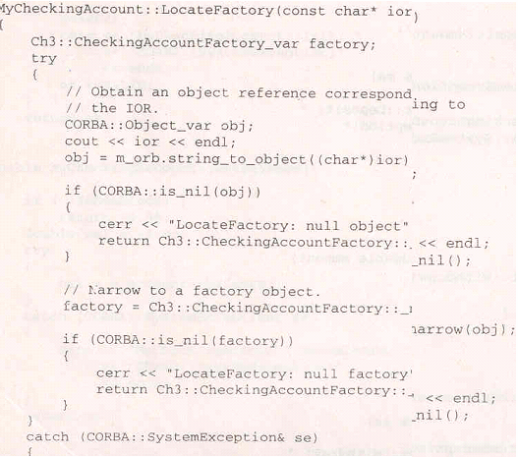
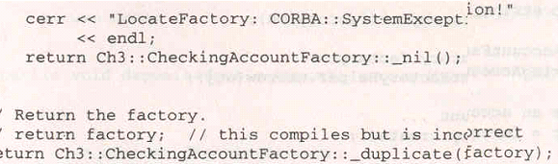

The Locate Factory() method first obtains an object reference corresponding to the stringified IOR that was passed as parameter. It does this by calling the String_to_object() method on the ORB. Successful completion of this call returns an object reference to the CORBA object instance uniquely identified by the IOR. The CORBA object reference is then narrowed to a Ch3:CheckingAccountFactory object reference and returned to the caller.

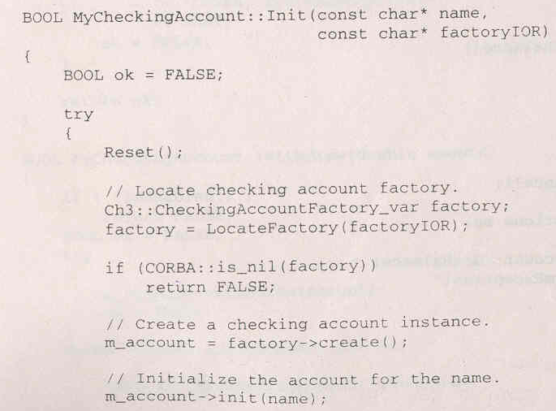
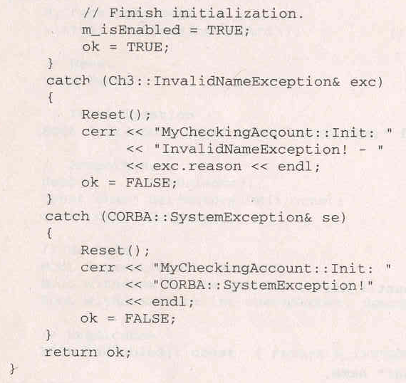

An object reference for the factory is created by calling the LocateFactory () method with factoryIOR passed as a parameter. The checking account instance is then created by calling the create() method on the factory. Finally , the m_account_init() method is called using the customer name passed in as a parameter to MYCheckingAccount::Init().

Creating a CORBA object in Java is even simpler than it is in C++ because the reference – counting issues do not convolute the solution

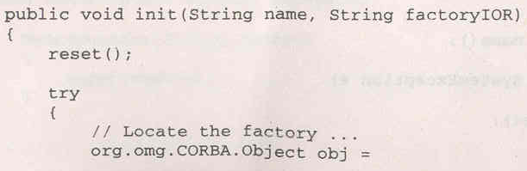
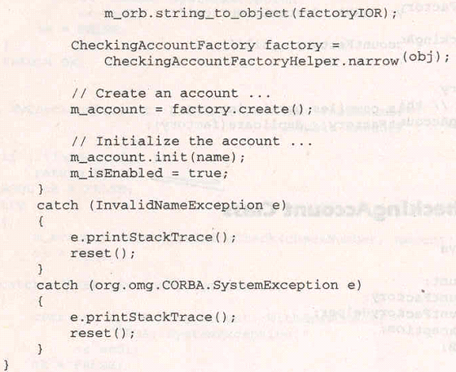

The MyCheckingAccount .init() method locates the factory by calling the String_to_Object() method on the ORB. Successful completion of String_to_object() method returns an object reference to the CORBA object instance uniquely identified by the factoryIOR parameter. The CORBA object reference is then narrowed to the CheckingAccountFactory object reference and returned to the caller. Next, the checking account instance is created by calling the create() method on the factory. Finally , the m_account.init() method is called using the customer name passed in as a parameter to MyCheckingAccount.init().

CORBA EXCEPTIONS
CORBA defines the following types of exceptions:
System exceptions, which are general errors, such as running out of memory and communication failures. System exceptions include exceptions raised by the Object Request Broker (ORB). The CORBA specification defines a set of system exceptions that can be raised when errors occur in the processing of a request from a CORBA client application. User exceptions, which are exceptions triggered by an object, where the exception contains user-defined data. When you define your CORBA object's interface in OMG IDL, you can specify the user exceptions that the object may raise.
The following sections describe how each type of CORBA client application handles exceptions.
CORBA C++ Client Applications
Since both system and user exceptions require similar functionality, the SystemException and UserException classes are derived from the common Exception class. When an exception is raised, your CORBA client application can narrow from the Exception class to a specific SystemException or UserException class.
C++ Exception Inheritance Hierarchy
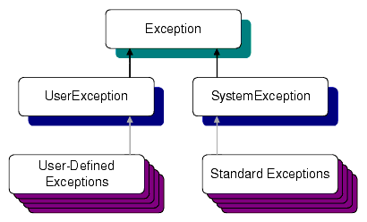
The Exception class provides the following public operations:
- copy constructor
- destructor
- _narrow
The copy constructor and destructor operations automatically manage the storage associated with the exception.
The _narrow operation allows your CORBA client application to catch any type of exception and then determine its type. The exception argument passed to the _narrow operation is a pointer to the base class Exception. The _narrow operation accepts a pointer to any Exception object. If the pointer is of type SystemException, the narrow() operation returns a pointer to the exception. If the pointer is not of type SystemException, the narrow() operation returns a Null pointer.
Unlike the _narrow operation on object references, the _narrow operation on exceptions returns a suitably typed pointer to the same exception argument, not a pointer to a new exception. Therefore, you do not free a pointer returned by the _narrow operation. If the original exception goes out of scope or is destroyed, the pointer returned by the _narrow operation is no longer valid.

Handling System Exceptions
The CORBA C++ client applications in the BEA Tuxedo sample applications use the standard C++ try-catch exception handling mechanism to raise and catch exceptions when error conditions occur, rather than testing status values to detect errors. This exception-handling mechanism is also used to integrate CORBA exceptions into CORBA client applications. In C++, catch clauses are attempted in the order specified, and the first matching handler is called.
User Exceptions
User exceptions are generated from the user-written OMG IDL file in which they are defined. When handling exceptions, the code should first check for system exceptions. System exceptions are predefined by CORBA, and often the application cannot recover from a system exception. For example, system exceptions may signal problems in the network transport or signal internal problems in the ORB.
The handling of CORBA Exceptions in C++ and Java is basically the same.CORBA method invocations from C++ and Java should always be made with in a try –catch block.The init method in the MyChecking Account C++ wrapper class illustrates a CORBA method invocation:
_____________________________________________________________________
//MyCheckingAccount.cpp – Wrapper Class
BOOL MyCheckingAccount ::Init(Const char* name ,const char* factoryIOR)
{
try {
…….
m_account->init(name);
…….
} catch(ch3:: InvalidNmaeException& exc)
{
cerr<<”MyCheckingAccount::Init:”<<”InvalidNameException- “ <<exc.reason<<endl;
}
Catch(CORBA::SystemException& se)
{
cerr<<”MyCheckingAccount::Init:”<< ” CORBA ::SystemExceoption!”
}
……
}
_____________________________________________________________________
The call to m_account->init() is made within a try block. Catch blocks are defined for the Ch3::InvalidNameException as well as the CORBA SystemException.
CORBA Java Client Applications
CORBA Java client applications handle exceptions in a similar way to CORBA C++ client applications:
System exceptions inherit from java.lang.RuntimeException.
User-defined exceptions inherit from java.lang.Exception.
Figure 5-2 Java Exception Inheritance Hierarchy
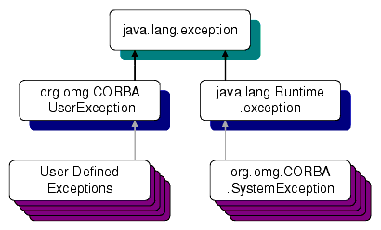
System Exceptions
The standard OMG IDL system exceptions are mapped to final Java classes that extend org.omg.CORBA.SystemException and provide access to the OMG IDL major and minor exception code, as well as a string describing the reason for the exception.
Note: There are no public constructors for org.omg.CORBA.SystemException; only classes that extend it can be instantiated.
The Java class name for each standard OMG IDL exception is the same as its OMG IDL name and is declared to be in the org.omg.CORBA package. For example, the CORBA-defined system exception BAD_CONTEXT maps to Java as org.omg.CORBA.BAD_CONTEXT. The default constructor supplies zero for the minor code, COMPLETED_NO for the completion code, and "" for the reason string. There is also a constructor that takes the reason and uses defaults for the other fields, as well as a constructor that requires all three parameters to be specified.
User Exceptions
User exceptions are mapped to final Java classes that extend org.omg.CORBA.UserException and are otherwise mapped like the OMG IDL struct data type, including the generation of Helper and Holder classes.
The init() method in the MyCheckingAccount Java wrapper class trats the CORBA method invocation much as the C++ version did. The call to m_account.init() is made within a try block. Catch blocks are defined for the InvalidNameException as well as the CORBA SystemException:
_____________________________________________________________________
MyCheckingAccount.java (wrapper Class)
Public void init(String name, String FactoryIOR)
{
try {
……
m_account.init();
…….
}catch(InvalidNameException e)
{ e.printStackTrace();
}catch(org.omg.CORBA.SystemException e)
{ e.printStackTrace();
}
}
____________________________________________________________________
Java enforces usage of all exceptions not derived from the RunTimeException class defined in the java.lang package. The CORBA SystemException class derives from the java.lang.RuntimeException
In general CORBA relies heavily on exceptions and Java provides much better exception support than C++.

DESTROYING CORBA OBJECTS
Object lifetimes are managed differently in different programming environments. In C++ an object is destroyed using the delete operator. In java, the garbage collector locates objects no longer needed and destroys then.
CORBA takes the stance that a server objects reference count should not be affected by the uncontrollable actions of an arbitrary client. In CORBA server side reference counts are maintained and have no direct relationship to client side reference counts . The reference counts maintained in a CORBA server for a specific instance can be manipulated only with in the context of a server.
The lifetime of a CORBA object instance depends solely on the reference count maintained within its CORBA server implementation. A CORBA objects server side reference count is initialized when the object is created.
Several approaches are made to decrement the server side reference count. The simplest method is to create an interface method that releases the object .This is the approach used in the checking account example. The CORBA IDl for the Account interface includes the destroy() method.
___________________________
interface Account
{
………..
Void destroy();
};

The destroy() method simply calls release() on the CORBA server instance, thereby reducing its reference count to 0;Once the reference count reaches 0, the ORB automatically calls delete on the instance. The implementation of destroy() is presented here.

Void CheckingAccountImpl:: destroy( CORBA::Environment & IT_env)
{
CORBA :: release(this);
}

When a client references a CORBA object, it uses a client stub to communicate with that object. Resources allocated with the client stub cannot be deallocated until the client side reference count for the CORBA object goes to zero. Although the client side resources are freed when the clients reference count goes to 0, the actual server object instance is unaffected .To destroy the server object instance , the C++ client calls the destroy() like this.
___________________________________________________
Void MyCheckingAccount:: reset()
{
If (!CORBA::is_nil(m_account))
{
m_account->destroy()
m_account = ch3::CheckingAccount::_ptr();
}
}

A java Client:

//MyCheckingAccount.java
Public void reset()
{
If (m_account!=null)
{
m_account.destroy();
m_account = null;
}
}
______________________________________________________________

If the destroy() method is never called due to program error or abnormal program termination ,the server object instance will never get destroyed.
To guarantee the eventual destruction of unused CORBA instances, the CORBA developer is required to implement an eviction scheme with in the CORBA server. Eviction schemes are usually based on time-outs. A CORBA server maintains a list o object references and time stamps for all object instances created in the server. The time stamp is used to determine the last time the object instance was invoked. Time out value is set to 10 minutes .A sweep method is run every 2minutes that evicts objects not used within the last 10 minutes. To keep a server object alive, the instance provides a method called keep alive() that must be called in every 10 minutes by the client if no other methods are invoked.

Comparison of CORBA & DCOM Architectures.

DCOM
*Supports multiple interfaces for objects and uses the QueryInterface() method to navigate among interfaces. This means that a client proxy dynamically loads multiple server stubs in the remoting layer depending on the number of interfaces being used. *Every object implements IUnknown. * Uniquely identifies a remote server object through its interface pointer, which serves as the object handle at run-time * Uniquely identifies an interface using the concept of Interface IDs (IID) and uniquely identifies a named implementation of the server object using the concept of Class IDs (CLSID) the mapping of which is found in the registry. * The remote server object reference generation is performed on the wire protocol by the Object Exporter * Tasks like object registration, skeleton instantiation etc. are either explicitly performed by the server program or handled dynamically by the COM run-time system. * Uses the Object Remote Procedure Call(ORPC) as its underlying remoting protocol * When a client object needs to activate a server object, it can do a CoCreateInstance()- * The object handle that the client uses is the interface pointer *The mapping of Object Name to its Implementation is handled by the Registry * The type information for methods is held in the Type Library *The responsibility of locating an object implementation falls on the Service Control Manager (SCM) * The responsibility of activating an object implementation falls on the Service Control Manager (SCM) * The client side stub is called a proxy. The server side stub is called stub *All parameters passed between the client and server objects are defined in the Interface Definition file. Hence, depending on what the IDL specifies, parameters are passed either by value or by reference. * Attempts to perform distributed garbage collection on the wire by pinging. *Allows you to define arbitrarily complex structs, discriminated unions and conformant arrays in IDL and pass these as method parameters. Complex types that will cross interface boundaries must be declared in the IDL. * Will run on any platform as long as there is a COM Service implementation for that platform *Since the specification is at the binary level, diverse programming languages like C++, Java, Object Pascal (Delphi), Visual Basic and even COBOL can be used to code these objects * Each method call returns a well-defined "flat" structure of type HRESULT, whose bit settings encode the return status. For richer exception handling it uses Error Objects (of type IErrorInfo), and the server object has to implement the ISupportErrorInfo interface.

CORBA
- Supports multiple inheritance at the interface level
- Every interface inherits from CORBA.Object
- Uniquely identifies remote server objects through object references(objref), which serves as the object handle at run-time. These object references can be externalized (persistified) into strings which can then be converted back into an objref.
- Uniquely identifies an interface using the interface name and uniquely identifies a named implementation of the server object by its mapping to a name in the Implementation Repository
- The remote server object reference generation is performed on the wire protocol by the Object Adapter
- The constructor implicitly performs common tasks like object registration, skeleton instantiation etc
- Uses the Internet Inter-ORB Protocol(IIOP) as its underlying remoting protocol
- When a client object needs to activate a server object, it binds to a naming or a trader service –
- The object handle that the client uses is the Object Reference
- The mapping of Object Name to its Implementation is handled by the Implementation Repository
- The type information for methods is held in the Interface Repository
- The responsibility of locating an object implementation falls on the Object Request Broker (ORB)
- The responsibility of locating an object implementation falls on the Object Adapter (OA) - either the Basic Object Adapter (BOA) or the Portable Object Adapter (POA
- The client side stub is called a proxy or stub. The server side stub is called a skeleton
- When passing parameters between the client and the remote server object, all interface types are passed by reference. All other objects are passed by value including highly complex data types
- Does not attempt to perform general-purpose distributed garbage collection
- Complex types that will cross interface boundaries must be declared in the IDL
- Will run on any platform as long as there is a CORBA ORB implementation for that platform
- Since this is just a specification, diverse programming languages can be used to code these objects as long as there are ORB libraries you can use to code in that language
- Exception handling is taken care of by Exception Objects. When a distributed object throws an exception object, the ORB transparently serializes and marshals it across the wire

