B.TECH DEGREE EXAMINATION , NOVEMBER 2008
Seventh Semester
Branch:-Computer Science and Engineering
ADVANCED SOFTWARE ENVOIRNMENTS( R)

PART A
Answer All Questions
Each Question Carry 4 marks

- Explain the concept of Windows Programming?

In the event driven programming model that Windows is based on, Windows sends numerous messages to the application. For example a message is sent when the window is first being created. Messages are also sent when a menu item is clicked,or the window is moved or the window is resized.There are over 200 messages that Windows can send to an application.Some of these messages are placed in a message queue.These are known as queued messages.A Window program has a message loop that retrieves messages from the message queue by calling the GetMessage() function and dispatches them to the window procedure by calling the DispatchMessage() function.At times Windows sends messages to the application by straight-way calling the window procedure instead of following the message loop route.The message which are sent to the application by directly calling its window procedure are called nonqueued message.So windows procedures gets two type of messages for the application.The queued messages are posted to the window procedure and non-ueued messages are sent to the window procedure.
In procedural programming the flow of execution of program is determined by programmer while in window programming or event driven programming the flow of execution is determined by user events.
- Explain Message Loop?
Messages come in the form of an MSG data type in windows. This data object is passed to the GetMessage() function, which reads a message from the message queue, or waits for a new message from the system. Next, the message is sent to the TranslateMessage() function, which takes care of some simple tasks such as translating to Unicode or not. Finally, the message is sent to the window for processing using the DispatchMessage() function.
A simple message loop consists of one function call to each of these three functions: GetMessage, TranslateMessage, and DispatchMessage.
If there is an error, GetMessage returns -1 -- thus the need for the special testing.
MSG msg;
BOOL bRet;

while( (bRet = GetMessage( &msg, NULL, 0, 0 )) != 0)
{
if (bRet == -1)
{
// handle the error and possibly exit
}
else
{
TranslateMessage(&msg);
DispatchMessage(&msg);
}
}
The GetMessage function retrieves a message from the queue and copies it to a structure of type MSG. It returns a nonzero value, unless it encounters the WM_QUIT message, in which case it returns FALSE and ends the loop. In a single-threaded application, ending the message loop is often the first step in closing the application. An application can end its own loop by using the PostQuitMessage function, typically in response to the WM_DESTROY message in the window procedure of the application's main window.
If you specify a window handle as the second parameter of GetMessage, only messages for the specified window are retrieved from the queue. GetMessage can also filter messages in the queue, retrieving only those messages that fall within a specified range. For more information about filtering messages, see Message Filtering.
A thread's message loop must include TranslateMessage if the thread is to receive character input from the keyboard. The system generates virtual-key messages (WM_KEYDOWN and WM_KEYUP) each time the user presses a key. A virtual-key message contains a virtual-key code that identifies which key was pressed, but not its character value. To retrieve this value, the message loop must contain TranslateMessage, which translates the virtual-key message into a character message (WM_CHAR) and places it back into the application message queue. The character message can then be removed upon a subsequent iteration of the message loop and dispatched to a window procedure.
The DispatchMessage function sends a message to the window procedure associated with the window handle specified in the MSG structure. If the window handle is HWND_TOPMOST, DispatchMessage sends the message to the window procedures of all top-level windows in the system. If the window handle is NULL, DispatchMessage does nothing with the message.

- Explain drawing on MFC Windows
Windows provides a variety of drawing tools to use in device contexts. It provides pens to draw lines, brushes to fill interiors, and fonts to draw text. MFC provides graphic-object classes equivalent to the drawing tools in Windows. Windows has a rich and flexible set of graphics functions .In the coordinate system the upper left corner is location (0 ,0) and the pixe Graphics functions:-

MFC encapsulated the graphics functions within the CDC.
1)setting a pixel
COLORREF CDC ::SetPixel (int x,int y,COLORREF color)
Point X,Y, is set to the color and this color is returned.

2) Drawing a line: Line To()

BOOL CDC::LineTo (int x,int y)
A line is drawn from the current graphics position to the coordinates specified by X,Y.The current position is then changed to X,Y.The function returns non zero if successful and zero on failure.

3) Setting the current location : MoveTo()

CPoint CDC:: MoveTo( int x,int y);
The current position is set to the point x,y;
ls are the logical units. Windows maintains a current position that is used and updated by certain graphics functions. Windows graphics system is based upon 2 objects pens and brushes.Pen is used to draw lines and curves .default pen is black and one pixel thick..Brush is used to fill closed graphics shapes.

Working with Pen Creating brushes

BOOL CBrush ::CreateSolidBrush(COLORREF color);
In MFC pens are encapsulated by the CPen class .the default pen is black pen
BOOL CPen::Createpen (int style ,int width,COLORREF color);
MFC Uses different classes such as CpaintDC,CClientDC,CWindowDC and CMetaFileDC for handling the problem of device context handle.

- Give an account on MFC Classes?

A part of the MFC class hierarchy is shown in the below figure. At the top is a class called CObject. This base class provides various run- time support features, including run- time type information, serialization, and diagnostics. Many MFC base classes are derived directly from CObject. Some of the most commonly used derived MFC classes are CCmdTarget, CWinApp, CDocTemplate, CWnd, CDocument, CFrameWnd, CView, CDialog, and CMDIFrameWnd. The serialization feature of the MFC base class CObject allows building persistent objects. A persistent object store itself on disk or some other type of storage device and be restored later - usually by a subsequent invocation of the program.
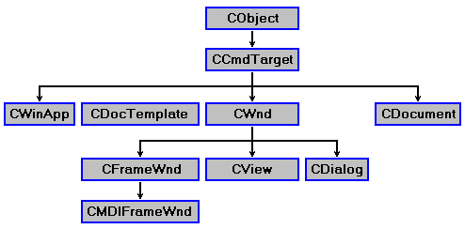

In the Windows programming model, applications respond to events by processing messages sent by Windows. An event could be a keystroke, a mouse move, or something else. For message processing, MFC applications use message maps to correlate incoming messages with class member functions. To use a MFC message map, a class must be derived from the MFC top level base class CCmdTarget. This class encapsulates the basics for message processing. Some of the other important MFC base classes are:
- CWinApp: The CWinApp class is the base class from which you derive a Windows application object. An application object provides member functions for initializing your application and for running the application.
- CDocTemplate: The CDocTemplate class is derived from the CCmdTarget base class. The MFC class CDocTemplate provides some basic functionality for the MFC document / view architecture and works in conjunction with the CDocument and CView classes.
- CWnd: The CWnd class provides the base functionality of all window classes in the MFC. The CWnd class encapsulates the properties of a window. This class also provides default handlers for many messages and offers many member functions.
- CDocument: The CDocument class is derived from the base class CCmdTarget. The CDocument class provides the basic functionality for MFC user- defined document classes. A document is a part of the MFC document / view architecture.
- CFrameWnd: The CFrameWnd class is derived from the CWnd base class. The CFrameWnd class provides the functionality of a Windows single document interface (SDI) overlapped or pop- up frame window, along with members for managing the window.
- CView: The CView class is derived from the base class CWnd. The CView class provides the basic functionality for MFC user- defined view classes. A view is a part of the MFC document / view architecture.
- CDialog: The CDialog class is derived from the base class CWnd. The CDialog class provides the basic functionality of a Windows dialog box window, along with members for managing the window.

- CMDIFrameWnd: The CMDIFrameWnd class is derived from the CFrameWnd base class. The class CMDIFrameWnd provides the functionality of a Windows multiple document interface (MDI) frame window, along with members for managing the window

5)Explain the features of CORBA?
CORBA is currently the dominant remoting architecture because it provides robust cross-language, cross-platform and cross-vendor support for creating servers on a wide range of operating system platforms.
The use of CORBA allows for incredible versatility when implementing distributed systems.This versatility is a result of

Broad language support.CORBA products support official mappings to C,C++,Smalltalk,COBOL and Ada.

Diverse Platform Support:-CORBA products exist on mainframe platforms,all majo UNIX platforms,Windows NT ,Windows 95/98,OS/2 and Vax /VMs platform.Several Java based ORBs can be used on any platform that support the Java Virtual Machine.

Multivendor support.CORBA products are sold and supported by many vendors including Iona Technologies,Inspire,BEA Systems,Expersoft and IBM.CORBA ORBs that support the IIOp interoperability standard can be intermixed within the enterprise.
Freely available CORBA products-Freely available CORBA products include Java IDL in Suns JDK 1.2 OmniORB 2 from the Olivetti and Oracle Reasearch Laboratories,JacORB for Java and many others.

6)What is CORBA IDL?Explain?

An important part of CORBA is its use of the Interface Definition Language, which specifies interfaces between CORBA components. IDL facilitates CORBA's language independence—because interfaces described in IDL can be mapped to any supported programming language, CORBA applications are independent of the language(s) used to implement them. For example, a client written in C++ can communicate with a server written in Java, which in turn can communicate with another server written in Smalltalk, and so forth. IDL isn't an implementation language—you can't write applications in IDL. The sole purpose of IDL is to define interfaces that you can implement using a programming language.
A component that needs to provide remote services must specify its interface in an IDL. Recall that an interface consists of a set of operations, and that access to a particular component's services is provided by the interface that the component supports. Actually, IDL defines a component's object model as defined by OMG. IDL also makes transparent to clients the representation of a component's internal data and the implementation of its behavior.
OMG IDL obeys the same lexical rules as C++; it provides basic data types (such as short, long, float, double, and boolean) and user-defined types (such as struct, union, and sequence). These are used in operation declarations to define arguments' types and return types.
7)What are CORBA Factories?
CORBA rely on an abstraction called a factory to create distributed object instances. A factory is a special type of distributed object whose main purpose is to create other distributed objects. A factory lives within the same server process as the objects that it creates. Creating a distributed object in CORBA is a two step process.First appropriate factory is located. Then the factory is used to create the object of interest.
In CORBA the factory interface are user defined. Once these objects are created their handle can be used to invoke the object methods. CORBA provides for persistent objects, that is objects that can live beyond the lifetime of a single process. A persistent object provides a useful mechanism for creating a factory. A single persistent instance of the server object is always available.The CORBA clients rely on a stringified interoperable object reference(IOR).A IOR is simply a string of characters that can be used to uniquely identify a CORBA object instance available on the network regardless of vendor or hardware platform.When a server is atarted an instance of the server object created and its IOR is written to a file.Then clients can read these IOR from file and then later use it for object reference.with IOR we will identify the factory object then we will call the create() method of factory object to create other distributed objects.

8)Explain the CORBA object creation in C++.
CORBA rely on an abstraction called a factory to create distributed object instances. A factory is a special type of distributed object whose main purpose is to create other distributed objects. A factory lives within the same server process as the objects that it creates. Creating a distributed object in CORBA is a two step process.First appropriate factory is located. Then the factory is used to create the object of interest.
9)Explain layers in X-Windows Architecture?

X is a combination of several things,the X protocol,X display server XLib routines and XToolkit Explain each of them and the layered architecture.
10)Explain the concept of creating child window?
Explain the function xcreatesimplewindow and their arguments.

11)Describe in detail the components of Windows API?
From the programmers perspective a window is an object that receives and process messages .A window receives and processes user inputs. The message that a window receives contains information about an event (Eg:- mouse event)

These messages are actually passed to the window’s window function. A window also uses messages to communicate with other windows. To receive and process messages we need a window procedure At this point we are writing a windows program.

Windows application
USER.EXE
GDI.EXE
MOUSE.DRV
KEYBOARD.DRV
COMM.DRV
SOUND.DRV
SYSTEM.DRV
PRINTER.DRV
MOUSE
KEYBOARD.
MUSIC
SOUND
Timer hardware
PRINTER

KERNEL.EXE

. Windows API
The functionality provided by the Windows API can be grouped into seven categories
- Base Services
Provide access to the fundamental resources available to a Windows system like file systems, devices, processes and threads, access to the Windows registry, and error handling. These functions reside in kernel.exe, krnl286.exe or krnl386.exe files on 16-bit Windows, and kernel32.dll and advapi32.dll on 32-bit Windows.

- Graphics Device Interface
Provide the functionality for outputting graphical content to monitors, printers and other output devices. It resides in gdi.exe on 16-bit Windows, and gdi32.dll on 32-bit Windows.

- User Interface
Provides the functionality to create and manage screen windows and most basic controls, such as buttons and scrollbars, receive mouse and keyboard input, and other functionality associated with the GUI part of Windows. This functional unit resides in user.exe on 16-bit Windows, and user32.dll on 32-bit Windows. Since Windows XP versions, the basic controls reside in comctl32.dll, together with the common controls (Common Control Library).

- Common Dialog Box Library
Provides applications the standard dialog boxes for opening and saving files, choosing color and font etc. The library resides in a file called commdlg.dll on 16-bit Windows, and comdlg32.dll on 32-bit Windows. It is grouped under the User Interface category of the API.

- Common Control Library
Gives applications access to some advanced controls provided by the operating system. These include things like status bars, progress bars, toolbars and tabs. The library resides in a DLL file called commctrl.dll on 16-bit Windows, and comctl32.dll on 32-bit Windows. It is grouped under the User Interface category of the API.

- Windows Shell
Component of the Windows API allows applications to access the functionality provided by the operating system shell, as well as change and enhance it.

- Network Services
Give access to the various networking capabilities of the operating system. Its sub-components include NetBIOS, Winsock, NetDDE, RPC and many others.

Multimedia related APIs
Microsoft has provided the DirectX set of APIs as part of every Windows installation since Windows 95 OSR2. DirectX provides a loosely related set of multimedia and gaming services, including:
- Direct3D as an alternative to OpenGL for access to 3D acceleration hardware.
- DirectDraw for hardware accelerated access to the 2D framebuffer. As of DirectX 9, this component has been deprecated in favor of Direct3D, which provides more general high-performance graphics functionality (as 2D rendering is a subset of 3D rendering).
- DirectSound for low level hardware accelerated sound card access.
- DirectInput for communication with input devices such as joysticks and gamepads.
- DirectPlay as a multiplayer gaming infrastructure. This component has been deprecated as of DirectX 9 and Microsoft no longer recommends its use for game development.
- DirectShow which builds and runs generic multimedia pipelines. It is comparable to the GStreamer framework and is often used to render in-game videos and build media players (Windows Media Player is based upon it). DirectShow is no longer recommended for game development.
- DirectMusic

Web related APIs
The Internet Explorer web browser also uses many APIs that are considered as part of the Windows API. Internet Explorer has been an integrated component of the operating system since Windows 98, and provides web related services to applications. The integration will stop with Windows Vista.
It provides:
- An embeddable web browser control, contained in shdocvw.dll and mshtml.dll.
- The URL monitor service, held in urlmon.dll, which provides COM objects to applications for resolving URLs. Applications can also provide their own URL handlers for others to use.
- A library for assisting with multi-language and international text support (mlang.dll).
- DirectX Transforms, a set of image filter components.
- XML support (the MSXML components).
- Access to the Windows Address Book.

APIs for interaction between programs
The Windows API is concerned with the interaction between the Operating System and an application. For communication between the different Windows applications among themselves, Microsoft has developed a series of technologies alongside the main Windows API. This includes Dynamic Data Exchange (DDE), which was superseded by Object Linking and Embedding (OLE) and later by the Component Object Model (COM).

11)Explain in detail(a)Win Main Function (b)Menus and Buttons
Win Main Function

The WinMain function is the entry point of the application. When a user double clicks, Windows carries out some initialization code then passes control to this function. Its just like main() in C. In this function the application is set up and then enter a loop that will continue until the application is closed. i.e. The WinMain function is the conventional name for the user-provided entry point for a Microsoft Windows-based application.
Syntax:-
int WINAPI WinMain(
HINSTANCE hInstance,
HINSTANCE hPrevInstance,
LPSTR lpCmdLine,
int nCmdShow );
5.2) Parameters of WinMain Function
- hInstance
Handle to the current instance of the application.
- hPrevInstance
Handle to the previous instance of the application. This parameter is always NULL. If you need to detect whether another instance already exists, create a uniquely named mutex using the CreateMutex function. CreateMutex will succeed even if the mutex already exists, but the function will return ERROR_ALREADY_EXISTS.
- lpCmdLine
Pointer to a null-terminated string specifying the command line for the application, excluding the program name. To retrieve the entire command line, use the GetCommandLine function.
- nCmdShow
Specifies how the window is to be shown. This parameter can be one of the following values.
SW_HIDE - Hides the window and activates another window.
SW_MAXIMIZE - Maximizes the specified window.
SW_MINIMIZE - Minimizes the specified window and activates the next top-level window in the Z order.
SW_RESTORE -Activates and displays the window. If the window is minimized or maximized, the system restores it to its original size and position. An application should specify this flag when restoring a minimized window.
SW_SHOW -Activates the window and displays it in its current size and position.
SW_SHOWMAXIMIZED - Activates the window and displays it as a maximized window.
SW_SHOWMINIMIZED -Activates the window and displays it as a minimized window.
SW_SHOWMINNOACTIVE -Displays the window as a minimized window. This value is similar to SW_SHOWMINIMIZED, except the window is not activated.
SW_SHOWNA -Displays the window in its current size and position. This value is similar to SW_SHOW, except the window is not activated.
SW_SHOWNOACTIVATE -Displays a window in its most recent size and position. This value is similar to SW_SHOWNORMAL, except the window is not made active.
SW_SHOWNORMAL -Activates and displays a window. If the window is minimized or maximized, the system restores it to its original size and position. An application should specify this flag when displaying the window for the first time.

Return Value
If the function succeeds, then terminating is done when it receives a WM_QUIT message. Then it should return the exit value contained in that message's wParam parameter. If he function terminates before entering the message loop, it should return zero.
Menus and Buttons MENUS
A menu is the most important part of the consistent user interface that windows program offer. A menu is a list of application commands. Each command is replaced by a string or bitmap called a menu item. When ever the user chooses a menu item, windows sends the application a command message that indicates which menu item the user choose. Menu items I pop ups can be enabled , disabled or grayed.

Menu has a hierarchical structure .A menu bar resides at the uppermost level of hierarchy, immediately below the caption bar. The top level menu has a menu handle. Each popup menu within a top level menu has its own handle. Selecting an item from the menu bar activates the popup menu.

Eg:- Selecting a file item in the menu bar activates a popup menu with the items such as the New, Open ,save and so on.

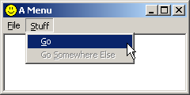

Each item in a menu is defined by three characteristics which include,
  - what appears in the menu (either a text string or a bitmap)
  - an ID number that WINDOWS sends to the program
  - the handle to the top up menu.

Each item of the menu list is primarily a word or a group of words on a line. Different menu items are used for different reasons. For example, some menu items simply display a word or a group of words. Some other items display a check mark. This indicates that the item toggles the availability or disappearance of an object.

Buttons are special control which are used to notify special event.we buttons like submit button,confirm button,prompt box etc.
13) Explain the features and advantages of MFC?
The Microsoft Foundation Class library is an application framework specifically tailored
for creating applications for the Windows operating system. An application framework is
“an integrated collection of object-oriented software components that offers all that’s
needed for a generic application”. So, the framework not only provides many classes for
making an application, but also defines the structure of the program itself.
MFC is arguably one of the most distinguishing features of Visual C++. The vast
collection of C++ classes encapsulates most of the Win32 API and provides a powerful
framework for typical (and not so typical) applications. Although that is not the only
reason why one would use MFC for delivering real-world applications, it is certainly a
good reason to use it. The other advantages of using MFC would be –

1. It simplifies the Windows API by grouping the API functions into logical units. In
doing this, it takes advantage of C++’s classes and inheritance to make
development conceptually easier. It completely hides away the messy details of
Windows programming such as registering window classes, window and dialog
procedures, and message routing.

2. It also makes the transition from standard API function calls to the use of class
libraries as simple as possible by designing classes that requires minimal
relearning of function names for seasoned Windows programmers. It also allows
mixing of traditional function calls with the use of the class library.

3. One of the design considerations of the MFC was to have the speed and efficiency
of C/SDK applications. By inventing mechanisms to avoid the overhead of virtual
functions for handling Windows messages, applications developed using MFC
still manage to be fast and small in size.

4. Extensibility is one major factor for projects using any class library and MFC is
no exception. The Windows API still continues to collect new material. When
OLE, ODBC and 32-bit API was added, MFC still provided a firm foundation
with it’s extensible design. Each new API introduces a new learning curve but
MFC eases the burden by encapsulating the details of the API in a set of classes.

Features

When MFC was introduced, Microsoft extended the C++ syntax with a series of macros for management of Windows messages (via Message Maps), exceptions, run time type identification, and dynamic class instantiation.

A macro in is a rule or pattern that specifies how a certain input sequence (often a sequence of characters) should be mapped to an output sequence (also often a sequence of characters) according to a defined procedure.
The macros for Windows messages were intended to reduce memory required by avoiding needless virtual table use and provide a more concrete structure for various Visual C++ supplied tools to edit and manipulate code without parsing the full language. The message-handling macros replaced the virtual function mechanism provided by C++.
MFC provides really nice classes for doing windows programming. It has taken away all the pains of SDK, where a programmer is expected to handle everything in the world except writing for application logic.

Some features of MFC

MFC provides incredible number of features. The major supported features are

- Document /view architecture
MFC provides an application development model called document /view model .It is a method designing an application so that the application data is separated from the user interface elements so that programmer can make changes to one without changing the other. The document object usually represents file that the application has opened while the view window provides a visual presentation of the documents data and accepts user interaction.

Eg:- Consider a word processor or spread sheet application The data contained in the application is the documents and the presentation of the data is the view

CDocument class
Contains data

Pointer to
CView1
Pointer to
CView2
Pointer to
CView3

This shows a one to many relationship between the document and its views .The document stores the data and manages printing the data and coordinates updating multiple views of the data.

There are four main classes used in a Document/View application.

- The Document class derived from CDocument- controls the data used by the application, which includes the storage when necessary.
- The View class derived from CView - Displays information about the document to the user and handles any interaction between the user and the document.
- The Frame class derived from CFrmWnd- Physically contains the view, menu, toolbar etc.
- The Application class derived from CWinApp- Controls the application level interaction with window.

2) Multiple document Interface (MDI)

MDI are those whose windows reside under single parent window .In a single document interface all windows are separated from each other.

Tool bar

Some text

Egs of MDI – word ,excel ,power point adobe Photoshop.
Egs of SDI – Windows explorer, Internet explorer, notepad.

3) Print and print preview Support
4) Using and creating ActiveX Controls
ActiveX is
-reusable components that can be plugged in to VB,VC++ etc.
-examples calendars, spellcheckers, image editor

5) ODBC and Access database support
6) Internet (TCP/IP) programming support
7) Multithreaded support

14)Explain the handling of mouse and keyboard events?
Mouse messages
  - WM_LBUTTONDOWN –It is generated when the left button is pressed .The massage handler function is OnLButtonDown( )
Afx_msg_ void OnLButtonDown( UNIT flag ,CPoint Loc);
The flag can take the values
- MK_CONTROL –means control key is pressed when the mouse button is pressed
- MK_SHIFT –shift key is pressed when mouse button is pressed
- MK_RBUTTON -If the right button is down when the left button is pressed
- MK_LBUTTON If the left button is down when the right button is pressed
- MK_MBUTTON .Middle button is pressed when one of the other button is pressed
  - WM_ RBUTTONDOWN
This message is generated when the right mouse button is pressed .
The message handler function is
OnRButtonDown()
Afx_msg_ void OnRButtonDown( UNIT flag ,CPoint Loc);

Input events

1 Mouse events:

  - mouse-down and mouse-up events for each mouse button,
  - mouse-click (and mouse-double-click) for each mouse button,
  - mouse-move and mouse-drag for moving or dragging the mouse, and
  - mouse-enter and mouse-exit for entering and exiting a user interface component (window).
Every mouse event carries the mouse coordinates and the state of the modifier buttons.

Mouse click occurs when the mouse button is pressed down and released sufficiently close to the same spot. Depending on the situation, the spot might be one pixel or a single gui component.Usually, a window receives mouse messages that happen inside it. A window can capture the mouse in order to receive all mouse events.

Keyboard events:

The system provides device-independent keyboard support for applications by installing a keyboard device driver appropriate for the current keyboard. The system provides language-independent keyboard support by using the language-specific keyboard layout currently selected by the user or the application. The keyboard device driver receives scan codes from the keyboard, which are sent to the keyboard layout where they are translated into messages and posted to the appropriate windows in your application.
Assigned to each key on a keyboard is a unique value called a scan code, a device-dependent identifier for the key on the keyboard. A keyboard generates two scan codes when the user types a key—one when the user presses the key and another when the user releases the key.
The keyboard device driver interprets a scan code and translates (maps) it to a virtual-key code, a device-independent value defined by the system that identifies the purpose of a key. After translating a scan code, the keyboard layout creates a message that includes the scan code, the virtual-key code, and other information about the keystroke, and then places the message in the system message queue. The system removes the message from the system message queue and posts it to the message queue of the appropriate thread. Eventually, the thread's message loop removes the message and passes it to the appropriate window procedure for processing

- key-down and key-up events for pressing the keyboard keys,
- character events for generated characters (ASCII or UNICODE), and
- system keyboard events for menu shortcuts.

The system makes a distinction between system keystrokes and nonsystem keystrokes. System keystrokes produce system keystroke messages, WM_SYSKEYDOWN and WM_SYSKEYUP. Nonsystem keystrokes produce nonsystem keystroke messages, WM_KEYDOWN and WM_KEYUP.

Window receives keyboard events if it has the input focus. Window gets input focus for example when it is clicked with the mouse. The window gets notified with event messages about receiving and losing input focus.

15)Explain the fundamental concepts of distributed objects?
Distributed Applications
CORBA products provide a framework for the development and execution of distributed applications. But why would one want to develop a distributed application in the first place? As you will see later, distribution introduces a whole new set of difficult issues. However, sometimes there is no choice; some applications by their very nature are distributed across multiple computers because of one or more of the following reasons:
- The data used by the application are distributed
- The computation is distributed
- The users of the application are distributed

Data are distributed
Some applications must execute on multiple computers because the data that the application must access exist on multiple computers for administrative and ownership reasons. The owner may permit the data to be accessed remotely but not stored locally. Or perhaps the data cannot be co-located and must exist on multiple heterogeneous systems for historical reasons.

Computation is distributed
Some applications execute on multiple computers in order to take advantage of multiple processors computing in parallel to solve some problem. Other applications may execute on multiple computers in order to take advantage of some unique feature of a particular

system. Distributed applications can take advantage of the scalability and heterogeneity of the distributed system.

Users are distributed
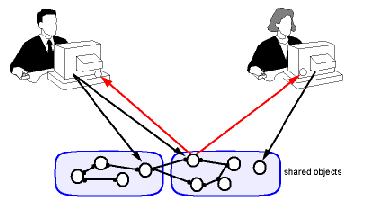
Some applications execute on multiple computers because users of the application communicate and interact with each other via the application. Each user executes a piece of the distributed application on his or her computer, and shared objects, typically execute on one or more servers. A typical architecture for this kind of application is illustrated below. Prior to designing a distributed application, it is essential to understand some of the fundamental realities of the distributed system on which it will execute.
Fundamental Realities of Distributed Systems
Distributed application developers must address a number of issues that can be taken for granted in a local program where all logic executes in the same operating system process. The following table summarizes some of the basic differences between objects that are co-located in the same process, and objects that interact across process or machine boundaries.
 | Co-located | Distributed
Communication | Fast | Slow
Failures | Objects fail together | Objects fail separately  Network can partition
Concurrent access | Only with multiple threads | Yes
Secure | Yes | No

The communication between objects in the same process is orders of magnitude faster than communication between objects on different machines. The implication of this is that you should avoid designing distributed applications in which two or more distributed objects have very tight interactions. If they do have tight interactions, they should be co-located. When two objects are co-located, they fail together; if the process in which they execute fails, both objects fail. The designer of the objects need not be concerned with the behavior of the application if one of the objects is available and the other one is not. But if two objects are distributed across process boundaries, the objects can fail independently. In this case, the designer of the objects must be concerned with each of the object's behavior in the event the other object has failed. Similarly, in a distributed system the network can partition and both objects can execute independently assuming the other has failed.
The default mode for most local programs is to operate with a single thread of control. Single threaded programming is easy. Objects are accessed in a well-defined sequential order according to the program's algorithms, and you need not be concerned with concurrent access.
If you decide to introduce multiple threads of control within a local program, you must consider the possible orderings of access to objects and use synchronization mechanisms to control concurrent access to shared objects. But at least you have a choice of introducing multiple threads of control. In a distributed application, there are necessarily multiple threads of control. Each distributed object is operating in a different thread of control. A distributed object may have multiple concurrent clients. As the developer of the object and the developer of the clients, you must consider this concurrent access to objects and use the necessary synchronization mechanisms.
When two objects are co-located in the same process, you need not be concerned about security. When the objects are on different machines, you need to use security mechanisms to authenticate the identity of the other object.

Distributed Object Systems
Distributed object systems are distributed systems in which all entities are modeled as objects. Distributed object systems are a popular paradigm for object-oriented distributed applications. Since the application is modeled as a set of cooperating objects, it maps very naturally to the services of the distributed system.
In spite of the natural mapping from object-oriented modeling to distributed object systems, do not forget the realities of distributed systems described above. Process boundaries really do matter and they will impact your design.

ALSO YOU CAN WRITE NOTES ON THE SEQUANCE OF STEPS THAT TAKE PLACE WHEN A REMOTE OBJECT IS CALLED.

16)Explain Implementing a simple CORBA server and client in C++?
CORBA IDL stubs and skeletons serve as the ``glue'' between the client and server applications, respectively, and the ORB. The transformation between CORBA IDL definitions and the target programming language is automated by a CORBA IDL compiler. The use of a compiler reduces the potential for inconsistencies between client stubs and server skeletons and increases opportunities for automated compiler optimizations.

Suppose one client is implemented by using c++ . To generate Orbix stub and skeleton, we invoke the Orbix IDL compiler as shown
C:\orbix\bin\idl.exe –B ch3.idl
The following files are generated by the IDL compiler
Ch3.hh //declarations
Ch3c.cpp //Orbix client stub
Ch3s.cpp //Orbix server skeleton
The structure CORBA client, stub, skeleton and server ifor the example is as shown below.
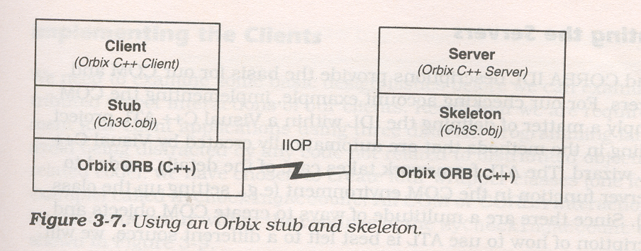
The stub (ch3c.obj) allows the client to link with the ORB and the skeleton (ch3s.obj) allows the server to link with ORB. The client and server ORBs communicate usion a protocol called IIOP – CORBA 2.0 standard communication protocol for TCP/IP.
COM and CORBA rely on an abstraction called a factory to create distributed object instances. A factory is a special type of distributed object whose main purpose is to create other distributed objects. A factory lives within the same server process as the objects that it creates. Creating a distributed object in COM and CORBA is a two step process. First appropriate factory is located. Then the factory is used to create the object of interest.

The steps required to create a CORBA object in C++ and Java are the same. First the CORBA object reference for the class instance is located. Next class instance is created using the create () method provided by the factory. Reference counting issues make locating the factory somewhat complex in C++.
CORBA object reference in C++ is hard due to the reference counting problem. When we use CORBA with C++ reference counting directly affects how object references are declared. An object reference type that is appended with _ptr never implicitly affects the reference count of the object that it reference. An object reference type that is appended with _var implicitly decrements the reference count of any object it currently references when it is destroyed or assigned to a new object. CORBA C++ provides the CORBA::RELEASE(ptr) function to explicitly decrement the reference count of a CORBA object referenced by ptr.There are methods for incrementing reference count.CORBA C++ mapping provides a static _duplicate() method to be used for exactly that purpose.So in CORBA C++ we have two types of variables and different methods to address object reference problem.This makes CORBA object reference in C++ hard.

17)Compare CORBA and DCOM?

DCOM
*Supports multiple interfaces for objects and uses the QueryInterface() method to navigate among interfaces. This means that a client proxy dynamically loads multiple server stubs in the remoting layer depending on the number of interfaces being used. *Every object implements IUnknown. * Uniquely identifies a remote server object through its interface pointer, which serves as the object handle at run-time * Uniquely identifies an interface using the concept of Interface IDs (IID) and uniquely identifies a named implementation of the server object using the concept of Class IDs (CLSID) the mapping of which is found in the registry. * The remote server object reference generation is performed on the wire protocol by the Object Exporter * Tasks like object registration, skeleton instantiation etc. are either explicitly performed by the server program or handled dynamically by the COM run-time system. * Uses the Object Remote Procedure Call(ORPC) as its underlying remoting protocol * When a client object needs to activate a server object, it can do a CoCreateInstance()- * The object handle that the client uses is the interface pointer *The mapping of Object Name to its Implementation is handled by the Registry * The type information for methods is held in the Type Library *The responsibility of locating an object implementation falls on the Service Control Manager (SCM) * The responsibility of activating an object implementation falls on the Service Control Manager (SCM) * The client side stub is called a proxy. The server side stub is called stub *All parameters passed between the client and server objects are defined in the Interface Definition file. Hence, depending on what the IDL specifies, parameters are passed either by value or by reference. * Attempts to perform distributed garbage collection on the wire by pinging. *Allows you to define arbitrarily complex structs, discriminated unions and conformant arrays in IDL and pass these as method parameters. Complex types that will cross interface boundaries must be declared in the IDL. * Will run on any platform as long as there is a COM Service implementation for that platform *Since the specification is at the binary level, diverse programming languages like C++, Java, Object Pascal (Delphi), Visual Basic and even COBOL can be used to code these objects * Each method call returns a well-defined "flat" structure of type HRESULT, whose bit settings encode the return status. For richer exception handling it uses Error Objects (of type IErrorInfo), and the server object has to implement the ISupportErrorInfo interface.

CORBA
- Supports multiple inheritance at the interface level
- Every interface inherits from CORBA.Object
- Uniquely identifies remote server objects through object references(objref), which serves as the object handle at run-time. These object references can be externalized (persistified) into strings which can then be converted back into an objref.
- Uniquely identifies an interface using the interface name and uniquely identifies a named implementation of the server object by its mapping to a name in the Implementation Repository
- The remote server object reference generation is performed on the wire protocol by the Object Adapter
- The constructor implicitly performs common tasks like object registration, skeleton instantiation etc
- Uses the Internet Inter-ORB Protocol(IIOP) as its underlying remoting protocol
- When a client object needs to activate a server object, it binds to a naming or a trader service –
- The object handle that the client uses is the Object Reference
- The mapping of Object Name to its Implementation is handled by the Implementation Repository
- The type information for methods is held in the Interface Repository
- The responsibility of locating an object implementation falls on the Object Request Broker (ORB)
- The responsibility of locating an object implementation falls on the Object Adapter (OA) - either the Basic Object Adapter (BOA) or the Portable Object Adapter (POA
- The client side stub is called a proxy or stub. The server side stub is called a skeleton
- When passing parameters between the client and the remote server object, all interface types are passed by reference. All other objects are passed by value including highly complex data types
- Does not attempt to perform general-purpose distributed garbage collection
- Complex types that will cross interface boundaries must be declared in the IDL
- Will run on any platform as long as there is a CORBA ORB implementation for that platform
- Since this is just a specification, diverse programming languages can be used to code these objects as long as there are ORB libraries you can use to code in that language
- Exception handling is taken care of by Exception Objects. When a distributed object throws an exception object, the ORB transparently serializes and marshals it across the wire

18)Explain the steps in CORBA object creation in C++ and JAVA?

CORBA OBJECT CREATION in C++ and Java

The basic steps needed to create a CORBA object in C++ and in Java are the same.
They are
- The CORBA object reference for the CheckingAccountFactory instance is located.
- A checking account instance is created using the create() method provided by the factory.
- The Checking account Instance is initialized with the customer name.

Reference counting issues make locating the factory some what complex in C++.
The locate factory method for the C++ client is shown here..

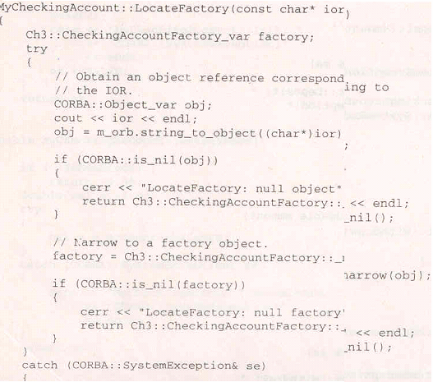
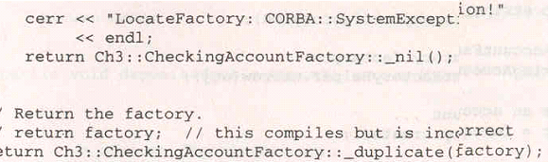

The Locate Factory() method first obtains an object reference corresponding to the stringified IOR that was passed as parameter. It does this by calling the String_to_object() method on the ORB. Successful completion of this call returns an object reference to the CORBA object instance uniquely identified by the IOR. The CORBA object reference is then narrowed to a Ch3:CheckingAccountFactory object reference and returned to the caller.

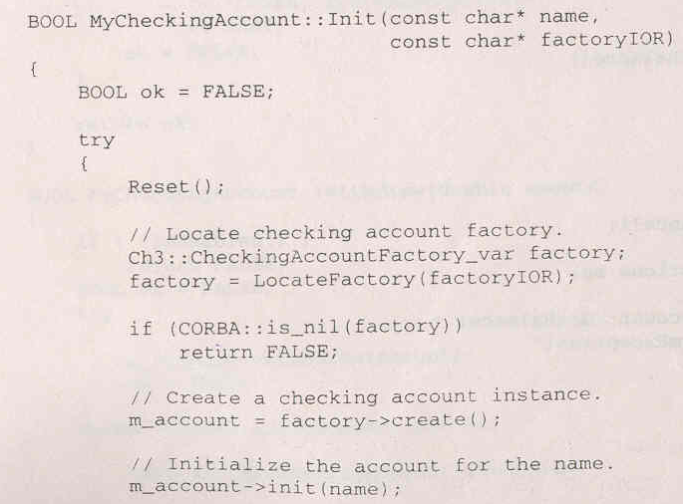
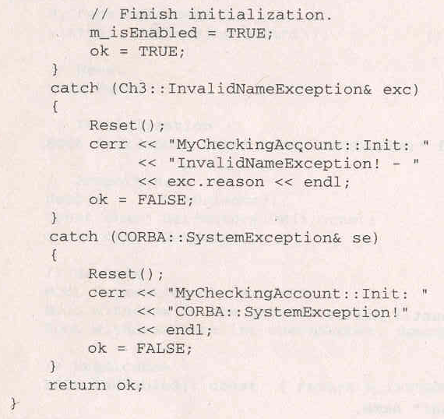

An object reference for the factory is created by calling the LocateFactory () method with factoryIOR passed as a parameter. The checking account instance is then created by calling the create() method on the factory. Finally , the m_account_init() method is called using the customer name passed in as a parameter to MYCheckingAccount::Init().

Creating a CORBA object in Java is even simpler than it is in C++ because the reference – counting issues do not convolute the solution

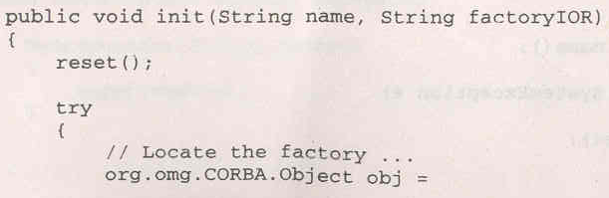
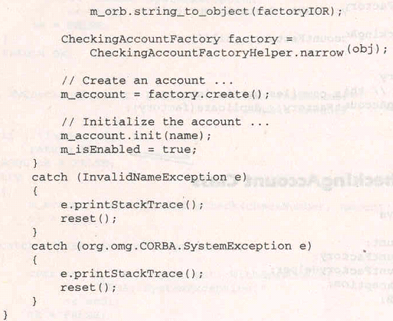

The MyCheckingAccount .init() method locates the factory by calling the String_to_Object() method on the ORB. Successful completion of String_to_object() method returns an object reference to the CORBA object instance uniquely identified by the factoryIOR parameter. The CORBA object reference is then narrowed to the CheckingAccountFactory object reference and returned to the caller. Next, the checking account instance is created by calling the create() method on the factory. Finally , the m_account.init() method is called using the customer name passed in as a parameter to MyCheckingAccount.init().

19)Explain in detail the basic architecture of X-Windows systems?
Explain the components of x-windows like x protocol,x display server,x clients and xlib routines and x tool kit.explain the layered architecture.

20)Give an account on

(a)X-windows programming
Explain the steps needed for writing x windows programming
(b) Client and server in X-windows
Explain client and server and its components in x-windows architecture.

