INTRODUCTION

Mobile computing means being able to use a computing device even when being mobile and therefore changing location. Work from a non-fixed location using portable computing/communications devices such as laptops, notebooks, palmtops, smart cell phones and PDAs. Portability is one aspect of mobile computing.

There are two different kinds of mobility.

- User mobility: It refers to a user who has access to the same or similar telecommunication services at different places, i.e. the user can be mobile, and the service will follow him or her. Example is simple call forwarding solutions known from the telephone or computer desktops supporting roaming.

- Device portability: The communication device moves (with or without user). Many mechanisms in the network and inside the device have to make sure that communication is still possible while device is moving. A typical example for system supporting device portability is mobile phone system, where the systems itself hands the device from one radio transmitter to the next if the signal becomes too weak.

Wireless is a way of accessing a network or other communication partners without wire. The wire is replaced by the transmission of electromagnet waves through the air.

A communication device can exhibit one of the following characteristic:

- Fixed and wired: This configuration describes the typical desktop computer in an office.

- Mobile and wired: Many of today’s laptops fall into this category.

- Fixed and wireless: This mode is used for installing networks, e.g., in historical buildings to avoid damage by installing wires.

- Mobile and wireless: No cable restricts the user who can roam between different wireless networks.

SHORT HISTORY

The use of light for wireless communication reaches back to the ancient times. In former times, the light was either ‘modulated’ using the mirrors to create a certain light on/light off pattern or for example, flags were used to signal code words. The use of smoke signals for communication is used in early as 150 BC.

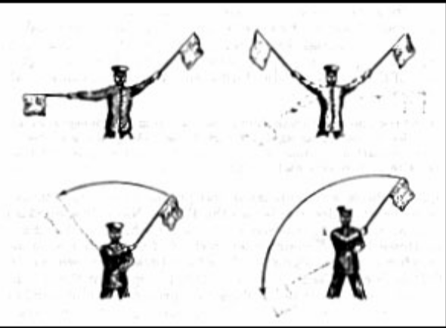

Here electromagnetic waves are of special importance. In 1831, Faraday demonstrates electromagnetic induction.

The name which is most closely connected with the success of wireless communication is Guglielmo Marconi (1874-1937). He gave the first demonstration of wireless telegraphy in 1895 using long waves transmission with very high transmission power (>200KW). The first transatlantic connection was set up. Huge base stations using up to thirty 100 m high antennas were needed on both sides of the Atlantic Ocean. The first communication radio station started in 1920. Sender and receiver still needed huge antennas and high transmission power. In 1920, Marconi discovered short waves. It was now possible to send short radio waves around the world bouncing at the ionosphere.

1958 “A-Netz” was discovered in Germany. It is analog, 160 MHz, connection setup only from the mobile station, no hand-over, 80% coverage, 1971 11000 customers

1972 “B-Netz” in Germany. It is Analog, 160 MHz, connection setup from the fixed network too (but location of the mobile station has to be known). Available also in A, NL and LUX, 1979 13000 customer.

In 1981, the northern European countries of Denmark, Finland, Norway, and Sweden agreed upon the Nordic Mobile Telephone (NMT) system. The NMT uses a 450 MHz carrier and is still the only available system for mobile communication in some remote places. NMT at 900 MHz followed in 1986. in accordance to general idea of a European Union, the European country decided to develop a pan-European mobile phone standard in 1982. The new system aimed to:

- Use a new spectrum at 900 MHz;
- Allow roaming throughout Europe;
- Be fully digital;
- Offer voice and data service.

The ‘Groupe Spe’ciale Mobile’ (GSM) was founded for this new development.

In 1983 the US system advanced mobile phone system (AMPS) started. AMPS are an analog mobile phone system working at 850 MHz. Telephones at home went wireless with CT-1 standard (Europe) for cordless telephones in 1984.

In 1986, “C-Netz” in Germany. It was analog voice transmission, 450 MHz, hand-over possible, digital signaling, automatic location of mobile device. It was in use until 2000, services: FAX, modem, X.25, e-mail, 98% coverage
In 1991 Specification of DECT: Digital European Cordless Telephone: Digital Enhanced Cordless Telecommunications)
- 1880-1900MHz
- ~100-500 m range,
- 120 duplex channels,
- 1.2 Mbit/s data transmission, voice encryption, authentication, up to several 10000 user/km2, used in more than 50 countries

In 1992 Start of GSM:
- In Germany as D1 and D2, fully digital, 900 MHz, 124 channels
- Automatic location, hand-over, cellular
- Roaming in Europe - now worldwide in more than 170 countries
- Services: data with 9.6 kbit/s, FAX, voice,

In 1994 “E-Netz” in Germany:

- GSM with 1800 MHz, smaller cells
- Operated as Eplus in D (1997 98% coverage of the population)
- 1996 HiperLAN (High Performance Radio Local Area Network):
- ETSI, standardization of type 1: 5.15 - 5.30 GHz, 23.5 Mbit/s

1997 Wireless LAN

IEEE802.11:
- IEEE standard, 2.4 - 2.5 GHz and infrared, 2 Mbit/s
- Already many (proprietary) products available in the beginning

IEEE standard 802.11b
- 2.4-2.5 GHz, 11 Mbit/s
- Bluetooth for piconets, 2.4 GHz, < 1 Mbit/s

Iridium:
- 66 satellites (+6 spare), 1.6 GHz to the mobile phone

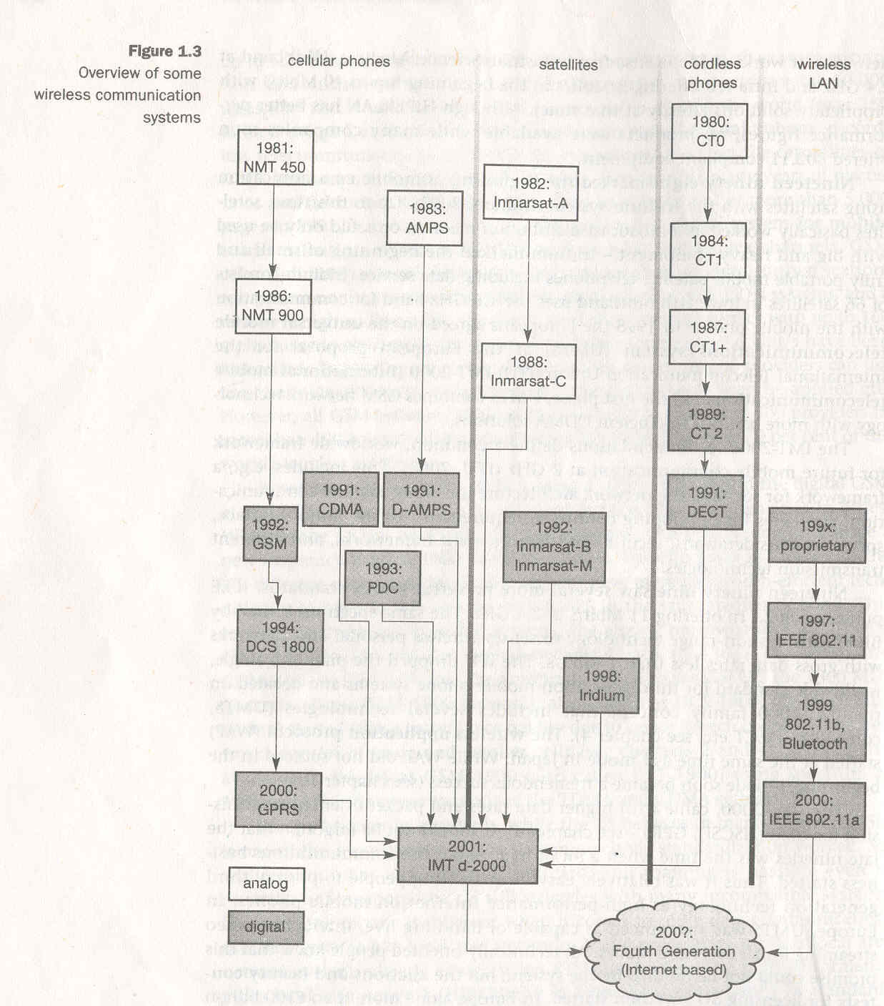

MOBILE TELEPHONE SYSTEM SIMPLEIFIED REFERENCE MODEL

Figure shows a personal digital assistant (PDA) which provides an example for a wireless and portable device. This PDA communicates with the base station. The base station consists of radio transceiver (sender and receiver) and an interworking unit connecting wireless link with the fixed link. The communication partner of the PDA is conventional computer.

Underneath each network element (such PDA, inter working unit, computer), figure shows the protocol stack implemented in the system according to reference model.
End systems such as PDA and computer in the example, need a full protocol stack comprising application layer, transport layer, network layer, data link layer and physical layer.

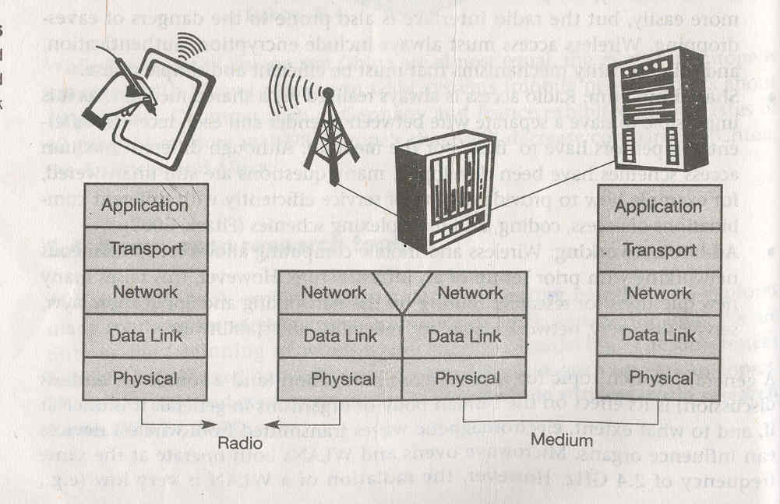

Application of the end system communicates with each other using low layer services. Intermediate systems such as interworking units; do not necessarily need all of the layers.
As only entities at the same level communicate with each other (i.e. transport with transport, network with network) the end system application do not notice the intermediate system directly in the scenario.

Functions of each layer

1. Physical layer: This is the lowest layer in the communication system and is responsible for the conversion of streams of bits into signals that can be transmitted on the centre side. The physical layer of the receiver then transforms the signal back into a bit stream. For wireless communication, physical layer is responsible for

A. Frequency selection.
B. Generation of carrier frequency.
C. Signal detection.
D. Modulation of data onto a carrier frequency.
E. Encryption.

2. Data link layer: The main task of this layer includes

A. Accessing the medium.
B. Multiplexing of different data streams.
C. Correction of transmission errors.
D. Synchronization.

Altogether, data link layer is responsible for a reliable point to point connection between two devices or a point to multipoint connection between one centre and several receivers.

3. Network layer: The third layer is responsible for
A. Rooting packets through a network.
B. Establishing a connection between two entities over many other intermediate systems.
C. Addressing device location handover between different networks.

4. Transport layer: This layer is used in reference model to

A. Establish end-to-end connection.
B. Flow and congestion control.
C. Quality of service.

5. Application Layer: Finally the applications (complemented by additional layers that can support application) are situated on top of all transmission-oriented-layers. It includes

A. Service location
B. Support for multimedia applications
C. Adaptive applications that can handle the large variations in the transmission characteristic
D. Wireless access to World Wide Web using portable device

MULTI CARRIER MODULATION

The method of transmitting data by splitting it into several components and sending each of these components over separate carrier signal is called multi carrier modulation. The individual carrier has narrow bandwidth. MCM splits the high bit rate stream into many lower bit rate streams, each stream being sent using an independent carrier frequency. If, for example, n symbols/s has to be transmitted, each sub carrier transmits n/c symbols/s with c being the number of sub carriers.

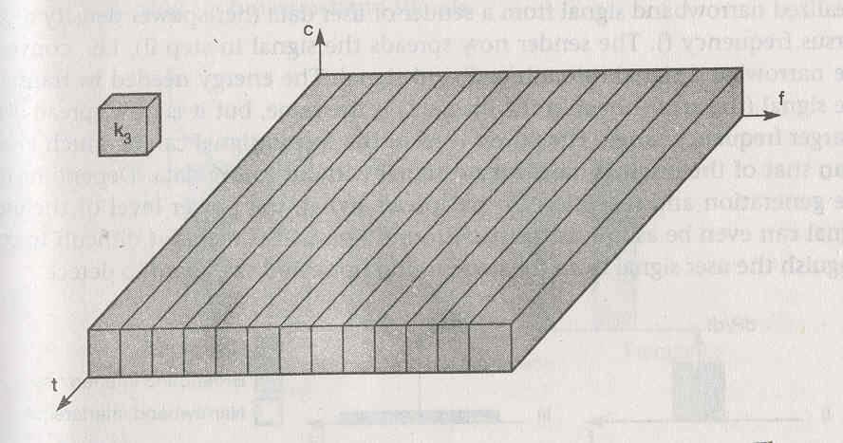

Need for MCM

- Data may be lost in 1 or 2 sub carriers, but we do not loose the whole stream.
- It provides ways to combat frequency selective channels.
- Another advantage is MCM has good ISI (Inter Symbol Interference) mitigation property.

ISI (Inter Symbol Interference)

Radio waves emitted by the sender can either travel along a straight line, or they may be reflected at a large building, or scattered at small obstacle. Due to finite speed of light, signals traveling along different paths with different lengths arrive at the receiver at different times. This effect (caused by multi path propagation) is called delay spread: the original signal is spread due to different delays of parts of the signal. This delay spread is a typical effect of radio transmission, because no wire guides the waves along the single path as in the case wired network.

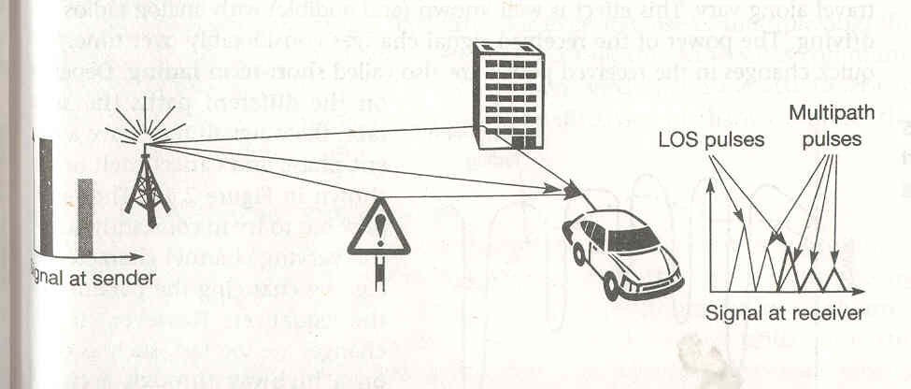

On the sender side, both impulses are separated. At the receiver, both impulses interfere, that is they overlap in time. Each impulse should represent a symbol and that one or several symbols could represent a bit. The energy intended for one symbol now spills over to the adjacent symbols, an effect which is called inter symbol interference (ISI). The higher the symbol rate to be transmitted, the worse the effects of ISI will be, as original symbols are moved closer and closer to each other. Due to interference, the signals of different symbols can cancel each other out leading to misinterpretations at the receiver and causing transmission errors.

CELLULAR SYSTEMS

Cellular systems for mobile communication implement SDM (Space division Multiplexing).Each transmitter, typically called a base station, covers a certain area, a cell. Cell radii can vary from tens of meters in buildings and hundreds of meters in cities, up to tens of kilometers in the country sides. The shapes of the cells are never perfect circles or hexagon but depends upon the

1. Environment (buildings, mountains, valleys, etc).
2. On weather conditions.
3. On system load.

Typical systems using this approach are mobile telecommunication system, where a mobile station within the cell around a base station communicates with this base station and vice versa.

Advantages of cellular system with small cells are the following

1. Higher capacity: Implementing SDM allows frequency reuse. If one transmitter is far away from another, i.e. outside the interference range, it can reuse the same frequency. As most mobile phones systems assign frequencies to certain users, this frequency is blocked for other users but frequency are a scarce resource and, number of concurrent users per cell is limited. Huge cells do not allow for more users. This is also the reason of using very small cells in cities where many more people use mobile phones.

2. Less transmission power: A receiver far away from base station would need much more transmission power than the current few Watts. But energy is a serious problem for mobile handheld devices

3. Local interference only: Having long distances between sender and receiver results in even more interference problem. With small sense mobile stations and base stations only have to deal with local interference.

4. Robustness: Cellular systems are decentralized and so, more robust against failure of single components. If one antenna fails, this only influences communication within a small area.

Small cells can have disadvantages

1. Infrastructure needed: Cellular systems need a complex infrastructure to connect all base stations.

2. Handover needed: Mobile station has to perform a handover when changing from one cell to another. Depending upon the cell size and speed of movement, this can happen quite often.

3. Frequency planning: To avoid interference between transmitters using the same frequencies, frequencies has to be distributed carefully.

Two possible models to create cell patterns with minimal interference are:

1. In figure 1, cells are combined in clusters – On the left side three cells form a cluster, on the right side seven cells form a cluster. All cells within a cluster use disjoined sets of frequencies.
On the left side, one cell in the cluster uses f1, another cell f2, third cell f3. In real-life transmission, the pattern will look somewhat different. The hexagonal pattern is chosen as simple way illustrating the model. This pattern also shows the repetition of same frequency set. The transmission power of centre has to limit to avoid interference with the next cell using the same frequencies.

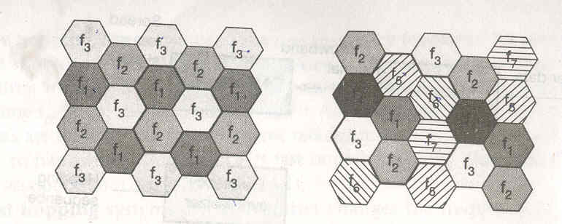

2. To reduce interference even further, sectorized antennas can be used. Figure shows the use of three sectors per cell in a cluster with three cells.

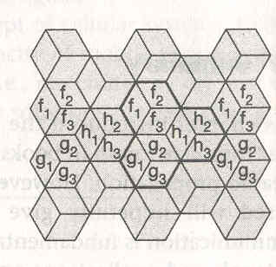

Channel allocation

Fixed and Borrowing channel allocation

The fixed assignment of frequencies to cell clusters and cells respectively, is called fixed channel allocation (FCA). It is not very efficient if load varies. For instance, in the case of a heavy load in one cell and light load in a neighboring cell, it could make sense to 'borrow' frequencies. Cells with more traffic are dynamically allotted more frequencies. This scheme is known as borrowing channel allocation (BCA).

FCA is used in the GSM systems as it is much simpler to use, but it requires careful traffic analysis before installation.

Dynamic channel allocation: In this scheme, frequencies can only be borrowed, but it is also possible to freely assign frequencies to cells. With dynamic assignment of frequencies to cells, the danger of interference with cells using the same frequencies exists. The borrowed frequency can be blocked in the surrounding cells.

Cellular system using CDM instead of FDM do not need such elaborate channel allocation schemes and complex frequency planning. Here users are separated through the code they use, not through the frequency. Cell planning faces another problem – cell size depends on the current load. Accordingly CDM cells are commonly said to ‘breathe’. While a cell can cover a large area under a light load, it shrinks if the load increases. The reason for this is the growing noise level if more users are in a cell. The higher the noise, the higher the path loss and higher the transmission errors. Finally, mobile stations further away from the base station drop out of the cell. Figure shows this phenomenon.

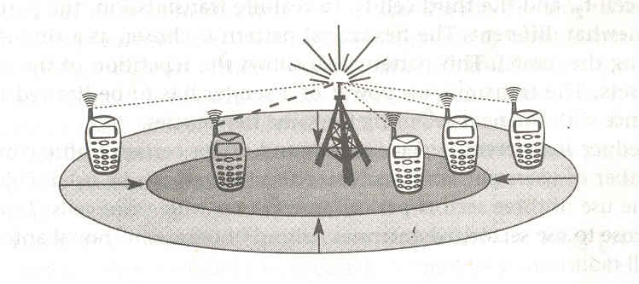

APPLICATIONS

1. Vehicles

- Transmission of news, road condition, weather, music via DAB ( Digital Audio Broadcasting).
- Personal communication using GSM.
- Position via GPS (Global Positioning System).
- Local ad-hoc network with vehicles close-by to prevent accidents, guidance
system, redundancy.
- Vehicle data (e.g., from busses, high-speed trains) can be transmitted in advance
for maintenance.

2. Emergencies

Suppose an ambulance has a high quality wireless connection to a hospital. Early transmission of patient data to the hospital, current status, first diagnosis and other vital information about injured persons can be send to the hospital from the scene of the accident. All necessary steps for this particular type accident can be prepared and specialist can be consulted for an early diagnosis. Wireless network is the only means of communication in the case of natural disasters such as hurricanes or earthquakes.

4. Business (Traveling salesmen)

A traveling salesman today needs direct access to customer files stored in a central location, to ensure that files on his or her laptop reflects the current situation, to enable the company to keep track of all activities of their traveling employee, to keep database consistent.

5. Replacement of wired networks

Wireless network can be used to replace wired network, e.g., remote sensors, for tradeshows, or in historic buildings. Due to economic reasons, it is often impossible to wire remote sensors for weather forecasting, earthquake detection, or to provide environment information. Wireless connections via satellites can help in this situation.

6. Infotainment and more

  - Outdoor Internet access.
  - Intelligent travel guide with up-to-date location dependent information.
  - Ad-hoc networks for multi user games.

7. Location dependent services

