Module-I

Here we learn about the object oriented approach to software development based on modeling objects from the real world and using the model to build a language independent design organized around those objects.

Object oriented modeling is based on
-certain object oriented concepts
-a language independent graphical notation

Object Oriented Methodology is a methodology for object oriented development and a graphical notation for representing objects oriented concepts.

The methodology has the following stages:
- Analysis :An analysis model is a precise abstraction of what the desired system must do, not how it will be done including the implementation details. The objects in the model should be application domain concepts and not the computer implementation concepts.

- Design:
(i)System design - The designer makes high level decisions about the overall architecture. In system design, the target system is organized as various subsystems based on both the analysis structure and the proposed architecture.
(ii) Object design - The designer builds a design model based on the analysis model but containing implementation details. The focus of object design is the data structures and algorithms needed to implement each cycle.
- Implementation :
The object classes and relationships developed during object design are finally translated into a particular programming language, database, or hardware implementation. During implementation, it is important to follow good software engineering practice so that the system can remain the traceability, flexibility and extensibility.
The OMT methodology uses three kinds of models
  - Object Model-describes the static structure of the objects in a system and their relationships. This model mainly contains object diagrams.
  - Dynamic Model-describes the aspects of a system that change over time. This model mainly contains state diagrams.
  - Functional Model-describes the data value transformations within a system. This model contains the data flow diagrams

(v) Object Oriented Themes:
There are several themes in an object oriented technology. These themes are not unique to object oriented systems. We can see some important themes:
  - Abstraction-Abstraction consists of focusing on the essential, inherent aspects of an entity and ignoring its accidental properties. In system development, it focuses only on what an object is and does, before deciding how it should be implemented.
  - Encapsulation- It can also be called as information hiding. It consists of separating the external aspects of an object, which are accessible to other objects, from the internal implementation details of the object, which are hidden from other objects. It is not unique to object oriented languages.
  - Combining Data and Behavior-The caller of an operation need not consider how many implementations of a given operation exist. Operator polymorphism shifts the burden of deciding what implementation to use from the calling code to the class hierarchy. As an example, let us talk about an object oriented program calling a draw procedure for drawing different figures say a polygon, circle, or text. The decision of which procedure to use is made by each object, based on its class.
  - Sharing- Inheritance of both data structure and behavior allows a common structure and behavior allows common structure to be shared among several similar subclasses without redundancy. The sharing of code using inheritance is one of the main advantages of object oriented languages.

Object Modeling: A model is an abstraction of something for the purpose of understanding it before building it. It is easier to manipulate than the original entity.
An object model captures the static structure of a system, relationships between the objects, and the attributes and operations that characterize each class of objects. This model is the most important one. Some basic concepts covered in object modeling:
(a) Objects: We can define an object as a concept or a abstraction. All objects have identity that is distinguishable.
(b) Classes: An ‘object class’ or ‘class’ describes a group of objects with similar properties, common behavior, common relationships to other objects, and common semantics.
(c)Object Diagrams: They provide a formal graphic notation for modeling objects, classes and their relationships to one another.

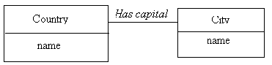

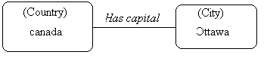

Fig.2.1 Classes and Objects

  - Class Diagram: It is a schema, pattern or template for describing many possible instances of data.
  - An Instance Diagram describes how a particular set of objects relate to each other. An instance diagram describes object instances.
Eg:Joe,Johny are instances of class Person.
(d)Attributes: An attribute is a data value held by objects in a class.
Attributes are listed in the second part of the class box. So in the above example,
Age.name are attributes of class Person

Operations and methods: An operation is a function or transformation that may be applied to or by objects in a class. Operations are listed in the lower third of the class box.
  - Each attribute name may be followed by optional details, list of attributes and list of operations.

(f)Links and associations: They are used for establishing relationships among objects and classes.
Link- A link is a physical or conceptual connection between object instances .We can say that a link is an instance of an association.
Eg: - Joe works for Infosys
Association –Describes a group of links with common structure and common semantics’:- A person works for a company.
They are inherently bidirectional. It means that a binary association can be traversed in both directions. They are implemented as pointers.
The below figure shows a 1-1 association and corresponding links.

  - Multiplicity –specifies how many instances of one class may relate to each instance of another class. The solid balls,”2+” are multiplicity symbols. Associations may be binary, ternary or higher order.
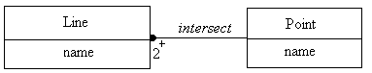

Advanced Link and Association Concepts

Link attributes:

- An attribute is a property of the objects in a class.

- a link attribute is a property of the links in an association

- Eg: access permission is an attribute of the link accessible by for the class File to the class User.
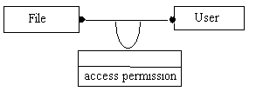

Role names:
- A role-is an end of an association
- A binary association has two roles
- a role name identifies one end of an association
- helps in traversing association from an object at one end, without explicitly mentioning the association name.
- Eg: Person and Company participate in association Works for .

- A person assumes the role of the employee with respect to a company and company –the role of the employer.

Ordering:

- The objects on the “many” side of an association have no explicit order and can be regarded as a set.
- Eg:
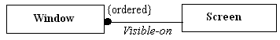

- The windows are explicitly ordered,so only the top most is visible at any point of time.
- -an ordered set of objects on the “many” end of an association is indicated by writing
- “{ordered}” next to multiplicity dot for the role

Qualification:

- Qualifier is a special attribute that reduces the effective multiplicity of an association.
- Eg:A file may only belong to a single directory and qualifier specifies the files that are found in a directory

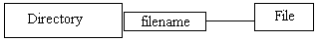

- Here Directory and File are object classes and file name is the qualifier
- Qualification improves semantic accuracy and increases the visibility of navigation paths.

Aggregation:
- is a part –of relationship in which objects representing the components of something are associated with the object representing the entire assembly
- is a tightly coupled form of association with some extra semantics
- most significant property of aggregation is transitivity that is a is a part of B ,B is a part of C then C is a part of A.
- is anti symmetric in nature ie. A is a part of B, then B is not part of A.
- aggregation is drawn like association except a small diamond that indicates the assembly end of the relationships
- eg:

A document consists of many paragraphs, each of which consists of many sentences.

Generalization and Inheritance:

  - Generalization is the relationship between a class and one or more refined versions of it. The class being refined is called the ‘superclass’ and each refined version are called a ‘subclass’. For example, Equipment is the superclass of Pump and tank. Attributes and operations that are common to a group of subclasses are attached to the superclass and shared by each subclass. Generalization is sometimes called a ‘is-a’ relationship. Each instance of a subclass is an instance of the superclass. The notation for generalization is a triangle connecting a superclass to subclass. 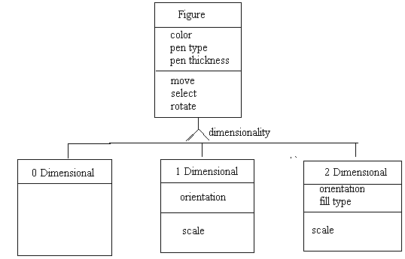
Fig. 3.1 An inheritance hierarchy

Overriding Features:
I think you are all familiar with this term. A subclass may override a superclass feature by defining a feature with the same name. Here you can see that the subclass feature refines and replaces the superclass feature. What is the need for this feature? The reasons are many
- to specify behavior that depends on the subclass
- to tighten the specification of a feature.
- better performance

(ii) Grouping Constructs:
a) Module- A module is a logical construct for grouping classes, associations, and generalizations. It captures one view of a situation.
For example: Let us say, electrical, plumbing, etc. are different views of a building.
An object model consists of one or more modules. Class names and association names must be unique within a module. Module names are usually listed at the top of each sheet. The same class may be referenced in many modules.

b) Sheet- A sheet is a mechanism for breaking a large object model down into a series of pages. A sheet is a single printed page. Each module consists of one or more sheets.

Each sheet has a title and a name or number. Each association/generalization appears on a single sheet. Classes may appear on multiple sheets.

(iii) Sample Model: For the sample model you please look through the text book. It shows an object model of a workstation window management system.

Advanced Object Modeling:

Aggregation versus Association:

Aggregation | Association
is a special form of association
If two objects are tightly bound by a part –whole relationship, it is aggregation | If the two objects are independent even if they are linked, it is an association
A company is an aggregation of its division, which are in turn aggregation of their departments | A company is not an aggregation of its employees further they are linked by assosiation

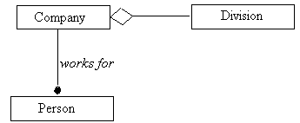
Aggregation versus Generalization:

Aggregation | Generalization
Aggregation tree is composed of object instances that are all part of a components objects | A Generalization tree is composed of classes that describe an object
Aggregation is often called “a-part-of” relationship | Generalization is often called “a kind-of” or “is –a” relationship

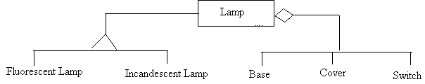

Recursive Aggregates:
- Aggregation can be fixed ,variable or recursive.
- Fixed aggregate: has a fixed structure. The number and types of subparts are predefined.
- Variable aggregate: has a finite number of levels, but the number of parts may vary.
- Eg:The company is a variable aggregate with a two-level tree structure.There can be many divisions per company.
- Recursive Aggregate:
- -contains unlimited number of potential levels
- -nested to the arbitrary depth

- Eg:
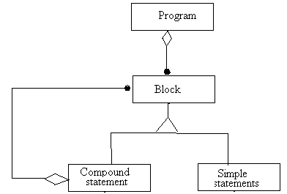

Propagation of Operation:
- Propagation of Operations-Propagation (also called triggering) is the automatic application of an operation to a network of objects when the operation is applied to some starting object.
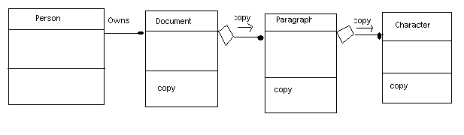
Propogation of Operation copy.

- Here, let us say a person owns multiple documents .Each document is composed of paragraphs that are in turn composed of characters. The copy operation propagates from documents to paragraphs to characters
- It does not propagate in the reverse direction. The propagation is indicated with a small arrow and operation name next to the affected association.

Abstract Classes-
- An abstract class is a class that has no direct instances but whose descendent classes have direct instances.
- A concrete class is a class that is an instantiable; that is, it can have direct instances.
- A concrete class may be leaf classes in the inheritance tree; only concrete classes may be leaf classes in the inheritance tree
- Abstract classes organize features common to several classes
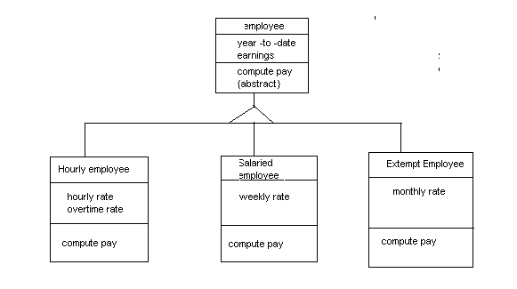
- Here the concrete classes are Hourly employee,Salaried employee,extempt employee
- Employee is the abstract class.

Generalization as Extension and Restriction:
- In generalization, an instance of a class is an instance of a class is an instance of all ancestors of the class
- A subclass may add new features with the inherited features of superclass
- Eg: Employee with three subclasses that inherit all employee features and add new features of their own
- A subclass may also have ancestor attributes that acts as a constraint since it restricts the values that instances can assume.This is called restriction.
- Eg: A Circle can be a subclass of ellipse with its major and minor axis equal. So here inheritances acts as a restriction for the class Circle.
- Arbitary changes to the attribute values of a restricted subclass may cause it to violate the constraints
- The inherited features can be renamed in a restriction.

Overriding Operations:
Sometimes the overriding method varies from overridden method .In such case the main reasons behind overriding have to be found. Some of the reasons for overriding are:
- Overriding for Extension: For example, suppose say you have a Window superclass and a Window Labeled subclass. Now this superclass has draw() operations that is used to draw the Window boundary and contents. The subclass also have the same method draw().The method draw-Labeled Window could be invoked by invoking the method to draw a Window.

- Overriding for Restriction: This is quite necessary when you have to keep the inherited operations closed within the subclass. For example, the suprclass Set may have the operation add(object).the subclass IntegerSet would then have the more restrictive operation add(integer).
- Overriding for optimization:An implementation can take advantage of the constraints imposed by a restriction to improve the code of the operation.For eg: superclass IntegerSet could have an operation to find the maximum integer. The method for finding the maximum of an IntergerSet can be implemented by sequential search. The subclass Sorted Integer Set could provide a more efficient implementation of the maximum operation, since the contents of the set are already sorted.

Multiple Inheritances:
Multiple inheritance permits a class to have more than one superclass and to inherit features from all parents.
- A class with more than one superclass is called a join class.
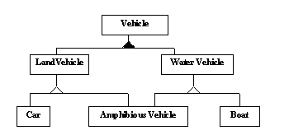
Fig. Multiple inheritance from disjoint classes
- Here in the above example, Amphibious Vehicle is a join class.
- A hollow triangle indicates disjoint subclasses.
- A solid triangle indicates overlapping subclasses.

Accidental Multiple Inheritance:

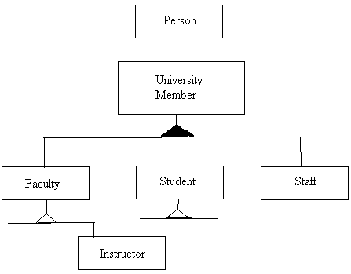
Here an instructor is inherently both a faculty and a student. This is an example of multiple inheritances but there can occur multiple inheritances accidentally. For example John is a Person who takes in Michigan University within that he is a visiting professor for Harvard University .So here one instance happens to participate in two overlapping classes. This can be avoided by replacing inheritance with aggregation as the delegation. Delegation is an implementation mechanism by which an operation is forwarded by one object to the other. Here aggregation is forwarded by University member class to the class Person. So the figure becomes.
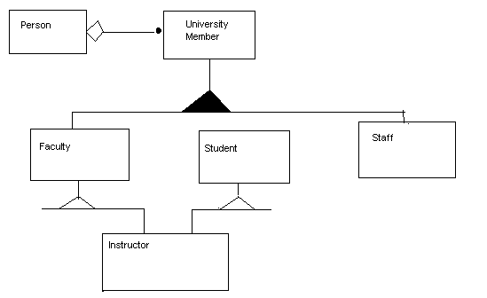

Here we avoid multiple inheritance with delegation.
Delegation:
- is referred as an implementation mechanism by which objects forwards an operation to another object for execution.
- -Here delegation is done using aggregation of roles.
- More workarounds can be performed for avoiding multiple inheritance.They are:
Inherit the most important class and delegate the rest:
- Here a join class is made a subclass of its most important super class.
- The join class is treated as the aggregation of the remaining superclasses and their operations.
Another alternative is Nested Generalization
- Factor on one generalization first and then the other.

Constraints:
Constraints are functional relationships between entities of an object model.
The term entity includes objects, classes ,attributes, links and associations.
A constraint restricts the values that entities can assume
Simple constraints may be placed in object models.
Complex constraints should be specified in the function model
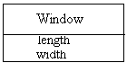
0.8<=length/width<=1.5
Constraints provide one criterion for measuring the quality of an object model.
A good object model captures many constraints through its structures.
Constraints are delimited by braces and positioned near the constrained entity.
A dotted line connects multiple constrained entities.
An arrow may be used to connect a constrained entity to the entity it depends on.

Constraints on Links:
Multiplicity constraints an association. It restricts the number of objects related to a given object.

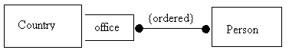
The notation “{ordered}” indicates that the elements of the “many” end of an association have an explicit order that must be preserved.

General Constraints:
Must be expressed with natural language or equations.
A dotted line between classes involved in the constraint with details specified as comment with braces.
One association may be a subset of another.
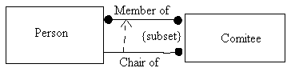

The chair-of a committee must be a member of the committee; the chair-of association is a subset of the member-of association.

Meta Data(will be updated later)

