MOBILE SERVICES

GSM permits the integration of different voice and data services and the interworking with the existing network. GSM is defined for three different categories of services: bearer, tele, supplementary services. Figure shows the reference model for GSM services. A mobile station (MS) is connected to the GSM public land mobile network (PLMN) via U_{m} interface. GSM-PLMN is the infrastructure needed for GSM network. This network is connected to transit network, e.g., integrated service digital network (ISDN), or traditional public switched telephone network (PSTN). There might be additional network, the source/destination network, before another terminal TE is connected.
Bearer service comprises all services that enable transparent transmission of data between the interfaces to the network. Interfaces like U, S, and R in case of ISDN have not been defined for all networks, so it depends on the specific network which interface is used as a reference for transparent transmission of data. In classical GSM model, bearer services are connection oriented and circuit -or packet- switched. These services only need the lower three layers of the ISO/ISI reference model.

Within the mobile station MS, mobile termination (MT) performs all network specific tasks (TDMA, FDMA, coding etc) and offers an interface for data transmission(S) to the terminal TE which can then be network independent. Tele services are application specific and may thus need all seven layers of ISO/OSI reference model. These services are specific end to end i.e., from one terminal TE to another.

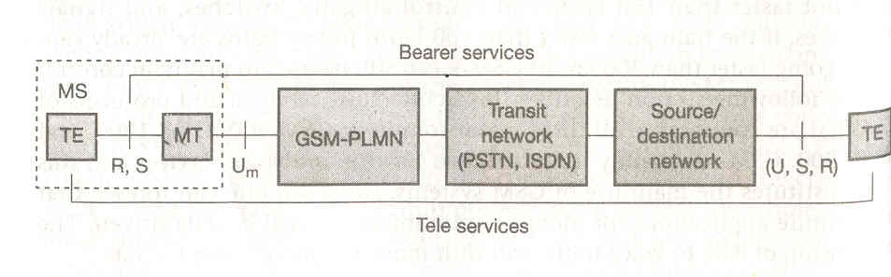

Bearer services

GSM specifies different mechanisms for data transmission, the original GSM allowing data rates up to 9600 bit/s for non-voice services. Bearer services permit transparent and non-transparent, synchronous or asynchronous data transmission. Transparent bearer services only use the functions of the physical layer to transmit data. Data transmission has a constant delay and throughput if no transmission errors occur. The only mechanism to increase transmission quality is the use of forward error correction (FEC), which codes redundancy into the data stream and helps to reconstruct the original data in the case of transmission errors.
Non-transparent bearer services use protocols of layers tow and three to implement error correction and flow control. These services use the transparent bearer services, adding a radio link protocol (RLP). This protocol comprises mechanisms of high-level data link control (HDLC) and special selective mechanisms to trigger transmission of erroneous data.
Data transmission can be full duplex, synchronous with data rate of 1.2, 2.4, 4.8, 9.6 kbits/s or full duplex, asynchrous from 300 to 9600 bits/s.

Tele services

GSM mainly focuses in voice-oriented tele services. These comprise encrypted voice transmission, message services and basic data communication with terminals as known from the PSTN or ISDN. As the main service is telephony, the primary goal of GSM was the provision of high quality digital voice transmission, offering at least a typical bandwidth of 3.1 kHz of analog phone systems.
Another service offered by GSM is emergency number. This service is mandatory for all providers and free of charge. This connection also has the highest priority, possibly preempting other connections.
A useful service for very simple message transfer is the short message service (SMS), which offers transmission of messages up to 160 characters.
The successor of SMS, the enhances message service (EMS) offers a larger message size up to 760 characters, formatted text and transmission of animated pictures, small images and ring tones in a standardized way.
Multimedia message service was available. It offers the transmission of large pictures (gif, jpg), short video clips and comes mobile phone that integrates small cameras.

Supplementary services

- user identification
- call redirection
- forwarding of ongoing calls
- closed user groups
- multi party communication

SYSTEM ARCHITECTURE

A GSM system consist of three subsystem,

1. Radio Subsystem (RSS).
2. Network and switching subsystem (NSS).
3. Operation subsystem.
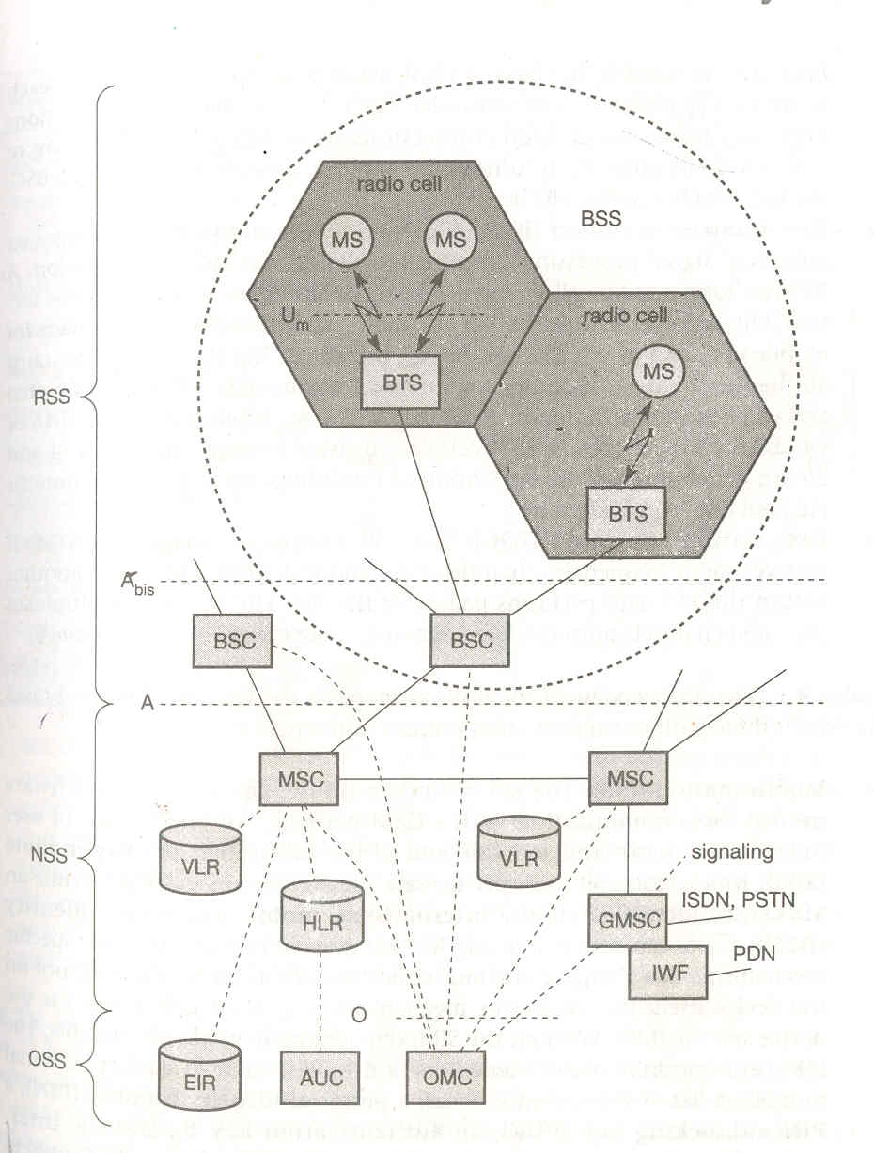

Radio subsystem

RSS comprises all radio specific entities, i.e., the mobile station (MS) and the base station subsystem (BSS). The connection between RSS and NSS is via the A interface and connection to OSS via the O interface. The A interface is typically based on the circuit switched PCM 30 systems (2.048 Mbit/s), carrying up to 30 64 Kbit/s connections, whereas the O interface uses the Signaling system No.7 (ss7) based on X.25 carrying management data to/from the RSS.

- Base station subsystem (BSS)

A GSM network comprises of many BSSs, each controlled by a base station controller (BSC). The BSS performs all functions necessary to maintain radio connection to a MS, coding/decoding of voice, and rate adaptation to/from the wireless network part.

- Base transceiver station(BTS)

A BTS comprises of all radio equipment that is antennas, signal processing, amplifiers necessary for radio transmission. A BTS can form a radio cell or, using sectorized antenna several cells and is connected to MS via U_{m} interface and to the BSC via the A_{bis} interface. U_{m} interface contains all mechanism necessary for wireless transmission. A_{bis} interface consists of 16 or 64 Kbit/s connections.

- Base station controller (BSC)

The BSC basically manages the BTSs. It reserves radio frequency, handles the handover from one BTS to another within the BSSs, and performs paging of MS.
The BSC also multiplexes the radio channels onto the fixed network connection at the A interface.

- Mobile station (MS)

The MS comprises of all user equipments and software needed for communication with a GSM network. An MS consists of user independent hard- and software and of the subscriber’s identity module (SIM) which stores all user specific data that is relevant to GSM. While a MS can be identified via international mobile equipment identity (IMEI), a user can personalize any MS using his or her SIM. The SIM card contains identifiers and table such as card type, serial number, list of subscriber’s services, personal identity number (PIN), PIN unblocking key (PUK), authentication key and IMSI (international mobile subscribers identity). The PIN is used to unlock the MS. Using the wrong PIN three times, will lock the SIM. In such cases PUK is needed to unlock the SIM. Typical MS for GSM 900 have a transit power of up to 2 W whereas for GSM 1800 1 W is enough due to smaller cell size.

Network and switching subsystem (NSS)

The heart of the GSM is formed by NSS. The NSS connects the wireless network standard public network, performs handover between different BSSs, comprises the functions for world wide localization of users and supports charging, accounting, roaming of users between providers in different countries.

- Mobile services switching centre (MSC)

MSC is high performance digital ISDN switches. They set up connections to other MSCs and to the BSCs via the A interface and form the fixed backbone network of a GSM system. It manages several BSCs in a geographical region. A gateway MSC (GMSC) has additional connections to other fixed networks such as PSTN, ISDN. Using additional interworking functions (IWF), an MSC can also connect to public data network (PDN) such as X.25. An MSC handles all signaling needed for connection setup, connection release and handover of connections to other MSC. This standard signaling system No.7 (SS7) is used for this purpose.SS7 covers all aspects of control signaling for digital network. Features of SS7 are number portability, free phone/toll/collect/credit calls, call forwarding, three way calling etc. An MSC also performs all functions needed for supplementary services such as call forwarding etc.

- Home location register (HLR)

HLR is the most important database in a GSM system as it stores all user relevant information. This comprises of static information such as mobile subscriber ISDN number (MSISDN), subscribed services, IMSI. Dynamic information is also needed such as current location area LA of the MS, mobile subscribers roaming number (MSRN), current VLR and MSC.

- Visitor location register (VLR)

The VLR associated to each MSC is a dynamic database which stores all important information needed for the MS users currently in the LA i.e. associated to the MSC (e.g. IMSI, MSIDN, HLR address). If a new MS comes into an LA the VLR is responsible for, it copies all relevant information for those users from the HLR. Some VLRs in existence are capable of managing up to 1 million customers.

Operation subsystem (OSS)

The 3rd part of GSM system, the OSS contains the necessary functions for network operations and maintenance

- Operation and maintenance center (OMC)

The OMC monitors and controls all other network entity via the O interface. Typical OMC management functions are traffic monitoring, status reports of network entity, subscriber and security management and accounting and billing.

- Authentication center (AuC)

As the radio interface and mobile stations are particularly vulnerable, separate AuC has been defined to protect user identity and data transmission. AuC contain the algorithm for authentication as well as keys for encryption and generates a values needed for user authentication in the HLR.

- Equipment identity register (EIR)

EIR is database for all IMEIs i.e. it stores all device identification registered for this network. The EIR has a black list of stolen or locked devices. It also contains a list of valid IMEIs (white list) and list of malfunctioning devices (gray list)

PROTOCOLS

Layer1, the physical layer handles all radio specific functions. This includes the creation of burst according to 5 different formats. Data is transmitted in small portions called burst.
- Normal burst is used for data transmission inside a time slots (user and signaling data).
- Frequency correction burst allows the MS to correct the local oscillator to avoid interference with neighboring channels.
- Synchronizing burst with an extended training sequence synchronizes the MS with the BTS in time.
- Access burst is used for initial connection setup between MS and BTS.
- Dummy burst is used if no data is available for a slot.

Another functionality includes multiplexing of bursts into TDMA frame, synchronization with the BTS, detection of idle channels, and measurement of channel quality on the downlink. Synchronization also includes the correction of the individual path delay between an MS and the BTS. All MSs within a cell use the same BTS and thus must be synchronized to this BTS.
The main task of the physical layer comprises channel coding and error detection/detection, which is directly combined with the coding mechanism. Channel coding makes extensive use of different forward error correction (FEC) schemes. FEC adds redundancy to user data, allowing for the detection and correction of selected error. The GSM physical layer tries to correct errors, but it does not deliver erroneous data to the higher layer. As voice was assumed to be main service in GSM, the physical layer also contain special functions such as voice activity detection (VAD), which transmits voice data only when there is a voice signal. This mechanism helps to decrease interference as the channel might silent approximately 60% of the time (under the assumption that only one person speaks at a time and some extra time is needed to switch between speakers). During period of silence (if the user needs time to think before talking), the physical layer generates a comfort noise to fake a connection (complete silence would probably confuse a user), but no actual transmission takes places.

Data transmission at the physical layer typically uses pulse code modulation system (PCM). While PCM system offers transparent 64 Kbit\s channels, GSM also allows for the sub multiplexing of 4 16 Kbit\s channel into a single 64 Kbit\s channel.

Signaling between entities in a GSM network requires higher layer. For this purpose, the LAPD_{m} protocol has been defined at the U_{m} interface for layer 2. LAPD_{m} protocol has been derived from link access procedure for the D channel (LAPD) in ISDN systems which is a version of HDLC. LAPD_{m} is a light weight LAPD because it does not need synchronization flags or check summing for error detection. LAPD_{m} offers reliable data transfer over connections, re sequencing of data frames, and flow control.

The network layer in GSM, layer 3 comprises several sub layers.

The lowest sub layer is the radio resource management (RR). Only a part of this layer RR’, is implemented in the BTS and remaining is situated in the BSC. The functions of RR’ are supported by the BSC via BTS management (BTSM). The main tasks of RR are setup, maintenance and release of radio channels. RR also access physical layer for radio information and offers reliable connection to the next higher layer.

Mobility management (MM) contains the functions for registration, authentication, identification, location updating and provision of a temporary mobile subscriber’s identity (TMSI) that replaces international mobile subscriber identity (IMSI) which hides the real identity of an MS user over the air interface. While IMSI identifies a user, the TMSI is valid only in the current location area of a VLR.

The call management (CM) layer contains three entities:
- Call control (CC): CC provide a point to point connection between two terminals and is used by higher layers for call establishment, call clearing and change of call parameters.
- Short message service( SMS):
- Supplementary service

SS7 (signaling system No.7) is used for signaling between an MSC and BSC. This protocol also transfers all management information between MSCs HLRs, VLRs, AuC, EIR and OMC.
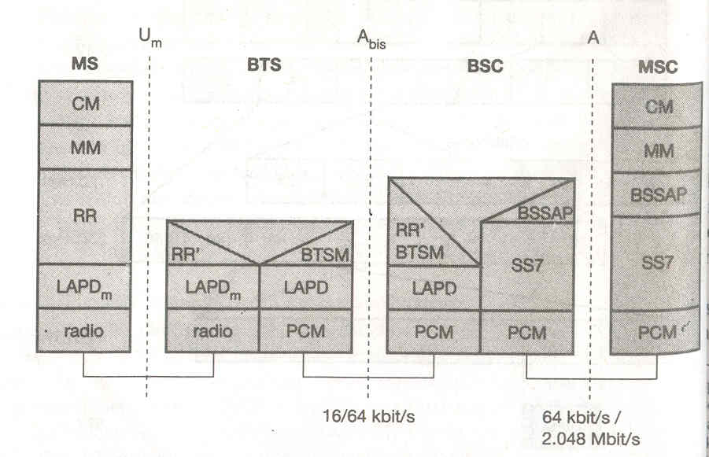

DECT (Digital enhanced cordless telecommunications)

DECT systems formally also called digital European cordless telephone and digital European cordless telecommunication. DECT replaces older analog cordless phone systems such as CT1 and CT1+. This analog system only ensured security to a limited extent as they did not use encryption for data transmission and only offered a relatively lower capacity. DECT is mainly used in offices, on campus, at trade shows or at home. A

A big difference between DECT and GSM exist in terms of cell diameter and cell capacity. While GSM is designed for outdoor use with a cell diameter of 70 km, the range of DECT is limited about 300 m from the base station. Due to this limited range and additional multiplexing techniques DECT can offers its service to some 10,000 people within 1 km. DECT can handle handover, but it was not designed to work at a higher speed ( e.g. up to 250 km\hr like GSM).

SYSTEM ARCHITECTURE

A global network connects a local communication structure to the outside world and offers its service via interface D1. Global network could be integrated services digital network (ISDN), public switched telephone network (PSTN), public land mobile network (PLMN), e.g. GSM, or packet switched public data network (PSPDN). Services offered by these networks include transportation of data and translation of address and routing of between local networks.

Local network in the DECT network offers local telecommunication services that can include everything from simple switching to intelligent call forwarding, address translation etc. example for such network are analog or digital private branch exchange.

As the core of the DECT system itself is quite simple, all typical network functions have to be integrated in the local or global network, where the databases home database (HDB) and visitors database (VDB) are also located. Both databases support mobility with functions that are similar to those in the HLR and VLR in the GSM system. Incoming calls are automatically forwarded to the current subsystem responsible for the DECT user, and the current VDB informs the HDB about the changes in location.

The DECT core network consists of fixed radio termination (FT) and the portable radio termination (PT), and basically provides a multiplexing service. FT and PT cover layers 1 to 3 at the fixed network side and mobile network side respectively. Additionally several portable applications (PA) can be implemented on the device.

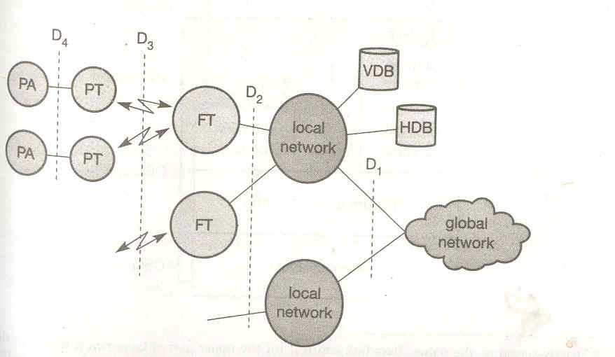

PROTOCOL ARCHITECTURE

The DECT protocol reference architecture follows OSI reference model.

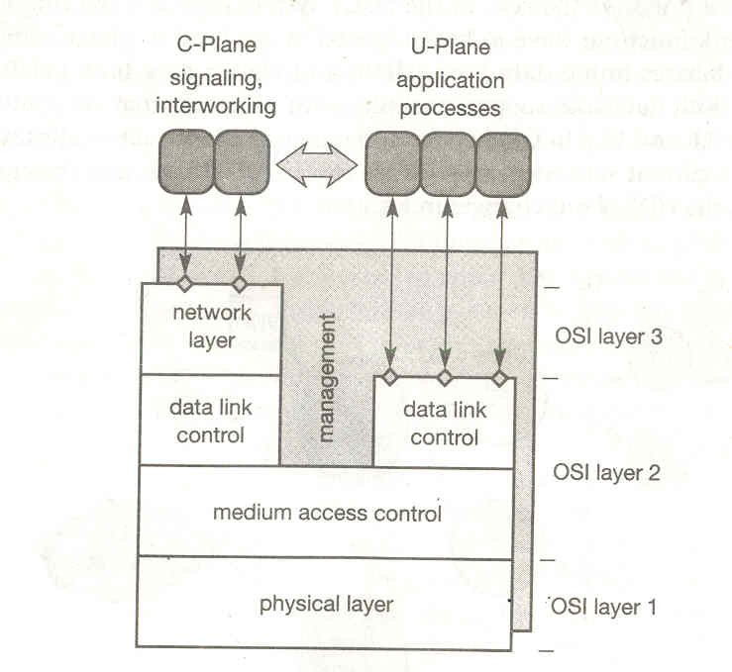
Physical Layer

As in all wireless networks, the physical layer comprises all functions for modulation/demodulations, incoming signal detection, sender/ receiver synchronization, and collection of status information for the management plane. This layer generates the physical channel structure with a certain guaranteed throughput. On request from MAC layer, the physical layer assigns a channel for data transmission.

Figure shows the standard TDMA frame structure used in DECT and some typical data packet. Each frame has duration of 10 ms and contains 12 slots for downlink and 12 slots for uplink in the basic connection mode. If a mobile node receives data in slot s, it returns data in slot s+12. An advanced connection mode allows different allocation schemes. Each slot has duration of 0.4167ms and can contain several different physical packets. Typically, 420 bits are used for data; the remaining 52 microseconds are left as guard space. The 420 data bits are again divided into a 32 bit synchronization pattern followed by the data field D.

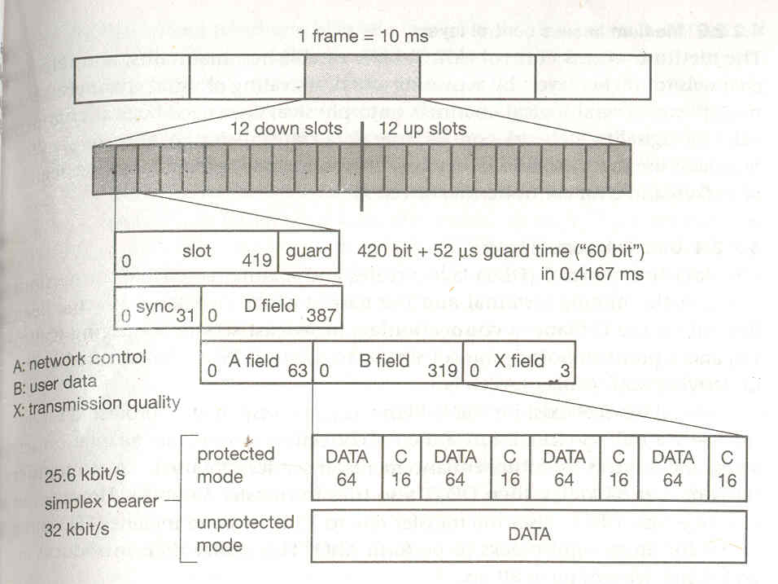

The fields for data transmission now use these remaining 388 bits for network control (A field), user data (B field) and the transfer of transmission quality(X field). While network control is transmitted with a data rate of 6.4 Kbit per sec, the user data rate depends on additional error correction mechanisms. The simplex bearer provides a data rate of 32 Kbit/sec, in an unprotected mode, while using a 16 bit CRC checksum C for a data block of 64 bit in the protected mode reduces the data rate to 25.6 kilo bit /sec.

Medium access control layer (MAC)

The MAC layer establishes, maintains, and releases channels for higher layers by activating and deactivating physical channels. MAC multiplexes several logical channels onto physical channels. Logical channels exist for signaling network control, user data transmission, paging or sending broadcast messages. Additional services offered include segmentation/reassembly of packets and error control/error correction.

Data link control layer (DLC)

The DLC layer creates and maintains reliable connections between the mobile terminal and the base station. Two services have been defined for C plane: connectionless broadcast service for paging (called Lb) and point to point protocol similar to LAPD in ISDN.
Several services exist for the U plane, example, a transparent unprotected service, a forward error correction service, rate adaptation service and service for future and enhancement.

Network layer

The network of the DECT is similar to those in ISDN and GSM and only exists for the C plane. This layer provides services to request, check, reserve, control, and release resources and fixed station and the mobile terminal. The mobility management (MM) within the network layer is responsible for identity management, authentication, and the management of location data bases. Call control (CC) handles connection setup, release, and negotiation. Two message services, the connection oriented message service (COMS) and the connectionless message service (CLMS), transfer data to and from the interworking unit that connects the DECT system with the outside world.

BROADCASTING SYSTEMS

Unidirectional distribution system or broadcasting systems are an extreme version of asymmetric communication system. Symmetrical communication system offer the same transmission capabilities in both communication directions, i.e., the channel characteristic from A to B are same as from B to A (e.g., bandwidth, delay, cost).
Examples of symmetrical communication service are the plain old telephone service (POTS) or GSM, if end to end communication is considered. In this case it does not matter, if one mobile station calls the other or the other way round, bandwidth and delay are the same in both scenarios.

Consider a typical client/server environment. Typically the client needs much more data from the server than the server needs from the client. Today’s pagers and radio work completely one way. These devices can only receive information and the user needs additional communication technologies to send any information back to e.g. radio station. This is the example of asymmetrical communication system.
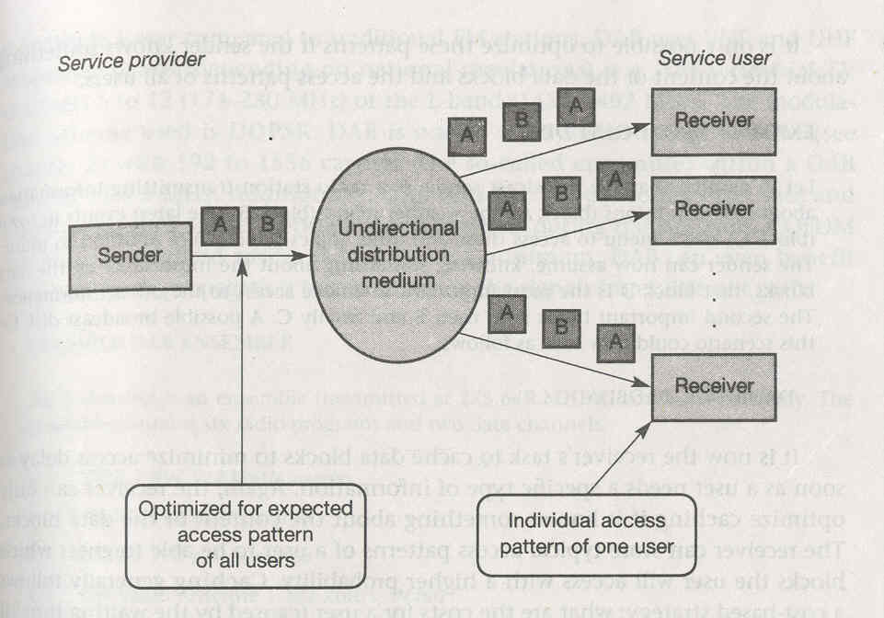
A special case of asymmetrical communication systems are unidirectional broadcast system where typically a high bandwidth data stream exist from one sender to many receivers. The problem arising from this is that the sender can only optimize transmitted data for a whole group of receivers and not for an individual user. Figure shows simple broadcast scenarios. A sender tries to optimize the transmitted packet stream for the access patterns of all receivers without knowing their exact requirement. All packets are then transmitted via a broadcast to all receivers. Each receiver now picks up the packets needed and drops the others or stores them for future use respectively.

CYCLICAL REPETITION OF DATA

A broadcast sender does not know when a receiver starts to listen to the transmission. While for radio or television this is no problem, transmission of other important information such as traffic or weather condition, has to be repeated to give receivers a chance to receive this information after having listened for a certain amount of time.

The cyclical repetition of data blocks sent via broadcast is often called a broadcast disk. Let us consider the sender repeats the three blocks A, B, C in a cycle. Different patterns are possible.

- Flat disk: Using flat disk, all blocks are repeated one after another. Every block is transmitted for an equal amount of time; average waiting time receiving a block is same for A, B, C.

- Skewed disk: It favors one or more data block by repeating them once or several times. This raises the probability of receiving a repeated block (here A) if block was corrupted the first time.

- Multi disk: It distributes blocks that are repeated more often than others evenly over the cyclic pattern. This minimizes the delay if a user wants to access, e.g., block A.

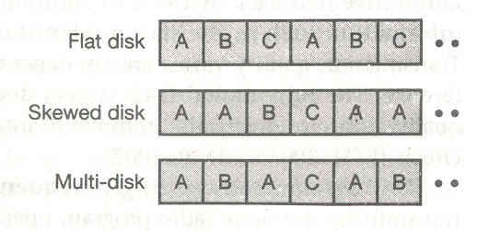

DIGITAL AUDIO BROADCASTING (DAB)

The fully digital Dab system does not only offer sound in a CD-like quality, it is also practically immune to interference and multi path propagation. DAB systems can use single frequency network (SFN), i.e., all senders transmitting the same radio program operates at the same frequency. Today, different senders have to use different frequencies to avoid interference although they are transmitting the same radio program. Using an SFN is very frequency efficient, as a single radio station only needs one frequency throughout the whole country. Additionally, DAB transmission power per antenna is orders of magnitude lower compared to traditional Fm station. DAB uses VHF and UHF frequency bands, e.g., the terrestrial TV channels 5 to 12 (174-240 MHz) or L band (1452-1492 MHz). DAB uses FEC to reduce the error rate and introduces guard spaces between single symbols during transmission.

DAB uses two basic transport mechanisms:

- Main service channel (MSC): The MSC carries all user data, e.g. audio, multimedia data. The MSC consist of common interleaved frames (CIF), i.e., data fields of 55,296 bits that are sent every 24 ms. This results in a data rate of 2.304 Mbit\s. A CIF consists of capacity unit (CU) with a size of 64 bits, which forms the smallest addressable unit within a DAB system.

- Fast information channel (FIC): The FIC contains fast information block (FIB) with 256 bits each (16 bit checksum). A FIC carries all control information which is required for interpreting the configuration and content of the MSC.

Two transport modes have been defined for the MSC.

- The stream mode offers a transparent data transmission from the source to the destination with a fixed bit rate in a sub channel. A sub channel is a part of MSC and comprises several CUs within CIF. The fixed data rate can be multiples of 8 Kbit/s.
- The packet mode transfers data in addressable blocks (packets). These blocks are used to convey MSC data within a sub channel.

DAB defines many service information structures accompanying an audio stream. This program associated data (PAD) can contain program information, control information, still pictures for display on a small LCD, title display etc.

Figure shows general frame structure of DAB. Each frame has duration T_{f} of 24, 48, or 96 ms depending on the transmission mode. Within each frame, 76 or 156 symbols are transmitted using 192, 384, 768 or 1536 different carriers for COFDM. The guard interval T_{d} protecting each symbol can be 31, 62, 123 or 246 microseconds.

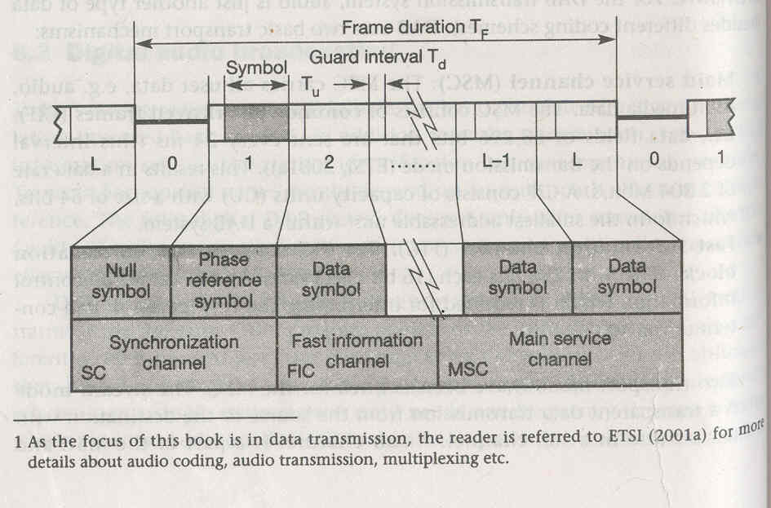

Each frame has three parts.

- Synchronization channel (SC): marks the starts of the frame. It consists of null symbols and phase reference symbols to synchronize the receiver.
- Fast information channel (FIC): containing control data in the FIBs.
- Main service channel (MSC): carries audio and data service components.

Figure below shows a simplified overview of a DAB sender. Audio services are encoded (MPEG compression) and coded for transmission (FEC). All data services are multiplexed and also coded for redundancy. The MSC multiplexer combines all user data streams and forwards them to the transmission multiplexer. This unit creates a frame structure by interleaving the FIC. Finally, OFDM (orthogonal frequency division multiplexing) coding is applied and DAB signal is transmitted.

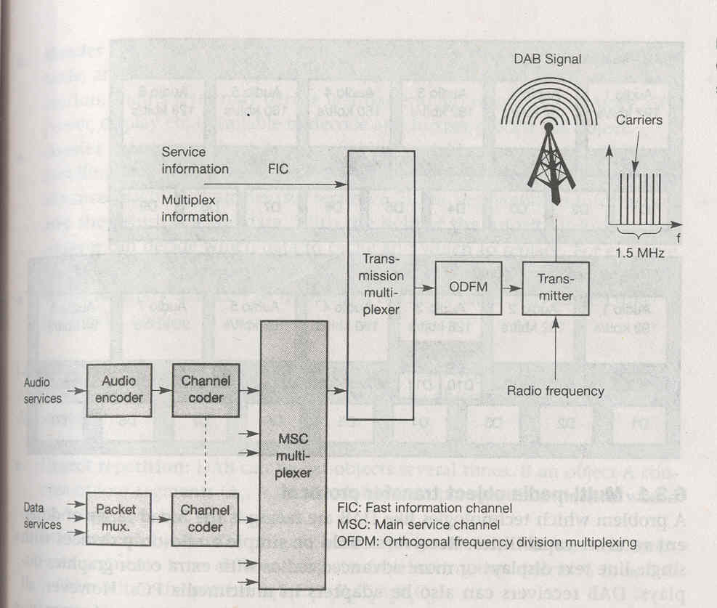

MULTI MEDIA OBJECT TRANSFER PROTOCOL

A problem which technologies like DAB are facing is the broad range of different receiver capabilities. Receiver could be simple audio only devices with single line text displays or more advanced radios with extra color graphics displays. DAB receivers can also be adapters in multi media PCs. However, all different types of receiver should at least be able to recognize all program associated and program independent data, and process some of this data.

To solve this problem, DAB defines a common standard for data transmission; the multi media object transfer (MOT) protocol. The primary goal of MOT is the support of data formats used in other multi media systems (e.g., on line services, internet, CD-ROM). Example formats are multi-media and hypermedia information coding experts group (MHEG), Java, joint photographic experts group (JPEG), American standard code for information interchange (ASCII), moving pictures expert group (MPEG), hypertext markup language (HTML), hypertext transfer protocol (HTTP), bitmap (BMP), graphics interchange format (GIF).

MOT data is transferred in MOT objects consisting of header core, a header extension, and a body.

Header Header Body
CoreExtension
MOT object structure
7 byte
- Header core: This 7 byte field contains the sizes of the header and the body, and the content type of the object. Depending on this header information, the receiver may decide if it has enough resources (memory, CPU, power, display etc.) available to decode and further process the object.

- Header extension: The extension field of variable size contains additional handling data for the object, such as, e.g., the repetition distance to support advanced caching strategies, the segmentation information, and the priority of the data. With the help of the priority information a receiver can decide which data to cache and which to replace. For example, index HTML page may have a higher priority than an arbitrary page.

- Body: Arbitrary data can be transferred in the variable body described in the header fields.

Larger MOT objects will be segmented into smaller segments. DAB can apply different interleaving and repetition schemes to objects and segments.

- Object repetition: DAB can repeat objects several times. If an object A consists of four segments (A1, A2, A3, and A4), a simple repetition pattern would be A1A2A3A4A1A2A3A4……..

- Interleaved objects: To mitigate burst error problem, DAB can also interleave segments from different objects. Interleaving the objects A, B, C could result in the pattern A1B1C1A2B2C2………..

- Segment repetition: If some segments are more important than others, DAB can repeat these segments more often. E.g. A1A1A2A2A2A3A4A4…….

- Header repetition: If a receiver cannot receive the header of an MOT, it will not be able to decode the object. It can be useful to transmit the header several times. Then, the receiver can synchronize with the data stream as soon as it receives the header and can start decoding. A pattern could be HA1A2HA3A4HA5A6H…. where H being the header of the MOT objects A.

DIGITAL VIDEO BROADCASTING

European Launching Group was founded in 1991 with the aim of developing a common digital television system for Europe. In 1993 these common effort were named digital video broadcasting (DVB). The goal of DVB is to introduce digital television broadcasting using satellite transmission (DVB-S), cable technology (DVB-C), and also terrestrial transmission (DVB-T).

Figure shows components that should be integrated into the DVB architecture. The centre point is an integrated receiver-decoder (set-top box) connected to a high resolution monitor. This set top box can receive DVB signals via satellites, terrestrial local/regional senders (multipoint distribution systems, terrestrial receiver), cable, B-ISDN, ADSL, or other possible future technologies. Cable, ADSL, and B-ISDN connections also offers a return channel, i.e., a user can send data such as channel selection, authentication information, or a shopping list. Audio/video streams can be recorded, processed and replayed using digital versatile disk (DVD) or multimedia PCs. Different levels of quality are envisaged: standard definition TV (SDTV), enhanced definition TV (EDTV), and high definition TV (HDTV) with a resolution of up to 1,920 * 1,080 pixels.

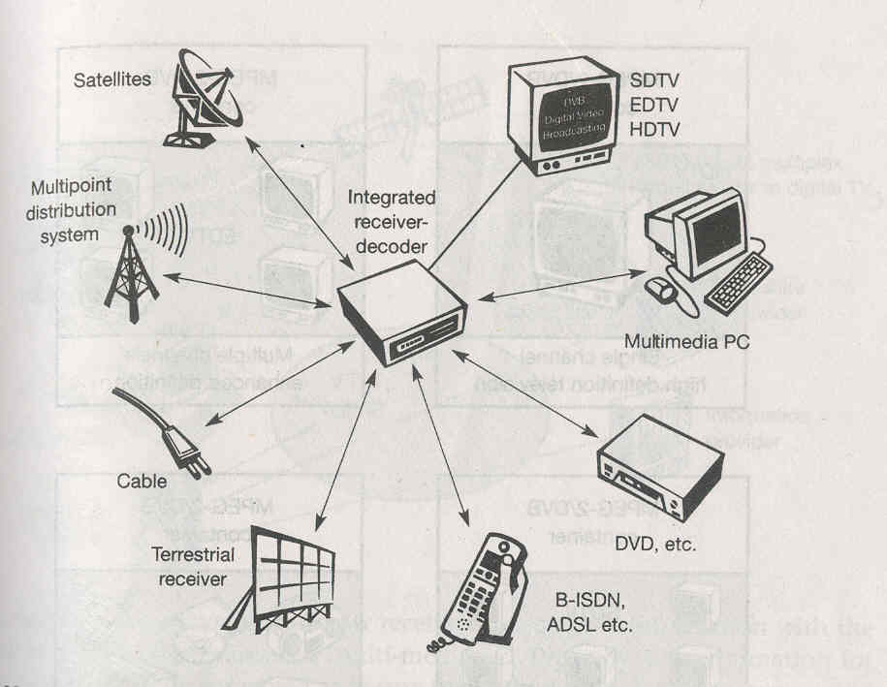

Similar to DAB, DVB also transmits data using flexible containers. These containers are basically MPEG-2 frames that do not re3strict the type of information. DVB sends service information contained in its data stream, which specifies the content of a container. The following contents have been defined:

- Network information table (NIT): NIT lists the services of a provider and contains additional information for set top box.
- Service description table (SDT): SDT list names and parameters for each service within an MPEG multiplex channel.
- Event information table (EIT): EIT contains status information about the current transmission and some additional information for set top boxes.
- Time and date table (TDT): Finally, TDT contains update information for set top box.

As shown in figure, an MPEG-2/DVB container can store different types of data. It either contains a single channel for HDTV, multiple channels for EDTV or SDTV or arbitrary multi media data (data broadcasting).
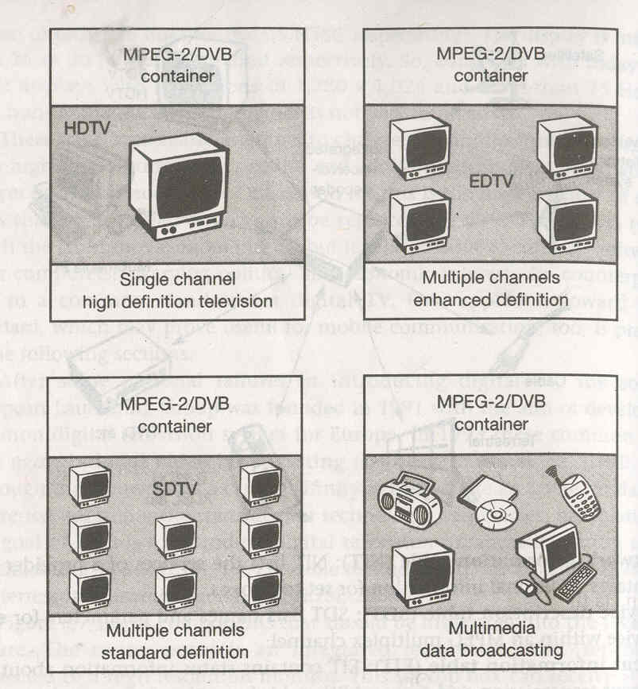

DVB data broadcasting

As the MPEG-2 transport stream is able to carry arbitrary data within packets with a fixed length of 188 byte ( 184 byte payload), ETSI defines several profiles for data broadcasting which can be used e.g., for high bandwidth mobile internet service.

- Data pipe: Simple, asynchronous end to end delivery of data; data is directly inserted in the payload of MPEG2 transport packets.
- Data streaming: Streaming-oriented, asynchronous, synchronized (synchronization with other streams e.g., audio/video possible), or synchronous (data and clock regeneration at receiver possible) end to end delivery of data.
- Multi protocol encapsulation: transport of arbitrary data network protocols on top of the MPEG 2 transport stream; optimized for IP, support for 48 bit MAC address, unicast, multi-cast and broadcast.
- Data carousels: Periodic transmission of data.
- Object carousels: Periodic transmission of objects; platform independent compatible with the object request broker (ORB) framework as defined by CORBA.

DVB for high speed internet access

Apart from the data/multimedia broadcasting, DVB can be also used for high bandwidth, asymmetrical Internet access. A typical scenario could be as shown in the figure

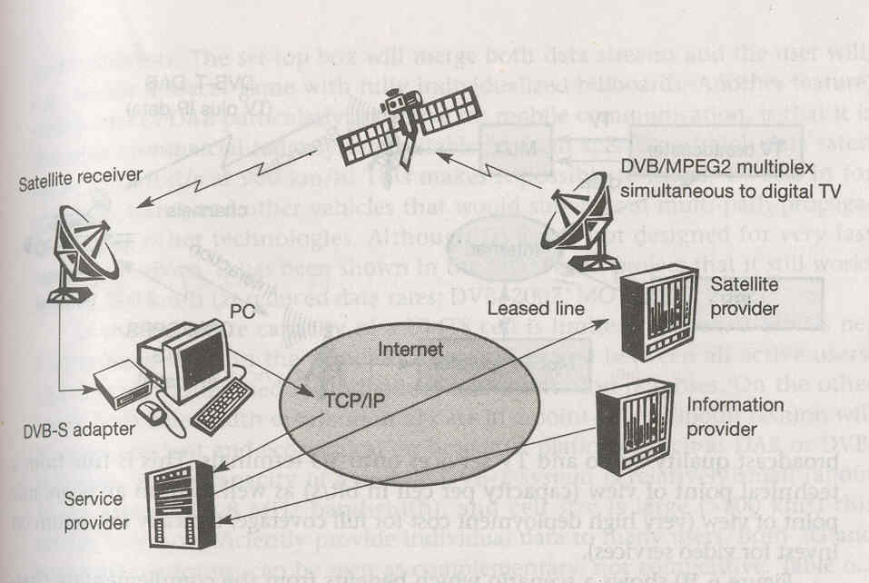
An information provider, e.g., video store, offers its data to potential customers with the help of service providers. If a customer wants to download high volume information, the information provider transmits this information to satellite providers via a service provider. In fixed networks, this is done using leased lines because high bandwidth and QoS guarantees are needed. The satellite provider now multiplexes this data stream together with other digital TV channels and transmits it to the customer via satellite and a satellite receiver. The customer can now receive the requested information with the help of a DVB adaptor inside a multi media PC. Typically, this information for the customer will be encrypted to ensure that only paying customers can use the information. The return channel for request etc. can be standard TCP/IP connection via the internet as this channel only requires a low bandwidth.

One advantage of this approach is that it is transmitted along with the TV programs using free space in the transmitted data stream, so it does not require additional lines or hardware per customer. This factor is particularly important for remote area or developing countries where high bandwidth wired access such as ADSL is not available. A clear disadvantage of this approach however is the shared medium ‘satellite’. If a lot of users request data streams via DVB, they all have to share the satellite’s bandwidth. This system cannot give hard QoS guarantees to all users without being very expensive.

SATELLITE SYSTEM

Satellite communication introduces another system supporting mobile communication. Satellite offers global coverage without wiring costs for base stations and is almost independent of varying population density.

Different types of orbits

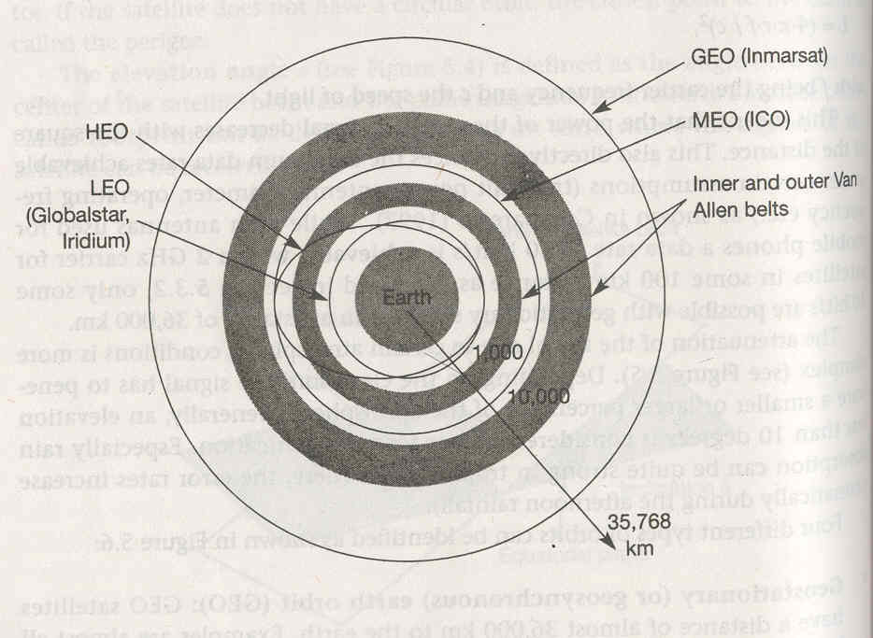

- Geostationary or geosynchronous earth orbit (GEO): GEO satellites have a distance of almost 36,000 km to the earth. Examples are almost all TV and radio broadcast satellite, many weather satellite and satellites operating as backbone for the telephone network.
The satellite in this orbit appears fixed in the sky because it has a period of 24 hours. The orbit must have an inclination of 0 degree.

Advantage

- Three GEO satellites are enough for a complete coverage of almost any spot on earth.
- Senders and receivers can use fixed antennas positions, no adjusting is needed.
- GEOs are ideal for TV and radio broadcasting.
- Life time expectation for GEOs is rather high, at about 15 years.
- GEOs do not need a handover due to large footprint.

Disadvantage

- Northern or southern regions of the earth have more problems receiving these satellites due to the low elevation above latitude of 60 degree i.e. larger antennas are needed in this case.
- Shading of signals in cities due to high buildings and the low elevation further away from the equator limit transmission quality.
- Transmit power needed is relatively high (some 10 W) which causes problems for battery powered devices.
- These satellites cannot be used for small mobile phones.
- Due to larger footprint, either frequencies cannot be reused or the GEO satellites need special antennas focusing on a smaller footprint.
- Transferring a GEO into orbit is very expensive.

- Medium earth orbit (MEO): MEOs operates at a distance of about 5,000-12,000 km. Up to now there have not been many satellites in this class. MEOs can be positioned somewhere between LEOs and GEOs, both in terms of their orbits and due to their advantages and disadvantages

Advantage

  - Using orbits around 10,000 km, the system only requires a dozen satellites which is more than a GEO system, but less than a LEO system.
  - These satellites move more slowly relative to the earth’s rotation allowing a simpler system design.
  - Depending on the inclination, a MEO can cover larger populations , so requiring fewer handovers.

Disadvantage
- Due to the larger distance to the earth, delay increases to about 70-80 ms.
- The satellites need higher transmit power and special antennas for smaller footprints.

- Low earth orbit (LEO): While some time ago LEO satellites were mainly used for espionage, several of the new satellites systems now rely on this class using altitude of 500-1,500 km. LEOs offer a typical duration of 95 to 120 minutes. Each LEO satellite will only be visible from the earth from around 10 minutes. A further classification of LEOs into little LEOs with low bandwidth service (some 100 bit/s), big LEOs (some 1,000 bit/s) and broadband LEOs with plans reaching into Mbit/s range can be found.
Advantages
  - Transmission rates of about 2,400 bit/s can be enough for voice communication. LEOs even provide this bandwidth for mobile terminals
with omni directional antennas. Using a low transmit power in the range of 1 W.
  - The delay for packet delivery via a LEO is relatively low.
  - Smaller footprints of LEOs allow for better frequency reuse.
  - LEOs can provide a much higher elevation in Polar Regions and so
better global coverage.

Disadvantages
- It needs many satellites if global coverage is to be reached. Several concepts involve 50-200 or even satellites in orbit.
- The short time of visibility with a high elevation requires additional mechanism for connection handover between different satellites.
- The high number of satellites combined with the fast movement results in a high complexity of whole satellite system.
- Another problem is the short lifetime of about five to eight years due to atmospheric drags and radiation.
- Low latency.
- Need for routing of data packets from satellite to satellite if a user wants to communicate around the world.

- Highly elliptical orbit (HEO): This class comprises all satellites with non circular orbits. Currently, only a few commercial communication systems using satellites with elliptical orbits are planned.

APPLICATIONS

- Weather forecasting
Several satellites deliver pictures of earth using infra red or visible light. Without the help of satellites, the forecasting of hurricanes would be impossible.

- Radio and TV broadcast satellites
Hundreds of radio and TV programs are available via satellites. This technology competes with cable in many places, as it is cheaper to install and, in most cases, no extra fees have to be paid for this service.

- Military satellites
One of the earliest applications of satellites was their use for carrying out espionage. Many communication links are managed via satellites because they are much safer from attack by enemies.
- Satellites for navigation
The global positioning system (GPS) is nowadays well known and available for everyone. The system allows for precise localization worldwide, and with some additional techniques, the precision is in the range of some meters.

- Global telephone backbones
One of the first applications of satellites for communication was the establishment of international telephone backbones. These satellites are increasingly replaced by fiber optical cable crossing the oceans. The main reason behind this is the tremendous capacity of fiber optical links and the much lower delay compared to satellites.

- Connections for remote or developing area
Due to their geographical location many places all over the world do not have direct wired connection to the telephone network or the internet or because of the current state of the infrastructure of a country.

- Global mobile communication
The latest trend for satellites is the support of global mobile data communication. Due to the high latency, geostationary satellites are not ideal fir this task; therefore, satellites using lower orbits are needed. The basic purpose of satellites for mobile communication is not to replace the existing mobile phone networks but to extent the area of coverage.

