- INTRODUCTION

The graphics processing unit (GPU) has become an integral part of today’s mainstream computing systems. Over the past many years, there has been a marked increase in the performance and capabilities of GPUs. The modern GPU is not only a powerful graphics engine but also a highly parallel programmable processor featuring peak arithmetic and memory bandwidth that substantially outpaces its CPU counterpart. The GPU’s rapid increase in both programmability and capability has spawned a research community that has successfully mapped a broad range of computationally demanding, complex problems to the GPU. This effort in general purpose computing on the GPU, also known as GPU computing, has positioned the GPU as a compelling alternative to traditional microprocessors in high-performance computer systems of the future.

A GPU is tailored for highly parallel operation while a CPU executes programs serially. For this reason, GPUs have many parallel execution units and higher transistor counts, while CPUs have few execution units and higher clock speeds. A GPU is for the most part deterministic in its operation (though this is quickly changing).GPUs have much deeper pipelines (several thousand stages vs 10-20 for CPUs).GPUs have significantly faster and more advanced memory interfaces as they need to shift around a lot more data than CPUs.
GPU computing is the use of a GPU (graphics processing unit) to do general purpose scientific and engineering computing. The model for GPU computing is to use a CPU and GPU together in a heterogeneous computing model. The sequential part of the application runs on the CPU and the computationally-intensive part runs on the GPU. From the user’s perspective, the application just runs faster because it is using the high-performance of the GPU to boost performance. GPU computing is enabled by the massively parallel architecture of NVIDIA’s GPUs called the CUDA architecture. The CUDA architecture consists of 100s of processor cores that operate together to crunch through the data set in the application. The Tesla 10-series GPU is the second generation CUDA architecture with features optimized for scientific applications such as IEEE standard double precision floating point hardware support, local data caches in the form of shared memory dispersed throughout the GPU, coalesced memory accesses and so on.

The GPU is designed for a particular class of applications with the following characteristics:
- Computational requirements are large.
- Parallelism is substantial.
- Throughput is more important than latency.

The GPU was a fixed-function processor earlier, built around the graphics pipeline, that excelled at three dimensional graphics but little else. Since that time, the GPU has evolved into a powerful programmable processor, with both application programming interface and hardware increasingly focusing on the programmable aspects of the GPU. The result is a processor with enormous arithmetic capability [a single NVIDIA GeForce 8800 GTX can sustain over 330 Giga floating-point operations per second (Gflops)] and streaming memory bandwidth (80+ GB/s), both substantially greater than a high-end CPU. The GPU has a distinctive architecture centered around a large number of fine-grained parallel processors.
As the shader model has evolved and become more powerful, and GPU applications of all types have increased vertex and fragment program complexity, GPU architectures have increasingly focused on the programmable parts of the graphics pipeline. Indeed, while previous generations of GPUs could best be described as additions of programmability to a fixed-function pipeline, today’s GPUs are better characterized as a programmable engine surrounded by supporting fixed-function units.

Successful GPU computing applications do the following:

- Emphasize parallelism
- Minimize SIMD divergence
- Maximize arithmetic intensity
- Exploit streaming bandwidth

- GPU ARCHITECTURE

The GPU has always been a processor with ample computational resources. The most important recent trend, however, has been exposing that computation to the programmer. Over the past few years, the GPU has evolved from a fixed-function special-purpose processor into a full-fledged parallel programmable processor with additional fixed-function special-purpose functionality.

2.1 THE GRAPHICS PIPELINE

The input to the GPU is a list of geometric primitives, typically triangles, in a 3-D world coordinate system. Through many steps, those primitives are shaded and mapped onto the screen, where they are assembled to create a final picture. The different steps in the canonical graphical pipeline are:

Vertex Operations: The input primitives are formed from individual vertices. Each vertex must be transformed into screen space and shaded, typically through computing their interaction with the lights in the scene. Because typical scenes have tens to hundreds of thousands of vertices, and each vertex can be computed independently, this stage is well suited for parallel hardware.

Primitive Assembly: The vertices are assembled into triangles, the fundamental hardware-supported primitive in today’s GPUs.

Rasterization: Rasterization is the process of determining which screen-space pixel locations are covered by each triangle. Each triangle generates a primitive called “fragment” at each screen-space pixel location that it covers. Because many triangles may overlap at any pixel
location, each pixel’s colour value may be computed from several fragments.

Fragment Operations: Using colour information from the vertices and possibly fetching additional data from global memory in the form of textures (images that are mapped onto surfaces), each fragment is shaded to determine its final colour. Just as in the vertex stage, each fragment can be computed in parallel. This stage is typically the most computationally demanding stage in the graphics pipeline.

Composition: Fragments are assembled into a final image with one colour per pixel, usually by keeping the closest fragment to the camera for each pixel location.

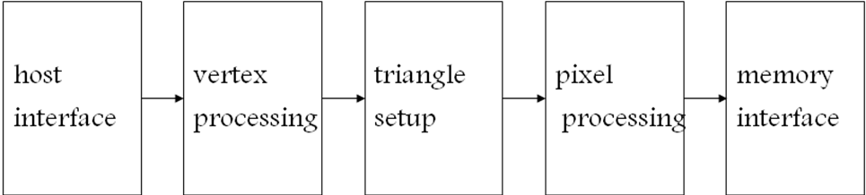

Fig.1: Block diagram of a graphics pipeline

The different stages in a graphics pipeline are:

Host Interface

The host interface is the communication bridge between the CPU and the GPU. It receives commands from the CPU and also pulls geometry information from system memory. It outputs a stream of vertices in object space with all their associated information (normals, texture coordinates, per vertex color etc.)

Vertex Processing

The vertex processing stage receives vertices from the host interface in object space and outputs them in screen space. This may be a simple linear transformation, or a complex operation involving morphing effects. Normals, texcoords, etc. are also transformed. No new vertices are created in this stage, and no vertices are discarded (input/output has 1:1 mapping)

Triangle Setup

In this stage geometry information becomes raster information (screen space geometry is the input, pixels are the output). Prior to rasterization, triangles that are backfacing or are located outside the viewing frustrum are rejected. Some GPUs also do some hidden surface removal at this stage. A fragment is generated if and only if its center is inside the triangle. Every fragment generated has its attributes computed to be the perspective correct interpolation of the three vertices that make up the triangle.

Fragment Processing

Each fragment provided by triangle setup is fed into fragment processing as a set of attributes (position, normal, texcoord etc), which are used to compute the final color for this pixel. The computations taking place here include texture mapping and math operations, typically the bottleneck in modern applications.

Memory Interface

Fragment colors provided by the previous stage are written to the framebuffer, which used to be the biggest bottleneck before fragment processing took over. Before the final write occurs, some fragments are rejected by the zbuffer, stencil and alpha tests. On modern GPUs, z and color are compressed to reduce framebuffer bandwidth (but not size).

Historically, the operations available at the vertex and fragment stages were configurable but not programmable. For instance, one of the key computations at the vertex stage is computing the colour at each vertex as a function of the vertex properties and the lights in the scene. In the fixed-function pipeline, the programmer could control the position and colour of the vertex and the lights, but not the lighting model that determined their interaction.

2.2 EVOLUTION OF GPU ARCHITECTURE

The fixed-function pipeline lacked the generality to efficiently express more complicated shading and lighting operations that are essential for complex effects. The key step was replacing the fixed-function per-vertex and per-fragment operations with user-specified programs run on each vertex and fragment. These vertex programs and fragment programs have become increasingly more capable, with larger limits on their size and resource consumption, with more fully featured instruction sets, and with more flexible control-flow operations.

After many years of separate instruction sets for vertex and fragment operations, current GPUs support the unified Shader Model 4.0 on both vertex and fragment shaders.
• The hardware must support shader programs of at least 65 k static instructions and unlimited dynamic instructions.
• The instruction set, for the first time, supports both 32-bit integers and 32-bit floating-point
numbers.
• The hardware must allow an arbitrary number of both direct and indirect reads from global memory (texture).
• Finally, dynamic flow control in the form of loops and branches must be supported.

As the shader model has evolved and become more powerful, and GPU applications of all types have increased vertex and fragment program complexity, GPU architectures have increasingly focused on the programmable parts of the graphics pipeline. Indeed, while previous generations of GPUs could best be described as additions of programmability to a fixed-function pipeline, today’s GPUs are better characterized as a programmable engine surrounded by supporting fixed-function units.

2.3. ARCHITECTURE OF A MODERN GPU

The GPU is built for different application demands than the CPU: large, parallel computation requirements with an emphasis on throughput rather than latency. Consequently, the architecture of the GPU has progressed in a different direction than that of the CPU.

In a pipeline of tasks such as those in graphics APIs, the output of each successive task is fed into the input of the next task. The pipeline exposes the task parallelism of the application, as data in multiple pipeline stages can be computed at the same time; within each
stage, computing more than one element at the same time is data parallelism. To execute such a pipeline, a CPU would take a single element (or group of elements) and process the first stage in the pipeline, then the next stage, and so on. The CPU divides the pipeline in time, applying all resources in the processor to each stage in turn. GPUs have historically taken a different approach. The GPU divides the resources of the processor among the different stages, such that the pipeline is divided in space, not time. The part of the processor working on one stage feeds its output directly into a different part that works on the next stage.

This machine organization was highly successful in fixed-function GPUs for two reasons. First, the hardware in any given stage could exploit data parallelism within that stage, processing multiple elements at the same time. Because many task-parallel stages were running at any time, the GPU could meet the large compute needs of the graphics pipeline. Secondly, each stage’s hardware could be customized with special-purpose hardware for its given task, allowing substantially greater compute and area efficiency over a general-purpose solution. For instance, the rasterization stage, which computes pixel coverage information for each input triangle, is more efficient when implemented in special-purpose hardware. As programmable stages (such as the vertex and fragment programs) replaced fixed-function stages, the special-purpose fixed function components were simply replaced by programmable components, but the task-parallel organization did not change.

The result was a lengthy, feed-forward GPU pipeline with many stages, each typically accelerated by special purpose parallel hardware. In a CPU, any given operation may take on the order of 20 cycles between entering and leaving the CPU pipeline. On a GPU, a graphics operation may take thousands of cycles from start to finish. The latency of any given operation is long. However, the task and data parallelism across and between stages delivers high throughput.

The major disadvantage of the GPU task-parallel pipeline is load balancing. Like any pipeline, the performance of the GPU pipeline is dependent on its slowest stage. If the vertex program is complex and the fragment program is simple, overall throughput is dependent on the performance of the vertex program. In the early days of programmable stages, the instruction set of the vertex and fragment programs were quite different, so these stages were separate. However, as both the vertex and fragment programs became more fully featured, and as the instruction sets converged, GPU architects reconsidered a strict task-parallel pipeline in favour of a unified shader architecture, in which all programmable units in the pipeline share a single programmable hardware unit. While much of the pipeline is still task-parallel, the programmable units now divide their time among vertex work, fragment work, and geometry work (with the new DirectX 10 geometry shaders). These units can exploit both task and data parallelism. As the programmable parts of the pipeline are responsible for more and more computation within the graphics pipeline, the architecture of the GPU is migrating from a strict pipelined task-parallel architecture to one that is increasingly built around a single unified data-parallel programmable unit.

AMD introduced the first unified shader architecture for modern GPUs in its Xenos GPU in the XBox 360 (2005). Today, both AMD’s and NVIDIA’s flagship GPUs feature unified shaders (Fig. 1). The benefit for GPU users is better load-balancing at the cost of more complex hardware. The benefit for GPGPU users is clear: with all the programmable power in a single hardware unit, GPGPU programmers can now target that programmable unit directly, rather than the previous approach of dividing work across multiple hardware units.

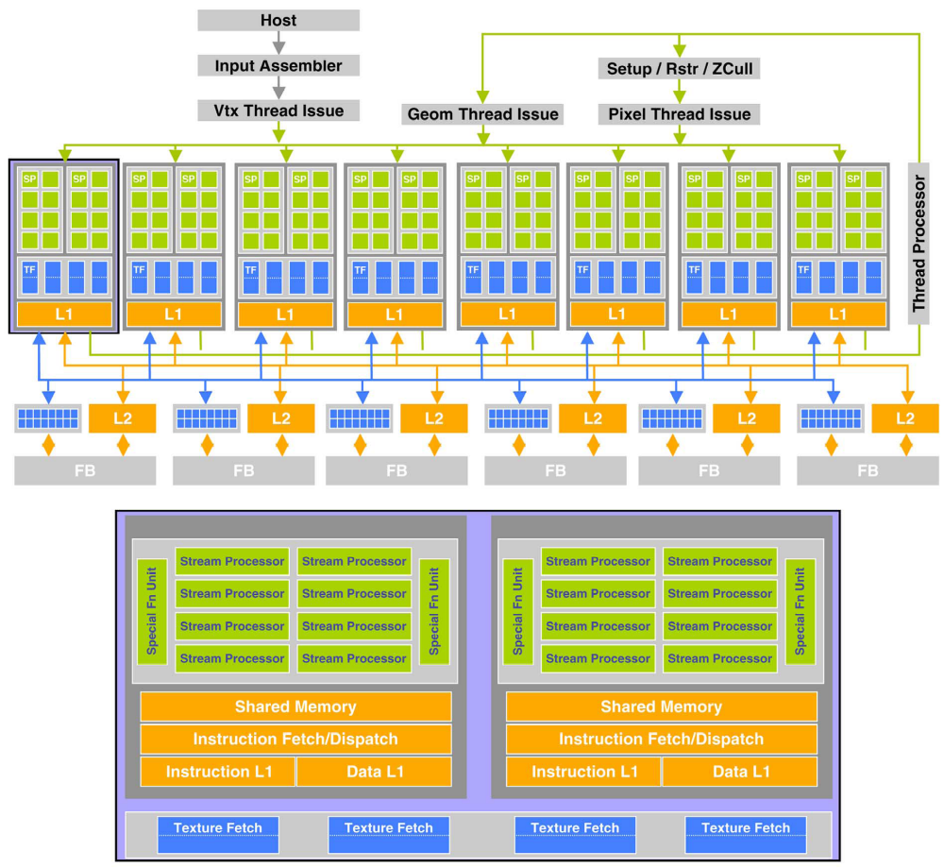

Fig. 1. Today, both AMD and NVIDIA build architectures with unified, massively parallel programmable units at their cores. (a) The NVIDIA GeForce 8800 GTX (top) features 16 streaming multiprocessors of 8 thread (stream) processors each. One pair of streaming multiprocessors is shown below; each contains shared instruction and data caches, control logic, a 16 kB shared memory, eight stream processors, and 2 special function units.

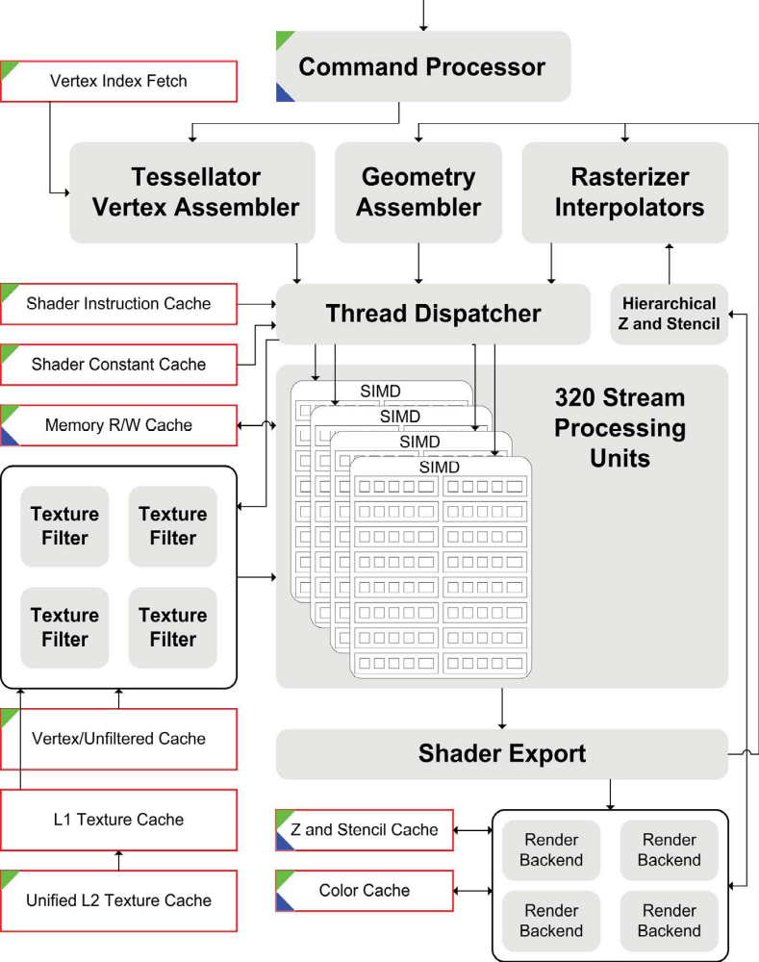

Fig. 1. (continued).(b) AMD’s Radeon HD 2900XT contains 320 stream processing units arranged into four SIMD arrays of 80 units each. These units are arranged into stream processing blocks containing five arithmetic logic units and a branch unit. In the diagram, gray ovals indicate logic units and red-bordered rectangles indicate memory units. Green triangles at the top left of functional units are units that read from memory, and blue triangles at the bottom left write to memory.

- GPU COMPUTING

3.1 THE GPU PROGRAMMING MODEL

The programmable units of the GPU follow a single program multiple-data (SPMD) programming model. For efficiency, the GPU processes many elements (vertices or fragments) in parallel using the same program. Each element is independent from the other elements, and in the base programming model, elements cannot communicate with each other. All GPU programs must be structured in this way: many parallel elements, each processed in parallel by a single program.

Each element can operate on 32-bit integer or floating point data with a reasonably complete general-purpose instruction set. Elements can read data from a shared global memory, a gather operation and, with the newest GPUs, also write back to arbitrary locations in shared global memory, a scatter operation.

This programming model is well suited to straight-line programs, as many elements can be processed in lockstep running the exact same code. Code written in this manner is single instruction, multiple data (SIMD). As shader programs have become more complex, programmers prefer to allow different elements to take different paths through the same program, leading to the more general SPMD model.

One of the benefits of the GPU is its large fraction of resources devoted to computation. Allowing a different execution path for each element requires a substantial amount of control hardware. Instead, today’s GPUs support arbitrary control flow per thread but impose a penalty for incoherent branching. GPU vendors have largely adopted this approach. Elements are grouped together into blocks, and blocks are processed in parallel. If elements branch in different directions within a block, the hardware computes both sides of the branch for all elements in the block. The size of the block is known as the branch granularity and has been decreasing with recent GPU generations -today, it is on the order of 16 elements.

3.2. GENERAL-PURPOSE COMPUTING ON THE GPU

Mapping general-purpose computation onto the GPU uses the graphics hardware in much the same way as any standard graphics application. Because of this similarity, it is both easier and more difficult to explain the process. On one hand, the actual operations are the same and are easy to follow; on the other hand, the terminology is different between graphics and general-purpose use. The different steps are:

Programming a GPU for Graphics:

1) The programmer specifies geometry that covers a region on the screen. The rasterizer generates a fragment at each pixel location covered by that geometry.
2) Each fragment is shaded by the fragment program.
3) The fragment program computes the value of the fragment by a combination of math operations and global memory reads from a global “texture” memory.
4) The resulting image can then be used as texture on future passes through the graphics pipeline.

Programming a GPU for General-Purpose Programs (Old)

Coopting this pipeline to perform general-purpose computation involves the exact same steps but different terminology.
1) The programmer specifies a geometric primitive that covers a computation domain of interest. The rasterizer generates a fragment at each pixel location covered by that geometry.
2) Each fragment is shaded by an SPMD general purpose fragment program.
3) The fragment program computes the value of the fragment by a combination of math operations and “gather” accesses from global memory.
4) The resulting buffer in global memory can then be used as an input on future passes.

Programming a GPU for General-Purpose Programs (New)

One of the historical difficulties in programming GPGPU applications has been that despite their general-purpose tasks’ having nothing to do with graphics, the applications still had to be programmed using graphics APIs. In addition, the program had to be structured in terms of the graphics pipeline, with the programmable units only accessible as an intermediate step in that pipeline, when the programmer would almost certainly prefer to access the programmable units directly. Today, GPU computing applications are structured in the following way.
1) The programmer directly defines the computation domain of interest as a structured grid of threads.
2) An SPMD general-purpose program computes the value of each thread.
3) The value for each thread is computed by a combination of math operations and both “gather”(read) accesses from and “scatter” (write) accesses to global memory. Unlike in the previous two methods, the same buffer can be used for both reading and writing, allowing more flexible algorithms (for example, in-place algorithms that use less memory).
4) The resulting buffer in global memory can then be used as an input in future computation.

This programming model is a powerful one for several reasons. First, it allows the hardware to fully exploit the application’s data parallelism by explicitly specifying that parallelism in the program. Next, it strikes a careful balance between generality (a fully programmable routine at each element) and restrictions to ensure good performance. Finally, its direct access to the programmable units eliminates much of the complexity faced by previous GPGPU programmers in coopting the graphics interface for general-purpose programming. As a result, programs are more often expressed in a familiar programming language(such as NVIDIA’s C-like syntax in their CUDA programming environment) and are simpler and easier to build and debug (and are becoming more so as the programming tools mature). The result is a programming model that allows its users to take full advantage of the GPU’s powerful hardware but also permits an increasingly high-level programming model that enables productive authoring of complex applications.

4. COMPARISON: CPU AND GPU

To execute a graphical pipeline, a CPU would take a single element (or group of elements) and process the first stage in the pipeline, then the next stage, and so on. The CPU divides the pipeline in time, applying all resources in the processor to each stage in turn. GPUs have historically taken a different approach. The GPU divides the resources of the processor among the different stages, such that the pipeline is divided in space, not time. The part of the processor working on one stage feeds its output directly into a different part that works on the next stage.

In a CPU, any given operation may take on the order of 20 cycles between entering and
leaving the CPU pipeline. On a GPU, a graphics operation may take thousands of cycles from start to finish. The latency of any given operation is long. However, the task and data parallelism across and between stages delivers high throughput. GPUs have much deeper pipelines (several thousand stages vs 10-20 for CPUs)

A GPU is tailored for highly parallel operation while a CPU executes programs serially.For this reason, GPUs have many parallel execution units and higher transistor counts, while CPUs have few execution units and higher clockspeeds. A GPU is for the most part deterministic in its operation (though this is quickly changing).

GPUs have significantly faster and more advanced memory interfaces as they need to shift around a lot more data than CPUs.

5. PROGRAMMABILITY IN THE GPU

- Vertex and fragment processing, and now triangle set-up, are programmable
- The programmer can write programs that are executed for every vertex as well as for every fragment
- This allows fully customizable geometry and shading effects that go well beyond the generic look and feel of older 3D applications

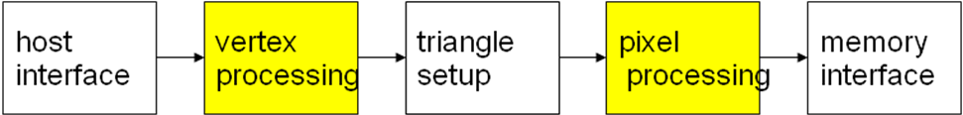

6. SOFTWARE ENVIRONMENTS

In the past, the majority of GPGPU programming was done directly through graphics APIs. Although many researchers were successful in getting applications to work through these graphics APIs, there is a fundamental mismatch between the traditional programming models people were using and the goals of the graphics APIs. Originally, people used fixed function, graphics-specific units (e.g. texture filters, blending, and stencil buffer operations) to perform GPGPU operations. This quickly got better with fully programmable fragment processors which provided pseudo assembly languages, but this was still unapproachable by all but the most ardent researchers.

With DirectX 9, higher level shader programming was made possible through the high-level shading language (HLSL), presenting a C-like interface for programming shaders. NVIDIA’s Cg provided similar capabilities as HLSL but was able to compile to multiple targets and provided the first high-level language for OpenGL. The OpenGL Shading Language (GLSL) is now the standard shading language for OpenGL. However, the main issue with Cg/HLSL/GLSL for GPGPU is that they are inherently shading languages. Computation must still be expressed in graphics terms like vertices, textures, fragments, and blending. So, although you could do more general computation with graphics APIs and shading languages, they were still largely unapproachable by the common programmer. What developers really wanted were higher level languages that were designed explicitly for computation and abstracted all of the graphics-isms of the GPU.

BrookGPU and Sh were two early academic research projects with the goal of abstracting the GPU as a streaming processor. The stream programming model structures programs to express parallelism and allows for efficient communication and data transfer, matching the parallel processing resources and memory system available on GPUs. A stream program comprises a set of streams, ordered sets of data, and kernels, the functions applied to each element in a set of streams producing one or more streams as output. Brook takes a pure streaming computation abstraction approach representing data as streams and computation as kernels. There is no notion of textures, vertices, fragments, or blending in Brook. Kernels are written in a restricted subset of C, notably the absence of pointers and scatter, and defined the input, output, and gather streams used in a kernel as part of the kernel definition. Brook contains stream access functionality such as repeat and stride, reductions over streams, and the ability to define domains, subsets, of streams to use as input and output. The kernels are run for each element in the domain of output streams. The user’s kernels are mapped to fragment shader code and streams to textures. Data upload and download to the GPU is performed via explicit read/write calls translating into texture updates and framebuffer readbacks. Lastly, computation is performed by rendering a quad covering the pixels in the output domain.

Microsoft’s Accelerator project has a similar goal as Brook in being very compute-centric, but instead of using offline compilation, Accelerator relies on just-in-time compilation of data-parallel operators to fragment shaders. Unlike Brook and Sh, which are largely extensions to C, Accelerator is an array-based language based on C#, and all computation is done via operations on arrays. Unlike Brook, but similar to Sh, the delayed evaluation model allows for more aggressive online compilation, leading to potentially more specialized and optimized generated code for execution on the GPU.

RapidMind commercialized Sh and now targets multiple platforms including GPUs, the STI Cell Broadband Engine, and multicore CPUs, and the new system is much more focused on computation as compared to Sh, which included many graphics-centric operations. Similar to Accelerator, RapidMind uses delayed evaluation and online compilation to capture and optimize the user’s application code along with operator and type extensions to C++ to provide direct support for arrays.

PeakStream is a new system, inspired by Brook, designed around operations on arrays. Similar to RapidMind and Accelerator, PeakStream uses just-in-time compilation but is much more aggressive about vectorizing the user’s code to maximize performance on SIMD architectures. PeakStream is also the first platform to provide profiling and debugging support, the latter continuing to be a serious problem in GPGPU development. Both of these efforts represent third-party vendors creating systems with support from the GPU vendors. As a demonstration of the excitement around GPGPU and the success of these approaches to parallel computation, Google purchased PeakStream in 2007.

Both AMD and NVIDIA now also have their own GPGPU programming systems. AMD announced and released their system to researchers in late 2006. CTM, or “close to the metal” provides a low-level hardware abstraction layer (HAL) for the R5XX and R6XX series of ATI GPUs. CTMHAL provides raw assembly-level access to the fragment engines (stream processors) along with an assembler and command buffers to control execution on the hardware. No graphics-specific features are exported through this interface. Computation is performed by binding memory as inputs and outputs to the stream processors, loading an ELF binary, and defining a domain over the outputs on which to execute the binary. AMD also offers the compute abstraction layer (CAL), which adds higher level constructs, similar to those in the Brook runtime system, and compilation support to GPU ISA for GLSL, HLSL, and pseudoassembly like Pixel Shader 3.0. For higher level programming, AMD supports compilation of Brook programs directly to R6XX hardware, providing a higher level programming abstraction than provided by CAL or HAL.

NVIDIA’s CUDA is a higher level interface than AMD’s HAL and CAL. Similar to Brook, CUDA provides a C-like syntax for executing on the GPU and compiles offline. However, unlike Brook, which only exposed one dimension of parallelism, data parallelism via streaming, CUDA exposes two levels of parallelism, data parallel and multithreading. CUDA also exposes much more of the hardware resources than Brook, exposing multiple levels of memory hierarchy: per-thread registers, fast shared memory between threads in a block, board memory, and host memory. Kernels in CUDA are also more flexible that those in Brook by allowing the use of pointers (although data must be on board), general load/store to memory allowing the user to scatter data from within a kernel, and synchronization between threads in a thread block. However, all of this flexibility and potential performance gain comes with the cost of requiring the user to understand more of the low-level details of the hardware, notably register usage, thread and thread block scheduling, and behavior of access patterns through memory.

All of these systems allow developers to more easily build large applications. For example, the Folding@Home GPU client and large fluid simulation application are written in BrookGPU, NAMD and VMD support GPU execution through CUDA, RapidMind has demonstrated ray-tracing and crowd simulation, and PeakStream has shown oil and gas as well as computational finance applications. CUDA provides tuned and optimized basic linear algebra subprograms (BLAS) and fast Fourier transform (FFT) libraries to use as building blocks for large applications. Low-level access to hardware, such as that provided by CTM, or GPGPU specific systems like CUDA, allow developers to effectively bypass the graphics drivers and maintain stable performance and correctness. The vendors’ driver development and optimizations for graphics APIs tend to test only the latest released or most popular games. Optimizations performed to optimize for game performance can affect GPGPU application stability and performance.

7. TECHNIQUES AND APPLICATIONS

7.1 COMPUTATIONAL PRIMITIVES

Scatter/gather: Write to or read from a computed location in memory. Graphics-based GPU computing allows efficient gather using the texture subsystem, storing data as images (textures) and addressing data by computing corresponding image coordinates and performing a texture fetch. However, texture limitations make this unwieldy: texture size restrictions require wrapping arrays containing more than 4096 elements into multiple rows of a two-dimensional (2-D) texture, adding extra addressing math, and a single texture fetch can only retrieve four 32-bit floating point values, limiting per-element storage. Scatter in graphics-based GPU computing is difficult and requires rebinding data for processing as vertices, either using vertex texture fetch or render-to-vertex-buffer. By contrast, direct-compute layers allow unlimited reads and writes to arbitrary locations in memory. NVIDIA’s
CUDA allows the user to access memory using standard C constructs (arrays, pointers, variables). AMD’s CTM is nearly as flexible but uses 2-D addressing.

Map: apply an operation to every element in a collection. Typically expressed as a for loop in a sequential program (e.g., a thread on a single CPU core), a parallel implementation can reduce the time required by applying the operation to many elements in parallel. Graphics-based GPU computing performs map as a fragment program to be invoked on a collection of pixels (one pixel for each element). Each pixel’s fragment program fetches the element data from a texture at a location corresponding to the pixel’s location in the rendered image, performs the operation, then stores the result in the output pixel. Similarly, CTM and CUDA would typically launch a thread program to perform the operation in many threads, with
each thread loading an element, performing the computation, and storing the result. Note that since loops are supported, each thread may also loop over several elements.

Reduce: repeatedly apply a binary associative operation to reducing a collection of elements to a single element or value. Examples include finding the sum (average, minimum, maximum, variance, etc.) of a collection of values. A sequential implementation on a traditional CPU would loop over an array, successively summing (for example) each element with a running sum of elements seen so far. By contrast, a parallel reduce-sum implementation would repeatedly perform sums in parallel on an ever-shrinking set of elements. Graphics-based GPU computing implements reduce by rendering progressively
smaller sets of pixels. In each rendering pass, a fragment program reads multiple values from a texture (performing perhaps four or eight texture reads), computes their sum, and writes that value to the output pixel in another texture(four or eight times smaller), which is then bound as input to the same fragment shader and the process repeated until the output consists of a single pixel that contains the result. of the final reduction. CTM and CUDA express this same
process more directly, for example, by launching a set of threads each of which reads two elements and writes their sum to a single element. Half the threads then repeat this process, then half of the remaining threads, and so on until a single surviving thread writes the final
result to memory.

Scan: Sometimes known as parallel-prefix-sum, scan takes an array A of elements and returns an array B of the same length in which each element B[i] represents a reduction of the subarray A[1 . . . i]. Scan is an extremely useful building block for data-parallel algorithms.

7.2 APPLICATIONS

GPUs are being applied in a wide variety of applications:
- Matrix multiplication
- Database queries
- Conjugate gradient
- Geometric Optimization
- Force-field simulation
- Molecular dynamics

8. FUTURE OF GPU COMPUTING

The fate of coprocessors in commodity computers (such as floating-point coprocessors) has been to move into the chipset or onto the microprocessor. The GPU has resisted that trend with continued improvements in performance and functionality and by becoming an increasingly important part of today’s computing environments-unlike with CPUs, the demand for continued GPU performance increases has been consistently large. However, economics and potential performance are motivating the migration of powerful GPU functionality onto the chipset or onto the processor die itself. While it is fairly clear that graphics capability is a vital part of future computing systems, it is wholly unclear
which part of a future computer will provide that capability, or even if an increasingly important GPU with parallel computing capabilities could absorb a CPU.
GPU vendors are constantly weighing decisions regarding flexibility and features for their programmers: how do those decisions impact the programming model and their ability to build hardware capable of top performance? An illustrative example is data conditionals.
Today, GPUs support conditionals on a thread granularity, but conditionals are not free; any GPU today pays a performance penalty for incoherent branches. Programmers want a small branch granularity so each thread can be independent; architects want a large branch granularity to build more efficient hardware. Another important design decision is thread granularity: less powerful but many lightweight threads versus fewer, more powerful heavyweight threads. As the programmable aspects of the hardware increasingly take center stage, and the GPU continues to mature as a general-purpose platform, these tradeoffs are only increasing in importance.
GPUs are not the only innovative parallel architecture in the field. The Cell Broadband Engine, multicore CPUs, stream processors, and others are all exploiting parallelism in different ways. The future health of GPU computing would benefit if programs written for GPUs run efficiently on other hardware and programs written for other architectures can be run on GPUs. The landscape of parallel computing will continue to feature many kinds of hardware, and it is important that GPUs be able to benefit from advances in parallel computing that are targeted toward a broad range of hardware.

Practitioners of GPU computing know that the interface to the GPU changes markedly
from generation to generation. This is a very different model than CPUs, which typically maintain API consistency over many years. As a consequence, code written for one generation of GPUs is often no longer optimal or even useful in future generations. However, the lack of backward compatibility is an important key in the ability of GPU vendors to innovate in new GPU generations without bearing the burden of previous decisions.
For GPU programmers, however, the lack of backward compatibility and the lack of
roadmaps going forward make writing maintainable code for the long term a difficult task.
One of the most difficult ordeals for the GPU programmer is the performance cliff, where small changes to the code, or the use of one feature rather than another, make large and surprising differences in performance. The challenge going forward is for vendors and users to build tools that provide better visibility into the hardware and better feedback to the
programmer about performance characteristics.
The most notable tradeoff is the precision of 32-bit floating-point values in the graphics pipeline. Though the precision has improved, it is still not IEEE compliant, and features such as denorms are not supported. As this hardware is used for general-purpose computation, noncompliance with standards becomes much more important, and dealing with
faults-such as exceptions from division by zero, which are not currently supported in GPUs-also becomes an issue.
On CPUs, any given application is likely to have only a small fraction of its code written by its author. Most of the code comes from libraries, and the application developer
concentrates on high-level coding, relying on established APIs such as STL or Boost or BLAS to provide lower level functionality. This is termed as the “horizontal” model of
software development, as the program developer generally only writes one layer of a complex program. In contrast, program development for general-purpose computing on today’s GPUs is largely “vertical”-the GPU programmer writes nearly all the code that goes into his program, from the lowest level to the highest. Libraries of fundamental data structures and algorithms that would be applicable to a wide range of GPU computing applications (such as
NVIDIA’s FFT and dense matrix algebra libraries) are only just today being developed but are vital for the growth of GPU computing in the future.
One of the most powerful motivations for GPU computing in the near term
is the use of general-purpose elements within traditional graphics applications. As new programming environments for GPU computing offer easier and more flexible ways to share data between computing and graphics, and the performance of that sharing improves from the relatively inefficient methods of today, we expect to see an increasing amount of GPU based
general-purpose computation within traditional graphics applications such as games and visualization applications.

9. CONCLUSION

The modern GPU is not only a powerful graphics engine but also a highly parallel programmable processor featuring peak arithmetic and memory bandwidth that substantially outpaces its CPU counterpart. The GPU has evolved from the traditional fixed function pipeline processor into a powerful programmable processor, with both application programming interface and hardware increasingly focusing on the programmable aspects of the GPU. The different stages of the graphics pipeline include the vertex operations, primitive assembly, rasterization, fragment operations and composition. The model for GPU computing is to send the sequential part of the application to the CPU and the computationally intensive part to the kernel so that according to the users’ perspective the application just runs faster since the high performance of the GPU is used to boost performance.

Ideal GPGPU applications have large data sets, high parallelism, and minimal dependency between data elements. It is important for GPGPU applications to have high arithmetic intensity else the memory access latency will limit computational speedup. GPUs are designed specifically for graphics and thus are very restrictive in terms of operations and programming. Because of their nature, GPUs are only effective at tackling problems that can be solved using stream processing and the hardware can only be used in certain ways. GPUs are hence designed for certain applications with these characteristics:
-Large computational requirements.
-Throughput is more important than latency.
-Parallelism is substantial.

10. REFERENCES

[1] John D. Owens, Mike Houston, David Luebke, Simon Green, John E. Stone, and James C. Phillips, “GPU Computing”, Proceedings of the IEEE, Vol. 96, No. 5, May 2008,page no:879-899.

[2] Prof. Roger Crawfis , Modern GPU architectures: Game Design and Project, CSE 694G

[3] http://www.nvidia.com/object/GPU_Computing.html

