ACKNOWLEDGEMENT

Behind every successful endeavour there is the involvement of many inspiring people. It is with deep sense of gratitude that I acknowledge all helping hands that have contributed to the successful completion of my seminar.
Foremost in the list is our principal Dr. J. Issac and The Head of the Department, Department of Computer Science and Engineering, Prof. Biju Abraham, for providing me an opportunity to conduct a seminar.
I extend my heartiest gratitude to my teachers Ms.Gopika.S and Mr.Ajith.S for their valuable assistance and guidance for the seminar and my judging panel members Ms. and
.
Above all, I thank God Almighty for the immense grace and blessings that has made my seminar a success.

ABSTRACT

The graphics processing unit (GPU) has become an integral part of today’s mainstream computing systems. Over the past many years, there has been a marked increase in the performance and capabilities of GPUs. The modern GPU is not only a powerful graphics engine but also a highly parallel programmable processor featuring peak arithmetic and memory bandwidth that substantially outpaces its CPU counterpart. The GPU’s rapid increase in both programmability and capability has spawned a research community that has successfully mapped a broad range of computationally demanding, complex problems to the GPU. This effort in general purpose computing on the GPU, also known as GPU computing, has positioned the GPU as a compelling alternative to traditional microprocessors in high-performance computer systems of the future.
A GPU is tailored for highly parallel operation while a CPU executes programs serially. For this reason, GPUs have many parallel execution units and higher transistor counts, while CPUs have few execution units and higher clock speeds. A GPU is for the most part deterministic in its operation (though this is quickly changing).GPUs have much deeper pipelines (several thousand stages vs 10-20 for CPUs).GPUs have significantly faster and more advanced memory interfaces as they need to shift around a lot more data than CPUs.
GPU computing is the use of a GPU (graphics processing unit) to do general purpose scientific and engineering computing. The model for GPU computing is to use a CPU and GPU together in a heterogeneous computing model. The sequential part of the application runs on the CPU and the computationally-intensive part runs on the GPU. From the user’s perspective, the application just runs faster because it is using the high-performance of the GPU to boost performance.
GPU computing is enabled by the massively parallel architecture of NVIDIA’s GPUs called the CUDA architecture. The CUDA architecture consists of 100s of processor cores that operate together to crunch through the data set in the application. The Tesla 10-series GPU is the second generation CUDA architecture with features optimized for scientific applications such as IEEE standard double precision floating point hardware support, local data caches in the form of shared memory dispersed throughout the GPU, coalesced memory accesses and so on.
The GPU is designed for a particular class of applications with the following characteristics:
- Computational requirements are large.
- Parallelism is substantial.
- Throughput is more important than latency.
TABLE OF CONTENTS

Sl. No | Title | Page
1. | Introduction | 6
2. | GPU architecture | 8
3. | GPU Computing
4. | GPU Vs CPU
5. | Software Environments
6. | Techniques and applications
7. | Future of GPU computing
8. | Conclusion

LIST OF FIGURES

LIST OF ABBREVIATIONS

- INTRODUCTION

The graphics processing unit (GPU) has become an integral part of today’s mainstream computing systems. Over the past many years, there has been a marked increase in the performance and capabilities of GPUs. The modern GPU is not only a powerful graphics engine but also a highly parallel programmable processor featuring peak arithmetic and memory bandwidth that substantially outpaces its CPU counterpart. The GPU’s rapid increase in both programmability and capability has spawned a research community that has successfully mapped a broad range of computationally demanding, complex problems to the GPU. This effort in general purpose computing on the GPU, also known as GPU computing, has positioned the GPU as a compelling alternative to traditional microprocessors in high-performance computer systems of the future.
A GPU is tailored for highly parallel operation while a CPU executes programs serially. For this reason, GPUs have many parallel execution units and higher transistor counts, while CPUs have few execution units and higher clock speeds. A GPU is for the most part deterministic in its operation (though this is quickly changing).GPUs have much deeper pipelines (several thousand stages vs 10-20 for CPUs).GPUs have significantly faster and more advanced memory interfaces as they need to shift around a lot more data than CPUs.
GPU computing is the use of a GPU (graphics processing unit) to do general purpose scientific and engineering computing. The model for GPU computing is to use a CPU and GPU together in a heterogeneous computing model. The sequential part of the application runs on the CPU and the computationally-intensive part runs on the GPU. From the user’s perspective, the application just runs faster because it is using the high-performance of the GPU to boost performance.
GPU computing is enabled by the massively parallel architecture of NVIDIA’s GPUs called the CUDA architecture. The CUDA architecture consists of 100s of processor cores that operate together to crunch through the data set in the application. The Tesla 10-series GPU is the second generation CUDA architecture with features optimized for scientific applications such as IEEE standard double precision floating point hardware support, local data caches in the form of shared memory dispersed throughout the GPU, coalesced memory accesses and so on.
The GPU is designed for a particular class of applications with the following characteristics:
- Computational requirements are large.
- Parallelism is substantial.
- Throughput is more important than latency.
The GPU was a fixed-function processor earlier, built around the graphics pipeline, that excelled at three dimensional graphics but little else. Since that time, the GPU has evolved into a powerful programmable processor, with both application programming interface and hardware increasingly focusing on the programmable aspects of the GPU. The result is a processor with enormous arithmetic capability [a single NVIDIA GeForce 8800 GTX can sustain over 330 Giga floating-point operations per second (Gflops)] and streaming memory bandwidth (80+ GB/s), both substantially greater than a high-end CPU. The GPU has a distinctive architecture centred around a large number of fine-grained parallel processors.
As the shader model has evolved and become more powerful, and GPU applications of all types have increased vertex and fragment program complexity, GPU architectures have increasingly focused on the programmable parts of the graphics pipeline. Indeed, while previous generations of GPUs could best be described as additions of programmability to a fixed-function pipeline, today’s GPUs are better characterized as a programmable engine surrounded by supporting fixed-function units.
Successful GPU computing applications do the following:

- Emphasize parallelism
- Minimize SIMD divergence
- Maximize arithmetic intensity
- Exploit streaming bandwidth

- GPU ARCHITECTURE

The GPU has always been a processor with ample computational resources. The most important recent trend, however, has been exposing that computation to the programmer. Over the past few years, the GPU has evolved from a fixed-function special-purpose processor into a full-fledged parallel programmable processor with additional fixed-function special-purpose functionality.

2.1 THE GRAPHICS PIPELINE

The input to the GPU is a list of geometric primitives, typically triangles, in a 3-D world coordinate system. Through many steps, those primitives are shaded and mapped onto the screen, where they are assembled to create a final picture. The different steps in the canonical graphical pipeline are:

Vertex Operations: The input primitives are formed from individual vertices. Each vertex must be transformed into screen space and shaded, typically through computing their interaction with the lights in the scene. Because typical scenes have tens to hundreds of thousands of vertices, and each vertex can be computed independently, this stage is well suited for parallel hardware.

Primitive Assembly: The vertices are assembled into triangles, the fundamental hardware-supported primitive in today’s GPUs.

Rasterization: Rasterization is the process of determining which screen-space pixel locations are covered by each triangle. Each triangle generates a primitive called “fragment” at each screen-space pixel location that it covers. Because many triangles may overlap at any pixel
location, each pixel’s colour value may be computed from several fragments.

Fragment Operations: Using colour information from the vertices and possibly fetching additional data from global memory in the form of textures (images that are mapped onto surfaces), each fragment is shaded to determine its final colour. Just as in the vertex stage, each fragment can be computed in parallel. This stage is typically the most computationally demanding stage in the graphics pipeline.

Composition: Fragments are assembled into a final image with one colour per pixel, usually by keeping the closest fragment to the camera for each pixel location.

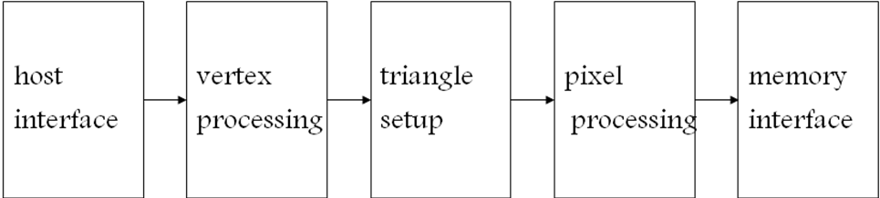

Fig.1:Block diagram of a graphics pipeline

The different stages in a graphics pipeline are:

Host Interface

The host interface is the communication bridge between the CPU and the GPU. It receives commands from the CPU and also pulls geometry information from system memory. It outputs a stream of vertices in object space with all their associated information (normals, texture coordinates, per vertex color etc.)

Vertex Processing

The vertex processing stage receives vertices from the host interface in object space and outputs them in screen space. This may be a simple linear transformation, or a complex operation involving morphing effects. Normals, texcoords, etc. are also transformed. No new vertices are created in this stage, and no vertices are discarded (input/output has 1:1 mapping)

Triangle Setup

In this stage geometry information becomes raster information (screen space geometry is the input, pixels are the output). Prior to rasterization, triangles that are backfacing or are located outside the viewing frustrum are rejected. Some GPUs also do some hidden surface removal at this stage. A fragment is generated if and only if its center is inside the triangle. Every fragment generated has its attributes computed to be the perspective correct interpolation of the three vertices that make up the triangle.
Fragment Processing
Each fragment provided by triangle setup is fed into fragment processing as a set of attributes (position, normal, texcoord etc), which are used to compute the final color for this pixel. The computations taking place here include texture mapping and math operations, typically the bottleneck in modern applications.
Memory Interface
Fragment colors provided by the previous stage are written to the framebuffer, which used to be the biggest bottleneck before fragment processing took over. Before the final write occurs, some fragments are rejected by the zbuffer, stencil and alpha tests. On modern GPUs, z and color are compressed to reduce framebuffer bandwidth (but not size).
Historically, the operations available at the vertex and fragment stages were configurable but not programmable. For instance, one of the key computations at the vertex stage is computing the colour at each vertex as a function of the vertex properties and the lights in the scene. In the fixed-function pipeline, the programmer could control the position and colour of the vertex and the lights, but not the lighting model that determined their interaction.

2.2 EVOLUTION OF GPU ARCHITECTURE

The fixed-function pipeline lacked the generality to efficiently express more complicated shading and lighting operations that are essential for complex effects. The key step was replacing the fixed-function per-vertex and per-fragment operations with user-specified programs run on each vertex and fragment. These vertex programs and fragment programs have become increasingly more capable, with larger limits on their size and resource consumption, with more fully featured instruction sets, and with more flexible control-flow operations.

After many years of separate instruction sets for vertex and fragment operations, current GPUs support the unified Shader Model 4.0 on both vertex and fragment shaders.
• The hardware must support shader programs of at least 65 k static instructions and unlimited dynamic instructions.
• The instruction set, for the first time, supports both 32-bit integers and 32-bit floating-point
numbers.
• The hardware must allow an arbitrary number of both direct and indirect reads from global memory (texture).
• Finally, dynamic flow control in the form of loops and branches must be supported.

As the shader model has evolved and become more powerful, and GPU applications of all types have increased vertex and fragment program complexity, GPU architectures have increasingly focused on the programmable parts of the graphics pipeline. Indeed, while previous generations of GPUs could best be described as additions of programmability to a fixed-function pipeline, today’s GPUs are better characterized as a programmable engine surrounded by supporting fixed-function units.

2.3. ARCHITECTURE OF A MODERN GPU

The GPU is built for different application demands than the CPU: large, parallel computation requirements with an emphasis on throughput rather than latency. Consequently, the architecture of the GPU has progressed in a different direction than that of the CPU.

In a pipeline of tasks such as those in graphics APIs, the output of each successive task is fed into the input of the next task. The pipeline exposes the task parallelism of the application, as data in multiple pipeline stages can be computed at the same time; within each
stage, computing more than one element at the same time is data parallelism. To execute such a pipeline, a CPU would take a single element (or group of elements) and process the first stage in the pipeline, then the next stage, and so on. The CPU divides the pipeline in time, applying all resources in the processor to each stage in turn. GPUs have historically taken a different approach. The GPU divides the resources of the processor among the different stages, such that the pipeline is divided in space, not time. The part of the processor working on one stage feeds its output directly into a different part that works on the next stage.

This machine organization was highly successful in fixed-function GPUs for two reasons. First, the hardware in any given stage could exploit data parallelism within that stage, processing multiple elements at the same time. Because many task-parallel stages were running at any time, the GPU could meet the large compute needs of the graphics pipeline. Secondly, each stage’s hardware could be customized with special-purpose hardware for its given task, allowing substantially greater compute and area efficiency over a general-purpose solution. For instance, the rasterization stage, which computes pixel coverage information for each input triangle, is more efficient when implemented in special-purpose hardware. As programmable stages (such as the vertex and fragment programs) replaced fixed-function stages, the special-purpose fixed function components were simply replaced by programmable components, but the task-parallel organization did not change.

The result was a lengthy, feed-forward GPU pipeline with many stages, each typically accelerated by special purpose parallel hardware. In a CPU, any given operation may take on the order of 20 cycles between entering and leaving the CPU pipeline. On a GPU, a graphics operation may take thousands of cycles from start to finish. The latency of any given operation is long. However, the task and data parallelism across and between stages delivers high throughput.

The major disadvantage of the GPU task-parallel pipeline is load balancing. Like any pipeline, the performance of the GPU pipeline is dependent on its slowest stage. If the vertex program is complex and the fragment program is simple, overall throughput is dependent on the performance of the vertex program. In the early days of programmable stages, the instruction set of the vertex and fragment programs were quite different, so these stages were separate. However, as both the vertex and fragment programs became more fully featured, and as the instruction sets converged, GPU architects reconsidered a strict task-parallel pipeline in favour of a unified shader architecture, in which all programmable units in the pipeline share a single programmable hardware unit. While much of the pipeline is still task-parallel, the programmable units now divide their time among vertex work, fragment work, and geometry work (with the new DirectX 10 geometry shaders). These units can exploit both task and data parallelism. As the programmable parts of the pipeline are responsible for more and more computation within the graphics pipeline, the architecture of the GPU is migrating from a strict pipelined task-parallel architecture to one that is increasingly built around a single unified data-parallel programmable unit.

AMD introduced the first unified shader architecture for modern GPUs in its Xenos GPU in the XBox 360 (2005). Today, both AMD’s and NVIDIA’s flagship GPUs feature unified shaders (Fig. 1). The benefit for GPU users is better load-balancing at the cost of more complex hardware. The benefit for GPGPU users is clear: with all the programmable power in a single hardware unit, GPGPU programmers can now target that programmable unit directly, rather than the previous approach of dividing work across multiple hardware units.

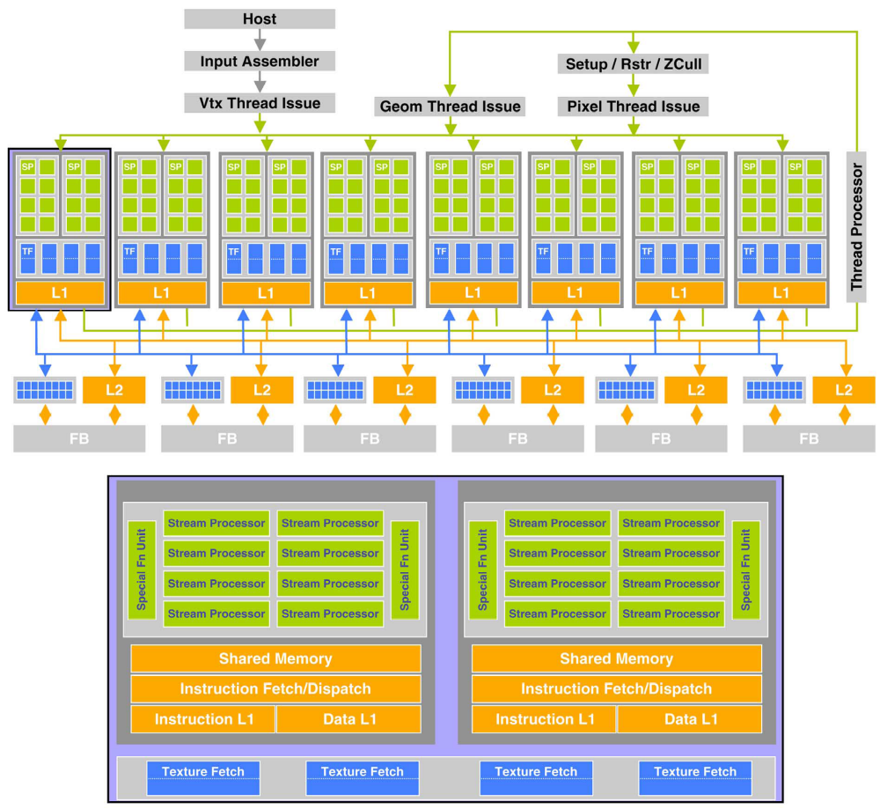

Fig. 1. Today, both AMD and NVIDIA build architectures with unified, massively parallel programmable units at their cores. (a) The NVIDIA GeForce 8800 GTX (top) features 16 streaming multiprocessors of 8 thread (stream) processors each. One pair of streaming multiprocessors is shown below; each contains shared instruction and data caches, control logic, a 16 kB shared memory, eight stream processors, and 2 special function units.

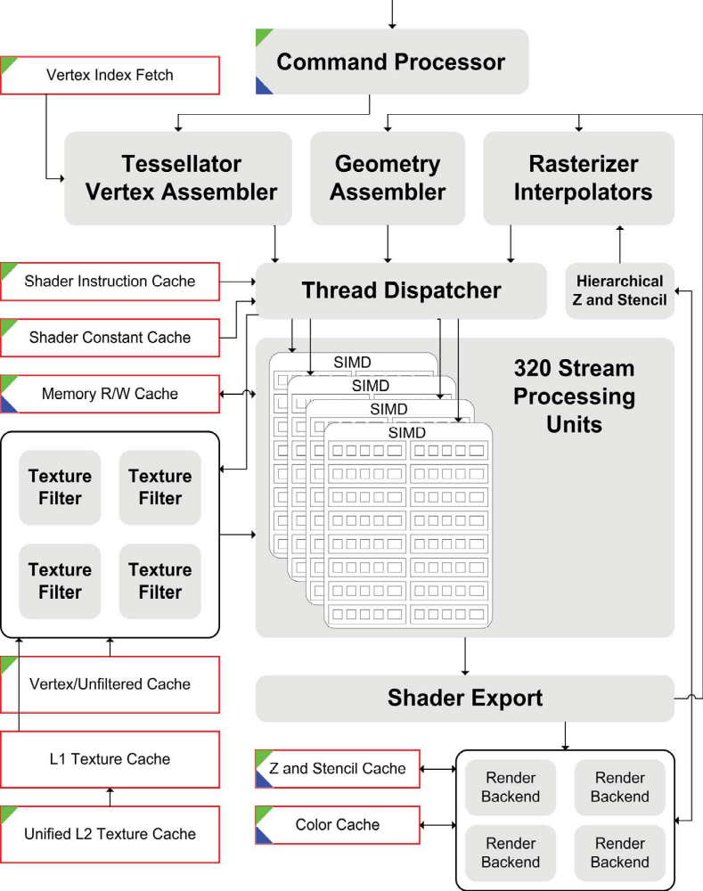

Fig. 1. (continued).(b) AMD’s Radeon HD 2900XT contains 320 stream processing units arranged into four SIMD arrays of 80 units each. These units are arranged into stream processing blocks containing five arithmetic logic units and a branch unit. In the diagram, gray ovals indicate logic units and red-bordered rectangles indicate memory units. Green triangles at the top left of functional units are units that read from memory, and blue triangles at the bottom left write to memory.
- GPU COMPUTING

3.1 THE GPU PROGRAMMING MODEL

The programmable units of the GPU follow a single program multiple-data (SPMD) programming model. For efficiency, the GPU processes many elements (vertices or fragments) in parallel using the same program. Each element is independent from the other elements, and in the base programming model, elements cannot communicate with each other. All GPU programs must be structured in this way: many parallel elements, each processed in parallel by a single program.

Each element can operate on 32-bit integer or floating point data with a reasonably complete general-purpose instruction set. Elements can read data from a shared global memory, a gather operation and, with the newest GPUs, also write back to arbitrary locations in shared global memory, a scatter operation.

This programming model is well suited to straight-line programs, as many elements can be processed in lockstep running the exact same code. Code written in this manner is single instruction, multiple data (SIMD). As shader programs have become more complex, programmers prefer to allow different elements to take different paths through the same program, leading to the more general SPMD model.

One of the benefits of the GPU is its large fraction of resources devoted to computation. Allowing a different execution path for each element requires a substantial amount of control hardware. Instead, today’s GPUs support arbitrary control flow per thread but impose a penalty for incoherent branching. GPU vendors have largely adopted this approach. Elements are grouped together into blocks, and blocks are processed in parallel. If elements branch in different directions within a block, the hardware computes both sides of the branch for all elements in the block. The size of the block is known as the branch granularity and has been decreasing with recent GPU generations -today, it is on the order of 16 elements.

- CONCLUSION

REFERENCES

[1] John D. Owens, Mike Houston, David Luebke, Simon Green, John E. Stone, and James C. Phillips, GPU Computing, Proceedings of the IEEE, Vol. 96, No. 5, May 2008,page no:879-899.
[2]http://www.nvidia.com/object/GPU_Computing.html
[3] Prof. Roger Crawfis , Modern GPU architectures: Game Design and Project, CSE 694G

