3D OBJECT REPRESENTATION
One of the major concepts in computer graphics is modeling of objects. Modeling of objects means describing the objects in terms of their geometric properties (like shape and size) and how they interact with light (reflect, transmit).A graphics system usually uses a set of primitives or geometric forms to model variety of objects . Geometric forms that are often used as primitives include points, lines, polylines, polygons and polyhedra. More complex geometric form includes curves, curved surface patches, and quadratic surfaces.

SIMPLE GEOMETRIC FORMS

Points and lines
The basic building blocks of computer graphics can be termed as points and lines. How do we specify a point? We do it by specifying its coordinate sin three or two dimensional space. For example, a point can be represented as P (x, y, z). How do we specify a line segment? It can be done by specifying the two end points P1(x1, y1, z1) and P2(x2, y2, z2).

Polylines
What is a polyline? It’s a chain of connected line segments. It is specified by giving the vertices or nodes that defines the line segment. For example, a polyline can be defined as P0, P1…, Pn. The first vertex of the polyline is called the starting point or the initial point and the last vertex is called the terminal point or the final point.

Polygons
How do you specify a polygon? A polygon can be treated as a closed polyline, that is, a polyline where the initial and the terminal vertices coincides. It is specified by its vertex list as P0, P1,….Pn, P0.The edges of the polygon are specified as line segments P0P1, P1P2, ………….PnP0. What is a planar polygon? A polygon in which all vertices lie on the same plane can be called as a planar polygon.

WIRE FRAME MODELS
A wire frame model consists of edges, vertices, and polygons. In a wire frame the vertices are connected by edges, and the polygons are sequences of vertices and edges. The edges may be curves or it may be straight line segments. If the edges are straight line segments then the wire frame model is called a polygonal net or polygonal mesh.

The wire frame models are used in engineering applications. The advantage of wire frame model is that they are easy to construct. They are easy to clip and manipulate if they are composed of straight lines. But they cannot be used in building up realistic models. For modeling highly curved objects we will be forced to use very large number of polygons to achieve the illusions of roundness and smoothness.

Polyhedron
A polyhedron is a closed polygonal net in which each polygon is planar. A closed polygonal net means it encloses a definite volume. The polygons are called the faces of the polyhedron. In modeling, polyhedrons are quite often treated as solid objects (block)

POLYGON SURFACES
The boundary of a three dimensional graphics object can be represented by a set of polygon surfaces that enclose the object interior. The object descriptions are stores as sets of surface polygons. Therefore all polygon surfaces can be easily described with linear equations. A polygon representation of a polygon precisely defines the surface features of the object.

Polygon Tables
How do you specify a polygon surface? This can be done by using a set of vertex coordinates and associated attributes parameters. We use polygon tables to store such information. These tables are used in processing, display and manipulation of objects in a scene. The polygon tables can be categorized into two: geometric tables and attribute tables. The geometric table contains vertex coordinates and parameters to identify the spatial orientation of the polygon surfaces. The attribute table contains information about the degree of transparency of the object and its surface reflectivity and texture characteristics.

Now let’s see how the geometric data is stored. This can be done by creating three lists:
- Vertex table
- Edge table
- Polygon table
The coordinate value for each vertex in the object is stored in the vertex table. The edge table contains the list of vertices that forms each edge. The polygon table contains the list of edges that forms the polygon surfaces. Now how are these list linked inter related? There is a back pointer pointing from the edge table to the vertex table. Similarly there is another pointer that points back to the edge table from the polygon table.

Now how do you construct a polyhedron from these three tables? At first, the polygon surface table will be searched to identify the edges that compose the polygon. From the polygon table the information about the edges are obtained. Now we need to find the details of the edges. The details of the edges are stored in the edge table. Using the pointer from the polygon table we move to the edge table to locate the vertices that compose the edges of the polygon. From the edge table we will get the details of the vertices that compose each edge. But now we need to get the information about each vertex. These details are stored in the vertex table. By using the pointer from the edge table to the vertex table we can get the details about the x, y, and z coordinates that compose each vertex.

We can always add extra information to the data tables for faster information extraction. For example we could expand the edge table to include forward pointers into the polygon table so that common edges between the polygons could be identified more rapidly. Similarly, the vertex table could be expanded so that the vertices are cross reference to corresponding edges. We can also store additional information in the data tables like the slope foe each edge and the coordinate extent for each polygon.
We can eliminate the edge table by letting the polygon table reference the vertices directly, but we can run into problems, such as drawing some edges twice, because we don't realize that we have visited the same set of points before, in a different polygon. We could go even further and eliminate the vertex table by listing all the coordinates explicitly in the polygon table, but this wastes space because the same points appear in the polygon table several times.
Let’s consider the example of a polyhedron with two surfaces. The three tables that describes the polygon is as shown in the figure

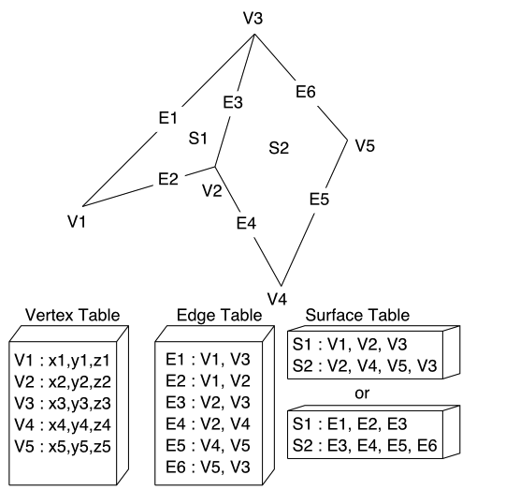

Now what abut the spatial orientation of the individual surface of the object? Often in the graphics pipeline, we need to know the orientation of an object. This information is obtained from the equation of the plane that describes the polygon.

The equation of the plane can be expressed as Ax + By + Cz = 0 where (x, y, z) is any point on the plane and coefficients A, AB, C, and D are constants defining the spatial properties of the plane. Here the value of ABCD can be obtained by solving the set of three plane equations using the coordinate for three non collinear points in the plane. For this purpose let us select three consecutive polygon vertices (x1, y1, z1), (x2, y2, z2), (x3, y3, z3) and solve the simultaneous linear plane equations.

(A/D)x _{k} + (B/D)y _{k} + (C/D)z _{k} = -1

Then we can use the equation to determine whether a point is on the inside or outside of the plane formed by this polygon:

Ax + By + Cz + D < 0 = the point (x, y, z) is inside the surface
Ax + By + Cz + D > 0 = the point (x, y, z) is outside the surface

Normal to the plane
The coefficients A, B, and C can also be used to determine a vector normal to the plane of the polygon. This vector, called the surface normal, is given simply by:
N = (A, B, C).
If we specify the vertices of a polygon counterclockwise when viewing the outer side, in a right-handed coordinate system, the surface normal N will point from inside to outside. You can verify this from an alternate definition for N, based on three vertices:

N = (V2 - V1) x (V3 - V1) = (A, B, C)

Polygon Meshes

Objects can be modeled by several polygon functions. But when object surfaces are to be tiled, it is more convenient to specify the surface faces with mesh function. One type of the polygon mesh is the triangle strip. The function produces n – 2 triangles given the coordinate for n vertices. A triangle list will produce only n/3 triangles for a polygon with n vertices.

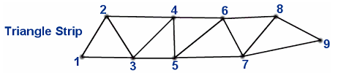
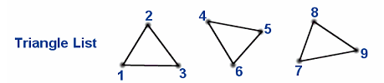

Another similar function is the quadrilateral mesh, which generates a mesh of (n-1) by (m-1) quadrilaterals, given the coordinates for an n by m array of vertices. A quadrilateral mesh containing 12 quadrilaterals constructed from a 5 by 4 input vertex array is shown in the figure below
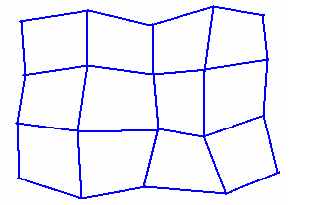

CURVES AND SURFACES

You know that objects with complex shapes occur frequently in our 3D world. Therefore special techniques have to be developed to model these objects so that we get realistic images. These objects can be approximated as plane faced polyhedra. For example the polyhedral approximation of a coffee cup may contain 1000 faces. In this case it will be difficult to generate and modify the shape of the cup. We need a more direct representation of shapes which is tractable both to the computer and to the person trying to make modifications on the shape.

Representation of curves

Let’s discuss some of the crucial properties that our representation must have. These properties are important in designing the curves.
- Control Points
- Multiple value
- Axis independence
- Global and local control
- Variation Diminishing property
- Versatility
- Order of Continuity

Control Points
How do you give shape to the curve? How do you control its shape? The answer to these questions is control points. Control points are a set of coordinate positions that indicates the general shape of the curve. It is by the control points the shape of the curve is controlled. The control points influence the shape of the curve. it is through these control points the curve pass. Examples are given below:

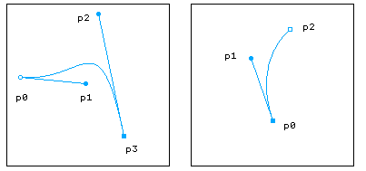
The line connecting the control points in order is called the control graph, or control polygon, or even characteristic polygon. If the curve passes exactly through each of the control points then the curve is said to interpolate the set of control points. If the curve doesn’t pass necessarily through the control points then it is said to approximate the set of control points. Examples re given below:
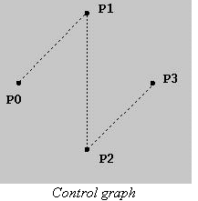
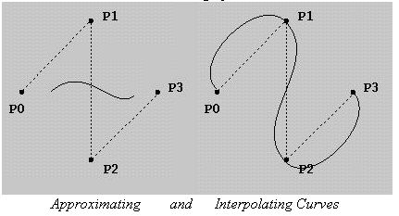

Multiple values: The curve can have multiple values. It is not a graph that is plotted by using a single values function. A curve can be multivalued with respect to all coordinate systems.
Axis independence: The shape of the curve must not change when the control points are measured in a different coordinate system. For example if the control points are rotated 60º the curve should rotate 60º but the shape of the curve should not change.
Global and local control: We know that control points are used to control the shape of the curve. When we try to manipulate or change the position of a control point the shape of the curve changes. Manipulation of the control point can bring in two effects on the curve. The shape of the curve gets affected entirely or the shape of the curve changes only in the region near to the control point .If the shape of the curve changes entirely then it is said to have global control. If the shape changes only in the region near the control point, it is said to have local control.
Variation-diminishing property: Certain curves have a tendency to amplify small irregularities in the shape outlined by the control points. But there are certain other curves that always smooth the designer’s control points diminishing the irregularities in the shape. A curve that oscillates about its control points is usually undesirable. But there will not be such oscillations in curves that possess variation diminishing property. The curve will always tend to smooth out the sequence of control points.
Versatility: The shapes of the curves formed from the control points should not be limited. It should not lack versatility. How can we bring in versatility in curve designs? This can be done by adding or removing control points from the framework. For example, a straight line can be formed from two control points. This straight line can be changed into a curve by simply adding one more control point. This third control point can create a large number of additional shapes by just changing its location.
Order of continuity: Using simple curves simple object shapes can be modeled but for complex shapes we need to depend on complex curves. Now you know how a curve is formed from the control points. Now let’s discuss how a complex curve is formed? A complex curve can be formed by joining simple curves together. The shape that cannot be described by a simple curve can often be described by several curves joined together.
When the curves are joined the order of continuity has to be maintained. There are three orders of continuity defined. They are:
- Zero Order
- First order
- Second order
Zero order continuity means simply that two curves meet. First order continuity requires the curve to be tangent at the point of intersection. Second order continuity requires that the curvatures be the same.
BEZIER METHODS
This spline approximation method was developed by P.Bezier, a French engineer, for use in the design of Renault automobile bodies.
Bezier Curves
In general a Bezier curve section can be fitted to any number of control points. The degree of the polynomial is determined by two factors. The number of control points and their relative position are the factors that contribute to the degree of the Bezier curve. The degree of the Bezier curve is one less than the number of control points used. If there are n + 1 control points then the degree of the Bezier curve will be n. For example, three points will generate a parabola and four control points will generate a cubic curve.
As we know the main form used to model curves and surfaces is the parametric function or vector- valued function. A point on the curve is represented as a vector:
P(u) = [ x(u) y(u) z(u)]
Bezier defines the curve P(u) in terms of the location of n+1 control points pi
P(u)
where B_{i, n} (u) is a blending function
B_{i, n} (u) = C(n,i)u ^{i}(1-u) ^{n-i}
And C(n,i) is the binomial coefficient, C(n,i)= n!/(i! (n-i)!)
Here pi is the control point where pi can be defined as [xi yi zi].
X(u)= ∑Xk BEZk,n(u) 0<k<n
Y(u)= ∑Yk BEZk,n(u) 0<k<n
Z(u)= ∑Zk BEZk,n(u) 0<k<n
Here there are n+1 control points as pi ranges from 0 to n. These control points along with the blending function gives the shape to the curve. The blending function defined influences the control points i.e. it actually blends the control point pi. The blending functions are the key to the behaviour of Bezier curves.
Here let us take an example of a Bezier curve with four control points. So pi ranges from 0 to 3. Therefore the Bezier parametric function can be written as
P(u) = p₀ B _{0,3} + p₁ B _{1,3}+ p₂ B _{2,3}+ p₃ B _{3,3}
Here the control points pi’s are influenced by their respective blending functions. The graph
Algorithm:
- Compute C(n,k), k ranging from 0 to n where n =Control points-1
- Repeat steps 3,4,5,6 and 7 with k ranging from 1 to n
- blend=nCk * uk * (1-u)n-k
- x=x+x*blend
- y=y+y*blend
- z=z+z*blend
- Join the points
- End
Properties:

- Curve always passes through first and last control points
i.e. P(0)=P0
P(1)=Pn

- Values of the parametric first derivatives at the endpoints can be calculated from control point coordinates as
P`(0)=-nP0+nP1
P`(1)=-nP¬n-1+nPn

- Slope at the beginning of curve is along the line joining the first two control points and the slope at the end of the curve is along the line joining the last two endpoints.

- Curve lies within a convex hull (convex polygon boundary) of the control points. The curve is contained by the polygon.

Applications:

- Painting and drawing packages-for drawing curves
- CAD systems- for drawing smooth curves
- Curve Fitting- to fit a curve along the layout of an object
- Animation- to transform from one shape to another or to simulate a motion
- Accelerating 3D Graphics- to simulate transformation of an object

B-Spline Curves
- B-spline functions of order m are piecewise polynomials of degree m-1. They are m-2 smooth.
- The B-spline functions form a basis; every spline function can be written as a linear combination of B-splines.
- Nk,m(t) has support [tk, t k+m].
- A B-spline curve lies within the convex hull of m consecutive control points.
- Knots can appear multiple times within the knot vector. A knot with multiplicity m will cause the resulting curve to interpolate the corresponding control point.
- Affine invariance.

