RT 702 - Computer Graphics
Class Assignment Test on 6th September 2007
S7 CS and IT
________________________________________________________________________
SET A
- What is the function of a Display processor?
Display processor is sometimes referred to as graphics controller or a display coprocessor. The purpose of the display processor is to free the CPU from the graphics chores. A major task of the display processor is digitizing a picture definition given in an application program into a set of pixel-intensity values for storage in the frame buffer. This digitization process is called scan conversion.
Display processor are deigned to perform different other functions. They are
- To generate various line styles (dashed , dotted, or solid)
- To display colour areas
- To perform certain manipulations and transformations on displayed objects
- To interface with interactive input devices, such as mouse

- How is the DDA algorithm implemented?
DDA algorithm is an incremental scan conversion method. Here we perform calculations at each step using the results from the preceding step. The characteristic of the DDA algorithm is to take unit steps along one coordinate and compute the corresponding values along the other coordinate. The unit steps are always along the coordinate of greatest change, e.g. if dx = 10 and dy = 5, then we would take unit steps along x and compute the steps along y.

Suppose at step i we have calculated (x_{i}, y_{i}) to be a point on the line. Since the next point (x _{i+1},y _{i+1}) should satisfy ∆y/∆ x =m where ∆y= y _{i+1}–yi and ∆ x= x _{i+1}–xi , we have y _{i+1}= y_{i} + m∆ x or x _{i+1}=x_{i}+ ∆ y/m

These formulas are used in DDA algorithm as follows. When |m| ≤ 1, we start with x = x1’≤ (assuming that x1’ <x2’) and y = y1’, and set ∆ x =1( i.e., unit increment in the x direction). The y coordinate of each successive point on the line is calculated using y _{i+1}= y_{i} + m. When |m| >1, we start with x= x1’ and y= y1’ (assuming that y1’ < y2’), set ∆ y =1 ( i.e., unit increment in the y direction). The x coordinate of each successive point on the line is calculated using x _{i+1}=x_{i}+ 1/m. This process continues until x reaches x2’(for m| ≤ 1 case )or y reaches y2’ (for m| > 1 case ) and all points are scan converted to pixel points.

The explanation is as follows: In DDA algorithm we have to find the new point xi+1 and yi+1 from the existing points xi and yi. As a first step here we identify the major axis and the minor axis of the line to be drawn. Once the major axis is found we sample the major axis at unit intervals and find the value in the other axis by using the slope equation of the line. For example if the end points of the line is given as (x1,y1)= (2,2) and (x2, y2)= (9,5). Here we will calculate y2-y1 and x2-x1 to find which one is greater. Here y2-y1 =3 and x2-x1 =7; therefore here the major axis is the x axis. So here we need to sample the x axis at unit intervals i.e.∆ x = 1 and we will find out the y values for each ∆ x in the x axis using the slope equation.
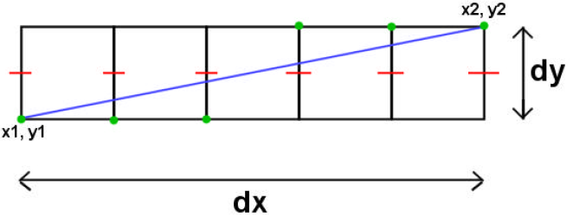
In DDA we need to consider two cases; one is slope of the line less than or equal to one (|m| ≤ 1)and slope of the line greater than one (m| > 1). When |m| ≤ 1 means y2-y1 = x2-x1 or y2-y1 <x2-x1.In both these cases we assume x to be the major axis. Therefore we sample x axis at unit intervals and find the y values corresponding to each x value. We have the slope equation as
∆ y = m ∆ x
y2-y1 = m (x2-x1)

In general terms we can say that y _{i+1} - y_{i} = m(x _{i+1} - x_{i} ). But here ∆ x = 1; therefore the equation reduces to y _{i+1}= y_{i} + m = y_{i} + dy/dx.
When m| > 1 means y2-y1> x2-x1 and therefore we assume y to be the major axis. Here we sample y axis at unit intervals and find the x values corresponding to each y value.We have the slope equation as
∆ y = m ∆ x
y2-y1 = m (x2-x1)

In general terms we can say that y _{i+1} - y_{i} = m(x _{i+1} - x_{i} ). But here ∆ y = 1; therefore the equation reduces to 1 = m(x _{i+1} - x_{i)}. Therefore
x _{i+1}=x_{i}+ 1/m
x _{i+1}=x_{i}+ dx/dy

The Algorithm is given below:
procedure DDA( x1, y1, x2, y2: integer);
var
dx, dy, steps: integer;
x_inc, y_inc, x, y: real;
begin
dx := x2 - x1; dy := y2 - y1;
if abs(dx) > abs(dy) then
steps := abs(dx); {steps is larger of dx, dy}
else
steps := abs(dy);
x_inc := dx/steps; y_inc := dy/steps;
{either x_inc or y_inc = 1.0, the other is the slope}
x:=x1; y:=y1;
set_pixel(round(x), round(y));
for i := 1 to steps do
begin
x := x + x_inc;
y := y + y_inc;
set_pixel(round(x), round(y));
end;
end; {DDA}
The DDA algorithm is faster than the direct use of the line equation since it calculates points on the line without any floating point multiplication.

- What is a frame buffer?
Interactive graphics display consists of three components
- A display controller
- A digital memory or frame buffer
- A television monitor
- A video controller

The display controller gets the inputs and commands from the user and determines the image to be displayed on the monitor. The display controller will divide the image into a number of pixels. This image which is to be displayed is stored in the frame buffer.
The image will be stored as a matrix of intensity values. The image will be displayed onto the television monitor and the video controller will act as a simple interface that passes the contents of the frame buffer to the monitor. The image must be repeatedly passed to the monitor, 30 or more times a second. This helps you to maintain a steady picture on the screen.

In the frame buffer the image is stored as a pattern of binary digital numbers. These binary digital numbers represents a rectangular array of picture elements or pixels (a picture can be divided into a number of picture elements or pixels. You will learn more about pixels in the coming lectures.). So corresponding to each pixel you have a binary digital number in the frame buffer. If your image is a black and white image you can represent the black pixels by 0 s and white pixels by 1s. Therefore a 16 X 16 array of black and white pixels could be represented by the binary values stored in the 32 8-bit bytes.

RT 702 - Computer Graphics
Class Assignment Test on 6th September 2007
S7 CS and IT
_____________________________________________________________________

SET B
- Explain and compare the working of raster scan and random scan display system.
The display systems can be broadly divided into two:
- Raster scan
- Random scan

Raster Scan Systems

In commonly used raster systems a fixed area is reserved for the frame buffer, and the video controller is given direct access to the frame buffer memory. Frame buffer locations and the corresponding screen positions are referenced in Cartesian coordinates.
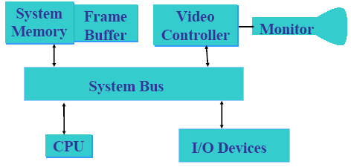
Architecture of a raster system with a fixed portion of the system memory reserved for the frame buffer

For the graphics monitor, the origin I defined at the lower left screen corner. The screen is represented as a two dimensional system i.e. the x values increasing to the right and the y values increasing from bottom to top. Each scan line is labeled as y _{max} at the top of the screen to 0 at the bottom. Along each scan line, screen pixel positions are labeled from 0 to x _{max}.

Raster Scan Display Processor

Raster Scan system may contain a separate display processor.

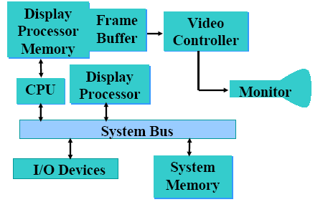
Raster Scan with Display processor

Raster Scan Display processor is sometimes referred to as graphics controller or a display coprocessor. The purpose of this processor is to free the CPU from the graphics tasks. But what is its major task? Its major task is to digitize a picture definition given in an application program into a set of pixel intensity values for storage in the frame buffer. This digitization process is called scan conversion. Graphics commands specifying straight lines and other geometric shapes can be can converted into a set of intensity points. When you scan convert a straight line segment we have to locate the pixel positions closest to the line path and store the intensity for each position in the frame buffer.

Characters can be defined with rectangular grids or they can be defined with outlines. The array size for character grids can vary from about 5 by 7 or 9 by 12.
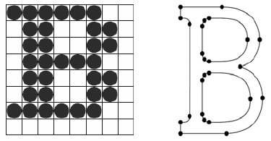
Defined as a grid of pixel position Defined as a curve outline

Display processor are deigned to perform different other functions. They are
- To generate various line styles (dashed , dotted, or solid)
- To display colour areas
- To perform certain manipulations and transformations on displayed objects
- To interface with interactive input devices, such as mouse
How is the frame buffer implemented?
It is implemented as a linked list and encodes the intensity information. One way to do this is to store each scan line as a set of integer pairs. One number of each pair indicates an intensity value and the second number specifies the number of adjacent pixels on the scan line that have that intensity. This technique is called run length encoding.

Raster Scan Display

Raster Scan methods have increasingly become the dominant technology since about 1975. These methods use the TV type raster scan. The growth in the use of such methods has been dependent on rapidly decreasing memory prices and on the availability of cheap scan generating hardware from the TV industry.

The screen is coated with discrete dots of phosphor, usually called pixels, laid out in a rectangular array. The image is then determined by how each pixel is intensified. The representation of the image used in servicing the refresh system is thus an area of memory holding a value for each pixel. This memory area holding the image representation is called the frame buffer.

The values in the frame buffer are held as a sequence of horizontal lines of pixel values from the top of the screen down. The scan generator then moves the beam in a series of horizontal lines with fly-back (non-intensified) between each line and between the end of the frame and the beginning of the next frame. This is illustrated below.

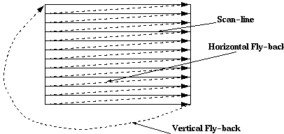

Unlike random-scan which is a line drawing device, refresh CRT is a point-plotting device. Raster displays store the display primitives (lines, characters, shaded and patterned areas) in a refresh buffer. Refresh buffer (also called frame buffer) stores the drawing primitives in terms of points and pixels components

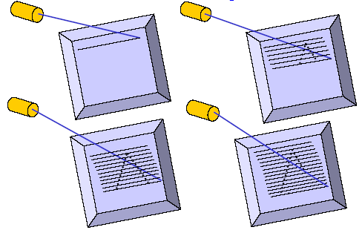
This scan is synchronized with the access of the intensity values held in the frame buffer.
The maximum number of points that can be displayed without overlap by a system is called the resolution and is quoted as the number of points per horizontal line versus the number of horizontal lines. Typical resolutions are 640*480, 1024*768, and 1280*1024. The maximum resolution is determined by the characteristics of the monitor and/or by the memory capacity available for storing the frame buffer.

Random Scan Systems

In Random Scan Systems an application program is input and stored in the system memory along with a graphics package. Graphics commands in the application program are translated by the graphics package into a display file stored in the system memory. This display file is then accessed by the display processor to refresh the screen. The display processor cycles through each command in the display file program once during every refresh cycle. Sometimes the display processor in the random scan system is referred to as a display processing unit or a graphics controller. Graphics patterns are drawn on a random scan system by directing the electron beam along the component lines of picture. Lines are defined by the values for their coordinate endpoints, and these input coordinate values are converted to x and y deflection voltage. A scene is then drawn one line at a time by positioning the beam to fill in the line between specified endpoints

Random Scan Display

Random scan displays, often termed vector Vector, Stroke, and Line drawing displays, came first and are still used in some applications. Here the characters are also made of sequences of strokes (or short lines). The electron gun of a CRT illuminates straight lines in any order. The display processor repeatedly reads a variable 'display file' defining a sequence of X,Y coordinate pairs and brightness or color values, and converts these to voltages controlling the electron gun.
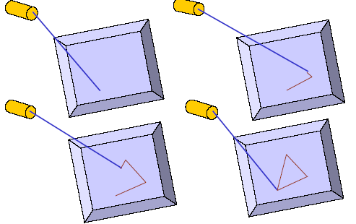

In random scan display an electron beam is deflected from endpoint to end-point. The order of deflection is dictated by the arbitrary order of the display commands. The display must be refreshed at regular intervals – minimum of 30 Hz (fps) for flicker-free display.

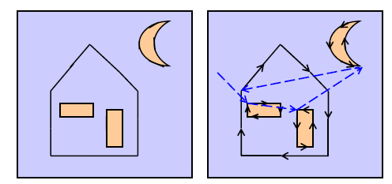

Ideal line drawing Random Scan Display

- Explain the working of a shadow mask CRT?
In Shadow Mask CRT tiny holes in a metal plate separate the colored phosphors in the layer behind the front glass of the screen. The holes are placed in a manner ensuring that electrons from each of the tube's three cathode guns reach only the appropriately-colored phosphors on the display. All three beams pass through the same holes in the mask, but the angle of approach is different for each gun. The spacing of the holes, the spacing of the phosphors, and the placement of the guns is arranged so that for example the blue gun only has an unobstructed path to blue phosphors. The red, green, and blue phosphors for each pixel are generally arranged in a triangular shape (sometimes called a "triad"). All early color televisions and the majority of computer monitors, past and present, use shadow mask technology.

Traditionally, shadow masks have been made of materials which temperature variations cause to expand and contract to the point of affecting performance. The energy the shadow mask absorbs from the electron gun in normal operation causes it to heat up and expand, which leads to blurred or discolored (see doming) images. The invar shadow mask is composed of the nickel-iron alloy invar. Therefore it expands and contracts much less than other materials in response to temperature changes. This property allows displays made with this technology to provide a clearer, more accurate picture. It also reduces the amount of long-term stress and damage to the shadow mask that can result from repeated expand/contract cycles, thus increasing the display's life expectancy.

In other words, In Shadow Mask CRT, before the stream of electrons produced by the CRT's cathode reach the phosphor coated faceplate, it encounters the shadow mask, a sheet of metal etched with a pattern of holes. The mask is positioned in the glass funnel of the CRT during manufacture and the phosphor is coated onto the screen so that electrons coming from the red, green and blue gun positions only land on the appropriate phosphor.
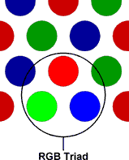

RGB color model

Stray electrons strike the shadow mask and are absorbed by it, generating a great deal of heat, which in turn causes the metal to expand. To allow flatter CRTs to be made, the metal most commonly used now for shadow masks is Invar, an alloy of iron and nickel. The metal has a low coefficient of expansion and its name derives from the supposed invariability of its dimensions when heat is applied. In reality, its dimensions are not completely invariable and the build up of heat in a shadow mask can lead to a form of distortion known as doming, where the centre of the mask bulges towards the faceplate slightly.

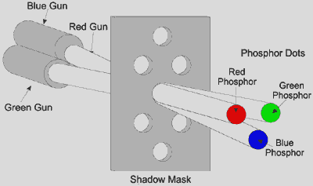

An alternative to the shadow mask which is less prone to distortion, the aperture grille , was included as part of the design of Trinitron CRTs by Sony in 1968 and Mitsubishi in its Diamondtron products in the early 1990s.

- What is the function of a video controller?
Interactive graphics display consists of three components
- A display controller
- A digital memory or frame buffer
- A television monitor
- A video controller

The display controller gets the inputs and commands from the user and determines the image to be displayed on the monitor. The display controller will divide the image into a number of pixels. This image which is to be displayed is stored in the frame buffer.
The image will be stored as a matrix of intensity values. The image will be displayed onto the television monitor and the video controller will act as a simple interface that passes the contents of the frame buffer to the monitor. The image must be repeatedly passed to the monitor, 30 or more times a second. This helps you to maintain a steady picture on the screen.

In the frame buffer the image is stored as a pattern of binary digital numbers. These binary digital numbers represents a rectangular array of picture elements or pixels (a picture can be divided into a number of picture elements or pixels. You will learn more about pixels in the coming lectures.). So corresponding to each pixel you have a binary digital number in the frame buffer. If your image is a black and white image you can represent the black pixels by 0 s and white pixels by 1s. Therefore a 16 X 16 array of black and white pixels could be represented by the binary values stored in the 32 8-bit bytes. Now what happens to this data?

The video controller simply reads each successive byte of data from the frame buffer and converts its 0s and 1s into the corresponding video signal. This signal is then fed into the TV monitor, producing a black and white pattern on the screen. The video controller repeats this operation 30 times a second in order to maintain a steady picture on the TV screen.

RT 702 - Computer Graphics
Class Assignment Test on 6th September 2007
S7 CS and IT
_____________________________________________________________________

SET C
- What are the applications of Computer Graphics?
The following are also considered graphics applications:

Paint programs: Allow you to create rough freehand drawings. The images are stored as bit maps and can easily be edited. It is a graphics program that enables you to draw pictures on the display screen which is represented as bit maps (bit-mapped graphics). In contrast, draw programs use vector graphics (object-oriented images), which scale better. Most paint programs provide the tools shown below in the form of icons. By selecting an icon, you can perform functions associated with the tool. In addition to these tools, paint programs also provide easy ways to draw common shapes such as straight lines, rectangles, circles, and ovals.

Illustration/design programs: Supports more advanced features than paint programs, particularly for drawing curved lines. The images are usually stored in vector-based formats. Illustration/design programs are often called draw programs.

Presentation graphics software: Lets you create bar charts, pie charts, graphics, and other types of images for slide shows and reports. The charts can be based on data imported from spreadsheet applications.

A type of business software that enables users to create highly stylized images for slide shows and reports. The software includes functions for creating various types of charts and graphs and for inserting text in a variety of fonts. Most systems enable you to import data from a spreadsheet application to create the charts and graphs. Presentation graphics is often called business graphics.

Animation software: Enables you to chain and sequence a series of images to simulate movement. Each image is like a frame in a movie. It can be defined as a simulation of movement created by displaying a series of pictures, or frames. A cartoon on television is one example of animation. Animation on computers is one of the chief ingredients of multimedia presentations. There are many software applications that enable you to create animations that you can display on a computer monitor.

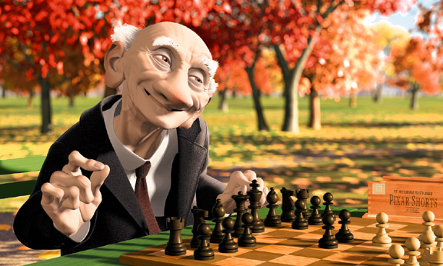

An Animated Picture

There is a difference between animation and video. Whereas video takes continuous motion and breaks it up into discrete frames, animation starts with independent pictures and puts them together to form the illusion of continuous motion.

CAD software: Enables architects and engineers to draft designs. It is the acronym for computer-aided design. A CAD system is a combination of hardware and software that enables engineers and architects to design everything from furniture to airplanes. In addition to the software, CAD systems require a high-quality graphics monitor; a mouse, light pen, or digitizing tablet for drawing; and a special printer or plotter for printing design specifications.

CAD systems allow an engineer to view a design from any angle with the push of a button and to zoom in or out for close-ups and long-distance views. In addition, the computer keeps track of design dependencies so that when the engineer changes one value, all other values that depend on it are automatically changed accordingly.
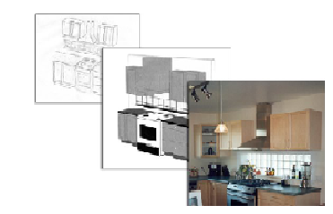
From pencil sketch to Computer Aided Design to Real Design.

Until the mid 1980s, all CAD systems were specially constructed computers. Now, you can buy CAD software that runs on general-purpose workstations and personal computers.

Desktop publishing: Provides a full set of word-processing features as well as fine control over placement of text and graphics, so that you can create newsletters, advertisements, books, and other types of documents. It means by using a personal computer or workstation high-quality printed documents can be produced. A desktop publishing system allows you to use different typefaces, specify various margins and justifications, and embed illustrations and graphs directly into the text. The most powerful desktop publishing systems enable you to create illustrations; while less powerful systems let you insert illustrations created by other programs.

As word-processing programs become more and more powerful, the line separating such programs from desktop publishing systems is becoming blurred. In general, though, desktop publishing applications give you more control over typographical characteristics, such as kerning, and provide more support for full-color output.

A particularly important feature of desktop publishing systems is that they enable you to see on the display screen exactly how the document will appear when printed. Systems that support this feature are called WYSIWYGs (what you see is what you get).

Until recently, hardware costs made desktop publishing systems impractical for most uses. But as the prices of personal computers and printers have fallen, desktop publishing systems have become increasingly popular for producing newsletters, brochures, books, and other documents that formerly required a typesetter.

Once you have produced a document with a desktop publishing system, you can output it directly to a printer or you can produce a PostScript file which you can then take to a service bureau. The service bureau has special machines that convert the PostScript file to film, which can then be used to make plates for offset printing. Offset printing produces higher-quality documents, especially if color is used, but is generally more expensive than laser printing.

In general, applications that support graphics require a powerful CPU and a large amount of memory. Many graphics applications—for example, computer animation systems—require more computing power than is available on personal computers and will run only on powerful workstations or specially designed graphics computers. This is true of all three-dimensional computer graphics applications.

In addition to the CPU and memory, graphics software requires a graphics monitor and support for one of the many graphics standards. Most PC programs, for instance, require VGA graphics. If your computer does not have built-in support for a specific graphics system, you can insert a video adapter card.
The quality of most graphics devices is determined by their resolution—how many pixels per square inch they can represent—and their color capabilities

- How does an interactive graphics system work?
Interactive Computer Graphics: Interactive Computer Graphics involves a two way communication between computer and user. Here the observer is given some control over the image by providing him with an input device for example the video game controller of the ping pong game. This helps him to signal his request to the computer. The computer on receiving signals from the input device can modify the displayed picture appropriately. To the user it appears that the picture is changing instantaneously in response to his commands. He can give a series of commands, each one generating a graphical response from the computer. In this way he maintains a conversation, or dialogue, with the computer.

Interactive computer graphics affects our lives in a number of indirect ways. For example, it helps to train the pilots of our airplanes. We can create a flight simulator which may help the pilots to get trained not in a real aircraft but on the grounds at the control of the flight simulator. The flight simulator is a mock up of an aircraft flight deck, containing all the usual controls and surrounded by screens on which we have the projected computer generated views of the terrain visible on take off and landing. Flight simulators have many advantages over the real aircrafts for training purposes, including fuel savings, safety, and the ability to familiarize the trainee with a large number of the world’s airports.

Working of an Interactive Graphics Display

Interactive graphics display consists of three components
- A display controller
- A digital memory or frame buffer
- A television monitor
- A video controller

The display controller gets the inputs and commands from the user and determines the image to be displayed on the monitor. The display controller will divide the image into a number of pixels. This image which is to be displayed is stored in the frame buffer.
The image will be stored as a matrix of intensity values. The image will be displayed onto the television monitor and the video controller will act as a simple interface that passes the contents of the frame buffer to the monitor. The image must be repeatedly passed to the monitor, 30 or more times a second. This helps you to maintain a steady picture on the screen.

In the frame buffer the image is stored as a pattern of binary digital numbers. These binary digital numbers represents a rectangular array of picture elements or pixels (a picture can be divided into a number of picture elements or pixels. You will learn more about pixels in the coming lectures.). So corresponding to each pixel you have a binary digital number in the frame buffer. If your image is a black and white image you can represent the black pixels by 0 s and white pixels by 1s. Therefore a 16 X 16 array of black and white pixels could be represented by the binary values stored in the 32 8-bit bytes. Now what happens to this data?

The video controller simply reads each successive byte of data from the frame buffer and converts its 0s and 1s into the corresponding video signal. This signal is then fed into the TV monitor, producing a black and white pattern on the screen. The video controller repeats this operation 30 times a second in order to maintain a steady picture on the TV screen.

Now what should be done to change or modify this image?
All we need is to modify the frame buffer’s contents. Set the frame buffer with a new set of values so that it represents the new image. In this way we can achieve effects like a rotating wheel and a wheel that grows and shrinks.

The figure given below gives an idea about the graphics display system
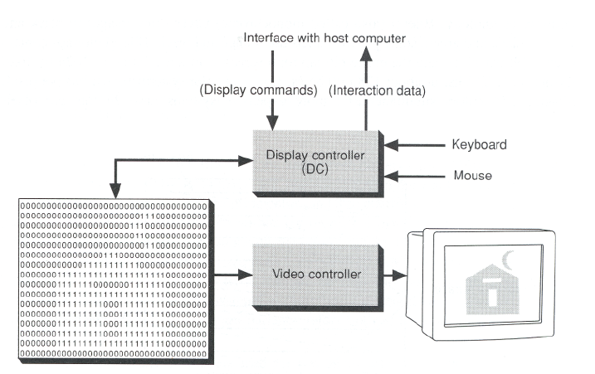

Graphics display system

- How do you scan convert a point?
A mathematical point (x, y) where x and y are real numbers within an image area, needs to be scan converted to a pixel at location (x’, y’). This may be done by making x’ to be the integer part of x, and y’ to be the integer part of y. In other words, x’ = floor(x) and y’ = floor(y), where function floor returns the largest integer that is less than or equal to the arguments. Doing so in essence places the origin of a continuous coordinate system for (x, y) at the lower left corner of the pixel grid in the image space. All the points that satisfy x’≤ x ≤ x’ + 1 and y’≤ y ≤ y’ + 1 are mapped to pixel (x’, y’).
Let us take for example a point P1(1.7, 0.8). It will be represented by pixel (1, 0). Points P2 (2.2, 1.3) and P3(2.8, 1.9) are both represented by pixel (2, 1).
Let us take another approach to align the integer values in the coordinate system for (x, y) with the pixel coordinates. Here we can convert (x, y) by making x’ = floor(x + 0.5) and y’ = floor(y + 0.5). This approach places the origin of the coordinate system for (x, y) at the center of pixel(0,0). All points that satisfy x’- 0.5 ≤ x ≤ x’+0.5 and y’- 0.5 ≤ y ≤ y’+0.5 are mapped to pixel (x’, y’). This means that points P1 and P2 are now both represented by pixel (2, 1), whereas point P3 is represented by pixel (3, 2).

