R 704 Register No:…………………

RAJAGIRI SCHOOL OF ENGINEERING AND TECHNOLOGY

B.TECH. DEGREE SECOND INTERNAL EXAMINATION, Oct 2008

S7CS

ADVANCED SOFTWARE ENVIRONMENTS

Time:2 hours Maximum Marks:50

Answer all questions

Part A
1) Write a note on distributed objects.
2) How stub and skeleton created in CORBA?
3) Explain how CORBA objects are referred in Java.
4) Explain the use of IDL in CORBA.
5) Write a note on DCOM.

(5x 4 = 20 marks)

Part B
6) Explain the implementation of CORBA server and client in C++ with an example.

7)
a)Explain Exception handling in CORBA.
b)Differentiate between single tier,two tier and N-tier Architectures.
8)
a) Explain the interoperability of ORBs.

b) Compare COM and CORBA.

(3x 10 =30 marks)

.
.
.

Answers

1. 1. Interfaces: is used to describe the contracts that describe the capabilities of the distributed object in the system
2.Data types: A doc must support data types that allow data to be transmitted to and from distributed objects. CORBA provides a rich set of types as well as support for enumerated types, constants and structures.
3.Marshaling & unmarshaling: This is for ensuring data integrity. Marshalling process packages data into a standard format so that it can be transmitted. Un marshalling is the reverse process.
4.Proxies, stubs & skeletons: mechanism used for the seamless access to remote objects.
5.Object handles:(object reference):used to reference distributed object instances within the context of a client’s programming language or script
6.Object creation: A DOC must provide a mechanism for creating a new instance of distributed object. A factory is a special type of object used to create other distributed object. In CORBA factory interfaces are user defined.
7.Object invocation: mechanism for invoking operations on a distributed object. CORBA provides both static and dynamic invocation.
8.Object destruction: mechanism for removing a distributed object instance from the system once it is no longer in use. But in CORBA distributed object remains alive forever unless explicitly or timed out

2. CORBA IDL stubs and skeletons serve as the ``glue'' between the client and server applications, respectively, and the ORB. The transformation between CORBA IDL definitions and the target programming language is automated by a CORBA IDL compiler. The use of a compiler reduces the potential for inconsistencies between client stubs and server skeletons and increases opportunities for automated compiler optimizations.

Suppoese one client is implemented by using c++ and server in JAVA. To generate Orbix stub and skeleton, we invoke the Orbix IDL compiler as shown,if we have created an IDL with name ch3.idl.
C:\orbix\bin\idl.exe –B ch3.idl
The following files are generated by the IDL compiler
Ch3.hh //declarations
Ch3c.cpp //Orbix client stub
Ch3s.cpp //Orbix server skeleton
The structure CORBA client, stub, skeleton and server ifor the example is as shown below.
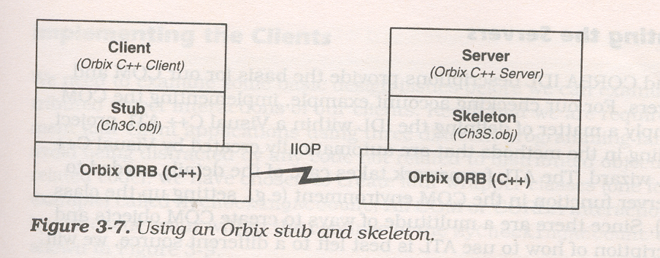
The stub (ch3c.obj) allows the client to link with the ORB and the skeleton (ch3s.obj) allows the server to link with ORB. The client and server ORBs communicate usion a protocol called IIOP – CORBA 2.0 standard communication protocol for TCP/IP.
The Java client invokes the VisiBroker IDL compiler to generate the VisiBroker client stub.
C:\vbroker\bin\idl2java...\...\servers\idl\ch3.idl
This Idljava2 compiler generates a package named ch3 corresponding to the ch3 IDL module. This package contains the stub classes needed by the java client.
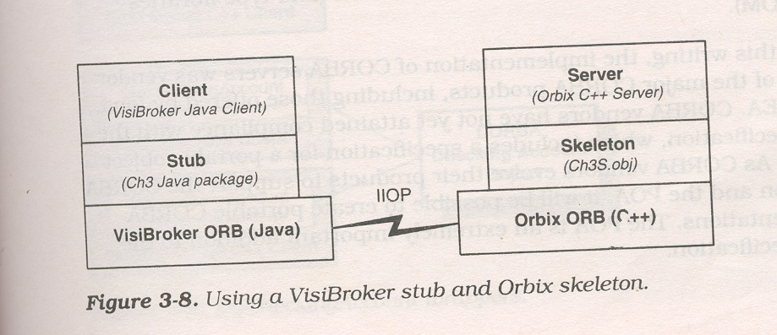

The VisiBroker and Orbix ORBs communicate using IIOP.

3) Creating a CORBA object in Java is even simpler than it is in C++ because the reference – counting issues do not convolute the solution

The program below shows how objects are created and referred in Java. The program creates an handle for MyCheckingAccount class and then refers it.

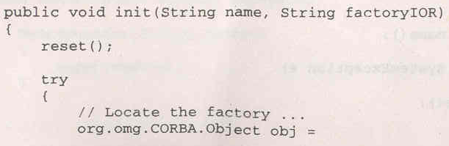
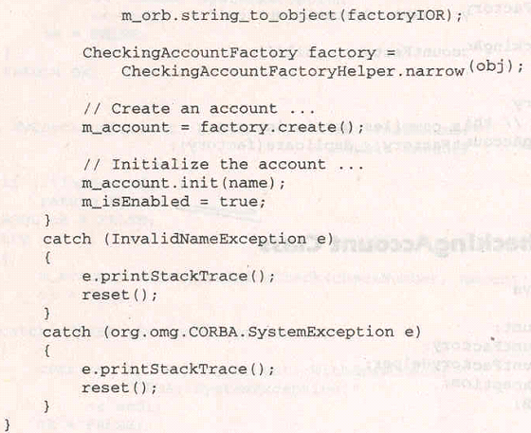

The MyCheckingAccount .init() method locates the factory by calling the String_to_Object() method on the ORB. Successful completion of String_to_object() method returns an object reference to the CORBA object instance uniquely identified by the factoryIOR parameter. The CORBA object reference is then narrowed to the CheckingAccountFactory object reference and returned to the caller. Next, the checking account instance is created by calling the create() method on the factory. Finally , the m_account.init() method is called using the customer name passed in as a parameter to MyCheckingAccount.init().

4.
An important part of CORBA is its use of the Interface Definition Language, which specifies interfaces between CORBA components. IDL facilitates CORBA's language independence—because interfaces described in IDL can be mapped to any supported programming language, CORBA applications are independent of the language(s) used to implement them. For example, a client written in C++ can communicate with a server written in Java, which in turn can communicate with another server written in Smalltalk, and so forth. IDL isn't an implementation language—you can't write applications in IDL. The sole purpose of IDL is to define interfaces that you can implement using a programming language.
A component that needs to provide remote services must specify its interface in an IDL. Recall that an interface consists of a set of opera-tions, and that access to a particular component's services is provided by the interface that the component supports. Actually, IDL defines a component's object model as defined by OMG. IDL also makes transparent to clients the representation of a component's internal data and the implementation of its behavior.
OMG IDL obeys the same lexical rules as C++; it provides basic data types (such as short, long, float, double, and boolean) and user-defined types (such as struct, union, and sequence). These are used in operation declarations to define arguments' types and return types.
The following example creates the specification for the Account component by using the 1DL syntax:
module CoBank
{
Interface__Account
{
void deposit(in double money);
boolean withdraw(in double money);
};
};
In this example, an Account interface has been declared within the module CoBank. The module provides a sort of namespace for different interfaces. The Account interface has two operations: deposit() and withdraw().
Like a C++ class, an interface can be derived from another interface,, which is then called a base interface of the derived interface. A derived interface, like all interfaces, may declare new elements (constants, types, attributes, exceptions, and operations)

5. DCOM
*Supports multiple interfaces for objects and uses the QueryInterface() method to navigate among interfaces. This means that a client proxy dynamically loads multiple server stubs in the remoting layer depending on the number of interfaces being used. *Every object implements IUnknown. * Uniquely identifies a remote server object through its interface pointer, which serves as the object handle at run-time * Uniquely identifies an interface using the concept of Interface IDs (IID) and uniquely identifies a named implementation of the server object using the concept of Class IDs (CLSID) the mapping of which is found in the registry. * The remote server object reference generation is performed on the wire protocol by the Object Exporter * Tasks like object registration, skeleton instantiation etc. are either explicitly performed by the server program or handled dynamically by the COM run-time system. * Uses the Object Remote Procedure Call(ORPC) as its underlying remoting protocol * When a client object needs to activate a server object, it can do a CoCreateInstance()- * The object handle that the client uses is the interface pointer *The mapping of Object Name to its Implementation is handled by the Registry * The type information for methods is held in the Type Library *The responsibility of locating an object implementation falls on the Service Control Manager (SCM) * The responsibility of activating an object implementation falls on the Service Control Manager (SCM) * The client side stub is called a proxy. The server side stub is called stub *All parameters passed between the client and server objects are defined in the Interface Definition file. Hence, depending on what the IDL specifies, parameters are passed either by value or by reference. * Attempts to perform distributed garbage collection on the wire by pinging. *Allows you to define arbitrarily complex structs, discriminated unions and conformant arrays in IDL and pass these as method parameters. Complex types that will cross interface boundaries must be declared in the IDL. * Will run on any platform as long as there is a COM Service implementation for that platform *Since the specification is at the binary level, diverse programming languages like C++, Java, Object Pascal (Delphi), Visual Basic and even COBOL can be used to code these objects * Each method call returns a well-defined "flat" structure of type HRESULT, whose bit settings encode the return status. For richer exception handling it uses Error Objects (of type IErrorInfo), and the server object has to implement the ISupportErrorInfo

6) They are the mechanism used for remote method invocation. In COM the client side mechanism is called proxies and server side mechanism is called stub. In CORBA the client side mechanism refer to as client stub and the server side mechanism as a server stub.
A RMI is implemented as follows
- A client invokes a remote method. The remote method is actually invoked in the client stub.
- The client stub creates a message containing information needed for the RMI(marshalling)
- The client stub sends the message to the server stub using the communication bus
- The server stub receives the message and unpack it.(unmarshalling)
- The server stub calls the appropriate server method based on the information provided in the message
- The server stub creates a message based on the outputs of the call to the server method(i.e. the return value and the out parameters)
- The server stubs sends the result message to the client stub using the communication bus
- The client stub receives the result message, unpacks the message, and returns the result to the client.
The stub and skeleton are used to support the custom interfaces that are used in the system. So it should not be a hand-coding. So CORBA provides tools to generate client and server stubs from IDL description.
Let us now look how the stub and skeletons are generated from CORBA IDL
CORBA stubs and Skeletons
In our example one client is implemented by using c++ and other by java. To generate Orbix stub and skeleton, we invoke the Orbix IDL compiler as shown
C:\orbix\bin\idl.exe –B ch3.idl
The following files are generated by the IDL compiler
Ch3.hh //declarations
Ch3c.cpp //Orbix client stub
Ch3s.cpp //Orbix server skeleton
The structure CORBA client, stub, skeleton and server in checking Account example is as shown below.
The stub (ch3c.obj) allows the client to link with the ORB and the skeleton (ch3s.obj) allows the server to link with ORB. The client and server ORBs communicate usion a protocol called IIOP – CORBA 2.0 standard communication protocol for TCP/IP.
The Java client invokes the VisiBroker IDL compiler to generate the VisiBroker client stub.
C:\vbroker\bin\idl2java...\...\servers\idl\ch3.idl
This Idljava2 compiler generates a package named ch3 corresponding to the ch3 IDL module. This package contains the stub classes needed by the java client.

The VisiBroker and Orbix ORBs communicate using IIOP.

Explain with some sample code implementation of a corba client in C++ with the help of IDLMycheckingAcoount will do

7(a)
CORBA defines the following types of exceptions:
System exceptions, which are general errors, such as running out of memory and communication failures. System exceptions include exceptions raised by the Object Request Broker (ORB). The CORBA specification defines a set of system exceptions that can be raised when errors occur in the processing of a request from a CORBA client application. User exceptions, which are exceptions triggered by an object, where the exception contains user-defined data. When you define your CORBA object's interface in OMG IDL, you can specify the user exceptions that the object may raise.
The following sections describe how each type of CORBA client application handles exceptions.
CORBA C++ Client Applications
Since both system and user exceptions require similar functionality, the SystemException and UserException classes are derived from the common Exception class. When an exception is raised, your CORBA client application can narrow from the Exception class to a specific SystemException or UserException class.
C++ Exception Inheritance Hierarchy
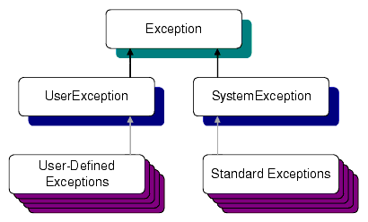
The Exception class provides the following public operations:
- copy constructor
- destructor
- _narrow
The copy constructor and destructor operations automatically manage the storage associated with the exception.
The _narrow operation allows your CORBA client application to catch any type of exception and then determine its type. The exception argument passed to the _narrow operation is a pointer to the base class Exception. The _narrow operation accepts a pointer to any Exception object. If the pointer is of type SystemException, the narrow() operation returns a pointer to the exception. If the pointer is not of type SystemException, the narrow() operation returns a Null pointer.
Unlike the _narrow operation on object references, the _narrow operation on exceptions returns a suitably typed pointer to the same exception argument, not a pointer to a new exception. Therefore, you do not free a pointer returned by the _narrow operation. If the original exception goes out of scope or is destroyed, the pointer returned by the _narrow operation is no longer valid.

Handling System Exceptions
The CORBA C++ client applications in the BEA Tuxedo sample applications use the standard C++ try-catch exception handling mechanism to raise and catch exceptions when error conditions occur, rather than testing status values to detect errors. This exception-handling mechanism is also used to integrate CORBA exceptions into CORBA client applications. In C++, catch clauses are attempted in the order specified, and the first matching handler is called.
User Exceptions
User exceptions are generated from the user-written OMG IDL file in which they are defined. When handling exceptions, the code should first check for system exceptions. System exceptions are predefined by CORBA, and often the application cannot recover from a system exception. For example, system exceptions may signal problems in the network transport or signal internal problems in the ORB.
The handling of CORBA Exceptions in C++ and Java is basically the same.CORBA method invocations from C++ and Java should always be made with in a try –catch block.The init method in the MyChecking Account C++ wrapper class illustrates a CORBA method invocation:
_____________________________________________________________________
//MyCheckingAccount.cpp – Wrapper Class
BOOL MyCheckingAccount ::Init(Const char* name ,const char* factoryIOR)
{
try {
…….
m_account->init(name);
…….
} catch(ch3:: InvalidNmaeException& exc)
{
cerr<<”MyCheckingAccount::Init:”<<”InvalidNameException- “ <<exc.reason<<endl;
}
Catch(CORBA::SystemException& se)
{
cerr<<”MyCheckingAccount::Init:”<< ” CORBA ::SystemExceoption!”
}
……
}
_____________________________________________________________________
The call to m_account->init() is made within a try block. Catch blocks are defined for the Ch3::InvalidNameException as well as the CORBA SystemException.
CORBA Java Client Applications
CORBA Java client applications handle exceptions in a similar way to CORBA C++ client applications:
System exceptions inherit from java.lang.RuntimeException.
User-defined exceptions inherit from java.lang.Exception.
Figure 5-2 Java Exception Inheritance Hierarchy
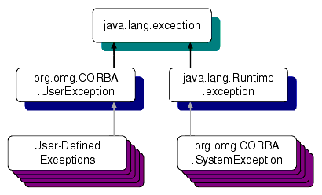

7(b) A single computer that contains a database and a front-end to access the database. Generally this type of system is found in small businesses. There is one computer which stores all of the company’s data on a single database. The interface used to interact with the database may be part of the database or another program which ties into the database itself. A single-tier system requires only one stand-alone computer. It also requires only one installation of proprietary software. This makes it the most cost-effective system available. May be used by only one user at a time. A single tier system is impractical for an organization which requires two or more users to interact with the organizational data store at the same time.
2-Tier Architecture

In this architecture management of database occurred on the server tier and all other processing occurred on the client tier. So each client was required to posses a significant processing power. Here we can use the storage procedure mechanism to relieve the client in many cases, but it will not work in all cases. Why? Can you give one example?
Here we find that in the two tier architecture the client has to do a lot of processing work. In order to minimize the processing work we need a model that will distribute the work. So the client side processing was possible to separate into application presentation and business logic processing resulted in three tiers: a client tier for visual presentation, a middle tier for processing based on business logic and a data tier for persistent data management.
- Presentation logic = User Interface, displaying data to the user, accepting input from the user.
- Business logic = Data Validation, ensuring the data is kosher before being added to the database.
- Data Access Logic = Database Communication, accessing tables and indices, packing and and unpacking data

3-Tier System
A Multi-tier architecture is thus defined by the following three component layers:
- A front-end component, which is responsible for providing portable presentation logic;
- A back-end component, which provides access to dedicated services, such as a database server.
- A middle-tier component, which allows users to share and control business logic by isolating it from the actual application;

Advantages of Multi-Tier Client/Server architectures
- Network bottlenecks are minimized because the application layer does not transmit extra data to the client, only what is needed to handle a task.
- When business logic changes are required, only the server has to be updated. In two-tier architectures, each client must be modified when logic changes.
- The client is insulated from database and network operations. The client can access data easily and quickly without having to know where data is or how many servers are on the system.
- Database connections can be 'pooled' and thus shared by several users, which greatly reduces the cost associated with per-user licensing.
- The organization has database independence because the data layer is written using standard SQL which is platform independent. The enterprise is not tied to vendor-specific stored procedures.
- Changes to the user interface or to the application logic are largely independent from one another, allowing the application to evolve easily to meet new requirements.

- The application layer can be written in standard third or fourth generation languages, such as Java, C or COBOL, with which the organization's in-house programmers are experienced.
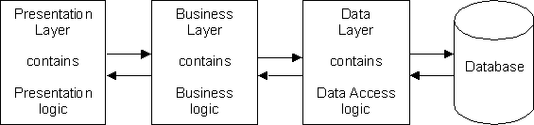
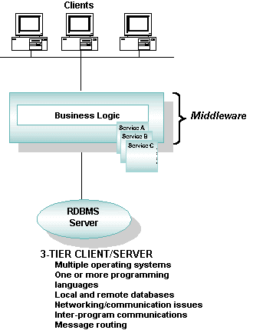

8(a) An object request broker (ORB) is a middleware technology that manages communication and data exchange between objects. ORBs promote interoperability of distributed object systems because they enable users to build systems by piecing together objects- from different vendors- that communicate with each other via the ORB. The implementation details of the ORB are generally not important to developers building distributed systems. The developers are only concerned with the object interface details.

ORB technology promotes the goal of object communication across machine, software, and vendor boundaries. The relevant functions of an ORB technology are
- interface definition
- location and possible activation of remote objects
- communication between clients and object

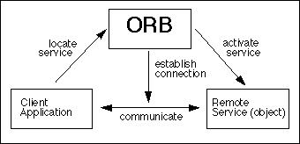
Object Request Broker

An object request broker acts as a kind of telephone exchange. It provides a directory of services and helps establish connections between clients and these services [CORBA 96, Steinke 95]. The ORB must support many functions in order to operate consistently and effectively, but many of these functions are hidden from the user of the ORB. It is the responsibility of the ORB, to make it appear as if the object is local to the client, while in reality it may reside in a different process or machine. Thus the ORB provides a framework for cross-system communication between objects. This is the first technical step toward interoperability of object systems.
The next technical step toward object system interoperability is the communication of objects across platforms. An ORB allows objects to hide their implementation details from clients. This can include programming language, operating system, host hardware, and object location. Each of these can be thought of as a "transparency, and different ORB technologies may choose to support different transparencies, thus extending the benefits of object orientation across platforms and communication channels.
There are many ways of implementing the basic ORB concept; for example, ORB functions can be compiled into clients, can be separate processes, or can be part of an operating system kernel. These basic design decisions might be fixed in a single product; or there might be a range of choices left to the ORB implementer.
There are two major ORB technologies:
- The Object Management Group's (OMG) Common Object Request Broker Architecture (CORBA) specification
Microsoft's Component Object Model (see Component Object Model (COM), DCOM, and Related Capabilities)

The Object Management Architecture (OMA)
OMA is a high-level vision of a complete distributed environment. It consists of four components that can be roughly divided into two parts: system oriented components (Object Request Brokers and Object Services), and application oriented components (Application Objects and Common Facilities).
Of these parts Object Request Broker is the one which constitutes the foundation of OMA and manages all communication between its components. It allows objects to interact in a heterogeneous, distributed environment, independent of the platforms on which these objects reside and techniques used to implement them. In performing its task it relies on Object Services which are responsible for general object management such as creating objects, access control, keeping track of relocated objects, etc. Common Facilities and Application Objects are the components closest to the end user, and in their functions they invoke services of the system components. The OMA is itself a specification (actually, a collection of related specifications) that defines a broad range of services for building distributed applications. The OMA goes far beyond RPC in scope and complexity. The distinction between CORBA and the OMA is an important one because many services one might expect to find in a middleware product such as CORBA (e.g., naming, transaction, and asynchronous event management services) are actually specified as services in the OMA.
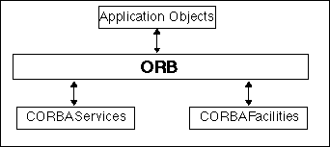
Object Management Architecture

OMA services are partitioned into three categories: CORBA Services, CORBA Facilities, and Application Objects. The ORB (whose details are specified by CORBA) is a communication infrastructure through which applications access these services, and through which objects interact with each other. CORBA Services, CORBA Facilities, and Application Objects define different categories of objects in the OMA; these objects (more accurately object types) define a range of functionality needed to support the development of distributed software systems.
- CORBA Services or COS are defined as standard CORBA objects with IDL interfaces, sometimes referred to as "Object Services”. They are considered fundamental to building non-trivial distributed applications. These services are to support the integration and interoperation of distributed objects. These services currently include asynchronous event management, transactions, persistence, externalization, concurrency, naming, relationships, and lifecycle.
- CORBA Facilities may be useful for distributed applications in some settings, but are not considered as universally applicable as CORBA Services. These "facilities" include: user interface, information management, system management, task management, and a variety of "vertical market" facilities in domains such as manufacturing, distributed simulation, and accounting.
Application Objects
provide services that are particular to an application or class of applications. These are not a topic for standardization within the OMA, but are usually included in The OMG Object Model defines common object semantics for specifying the externally visible characteristics of objects in a standard and implementation-independent way. In this model clients request services from objects (which will also be called servers) through a well-defined interface. This interface is specified in OMG IDL (Interface Definition Language). A client accesses an object by issuing a request to the object. The request is an event, and it carries information including an operation, the object reference of the service provider, and actual parameters (if any). The object reference is an object name that defines an object reliably.
the OMA reference model for completeness, i.e., object are either application-specific, support common facilities, or are basic services.

The OMG Object Model
The OMG Object Model defines common object semantics for specifying the externally visible characteristics of objects in a standard and implementation-independent way. In this model clients request services from objects (which will also be called servers) through a well-defined interface. This interface is specified in OMG IDL (Interface Definition Language). A client accesses an object by issuing a request to the object. The request is an event, and it carries information including an operation, the object reference of the service provider, and actual parameters (if any). The object reference is an object name that defines an object reliably.
So with the help of IDL and OMG object model the ORB implements interoperability of ORBs.

8(b)last two pages of fourth chapter.

6)

