RAJAGIRI SCHOOL OF ENGINEERING
AND TECHNOLOGY
Rajagiri Valley, Kochi -39



R606 –Algorithm Analysis & Design
MODULE IV

Prepared by
Preetha K G

INDEX

  - Introduction to Dynamic Programming & Principle of Optimality
  - Multi Stage Graph
  - All Pairs Shortest Paths
  - Travelling Salesman Problem
  - Lower Bound Theory

4.1 Introduction to Dynamic Programming & Principle of Optimality
This design technique is used when the solution to a problem can be viewed as the result of a sequence of decisions. Dynamic Programming is a method of solving problems exhibiting the properties of overlapping sub problems and optimal substructure that takes much less time than naive methods. The term was originally used in the 1940s by Richard Bellman to describe the process of solving problems where one needs to find the best decisions one after another.
Difference between greedy method and dynamic programming: In greedy method only one decision sequence is ever generated but in dynamic programming more than one decision sequence may be generated.
Principle of Optimality states that an optimal sequence of decisions has the property that whatever the initial state and decisions are, the remaining decisions must constitute an optimal decision sequence with regard to the state resulting from the first decision
  - Multi Stage Graph
A multistage graph G=(V,E) is a directed graph in which the vertices are partitioned into k≥2 disjoint sets v_{i}, 1≤i≤k. If <u, v> is an edge in E, then u v_{i} and v v_{i+1} for some i, 1≤i≤k. Sets v_{i} and v_{k} is such that | v_{i} | = | v_{k} | = 1. Let s and t are vertices if v_{i} and v_{k} respectively such that s is the source and t is the sink. Let c(i,j) be the cost of edge <i,j>.The cost of the path from s to t is the sum of cost of all edges on the path.
Example:
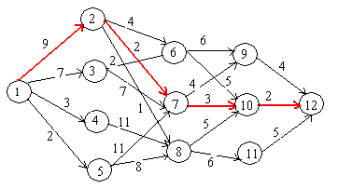
Multi stage graph problem is to find a minimum cost path from s to t. Every path from s to t starts at stage 1, goes to stage 2, etc. eventually terminates in stage k. Every path from s to t is the result of a sequence of k-1 decisions. i^{th} decision involves determining which vertex in v_{i+1} 1≤i≤k-2 is to be on the path.
Let p(i,j) is the minimum cost path from j in v_{i} to vertex t, and cost (i,j) be its cost.
According to forward approach
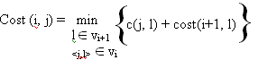

Since cost (k-1, j) = c(j. t) if <j,t> E and
cost (k-1, j) = ∞ if <j,t> E
First calculate cost(k-2, j) for all j v_{k-2}, then calculate cost (k-3, j) for all j v_{k-3}.etc, finally calculate cost(1,s).
Consider the directed graph given above
cost (3, 6) = min{6 + cost(4,9), 5 + cost(4,10)} = 7
cost (3, 7) = min{4 + cost(4,9), 3 + cost(4,10)} = 5
cost (3, 8) = min{5 + cost(4,10), 6 + cost(4,11)} = 7
cost (2, 2) = min{4 + cost(3,6) , 2 + cost(3,7), 1 + cost(3,8)} = 7
cost (2, 3) = min{1 + cost(3,6), 7 + cost(3,7)} = 9
cost (2, 4) = min{11 + cost(3,8)} = 18
cost (2, 5) = min{11 + cost(3, 7), 8 + cost(3,8)} =15
cost (1, 1) = min{9 + cost(2, 2), 7 + cost(2, 3) , 3 + cost(2, 4), 2 + cost(2, 5)} = 16
Let d(I, j) be the of l that minimizes c(j, l) + cost(i+1, l).
These values are
d(3,6) = 10 d(2,2) = 7 d(1,1) = 2
d(3, 7) =10 d(2,3) = 6
d(3,8) = 10 d(2,4) = 8
d(2,5) = 8

Minimum cost path is 1,V2,,V3,………….Vk-1 t.
V2=d(1,1)=2
V3=d(2,d(1,1,))=7
V4=d(3,d(2,d(1,1,)))=10
So the minimum cost path in the above example is 1,2,7,10,12
Algorithm
In the algorithm vertices are assigned index in the order of stages. Vertices in stage1 have indices less than in stage2 and so on. Hence first subscript in cost, p and d which is denoting the stage number is omitted.
Void FGraph( graph G, int k, int n, int p[])
// n vertices are indexed in the order of stages. E is set of edges and c[i][j] is cost of <i,j> // and p[i:k] is the minimum cost path.
{
float cost[10];
int d[10], r, j;
for(j = n-1; j>=n; j--) // compute cost[j]
{
Let r be a vertex such that <j,r> is an edge in G and c[j][r] + cost[r] is minimum;
cost[j] = c[j][r] + cost[r];
d[j] = r;
}
//Find a minimum-cost path
p[1] = 1; p[k] = n;
for(j=2; j<=k; j++)
p[j] = d[p[j-1]];
}

Time Complexity
If G is represented by adjacency list then r can be found in time proportional to the degree of the vertex j. If G has |E| edges, the number of times for loop executes is (|V| + |E|). The complexity of last for loop is Θ(k).
So the time complexity of the algorithm is Θ(|V| + |E|).
Same can be done using forward approach.
  - All Pairs Shortest Paths
Let G=(V,E) be a directed graph with n vertices. Let cost be the cost adjacency matrix.
cost(i, i) = 0, 1≤i≤n
cost(i, j) is the length of the edge <i, j> if <i, j> E and
cost(i, j) = ∞ if <i, j> E.
All Pairs shortest path problem determines a matrix A such that A(i,j) is the length of the shortest path from i to j.
The graph allows negative edges, but negative valued cycles are not allowed.
Consider a shortest path from i to j, i≠j. The path originates at i goes through possibly many vertices and terminates at j. Assume that there is no cycles. If there is a cycle we can remove them without increase in the cost.
Initially A[i][j] = c[i][j].
If k is an intermediate vertex on this shortest path then the sub paths from i to k and from k to j must be shortest path from I to k and k to j respectively. Otherwise i to j path is not of minimum length (optimality Principle)
Algorithm makes n passes over A. Let A₀, A₁, .. A_{n} represent the matrix on each pass.
After k-1 passes
A^{k-1}[i,j] represent the smallest path from i to j passing through no intermediate vertex greater than k-1.
k^{th} iteration explores whether k lies on optimal path.
A^{k}[i,j] = min{min{A^{k-1}[i,k] + A^{k-1}[k,j]},cost(i,j)}
A⁰[i,j]= cost(i, j)
We can obtain the recurrence for A^{k}[i,j]. A shortest path from i to j passes through no vertex greater than k, either it goes through k or does not.
If it does , A^{k}[i,j] = A^{k-1}[i,k] + A^{k-1}[k,j]
If it does not, then no intermediate vertex has index greater than k-1. Then A^{k}[i,j] = A^{k-1}[i,j]
Combining these two conditions we get
A^{k}[i,j] = min{ A^{k-1}[i,j], A^{k-1}[i,k] + A^{k-1}[k,j]}, k>=1
Algorithm
Void AllPaths ( float cost[][], float A[][], int n)
{
for (int i=1; i<=n; i++)
for (int j=1; j<=n; j++)
A[i][j] = cost[i][j];

for (int k=1; k<=n; k++)
for (i=1; i<=n; i++)
for (j=1; j<=n; j++)
A[i][j] = min{A[i][j], A[i][k] + A[k][j]);
}

Time complexity of the algorithm is O(n³).

Example
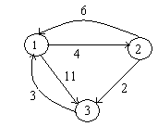
Cost adjacency matrix for the graph
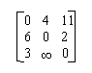
After each iteration matrix A is as follows
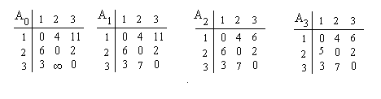
  - Travelling Salesman Problem
Let G=(V,E) be a directed graph with cost c_{ij}.
c_{ij} >0 for all <i j> E
c_{ij} = ∞ for all <j,t> E.
|V| = n and n>1.
A tour of a graph G is a directed simple cycle that includes every vertex in G. The cost of the tour is sum of the cost of the edges on the tour. TSP is to find a tour of a minimum cost. A salesman spends his time in visiting cities cyclically. In his tour he visits each city just once, and finishes up where he started. In which order should he visit to minimize the distance traveled.
The tour of the simple graph starts and ends at vertex1. Every tour consist of an edge <i, k> for some k V-{1} and a path from k to 1. Path from k to 1 goes through each vertex in V- {1,k} exactly once. If tour is optimal, path from k to 1 must be shortest k to 1 path going through all vertices in V-{1,k}. Hence the principle of optimality holds.
Let g(i, S) be length of shortest path starting at vertex i, going through all vertices in S terminating at 1. Function g(1, V-{1}) is the length of the optimal salesman tour. From the principle of optimality
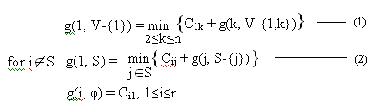
Example
Consider the directed graph with the cost adjacency matrix given below
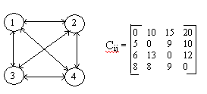
g(2, φ) = C₂₁ = 5
g(3, φ) = C₃₁ = 6
g(4, φ) = C₄₁ = 8

g(2, {3}) = C₂₃ + g(3, φ) = 15
g(2, {4}) = C₂₄ + g(4, φ) = 18
g(3, {2}) = C₃₂ + g(2, φ) = 18
g(3, {4}) = C₃₄ + g(4, φ) = 20
g(4, {2}) = C₄₂ + g(2, φ) = 13
g(4, {3}) = C₄₃ + g(3, φ) = 15

g(2, {3,4}) = min{C₂₃ + g(3, {4}) , C₂₄ + g(4, {3}) }= 25
g(3, {2,4}) = min{C₃₂ + g(2, {4}) , C₃₄ + g(4, {2}) }= 25
g(4, {2,3}) = min{C₄₂ + g(2, {3}) , C₄₃ + g(3, {2}) }= 23

g(1, {2,3,4}) = min{C₁₂ + g(2, {3,4}) , C₁₃ + g(3, {2,4}) , C₁₄ + g(4, {2,3}) }
= min{35, 40, 43} = 35

Let J(i, S) represent the value of j which is the value of g(i, S) that minimizes the right hand side of equation (2).
J(1, {2,3,4}) =2, which infers that the tour starts from 1 goes to 2. The remaining tour can be obtained from g(2,{3,4}). So J(2,{3,4})=4. Thus next edge is <2,4>. The remaining tour is for g(4, {3}). So J(4, {3})=3. So the optimal tour is 1,2,4,3,1.
  - Lower Bound Theory
This expose you to some techniques that have been used to establish that a given algorithm is the most efficient possible. The way that this is done is by discovering a function g(n) that is a lower bound on the time algorithm any algorithm must take to solve the given problem. If we take an algorithm whose computing time is the same order as g(n) , then we know that asymptotically we can do no better. Lower bound states a fact for all possible algorithms for solving a problem.
f (n) - running time of some algorithm
g (n) - lower bound -- (Omega)
Iff there exists positive constants c and n_{o} such that f(n) > cg(n) for all n , n > n_{o} (g(n) is a lower bound for f(n))
If f(n) > O(g(n)) and then asymptotically, we cannot have any improvement. Improvement in constant is possible.
Comparison Trees: Searching/Sorting
Comparison trees are useful for modeling the way in which a large number of sorting and searching algorithms work.
Comparison-based algorithms are those algorithms which work solely by making comparisons between elements; no arithmetic involving elements is permitted.
Ordered Searching
A(1) < A (2) . . .< A (n)
i if x = A(i) for some i
0 otherwise

Comparison Tree for Linear Search
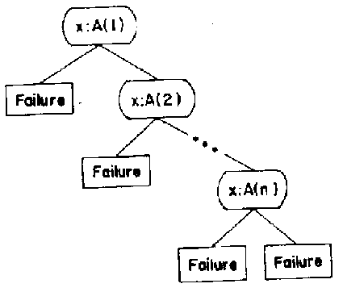
Running time is the longest path in tree - O(n)
Comparison Tree for Binary Search

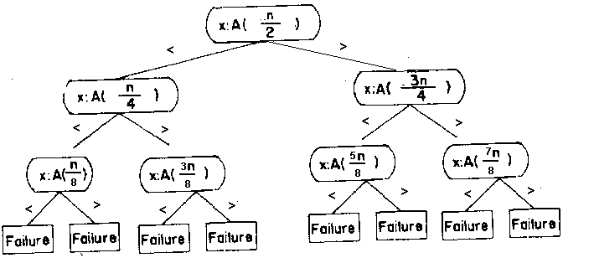

Running time – O (log n)
If search terminates at interior nodes - success . . . . . external (leaf) nodes - failure
Consider any comparison tree to search A [1 : n] .There must be n internal nodes corresponding to n possible successful outcomes.
k = maximum level of any internal node then, number of internal nodes < 2^{k} - 1 (proof by induction). n < 2^{k} - 1 implies k > log₂ (n+1)
Number of comparisons (worst case) = k = log₂ (n+1) = 0 (log n)
f (n) = (log n) f (n) = O(log n)
So best - optimal algorithm is binary search since it achieves this.
Sorting
Comparison Tree for sorting is given below
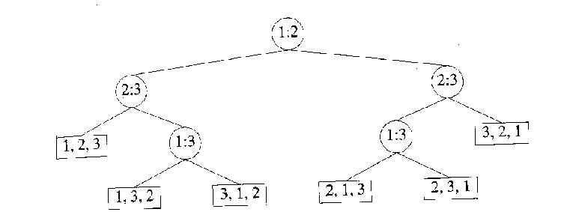

Number of external (leaf) nodes = number of distinct permutations of {1, 2, . . ., n} = n!
Let k be max. level of any internal node in tree
T(n) = k
If max level of any internal node is k, then at most 2^{k} external nodes n! < 2^{k} ; k = T(n) > log₂(n!) = O(n log n)
Hence any comparison-based sorting algorithm needs (nlog n) time

