The Booch Method - The Booch Method is a well-documented, proven method for object-oriented analysis and design.

What makes the Booch Method different?
The Booch method notation differs from other OO methodologies because it centers on the development of four fundamental models of the system in the problem domain that will be implemented primarily in software. These models are:
- The Logical Model
- The Physical Model
- The Static Model
- The Dynamic Model
These models document components: classes, class categories, objects, operations, subsystems, modules, processes, processors, devices and the relationships between them. Just as an architect has multiple views of a skyscraper under construction, so the software engineer has multiple view of the software system undergoing design.

Views of the Booch Method models
The Booch method recognizes that an engineer can view the four models from several different perspectives. In the Booch method, an engineer can document the models with several different diagrams:
- The Class Diagram
- The Object Diagram
- The Module Diagram
- The State Diagram
- The Interaction Diagram
- The Process Diagram
The engineer augments these diagrams with specifications that textually complement the icons in the diagrams. It's important to realize that there is not a one-to-one mapping between a model and a particular view. Some diagrams and/or specifications can contain information from several models, and some models can include information that ends up in several diagrams. Each model component and their relationships can appear in none, one, or several of a models diagram.

i) Class Diagram
A class diagram shows the existence of classes and their relationships in the logical view of the system. This is the diagram that most people think of when they think of the Booch notation, because the 'clouds' that represent classes are so unique.
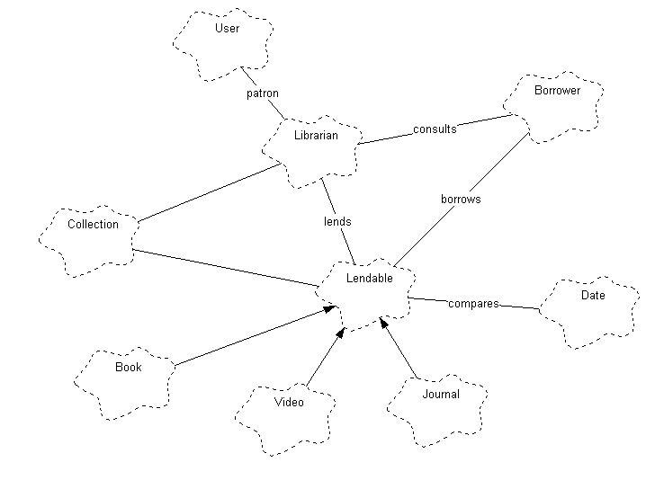

Figure: Initial Class Diagram for the Library Application
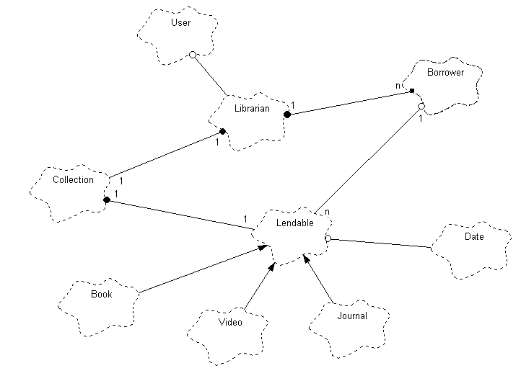

Figure: Second pass Class Diagram for the Library Application
In the above figure, the relationship with a dot on the end indicated a ``has'' relationship. The class on the ``dot'' side owns or uses the facilities of the class on the other end of the line.

ii) The Object Diagram
An object diagram, or for our purposes here an object-scenario diagram shows the existence of objects, their relationships in the logical view of the system, and how they execute a particular scenario or use-case.
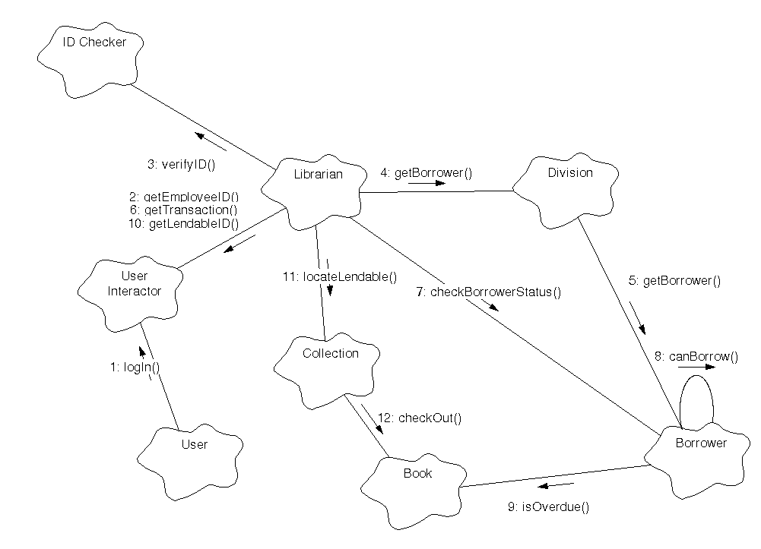
Figure: Object Diagram for checking out a book

iii) The Module Diagram
A module diagram shows the allocation of classes and objects to modules in the physical view of a system.
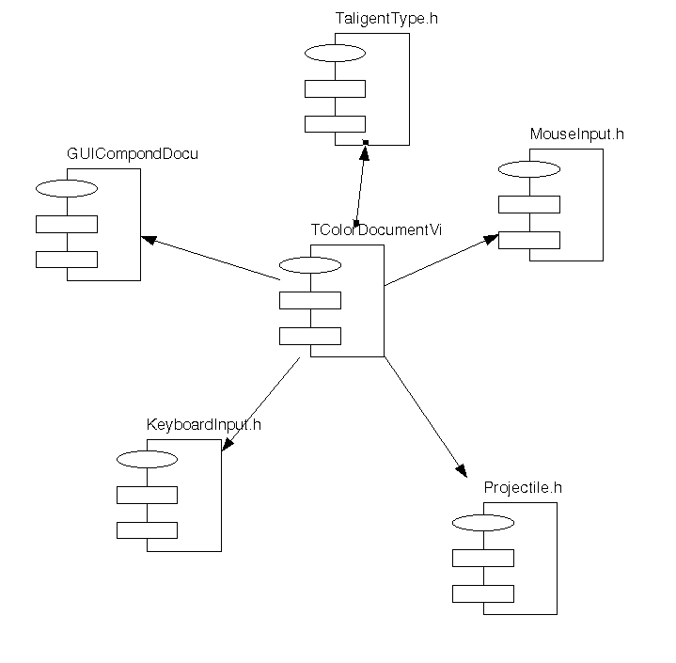
Figure: A Module Diagram for the ColorDocumentView class header file

iv) The State Transition Diagram
The State Transition diagram shows the state space of a given context, the events that cause a transition from one state to another, and the actions that result.
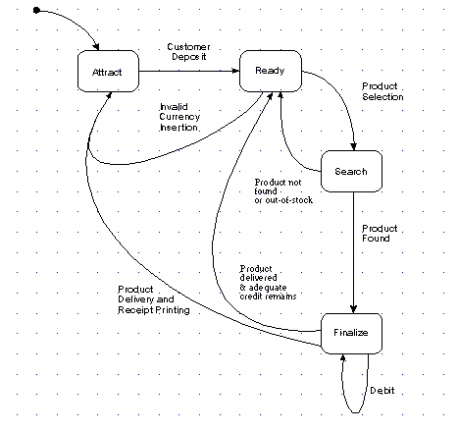
Figure: State Transition Diagram for the Postal Machine CPU
v) Interaction Diagrams
The interaction diagrams illustrate how objects interact via messages. They are used for dynamic object modeling.
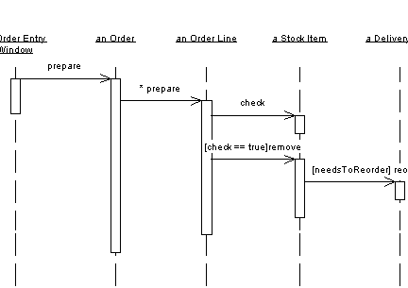
Figure: An interaction diagram
vi) Process Diagram
It is used to show allocation of processes to processors in the physical design. The following shows the notation for processes and devices.

Device Name

Processor Name
Process 1 Process 2

Processor 2

Processor 1

Processor 3
Figure: An example process diagram
The Booch’s method prescribes a macro development process and a micro development process:
a) Macro Development Process
The macro process serves as a controlling framework for the micro process and can take weeks or even months. The primary concern of the macro process is technical management of the system .Such management is interested less in the actual OOD than in how well the project corresponds to the requirements set for it and whether it is produced on time. The macro development process consists of the following steps:
i) Conceptualization: You establish the core requirements of the system .You establish a set of goals and develop a prototype to prove the concept.
ii) Analysis and Development of the Model: You use the class diagram to describe the roles and responsibilities objects are to carry out in performing the desired behavior of the system. Then you use the object diagram to describe the desired behavior of the system in terms of scenario or use interaction diagram to describe behavior of system in terms of scenarios.
iii) Design or create the system architecture: You use the class diagram to decide what classes exist and how they relate to each other. You use object diagram to decide what mechanisms are used to regulate how objects collaborate .You use module diagram to map out where each class and object should be declared. You use the process diagram to determine to which processor .Also determine the schedules for multiple processes on each relevant processor.
iv) Evolution or implementation: Successively refine the system through many iterations .Produce a stream of software implementations, each of which is a refinement of the prior one.
v) Maintenance: Making localized changes to the system to add new requirements and eliminate bugs.
b) Micro Development Process: Each macro development process has its own micro development processes. It is a description of the day-to-day activities by a single or small group of software developers, which looks blurry to an outsider, since analysis and design phases are not clearly defined. It consists of the following:
i) Identify classes and objects
ii) Identify class and object semantics
iii) Identify class and object relationships
iv) Identify class and object interfaces and implementation.

The Jacobson’s Methodology
The Jacobson’s methodologies (e.g.: - Object oriented Business Engineering (OOBE), Object Oriented Software Engineering (OOSE) and Objectory) cover the entire life cycle and stress traceability between the different phases, both forward and backward. This traceability enables reuse of analysis and design work, possibly much bigger factors in the reduction of development time than reuse of code. At the heart of their methodologies is the use-case concept, which evolved with Objectory.
i) Use cases
Use cases are scenarios for understanding system requirements .A use case is an interaction between users and a system. The use case model captures the goal of the user and the responsibility of the system to its users.
In the requirement analysis, the use case is described as one of the following:
- Non-formal text with no clear flow of events.
- Text, easy to read but with a clear flow of events to follow (this is a recommended style).
- Formal style using pseudocode.
The use case description must contain:
- How and when the use case begins and ends.
- The interaction between the use case and its actors, including when the interaction occurs and what is exchanged.
- How and when the use case will need data stored in the system or will store data in the system.
- Exceptions to the flow of events.
- How and when concepts of the problem domain are handled.
Every single use case should describe one main flow of events. An exceptional or additional flow of events could be added. The exceptional or additional flow of events could be added. The exceptional use case extends another use case to include the additional one. The use case model employs extends and uses relationships.
        - The extends relationship is used when you have one use case that is similar to another use case but does a bit more .It extends the functionality of the original use case.
        - The uses relationship senses common behavior in different use cases.
Use cases could be viewed as concrete or abstract.
        - An abstract use case is not complete and has no actors that initiate it but is used by another use case .This inheritance could be in several levels.
        - Abstract use cases are the ones that have uses or extend relationships.

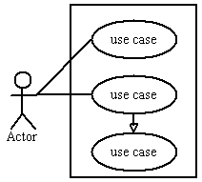
ii) Architecture
System development includes development of different models. We need to find modeling technique notation for each model. Such a set of modeling techniques defines the architecture. Each model shows certain aspects of the system. Collection of models is known as architecture.

iii) Object Oriented Software Engineering:
It is also called as Objectory. It is a method of object oriented development with the specific aim to fit the development of large, real time systems. The development process also use case driven development , stresses that use cases are involved in several phases of the development , including analysis , design ,validation and testing. The use case scenario begins with a user of the system initiating a sequence of interrelated events. The system development method based on OOSE, Objectory is a disciplined process for the industrialized development of software based on a use case driven design. It is an approach to OOAD that centers on understanding the ways in which a system actually is used. By organizing the analysis and design models around sequences of user interaction and actual usage scenarios, the method produces systems that are both usable and more robust adapting more easily to changing usage. Objectory has been developed and applied to numerous application areas and embodied in CASE tool systems.

Objectory is built around several different models:
- Use Case Model: The use case model defines the outside (actors) and inside (use case) of the system’ behavior.
- Domain Object Model: The objects of the real world are mapped into the domain object model.
- Analysis object model: The analysis model presents how the source code (implementation) should be carried out and written.
- Implementation Model: The implementation model represents the implementation of the system.
- Test Model: The test model constitutes the test plans, specifications and reports.
The maintenance of each model is specified in its associated process. A process is created when the first development project starts and is terminated when the developed system is taken out of service.

iv) Object Oriented Business Engineering:
OOBE is object modeling at the enterprise level .Use cases again are the central vehicle for modeling, providing traceability throughout the software engineering processes.
- Analysis Phase: It defines the system to be built in terms of the problem domain object model, the requirement model and analysis model. It shouldn’t take into account the actual implementation model. It reduces complexity and promotes maintainability over system. Jacobson doesn’t insist on development of problem domain object model, but refers to other models, who suggest that customers draw his view of system. This model should be developed just understanding for requirements model. The analysis process is iterative but requirements and analysis model should be stable before moving on to subsequent models. Prototyping is also useful.
- Design and Implementation Phases: Implementation environment should be identified for design model. The various factors affecting the design model are DBMS, distribution of process, constraints due to programming language, available component libraries and incorporation of GUI. It may be possible to identify implementation environment concurrently with analysis. The analysis objects are translated into design objects that fit current implementation environment.
- Testing Phase: It describes testing, levels and techniques (unit, integration and system.)

What is UML?
UML stands for Unified Modeling Language. This object-oriented system of notation has evolved from the work of Grady Booch, James Rumbaugh, Ivar Jacobson, and the Rational Software Corporation. These renowned computer scientists fused their respective technologies into a single, standardized model. Today, UML is accepted by the Object Management Group (OMG) as the standard for modeling object oriented programs. The primary goals in the design of the UML were as follows:
1. Provide users a ready to use expressive visual modeling language so they can develop and exchange meaningful models.
2. Provide extensibility and specialization mechanisms to extend the core concepts.
3. Be independent of particular programming languages and development processes.
4. Provide a formal basis for understanding the modeling language.
5. Encourage the growth of the OO tools market.
6. Support higher-level development concepts.
7. Integrate best practices and methodologies.
Types of UML Diagrams
UML defines nine types of diagrams: Class (package), Object, Use case, Sequence, Collaboration, State chart, Activity, Component, and Deployment.
i) UML Class Diagram
Class diagrams are the backbone of almost every object-oriented method including UML. They describe the static structure of a system.
Basic Class Diagram Symbols and Notations
Classes represent an abstraction of entities with common characteristics. Associations represent the relationships between classes.
Classes
Illustrate classes with rectangles divided into compartments. Place the name of the class in the first partition (centered, bolded, and capitalized), list the attributes in the second partition, and write operations into the third.
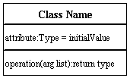
Active Class
Active classes initiate and control the flow of activity, while passive classes store data and serve other classes. Illustrate active classes with a thicker border.
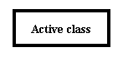
Visibility
Use visibility markers to signify who can access the information contained within a class. Private visibility hides information from anything outside the class partition. Public visibility allows all other classes to view the marked information. Protected visibility allows child classes to access information they inherited from a parent class.
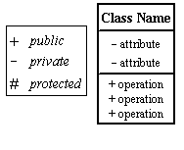
Associations - Associations represent static relationships between classes. Place association names above, on, or below the association line. Use a filled arrow to indicate the direction of the relationship. Place roles near the end of an association. Roles represent the way the two classes see each other.
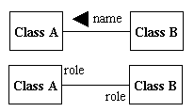

More Basic Class Diagram Symbols and Notations
Multiplicity(Cardinality)
Place multiplicity notations near the ends of an association. These symbols indicate the number of instances of one class linked to one instance of the other class. For example, one company will have one or more employees, but each employee works for one company only.
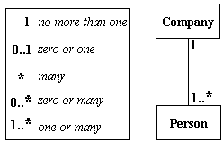
Constraint
Place constraints inside curly braces {}.
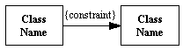
Simple Constraint

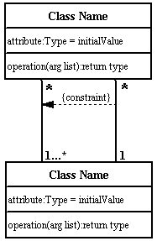
Composition and Aggregation
Composition is a special type of aggregation that denotes a strong ownership between Class A, the whole, and Class B, its part. Illustrate composition with a filled diamond. Use a hollow diamond to represent a simple aggregation relationship, in which the "whole" class plays a more important role than the "part" class, but the two classes are not dependent on each other. The diamond end in both a composition and aggregation relationship points toward the "whole" class or the aggregate.
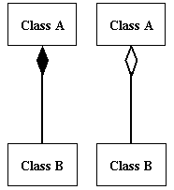
Generalization
Generalization is another name for inheritance or an "is a" relationship. It refers to a relationship between two classes where one class is a specialized version of another. For example, Honda is a type of car. So the class Honda would have a generalization relationship with the class car.
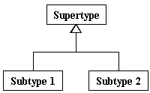
In real life coding examples, the difference between inheritance and aggregation can be confusing. If you have an aggregation relationship, the aggregate (the whole) can access only the PUBLIC functions of the part class. On the other hand, inheritance allows the inheriting class to access both the PUBLIC and PROTECTED functions of the superclass.
ii) UML Package Diagram
Package diagrams organize the elements of a system into related groups to minimize dependencies among them
Basic Package Diagram Symbols and Notations
Packages
Use a tabbed folder to illustrate packages. Write the name of the package on the tab or inside the folder. Similar to classes, you can also list the attributes of a package.
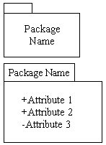
Visibility
Visibility markers signify who can access the information contained within a package. Private visibility means that the attribute or the operation is not accessible to anything outside the package. Public visibility allows an attribute or an operation to be viewed by other packages. Protected visibility makes an attribute or operation visible to packages that inherit it only.
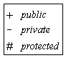

Dependency
Dependency defines a relationship in which changes to one package will affect another package. Importing is a type of dependency that grants one package access to the contents of another package.
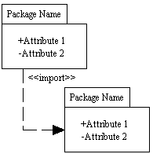
iii) UML Object Diagram
Object diagrams are also closely linked to class diagrams. Just as an object is an instance of a class, an object diagram could be viewed as an instance of a class diagram. Object diagrams describe the static structure of a system at a particular time and they are used to test the accuracy of class diagrams.

Basic Object Diagram Symbols and Notations
Object names
Each object is represented as a rectangle, which contains the name of the object and its class underlined and separated by a colon.
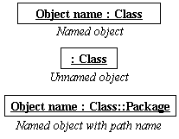

Object attributes
As with classes, you can list object attributes in a separate compartment. However, unlike classes, object attributes must have values assigned to them.
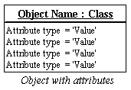
Active object
Objects that control action flow are called active objects. Illustrate these objects with a thicker border.
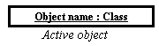
Multiplicity
You can illustrate multiple objects as one symbol if the attributes of the individual objects are not important.
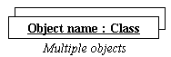
Links - Links are instances of associations. You can draw a link using the lines used in class diagrams.
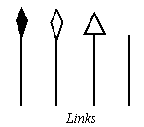

Self-linked
Objects that fulfill more than one role can be self-linked. For example, if Mark, an administrative assistant, also fulfilled the role of a marketing assistant, and the two positions are linked, Mark's instance of the two classes will be self-linked.
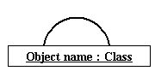
iv) UML Use Case Diagram
Use case diagrams model the functionality of a system using actors and use cases. Use cases are services or functions provided by the system to its users.

Basic Use Case Diagram Symbols and Notations
System
Draw your system's boundaries using a rectangle that contains use cases. Place actors outside the system's boundaries.
Use Case
Draw use cases using ovals. Label with ovals with verbs that represent the system's functions.
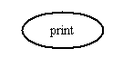
Actors
Actors are the users of a system. When one system is the actor of another system, label the actor system with the actor stereotype.
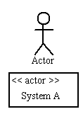
Relationships
Illustrate relationships between an actor and a use case with a simple line. For relationships among use cases, use arrows labeled either "uses" or "extends." A "uses" relationship indicates that one use case is needed by another in order to perform a task. An "extends" relationship indicates alternative options under a certain use case.
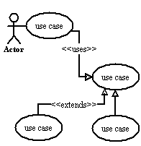

v) UML Sequence Diagram
Sequence diagrams describe interactions among classes in terms of an exchange of messages over time.

Basic Sequence Diagram Symbols and Notations
Class roles
Class roles describe the way an object will behave in context. Use the UML object symbol to illustrate class roles, but don't list object attributes.
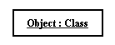
Activation
Activation boxes represent the time an object needs to complete a task.
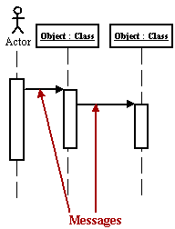
Messages - Messages are arrows that represent communication between objects. Use half-arrowed lines to represent asynchronous messages. Asynchronous messages are sent from an object that will not wait for a response from the receiver before continuing its tasks.
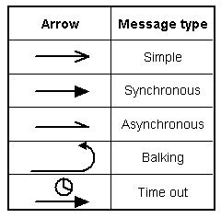
Various message types for Sequence and Collaboration diagrams
Lifelines
Lifelines are vertical dashed lines that indicate the object's presence over time.
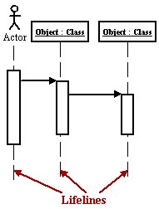
Destroying Objects
Objects can be terminated early using an arrow labeled "< < destroy > >" that points to an X.
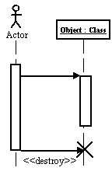

Loops
A repetition or loop within a sequence diagram is depicted as a rectangle. Place the condition for exiting the loop at the bottom left corner in square brackets [ ].
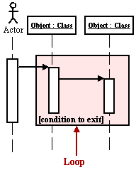
vi) UML Collaboration Diagram
A collaboration diagram describes interactions among objects in terms of sequenced messages. Collaboration diagrams represent a combination of information taken from class, sequence, and use case diagrams describing both the static structure and dynamic behavior of a system.

Basic Collaboration Diagram Symbols and Notations
Class roles
Class roles describe how objects behave. Use the UML object symbol to illustrate class roles, but don't list object attributes.
Association roles
Association roles describe how an association will behave given a particular situation. You can draw association roles using simple lines labeled with stereotypes.
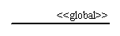

Messages
Unlike sequence diagrams, collaboration diagrams do not have an explicit way to denote time and instead number messages in order of execution. Sequence numbering can become nested using the Dewey decimal system. For example, nested messages under the first message are labeled 1.1, 1.2, 1.3, and so on. The condition for a message is usually placed in square brackets immediately following the sequence number. Use a * after the sequence number to indicate a loop.
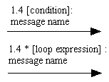
vii) UML State chart Diagram A state chart diagram shows the behavior of classes in response to external stimuli. This diagram models the dynamic flow of control from state to state within a system.
Basic State chart Diagram Symbols and Notations
States
States represent situations during the life of an object. You can easily illustrate a state in SmartDraw by using a rectangle with rounded corners.
Transition
A solid arrow represents the path between different states of an object. Label the transition with the event that triggered it and the action that results from it.
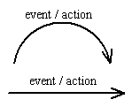

More Basic Collaboration Diagram Symbols and Notations

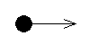
Initial State
A filled circle followed by an arrow represents the object's initial state.
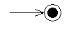
Final State
An arrow pointing to a filled circle nested inside another circle represents the object's final state.
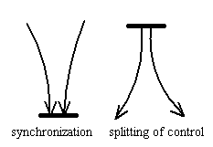
Synchronization and Splitting of Control
A short heavy bar with two transitions entering it represents a synchronization of control. A short heavy bar with two transitions leaving it represents a splitting of control that creates multiple states.
viii) UML Activity Diagram
An activity diagram illustrates the dynamic nature of a system by modeling the flow of control from activity to activity. An activity represents an operation on some class in the system that results in a change in the state of the system. Typically, activity diagrams are used to model workflow or business processes and internal operation. Because an activity diagram is a special kind of state chart diagram, it uses some of the same modeling conventions.

Basic Activity Diagram Symbols and Notations

Action states
Action states represent the non interruptible actions of objects. You can draw an action state in SmartDraw using a rectangle with rounded corners.
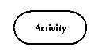
Action Flow
Action flow arrows illustrate the relationships among action states.
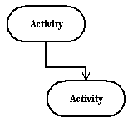
Object Flow
Object flow refers to the creation and modification of objects by activities. An object flow arrow from an action to an object means that the action creates or influences the object. An object flow arrow from an object to an action indicates that the action state uses the object.
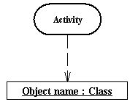

More Basic Collaboration Diagram Symbols and Notations
Initial State
A filled circle followed by an arrow represents the initial action state.
Final State
An arrow pointing to a filled circle nested inside another circle represents the final action state.
Branching
A diamond represents a decision with alternate paths. The outgoing alternates should be labeled with a condition or guard expression. You can also label one of the paths "else."
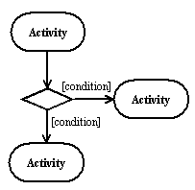

Synchronization
A synchronization bar helps illustrates parallel transitions. Synchronization is also called forking and joining.

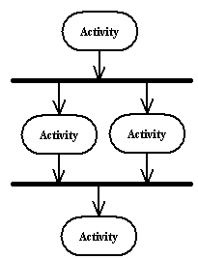
Swimlanes
Swimlanes group related activities into one column.
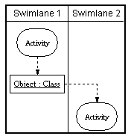
ix) UML Component Diagram
A component diagram describes the organization of the physical components in a system.

Basic Component Diagram Symbols and Notations
Component A component is a physical building block of the system. It is represented as a rectangle with tabs.
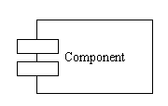
Interface
An interface describes a group of operations used or created by components.
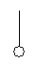
Dependencies
Draw dependencies among components using dashed arrows.
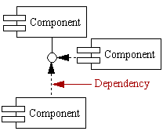
x) UML Deployment Diagram
Deployment diagrams depict the physical resources in a system including nodes, components, and connections.

Basic Deployment Diagram Symbols and Notations
Node
A node is a physical resource that executes code components.
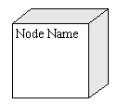
Association
Association refers to a physical connection between nodes, such as Ethernet.
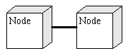
Components and Nodes
Place components inside the node that deploys them.
