Assignment Question’s Solutions (29/09/07)

Object Oriented Modeling and Design (S7 IT & CS)

SET 1

- Define multiple inheritance. Give an example of accidental multiple inheritance. How can they be overcome?

It permits a class to have more than one superclass and to inherit features from all parents. It rather allows mixing of information from two or mores sources. It provides increased opportunity for reuse. And to speak about its disadvantage, is a loss of conceptual and implementation simplicity. A class may inherit features from more than one class. A class with more than one superclass is called a join class. A feature from the same ancestor class found along more than one path is inherited only once; it is the same feature. Conflicts among parallel definitions create ambiguities that must be resolved in implementation.
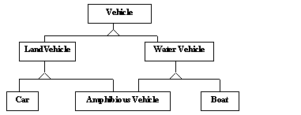
Fig. Multiple inheritance from disjoint classes
Here in the above example, Amphibious Vehicle is a join class. If a class can be refined on several distinct and independent dimensions, then use multiple generalizations.
Accidental Multiple Inheritance
An instance of a join class is inherently an instance of all the ancestors of the join class. For example, an instructor is inherently both faculty and student. But suppose lets say about a professor at HV taking classes at MIT.You can see there is no class to describe the combination .This is a case of accidental multiple inheritance.
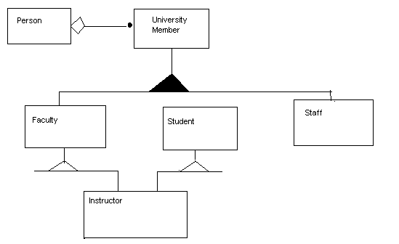
Fig. Workaround for accidental multiple inheritance

- What is the difference between abstract class and concrete class?
Abstract Classes- An abstract class is a class that has no direct instances but whose descendent classes have direct instances.
A concrete class is a class that is an instantiable; that is, it can have direct instances. A concrete class may be leaf classes in the inheritance tree; only concrete classes may be leaf classes in the inheritance tree. Now to get a clear idea about look at the below figure.
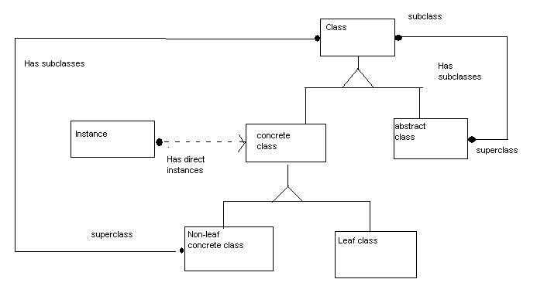
Fig. Object model defining abstract and concrete class
All the classes are concrete classes.
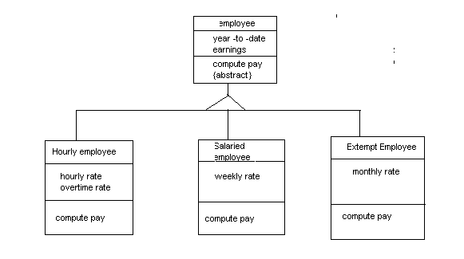
Fig. abstract class and abstract operation

- When are role names used in an association?
A role is an end of an association. Role name is a name that uniquely identifies one end of an association.
Eg: - “Person works for a Company.” Here the person plays the role of an employee and the company the role of the employer.

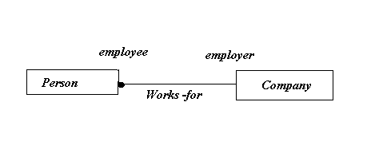
Fig.2.8 Role names for an association

SET 2

1. Explain the following:
  - Link attributes

A link attribute is a property of the links in an association. In the below figure access permission is an attribute of ‘Accessible by’.
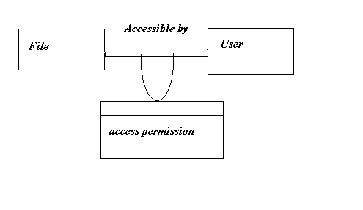
Fig. Link attribute for a many-many association
The OMT notation for a link attribute is a box attached to the association by a loop.

  - Inheritance

Generalization is the relationship between a class and one or more refined versions of it. The class being refined is called the ‘superclass’ and each refined version are called a ‘subclass’. For example, Equipment is the superclass of Pump and tank. Attributes and operations that are common to a group of subclasses are attached to the superclass and shared by each subclass. Generalization is sometimes called a ‘is-a’ relationship. Each instance of a subclass is an instance of the superclass. The notation for generalization is a triangle connecting a superclass to subclass.

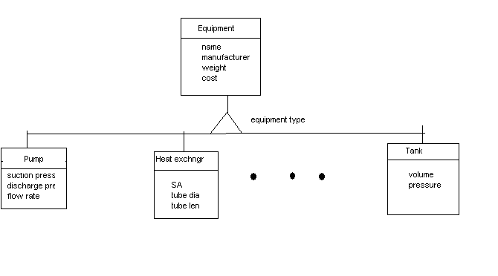

An inheritance hierarchy
The dangling ellipsis in the above figure indicates that there are additional subclasses that are not shown in the diagram. This may be since there is no room on the sheet and they are shown elsewhere or may be because enumeration of subclasses is still incomplete. You can also see equipment type written next to the triangle. This is called as a discriminator.
“A discriminator is an attribute of enumeration type that indicates which property of an object is being abstracted by a particular generalization relationship.”
What is the use of generalization? Generalization is a useful construct for both conceptual modeling and implementation.

  - Sheet
A sheet is a mechanism for breaking a large object model down into a series of pages. A sheet is a single printed page. Each module consists of one or more sheets. Each sheet has a title and a name or number. Each association/generalization appears on a single sheet. Classes may appear on multiple sheets.

2. What is the difference between association and generalization?

Association –Describes a group of links with common structure and common semantics’:- A person works for a company.
They are inherently bidirectional. It means that a binary association can be traversed in both directions. They are implemented as pointers.
The below figure shows a 1-1 association and corresponding links.
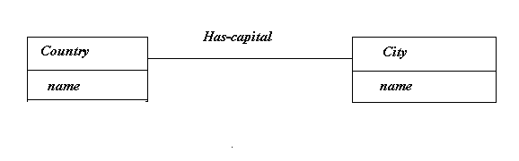
Class Diagram

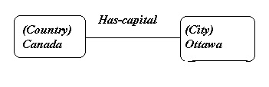

Instance Diagram

  - Multiplicity –specifies how many instances of one class may relate to each instance of another class. The solid balls,”2+” are multiplicity symbols. Associations may be binary, ternary or higher order.
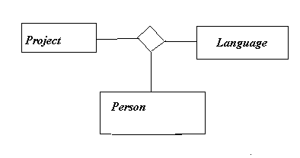
Ternary associations and links

Generalization
Generalization is the relationship between a class and one or more refined versions of it. The class being refined is called the ‘superclass’ and each refined version are called a ‘subclass’. For example, Equipment is the superclass of Pump and tank. Attributes and operations that are common to a group of subclasses are attached to the superclass and shared by each subclass. Generalization is sometimes called a ‘is-a’ relationship. Each instance of a subclass is an instance of the superclass. The notation for generalization is a triangle connecting a superclass to subclass.

An inheritance hierarchy

The dangling ellipsis in the above figure indicates that there are additional subclasses that are not shown in the diagram. This may be since there is no room on the sheet and they are shown elsewhere or may be because enumeration of subclasses is still incomplete. You can also see equipment type written next to the triangle. This is called as a discriminator.
“A discriminator is an attribute of enumeration type that indicates which property of an object is being abstracted by a particular generalization relationship.”
What is the use of generalization? Generalization is a useful construct for both conceptual modeling and implementation.

- What is the difference between links and associations?

They are used for establishing relationships among objects and classes. Link- A link is a physical or conceptual connection between object instances .We can say that a link is an instance of an association.
Eg: - J S works for Simplex company.
Association –Describes a group of links with common structure and common semantics’:- A person works for a company.
They are inherently bidirectional. It means that a binary association can be traversed in both directions. They are implemented as pointers.
The below figure shows a 1-1 association and corresponding links.

Fig. Class Diagram

Fig. Instance Diagram

SET 3

1. Explain the following:
a. Abstraction
Abstraction consists of focusing on the essential, inherent aspects of an entity and ignoring its accidental properties.
In system development, this means focusing on what an object does, before deciding how it should be implemented. Here use of abstraction preserves the freedom to make decisions by avoiding details.
Use of abstraction during analysis means dealing only with application-domain concepts, not making design and implementation decisions before the problem is understood.

- Encapsulation
Encapsulation is also known as information hiding, it consists of separating the external aspects of an object, which are accessible to other objects, from the internal implementation details of the object, which are hidden from other objects.
Encapsulation prevents a program from being so interdependent. The implementation of an object can be changed without affecting the applications that use it.
Encapsulation is not unique to object oriented language, but the ability to combine data structure and behavior in a single entity makes encapsulation more powerful.

- Model
A model is an abstraction of something for the purpose of understanding it before building it. It is easier to manipulate than the original entity.

- What is the difference between aggregation and association?

Aggregation vs. Association –Aggregation is a special form of association not an independent concept. If two objects are bound by a part-whole relationship, it is an aggregation .If two objects are usually considered independent, even though they may be linked, it is an association.

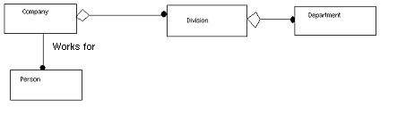
Fig. Aggregation and association

3. What are the stages of Object Oriented Methodology (OMT)?

Object Oriented Methodology is a methodology for object oriented development and a graphical notation for representing objects oriented concepts. We can call this methodology as OMT. The methodology has the following stages:
- Analysis - An analysis model is a concise, precise abstraction of what the desired system must do, not how it will be done. It should not contain any implementation details. The objects in the model should be application domain concepts and not the computer implementation concepts.
- System design - The designer makes high level decisions about the overall architecture. In system design, the target system is organized as various subsystems based on both the analysis structure and the proposed architecture.
- Object design - The designer builds a design model based on the analysis model but containing implementation details. The focus of object design is the data structures and algorithms needed to implement each cycle.
- Implementation - The object classes and relationships developed during object design are finally translated into a particular programming language, database, or hardware implementation. During implementation, it is important to follow good software engineering practice so that the system can remain the traceability, flexibility and extensibility.

