Program No:1
Date: 27.07.2010

INTRODUCTION TO SOCKET PROGRAMMING

PROBLEM DEFINITION

To study the concepts of socket programming in Java.

THEORETICAL BACKGROUND

Socket
A socket is a software endpoint that establishes bidirectional communication between a server program and one or more client programs. A socket enables an application to read from and write to the network. The socket associates the server program with a specific hardware port on the machine where it runs so any client program anywhere in the network with a socket associated with that same port can communicate with the server program. For example, a socket can be created as:
Socket socket = new Socket("192.2.1.168", 23);

Socket Class
This class implements client sockets (also called just "sockets"). A socket is an endpoint for communication between two machines.
The java.net.Socket class allows you to perform all four fundamental socket operations. It is not possible to connect to remote machines; but can send data; can receive data; can close the connection. Connection is accomplished through the constructors. Each Socket object is associated with exactly one remote host. To connect to a different host, you must create a new Socket object.
There's a method to close a socket:
public void close() throws IOException

Constructors for creating socket class

The different forms of constructors for the socket class are:

public Socket(): Creates an unconnected socket, with the system-default type of SocketImpl.

protected Socket(SocketImpl impl) throws SocketException: Creates an unconnected Socket with a user-specified SocketImpl.

public Socket(String host, int port, InetAddress localAddr, int localPort) throws IOException: Creates a socket and connects it to the specified remote host on the specified remote port. The Socket will also bind() to the local address and port supplied.

public Socket(InetAddress address, int port, InetAddress localAddr,int localPort) throws IOException: Creates a socket and connects it to the specified remote address on the specified remote port. The Socket will also bind() to the local address and port supplied.

public Socket(String host, int port, boolean stream) throws IOException: Creates a stream socket and connects it to the specified port number on the named host.

public Socket(InetAddress host, int port, boolean stream) throws IOException: Creates a socket and connects it to the specified port number at the specified IP address.

public Socket( InetAddress address, int port) throws IOException: Creates a stream socket and connects it to the specified port number at the specified IP address.

public Socket(String host, int port) throws UnknownHostException, IOException: Creates a stream socket and connects it to the specified port number on the named host.

Reading input from a socket

Receiving data is accomplished with input stream. The method to get an input stream for a socket is:

public InputStream getInputStream() throws IOException

Eg:BufferedReader stdin = new BufferedReader(new InputStreamReader(System.in));
System.out.print("Enter a line:");
System.out.println(stdin.readLine());

Writing output to a socket

Sending data is accomplished with output stream. The method to get an output stream for the socket is:

public OutputStream getOutputStream() throws IOException

Eg:PrintWriter pw = new PrintWriter("c:\\temp\\printWriterOutput.txt");
pw.println("PrintWriter is easy to use.");
pw.println(1234);

ServerSocket

In Java, a ServerSocket is the server end of a Socket connection that involves a client and a server. A server socket waits for requests to come in over the network. It performs some operation based on that request, and then possibly returns a result to the requester.

Eg: ServerSocket server = new ServerSocket(0);
This creates a server socket.

ServerSocket Class

This class implements server sockets. In Java, a ServerSocket is the server end of a Socket connection that involves a client and a server. The client creates a Socket to the specified host, and the host running the ServerSocket generates that Socket with an accept() call in the ServerSocket class. To accept clients, all you have to do is call ServerSocket.accept(), and when a client attempts to connect, you can accept that connection.
Constructors for creating server socket class

The different forms of constructors for the ServerSocket class are:

public ServerSocket() throws IOException: Creates an unbound server socket.

public ServerSocket(int port) throws IOException: Creates a server socket, bound to the specified port. A port of 0 creates a socket on any free port.

public ServerSocket(int port, int backlog) throws IOException: Creates a server socket and binds it to the specified local port number, with the specified backlog. A port number of 0 creates a socket on any free port.

public ServerSocket(int port, int backlog, InetAddress bindAddr) throws IOException: Create a server with the specified port, listen backlog, and local IP address to bind to. The bindAddr argument can be used on a multi-homed host for a ServerSocket that will only accept connect requests to one of its addresses. If bindAddr is null, it will default accepting connections on any/all local addresses. The port must be between 0 and 65535, inclusive.

Reading input from a ServerSocket

Receiving data is accomplished with input stream. The method to get an input stream for a socket is:

public InputStream getInputStream() throws IOException

Eg:BufferedReader stdin = new BufferedReader(new InputStreamReader(System.in));
System.out.print("Enter a line:");
System.out.println(stdin.readLine());

Writing output to a ServerSocket

Sending data is accomplished with output stream. The method to get an output stream for the socket is:

public OutputStream getOutputStream() throws IOException

public PrintWriter (File file, String characterSet)

Eg:
An example that shows reading and writing data with server socket using BufferedReader:
import java.io.*;
import java.net.*;
public class HTTPServer {
public static void main(String[] args) throws Exception {
ServerSocket sSocket = new ServerSocket(1777);
while (true) {
System.out.println("Waiting for a client...");
Socket newSocket = sSocket.accept();
System.out.println("accepted the socket");
OutputStream os = newSocket.getOutputStream();
BufferedReader br = new BufferedReader(new InputStreamReader(newSocket.getInputStream()));
String inLine = null;
while (((inLine = br.readLine()) != null) && (!(inLine.equals("")))) {
System.out.println(inLine);
}
System.out.println("");
StringBuffer sb = new StringBuffer();
sb.append("<html>\n");
sb.append("<head>\n");
sb.append("<title>Java \n");
sb.append("</title>\n");
sb.append("</head>\n");
sb.append("<body>\n");
sb.append("<H1>HTTPServer Works!</H1>\n");
sb.append("</body>\n");
sb.append("</html>\n");
String string = sb.toString();
byte[] byteArray = string.getBytes();
os.write("HTTP/1.0 200 OK\n".getBytes());
os.write(new String("Content-Length: " + byteArray.length + "\n").getBytes());
os.write("Content-Type: text/html\n\n".getBytes());
os.write(byteArray);
os.flush();
os.close();
br.close();
newSocket.close();
}
}
}

CONCLUSION
Socket Programming in Java has been studied.

Program No: 2
Date: 27.07.2010

INTRODUCTION TO MULTITHREADING

PROBLEM DEFINITION

To study about multithreading.

THEORETICAL BACKGROUND

A thread is a process in execution within a program. Both processes and threads provide an execution environment, but creating a new thread requires fewer resources than creating a new process. Within a program each thread defines a separate path of execution. A thread has a beginning, a body, and an end, and executes commands sequentially.
Threads exist within a process — every process has at least one. Threads share the process's resources, including memory and open files. This makes for efficient, but potentially problematic, communication.
Java provides built-in support for multithreaded programming. Multithreading is a conceptual programming paradigm where a program (process) is divided into two or more subprograms (process), which can be implemented at the same time in parallel. The ability of a language to support multithreads is referred to as concurrency. The java interpreter handles the switching of control between the threads in such a way that it appears they are running concurrently.

Creating a Thread:
Java defines two ways in which this can be accomplished:
- Implement the Runnable interface.
- Extend the Thread class, itself.

Create Thread by Implementing Runnable:
The easiest way to create a thread is to create a class that implements the Runnable interface.To implement Runnable, a class need only implement a single method called run( ), which is declared like this:
public void run( )
The code that constitutes the new thread should be written inside run() method. The method run() can call other methods, use other classes, and declare variables, just like the main thread can.
After creating a class that implements Runnable, an object of type Thread has to be instantiated from within that class. Thread defines several constructors like:
Thread(Runnable threadOb, String threadName);
Here threadOb is an instance of a class that implements the Runnable interface and the name of the new thread is specified by threadName.
After the new thread is created, it will not start running until you its start( ) method is called, which is declared within Thread. The start( ) method is shown here:
void start( );
Example:

public class HelloRunnable implements Runnable {

public void run() {
System.out.println("Hello from a thread!");
}

public static void main(String args[]) {
(new Thread(new HelloRunnable())).start();
}

}

Create Thread by Extending Thread:
The second way to create a thread is to create a new class that extends Thread, and then to create an instance of that class.
The extending class must override the run( ) method, which is the entry point for the new thread. It must also call start( ) to begin execution of the new thread.

Example:
public class HelloThread extends Thread {

public void run() {
System.out.println("Hello from a thread!");
}

public static void main(String args[]) {
(new HelloThread()).start();
}

}

Life Cycle Of A Thread
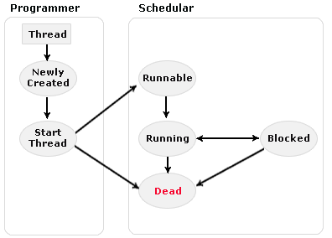
- New state – After the creations of Thread instance the thread is in this state but before the start() method invocation. At this point, the thread is considered not alive.
- Runnable (Ready-to-run) state – A thread start its life from Runnable state. A thread first enters runnable state after the invoking of start() method but a thread can return to this state after either running, waiting, sleeping or coming back from blocked state also. On this state a thread is waiting for a turn on the processor.
- Running state – A thread is in running state that means the thread is currently executing. There are several ways to enter in Runnable state but there is only one way to enter in Running state: the scheduler select a thread from runnable pool.
- Dead state – A thread can be considered dead when its run() method completes. If any thread comes on this state that means it cannot ever run again.
- Blocked - A thread can enter in this state because of waiting the resources that are hold by another thread.
Thread Priority

Every Java thread has a priority that helps the operating system determine the order in which threads are scheduled.
Java priorities are in the range between MIN_PRIORITY (a constant of 1) and MAX_PRIORITY (a constant of 10). By default, every thread is given priority NORM_PRIORITY (a constant of 5).
SetPriority () method can be used to set priority:
ThreadName.SetPriority(int Number);
Threads with higher priority are more important to a program and should be allocated processor time before lower-priority threads. However, thread priorities cannot guarantee the order in which threads execute and very much platform dependentant.
Thread Synchronization
When two or more threads need access to a shared resource, they need some way to ensure that the resource will be used by only one thread at a time.
The process by which this synchronization is achieved is called thread synchronization.
The synchronized keyword in Java creates a block of code referred to as a critical section. Every Java object with a critical section of code gets a lock associated with the object. To enter a critical section, a thread needs to obtain the corresponding object's lock.
This is the general form of the synchronized statement:
synchronized(object) {
// statements to be synchronized
}
Here, object is a reference to the object being synchronized. A synchronized block ensures that a call to a method that is a member of object occurs only after the current thread has successfully entered object's monitor.

CONCLUSION

Multithreading concepts in java have been studied.

Program No:3
Date: 28.07.2010

CLIENT TO SERVER DATA TRANSFER USING TCP/IP

PROBLEM DEFINITION

To write a Java program to implement the unidirectional data transfer from client to server.

THEORETICAL BACKGROUND

A client is the requesting program or user in a client/server relationship. The computer handling the request and sending back the response is a server. A socket is the basic communication interface between these networked computers. A TCP stream socket server application listens on the network for incoming client request packets. A TCP stream socket client application initiates communication with the server by sending a request packet. When the server receives the request, it processes it and responds. After this initial sequenced message exchange, client and server can exchange data.
In order to make a socket connection, you need a host to connect to. Here we’re going to be running the client(s) and the server on the same machine. Thus we define a String host as ‘localhost’. We could have used the TCP/IP address 127.0.0.1 instead of ‘localhost’ also. The next piece of information we need to know is the TCP/IP port that the program is going to be communicating on. TCP/IP uses ports because it is assumed that servers will be doing more than one network function at a time and ports provide a way to manage this. For example: a server may be serving up web pages (port 80), it may have a FTP (port 21) server, and it may be handling a SMTP mail server (port 25). Ports are assigned by the server. The client needs to know what port to use for a particular service. In the TCP/IP world, each computer with a TCP/IP address has access to 65,535 ports. Ports are not physical devices like a serial, parallel, or USB port; they are an abstraction in the computer’s memory running under the TCP/IP transport layer protocol. Ports 1 – 1023 are reserved for services such as HTTP, FTP, email, and Telnet.. On establishing the connection, we can write some information to the server. Java treats reading and writing sockets is much like reading and writing files. Subsequently we start by establishing an OutputStream object. In general TCP stacks use buffers to improve performance within the network.
The following steps occur when establishing a TCP connection between two computers using sockets:
1. The server instantiates a ServerSocket object, indicating which port number communication is to occur on.
2. The server invokes the accept() method of the ServerSocket class. This method waits until a client connects to the server on the given port.
3. After the server is waiting, a client instantiates a Socket object, specifying the server name and port number to connect to.

4. The constructor of the Socket class attempts to connect the client to the specified server and port number. If communication is established, the client now has a Socket object capable of communicating with the server.
5. On the server side, the accept() method returns a reference to a new socket on the server that is connected to the client's socket.
6. After the connections are established, communication can occur using I/O streams. Each socket has both an OutputStream and an InputStream. The client's OutputStream is connected to the server's InputStream, and the client's InputStream is connected to the server's OutputStream. TCP is a two-way communication protocol, so data can be sent across both streams at the same time.

ALGORITHM
Server:
Step 1: Start
Step 2: Create a server socket, ss and a socket, s
Step 3: Server socket listens for a client to connect, and accepts it when a socket is created by the client.
Step 4: Read the data from the input stream and print it as the client data.
Step 5: Close the socket and the server socket
Step 6: Catch if any exceptions
Step 7: Stop

Client:
Step 1: Start
Step 2: Create a socket, s, for the client
Step 3: Enter the data to be sent to the server through the keyboard
Step 4: Write it into the input stream
Step 5: Close the socket
Step 6: Print if any exceptions
Step 7: Stop

PROGRAM

Server:
import java.io.*;
import java.net.*;
import java.lang.*;

class Server
{
public static void main(String args[])
{
try
{
System.out.println("Server listening");
ServerSocket ss=new ServerSocket(3000);

Socket s=ss.accept();
String str;
System.out.println("client connected");
BufferedReader b=new BufferedReader(new InputStreamReader (s.getInputStream()));
System.out.println("from client:");
str=b.readLine();
while(!str.equals("exit"))
{
System.out.println(str);
str=b.readLine();
}
ss.close();
s.close();
}
catch(Exception e)
{
System.out.println("client exit");
}
}
}

Client:
import java.io.*;
import java.net.*;
import java.lang.*;

class Client
{
public static void main(String args[])
{
try
{
Socket s=new Socket("localhost",3000);
String str;char a;
BufferedReader br=new BufferedReader(new InputStreamReader(System.in));
System.out.println("enter data----press * to end");
PrintWriter pw=new PrintWriter(s.getOutputStream(),true);
str=br.readLine();
while(!str.equals("exit"))
{
pw.println(str);
str=br.readLine();
}
s.close();
}
catch(Exception e)
{
System.out.println(e);
}
}

TEST CASES

Server:

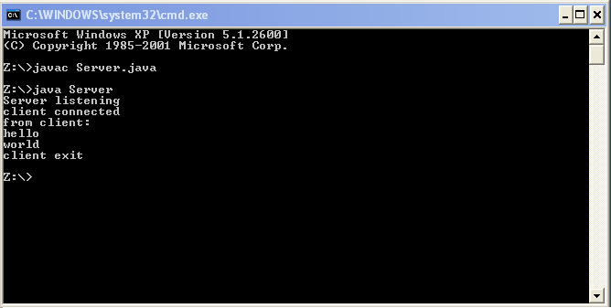

Client:

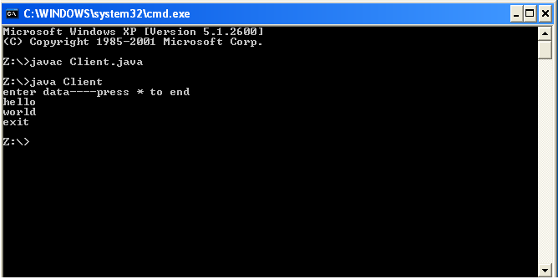

CONCLUSION

Java program to implement unidirectional data transfer from client to server has been written and executed successfully.
Program No: 4
Date: 28.07.2010

ECHO SERVER

PROBLEM DEFINITION

A Java program to implement an echo server.

THEORETICAL BACKGROUND

Networking support is provided in Java by java .net package. The classes defined in this package make Java a good language for networking. TCP/IP sockets are used to implement reliable, bidirectional, persistent, point-to-point connections between hosts on internet. Sockets are communication end points. There are two kinds of sockets in Java- ServerSocket and Socket. The ServerSocket class is designed to be the listener which waits for the client to be connected before communication. The Socket class is designed to connect to sever sockets and initiate protocol exchanges.

To start a communication there should be a server listening to some port for requests from the client. When a client wants to communicate to a server it should request for a connection with the server specifying the server and the port number. In this program client and the server is run on the same machine. So the socket class is created specifying server as ‘localhost’. The TCP/IP address 127.0.0.1 can also be used instead of ‘localhost’. The next piece of information we need to know is the TCP/IP port that the program is going to be communicating on. TCP/IP uses ports because it is assumed that servers will be doing more than one network function at a time and ports provide a way to manage this.

The server instantiates a ServerSocket object, indicating which port number communication is to occur on. The server invokes the accept() method of the ServerSocket class. This method waits until a client connects to the server on the given port. After the server is waiting, a client instantiates a Socket object, specifying the server name and port number to connect to. The constructor of the Socket class attempts to connect the client to the specified server and port number. If communication is established, the client now has a Socket object capable of communicating with the server. On the server side, the accept() method returns a reference to a new socket on the server that is connected to the client's socket. After the connections are established, communication can occur using I/O streams.

In an echo server the data send from the client to the server is sent back to the client by the server. The data is entered through the keyboard by the client is written to the output stream of the client using object of the Socket class which has been used to establish connection with the server by specifying the server and the port number. This is read from the InputStream of the server. The server writes the data it has read into the OutputStream of the socket using PrintWriter object. This is read by the client from its input stream and is displayed.

ALGORITHM

Server:
Step 1: Start
Step 2: Create a server socket, ss and a socket, s
Step 3: Server socket listens for a client to connect, and accepts it when a socket is created by the client.
Step 4: While data from client is not “exit” print the read string as the client data.
Step 5: Write the data that has been read to the OutputStream
Step 6: Close the Socket object.
Step 7: Close the ServerSocket object.
Step 8: Stop

Client:
Step 1: Start
Step 2: Create a socket s specifying localhost and port number to be connected.
Step 3: Data is read using BufferedReader object from the standard input device.
Step 4: While data entered is not “exit”
4.1: Write data read into the output stream
4.2: Read data from the server and display the echo
Step 5: Close the socket object
Step 6: Stop

PROGRAM

Server:

import java.io.*;
import java.lang.*;
import java.net.*;

class Eserver
{
public static void main(String args[]) throws IOException
{
try
{
String str;
System.out.println("Server listening....");
ServerSocket ss=new ServerSocket(3000);
Socket s=ss.accept();
System.out.println("Client connected");
BufferedReader br=new BufferedReader(new InputStreamReader(s.getInputStream()));
while(true)
{
System.out.println("From Client: ");
str=br.readLine();
if(str==null)
{
break;
}
PrintWriter pw=new PrintWriter(s.getOutputStream(),true);
pw.println(str);
if(str==null||str.equals("end"))
{
break;
}
while(true)
{

if(str==null||str.equals("end"))
{
break;
}
if(str==null||str.equals("exit"))
{
break;
}
System.out.println(str);
str=br.readLine();
if(str==null)
{
break;
}
pw.println(str);
}
if(str==null||str.equals("end"))
{
break;
}
}
ss.close();
s.close();
}
catch(Exception e)
{
System.out.println(e);
}
}
}

Client:

import java.io.*;
import java.lang.*;
import java.net.*;

class Eclient
{
public static void main(String args[]) throws IOException
{
try
{
String str;
Socket s=new Socket("localhost",3000);
BufferedReader br=new BufferedReader(new InputStreamReader(System.in));
BufferedReader b=new BufferedReader(new InputStreamReader(s.getInputStream()));

while(true)
{

System.out.println("Enter 'end' to end a conversation");
System.out.println("");
System.out.println("");
System.out.println("Enter data!---enter 'exit' to end a message");
str=br.readLine();
if(str==null)
{
break;
}
PrintWriter pw=new PrintWriter(s.getOutputStream(),true);
pw.println(str);
if(str==null||str.equals("end"))
{
System.out.println("client exited!");
break;
}
while(true)
{
if(str==null||str.equals("exit"))
{
break;
}
if(str==null||str.equals("end"))
{
break;
}
str=br.readLine();
if(str==null)

{
break;
}
pw.println(str);
}
if(str==null||str.equals("end"))
{
System.out.println("client exited!");
break;
}
System.out.println("");
System.out.println("");
System.out.println("Back from Server: ");
while(true)
{
str=b.readLine();
if(str==null||str.equals("exit"))
{
break;
}
if(str==null||str.equals("end"))
{
break;
}
System.out.println(str);
}
}
s.close();
}
catch(Exception e)
{
System.out.println(e);
}
}
}

TEST CASES

Case 1:
Javac Eserver.java
Java Eserver
Javac Eclient.java
Java Eclient

SUMMARY OF RESULTS
Case 1:
Server:

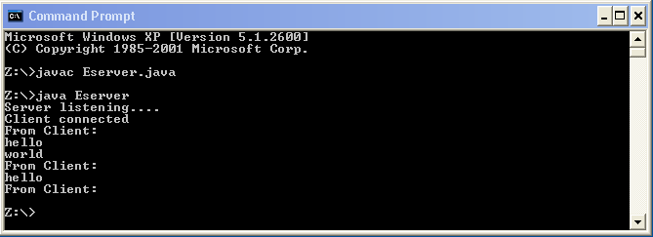

Client:

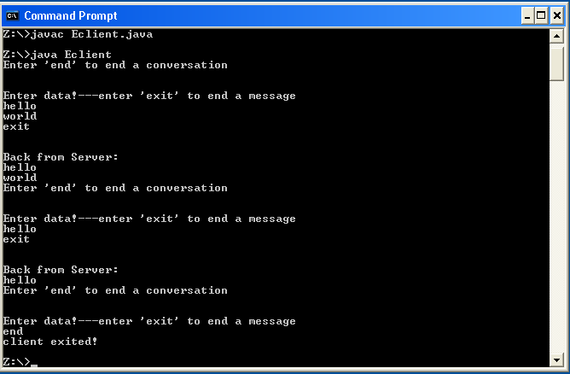

CONCLUSION
Java program to implement echo server has been coded, run successfully and output has been verified.

Program No: 5
Date: 04.08.2010

BIDIRECTIONAL DATA TRANSFER

PROBLEM DEFINITION

Program to implement the bidirectional data transfer from client to server.

THEORETICAL BACKGROUND

Most network application can be divided into two pieces: a client and a server. A client is the side that initiates the communication process, where as the server responds to incoming client requests.

A server runs on a specific computer and has a socket that is bound to a specific port number. The server just waits, listening to the socket for a client to make a connection request. On the client-side, the client knows the hostname of the machine on which the server is running and the port number on which the server is listening. The server accepts the connection, when client requests for a connection. On the client side, if the connection is accepted, a socket is successfully created and the client can use the socket to communicate with the server and vice-versa by writing to or reading from their sockets. In bidirectional communication, client and server both communicate with each other. The connection is released when either server or client tries to release connection. When client releases the connection, server listens to the port waiting for another connection.

The java.net package in the Java platform provides a class, Socket, that implements one side of a two-way connection between your Java program and another program on the network. Additionally, java.net includes the ServerSocket class, which implements a socket that servers can use to listen for and accept connections to clients.

BufferedReader Class provides an implementation of the abstract Reader class that buffers character data from another reader. The package of this class is java.io. The BufferedReader class provides functionality to read characters from a stream with buffering. It also provides mark and reset functionality for reading characters back and forth within a buffered limit from a sequential stream. BufferedReader has got a constructor which is overloaded and initializes a new instance of BufferedReader object. The readLine function reads the entire line from the underlying stream.

The method of writing to the console when using Java is through a PrintWriterstream. PrintWriter is one of the character-based classes. PrintWriter defines several constructors. The syntax of PrintWriter: PrintWriter(OutputStream outputStream, boolean flushOnNewline). Here, outputStream is an object of type OutputStream, and flushOnNewline controls whether Java flushes the output stream every time a newline ('\\n') character is output. If flushOnNewline is true, flushing automatically takes place. If false, flushing is not automatic. PrintWriter supports the print( ) and println( ) methods for all types including Object, to print to the underlying output stream. Thus, you can use these methods in the same way as they have been used with System.out.

ALGORITHM

Client Side

Step 1: Start
Step 2: Create a socket at client side specifying localhost and port number
Step 3: Create objects of BufferedReader to get the input from the keyboard from client side
and to get the input stream of server.
Step 4: Create an object of PrintWriter to put the contents of client to its output stream.
Step 5: Get the input from the client and store the content in a string.
Step 5: If the string is exit or null, then client exits and go to step 9, else go to step 6.
Step 6: Put the string from client to its output stream.
Step 7: Read the string from the server and store in a string.
Step 8: If the string is exit or null, server exits and go to step 9, client also exits. Else go to
step 5.
Step 9: Close the socket at client side.
Step 7: If any io exception occurs, catch it and print a error message.
Step 8: Stop.

Server Side

Step 1: Start
Step 2: Create a server socket at server side specifying port number.
Step 3: Accept the connection from the client when it connects.
Step 3: Create objects of BufferedReader to get the input from the keyboard from server side
and to get the input stream of client.
Step 4: Create an object of PrintWriter to put the contents of server to its output stream.
Step 5: Get the input from the server and store the content in a string.
Step 5: If the string is exit or null, then client exits and go to step 9, else go to step 6.
Step 6: Put the string from server to its output stream.
Step 7: Read the string from the client and store in a string.
Step 8: If the string is exit or null, client exits and go to step 9, server also exits. Else go to
step 5.
Step 9: Close the socket at client side and server side.
Step 7: If any io exception occurs, catch it and print a error message.
Step 8: Stop.

PROGRAM DEVELOPMENT

Server Side

import java.io.*;
import java.net.*;

public class BiServer
{
public static void main(String args[]) throws IOException
{
try{
ServerSocket ss = new ServerSocket(3000);
System.out.println("Server listening..");
Socket s = ss.accept();
System.out.println("Client connected..");
BufferedReader br = new BufferedReader(new InputStreamReader(s.getInputStream()));
BufferedReader br1 = new BufferedReader(new InputStreamReader(System.in));
PrintWriter pw=new PrintWriter(s.getOutputStream(),true);
while(true){
String str=br.readLine();
if(str.equals("exit"))
{
break;
}
System.out.println("from client:"+str);
System.out.println("enter data and exit to return...");
String str1= br1.readLine();
if(str1.equals("exit"))
{
pw.println("exit");
break;
}
pw.println(str1);
}
System.out.println("Server exited...");
s.close();
ss.close();
}

catch (IOException ioe) {
System.err.println(ioe);
}
}
}

Client Side

import java.io.*;
import java.net.*;

public class BiClient{
public static void main(String args[]) throws IOException
{
try{
Socket s= new Socket("localhost",3000);
BufferedReader br = new BufferedReader(new InputStreamReader(s.getInputStream()));
BufferedReader br1 = new BufferedReader(new InputStreamReader(System.in));
PrintWriter pw=new PrintWriter(s.getOutputStream(),true);
while(true){
System.out.println("Enter data and exit to return...");
String str=br1.readLine();
if(str.equals("exit"))
{
pw.println("exit");
break;
}
pw.println(str);
String str1= br.readLine();
if(str1.equals("exit"))
{
break;
}
System.out.println("from server:"+str1);
}
System.out.println("Client exited...");
s.close();
}

catch (IOException ioe) {
System.err.println(ioe);
}
}
}

TESTING STRATEGIES AND SUMMARY OF RESULTS

Client Side

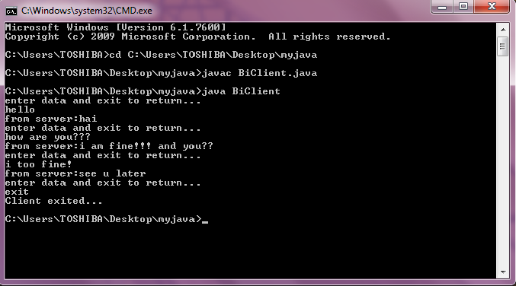

Server Side

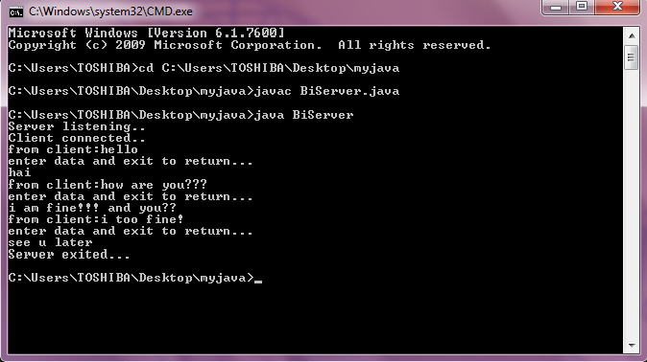

CONCLUSION

Java program to implement bidirectional data transfer between client and server was written, executed and output verified.

