RAJAGIRI SCHOOL OF ENGINEERING
AND TECHNOLOGY
Rajagiri Valley, Kochi -39



R703- THEORY OF COMPUTATION
MODULE II

Prepared by
Preetha K G

INDEX

Introduction to Automata theory
  - Basic Concepts
  - Finite Automata
    - Deterministic Finite Automata
1.2.1.1 Language acceptability by finite automata
    - Nondeterministic Finite Automata
1.2.2.1NFA withouttransitions
1.2.2.2 NFA with transitions
    - Conversion of NFA to DFA
    - Minimization of DFA
  - Regular Expressions
  - Regular Grammars
  - Pumping lemma for regular languages
  - Transition Diagrams and Transition systems
  - Applications of finite state automata

  - Basic Concepts
Automata
It is an abstract model of a digital computer. The model consists of an infinite tape which is equivalent to memory and finite control which is equivalent to CPU of a digital computer.
Features
- It has a mechanism for reading input.
- It will be assumed that the input is a string over a given alphabet, written on an input file which the automaton can read but not change.
- The input file is divided into cells each of which can hold one symbol.
- The input mechanism can read the input file left to right, one symbol at a time.
- The input mechanism can also detect the end of the input string.
- The automaton can produce output of some form
- It may have a temporary storage devices consisting of an unlimited number of cells each capable of holding a single symbol from an alphabet.
- The automaton can read and change the contents of the storage cells
- The automaton has control unit which can be in any one of a finite number of internal states which can change state in some defined manner.
The computation of an automaton is basically symbol processing. Initially automaton reads the first input from memory. Depending on the current state and symbol read it changes its state according to the given program, and then it moves to the right to read the next input symbol.

Schematic Representation of Automaton
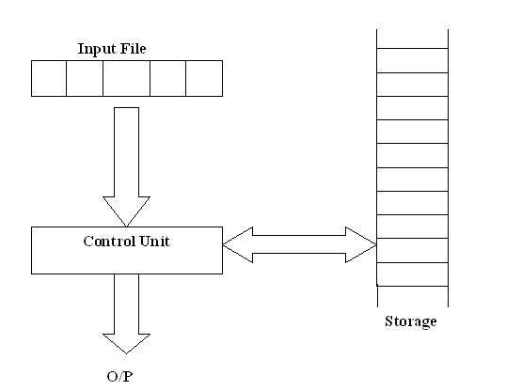
At any given time, the control unit is in some internal state, and the input mechanism is scanning a particular symbol on the input file. The internal state of the control unit at the next time step is determined by the next state or transition function. This transition function gives the next state in terms of the current state, current input symbol, information currently in the temporary storage. During the transition from one time interval to the next, output may be produced or the information in the temporary storage changed. Configuration is used to refer to a particular state of the control unit, input file, and temporary storage. Transition from one configuration to other is called a move.
1.2 Finite Automata
A finite amount of information can be retained in the control unit by placing the unit into a specific state. Finite automata are used as a model for
a) Designing digital circuits
b) Lexical analyzer of a compiler
c) Searching for keywords in a file or on the web
d) Software for verifying finite state systems
There are mainly two types of finite automata.

    - Deterministic Finite Automata
DFA is developed by Robin and Scott in 1950. Deterministic finite automaton is defined as a 5-tuple M= < Q, , , q_{0,} F>
- Q is a finite set of internal states.
- is a set of finite symbols called input alphabet.
- The transition function is also called a next state function meaning that the automaton moves into the state (q, a) if it receives the input symbol a while in state q. :QX→Q
- q0Q is the initial state.
- F is a subset of Q is the set of final states.
The accepting states are used to distinguish sequences of inputs given to the finite automaton. If the finite automaton is in an accepting state when the input ceases to come, the sequence of input symbols given to the finite automaton is "accepted". Otherwise it is not accepted.
Q0 is the initial state, take left most symbol of the input string. Input mechanism can move only from left to right and reads exactly one symbol on each step.
To visualize this we can use digraphs called transition graphs/ (state) transition diagrams. The vertices (denoted by single circles) of a transition diagram represent the states of the DFA and the arcs labeled with an input symbol correspond to the transitions. An arc ( p , q ) from vertex p to vertex q with label represents the transition (p, ) = q . The accepting states are indicated by double circles.
Transition functions can also be represented by tables as seen below. They are called transition table.
Example 1: Q = { 0, 1, 2 }, = { a }, F = { 1 }, the initial state is 0 and is as shown in the following table.
State (q) | Input (a) | Next State ( (q, a) )
0 | a | 1
1 | a | 2
2 | a | 2

A state transition diagram for this DFA is given below.
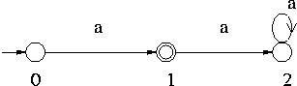
Example 2: Q = { 0, 1, 2 }, = { a, b }, F = { 1 }, the initial state is 0 and is as shown in the following table.
State (q) | Input (a) | Next State ( (q, a) )
0 | a | 1
0 | b | 2
1 | a | 2
1 | b | 2
2 | a | 2
2 | b | 2
Note that for each state there are two rows in the table for corresponding to the symbols a and b, while in the Example 1 there is only one row for each state.
A state transition diagram for this DFA is given below.
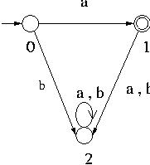
Example 3: Q = { 0, 1 }, = { a, b }, F = { 0 }, the initial state is 0 and is as shown in the following table.
State (q) | Input (a) | Next State ( (q, a) )
0 | a | 0
0 | b | 1
1 | a | 1
1 | b | 1
A state transition diagram for this DFA is given below.
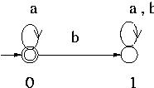

Definition of *:
* is the extended transition function.
QX→* is a string rather than a single symbol.
( q0 ,a) = q1
( q1 ,b) = q2
*( q0 ,a,b) = q2
*( q , ) = q , where denotes the empty string.
*( q , wa) =( *( q , w),a)
Example
For example suppose that a DFA contains the transitions shown below.
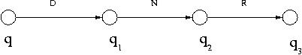
Then *( q , DNR ) can be calculated as follows:
*( q , DNR ) = ( *( q , DN ) , R ) by the Inductive Clause.
= ( ( *( q , D ) , N ) , R ) by applying the Inductive Clause to *( q , DN ).
= ( ( *( q , D ) , N ) , R ) since D = D .
= ( ( ( *( q , ) , D ) , N ) , R ) by applying the Inductive Clause to *( q , D ).
= ( ( ( q , D ) , N ) , R ) , since ( q , ) = q .
= ( ( q₁ , N ) , R ) , since ( q , D ) = q₁ as seen from the diagram.
= ( q₂ , R ) , since ( q₁ , N ) = q₂ as seen from the diagram.
= q₃ since ( q₂ , R ) = q₃ as seen from the diagram.
1.2.1.1 Language acceptability by finite automata
Every finite automaton accepts some language. If we consider all possible finite automata, we get a set of languages associated with them. We call such a set language a family.
If a language L is called regular if and only if there exists some finite acceptor M such that L= L(M)’.
L(M) is the language accepted by finite automata.
If a finite automaton accepts a string then it reaches its final state.
Example 1:
L = { awa : w{a,b}*}
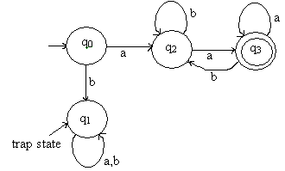
Example 2:

L = {aw₁aaw₂a : w₁w₂ {a,b}*}
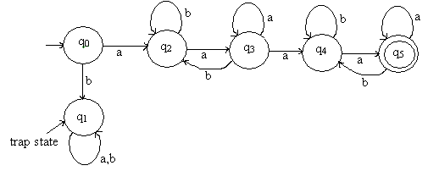

1.2.2 Nondeterministic Finite Automata (NFA)
Nondeterminism means a choice of moves for an automaton. Nondeterministic finite automaton is defined by a 5-tuple M= < Q, , q₀ , , F >

- Q is a finite set of internal states.
- is a set of finite symbols called input alphabet.
- The transition function is also called a next state function meaning that the automaton moves into the state (q, a) if it receives the input symbol a while in state q. :QX→2^{Q}
- q0Q is the initial state.
- F is a subset of Q is the set of final states.
Difference between DFA and NFA
- In NFA range of is 2^{Q}. In DFA this is Q
- Unlike DFA an NFA moves into one of the states given by (q, a) if it receives the input symbol a while in state q. Which one of the states in (q, a) to select is determined non deterministically.
- NFA can make transition without consuming an input symbol.
- In NFA the set (q, a) may be empty. This means there is no transition defined for this specific situation.
Example 1: Q = { 0, 1 }, = { a }, A = { 1 }, the initial state is 0 and is as shown in the following table.
State (q) | Input (a) | Next State ( (q, a) )
0 | A | {1}
1 | A
A state transition diagram for this finite automaton is given below.
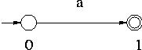
If the alphabet is changed to { a, b } in stead of { a }, this is still an NFA that accepts { a } .
Example 2: Q = { 0, 1, 2 }, = { a, b }, A = { 2 }, the initial state is 0 and is as shown in the following table.
State (q) | Input (a) | Next State ( (q, a) )
0 | A | {1,2}
0 | B
1 | A
1 | B | {2}
2 | A
2 | B

A state transition diagram for this finite automaton is given below.
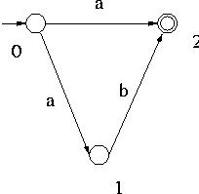

Definition of *:
* is the extended transition function.
*(q_{i,}w)=Q_{j}
Q_{j} is the set of all possible states the automaton may be in having started state q_{i} and having w.
For an NFA extended transition function is defined so that * (q_{i,}w) contains q_{j} if and only if there is a walk in the transition graph from q_{i} to q_{j} labeled w. This holds for all q_{i} , q_{j} Q and w *.
Example:
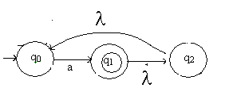
Consider the above figure and find *(q_{1,}a)
*(q_{1,}a)={ q_{0,} q₁ q_{2}}
1.2.2.1 NFA without transitions
For the figure given below, check whether input 011 is accepted or not
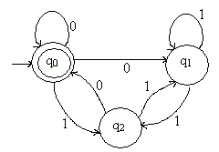

State | Input
 | 0 | 1
q₀ | { q₀, q₁} | {q₂}
q₁ | φ | { q₁, q₂}
q₂ | { q₀,q₂} | { q₁}

δ( q₀,0) = { q₀, q₁}

δ*( q₀,01) = δ( δ( q₀,0),1)
= δ( { q₀, q₁},1)
= δ( q₀,1) δ( q₁,1)
= { q₂} { q₁, q₂}
= { q₁, q₂}

δ*( q₀,011) = δ( δ*( q₀,01),1)
= δ( {q₁, q₂},1)
= δ( q₁,1) δ( q₂,1)
= { q₁, q₂} { q₂}
= { q₁, q₂}
But the final state from the picture is q₂ , hence ‘011’ is not accepted by the machine.

1.2.2.2 NFA with transitions
For the figure given below, check whether input ‘ab’ is accepted or not
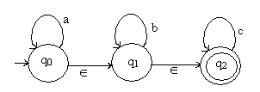
- closure (q₀) = {q₀, q₁, q₂}
// starting from q₀ which all states we can include by taking as input

δ*( q₀, ) = - closure (q₀) = {q₀, q₁, q₂}

δ*( q₀, a) = - closure (δ(δ*( q₀, )), a)
= - closure (δ({q₀, q₁, q₂}), a)
= - closure (δ( q₀,a), δ( q₁,a), δ( q₂,a) )
= - closure ({q₀}, φ, φ)
= - closure ({q₀})
= {q₀, q₁, q₂}

δ*( q₀, ab) = - closure (δ(δ*( q₀, a)), b)
= - closure (δ( q₀,b), δ( q₁,b), δ( q₂,b) )
= - closure (φ, {q₁}, φ)
= - closure (q₁)
= { q₁, q₂}

q₂ is the final state , hence ‘ab’ is accepted by the machine.
1.2.3 Conversion of NFA to DFA

The finite acceptors M1 and M2 are said to be equivalent if L(M1)=L(M2)

Let M₂ = < Q₂ , , q_{2,0} , ₂ , A₂ > be an NFA that recognizes a language L. If DFA M = < Q, , q₀ , , A > which accepts the same language as the given NFA M_{2.} Then both DFA and NFA are equivalent.

To obtain a DFA M = < Q, , q₀ , , A > which accepts the same language as the given NFA M₂ = < Q₂ , , q_{2,0} , ₂ , A₂ > does, you may proceed as follows:
1. Initially Q = .
2. First put { q_{2,0} } into Q. { q_{2,0} } is the initial state of the DFA M.
3. Then for each state q in Q do the following:
add the set 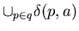, where here is that of NFA M₂, as a state to Q if it is not already in Q for each symbol a in .
For this new state, add ( q, a ) = to , where the on the right hand side is that of NFA M₂.
4. When no more new states can be added to Q, the process terminates. All the states of Q that contain accepting states of M₂ are accepting states of M.
5. The states that are not reached from the initial state are not included in Q obtained by this procedure.
Example:
Convert the following NFA to DFA
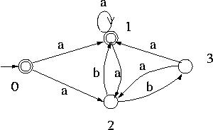
The initial state of the DFA is {0} , {0} is added to Q.
Since ₂( 0 , a ) = { 1 , 2 } , { 1 , 2 } is added to Q and ( { 0 } , a ) = { 1 , 2 } .
Since ₂( 0 , b ) = , is added to Q and ( { 0 } , b ) = .
Then since { 1 , 2 } is now in Q, the transitions from { 1 , 2 } on symbols a and b are computed. Since ₂( 1 , a ) = { 1 , 2 } , and ₂( 2 , a ) = , ( { 1 , 2 } , a ) = { 1 , 2 } .

Similarly ( { 1 , 2 } , b ) = { 1 , 3 } .

Thus { 1 , 3 } is added to Q .
Similarly ( { 1 , 3 } , a ) = { 1 , 2 } and ( { 1 , 3 } , b ) = .

Thus no new states are added to Q .
For the accepting states of M, since states 0 and 1 are the accepting states of the NFA, all the states of Q that contain 0 and/or 1 are accepting states. Hence { 0 }, { 1 , 2 } and { 1 , 3 } are the accepting states of M.
The DFA thus obtained is shown below.
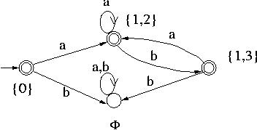
1.2.4 Minimization of DFA
Any DFA defines a unique language, but converse is not true. For a given language there are many DFAs that accept it. Difference is the number of states. Minimum number of states is preferable because computation requires space proportional to the number of states. For storage efficiency number of states must be reduced.
Two states p & q are called indistinguishable if δ*( p,w) F and δ*(q,w) F and
δ*( p,w) notF and δ*( q,w) notF for all w *
=Two states p & q are called distinguishable if δ*( p,w) F and δ*(q,w) notF and
for all w *
To reduce any DFA find and combine indistinguishable states.
Procedure: Mark( finding pairs of distinguishable states)
- Remove unreachable states, i.e. states which cannot be reached from the start state.
- Consider all pairs of states (p,q) .If p F and q notF then mark(p,q) are distinguishable.
- Repeat the following
a) For pair(p,q) , compute δ( p,a)=pa and δ( q,a)=qa. If a pair (pa,qa) marked as distinguishable for some a then mark (p,q) as distinguishable.
Procedure: Reduce (Given DFA M= < Q, , q₀ , , F > reduce to < Q’, , q_{0’} , ’, F’ >
- From the above procedure find the set of indistinguishable states.
- For each set (qi,qj…..qk) of each indistinguishable state create a state labels i,j…k.
- For each transition value of M of the form δ( qr,a)=qp find the set to which qr, qp belong. If qr in (qi,qj…qk) and qp in (ql,qm…qn) then add to δ’rule
δ’(I,j…k,a)=l,m….n
- Initial state is q0’
- F’ is the set of final states.
Example:

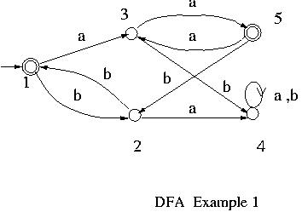
Initially = { { 1 , 5 } , { 2 , 3 , 4 } }.

Procedure mark is applied to . Since on b state 2 goes to state , state 3 goes to state 4 and 1 and 4 are in different sets in , states 2 and 3 are going to be separated from each other in _{new} .

Also since on a sate 4 goes to sate 4, state 3 goes to state 5 and 4 and 5 are in different sets in , states 3 and 4 are going to be separated from each other in _{new}.
Further, since on b 2 goes to 1, 4 goes to 4 and 1 and 4 are in different sets in , 2 and 4 are separated from each other in _{new}.

On the other hand 1 and 5 make the same transitions. So they are not going to be split.
Thus the new partition is { { 1 , 5 } , { 2 } , { 3 } , { 4 ] }. This becomes the in the second iteration.
When new_partition is applied to this new , since 1 and 5 do the same transitions, remains unchanged.

Thus _{final} = { { 1 , 5 } , { 2 } , { 3 } , { 4 ] }.
Select 1 as the representative for { 1 , 5 }. Since the rest are singletons, they have the obvious representatives.

Note here that state 4 is a dead state because the only transition out of it is to itself.
Thus the set of states for the minimized DFA is { 1 , 2 , 3 }.
For the transitions, since 1 goes to 3 on a, and to 2 on b in the original DFA, in the minimized DFA transitions are added from 1 to 3 on a, and 1 to 2 on b. Also since 2 goes to 1 on b, and 3 goes to 1 on a in the original DFA, in the minimized DFA transitions are added from 2 to 1 on b, and from 3 to 1 on a.
Since the rest of the states are singletons, all transitions between them are inherited for the minimized DFA.

Example2:

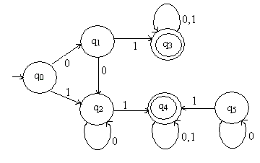
Set 1 Set 2
{q₀, q₁, q₂} {q₃, q₄}

(q₀, q₁)
- δ(q₀, 0) = q₁
δ(q₁, 0) = q₂
- δ(q₀, 1) = q₂
δ(q₁, 1) = q₃
Since q₃ is a final state and q₂ is a non final state, (q₀, q₁) is distinguishable for input 1

(q₀, q₂)
- δ(q₀, 0) = q₁
δ(q₂, 0) = q₂
- δ(q₀, 1) = q₂
δ(q₂, 1) = q₄
Since q₄ is a final state and q₁is a non final state, (q₀, q₂) is distinguishable for input 1

(q₁, q₂)
- δ(q₁, 0) = q₂
δ(q₂, 0) = q₂
- δ(q₁, 1) = q₃
δ(q₂, 1) = q₄
Since (q₁, q₂) fail for both inputs (q₁, q₂ ) is Indistinguishable.

(q₃, q₄)
- δ(q₃, 0) = q₃
δ(q₄, 0) = q₄
- δ(q₃, 1) = q₃
δ(q₄, 1) = q₄
Since (q₃, q₄) fail for both inputs (q₃, q₄) is Indistinguishable.

Distinguishable = { q₀}
Indistinguishable = {q₁, q₂} , { q₃, q₄}

DFA after reduction is
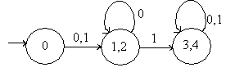

  - Regular Expressions
Regular language is the language accepted by finite acceptors. Regular expressions are used to denote regular languages. This involves combination of strings of symbols from some alphabet, parenthesis, operators +,.,*.
+ denote union
. denote concatenation
* denote star closure
Example:
(a+b.c)*
Language:{ ,a,aa,bc,abc,………}

Conventions on regular expressions
(1) If r1 and r2 are regular expressions then r1+r2,r1.r2,r1*,(r1) are regular expressions.
(2) The operation * has precedence over concatenation, which has precedence over union ( + ).
Example: ( a + ( b( c*) ) ) is written as a + bc*,
(3) The concatenation of k r's , where r is a regular expression, is written as r^{k}. Thus for Example: rr = r² .
The language corresponding to r^{k} is L_{r}^{k}, where L_{r} is the language corresponding to the regular expression r.
(4) We use ( r⁺) as a regular expression to represent L_{r}⁺ .
Examples of regular expression and regular languages corresponding to them
- ( a + b )² corresponds to the language {aa, ab, ba, bb}, that is the set of strings of length 2 over the alphabet {a, b}.
In general ( a + b )^{k} corresponds to the set of strings of length k over the alphabet {a, b}. ( a + b )* corresponds to the set of all strings over the alphabet {a, b}.
- a*b* corresponds to the set of strings consisting of zero or more a's followed by zero or more b's.
- a*b⁺a* corresponds to the set of strings consisting of zero or more a's followed by one or more b's followed by zero or more a's.
- ( ab )⁺ corresponds to the language {ab, abab, ababab, ... }, that is, the set of strings of repeated ab's.
Examples
Ex. 1: Find the shortest string that is not in the language represented by the regular expression a*(ab)*b*.
Solution: It can easily be seen that , a, b, which are strings in the language with length 1 or less. Of the strings wiht length 2 aa, bb and ab are in the language. However, ba is not in it. Thus the answer is ba.
Ex.2: For the two regular expressions given below,
(a) find a string corresponding to r₂ but not to r₁ and
(b) find a string corresponding to both r₁ and r₂.
r₁ = a* + b* r₂ = ab* + ba* + b*a + (a*b)*
Solution: (a) Any string consisting of only a's or only b's and the empty string are in r₁. So we need to find strings of r₂ which contain at least one a and at least one b. For example ab and ba are such strings.
(b) A string corresponding to r₁ consists of only a's or only b's or the empty string. The only strings corresponding to r₂ which consist of only a's or b's are a, b and the strings consiting of only b's (from (a*b)*).
Ex. 3: Let r₁ and r₂ be arbitrary regular expressions over some alphabet. Find a simple (the shortest and with the smallest nesting of * and +) regular expression which is equal to each of the following regular expressions.
(a) (r₁ + r₂ + r₁r₂ + r₂r₁)*
(b) (r₁(r₁ + r₂)*)⁺
Solution: One general strategy to approach this type of question is to try to see whether or not they are equal to simple regular expressions that are familiar to us such as a, a*, a⁺, (a + b)*, (a + b)⁺ etc.
(a) Since (r₁ + r₂)* represents all strings consisting of strings of r₁ and/or r₂ , r₁r₂ + r₂r₁ in the given regular expression is redundant, that is, they do not produce any strings that are not represented by (r₁ + r₂)*. Thus (r₁ + r₂ + r₁r₂ + r₂r₁)* is reduced to (r₁ + r₂)*.
(b) (r₁(r₁ + r₂)*)⁺ means that all the strings represented by it must consist of one or more strings of (r₁(r₁ + r₂)*). However, the strings of (r₁(r₁ + r₂)*) start with a string of r₁ followed by any number of strings taken arbitrarily from r₁ and/or r₂. Thus anything that comes after the first r₁ in (r₁(r₁ + r₂)*)⁺ is represented by (r₁ + r₂)*. Hence (r₁(r₁ + r₂)*) also represents the strings of (r₁(r₁ + r₂)*)⁺, and conversely (r₁(r₁ + r₂)*)⁺ represents the strings represented by (r₁(r₁ + r₂)*). Hence (r₁(r₁ + r₂)*)⁺ is reduced to (r₁(r₁ + r₂)*).
Ex. 4: Find a regular expression corresponding to the language of all strings over the alphabet { a, b } that do not end with ab.
Solution: Any string in a language over { a , b } must end in a or b. Hence if a string does not end with ab then it ends with a or if it ends with b the last b must be preceded by a symbol b. Since it can have any string in front of the last a or bb, ( a + b )*( a + bb ) is a regular expression for the language.
Ex. 5: Find a regular expression corresponding to the language of all strings over the alphabet { a, b } that contain no more than one occurence of the string aa.
Solution: If there is one substring aa in a string of the language, then that aa can be followed by any number of b. If an a comes after that aa, then that a must be preceded by b because otherwise there are two occurences of aa. Hence any string that follows aa is represented by ( b + ba )*. On the other hand if an a precedes the aa, then it must be followed by b. Hence a string preceding the aa can be represented by ( b + ab )*. Hence if a string of the language contains aa then it corresponds to the regular expression ( b + ab)*aa( b + ba )*
If there is no aa but at least one a exists in a string of the language, then applying the same argument as for aa to a, ( b + ab )*a( b + ba )* is obtained as a regular expression corresponding to such strings.
If there may not be any a in a string of the language, then applying the same argument as for aa to , ( b + ab )*( b + ba )* is obtained as a regular expression corresponding to such strings.
Altogether ( b + ab )*( + a + aa )( b + ba )* is a regular expression for the language.
followed by a substring with no bb.
Properties of regular language
Theorem 1: The set of regular languages over an alphabet is closed under operations union, concatenation and Kleene star.
Proof: Let L_{r} and L_{s} be regular languages over an alphabet . Then by the definition of the set of regular languages , L_{r} L_{s} , L_{r}L_{s} and L_{r}* are regular languages and they are obviously over the alphabet . Thus the set of regular languages is closed under those operations.
  - Regular Grammars
Grammar is an alternating way of describing languages.
Right and left linear grammar
A grammar G=(V,T,S,P) is said to be right linear if all the productions of the form
A→xB
A→x
A grammar G=(V,T,S,P) is said to be left linear if all the productions of the form
A→Bx
A→x
A regular grammar is one either right or left linear.
Theorem 1: A language L is accepted by an FA i.e. regular, if L - {} can be generated by a regular grammar.
This can be proven by constructing an FA for the given grammar as follows: For each nonterminal create a state. S corresponds to the initial state. Add another state as the accepting state Z. Then for every production X -> aY, add the transition ( X, a ) = Y and for every production X -> a add the transition ( X, a ) = Z.
For example = {a, b}, V = { S } and P = { S -> aS, S -> bS, S -> a, S -> b } form a regular grammar which generates the language ( a + b )⁺. An NFA that recognizes this language can be obtained by creating two states S and Z, and adding transitions ( S, a ) = { S, Z } and ( S, b ) = { S, Z } , where S is the initial state and Z is the accepting state of the NFA.
The NFA thus obtained is shown below.
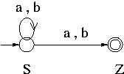
Thus L - {} is regular. If L contains as its member, then since { } is regular , L = ( L -{ } ) {} is also regular.
Conversely from any NFA < Q, , , q₀, A > a regular grammar < Q, , P, q₀ > is obtained as follows:
for any a in , and nonterminals X and Y, X -> aY is in P if and only if (X, a) = Y , and for any a in and any nonterminal X, X -> a is in P if and only if (X, a) = Y for some accepting state Y.
Thus the following converse of Theorem 3 is obtained.
Theorem 2: If L is regular i.e. accepted by an NFA, then L - {} is generated by a regular grammar.
For example, a regular grammar corresponding to the NFA given below is < Q, { a, b }, P, S > , where Q = { S, X, Y } , P = { S -> aS, S -> aX, X -> bS, X -> aY, Y -> bS, S -> a } .
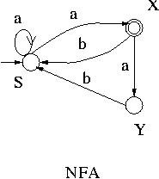
  - Pumping lemma for regular languages
The pumping lemma for regular languages describes an essential property of all regular languages. The pumping lemma was first articulated by Y. Bar-Hillel, M. Perles, E. Shamir in 1961. It is useful for disproving the regularity of a specific language.
It says that for any regular language L there exists a constant m such that any word w with length at least m can be split into three substrings, w = xyz, such that the middle portion, y (which must not be empty), can be repeated an arbitrary number of times (including zero times, which removes it) yielding a string that is still in L. This process of repetition is known as "pumping". Moreover, the pumping lemma guarantees that the length of xy will be at most m, imposing a limit on the ways in which w may be split.
Pumping lemma says:
- If an infinite language is regular, it can be defined by a dfa.
- The dfa has some finite number of states (say, n).
- Since the language is infinite, some strings of the language must have length > n.
- For a string of length > n accepted by the dfa, the walk through the dfa must contain a cycle.
- Repeating the cycle an arbitrary number of times must yield another string accepted by the dfa.
The pumping lemma for regular languages is another way of proving that a given (infinite) language is not regular.
The proof is always by contradiction. A brief outline of the technique is as follows:
- Assume the language L is regular.
- By the pigeonhole principle, any sufficiently long string in L must repeat some state in the dfa; thus, the walk contains a cycle.
- Show that repeating the cycle some number of times ("pumping" the cycle) yields a string that is not in L.
- Conclude that L is not regular.
Formal Definition
If L is an infinite regular language, then there exists some positive integer m such that any string w L whose length is m or greater can be decomposed into three parts, xyz, where
- |xy| is less than or equal to m,
- |y| > 0,
- w_{i} = xy^{i}z is also in L for all i = 0, 1, 2, 3, ....

Proof
For every regular language there is a finite state automaton (FSA) which accepts the language. If the regular language is finite, then the result is immediate since we may choose the pumping length p to be greater than the length of the longest word in the language: in this case there are no strings in the language greater than the pumping length p, and so the assertions made against such words are vacuously true.
If the regular language is infinite, then there must be some minimal FSA that accepts the language. The number of states in this FSA are counted, and then, that count is used as the pumping length p. If the string's length is longer than p, then there must be at least one state that is repeated (which we will call state S). The transitions that take the machine from state S back to state S match some string. This string is called y in the lemma, and since the machine will match a string without the y portion, or the string y can be repeated, the conditions of the lemma are satisfied.
- m is a (finite) number chosen so that strings of length m or greater must contain a cycle. Hence, m must be equal to or greater than the number of states in the dfa. Remember that we don't know the dfa, so we can't actually choose m; we just know that such an m must exist.
- Since string w has length greater than or equal to m, we can break it into two parts, xy and z, such that xy must contain a cycle. We don't know the dfa, so we don't know exactly where to make this break, but we know that |xy| can be less than or equal to m.
- We let x be the part before the cycle, y be the cycle, and z the part after the cycle. (It is possible that x and z contain cycles, but we don't care about that.) Again, we don't know exactly where to make this break.
- Since y is the cycle we are interested in, we must have |y| > 0, otherwise it isn't a cycle.
- By repeating y an arbitrary number of times, xy*z, we must get other strings in L.
- If, despite all the above uncertainties, we can show that the dfa has to accept some string that we know is not in the language, then we can conclude that the language is not regular.
To use this lemma, we need to show:
- For any choice of m,
- for some w L that we get to choose (and we will choose one of length at least m),
- for any way of decomposing w into xyz, so long as |xy| isn't greater than m and y isn't ,
- we can choose an i such that xy^{i}z is not in L.
Example: Prove that L = {a^{n}b^{n}: n 0} is not regular.
- We don't know m, but assume there is one.
- Choose a string w = a^{n}b^{n} where n > m, so that any prefix of length m consists entirely of a's.
- We don't know the decomposition of w into xyz, but since |xy| m, xy must consist entirely of a's. Moreover, y cannot be empty.
- Choose i = 0. This has the effect of dropping |y| a's out of the string, without affecting the number of b's. The resultant string has fewer a's than b's, hence does not belong to L. Therefore L is not regular.

  - Transition Systems
A transition system or transition diagram is a finite directed labeled graph in which each node represent a state and the directed edge indicate the transition of a state and the edges are labeled with input/output.
A transition system is a 5 tuple < Q, , , q_{0,} F>. A transition system accepts a string w in * if
a) There exists a path originates from some initial state, goes along the arrows and terminates at final state.
b) Path value obtained by concatenation of all edge labels of the path is equal to w.
  - Application of Finite Automata
Finite automata are a natural medium to describe dynamic behaviors of reactive systems. Finite automata are formal and rigorous and computer programs can be easily written to simulate their behaviors.
To model a reactive system with finite automaton, first the states the system goes in or the modes of its operation are identified. These become the states of the finite automaton that models it. Then the transitions between the states triggered by events and conditions, external or internal to the system, are identified and they become arcs in the transition diagram of the finite automaton. In addition actions that may take place in those states can also be added to the model.
Suppose we are given a set of words, called keywords, and we want to find occurrences of any of these words. For such a problem, a useful way to proceed is to design a NFA which recognizes, by entering in an accepting state, that it has seen one of the keywords.
The NFA is only a nondeterministic program, but we can runs it using lists or transform it to a DFA and get a deterministic (efficient) program.
1) Formal languages and grammars are widely in connection with programming language. If we write a compiler, correction of program is important. Grammars are widely used for this.
Example: identifies- It is a set of all strings starting with a letter and followed by an arbitrary number of letters and digits.
<identifier> → <letter><rest>
<rest>→<letter><rest>|<digit><rest>|
<letter> → a | b | . . . | Y | Z |
<digit> →0 | 1 | 2 | 3 | 4 | 5 | 6 | 7 | 8 | 9
An automaton can be represented by a graph in which the vertices give the internal state and the edge transitions. Label on the edge show what happen during transmission.
2) Another application area is digital design. Any digital computer can be viewed as an automaton. Consider an internal register and main memory of a computer as the automaton control unit. Then the automaton has total of 2^{n} states , n is the number of bits in the register and memory.
3) Lexycal analyzers
Token can be represented as regular sets. The number of lexical analyzer generator takes as input a sequence of regular expressions describing the tokens and produce a single finite automaton recognizing any token. Usually they convert regular expression to NFA and then construct DFA. Each final state indicates the particular token found.
4) Text search
This permit the substitution of a string for any string matching a given regular expression.
Example: Unix text editor allows a command such as S/bbb*/b/ that substitute a single blank first string of two or more blanks found in a given line.

