RAJAGIRI SCHOOL OF ENGINEERING
AND TECHNOLOGY
Rajagiri Valley, Kochi -39



R703- THEORY OF COMPUTATION
MODULE IV

Prepared by
Preetha K G

INDEX

4.1 Introduction to Turing Machines
4.2 Examples
4.3 Different Types of Turing Machines
4.4 Universal Turing Machine
4.5 Halting Problem
4.6 Church’s Thesis
4.7 Godelization

4.1 Introduction to Turing Machines
Turing machine is an abstract model of today’s computer. It is introduced by Allan Turing in 1930’s. It has all the capabilities of today’s computer. It is Powerful than Finite automata and Pushdown automata.
The standard Turing Machine
- It has a single one dimensional array of cells, unbounded in both directions. Each cell can hold one symbol.
- Information can be read and changed in any order. Hence they are called a tape.
- Necessary inputs will be kept in the tape before execution.
- Tape content after the execution is the output.
- The languages which can be recognized by TM are called recursive language
- It has a read write head that can travel right left on the tape that can read or write single symbol on each move.

Formal Definition
A TM can be represented as M = (Q, Σ, ⎡, δ, q_{0,} , F)
where Q – set of states
Σ - i/p alphabet
⎡ - stack alphabet
δ - Q x ⎡ Q x ⎡ x {L,R}
– blank symbol
F – set of final states

Σ is the subset of ⎡-{₊}
Schematic representation
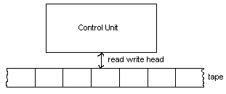
δ: QX⎡X{L,R}
The arguments of δ are the current state of the control unit and the current input symbol being read. Result is the new state, new tape symbol and the direction of the R/W head.
The Turing Machine is said to be halt
- Whenever it reaches a configuration for which δ is not defined.
- Whenever it reaches its final state.
Any configuration is completely determined by the current state of the control unit, content of the tape, and the position of the read write head.
Notation is x1qx2 OR a1a2….ak-1q ak……………an is the instantaneous description (ID) of Turing Machine.
The position of R/W head is over the cell containing the symbol immediately following q.
4.2 Exercises
1) TM accepting 00*
δ(q_{0 ,} 0) = (q_{1,} 0, R)
δ(q_{1 ,} 0) = (q_{1,} 0, R)
δ(q_{0 ,} ) = (q_{2,} , R)

2) Design a TM that Accepts L = {a^{n}b^{n} : n1}

M = {{q₀, q_{1,} q₂, q_{3,} q₄}, {a, b}, {a, b, x, y, }, δ, q_{0,} {q₄}}
δ(q_{0 ,} a) = (q_{1,} x, R)
δ(q_{1 ,} a) = (q_{1,} a, R)
δ(q_{1 ,} y) = (q_{1,} y, R)
δ(q_{1 ,} b) = (q_{2,} b, L)

δ(q_{2 ,} a) = (q_{2,} a, L)
δ(q_{2 ,} x) = (q_{0,} x, R)
δ(q_{2 ,} y) = (q_{2,} y, L)

δ(q_{0 ,} y) = (q_{3,} y, R)
δ(q_{3 ,} y) = (q_{3,} y, R)
δ(q_{3 ,} ) = (q_{4,} , R)
3) Check whether the given string is palindrome or not.
δ(q_{0 ,} ) = (q_{1,} , R)
δ(q_{1,} a) = (q_{2,} , R)
δ(q_{1,} b) = (q_{5,} , R)
δ(q_{5,} ) = (q_{6,} , L)
δ(q_{5 ,} a) = (q_{5,} a, R)
δ(q_{5 ,} b) = (q_{5,} b, R)
δ(q_{6 ,} b) = (q_{4,} , L)
δ(q_{2 ,} a) = (q_{2,} a, R)
δ(q_{2 ,} b) = (q_{2,} b, R)
δ(q_{2,} ) = (q_{3,} , L)
δ(q_{3,} a) = (q_{4,} , L)
δ(q_{4 ,} a) = (q_{4,} a, L)
δ(q_{4 ,} b) = (q_{4,} b, L)
δ(q_{3 ,} ) = (q_{7,} , R)
δ(q_{6 ,} ) = (q_{7,} , R)
δ(q_{1 ,} ) = (q_{7,} , R)
δ(q_{4,} ) = (q_{1,} , R)

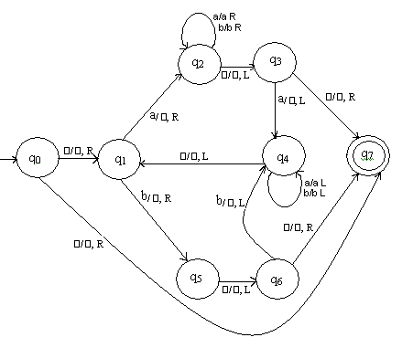
4) Compute x + y where x,y {0,1}*

δ(q_{0,} 1) = (q_{0,} 1, R)
δ(q_{0,} 0) = (q_{1,} 1, R)
δ(q_{1,} 1) = (q_{1,} 1, R)
δ(q_{1,} ) = (q_{2,} , L)
δ(q_{2 ,} 1) = (q_{3,} 0, L)
δ(q_{3 ,} 1) = (q_{3,} 1, L)
δ(q_{3 ,} ) = (q_{4,} , R)

5) Compute q₀w q_{f}ww

δ(q_{0,} 1) = (q_{0,} x, R)
δ(q_{0,} ) = (q_{1,} , L)
δ(q_{1,} x) = (q_{2,} 1, R)
δ(q_{2,} 1) = (q_{2,} 1, R)
δ(q_{2 ,} ) = (q_{1,} 1, L)
δ(q_{1 ,} 1) = (q_{1,} 1, L)
δ(q_{1 ,} ) = (q_{3,} , R)

6) TM that accepts all strings with sub string ‘aba’
δ(q_{0,} a) = (q_{1,} a, R)
δ(q_{0,} b) = (q_{0,} b, R)

δ(q_{1,} a) = (q_{1,} a, R)
δ(q_{1,} b) = (q_{2,} b, R)
δ(q_{2,} a) = (q_{3,} a ,R)
δ(q_{2,} b) = (q_{0,} b, R)
δ(q_{3,} a) = (q_{3,} a, R)
δ(q_{3,} b) = (q_{3,} b, R)
δ(q_{3,} ) = (q_{4, ,} L)
7) Parenthesis matching
δ(q_{0, (}) = (q_{0,} (, R)
δ(q_{0, *}) = (q_{0, *,} R)
δ(q_{0, )}) = (q_{0, ), L})
δ(q_{1, *}) = (q_{1, *,} L)
δ(q_{1, (}) = (q_{0, *,} R)
δ(q_{0,} ) = (q_{2, ,} L)
δ(q_{2, *}) = (q_{2, *,} L)
δ(q_{2,} ) = (q_{3, ,} R)

4.3 Different types of Turing Machines
1) Turing Machine with Stay Option

This category of TM’s can remain on the current state after accepting an input character. Hence the transition function can be written as δ - Q x ⎡ Q x ⎡ x {L,R,S}.
Let 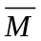= (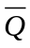,Σ, ⎡, ,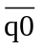, , 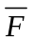) be a standard Turing Machine and M = (Q, Σ, ⎡, δ, q_{0,} , F) be the equivalent machine with stay option. We can simulate the transitions of the TM with stay option as

Case 1
δ(q_{i,} a ) = (q_{j,} b, R)  (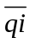, a) = (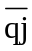, b, R)
Case 2
δ(q_{i,} a ) = (q_{j,} b, L) (, a) = (, b, L)
Case 3
δ(q_{i,} a ) = (q_{j,} b, N) (, a) = (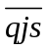, b, R)
(, c) = (, b, L)

In standard turing machine each tape symbol can be a composite characters rather than single character. Consider a sing containing one member of the symbol is a triplet.
We have divided each cell of tape into three parts called tracks each containing one member of the triplet.
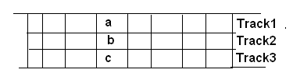
2) Multi dimensional Turing Machine
In this tape can be extended in more than one dimension.
Consider two dimensional tape
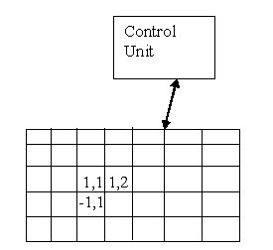
δ: QXX{L,R,U,D}
U and D are up And down.
This can be simulated with a Standard Turing machine with two tracks. One track is used to store the cell contents and other is used to store associated address.
Example: Address(a,2) contains a and address(10,-3) contains b.
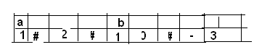
3) Turing machine with multiple head
This has one finite control and one tape but more than one R/W head. In each state only one of the heads is allowed to read or write.
H=h1,h2…..hn (tape heads)
δ: QXhXX{L,R}
4) Turing machine with multiple tapes
This contains multiple tape with its on R/W head.
δ: QX^{n}X{L,R}^{n}
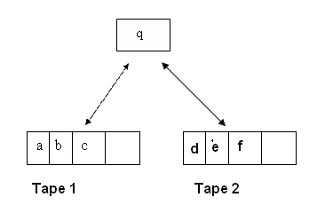
This can be simulated with standard Turing machine with 4 tracks. The first and third raw represent the cell contents and the second and fourth track has all zeros except 1 marking the position of R/W head.
a | b | c
0 | 0 | 1
d | e | f
0 | 0 | 1

5) Turing Machine with Semi Infinite Tape
In this tape is bounded in one direction. Assume tape has left boundary.

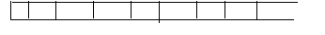
No left move is permitted when R/W head is at boundary. This can be simulated with a standard Turing machine with 2 tracks. On the upper one we keep the information to the right of some reference point (position of R/W head). The lower one contains the left of reference point in reverse order.
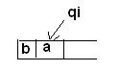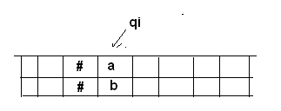
δ(q_{i ,} a) = (q_{j,} c,L)

δ(q_{i,} (a,b)) = (q_{j,}(c,b) ,L)

6) Non Deterministic Turing Machine
In this at any state for the tape symbol there is more than one choice of action.
δ: 2^{QXX{L,R}}
Example: δ(q0,a)={q1,b,R q2,c,L}
Consider the language L = { ww : w { a , b }* } . Given a string x, a nondeterministic Turing machine that accepts this language L would first guess the midpoint of x, that is the place where the second half of x starts. Then it would compare the first half of x with the second half by comparing the i-th symbol of the first half with the i-th symbol of the second half for i = 1, 2, ... . A deterministic Turing machine, on the other hand, can not guess the midpoint of the string x. It must find the midpoint by for example pairing off symbols from either end of x.
As in the case of NFA, it is understood that a nondeterministic Turing machine at any configuration selects one combination of next state, tape symbol and head movement out of the set of triples without following any specific predetermined rule.
7) Offline Turing Machine
This consists of a control unit, tape and a read only input file. 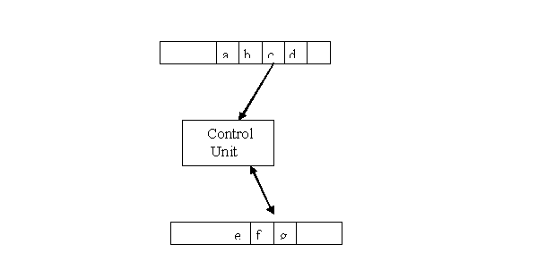
This can be simulated with a standard Turing Machine.
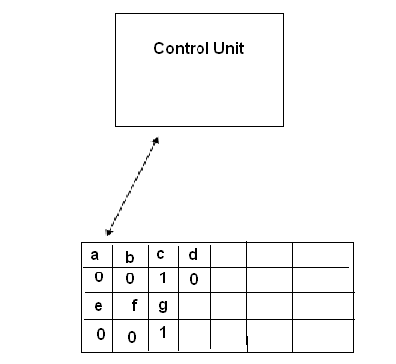
The tape has four tracks. First track has the input from input file, second track marks the position of the current input. Third track ha the tape content. Fourth track marks the position of the read write head. Initially TM search track 2 to locate the position at which the input file of M read. The symbol found in the track 1 is remembered by putting the control unit of M into state chosen for this purpose. Next track 4 is searched for the position of R/W head. At the end R/W moves to the standard position for next move.
4.4 Universal Turing Machine
A universal Turing machine Mu is a Turing machine that can simulate an arbitrary Turing Machine on arbitrary input. Universal machine essentially achieves this by reading both the description of machine to be simulated as well as the input thereof from its own tape.
Assume that Q={q1,q2…….qn} with q1 is the initial state and qn is the final state.
⎡ ={a1,a2…..an} where a1 represent the blank. We then select an encoding scheme in which q1 represented by 1 q2 by 11 a1 by 1 and a2by 11 etc. the symbol 0 will be used as a separator between 1’s.
δ(q1,a2)=(q2,a3,L) might appear as 10110110111010….
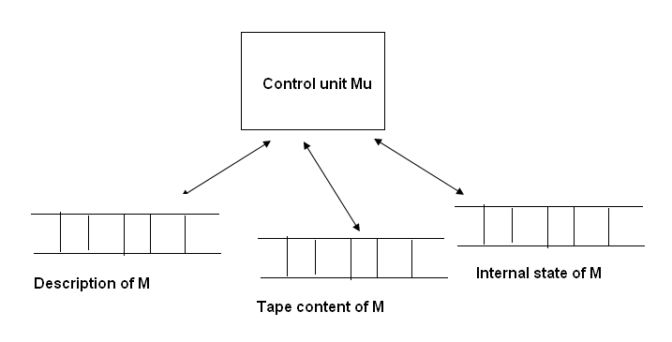
Any TM has a finite encoding as a string on 0 and 1, and that given any encoding of M, we can decode it uniquely.
For any input M and w, tape 1 will keep the encoded definition of M. Tape 2 will contain the tape contents of M, and tape 3 the internal state of M. Mu looks first at the contents of tape 2 and 3 to determine the configuration of M. It then consults tape1 to see that M would do in this configuration. Finally tape 2 and 3 will be modified to reflect the result of the move.
4.5 Halting Problem
Determination of whether a TM will come to a halt given a particular input program. Domain of this problem is to be taken as the set of all TM and all w.
Let Wm be the string describes TM M and let w be the string in M’s alphabet. We will assume Wm and w are encoded as string of 0’s and 1’s. A solution of the halting problem is a TM H which for any Wm and w performs the computation
q0 Wm w |--* x1 qy x2 (if M applies to w halts)
q0 Wm w |--* y1 qn y2(if M applies to w does not halts)
qy and qn are final state of H.
Theorem
Halting problem is Undecidable
Proof
This is going to be proven by "proof by contradiction".
Suppose that the halting problem is decidable. Then there is a Turing machine H that solves the halting problem. That is, given a description of a Turing machine M (over the alphabet ) and a string w, H writes "yes" if M halts on w and "no" if M does not halt on w, and then H halts.
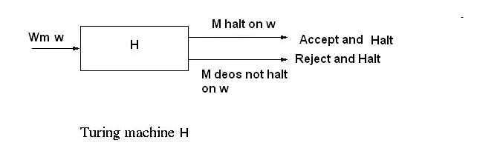
We construct a new TM by modifying H to produce TM H’so that if H accepts a string and halts, then H’ goes into an infinite loop.
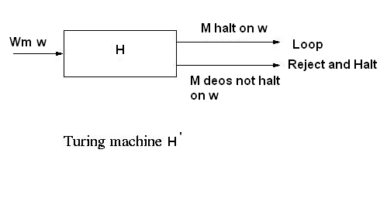
q0 Wm w |--* _{H’}α (if M applies to w halt)
q0 Wm w |--* _{H’} y1 qn y2(if M applies to w does not halt)

Next using H’ we are going to construct another Turing machine H^ as follows:
H’ takes as input a description of a Turing machine M, denoted by d(M), copies it to obtain the string d(M)*d(M), where * is a symbol that separates the two copies of d(M) and then supplies d(M)*d(M) to the Turing machine H’.
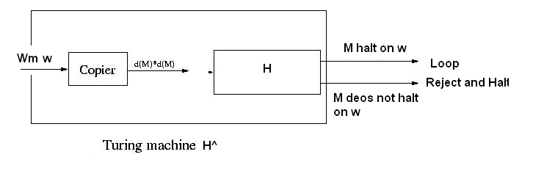
q0 Wm |--*WmWm |--* _{H^}α (if M applies to w halt)
q0 Wm |--*WmWm |--* _{H^} y1 qn y2(if M applies to w does not halt)
H^ is a Tm so it has a description say w^. What would happen if H^ is applied to w^.
q0 w^ |--* _{H^}α (if H^applies to w^ halt)
q0 w^ |--* _{H^} y1 qn y2(if H^applies to w^ does not halt)
H^ goes into an infinite loop if H^ halts on w^ and it halts if H^ does not halt on w^. This is a contradiction. This contradiction has been deduced from our assumption that there is a Turing machine that solves the halting problem. Hence that assumption must be wrong. Hence there is no Turing machine that solves the halting problem.
4.6 Church’s Thesis
This thesis states that all possible models of computation must be equivalent. It also implies that there is an inherent limitation in this and that there are functions that cannot be expressed in any way that gives an explicit method for their computation.
4.7 Godelization
A Godelization is an onto mapping from N to the set of all Turing Machines such that given a Turing Machine, one can actually ﬁnd the number mapped to, and given a number one can actually ﬁnd the Turing Machine that maps to it.
Let M = (Q, Σ, δ, q0 , h) be a Turing Machine.
We assume the following:
• there are n + 1 states labeled 1,2,3,. . . , n + 1,
• state n + 1 is the halting state,
• the alphabet is the numbers 3,4,5. . . , m.
• L, R are represented by the numbers 1 and 2. (We still denote L and R by L and R. Note that L and R have numbers deferent from those in the alphabet.)
We ﬁrst show how to encode a rule as a number:
Let q1, q2 ∈ Q and σ1, σ2 ∈ Σ. (By our convention, q1, q2, σ1, σ2 are numbers).
The rule
δ (q1 , σ1 ) = (q2 , σ2 ) is represented by the number 2^{q1} 3^{σ1} 5^{q2} 7^{σ2} . The representations for rules that have L or R in the last component are deﬁned similarly.

