ARTIFICIAL INTELLIGENCE
It is the science and engineering of making intelligent machines, especially intelligent computer programs. It is related to the similar task of using computers to understand human intelligence, but AI does not have to confine itself to methods that are biologically observable. Artificial Intelligence is the branch of computer science concerned with the study and creation of computer systems
-that exhibit some form of intelligence .
-that learn new concepts and tasks.
-that can reason and draw useful conclusions about the world around us.
-systems that can understand a natural language or perceive and comprehend a visual scene.

Intelligence is the ability to acquire ,understand and apply knowledge or the ability to exercise thought and reason.

Knowledge can be defined
-as the body of facts and principles accumulated by human kind .
-as act,fact or state of knowing.
-having familiarity with language,concepts,procedures ,rules,ideas,places, and to use
these notions effectively in modeling different aspects of the world around us.

Knowledge can be divided in to 3 categories.
1)procedural knowledge-compiled knowledge related to some task.Eg:-Steps required to solve some equations.
2)Declarative knowledge-passive knowledge expressed as statements of facts about the world.
3)Heuristic knowledge-special type of knowledge used to solve complex problems.

Knowledge is different from data.A physician uses both knowledge and data.Data is the patients record like his history,drugs,response to drugs,whereas knowledge is what physician has learned in medical colleges.

Branches of AI
.
logical AI
What a program knows about the world in general the facts of the specific situation in which it must act, and its goals are all represented by sentences of some mathematical logical language. The program decides what to do by inferring that certain actions are appropriate for achieving its goals

search
AI programs often examine large numbers of possibilities, e.g. moves in a chess game or inferences by a theorem proving program. Discoveries are continually made about how to do this more efficiently in various domains.
pattern recognition
When a program makes observations of some kind, it is often programmed to compare what it sees with a pattern. For example, a vision program may try to match a pattern of eyes and a nose in a scene in order to find a face. More complex patterns, e.g. in a natural language text, in a chess position, or in the history of some event are also studied. These more complex patterns require quite different methods than do the simple patterns that have been studied the most.
representation
Facts about the world have to be represented in some way. Usually languages of mathematical logic are used.
inference
From some facts, others can be inferred.. For example, when we hear of a bird, we man infer that it can fly, but this conclusion can be reversed when we hear that it is a penguin
common sense knowledge and reasoning
This is the area in which AI is farthest from human-level, in spite of the fact that it has been an active research area since the 1950s. The Cyc system contains a large but spotty collection of common sense facts.
learning from experience
Programs do that. The approaches to AI based on connectionism and neural nets specialize in that. There is also learning of laws expressed in logic. Programs can only learn what facts or behaviors their formalisms can represent, and unfortunately learning systems are almost all based on very limited abilities to represent information.
planning
Planning programs start with general facts about the world (especially facts about the effects of actions), facts about the particular situation and a statement of a goal. From these, they generate a strategy for achieving the goal. In the most common cases, the strategy is just a sequence of actions.
epistemology
This is a study of the kinds of knowledge that are required for solving problems in the world. Epistemology is the branch of philosophy that studies knowledge. It attempts to answer the basic question: what distinguishes true (adequate) knowledge from false (inadequate) knowledge?

ontology
Ontology is the study of the kinds of things that exist. In AI, the programs and sentences deal with various kinds of objects, and we study what these kinds are and what their basic properties are. Emphasis on ontology begins in the 1990s. An ontology is an explicit specification of a conceptualization. The term is borrowed from philosophy, where an Ontology is a systematic account of Existence. For AI systems, what "exists" is that which can be represented. When the knowledge of a domain is represented in a declarative formalism, the set of objects that can be represented is called the universe of discourse. This set of objects, and the describable relationships among them, are reflected in the representational vocabulary with which a knowledge-based program represents knowledge. Thus, in the context of AI, we can describe the ontology of a program by defining a set of representational terms. In such an ontology, definitions associate the names of entities in the universe of discourse (e.g., classes, relations, functions, or other objects) with human-readable text describing what the names mean, and formal axioms that constrain the interpretation and well-formed use of these terms. Formally, an ontology is the statement of a logical theory
heuristics
A heuristic is a way of trying to discover something or an idea imbedded in a program. The term is used variously in AI. Heuristic functions are used in some approaches to search to measure how far a node in a search tree seems to be from a goal. Heuristic predicates that compare two nodes in a search tree to see if one is better than the other, i.e. constitutes an advance toward the goal, may be more useful.
Genetic programming
Geneting programming (GP) is an automated method for creating a working computer program from a high level problem statement of a problem.GP delivers high return, human competitive machine intelligence. Human competitive means that the result should be equal to or better than the most recent human created solution to a long standing problem. The result should win a regulated competition involving human contestants.
Applications of AI
Game playing
You can buy machines that can play master level chess for a few hundred dollars. There is some AI in them, but they play well against people mainly through brute force computation--looking at hundreds of thousands of positions. To beat a world champion by brute force and known reliable heuristics requires being able to look at 200 million positions per second.

Speech recognition
In the 1990s, computer speech recognition reached a practical level for limited purposes. Thus United Airlines has replaced its keyboard tree for flight information by a system using speech recognition of flight numbers and city names. It is quite convenient. On the other hand, while it is possible to instruct some computers using speech, most users have gone back to the keyboard and the mouse as still more convenient.
Understanding natural language
Just getting a sequence of words into a computer is not enough. Parsing sentences is not enough either. The computer has to be provided with an understanding of the domain the text is about, and this is presently possible only for very limited domains.
Computer vision
The world is composed of three-dimensional objects, but the inputs to the human eye and computers' TV cameras are two dimensional. Some useful programs can work solely in two dimensions, but full computer vision requires partial three-dimensional information that is not just a set of two-dimensional views. At present there are only limited ways of representing three-dimensional information directly, and they are not as good as what humans evidently use.
Expert systems
A ``knowledge engineer'' interviews experts in a certain domain and tries to embody their knowledge in a computer program for carrying out some task. How well this works depends on whether the intellectual mechanisms required for the task are within the present state of AI. When this turned out not to be so, there were many disappointing results. One of the first expert systems was MYCIN in 1974, which diagnosed bacterial infections of the blood and suggested treatments. It did better than medical students or practicing doctors, provided its limitations were observed. Namely, its ontology included bacteria, symptoms, and treatments and did not include patients, doctors, hospitals, death, recovery, and events occurring in time. Its interactions depended on a single patient being considered. Since the experts consulted by the knowledge engineers knew about patients, doctors, death, recovery, etc., it is clear that the knowledge engineers forced what the experts told them into a predetermined framework. In the present state of AI, this has to be true. The usefulness of current expert systems depends on their users having common sense.
Heuristic classification
One of the most feasible kinds of expert system given the present knowledge of AI is to put some information in one of a fixed set of categories using several sources of information. An example is advising whether to accept a proposed credit card purchase. Information is available about the owner of the credit card, his record of payment and also about the item he is buying and about the establishment from which he is buying it (e.g., about whether there have been previous credit card frauds at this establishment).
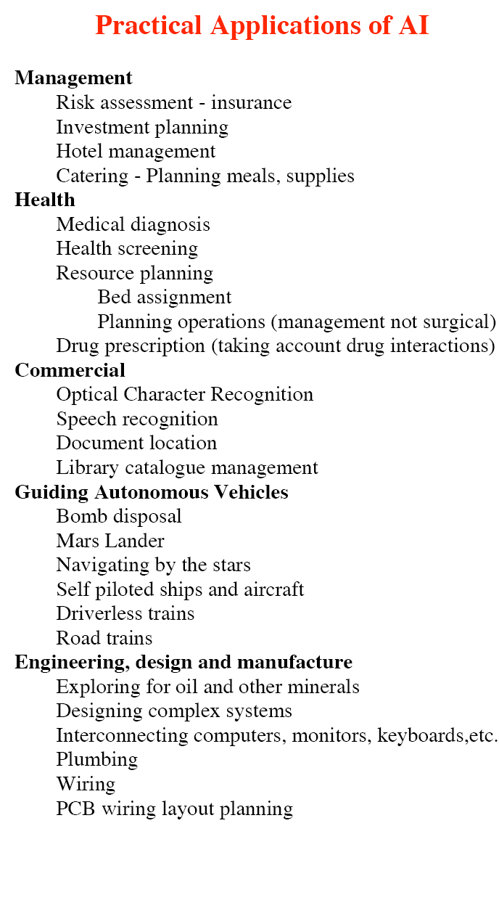
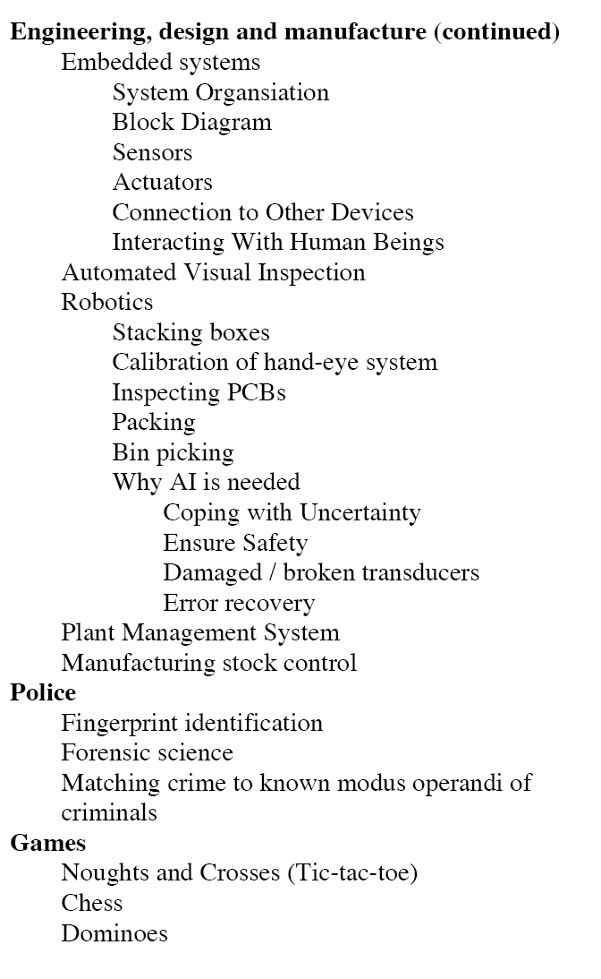
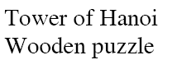
AI PROBLEMS

1) TIC-TAC-TOE


TIE

O LOSES

BOARD :Consists of nine elements ,where the elements of the vector
corresponds to the board positions

1 | 2 | 3
4 | 5 | 6
7 | 8 | 9
We store 2(indicating blank),3(indicating X),5 (indicating O).

Turn: An integer indicating which move the game is about to be played.
1-indicates the first move ,9 indicates the last move.

Method: Game is between two persons odd and even.Odd places X and even places O.A person wins if his letter comes in all vertical ,horizontal and diagonal lines.

The algorithm make use of the procedures
1) make2:-returns 5 if the center square of the board is blank,that is board[5]=2.Otherwise
the function returns any blank non corner squares(2,4,6,8).

2) posswin(p):-returns 0 if the player p cannot win in his next move
Else
Returns the number of the square that constitute a winning move.
If the product is 18 (3x3x2) then X will win
If the product is 50(5x5x2) then O will win.

3) Go (n)-makes a move in square n
Board[n]=3,if turn is odd.
Board[n]=5,if turn is even.
Turn=Turn+1.
Method
Turn=1 Go(1)(Upper left corner)
Turn=2 if Board[5]=blank;Go(5),else Go(1)
Turn=3 if Board[9]=blank;Go(9) else Go(3)
Turn=4 if posswin(X) # 0,then Go(posswin(X))(ie,block opponents win)
Else Go(make2)
Turn=5 if posswin(X) # 0 then
Go(posswin(X)) (ie win)
Else if posswin(O)# 0 then
Go(posswin(O))(ie block win)
Else if board[7]=blank then
Go(7)
Else Go(3).

Turn=6 if posswin(O) # 0 then Go(posswin(0))
Else if posswin(X) # 0 then Go(posswin(X))
Else Go(make2)

Turn=7 if posswin(X)#0,then Go(posswin(X))
Else if posswin(O)# 0 then Go(posswin(O)
Else go any where that is blank
Turn=8 if posswin(O) # 0 then Go(posswin(O)
Else if posswin(X)# 0 then Go(posswin(X))
Else go any where that is blank.
Turn=9 same as Turn=7.

2) 8 Puzzle

An 8 puzzle is a simple game consisting of a 3 x 3 grid (containing 9 squares). One of the squares is empty.
The object is to move to squares around into different positions and having the numbers displayed in the "goal state".
The image to the left can be thought of as an unsolved initial state of the "3 x 3" 8 puzzle.
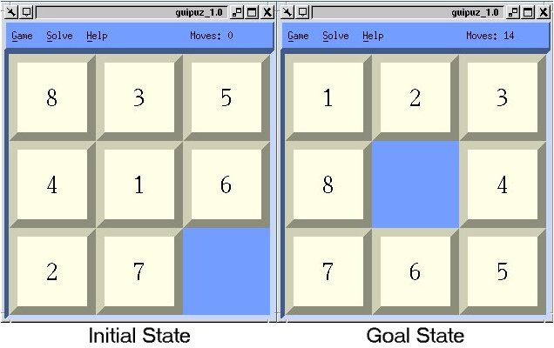

Here is the shortest solution generated by the 8 puzzle program for the initial state given above. (The program animates through each game state)
+-----+
|8 3 5|
|4 1 6|
|2 7 |
+-----+

+-----+
|8 3 5|
|4 1 |
|2 7 6|
+-----+

+-----+
|8 3 |
|4 1 5|
|2 7 6|
+-----+

+-----+
|8 3|
|4 1 5|
|2 7 6|
+-----+

+-----+
|8 1 3|
|4 5|
|2 7 6|
+-----+

+-----+
|8 1 3|
| 4 5|
|2 7 6|
+-----+

+-----+
|8 1 3|
|2 4 5|
| 7 6|
+-----+

+-----+
|8 1 3|
|2 4 |
|7 6 5|
+-----+

+-----+
|8 1 3|
|2 4|
|7 6 5|
+-----+

+-----+
|8 1 3|
| 2 4|
|7 6 5|
+-----+

+-----+
| 1 3|
|8 2 4|
|7 6 5|
+-----+

+-----+
|1 3|
|8 2 4|
|7 6 5|
+-----+

+-----+
|1 2 3|
|8 4|
|7 6 5|
+-----+

Total Number of moves: 14
A search tree for 8-puzzle.
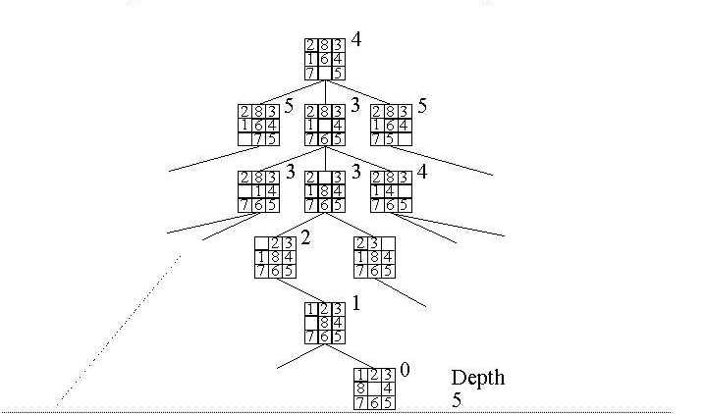

3) 8-Queens Problem
This problem is to place 8 queens on the chess board so that they do not check each other. For 8-queen, we have 92 solutions. If we exclude symmetry, there are 12 solutions.
8-queens problem n=8

7 |  |  | X
6 |  |  |  |  | X
5 |  | X
4 |  |  |  |  |  |  |  | X
3 | X
2 |  |  |  |  |  |  | X
1 |  |  |  | X
0 |  |  |  |  |  | X
 | 0 | 1 | 2 | 3 | 4 | 5 | 6 | 7

Recursive solution for 8-queens

PlaceNextQueen(Column)

if (Column > 8) problem is solved;

else {

while (unconsidered squares exist in the column and problem is unsolved)

{ determine next square that is not under attack by queen in an column;

if (such a square exists)

{ place queen; PlaceNextQueen(Column+1)

if (No queen is possible in column Column+1)

remove queen from column Column and consider next square in the column.

}//if

} //while

}//else
EIGHT QUEENS PROBLEM
Given:
- an 8 x 8 chess board
- 8 chess queen pieces

Objective:
- To find all 92 possible ways of placing 8 queens on a chess board such that no two queens can cancel each other.
- Develop a recursive algorithm for finding the solution to this problem.
To solve the 8 queens problem, start by superimposing the chess board on a on a cartesian coordinate plane.

Observe that the queen's move can be described mathematically and represented by linear functions as follows:

MOVES FUNCTIONS RANGE OF VALUES
vertical moves: | x = c | 0 <= x <= 7
horizontal moves: | y = c | 0 <= y <= 7
left diagonal moves: | y = – x + b | 0 <= b <= 14
right diagonal moves: | y = x + b | – 7 <= b <= 7

One possible approach is to use arrays of boolean, say:
bool yvalue [ 8 ] ;
bool leftb [ 15 ] ;
bool rightb [ 15 ] ;
In addition, have say:
int position [ 8 ] ;
bool okay ;
To indicate that all squares on the chess board are initially available:
for ( i = 0; i <= 7; i++ )
yvalue [ i ] = true;
for ( i = 0; i <= 14; i++ )
{
leftb [ i ] = true ;
rightb [ i ] = true ;
}
To check if ( x, y ) is an available position for the next queen:
okay = yvalue [ y ] + leftb [ y + x ] + rightb [ y - x + 7 ] ;
If okay, then place the next queen on the board:
yvalue [ y ] = false ;
leftb [ y + x ] = false ;
rightb [ y - x + 7 ] = false ;
To record the queen's position:
position [ x ] = y ;
When backtracking, a queen may have to be removed from the board as follows
yvalue [ y ] = true ;
leftb [ y + x ] = true;
rightb [ y - x + 7 ] = true;

Water –jug problem

Problem: You are given two jugs, a 4-gallon one and a 3-gallon one. Neither have any measuring marks on it. There is a pump that can be used to fill the jugs with water. How can you get exactly 2 gallons of water in the 4-gallon jug?

A state in this problem may be represented as a two-tuple (x,y), where x stands for the amount of water in the 4-gallon jug, and y denotes the amount of water in the 3-gallon jug.

The initial state is <0, 0> and the goal state is (2,0)

An OPERATOR is knowledge of an action possible in the world.

This kind of world knowledge can be represented in the LANGUAGE of PRODUCTION RULES.

Production rules offer one language for representing some kinds of knowledge including that of operations (that is, knowledge of the actions that can be performed in the world).

For this example, all ten basic operations can be represented in the language of
Production rules as follows:

R1: (x,y) --> (4,y)
if x < 4
R2: (x,y) --> (x,3)
if y < 3
R3: (x,y) --> (x-d,y)
if x > 0
R4: (x,y) --> (x,y-d)
if y > 0
R5: (x,y) --> (0,y)
if x > 0
R6: (x,y) --> (x,0)
if y > 0
R7: (x,y) --> (4,y-(4-x))
if x+y >= 4 and y > 0
R8: (x,y) --> (x-(3-y),y)
if x+y >= 3 and x > 0
R9: (x,y) --> (x+y,0)
if x+y =< 4 and y > 0
R10: (x,y) --> (0,x+y)
if x+y =< 3 and x > 0

A possible solution to the water jug problem is

x y Rule
applied

s1 0 0
R2
s2 0 3
R9
s3 3 0
R2
s4 3 3
R7
s5 4 2
R5
s6 0 2
R9
s7 2 0

4. Problem Spaces and Representation of Problem Solving

Together the problem and the operators characterize the problem space
associated with the problem:

(i) the initial state,
(ii) the goal state,
(iii) the operators that can transform one state into another, and
(iv) the states of that can be generated by applying the operators

The problem space is a ``virtual'' space that can be generated by
applying the operators.

Problem solving, i.e., search through a problem space, can be
represented as a tree.

The problem solving in the water jug example can be represented as the
following tree:

<0, 0>
/ \
R1 R2
<0, 3>
/ |...\
/ |... \
R1 R4... R9
<3, 0>
/ | \
/ | \
R2 R3 R5
<3, 3>
/ |...\...
/ |... \...
R1 R3 R7
<4, 2>
/ |...\...
/ |... \...
R2 R3 R5
<0, 2>
/ | \
/ | \
R1 R7 R9
<2, 0>

The Tower of Hanoi or Towers of Hanoi is a mathematical game or puzzle. It consists of three pegs, and a number of disks of different sizes which can slide onto any peg. The puzzle starts with the disks neatly stacked in order of size on one peg, the smallest at the top, thus making a conical shape.
The objective of the puzzle is to move the entire stack to another peg, obeying the following rules:
- Only one disk may be moved at a time.
- Each move consists of taking the upper disk from one of the pegs and sliding it onto another peg, on top of the other disks that may already be present on that peg.
- No disk may be placed on top of a smaller disk.

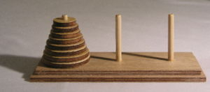
Initial configuration with 4 disks

Solution:-As in many mathematical puzzles, finding a solution is made easier by solving a slightly more general problem: how to move a tower of h (h=height) disks from a starting peg f (f=from) onto a destination peg t (t=to), r being the remaining third peg and assuming t ≠ f.
So if the number of disks is even the solution will start:
- Move disk 0 from peg f to peg r ignoring peg t.
- Move disk 1 from peg f to peg t ignoring peg r.
- Move disk 0 from peg r to peg t ignoring peg f.
- Move disk 2 from peg f to peg r ignoring peg t.
- Move disk 0 from peg t to peg f ignoring peg r.
- Move disk 1 from peg t to peg r ignoring peg f.
- Move disk 0 from peg f to peg r ignoring peg t.
- Move disk 3 from peg f to peg t ignoring peg r.
- Move disk 0 from peg r to peg t ignoring peg f.
- Move disk 1 from peg r to peg f ignoring peg t.
- Move disk 0 from peg t to peg f ignoring peg r.
- Move disk 2 from peg r to peg t ignoring peg f.
- Move disk 0 from peg f to peg r ignoring peg t.
- Move disk 1 from peg f to peg t ignoring peg r.
- Move disk 0 from peg r to peg t ignoring peg f.
- Move disk 4 from peg f to peg r ignoring peg t.

The missionaries and cannibals problem is a logic puzzle commonly used as an example of using abstract concepts to solve a problem. It was made famous within the field of artificial intelligence by Saul Amarel, who used the problem as an example in a paper on problem representation. A common version of the problem is as follows: Three missionaries and three cannibals stand on the bank of a river that they wish to cross. There is a boat available which can ferry up to two people across. The goal is to find a schedule for ferrying all the cannibals and all the missionaries safely across the river. The
constraint is that, if at any point the cannibals outnumber the missionaries on either bank, the cannibals will eat the missionaries. Note that the boat cannot cross the river by itself with no people on board.

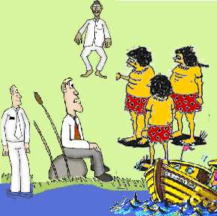

Solution:-
One solution (the three numbers representing the number of missionaries, cannibals, and boats on the near bank) is as follows:
331, 310, 321, 300, 311, 110, 221, 020, 031, 010, 021, 000
There are four unique solutions.

Problem Characteristics:-

Inorder to choose the most appropriate method for a particular problem,it is necessary to analyze the problem along several key dimensions .

1)Is the problem decomposable into a set of independent smaller or easier sub problems.

Consider the problem of computing the solution for the expression.

(x² + 3x +sin²x.cos²x) dx

x²dx 3xdx sin²xcos²xdx

X³/3 3x dx (1-cos²x)cos²x dx

3x²/2 cos²x dx -cos⁴xdx

The problem can be solved by dividing it in to a no of sub problems and solving it.

2)Can the solution steps be undone or ignored?

Consider the 8 puzzle problem
² | ⁸ | ³
¹ | ⁶ | ⁴
⁷ |  | ⁵
¹ | ² | ³
⁸ |  | ⁴
⁷ | ⁶ | ⁵

In attempting to solve the 8 puzzle,we might make a stupid move by moving tile 5 in to the empty space .Now we backtrack and undo the first move sliding tile 5 back in to the first move ,sliding tile 5 back to where it was.Then we can move tile 6.The control mechanism for the 8 puzzle must keep track of the order in which operations are performed so that the operations can be undone one at a time.

3)Is the universe predictable?

Consider the 8 puzzle problem.Every time we make a move we know exactly what is happening.it is possible to plan the entire sequence of moves to avoid having to undo it.But in case of chess we can’t plan the entire sequence because it depends on how the other pklayer plays.

4)Is a good solution absolute or relative?

Consider the problem of answering questions based on database of simple facts,such as the following

1.Marcus was a man

2.marcus was a Pompeian.

3.marcus was born in 40 A.D.

4.All men are mortal.

5.All pompeians died when volcano erupted in 79 A.D.

6.No mortal lives longer than 150 years.

7.It is now 1991 A.D

Suppose we want to find the answer to the question Is marcus alive? It can be found in 2 ways.

Solution 1

1. Marcus was a man 1

2 All men are mortal. 4

3.Marcus is mortal 1,4

4. marcus was born in 40 A.D. 3

5. It is now 1991 A.D 7

6.marcu’s age is 1951 years 3,7

7 No mortal lives longer than 150 years. 6.

8.marcus is dead 3,7,6.

Solution 2

1. It is now 1991 A.D 7

2. All pompeians died when volcano erupted in 79 A.D 5

3.All pompeians are dead now 7,5

4.Marcus was a Pompeian 2

5.Marcus is dead 7,5,2

Since we are interested in only answers to the question ,it doesnot matter which path we follow.

But suppose we consider the traveling sales man problem ,our goal is to find out the shortest city that visits each city exactly once.Suppose the cities to be visited and their distances are ordered like this
 | Boston | Newyork | Miami | Dallas | S.F
Boston |  | 250 | 1450 | 1700 | 3000
Newyork | 250 |  | 1200 | 1500 | 2900
Miami | 1450 | 1200 |  | 1600 | 3300
Dallas | 1700 | 1500 | 1600 |  | 1700
S.F | 3000 | 2900 | 3300 | 1700

Two paths the sales man can follow is
Boston
S.F
New york
Dallas
Miami
newyork
dallas
miami
San francisco
boston
boston

8850 7750

Total :3000+1700+1500+1200+1450=8850

Total: 250+1200+1600+1700+3000=7750

These 2 problems shows the difference between the any path problem and the best path problem.

Search techniques

Having formulated the problems ,solution for them is found out by a search through the state space.

Search tree

All the search techniques uses asearch tree that is generated by the initial state and the successor function.When same state is reached from multiple paths the tree becomes a graph.

Search node

The root of the search tree is a search node corresponding to the initial state.This is checked against the goal state.If not then iit is expanded with the successor function by generating a new set of states.The choice of which state to expand is determined by the search strategy.

Search strategies can be divided in to 2

i)Uninformed search(blind search)

2)Informed search(heuristic search)

Uninformed search

Means that they have no additional information regarding the states beyond that provided in the problem definition.All they can do is to generate successors and distinguish a goal state from a non goal state.it is blind search in which the nodes are explored in the predefined order.An uninformed search is available with a start state,search algorithm and a test for the goal state.

1)BFS

2)DFS

3)uniform cost search

4)depth limited search

5)iterative deepening search

6)bidirectional search

1)Breadth first search

Searches are performed by exploring all the nodes at a given depth before proceeding to the next level.

Algorithm

1.Place the starting node S on the queue.

2.If the queue is empty ,return failure AND STOP.

3.If the first element on the queue is a goal node g return success and stop.

Else remove and expand the first element from the queue and place all the children at

the end of the queue in any order.

3.return to step 2.

LEVEL 1
A
A
B
C
LEVEL 2

LEVEL 3
A
B
C
D
E
F
G

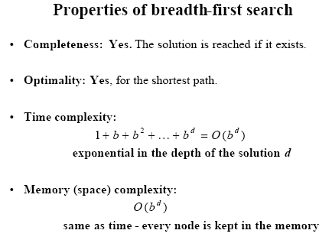

Advantages of BFS

1)If there is a path BFS is guaranteed to find it.Further if there is a multiple solution,then a minimal solution will be found.

2)Longer paths are never explored until al shorter ones are examined.

2)Depth First Search

A child is generated from the most recently expanded node ,then generating the child’s children and so on until a goal is found.

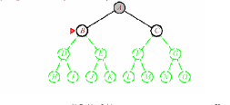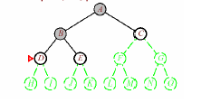

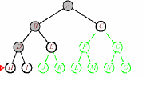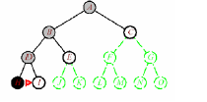

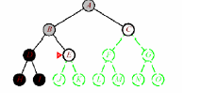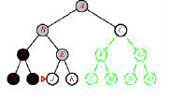

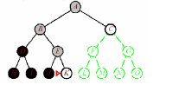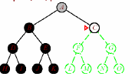

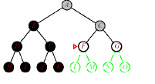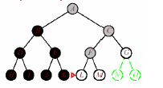

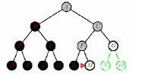

Algorithm

1)Place the starting node S on the stack.

2)If the stack is empty,return failure and stop.

3)If the first element on the stack is a goal node g,return success and stop.

Else

Remove and expand first element and place the children at the top of the stack.

4).return to step 2.

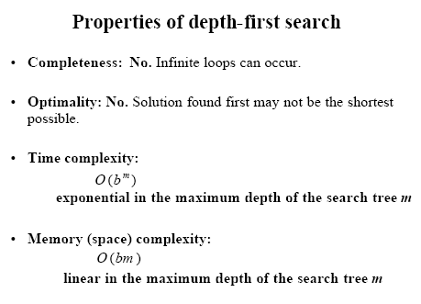

Advantages

1)requires only less memory since only the nodes on the current path are made.

2)By chance DFS may find a solution without examining much of the search space at all.

3)Uniform cost search

This method expands the node n with the lowest path cost.If all the step cost are equal,then it is identical to the BFS.

O
M
A
Z
T
L
S
D
C
R
71
151
75
118
80
146
120
75
70
111

A
QUEUE
A0
A
Z
S
T
140
118
75
140
118
QUEUE
Z75
T118
S140
A
Z
S
T
140
118
75
140
118
O
75
75
146
QUEUE
T118
S140
O146
A
Z
S
T
140
75
140
118
O
146
L
111
229
QUEUE
S140
O146
L229

A
Z
S
T
O
L
75
118
118
111
236
229
140

146
O
R
291
280
220
QUEUE
O146
R220
L229
O291
A

75 118

140
Z
S
T
QUEUE
R 220
L 229
O 291
S 297

80 111
71 151
229
O
R
O
L
146

151 291 220

S

297

Now q front is pointing to R -220 which is the goal node .Time complexity is O(b ^{d})

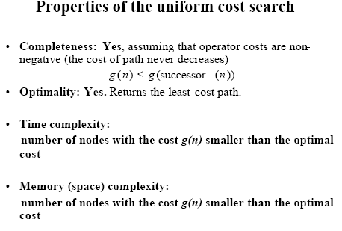

Notes:-

“Search all nodes of cost c before those of cost c+1”

In BFS deeper nodes always arrive after shallower nodes

In UCS the costs of new nodes do not have such a nice pattern of always increasing

In UCS we need to

explicitly store the cost g of a node

explicitly use such costs in deciding the ordering in the queue

Explicitly store the cost of a node with that node – convention “g” is the path-cost

Always remove the smallest cost node first

if using REMOVE-FIRST then sort the queue in increasing order

alternatively, instead of REMOVE-FIRST, just scan all queue and use REMOVE-SMALLEST-COST

Called a “priority queue” as highest priority removed first, not just by order of arrival

Algorithm

fringe ß MAKE-EMPTY-QUEUE()

fringe ß INSERT( root_node ) // with g=0

loop {

if fringe is empty then return false // finished without goal

node ß REMOVE-SMALLEST-COST(fringe)

if node is a goal

print node and g

return true // that found a goal

Lg ß EXPAND(node) // Lg is set of children with their g costs
// NOTE: do not check Lg for goals here!!

fringe ß INSERT-ALL(Lg, fringe )

}

4)Depth limited searchThe nodes at depth l are treated as if they have no successors.This solves the infinite path problem

Eg:-limit l =2
Not explored

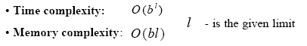

5)Iterative deepening depth first search

It is used in combination with depth first search that finds the best depth limit.It does this by gradually increasing the limit-first 0,then 1,then 2 and so on. Until a goal is found.

Algorithm

1.Set SEARCH-DEPTH=1.

2.Conduct a depth first search to depth of SEARCH-DEPTH .If a solution path is found,then return it.

3.Otherwise increment SEARCH-DEPTH by 1 and go to step 2.
Limit=0
Limit=1
Limit=2

Here black nodes are the visited ones.

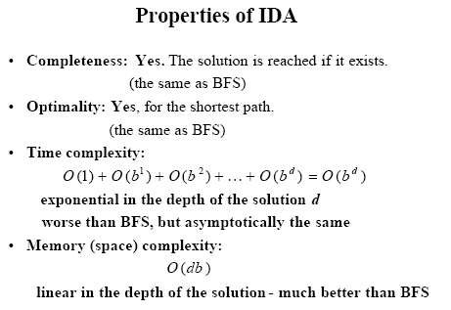

Constraint satisfaction problem
Taking the following map coloring problem as an example, we can explain the constraint satis faction problem

NT
Q
WA

SA
NSW

V

Constraint graph
WT
NT
SA
Q
NSW
V
Back tracking search for CSP
WA=red
WA=green
WA=blue
WA=red
NT=green
WA=red
NT=blue
WA=red
NT=green
Q=red
WA=red
NT=green
Q=blue
Forward checking
One way to make better use of constraints during search is called forward checking.whenever a variable is assigned forward checking process looks at each unassigned variable y that is connected to X by a constraint and deletes from Y’s domain any value that is inconsistent with the value chosed for X

 | WA | NT | Q | NSW | V | SA | T
Initial domain | R G B | R G B | R G B | R G B | R G B | R G B | R G B
After WA=red | R | G B | R G B | R G B | R G B | G B | R G B
After Q=green | R | B | G | R B | R G B | B | R G B
After V=blue | R | B | G | R | B |  | R G B

Intelligent backtracking(conflict directed back jumping)

WT
NT
SA
Q
NSW
V
red

Green

blue

T
red

Let the coloring order be {Q,NSW,V,T,SA,WA,NT}.Now when we try SA,we see that every value violates a constraint .Now instead of backtracking upto T,we backtrack to the set variables(conflict set) which caused the failure.here the conflict set is{Q,NSW,V}
So we jump over T and try a new value for V.

Tree –decomposition
WA
NT
SA
R
G
NT
Q
SA
G
R
B
R
G
B
SA
Q
NSW
B
R
G
SA
NSW
V
B
G
R
T

Cut set conditioning algorithm
1.Choose a subset S from variable [csp] such that the constraint graph becomes a tree after removal of S.S is called cycle cut set e.g.:-SA.
2.For each possible assignment to the variable in S that satisfies all constraint on S,
a)remove from the domains of the remaining variables any values that are
inconsistent with assignment for S &
b)if the remaining CSP has a solution return it together with the assignment for S.

6) Bidirectional Search
