MODULE II

Heuristic search

-Informed searches uses problem specific knowledge beyond the definition of the problem.They have more informnation than the initial state,operators and the goal state.Eg:-for 8-puzzle one heuristic function can be the no of tiles in incorrect position.
Heuristic function
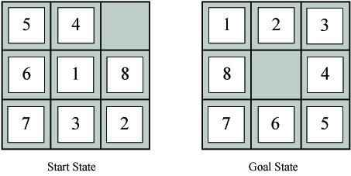
- h1(n) = Number of tiles in wrong position in state n
For start state h1(S)=7
For goal state h1(G)=0

Heuristic I for 8-puzzle
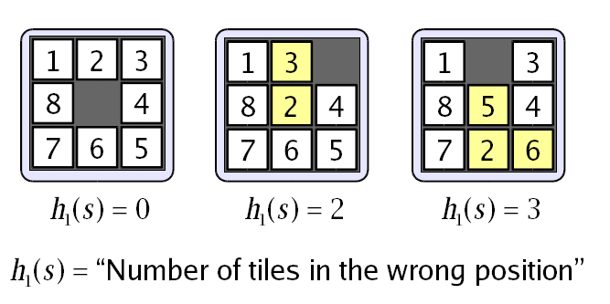

Heuristic II for 8 puzzle
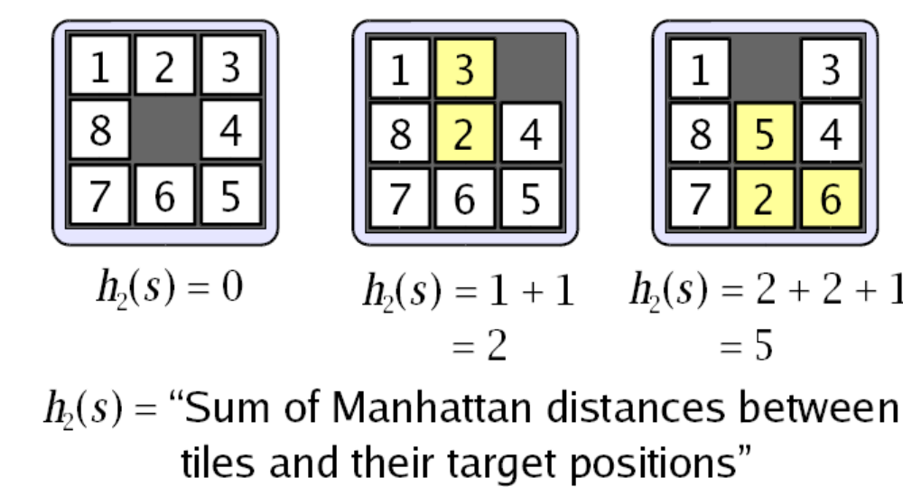

Admissible Search Algorithms
An algorithm is admissible if, for any graph, it always terminates in an optimal (least-cost) path from a node s to a goal node whenever a path from s to a goal node exists.
A* is admissible if
- All operators costs are 0
- All heuristic estimates are 0, and
- The heuristic function never overestimates

The heuristic algorithms are

1)generate and test

2)Hill climbing

3)steepest ascent hillclimbing

4)Best-first search

5)Simulated annealing

6)A* algorithm

generate and test

Algorithm

1. Generate a possible solution .For some problems, this means generating a particular

point in the problem space. For others it means generating the path from a start state.

2. Test to see if this is actually a solution by comparing the chosen point or the end point of the chosen path to the set of acceptable goal states.

3. If a solution has been found ,quit. Otherwise return to step 1.

This is a depth first search algorithm since complete solutions must be generated before they can be tested.

2)Hill Climbing

A feedback from a test procedure is used to help the generator decide which direction to move in search space.ie, the test function is augmented with a heuristic function which provides an estimate of how close a given state is to a goal state.

Algorithm

1. Evaluate the initial state. If it is a goal state then return it and quit; otherwise continue

with the initial state as the current state.

2. Loop until a solution is found or until there are no operators left to be applied in the current state.

a)Select an operator that has yet beenapplied to the current state and apply it to

produce a new state.

b)Evaluate the new state.

i)If it a goal stste ,then return it and quit.

ii)if it is nnot a goal state,but it is better than the current state,then make it

the current state.

iii)If it is not better than the current state ,then continue in the loop.

3)steepest ascent hill climbing
This algorithm selects all the moves from the current state and selects the best as the next state.In the previous method first state which is better than the current state is selected.
1. Evaluate the initial state .If it is a goal state, then return it and quit; otherwise continue
with the initial state as the current state.
2. Loop until a solution is found or until a complete iteration produces no change in the
current state.
a) Let the succ be a state such that any possible successor of the current state will
be better than the succ.
b) For each operator that applies to the current state do
i) Apply the operator and generate a new state.
ii) Evaluate the new state. If it is a goal state, then return it and quit. If not
compare it to the succ. If it is better, then set succ to this state. If it is
not better leave succ alone.
iii)If the succ is better than the current state,then set current state to succ.

Both these algorithms may sometimes fail to find a solution.
The program may reach either a local maximum, plateau or ridge.
Local maximum- As a state that is better than all its neighbours but it is not better than some other states farther away.
Plateau-it is flat area of search space in which a whole set of neighboring states have the same value. It is not possible to determine the best direction in which to move by making local comparisons.
Ridge-special kind of local maximum. It is are of the search space that is higher than the surrounding areas and that itself has a slope.

Global maximum

value
Local maxima

plateau

states

Methods to deal with the problem are
1.Backtrack to some earlier node and try going in a different direction.
2.Make a big jump in some direction to try to get a new section of the search space.

4)Simulated annealing: -
Simulated annealing is a variation of hill climbing in which downhill moves are made rather than uphill.
Eg:- Consider the physical process of annealing in which physical substances such as metals are melted (i.e. raised to a high energy level) and then gradually cooled until some solid state is reached. The goal is to produce a minimal-energy final state.
But there is some probability that a transition to a high-energy state will occur. This probability is given by the function
P = e- E/KT
Where E=positive change in the energy level.
T=temperature.
K=Boltzmann’s constant.
Large upward moves may occur early on but as the process progresses only relatively small upward moves are allowed until finally the process converges to a local maximum.The rate at which the system is cooled is called the annealing schedule.

Algorithm
1.Evaluate the initial state.If it is also a goal state,then return it and quit else continue
with the initial stste as the current state.
2.Initialize BEST-SO-FAR to the current state.
3.Initialize T according to the annealing schedule.
4.Loop until a solution is found or until there are no new operators left to be applied to the current state.
a)Select an operator that has not yet been applied to the current state and apply it to
produce a new state.
b)Evaluate the new state .
Compute E=(value of the current)-(value of the new state)
-if new state is a goal state,then return it and quit.
-if it is not a goal state,but it is better than the current state,then make it
the current state. BEST-SO-FAR = new state.
-if it is not better than the current state,then make it the current state with
probability p.
c)Revise T as necessary according to the annealing schedule..
5.Return BEST-SO-FAR as the result.

5)Best-First –search

It is the combination of depth-first search and breadth first search.at each step of the best-first search,we select the most promising of the nodes generated so far,by applying a heuristic function to each one of them.

algorithm
1.Place the starting state s on the queue.
2.If the queue is empty then,return failure and stop.
3.If the first element on the queue is a goal node g,return success and stop ,otherwise 4.remove the first element on the queue and expand it and compute the estimated goal
distances for each child .Place the children on the queue and arrange the elements in
ascending order corresponding to the goal distances from the front of the queue.
5.Return to step 2.

step 1 step2 step3
A
A
A
B
C
D

B
C
D

3 5 1 3 5 4 6
E
F

step 4 step 5

A
B
C
D
E
F
G
H
A
B
C
D
E
F
G
H
I
J

5 5
6

6 5 4 6 6 5

2 1

A* algorithm
1. Place the starting node S on open.
2. If open is empty, stop and return failure.
3. Remove from open the node n that has the smallest value of f*(n).If the node is a goal
node ,return success and stop.
4. Expand n,generating all of its successors n’ and place n on closed. For every successor
n’,if n’ is not already on open or closed attach a back pointer to n,compute f*(n’) and
place it on open.
5. Each n’ that is already on open or closed should be attached to back pointers which
reflect the lowest g*(n’) path if n’ was on closed and its pointer was changed, remove
it and place it on open.
6. Return to step 2.

State space search

A* is a type of search algorithm. Some problems can be solved by representing the world in the initial state, and then for each action we can perform on the world we generate states for what the world would be like if we did so. If you do this until the world is in the state that we specified as a solution, then the route from the start to this goal state is the solution to your problem.
In this tutorial I will look at the use of state space search to find the shortest path between two points (pathfinding), and also to solve a simple sliding tile puzzle (the 8-puzzle). Let's look at some of the terms used in Artificial Intelligence when describing this state space search.
Some terminology
A node is a state that the problem's world can be in. In path finding a node would be just a 2d coordinate of where we are at the present time. In the 8-puzzle it is the positions of all the tiles.
Next all the nodes are arranged in a graph where links between nodes represent valid steps in solving the problem. These links are known as edges. In the 8-puzzle diagram the edges are shown as blue lines. See figure 1 below.
State space search, then, is solving a problem by beginning with the start state, and then for each node we expand all the nodes beneath it in the graph by applying all the possible moves that can be made at each point.
Heuristics and Algorithms
At this point we introduce an important concept, the heuristic. This is like an algorithm, but with a key difference. An algorithm is a set of steps which you can follow to solve a problem, which always works for valid input. For example you could probably write an algorithm yourself for multiplying two numbers together on paper. A heuristic is not guaranteed to work but is useful in that it may solve a problem for which there is no algorithm.
We need a heuristic to help us cut down on this huge search problem. What we need is to use our heuristic at each node to make an estimate of how far we are from the goal. In path finding we know exactly how far we are, because we know how far we can move each step, and we can calculate the exact distance to the goal.
But the 8-puzzle is more difficult. There is no known algorithm for calculating from a given position how many moves it will take to get to the goal state. So various heuristics have been devised. The best one that I know of is known as the Nilsson score which leads fairly directly to the goal most of the time, as we shall see.
Cost
When looking at each node in the graph, we now have an idea of a heuristic, which can estimate how close the state is to the goal. Another important consideration is the cost of getting to where we are. In the case of path finding we often assign a movement cost to each square. The cost is the same then the cost of each square is one. If we wanted to differentiate between terrain types we may give higher costs to grass and mud than to newly made road. When looking at a node we want to add up the cost of what it took to
get here, and this is simply the sum of the cost of this node and all those that are above it in the graph.

8 Puzzle

Let's look at the 8 puzzle in more detail. This is a simple sliding tile puzzle on a 3*3 grid where one tile is missing and you can move the other tiles into the gap until you get the puzzle into the goal position. See figure 1.

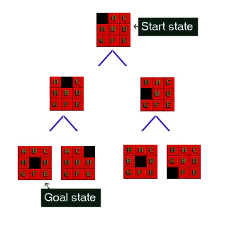
Figure 1 : The 8-Puzzle state space for a very simple example
There are 362,880 different states that the puzzle can be in, and to find a solution the search has to find a route through them. From most positions of the search the number of edges (that's the blue lines) is two. That means that the number of nodes you have in each level of the search is 2^d where d is the depth. If the number of steps to solve a particular state is 18, then thatï¿½s 262,144 nodes just at that level.
The 8 puzzle game state is as simple as representing a list of the 9 squares and what's in them. Here are two states for example; the last one is the GOAL state, at which point we've found the solution. The first is a jumbled up example that you may start from.
Start state SPACE, A, C, H, B, D, G, F, E

Goal state A, B, C, H, SPACE, D, G, F, E

The rules that you can apply to the puzzle are also simple. If there is a blank tile above, below, to the left or to the right of a given tile, then you can move that tile into the space. To solve the puzzle you need to find the path from the start state, through the graph down to the goal state.

Implementing A*

We are now ready to look at the operation of the A* algorithm. What we need to do is start with the goal state and then generates the graph downwards from there. Let's take the 8-puzzle in figure 1. We ask how many moves can we make from the start state? The answer is 2, there are two directions we can move the blank tile, and so our graph expands.
If we were just to continue blindly generating successors to each node, we could potentially fill the computer's memory before we found the goal node. Obviously we need to remember the best nodes and search those first. We also need to remember the nodes that we have expanded already, so that we don't expand the same state repeatedly.
Let's start with the OPEN list. This is where we will remember which nodes we haven't yet expanded. When the algorithm begins the start state is placed on the open list, it is the only state we know about and we have not expanded it. So we will expand the nodes from the start and put those on the OPEN list too. Now we are done with the start node and we will put that on the CLOSED list. The CLOSED list is a list of nodes that we have expanded.
f = g + h

Using the OPEN and CLOSED list lets us be more selective about what we look at next in the search. We want to look at the best nodes first. We will give each node a score on how good we think it is. This score should be thought of as the cost of getting from the node to the goal plus the cost of getting to where we are. Traditionally this has been represented by the letters f, g and h. 'g' is the sum of all the costs it took to get here, 'h' is our heuristic function, the estimate of what it will take to get to the goal. 'f' is the sum of these two. We will store each of these in our nodes.
Using the f, g and h values the A* algorithm will be directed, subject to conditions we will look at further on, towards the goal and will find it in the shortest route possible.
So far we have looked at the components of the A*, let's see how they all fit together to make the algorithm:

Hopefully the ideas we looked at in the preceding paragraphs will now click into place as we look at the A* algorithm pseudocode. You may find it helpful to print this out or leave the window open while we discuss it.
To help make the operation of the algorithm clear we will look again at the 8-puzzle problem in figure 1 above. Figure 3 below shows the f,g and h scores for each of the tiles.

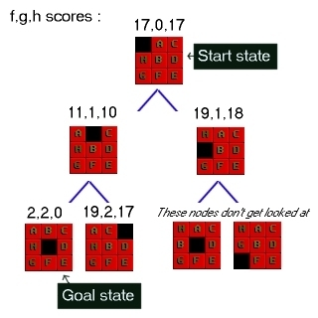

Figure 3 : 8-Puzzle state space showing f,g,h scores
First of all look at the g score for each node. This is the cost of what it took to get from the start to that node. So in the picture the center number is g. As you can see it increases by one at each level. In some problems the cost may vary for different state changes. For example in path finding there is sometimes a type of terrain that costs more than other types.
Next look at the last number in each triple. This is h, the heuristic score. As I mentioned above I am using a heuristic known as Nilsson's Sequence, which converges quickly to a correct solution in many cases. Here is how you calculate this score for a given 8-puzzle state:
Nilsson's sequence score

A tile in the center scores 1 (since it should be empty)
For each tile not in the center, if the tile clockwise to it is not the one that should be clockwise to it then score 2. Multiply this sequence by three and finally add the total distance you need to move each tile back to its correct position. Reading the source code should make this clearer.
Looking at the picture you should satisfy yourself that the h scores are correct according to this algorithm.
Finally look at the digit on the left, the f score. This is the sum of g and h, and by tracking the lowest f down through the state space you are doing what the A* algorithm would be doing during its search.

Comparison of Search Techniques
 | DFS | BFS | UCS | IDS | Best | HC | Beam | A* | IDA*
Complete? | N | Y | Y | Y | N | N | N | Y | Y
Optimal? | N | N | Y | N | N | N | N | Y | Y
Heuristic | N | N | N | N | Y | Y | Y | Y | Y
Time
Space |  |  |  |  |  | 1

