MODULE III

Game playing

Game is a multi agent environment in which impact of each agent is significant regardless of whether the agents is significant regardless of whether the agents are cooperative or competitive .games are too hard to solve, when compared to AI problems .Pruning allows us to ignore portions of the search tree that makes no difference to the final choice.

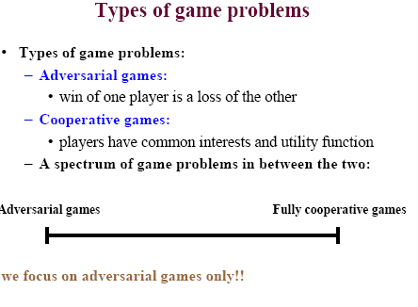

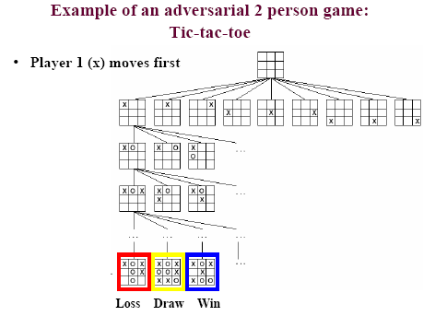

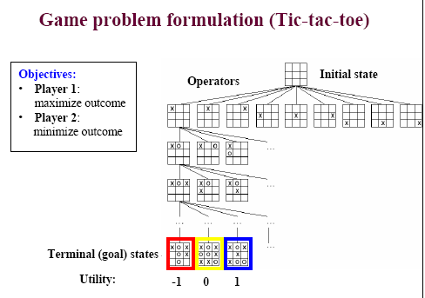

Minimax
Minimax is a search technique that demonstrates how we can use calculate the values of states and then use these values to guide search and determine which paths to goal states are better.
It is specific to search for two-player games. It looks at how a game should progress to maximise the favourable outcome for player one assuming that player two will try to minimise the outcome for player one (n.b these dynamics are quite different to the zero-sum game dynamics of the last module).
Minimax has as initial conditions the initial state of the game. There are then operators which define the moves a player can make. At the bottom of the tree of possible state and moves are the terminal nodes. These need to be detectable and to have a value associated with them. Given these factors, Minimax search will generate the entire game tree and propagate values from the terminal nodes back up the tree.
The game tree starts with an action (move) by player 1 in the initial state. This leads to a new state and a move by player 2 resulting in a third state. This sequence of forms a two-ply game tree. One such tree is as follows (Russell and Norvig 1995):
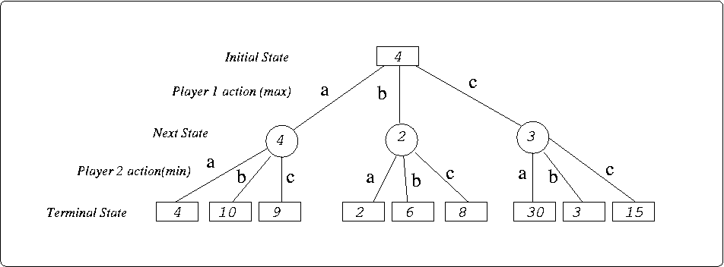

This tree represents the value of states given the Minimax moves. After action 1 by player 1 (either a, b or c). The fact that the opponent will take the move that minimises the payoff for player 1 means the value of the resulting state is the lowest possible value achievable given the actions of player 2 in that state.
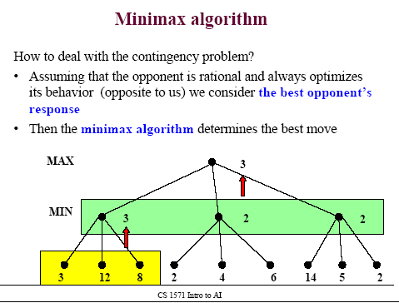

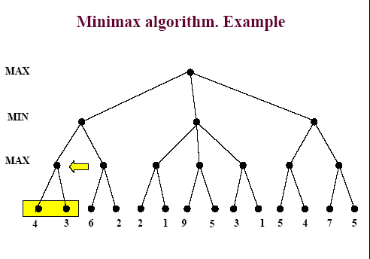
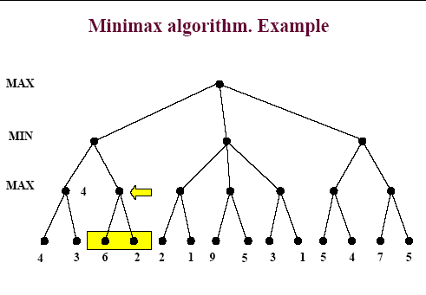
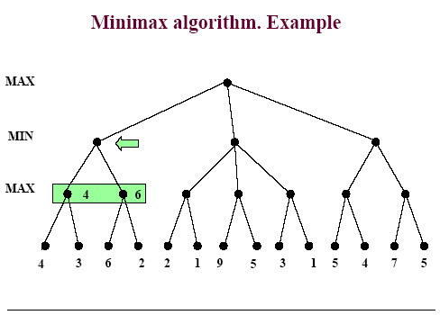
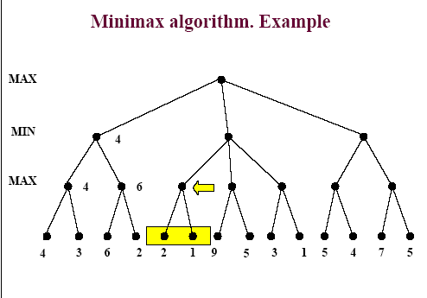
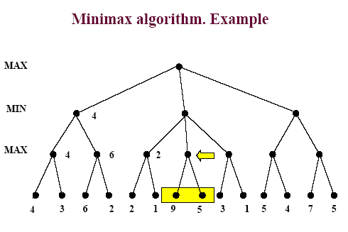
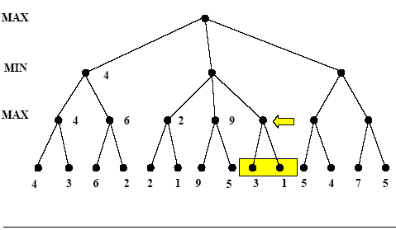
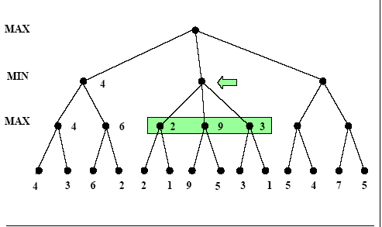
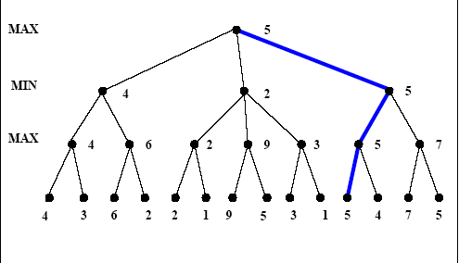
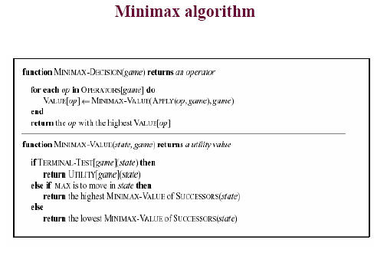
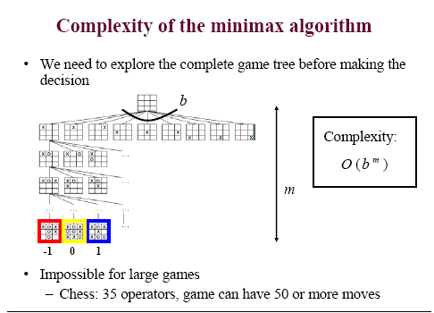
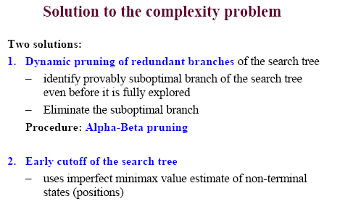
Minmax -steps
1.Start at the initial node.
2.for each node
a)If the node is a terminal state ,evaluate that state.
b)If the node is one where max moves,return the highest minimax value of the
children.
c)If the node is one where min moves,return the lowest minimax value of
children.
Minmax function
Minmax(u)
{
If u is a leaf return score of u;
Else if it is a min node
For all children of u;v1…vn;
Return min{minmax(v1),……minmax(vn)}
Else for all children of u;v1…..vn;
Return max(minmax(v1)…..minmax(vn)}
}

Since this process requires the generation of the entire game tree, it is not feasible for any but the smallest problems. But it does convey the idea that we want to search for the best outcome.
This takes advantage of knowledge of the decisions that will be made by players to prune (i.e not evaluate) branches of the tree.
Instead of searching all the way to the bottom of the tree, Alpha-beta search uses an estimate of the value of nodes, it then searches until it reaches a node with a reliable value and treats this in the same way Minimax treats terminal nodes (i.e propagates the value back from here).
Alpha-Beta search now uses these value estimates to reduce search as follows:
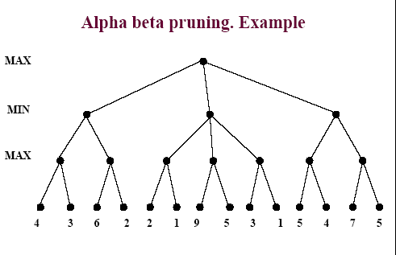
Player 1 (the max player) will act to maximise the α value, the best value generated so far. So if we know a branch will have a lower value than one generated so far we can skip that branch.
Player 2 (the min player) will act to minimise the β value, the lowest value generated so far. If we know a branch will have a higher value than one generated so far, then skip that branch.
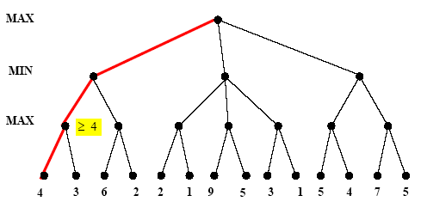
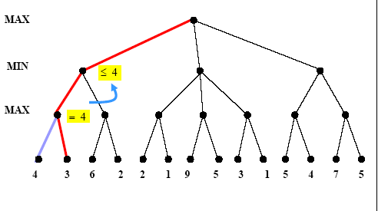

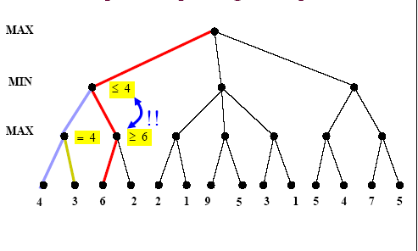
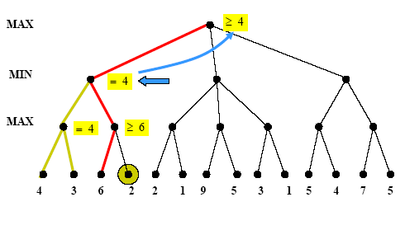

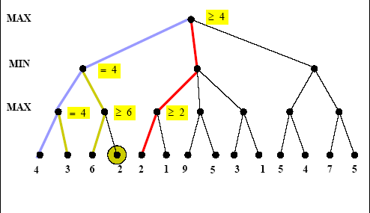

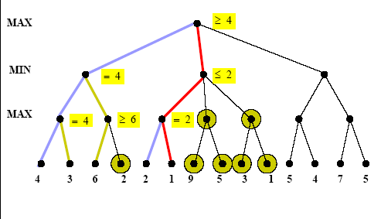

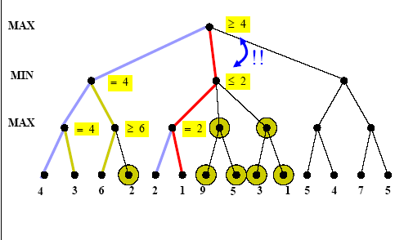
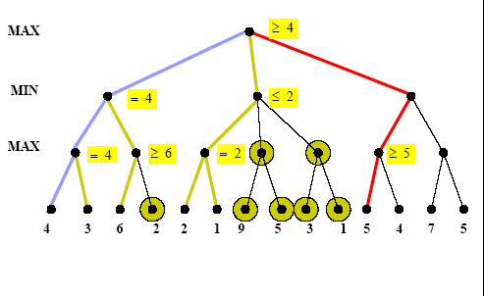

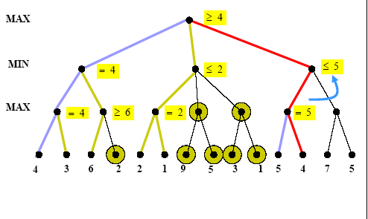

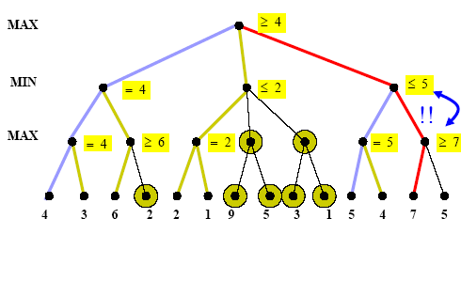
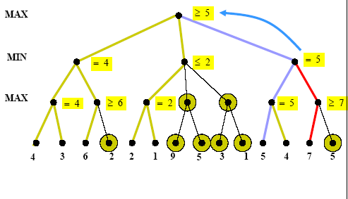

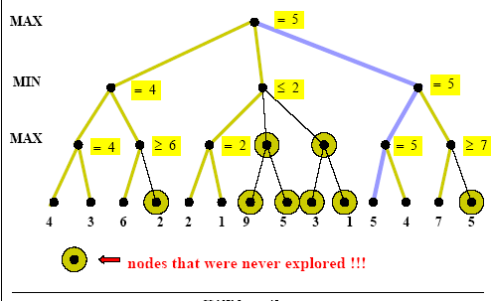
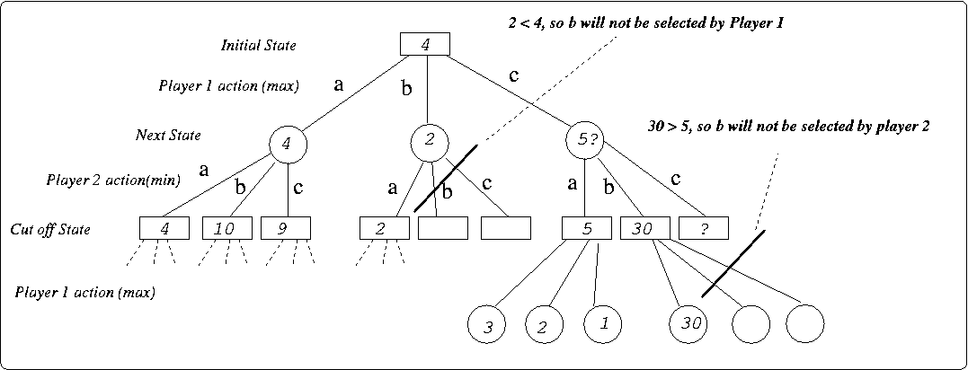

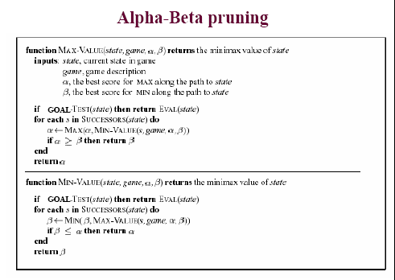

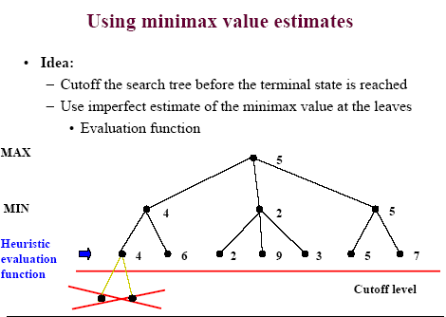

Heuristic Evaluation Functions
Minimax calculated the value of paths by using:
- Search all the way to the depth of those terminal nodes
- Propagating back knowledge of the value of terminal nodes
We would like to avoid the search to the depth of the tree as in large spaces it is simply not feasible. We would like to cut-off search before the terminal nodes, but without this search it is hard to determine the value of other nodes.
We therefore need some means to estimate the value of nodes other than terminal nodes in the tree. For example, in a chess game, a simple approximation for the value of nodes may be made using the material value of pieces. Of course, this approximation will not be as good as it could be as there are situations which may have a high utility and a small material value. Our estimate could be improved in this case by having a more complex evaluation function.
The problem with the material value estimate for chess then, is that the value of a state that is measured as good, may later turn out to be quite poor. In this case, the state lacks quiescence. By determining states which are quiescent, we can continue search to those points and be fairly sure of the reliability of our estimate.
STATE OF ART GAME PROGRAMS

I) CHECKERS

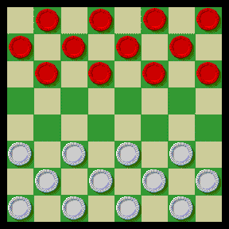
Checkers is a two-player strategy game played on a 64-square checkered board.
The object of the game is to capture or blockade all of the opponent's pieces. If neither player can accomplish this, the game is a draw.

Overview
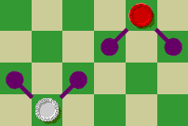 |  | Beginning with Red each player moves one of his or her pieces per turn. Throughout these rules, a "piece" means either a "man"--a single checker, which is all that players have at the start of the game--or a "king," which is what a man becomes if it reaches the last rank.  A man may move one square diagonally forward--that is, toward the opponent--onto an empty square, as shown.
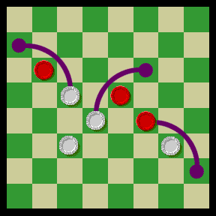 |  | If a square diagonally in front of a man is occupied by an opponent's piece, and if the square beyond that piece in the same direction is empty, the man may jump over the opponent's piece and land on the empty square. The opponent's piece is captured and removed from the board. The diagram shows two possible jumps by White and one possible jump by Red.
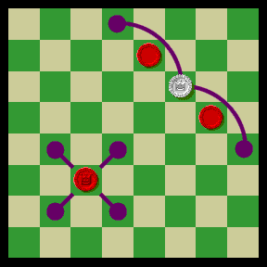 |  | When a man reaches the last rank--the row of squares closest to the opponent--it becomes a king. A previously captured checker is placed on top of it as a crown to distinguish it from an ordinary man. Kings have the ability to move and capture the same way as men, but they also may move and capture backward.

Captures and Multiple Captures
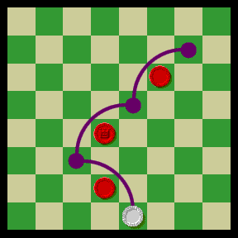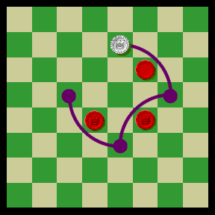 |  | A player must make a capture when able to do so, and may not make an ordinary noncapturing move. If, after making a capture, a piece is in a position to make another capture--either along the same diagonal or a different one--it must do so, all as part of the same turn. Capturing two opposing pieces in a turn is called a double jump, capturing three pieces in a turn is a triple jump, and so on. Triple jumps by a White man and a White king are shown in these two diagrams. (At Yahoo! multiple jumps are treated like multiple moves: If a checker jumps to a square from which it can make a further jump, its owner retains the turn after releasing the mouse button, and must then continue by making the next jump.)
 |  | Back to Top
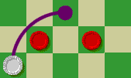  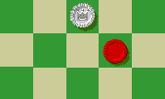 |  | A piece may not end its move in a position from which an additional capture is possible (except during a move in which a man becomes a king, as explained below). Both men and kings may capture men, kings, or a combination of men and kings. A player who has more than one way to make a capturing move may make whichever capturing move he or she chooses; there is no requirement to capture the most pieces or the most kings, as in some forms of checkers. When a man moves or jumps to the last rank, its turn ends. Even if the man made a jump to get there, it may not continue jumping backward as a king on the same turn. For example, after White makes the jump shown in the first diagram, White's turn ends with the second position shown.

II) OTHELLO / REVERSI

Board game

Board consists of 64 squares

2 players

2 coloured coins, one for each player

Player with more coins of his colour wins

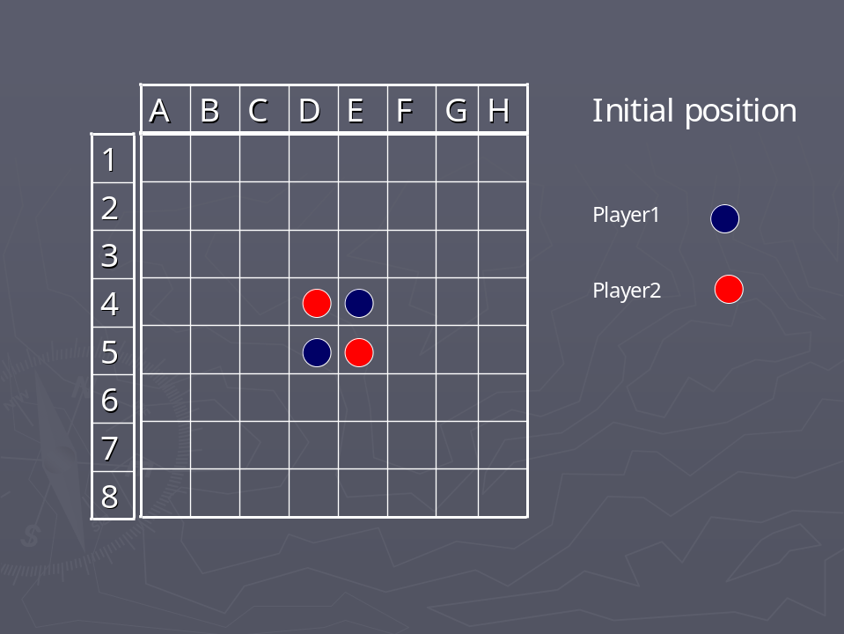

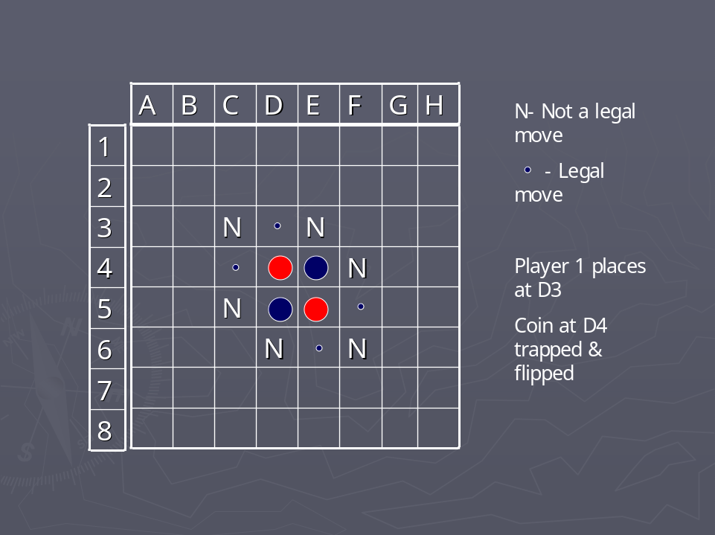

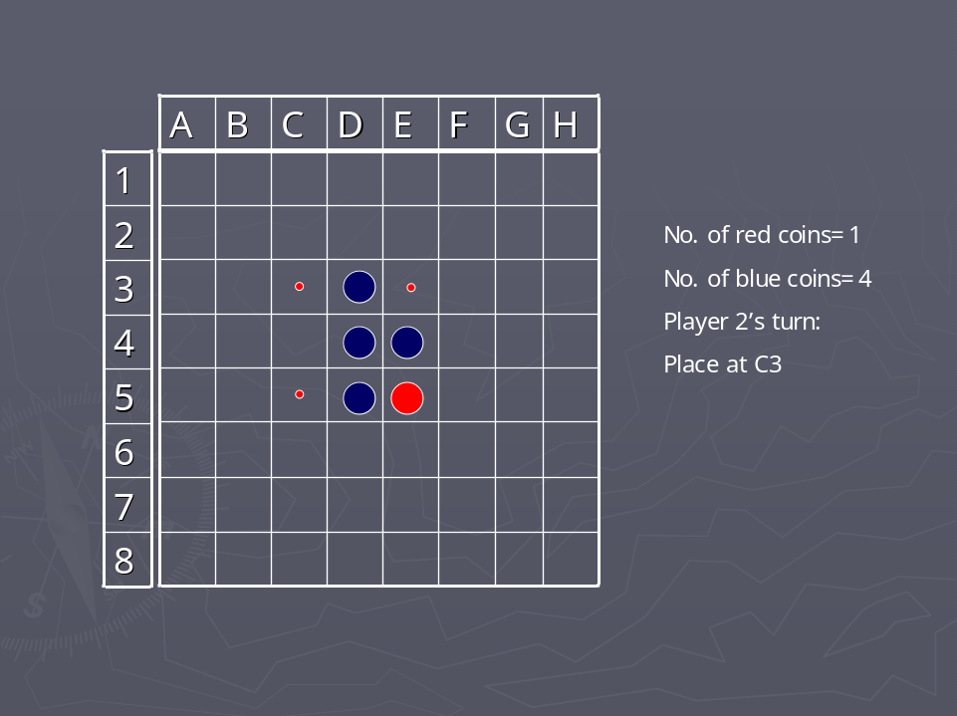

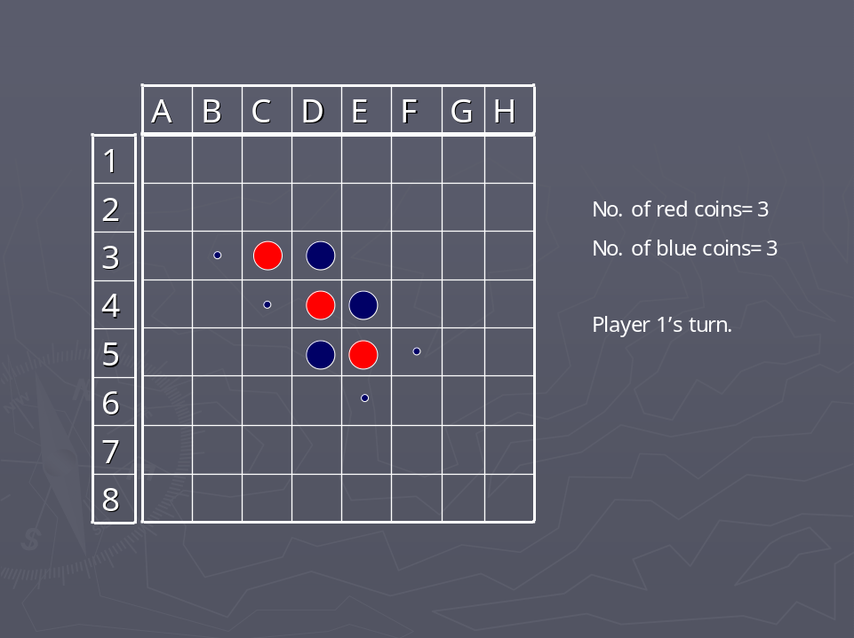

More than 1 coin in a row can be flipped.
A row can be horizontal, vertical or a diagonal line.
More than 1 row can be flipped in a single move

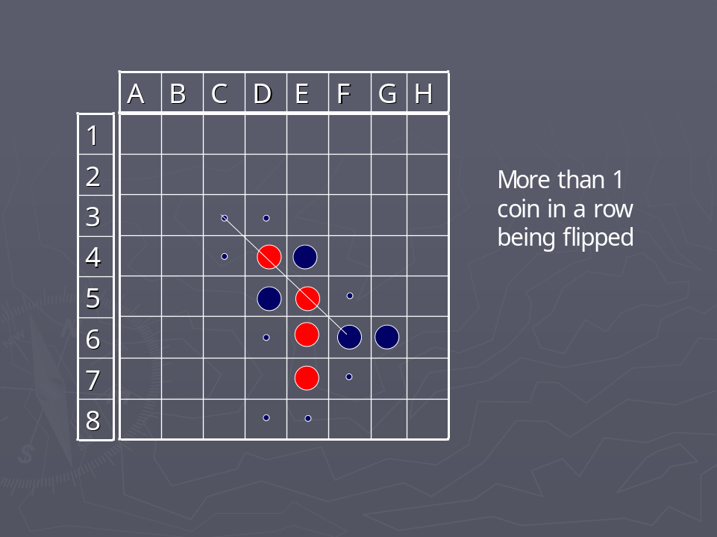

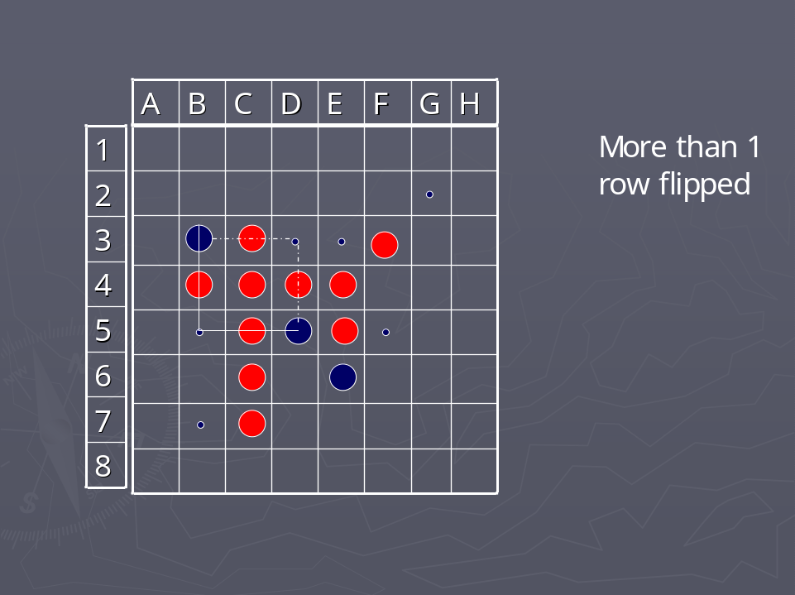

RULES
- Only legal moves can be made.
- If no legal move exists, player passes his turn.
- No coin is displaced from its position, they can only be flipped.
- Game ends when neither player has a legal move.
- Player with more coins of his color wins the game.

STATEGIES FOR WINNING

- Select moves that prevent your opponent from capturing several of your coins.
- Try to capture in more than 1 direction at a time.
- Move to the squares at the outer perimeter of the board, especially corner squares.
- Try to prevent the opponent from moving to the edge of the board.
- Avoid placing your coins adjacent to squares located just inside the outer perimeter, this gives the opponent an opportunity to move to the outer perimeter

III) GO

- A traditional board for the game is wooden, with the lines painted on.

- The stones are flattened spheroids and fit closely together when placed on adjacent points.

- Two Players

- The two players, black and white, battle to maximize the territory they control, seeking to surround large areas of the board with their stones, to entrap any opposing stones that invade these areas, and to protect their own stones from capture.

- The strategy involved can become very subtle and complex.

- Go is considered by some to be the ultimate strategy game, superior in depth of complexity to both chess and shoji.

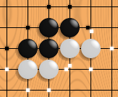

- This picture shows one black chain and two white chains. Their respective liberties are shown with dots. Note that liberties can be shared between stones and chains. If white plays where its two chains share a liberty, the chains will be connected into one.

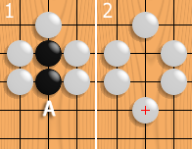

If white plays at A, the black chain loses its last liberty, and is captured and removed from the board
- Two players, black and white, take turns placing a stone (game piece) on the points (intersections) of a 19 by 19 board (grid). Black moves first.

- Stones must have liberties (empty adjacent points) to remain on the board. Stones connected by lines are called chains, and share their liberties.

- When a stone or a chain of stones is surrounded by opponent stones, so that it has no more liberties, it is captured and removed from the board.

- A player's score is the number of empty points enclosed only by his stones plus the number of points occupied by his stones.

- The player with the higher score wins.

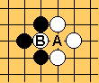

- Let's say that it is Black's turn. If Black plays at A (this is legal because Black is capturing White's stone at B, which means that his stone he played still has one liberty), then White could recapture at B (Black captured the White stone B, so the point is now empty). Then, Black could recapture at A, and White could...

Strategy

- Connection: Keeping one's own stones connected means that fewer groups need defense.

- Cut: Keeping opposing stones disconnected means that the opponent needs to defend more groups.

- Life: This is the ability of stones to permanently avoid capture.

- The simplest way is for the group to surround two "eyes" (separate empty areas), so that filling one eye will not kill the group and is therefore suicidal.

- Death: The absence of life, resulting in the removal of a group.

CAPTURE

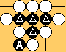

DEATH

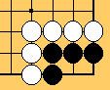

FINISHED

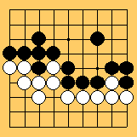

ILLEGAL

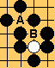

KO

