MODULE IV

Human beings know things and do reasoning. For successful behavior of artificial agents also require knowledge and reasoning.A logical method for representing knowledge is first order propositional logic.

Knowledge Base
This is the central component of knowledge base agents.It is a set of sentences represented in a language called knowledge representation language.

A knowledge representation system should have the following properties.

Representational adequacy-the ability to represent all kinds of knowledge .
Inferential adequacy -The ability to manipulate representational structures in such a way as to derive new structures corresponding to new knowledge inferred from them
Acquisitional efficiency- The ability to acquire new information easily is
Kinds of knowledge representation
1.Relational knowledge
Player | Height | Weight | Batting avg
X | 5 | 100 | 125
Y | 6 | 120 | 135
2.Inheritable knowledge
Here the elements of specific classes inherit attributes and values from more general classes in which they are included
The following figure is an example for inheritable knowledge representation.It is also called semantic net or slot and filler structure.
person
right
Adult male
Base ball
player
5-10
6-1
pitcher
fielder
.262
.106
Three-finger-brown
Pee-wee-reese
Brooklyn
Chicago
.252
instance
handed
height
isa
isa
isa
instance
isa
The above figure is a collection of frames.
Here base ball player is a frame with attributes height, batting average, bats etc.
Isa is an attribute which shows class inclusion and instance is an attribute which shows class membership.

3. Inferential knowledge.
Knowledge is useless unless there is some inference procedure which is used to arrive at certain conclusion.There is both forward and backward reasoning.

4.Procedural knowledge.
It is a method where programming language like LISP is used for representation

.

Base ball player
Isa:Adult male.
Bats: (lamda(x)
(prog( )
L1
(cond((caddr x)(return(caddr)))
(t(setq x(eval(caddr x)))
(cond (x(go L1))
(t(return nil)))))
Height:6-1
Batting avg:.252.

FIRST ORDER PREDICATE LOGIC
Syntax
Not negation
And & conjunction
Or V disjunction
If..then → implication
If and only if ↔ double implication.

The syntax of FOPL is recursively defined as follows.

T and F are formulas

If P and Q are formulas then the following are formulas

(- P)
(P & Q)
(P V Q)
(P → Q)
(P ↔ Q)

Precedence of connectives

¬ Highest
&
V
→
↔ Lowest

Equivalence laws

1)Idempotency
PVP=P
P& P=P
2)Associativity
(P VQ) V R=P V (Q V R)
(P & Q) & R= P & (Q & R)
3)commutativity
P V Q= Q V P.
P & Q =Q & P
P ↔ Q= Q ↔ P.
4)Distributivity: P &( Q V R) = ( P & Q) V (P & R)
P V (Q & R) = (P V Q) & (P V R)
5)De Morgan’s law -(P V Q) = -P & -Q
- (P& Q) = - P V -Q
Inference rules
Given a set of sentences S={s1,s2…..sn} we can prove the truth of s.

Modes ponens

From P and P → Q infer Q

This is written as
P
P → Q

Q
Chain rule

From P → Q and Q → R ,infer P → R
This is written as
P → Q
Q → R

P → R

Knowledge representation using first order predicate knowledge.
1.marcus was a man.
Man(marcus)
2.marcus was a Pompeian
Pompeian(marcus)
3.All pompeians were romans
: Pompeian(x) → Roman(x)
4.caesar was a ruler
Ruler(Caesar)
5.All romans were either loyalto Caesar or hated him
: roman(x) → loyalto(x,Caesar) V hate(x,caesar)
6.Every one is loyalto some one.
:: loyalto(x,y)
7.People try to assassinate rulers they are not loyalto
: y: tryassassinate(x,y) → loyalto(x,y)

Well formed formulas (wffs)

E1:All employees earning $ 1400 or more per year pay taxes.
E2:No employee earns more than the president.
We can define the predicates as
E(x) for x is an employee.
P(x) for x is a president.
I(x ) for income of x
GE(u,v) for u is greater than or equal to v.
S(x) for x is sick today.
T(x) for x pays tax.
Using the above predicats the statements can be written in FOPL as
E1: ( (E(x) & GE(i(x),1400)) →T(x))
E2: (E(y) →S(y))
E3: x y ((E(x) & P(y)) → GE( i(x),i(y)))
These are known as well formed formulas
Wff are defined as
-An atomic formula is a wff.
-if P and Q are wffs
then –P
P&Q
PVQ
P→Q
P ↔ Q
P(x)
and x P(x) are wffs

Conjunctive Normal form
Given wffs F1,F2…Fn each consisting of the disjunction of literals only (V) ,then F1,F2….Fn is in the conjunctive normal form.

Disjunctive Normal form
Given wffs F1,F2…Fn each consisting of the conjunction of literals only ( ) ,then F1,F2….Fn is in the disjunctive normal form.

Unification
A substitution S is a finite (possibly empty) set of pairs X_{i} ← t_{i} where X_{i} is a variable and t_{i} is a term; X_{i} ≠ X_{j} for i ≠ j; and X_{i} does not occur in t_{j} for any i, j. The notation TS indicates the application of a substitution to a term T; each occurrence in T of a variable in S is replaced by its corresponding term. We can also apply one substitution to another substitution (provided the two substitutions do not have variables in common), replacing variables in the terms on the right hand sides of the pairs.
A unifier of two terms is a substitution that makes the terms identical. The resulting term is a common instance of the two terms.
A most general unifier of two terms is a unifier that produces a most general common instance. If two terms unify, there is a most general unifier.
For example
man(john) and man(john) is a contradiction. ,but man(john) and man(spot) is not a contradiction..thus inorder to determine contradictions,we need a matching procedure that compares 2 literals and discover whether there exists a set of substitutions that makes them identical. This is known as unification algorithm
algorithm: Unify(L1,L2)
If L1 and L2 are both variables or constants then
  - if L1 and L2 are identical,then return NIL.
  - Else if L1 is a variable,then if L1 occurs in L2 then return {FAIL],else return (L2/L1)
  - Else if L2 is a variable then if L2 occurs in L1 then return {FAIL].,else return(L1/L2)
  - Else return{FAIL].
2. If the initial predicate symbols in L1 and L2 are not identical then return{FAIL]
3. If L1 and L2 have a different number of arguments,then return {FAIL}
4. Set SUBST to NIL.
5. for i← 1 to number of arguments in L1:
a)call unify with the ith argument of L1 and the Ith argument of L2,putting result
in S.
b)If S contains FAIL ,then return{FAIL}
c)If S is not equal to NIL then:
i)Apply S to the remainder of both L1 and L2.
ii)SUBST :=APPEND(S,SUBST)
6. return SUBST.
Resolution
Resolution is a method of proving statements. Resolution produces proofs by refutation. In other words ,to prove a statement ,resolution attempts to show that the negation of the statement produces a contradiction of the known statements. For resolution the statements should be converted to the standard clausal form.

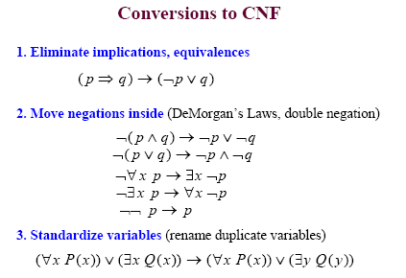

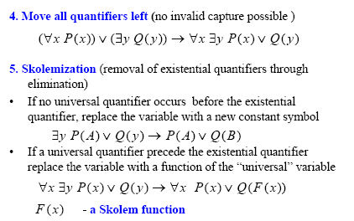

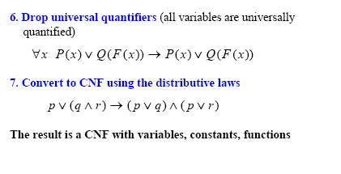
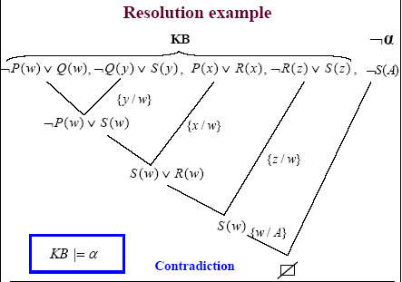

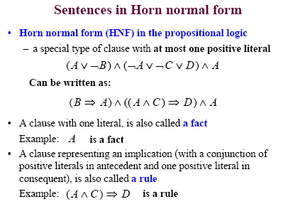

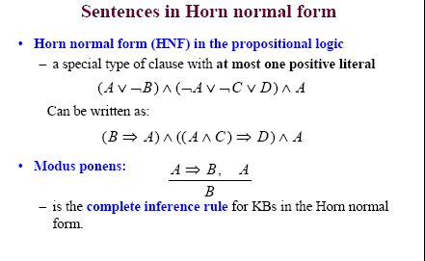

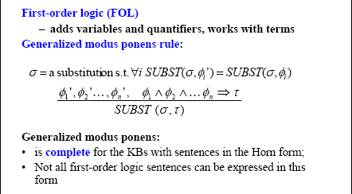

Algorithm :resolution
1.Convert all statements of F in to clausal form.
2.Negate P and convert the result to clausal form. Add it to the set of clauses obtained in step 1.
3.Repeat until either a contradiction is found or no progress can be made.
a) Select 2 clauses. Call these the parent clauses.
b) Resolve them together. If there is one pair of literals T1 and –T2 such that one
pair of parent clauses contains T1 and the other contains T2and if T1 and T2
are unifiable,then neither T1 nor T2 should appear in the resolvent.
c)If the resolvent is the mpty clause,then a contradiction hes been found.
If it is not then add it to the set of clauses available to the procedure.

Consider the following sentences in clausal form
1. man (marcus)
2. Pompeian (marcus)
3. Pompeian(x₁) V roman(x₁)
4. ruler(Caesar)
5. roman(x₂) V loyalto(x₁,Caesar) V hate(x₂,Caesar)
6. loyalto(x₃,fl(x₃))
7. man(x1) V ruler(y1) V tryassassinate(x4,y1) V loyalto (x4,y1)
8. tryassassinate (marcus,Caesar)

Prove hate(marcus,Caesar)
Negate: hate(marcus,Caesar)

(5). roman(x₂) V loyalto(x₁,Caesar) V hate(x₂,Caesar) hate(marcus,Caesar)

marcus / x₂

roman(marcus) V loyalto(marcus,Caesar) (3) Pompeian(x₁) V roman(x₁)

marcus / x₁

Pompeian(marcus) V loyalto(marcus,Caesar) (2). Pompeian (marcus)

loyalto(marcus,Caesar) (7). man(x1) V ruler(y1) V tryassassinate(x4,y1) V
loyalto (x₄,y₁)

marcus/ x_{4 ,} caesar/y₁

man(x1) V ruler(caesar) V tryassassinate(marcus,caesar)) (1). man (marcus)

marcus / x₁

ruler(caesar) V tryassassinate(marcus,caesar) (4). ruler(caesar)

tryassassinate(marcus,caesar) 8. tryassassinate (marcus,Caesar)

Nil

Since the result is nil the statement is proved.

Forward and backward chaining

forward chaining
Forward chaining is a means of utilizing a set of condition-action rules. In this mode of operation, a rule-based system is data-driven. We use the data to decide which rules can fire, then we fire one of those rules, which may add to the data in working memory and then we repeat this process until we (hopefully) establish a conclusion.
Reason forward from initial states

Begin building a tree of move sequences that might be solutions by starting with the initial configurations at the root of the tree. Generate next level of the tree by finding all the rules whose left sides match the root node and using their right sides to create the new configuratuions.Continue this until a configuration that matches the goal state is generated.

Forward-chaining is to be contrasted with backward chaining.
backward chaining
Backward chaining is a means of utilizing a set of condition-action rules. In backward chaining, we work back from possible conclusions of the system to the evidence, using the rules backwards. Thus backward chaining behaves in a goal-driven manner.
One needs to know which possible conclusions of the system one wishes to test for. Suppose, for example, in a medical diagnosis expert system, that one wished to know if the data on the patient supported the conclusion that the patient had some particular disease, D.
In backward-chaining, the goal (initially) is to find evidence for disease D. To achieve this, one would search for all rules whose action-part included a conclusion that the patient had disease D. One would then take each such rule and examine, in turn, the condition part of the rule. To support the disease D hypothesis, one has to show that these conditions are true. Thus these conditions now become the goals of the backward-chaining production system. If the conditions are not supported directly by the contents of working memory, we need to find rules whose action-parts include these conditions as their conclusions. And so on, until either we have established a chain of reasoning demonstrating that the patient has disease D, or until we can find no more rules whose action-parts include conditions that are now among our list of goals.
Reason backward from the goal state.

Begin building a tree of move sequences that might be solutions by starting with the goal configurations at the root of the tree. Generate next level of the tree by finding all the rules whose right sides match the root nodee and using their leftt sides to create the new configuratuions.Continue this until a configuration that matches the initial state is generated.
Backward-chaining is to be contrasted with forward chaining.

