Module -1

Basic concepts of parallel processing on high performance computers are introduced in this chapter. We will review the architectural evolution, examine various forms of concurrent activities in modern computer systems, and assess advanced applications of parallel processing computers.

Evolution Of Computer Systems

To design a powerful and cost effective computer system and to devise efficient programs to solve a computational problem, one must understand the underlying hardware and software system structures and the computing algorithms to be implemented on the machine with some user oriented programming languages. These disciplines constitute the technical scope of computer architecture. In this section we review the generations of computer systems and indicate the general trends in the development of high performance computers.

First Generation - 1940-1956: Vacuum Tubes
The first computers used vacuum tubes for circuitry and magnetic drums for memory, and were often enormous, taking up entire rooms. They were very expensive to operate and in addition to using a great deal of electricity, generated a lot of heat, which was often the cause of malfunctions. First generation computers relied on machine language to perform operations, and they could only solve one problem at a time. Input was based on punched cards and paper tape, and output was displayed on printouts.
The UNIVAC and ENIAC computers are examples of first-generation computing devices. The UNIVAC was the first commercial computer delivered to a business client, the U.S. Census Bureau in 1951.
Second Generation - 1956-1963: Transistors
Transistors replaced vacuum tubes and ushered in the second generation of computers. The transistor was invented in 1947 but did not see widespread use in computers until the late 50s. The transistor was far superior to the vacuum tube, allowing computers to become smaller, faster, cheaper, more energy-efficient and more reliable than their first-generation predecessors. Though the transistor still generated a great deal of heat that subjected the computer to damage, it was a vast improvement over the vacuum tube. Second-generation computers still relied on punched cards for input and printouts for output.
Second-generation computers moved from cryptic binary machine language to symbolic, or assembly, languages, which allowed programmers to specify instructions in words. High-level programming languages were also being developed at this time, such as early versions of COBOL and FORTRAN. These were also the first computers that stored their instructions in their memory, which moved from a magnetic drum to magnetic core technology. The first computers of this generation were developed for the atomic energy industry.

Third Generation - 1964-1971: Integrated Circuits
The development of the integrated circuit was the hallmark of the third generation of computers. Transistors were miniaturized and placed on silicon chips, called semiconductors, which drastically increased the speed and efficiency of computers.
Instead of punched cards and printouts, users interacted with third generation computers through keyboards and monitors and interfaced with an operating system, which allowed the device to run many different applications at one time with a central program that monitored the memory. Computers for the first time became accessible to a mass audience because they were smaller and cheaper than their predecessors.

Fourth Generation - 1971-Present: Microprocessors
The microprocessor brought the fourth generation of computers, as thousands of integrated circuits were built onto a single silicon chip. What in the first generation filled an entire room could now fit in the palm of the hand. The Intel 4004 chip, developed in 1971, located all the components of the computer - from the central processing unit and memory to input/output controls - on a single chip.
In 1981 IBM introduced its first computer for the home user, and in 1984 Apple introduced the Macintosh. Microprocessors also moved out of the realm of desktop computers and into many areas of life as more and more everyday products began to use microprocessors.
As these small computers became more powerful, they could be linked together to form networks, which eventually led to the development of the Internet. Fourth generation computers also saw the development of GUIs, the mouse and handheld devices.

Fifth Generation - Present and Beyond: Artificial Intelligence
Fifth generation computing devices, based on artificial intelligence, are still in development, though there are some applications, such as voice recognition, that are being used today. The use of parallel processing and superconductors is helping to make artificial intelligence a reality. Quantum computation and molecular and nanotechnology will radically change the face of computers in years to come. The goal of fifth-generation computing is to develop devices that respond to natural language input and are capable of learning and self-organization.

Trends towards parallel processing

- Data processing
Computer usage started with data processing, which is still a major task of today’s computers. With more and more data structures developed, many users are shifting to computer roles from pure data processing to information processing. Data space is the largest, including numeric numbers in various formats, character symbols, and multidimensional measures
- Information processing
An information item is a collection of data objects that are related by some syntactic structure.Therfore information items form a subspace of data space.
- Knowledge processing
Most of today’s computing is still confined within these data processing and information processing. A high degree of parallelism has been found at these levels. As the accumulated knowledge bases expanded rapidly in recent years, there grew a strong demand to use computers for knowledge processing
- Intelligence processing
To0day/s computers can be made very knowledgeable but are far from being intelligent .Intelligence is very difficult to create; its processing even more so. The degree of parallelism exploitable at the two highest processing levels should be higher than that at the data-information processing levels.
Definition for parallel processing
Parallel processing is an efficient form of information processing which emphasizes the exploitation of concurrent events in the computing process. Concurrently implies parallelism, simultaneity, and pipelining. Parallel events may occur in multiple resources during the same time interval; simultaneous events may occur at the same time instant; and pipelined events may occur in overlapped time spans.
Parallel processing can be challenged in four programmatic levels:
- Job or program level
- Task or procedure level
- Interinstruction level
- Intrainstruction level

What is Parallel Computing?
- Traditionally, software has been written for serial computation:
  - To be run on a single computer having a single Central Processing Unit (CPU);
  - A problem is broken into a discrete series of instructions.
  - Instructions are executed one after another.
  - Only one instruction may execute at any moment in time.
- In the simplest sense, parallel computing is the simultaneous use of multiple compute resources to solve a computational problem.
  - To be run using multiple CPUs
  - A problem is broken into discrete parts that can be solved concurrently
  - Each part is further broken down to a series of instructions
  - Instructions from each part execute simultaneously on different CPUs
- The compute resources can include:
  - A single computer with multiple processors;
  - An arbitrary number of computers connected by a network;
  - A combination of both.
- The computational problem usually demonstrates characteristics such as the ability to be:
  - Broken apart into discrete pieces of work that can be solved simultaneously;
  - Execute multiple program instructions at any moment in time;
  - Solved in less time with multiple compute resources than with a single compute resource
Parallelism in uniprocessor

Most general purpose uniprocessor systems have the same basic structure. In this section we will briefly review the architecture of uniprocessor systems.

Basic uniprocessor architecture

PC
Main memory
(2³² words of 32 bits each)
Console
Floppy disk
Diagnostic memory
R0
.
R15
PC
ALU
Floating point accelerator
Local memory
Synchronous backplane interconnect(SBI)
SBI I/O device
I/O devices
Unibus adapter
Mass bus adapter

A typical uniprocessor computer consists of three major components: The main memory, CPU, I/O subsystem. Figure shows the architectural components of the super minicomputer VAX-11/780, manufactured by Digital Equipment Company. The CPU contains the master controller of the VAX system. There are 16 32 bit general purpose registers, one of which serves as program counter. The CPU contains an ALU with an optional floating point accelerator, and some local cache memory with an optional diagnostic memory. The CPU can be intervened by the operator through the console connected to floppy disk.

Parallel Processing Mechanisms

Six categories of parallel processing Mechanisms

- Multiplicity of functional units
- Parallelism and pipelining within the CPU
- Overlapped CPU and I/O operations
- Use of a hierarchical memory system
- Balancing of subsystem bandwidths
- Multiprogramming and time sharing

Multiplicity of functional units:-

The early computer had only one ALU in its CPU.ALU could only perform one function at a time, a rather slow process for executing a long sequence of arithmetic logic instructions. In practice, many of the functions of ALU can be distributed to multiple and specialized functional units which can operate in parallel. The CDC-6600 has 10 functional units built in to its CPU .These 10 units are independent of each other and may operate simultaneously. A scoreboard is used to keep track of the availability of the functional units and registers being demanded.

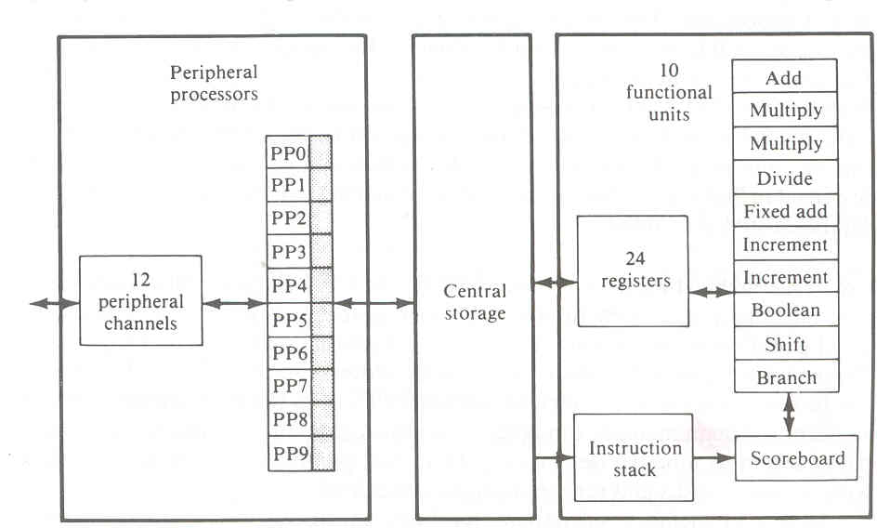

Parallelism and pipelining within the CPU:-

Parallel adders, using such techniques as carry-look ahead and carry save are now built into almost all ALUs. High speed multiplier recoding and convergence division are techniques for exploring parallelism and sharing of hardware resources for functions of multiply and divide.

Overlapped CPU and I/O operations

I/O operations can be performed simultaneously with the CPU computations by using separate I/O controllers, channels or I/O processors. The DMA channel can be used to provide direct information transfer between I/O devices and main memory. The DMA is conducted on a cycle stealing basis, which is apparent to the CPU.

Use of a hierarchical memory system:-

In computer memory hierarchy the innermost level is the register files directly addressable by ALU.Cache memory can be used to serve as a buffer between the CPU and the main memory. Block access of main memory can be achieved through multiway interleaving across parallel memory modules. Virtual memory space can be established with the use of disks and tape units at the outer levels.

Balancing of subsystem bandwidths:-

The bandwidth of a system is defined as the number of operations performed per unit time. In the case of a main memory system, the memory bandwidth is measured by the number of memory words that can be accessed per unit time. Let W be the number of words delivered per memory cycle t_{m}. Then the maximum memory bandwidth Bm is equal to

B_{m} = w
t_{m}

Multiprogramming and time sharing:-

Within the same time interval there may be multiple processes active in a computer. Competing for memory,I/O,and CPU resources. We are aware of the fact that some computer programs are cpu bound and some are I/O bound .We can mix the execution of various types of programs in the computer to balance bandwidths among the various functional units. Whenever a process P1 is tied up with I/O operations ,the system scheduler can switch the cpu to process p2.When p2 is done cpu can be switched to p3.This interleaving of CPU and I/O operations among several programs is called multiprogramming.
Time sharing:-Sometimes a high priority program may occupy the cpu for too long to allow others to share. This problem can be overcome by using a timesharing operating system.

Parallel computer structures

Parallel computers are those systems that emphasize parallel processing. We divide parallel computers three architectural configurations:

- Pipeline computers
- Array processors
- Multiprocessor systems
Pipeline Computers

In computing, a pipeline is a set of data processing elements connected in series, so that the output of one element is the input of the next one. The elements of a pipeline are often executed in parallel or in time-sliced fashion; in that case, some amount of buffer storage is often inserted between elements.

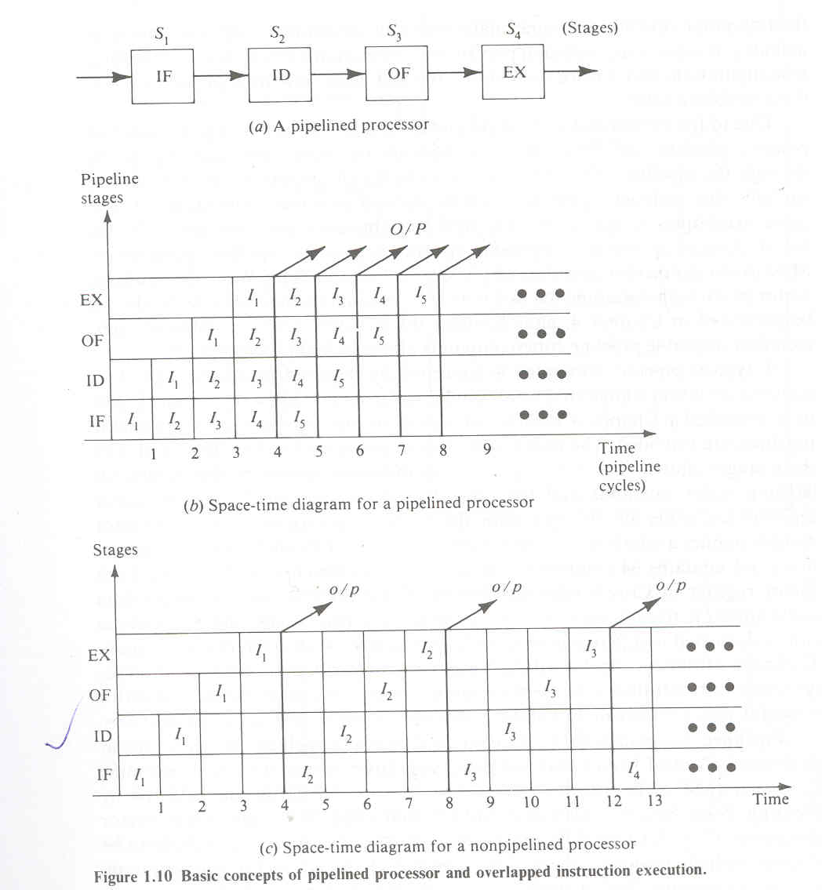

Computer-related pipelines include:
Instruction pipelines, such as the classic RISC pipeline, which are used in processors to allow the parallel execution of two or more consecutive instructions from a nominally sequential stream; the processing elements are the logical circuits that implement the various stages of an instruction (address decoding and arithmetic, register fetching, cache lookup, etc.).
Graphics pipelines, found in most graphics cards, which consist of multiple arithmetic units, or complete CPUs, that implement the various stages of common rendering operations (perspective projection, window clipping, color and light calculation, rendering, etc.).
Software pipelines, consisting of multiple processes arranged so that the output stream of one process is automatically and promptly fed as the input stream of the next one. Unix pipelines are the classical implementation of this concept
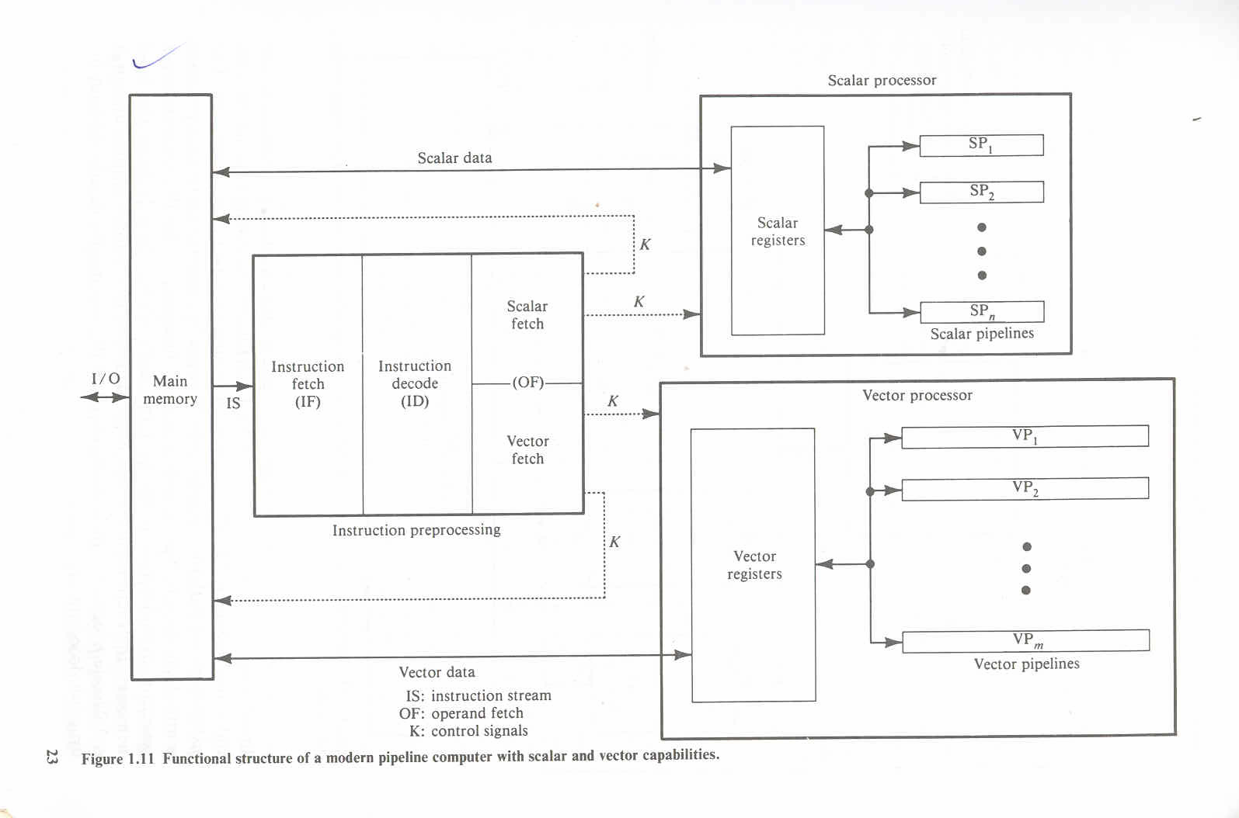

5.2) Array Processors

A computer, or extension to its arithmetic unit, that is capable of performing simultaneous computations on elements of an array of data in some number of dimensions. Common uses include analysis of fluid dynamics and rotation of 3D objects as well as data retrieval, in which elements in a database are scanned simultaneously.

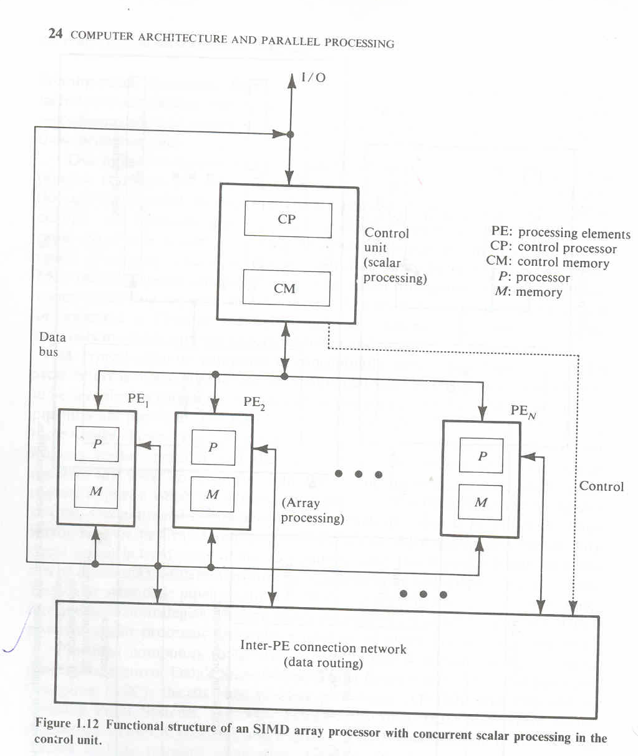

5.3) Multiprocessor systems

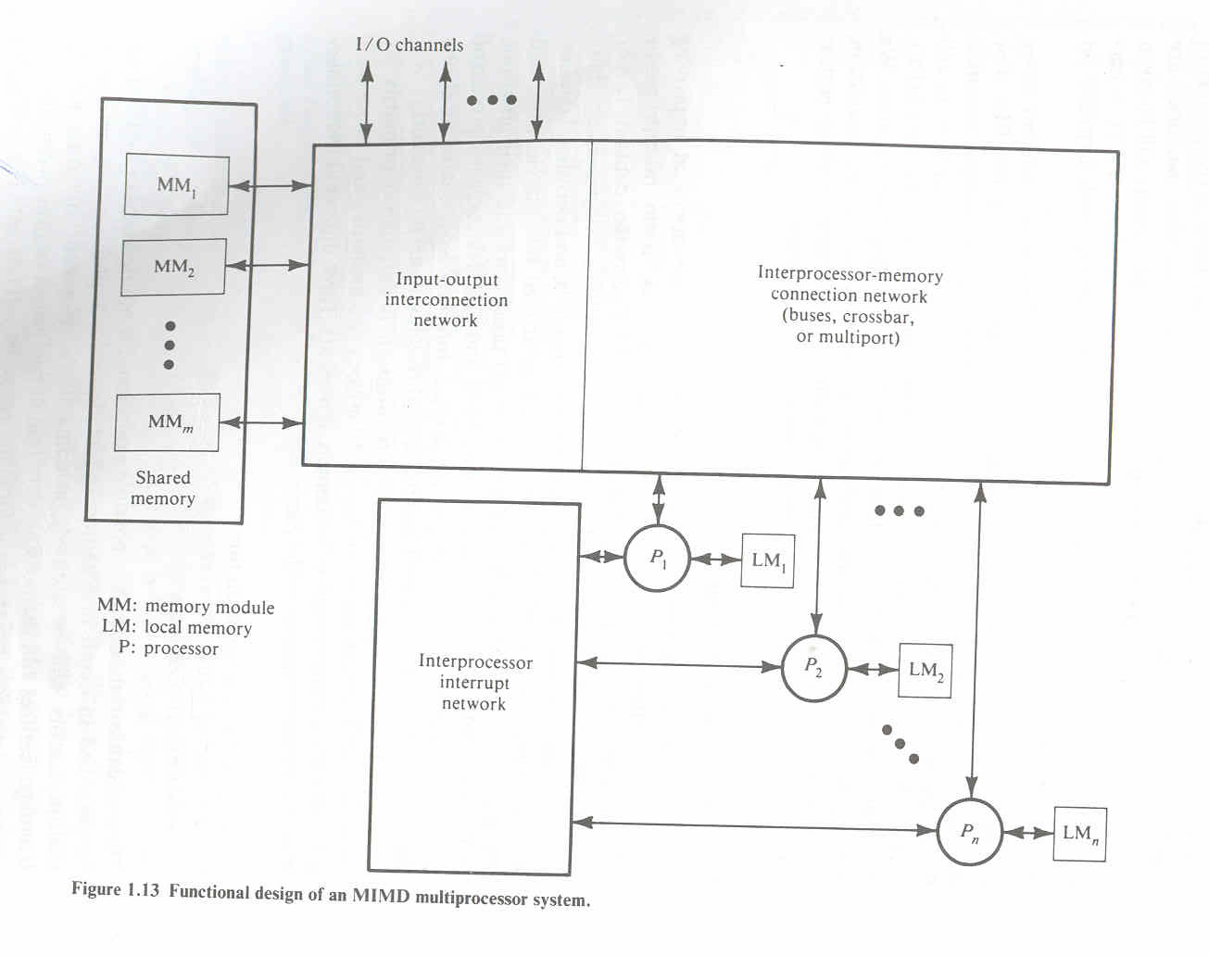

A multiprocessor system contains two or more processors of approximately comparable capabilities. All processors share access to common sets of memory modules, I/O channels and peripheral devices. Besides the shared memories and I/O devices each processor has its own local memory and private devices.Interprocessor communications can be done through the shared memories .Multiprocessor hardware system organization is determined primarily by the interconnection structure to be used between the memories and processors.

Architecture classification schemes

Three computer architectural classification schemes are presented here. Flynn’s classification is based on the multiplicity of instruction streams and data streams in a computer system.Feng’s scheme is based on serial versus parallel processing. Handler’s classification is determined by the degree of parallelism and pipelining in various subsystem levels.

Multiplicity of Instruction-Data streams

Digital computers may be classified in to 4 categories, according to the multiplicity of instruction and data streams. This scheme for classifying computer organizations was introduced by Michael J Flynn. The essential computing process is the execution of a sequence of instructions on a set of data. An instruction stream is a sequence of instructions as executed by the machine; a data stream is a sequence of data including input, partial, or temporary results, called for by the instruction team

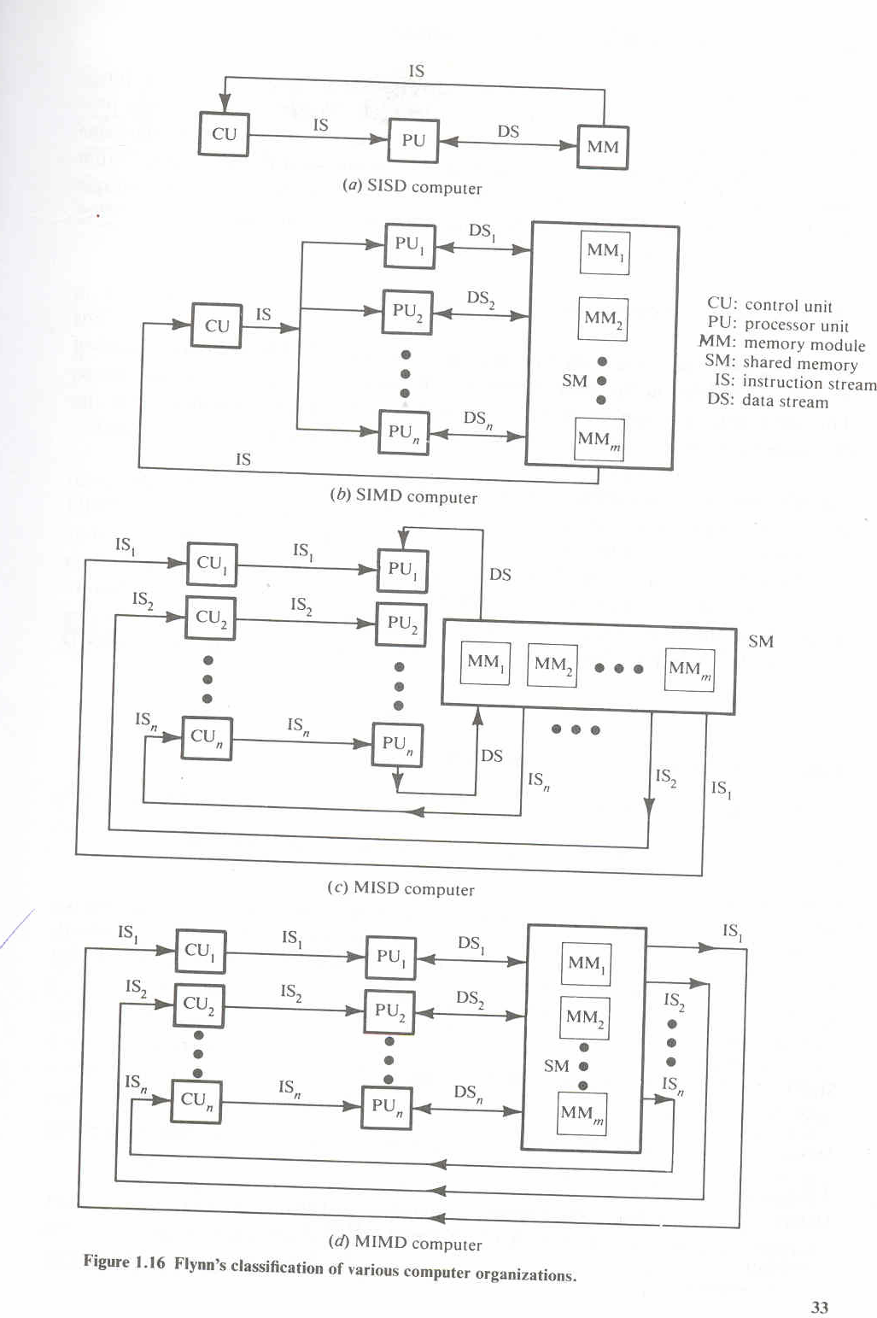

5.2) SISD computer organization

This organization represents most serial computers available today. Instructions are executed sequentially but may be overlapped in their execution stages. Most SISD uniprocesor systems are pipelined. An SISD computer may have more than one functional unit in it. All the functional units are under supervision of one control unit.

5.3) SIMD computer organization

This corresponds to array processors. Here multiple processing elements supervised by the same control unit. All PEs receive the same instruction broadcast from the control unit but operate on different data sets from distinct data streams.

5.4) MISD computer organization

There are n processor units, each receiving distinct instructions operating over the same data stream and its derivatives. The results of one processor become the input of the next processor in the macropipe.This structure has received much less attention and has been challenged as impractical by some computer architects.

5.5) MIMD computer organization
Most multiprocessor systems and multiple computer systems can be classified in this category. An intrinsic MIMD computer implies interactions among the n processors because all memory streams are derived from the same data space shared by all processors. If the n data streams were derived from disjointed subspaces of the shared memories, then we would have the so called multiple SISD operation, which is nothing but a set of n independent SISD uniprocesor systems.

5.6) Serial Versus Parallel Processing

The maximum number of binary digits that can be processed within a unit time by a computer system is called the maximum parallelism degree P.The maximum parallelism degree P(C)of a given computer system C is represented by the product of the word length n and the bit slice length m;that is p(c)=n.m

There are 4 types of processing methods.

- WSBS
- WPBS
- WSBP
- WPBP

WSBS has been called bit serial processing because one bit (n=m=1) is processed at a time, a rather slow process. This was done only in the first generation computers.WPBS (n=1, m>1) has been called bis processing because an m bit slice is processed at a time.WSBP (n>1.m=1) as found in most existing computers, has been called word slice processing because one word of n bits is processed at a time. Finally WPBP (n>1,m>1)is known as fully parallel processing, in which an array of n.m bits is processed at one time, the fastest processing mode of the four.

5.8) Parallelism versus pipelining

Wolfgang Handler has proposed a classification scheme for identifying the parallelism degree and pipelining degree built into the hardware structures of a computer system. He considers parallel pipeline processing at three subsystem levels

Processor Control unit (PCU)
Arithmetic logic unit (ALU)
Bit level circuit (BLC)

Indian contributions to parallel processing

.

India has made significant strides in developing high-performance parallel computers.
Many Indians feel that the presence of these systems has helped create a high-performance computing culture in India, and has brought down the cost of equivalent international machines in the Indian marketplace. However,questions remain about the cost-effectiveness of the government funding for these systems, and about their commercial viability

India’s government decided to support the development of indigenous parallel
processing technology. In August 1988 it set up the Center for Development of Advanced Computing (C-DAC).

The C-DAC’s First Mission was to deliver a 1 -Gflop parallel supercomputer by 1991.
Simultaneously, the Bhabha Atomic Research Center (BARC), the Advanced Numerical
Research & Analysis Group (Anurag) of the Defense Research and Development
Organization, the National Aerospace Laboratory WAL) of the Council of Scientific
and Industrial Research, and the Center for Development of Telematics (C-DOT) initiated complementary projects to develop high-performance parallel computers. Delivery of India’s firstgeneration parallel computers started in 199 1.

Param

The C-DAC’s computers are named Pairam (parallel machine), which means “supreme” in Sanskrit. The first Param systems, called the 8000 series, used Innios 800 and 805 Transputers as computing nodes.Although the theoretical peak-performance of a 256-node Param was 1 Gflop (a singlenode T805 performs at 4.25 Mflops), its sustained
performance in an actual application turned out to be between 100 and 200 Mflops.
The C-DAC named the programming environment Pavas, after the mythical stone that
can turn iron into gold by mere touch.

Early in 1992, the C-DAC realized that the Param 8000’s basic compute node was underpowered, so it integrated Intel’s i860 chip into the Param architecture. The objective
was to preserve the same application programming environment and provide
straightforward hardware upgrades by just replacing the Param 8000’s compute-
node boards. This resulted in the Param 8600, an architecture with the i860 as a main processor and four Transputers as communication processors, each with four built-in links. The CDAC extended Paras to the Param 8600 to give a user view identical to that of the Param 8000. Param 8000 applications could easily port to the new machine.
The C-DAC claimed that the sustained performance of the 16-node Param 8600
ranged from 100 to 200 Mflops, depending on the application. Both the C-DAC and the Indian government considered that the First Mission was accomplished and embarked on the Second Wssion, to deliver a teraflopsrange parallel system capable of addressing
grand challenge problems. This machine, the Param 9000, was announced
in 1994 and exhibited at Supercomputing ’94. The C-DAC plans to scale it to teraflops-
level performance.

The Param 9000’s multistage interconnect network uses a packet-switching
wormhole router as the basic switching element. Each switch can establish 32
simultaneous nonblocking connections to provide a sustainable bandwidth of
320 Mbytes per second. The communication links conform to the IEEE P13 55
standards for point-to-point links. The Param 9000 architecture emphasizes
flexibility. The C-DAC hopes that, as new technologies in processors, memory,
and communication links become available, those elements can be upgraded
in the field. The first system is the Param 9000/SS, which is based on
SuperSparc processors. A complete node is a 75-MHz Supersparc I1 processor
with 1 Mbyte of external cache, 16 to 12 8 Mbytes of memory, one to four communication links, and related I/O devices. When new MBus modules with
higher frequencies become available, the computers can be field-upgraded. Users
can integrate Sparc workstations into the Param 9000/SS by adding an Sbus-based
network interface card. Each card supports one, two, or four communication
links. The C-DAC also provides the necessary software drivers.

Anupam

The BARC, founded by Homi Bhabha and located in Bombay, is India’s major
center for nuclear science and is at the forefront of India’s Atomic Energy Program.
Through 1991 and 1992, BARC computer facility members started interacting
with the C-DAC to develop a high-performance computing facility.
The BARC estimated that it needed a machine of 200 Mflops sustained computing
power to solve its problems. Because of the importance of the BARC’s program, it decided to build its own parallel computer. In 1992, the BARC developed the
Anupam (Sanskrit for “unparalleled”) computer, based on the standard Multibus
I1 i860 hardware. Initially, it announced an eight-node machine, which it expanded to 16, 24, and 32 nodes. Subsequently, the BARC transferred Anupam to the Electronics Corporation of India, which manufactures electronic systems under the umbrella
of India’s Department of Atomic Energy.
SYSTEMA RCHITECTURE

Anupam has a multiple-instruction, multiple- data (MIMD) architecture realized
through off-the-shelf Multibus I1 i860 cards and crates. Each node is a 64-bit
i860 processor with a 64-Kbyte cache and a local memory of 16 to 64 Mbytes.
A node’s peak computing power is 100 Mflops, although the sustained power is
much less. The first version of the machine had eight nodes in a single cluster
(or Multibus I1 crate). There is no need for a separate host. Anupam scales to 64 nodes. The intercluster message-passing bus is a 32-bit Multibus II backplane bus operating at 40 Mbytesls peak. Eight nodes in a cluster share this bus. Communication between
clusters travels through two 16-bit-wide SCSI buses that form a 2D mesh. Standard
topologies such as a mesh, ring, or hypercube can easily map to the mesh.

PACE

Anurag, located in Hyderabad, focuses on R&D in parallel computing; VLSIs;
and applications of high-performance computing in computational fluid
dynamics, medical imaging, and other areas. Anurag has developed the Proces-
SOT for Aevodynamzc Computations and Evaluatzon, a loosely-coupled, messagepassing parallel processing system. The PACE program began in August
1988. The initial prototypes used the 16.67-MHz Motorola MC 68020 processor.
The first prototype had four nodes and used a VME bus for communication.
The VME backplane works well with Motorola processors and provided the necessary bandwidth and operational flexibility. Later, Anurag developed an eight-node prototype
based on the 2s-MHz MC 68030. This cluster forms the backbone of the PACE architecture. The 128-node prototype is based on the 33-MHz MC 68030. To enhance the
floating-point speed, Anurag has developed a floating-point processor, Anuco. The processor board has been specially designed to accommodate the MC 68881, MC 68882, or the Anuco floating-point accelerators. PACE+, the latest version, uses a 66-
MHz HyperSparc node. The memory per node can expand to 256 MBytes.

FLOSOLVER

In 1986, the NAL, located in Bangalore, started a project to design, develop, and
fabricate suitable parallel processing systems to solve fluid dynamics and aerodynamics
problems The project was motivated by the need for a powerful computer in the laboratory and was influenced by similar international developments
Florolver, the NAL’s parallel computer, was the first operational Indian
parallel computer. Since then, the NAL has built a series of updated versions,
including Flosolver Mkl and MklA, four-processor systems based on 16-bit
Intel 8086 and 8087 processors, Flosolver MklB, an eight-processor system,
Flosolver Mk2, based on Intel’s 32-bit 80386 and 80387 processors, and the latest
version, Flosolver Mk3, based on Intel’s 1860 RISC processor.

Chipps

The Indian government launched the CDOT to develop indigenous digital
switching technology. The C-DOT, located in Bangalore, completed its First
Mission in 1989 by delivering technologies for rural exchanges and secondary
switching areas. In February 1988, the C-DOT signed a contract with the
Department of Science and Technology to design and build a 640-Mflop, 1,000-
MIPS-peak parallel computer. The CDOT set a target of 200 Mflops for sustained
performance.

SYSTEM ARCHITECTURE

C-DOTS High Perfomance Parallel Processing System (Chipps) is based on the
single-algorithm, multiple-data architecture. Such an architecture provides
coarse-grain parallelism with barrier synchronization, and uniform startup
and simultaneous data distribution across all configurations. It also employs
off-the-shelf hardware and software. Chipps supports large, medium, and
small applications. The system has three versions: a 192-node, a 64-node, and a
16-node machine.

In terms of performance and software support, the Indian high-performance
computers hardly compare to the best commercial machines. For example, the
C-DAC’s 16-node Param 9000/SS has a peak performance of 0.96 Gflops,
whereas Silicon Graphics’ 16-processor Power Challenge has a peak performance
of 5.96 Gflops, and IBM’s 16- processor Para2 model 590 has a peak
performance of 4.22 Gflops. However, the C-DAC hopes that a future Param
based on DEC Alpha processors will match such performance.

