MODULE 3

S I M D

Traditional Von Neumann machine is SISD - it has one instruction stream, one CPU and one memory.

SIMD machines operate on multiple data sets in parallel.

Typical examples are vector machines and array processors.

SIMD Array Processor

This architecture consists of a square grid of processor/memory elements.

A single control unit broadcasts instructions which are carried out in lockstep by all the processors, each one using its own data from ts own memory. The array processor is well-suited to calculations on matrices.
Single Instruction stream Multiple Data stream) A computer that performs one operation on multiple sets of data. It is typically used to add or multiply eight or more sets of numbers at the same time for multimedia encoding and rendering as well as scientific applications. Hardware registers are loaded with numbers, and the mathematical operation is performed on all registers simultaneously.
SIMD capability was added to the Pentium CPU starting with the Pentium MMX chip and enhanced in subsequent Pentiums .Array processors are machines specialized for SIMD operations.
SIMD Computer organizations
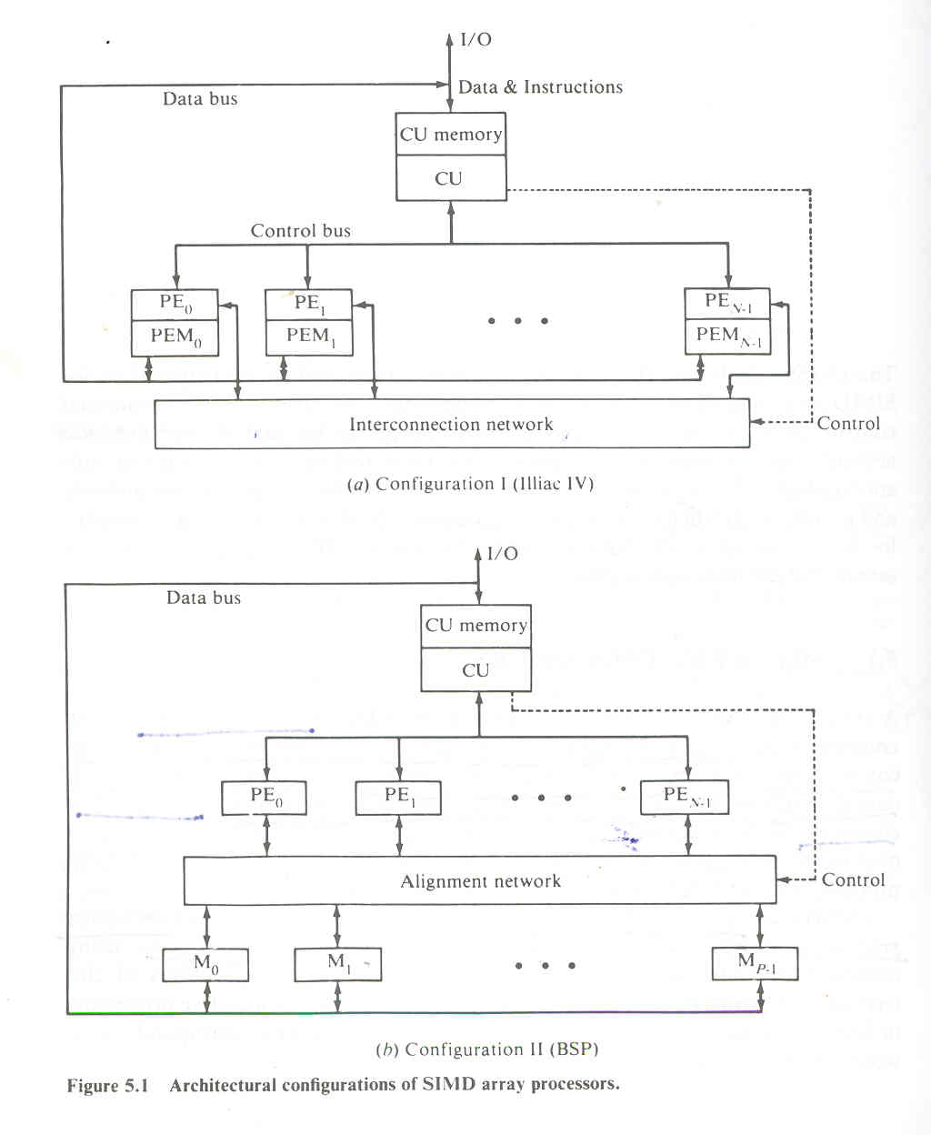

Configuration 1 is structured with N synchronized PEs,all of which are under the control of one CU.Each PE_{i} is essentially an ALU with attached working registers and local memory PEM_{i} for the storage of distributed data.The CU also has its own main memory for storage of programs.The function of CU is to decode all instruction and determine where the decoded instructions should be executed.Scalar or control type instructions are directly executed inside the CU.Vector instructions are broadcasted to the PEs for distributed execution.
Configuration II differs from configuration I in two aspects.First the local memries attached to the PEs are replaced by parallel memory modules shared by all the PEs through an aliognment network.Second the inter PE permutation network is replaced by inter PE memory alignment network.A good example of configuration II SIMD machine is Burroughs scientific processor.
Formally an SIMD computer is characterized by following set of parameters.
C=<N,F,I,M>
N=Number of PEs in the system.
F=A set of data routing functions.
I=Set of machine instructions
M=Set of masking schemes.
Masking and data routing mechanisms

In an array processor, vector operands can be specified by the registers to be used or by the memory addresses to be referenced. For memory-reference instructions, each PEi accesses the local PEMj, offset by its own index register Ii, The Ii register modifies the global memory address broadcast from the CU. Thus, different locations in different PEMs can be accessed simultaneously with the same global address specified by the CU. The following. example shows how indexing can be used to address the local memories in parallel at different local addresses.
Example 5.1 Consider an array of n x n data elements:
A = {A(i,j),0< i,j < n - I}
Elements in the jth column of A are stored in n consecutive locations of PEM j, say from location 100 to location 100 + n - 1 (assume n < N). If the programmer wishes to access the principal diagonal elements A(j, j) for j = 0, 1. . . n - 1 of the array A, 'then the CU must generate and broadcast an
effective memory addresses 100 (after offset by the global index register I in the CU, if there is a base address of A involved). The local index registers must be set to be I j = j for j = 0, 1, . . . , n - 1 in order to convert the global address 100 to local addresses 100 + I j = 100 + j for each PEMj' Within each PE, there should be a separate memory address register for holding these local addresses. However, if one wishes to address a row of the array A, say the ith row A(i, j) for j = 0, 1, 2, . . . , n - 1, all the I j registers will be reset to be for allj = 0,1,2,..., n - 1 in order to ensure the parallel access of the entire row.

Example 5.2 To illustrate the necessity of data routing in an array processor, we show the execution details of the following vector instruction in an array of N PEs. The sum S(k) of the first k components in a vector A is desired for each k from 0 to n - I. Let A = (Ao,A1….. ,An-I)We need to compute the following n summations:
S(k) = i Ai for k = 0, 1, . . ., n - 1

These n vector summations can be computed recursively by going through the \ following n - 1 iterations defined by: .
S(O) = Ao
S(k) = S(k - 1) + Ak for k = 1,2, . . ., n - 1 (5.4)

The above recursive summations for the case of n = 8 are implemented in an array processor with N = 8 PEs in log₂ n = 3 steps.. Both data routing and PE masking are used in the implementation. Initially, each Ai, residing in PEMi, is moved to the Ri register in PEi for i = 0, 1. . . n - 1 (n = N = 8 is assumed here). In the first step, Ai is routed from Rj to Rj+ 1 and added to Ai+ 1 with the resulting sum Ai + Ai+ 1 in Ri+ l for i = 0, 1, . . . , 6. The arrows in Figure 5.3 show the routing operations and the shorthand notation i - j is used to refer to the intermediate sum A_{i} + A_{i+ 1} + .. . + Aj. In step 2, the intermediate sums in Ri are routed to Ri+2 for i = 0 to 5. In the final step, the intermediate sums in Ri are routed to Ri+4 for i = 0 to 3. Consequently, PE. has the final value of S(k) for k =0, 1,2, ...,7.

As far as the data-routing operations are concerned, PE7 is not involved (receiving but not transmitting) in step 1. PE7 and PE6 are not involved in step 2. Also PE7, PE6, PE5, and PE4 are not involved in step 3. These un- wanted PEs are masked off during the corresponding steps. During the addition operations, PE0 is disabled in step 1; PE0 and PEl are made inactive in step 2; and PE0, PEl, PE2, and PE3 are masked off in step 3. The PEs that are masked off in each step depend on the operation (data-routing or arith- metic-addition) to be performed. Therefore, the masking patterns keep changing in the different operation cycles, as demonstrated by the example. Note that the masking and routing operations will be much more complicated when the vector length n > N.
Array processors are special-purpose computers for limited scientific applica tions. The array of PEs are passive arithmetic units waiting to be called for parallel-computation duties. The permutation network among PEs is under program control from the CU. However, the principles of PE masking, global versus local indexing, and data permutation are not much changed in the different machines.

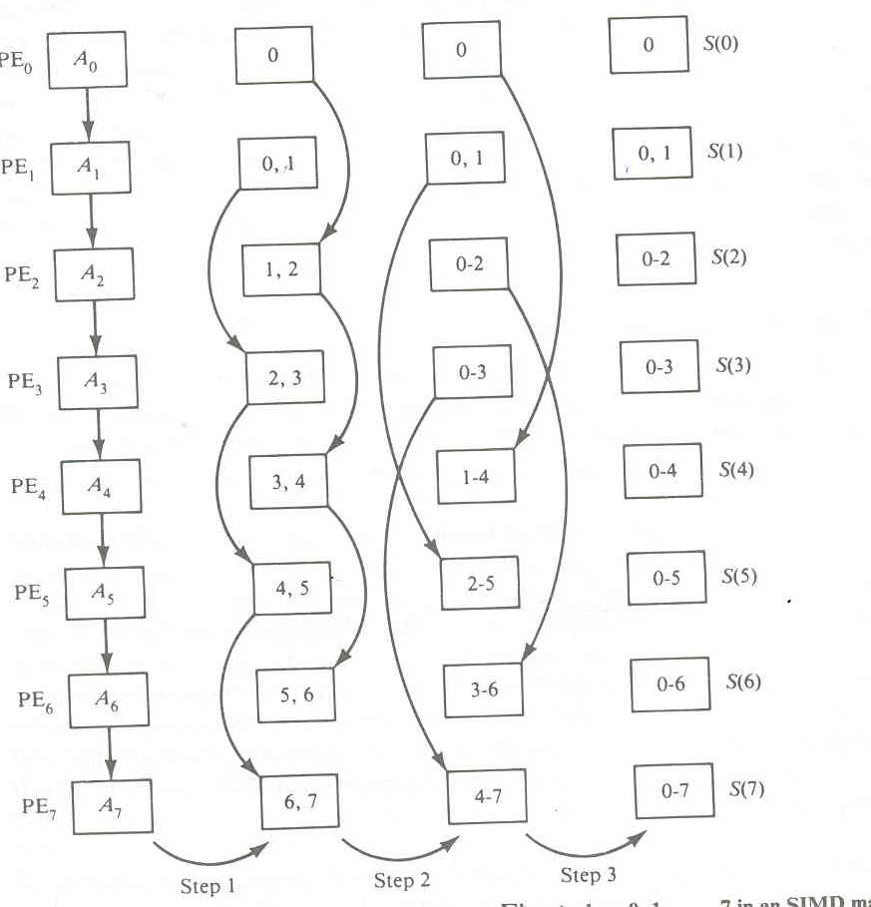

Inter PE communications

There are fundamental decisions in designing appropriate architecture of an interconnection network for an SIMD machine. The decisions are made between operation modes, control strategies, switching methodologies, and network topologies.

Operation Mode:

The types of communication can be identified :Synchronous and asunchronous.

Control strategy:

The control setting fumctions can be managed by a centralized controller or by individual switching element.The later strategy is called distributed controland the first strategy corresponds to centralized control.

Switching Methodology:

The two major switching methodologies are circuit switching and packet switching.

Network topology:

The topologies can be grouped into two categories:static and dynamic.In static topology dedicated buses cannot be reconfigured.But links in dynamic category can be reconfigured.

SIMD Interconnection Networks

Various interconnection networks have been suggested for SIMD computers. The classification includes static versus dynamic networks, Mesh-connected Illiac network, Cube interconnection networks, Barrel shifter and data manipulator, Shuffle exchange and omega networks. Here we will discuss the first three networks.

Static versus dynamic networks

The topological structure of an array processor is mainly characterized by the data routing network used in interconnecting the processing elements.Such network can be specified by a set of data routing functions.

Static networks

Topologies in static network can be classified according to the dimensions required for layout. Examples for one dimensional topologies include linear array.Two dimensional topology include ring, star, tree, mesh, and systolic array. Three dimensional topologies include completely connected chordal ring, 3 cube, and 3 cube connected cycle networks.

Dynamic networks

Two classes of dynamic networks are there. Single stage versus multistage.

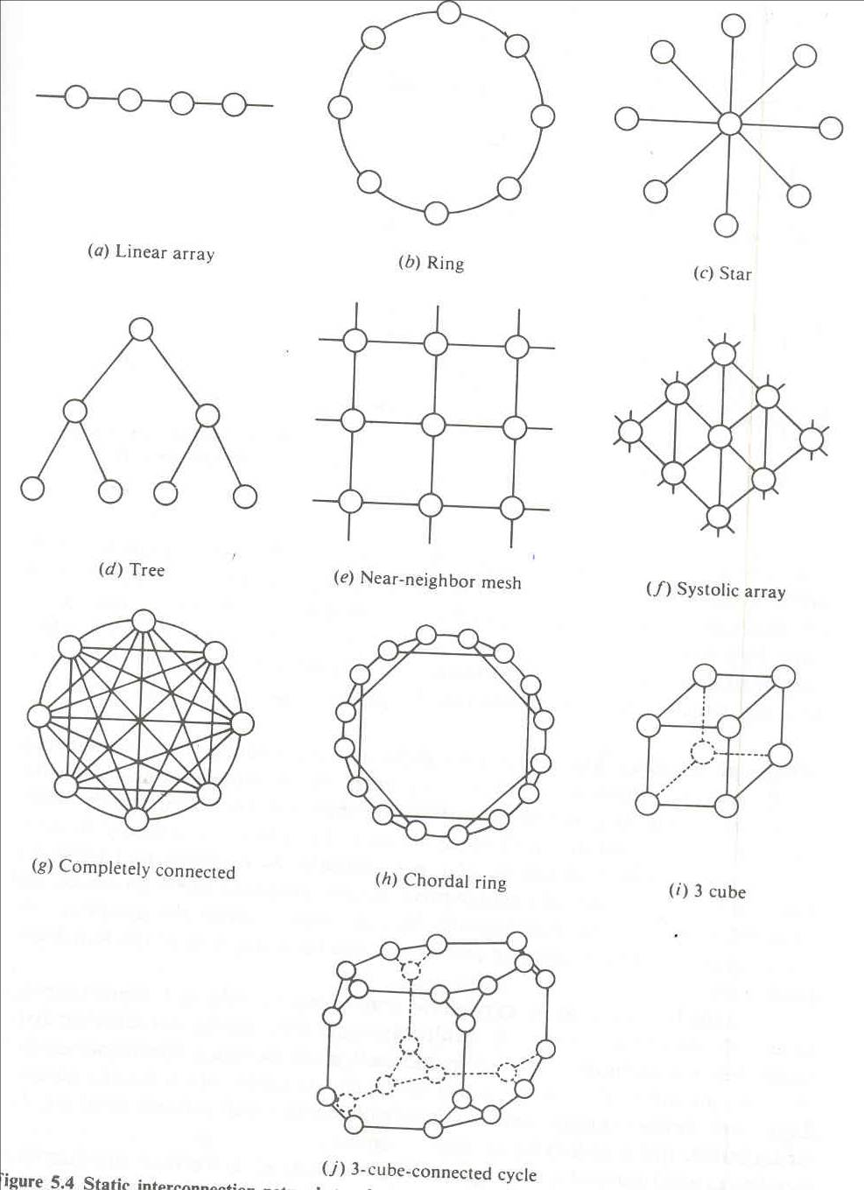

Single stage networks

A single stage network is a switching network with N input selectors (IS) and N output selectors (OS).Each IS is essentially a 1 to D demultiplexer and each OS is an M to 1 multiplexer where 1<D<N and 1<M<N.A single stage network with D=M=N is a crossbar switching network. To establish a desired connecting path different path control signals will be applied to all IS and OS selectors.

A single stage network is also called a reciculating network. Data items may have to reirculate through the single stage several times before reaching the final destination.The number of recirculations needed depend on the connectivity in the single stage network.In general,higher is the hardware connectivity,the less is the number of recirculations.

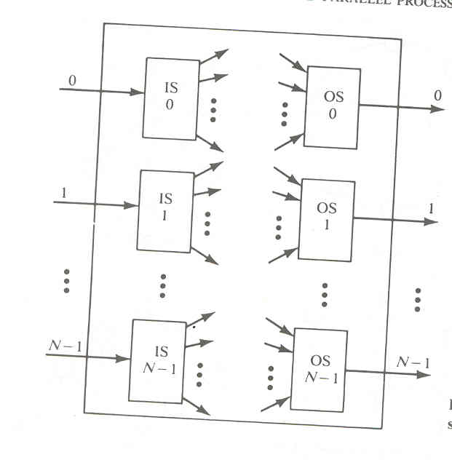
Multi stage networks

Many stages of an interconnected switch form the multistage network.They are described by three characterizing features :switch box,network topology and control structure.Many switch boxes are used in multistage networksEach box is essentially an interchange device with two inputs and outputs.The four states of a switch box are :straight,exchange,upper broadcast and lower broadcast.

Mesh-Connected Illiac Network

A single stage recirculating network has been implemented in the Illiac IV array processor with 64 PEs.Each PE_{i} is allowed to send data to PE _{I+1},PE _{i-1},PE,_{i+r} PE_{i-r} where r=√N.

Formally Illiac network is characterized by following four routing functions.

R₊₁(i)=(i+1)mod N
R₋₁(i)=(i-1)mod N

R_{+r}(i)=(i+r)mod N

R_{-r}(i)=(i-r)mod N

A reduced Illiac network is illustrated in Fig with N=16 and r=4.

R₊₁=(0 1 2 ……N-1)

R₋₁=(N-1………2 1 0)

R₊₄=(0 4 8 12)(1 5 9 13)(2 6 10 14 )(3 7 11 15)

R₋₄=(12 8 4 0)(13 9 5 1)(14 10 6 2 )(15 11 7 3)

This fig shows four PEs can be reached from any PE in one step,seven PEs in two steps,and eleven PEs in three steps.In general it take I steps to route data from PE_{i} to any other PE_{j} in an Illiac network of size N where I is upper bouded by I< √N-1

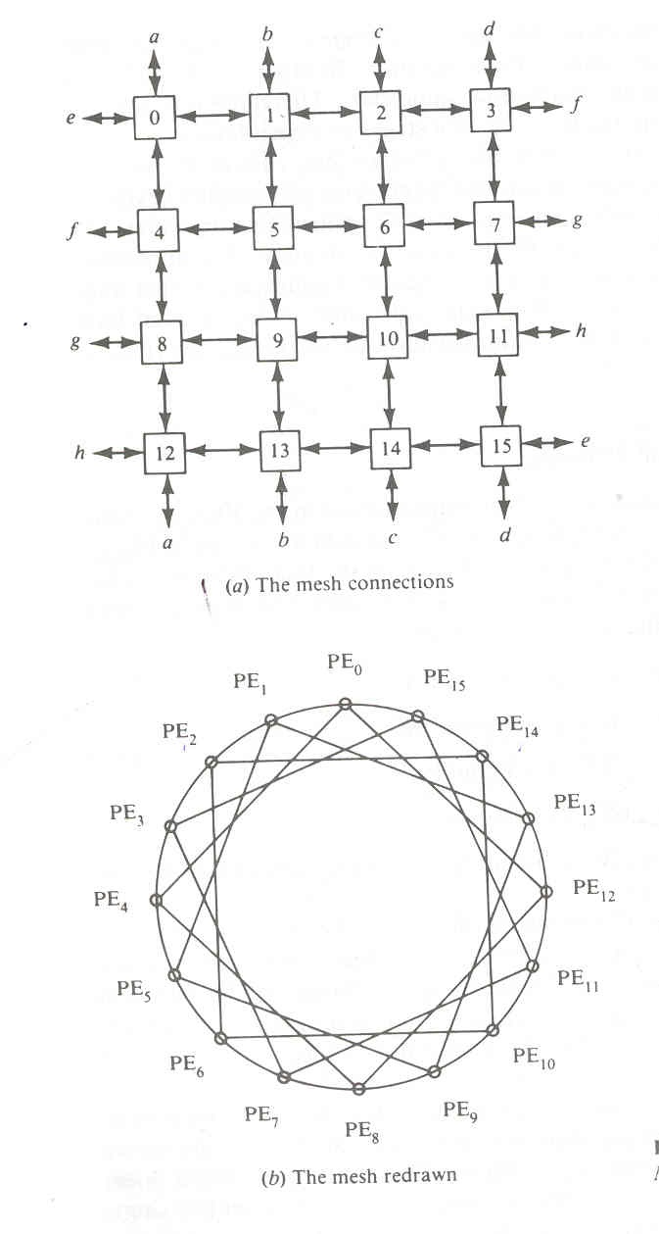

Cube Interconnection Networks
The cube network can be implemented as multi stage network for SIMD machines.Formally an n dimensional network of N pes is specified by following n routing functions. Vertical lines connect vertices whose address differ in the most significant bit position.Vertices at both ends of the diagonal lines differ in the middle bit position.Horizontal lines differ in the least significant bit position.
─
C_{i}(a_{n-1……}a_{i+1}a_{i} a_{i-1………..}a₀) for i=0,1,2……..n-1.

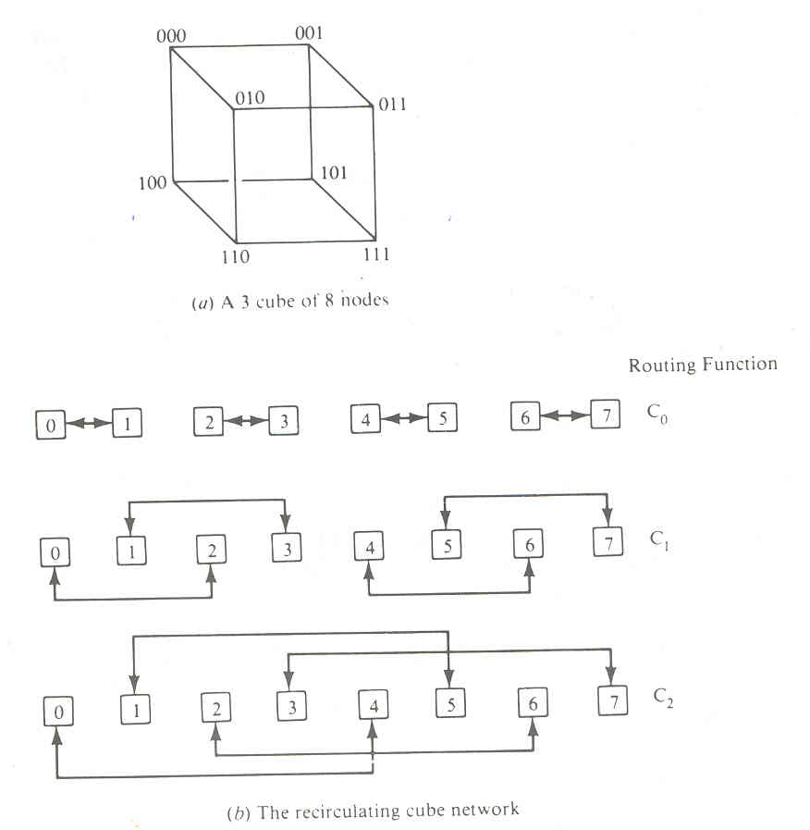

PARALLEL ALGORITHMS FOR ARRAY PROCESSORS
The original motivation for developing SIMD array processors was to perform parallel computations on vector or matrix types of data. Parallel processing algorithms have been developed by many computer scientists for SIMD computers. Important SIMD algorithms can be used to perform matrix multiplication, fast Fourier transform (FFT), matrix transposition, summation of vector elements, matrix inversion, parallel sorting, linear recurrence, boolean matrix operations, and to solve partial differential equations. We study below several representative SIMD algorithms for matrix multiplication, parallel sorting, and parallel FFT. We shall analyze the speedups of these parallel algorithms over the sequential algorithms on SISD computers. The implementation of these parallel algorithms on SIMD machines is described by concurrent ALGOL. The physical memory allocations and program implementation depend on the specific architecture of a given SIMD machine.
SIMD Matrix Multiplication
Many numerical problems suitable for parallprocessing can be formulated as matrix computations. Matrix manipulation is frequently needed in solving linear systems of equations. Important matrix operations include matrix multiplication, L-U decomposition, and matrix inversion. We present below two parallel algo- rithms for matrix multiplication. The differences between SISD and SIMD matrix algorithms are pointed out in their program structures and speed performances. In general, the inner loop of a multilevel SISD program can be replaced by one or more SIMD vector instructions.
Let A = [a_{ik}] and B = [b_{kJ} ]be n x n matrices. The multiplication of A and B generates a product matrix C = A x B = [C_{ij}] of dimension n x n. The elements of the product matrix C is related to the elements of A and B by:
Cij₌∑a_{ik} x b_{kj (5.22)}
There are n³ cumulative multiplications to be performed in Eq. 5.22. A cumulative multiplication refers to the linked multiply-add operation c= c + a x b. The addition is merged into the multiplication because the multiply is equivalent to multioperand addition. Therefore, we can consider the unit time as the time required to perform one cumulative multiplication, since add and multiply are performed simultaneously.
In a conventional SISD uniprocessor system, the n3 cumulative multiplications are carried out by a serially coded program with three levels of DO loops corresponding to three indices to be used. The time complexity of this sequential program is proportional to n3, as specified in the following SISD algorithm for matrix multiplication.

An O(n3) algorithm for SISD matrix multiplication
For i = I to n Do
For j = I to n Do
Cij = 0 (initialization)
For k = I to n Do
C_{ij}=C_{ij}+a_{ik b}ij (scalar additive multiply)

End of k loop
End of j loop
End of i loop
Now, we want to implement the matrix multiplication on an SIMD computer with n PEs. The algorithm construct depends heavily on the memory allocations of the A, B, and C matrices in the PEMs. Column vectors are then stored within the same PEM. This memory allocation scheme allows parallel access of all the elements in each row vector of the matrices. Based in this data -distribution, we obtain the following parallel algorithm. The two parallel do opera tions correspond to vector load for initialization and vector multiply for the inner loop of additive multiplications. The time complexity has been reduced to O(n2).
Therefore, the SIMD algorithm is n times faster than the SISD algorithm for matrix multiplication.
An O(n) algorithm for SIMD matrix multiplication
For i = I to n Do
Par for k = I to n Do
Cik = 0 (rector load)
For j = I to n Do
Par for k = 1 to n Do
Cik = Cik + aij . bjk (vector multiply)
End of j loop
End of i loop
It should be noted that the vector load operation is performed to initialize the row vectors of matrix C one row at a time. In the vector multiply operation, the
same multiplier aij is broadcast from the CU to all PEs to multiply all n elements {b_{ik} for k = 1,2, ..., n} of the ith row vector of B. In total, n2 vector multiply operations are neede in the double loops.

If we increase the number of PEs used in an array processor to n² an O(n log₂n) can be devised to multiply two n xn matrices a and b.Let n=2^{m}.Consider an array processor whose n² =2^{2m}pes are located at the 2^{2m} vertices of a 2m cube network.A 2m cube network can be considered as two (2m-1) cube networks linked together by 2m extra edges. In Figure a 4-cube network is constructed from two 3-cube networks by using 8 extra edges between corresponding vertices at the corner positions. For clarity, we simplify the 4-cube,drawing by showing only one of the eight fourth dimension connections. The remaining connections are implied.

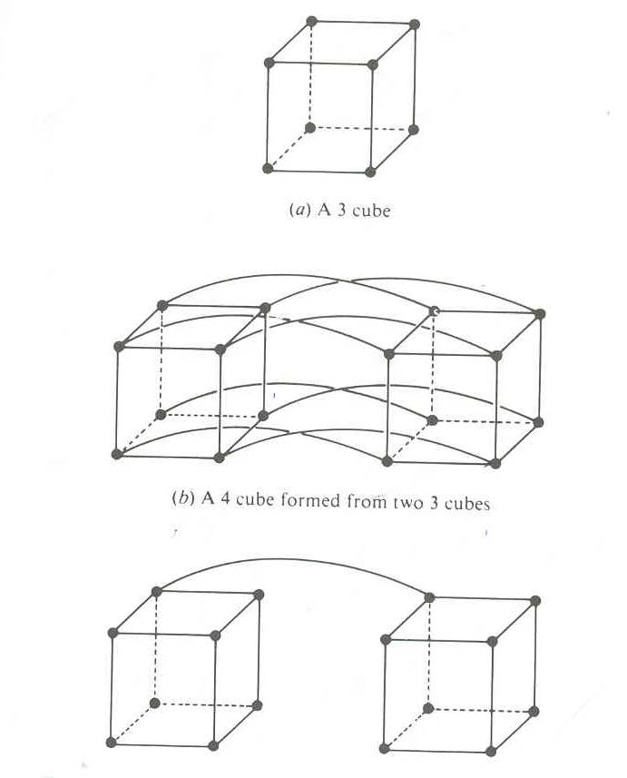

Let (P_{2m-l} P_{2m-2}... P_{m} P_{m-l}. .,P_{I} P_{O})2) be the PE address in the 2m cube. We can achieve the O(n log2 n) compute time only if initially the matrix elements are favorably distributed in the PE vertices. The n rows of matrix A are distributed over n distinct PEs whose addresses satisfy the condition
P2m-lP2m-l...Pm =Pm-lPm-2.
as demonstrated in Figure 5.20a for the initial distribution of four rows of the matrix A in a 4 x 4 matrix multiplication (n = 4, m = 2). The four rows of A are then broadcast over the fourth dimension and front to back edges, as marked by
row numbers in Figure a.

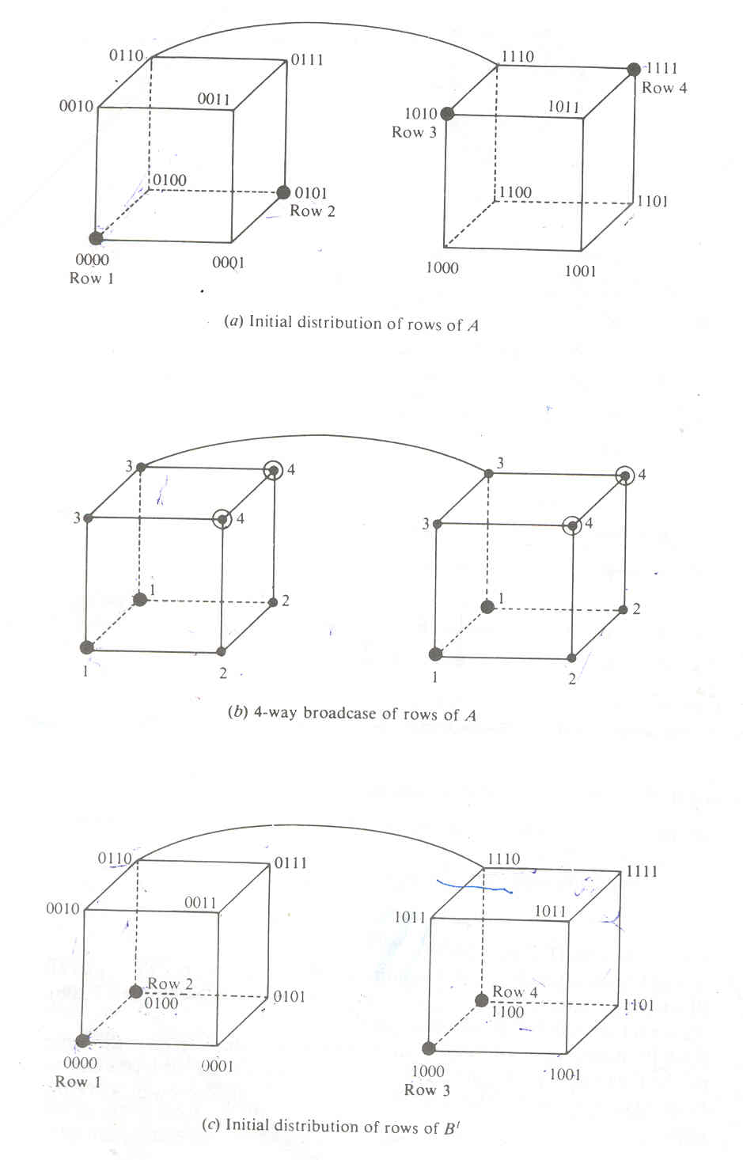
The n columns of matrix B (or the n rows of matrix B') are evenly distributed over the PEs of the 2m cubes, as illustrated in Figure 5.2Oc. The four rows of B' are then broadcast over the front and back faces, as shown in Figure 5.20d. Figure 5.21 shows the combined results of A and B' broadcasts with the inner product ready to be computed. The n-way broadcast depicted in Figure 5.20b and 5.20d
takes log n steps, as illustrated in Figure 5.21 in m = log2 n = log24 = 2 steps.
The matrix multiplication on a 2m-cube network is formally specified below

1.Transpose B to form B^{t over the m cubes x}_{2m-1}…………………._{Xm}0…..0.

2.N-way broadcast each row of B^{t}to all pes in the m cube.

3.N-way broadcast each row of A

4.Each PE now contain a row of A and a column of B.

Parallel Sorting on Array Processors

An SIMD algorithm is to be presented for sorting n² elements on a mesh-connected (llIiac-lV-Iike) processor array in O(n) routing and comparison steps. This shows a speedup of O(log2 n) over the best sorting algorithm, which takes O(n log2 n) steps on a uniprocessor system. We assume an array processor with N = n² identical PEs interconnected by a mesh network similar to llIiac-IV except that the PEs at the perimeter have two or three rather than four neighbors. In other words, there are no wraparound connections in this simplified mesh network.
Eliminating the wraparound connections simplifies the array-sorting algorithm. The time complexity of the array-sorting algorithm would be affected by, at most, a factor of two if the wraparound connections were included.

Two time measures are needed to estimate the time complexity of the parallel sorting algorithm. Let t R be the routing time required to move one item from a PE to one of its neighbors, and tc be the comparison time required for one comparison step. Concurrent data routing is allowed. Up to N comparisons may be performed simultaneously. This means that a comparison-interchange step between two items in adjacent PEs can be done in 2tR + tc time units (route left, compare, and. route right). A mixture of horizontal and vertical comparison interchanges requires at least 4tR + tc time units.

The sorting problem depends on the indexing schemes on the PEs. The PEs may be indexed by a bijection from {1,2,...,n} x {1,2,...,n}to{0,1,...,N-1}, where N = n². The sorting problem can be formulated as the moving of the jth smallest element in the PE array for all j = 0, 1, 2,..., N - 1. Illustrated in Figure are three indexing patterns formed after sorting the given array in part a with respect to three'different ways for indexing the
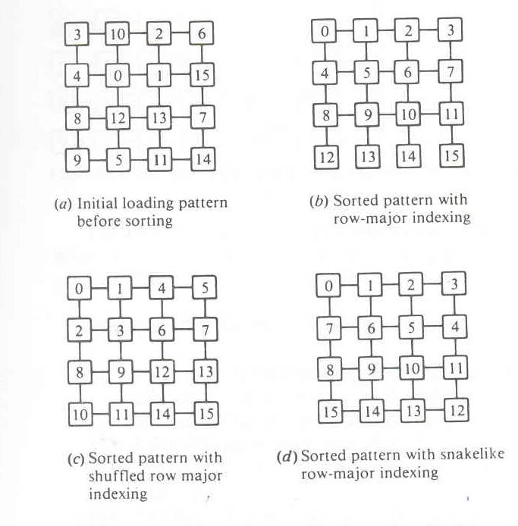

PEs. The pattern in part b corresponds to a row-majored indexing, part c corresponds to a shuffied row-major indexing, and is based on a snake-like row-major indexing. The choice of a particular indexing scheme depends upon how the sorted elements will be used. We are interested in designing sorting algorithms which minimize the total routing and comparison steps.

The longest routing path on the mesh in a sorting process is the transposition of two elements initially loaded at opposite corner PEs, as illustrated in Figure 5.24. This transposition needs at least 4(n - 1) routing steps. This means that no algorithm can sort n² elements in a time of less than O(n). In other words, an O(n) sorting algorithm is considered optimal on a mesh of n² PEs. Let M(j, k) be a sorting algorithm for merging two sorted j-by-k/2 subarrays to form a sorted j-by-k array, where j and k are powers of 2 and k > 1. The snakelike row-major ordering is assumed in all the arrays. In the degenerate case of M(l, 2), a single comparison-interchange step is sufficient to sort two unit subarrays. Given two sorted columns of length j > 2, the M(j, 2) algorithm consists of the following steps:
Example 5.6: The M(j, 2) sorting algorithm
J 1: .Move all odds to the left column and all evens to the right in 2tk time.
J2: Use the odd-even transposition sort to sort each column in 2jtk + jtc time.
J3: Interchange on even row in 2tk time.

J4: Perform one comparison-interchange in 2tk + tc time

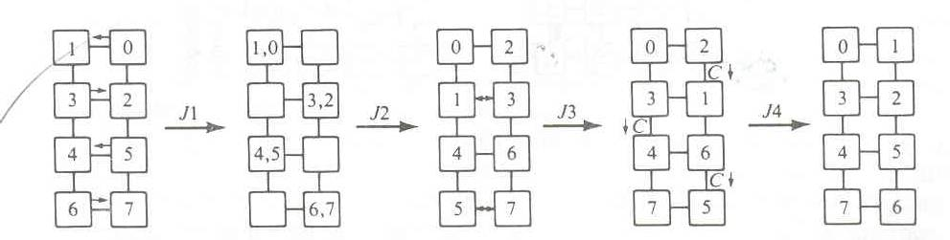

The M(j,k) algorithm

- .Perform single interchange step on even rows
- .Unshuffle each row.
- .Merge by calling algorithm m(j,k/2)
- .Shuffle each row
- .Interchange on even row
- Comparison interchange

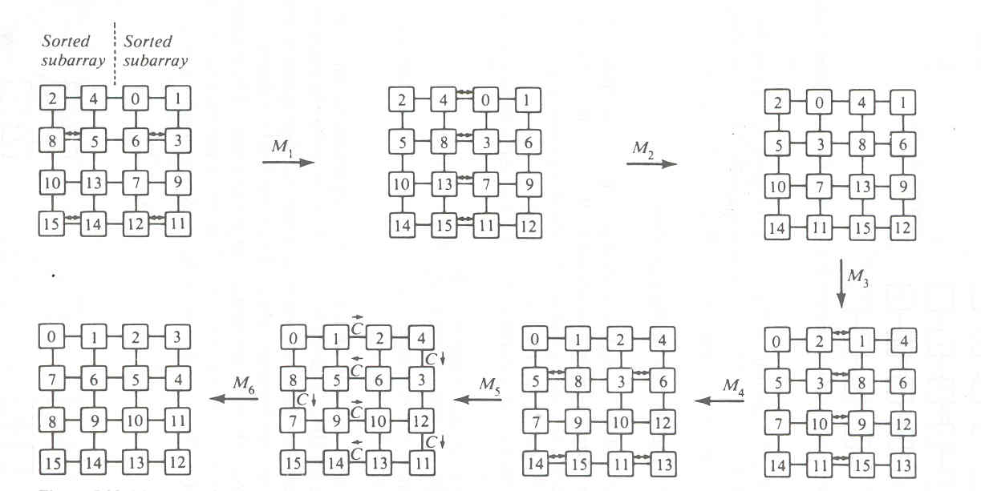

Associative array processing.

In this section, we describe the functional organization of an associative array processor and various parallel processing functions that can be performed on an associative processor. We classify associative processors based on associative- memory organizations. Finally, we identify the major searching applications of associative memories and associative processors. Associative processors have been built only as special-purpose computers for dedicated applications in the past.

Associative Memory Organizations

Data stored in an associative memory are addressed by their contents. In this sense, associative memories have been known as content.-addressable memory.
Parallel search memory and multiaccess memory . The major advantage of assosiative memory over RAM is its capability of performing parallel search and parallel search and parallel comparuison operations. These are frequently needed-in-many-impOrtant applications., such as the storage and retrieval of rapidly changing databases, radar- signal tracking, image processing, computer vision, and artificial intelligence. The major shortcoming of associative memory is its much increased hardware cost. Recently, the cost of associative memory is much Ihigher than that of RAMs.

The structure of AM is modeled in fig.The associatuive memory array consists of n words with mbits per word.Each cell in the array consists of a flip flop associated with some comparison logic gates for pattern match and read write control.A bit slice is a vertical column of bit cells of all the words at the same position.

Each bit cell B_{ij} can be written in,read out,or compared with an external interigating signal.The comparand register C=(C_{1,}C_{2,}…………..C_{m}) is used to hold the key operand being searched for .The masking registerM=(M_{1,}M₂,………..M_{m}) is used to enable the bit slices to be involved in the parallel comparison operations across all the word in the associative memory.

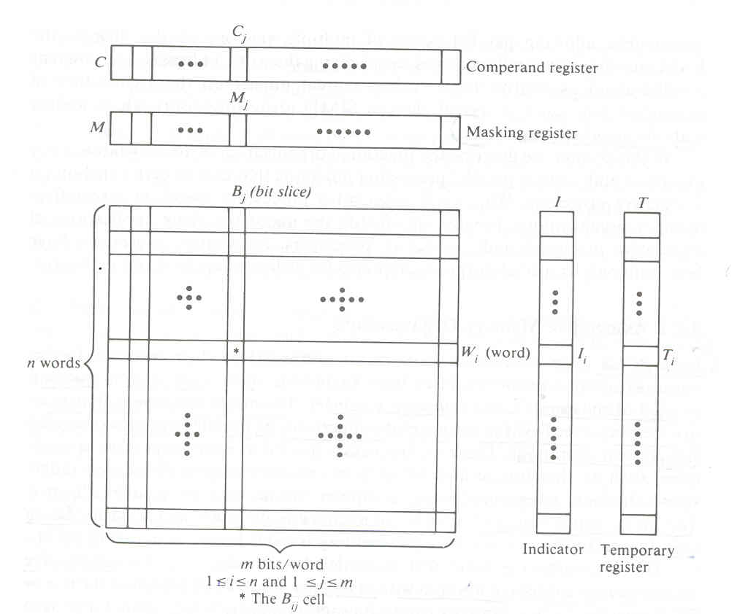

In practice, most associative memories have the capability of word parallel operations; that is, all words in the associative memory array are involved in the parallel search operations. This differs drastically from the word serial operations encountered in RAMs. Based on how bit slices are involved in the operation, we consider below two different associative memory organizations:
The bit parallel organization In a bit parallel organization, the comparison process is performed in a parallel-by-word and parallel-by-bit fashion. All bit slices which are not masked off by the masking pattern are involved in the comparison process. In this organization, word-match tags for all words are used (Figure 5.34a). Each cross point in the array is a bit cell. Essentially, the entire array of cells is involved in a search operation.
Bit serial organization The memory organization in Figure 5.34b operates with one bit slice at a time across all the words. The particular bit slice is selected by an extra logic and control unit. The bit-cell readouts will be used in subsequent bit-slice operations. The associative processor STARAN has. the bit serial memory organization and the PEPE has been installed with the bit parallel organization.
The associative memories are used mainly for search and retrieval of non- numeric information. The bit serial organization requires less hardware but is slower in speed. The bit parallel organization requires additional word-match detection logic but is faster in'speed. We present below an example to illustrate the search operation in a bit parallel associative memory. Bit serial associative memory will be presented in Section 5.4.3 with various associative search and retrieval algorithms.

