Module 4

Multiprocessor Architecture and programming:

Two different sets of architectural models for a multiprocessor are described below: One is tightly coupled multiprocessor and the other is a loosely coupled multiprocessor.

Loosely Coupled Multiprocessor:

Loosely coupled multiprocessor systems do not generally encounter the
degree of memory conflicts experienced by tightly coupled systems. In such systems,
each processor has a set of input-output devices and a large local memory where,it accesses most of the instructions and data. We refer to the processor, its local
memory and I/O interfaces . Processes which execute on , different computer modules communicate by exchanging messages through a message-transfer system (MTS). The degree of coupling in such a system is very loose. Hence, it is often referred to as a distributed system. The determinant factor of ' the degree of coupling is the communication topology of the associated message- transfer system. Loosely coupled systems (LCS) are usually efficient when the interactions between tasks are minimal. Tightly coupled systems (TCS) can tolerate a higher degree of interactions between tasks without significant deteriora- tion in performance. Figure 7.la shows an example of a computer module of a nonhierarchical loosely coupled multiprocessor system. It consists of a processor, a local memory, local input-output devices and an interface to other computer modules. The interface may contain a channel and arbiter switch (CAS). I
Figure 7.1 b illustrates the connection between the computer mbdules and a message-transfer system. If requests from two or more different computer modules collide in accessing a physical segment of the MTS, the arbiter is responsible for choosing one of the simultaneous requests according to a given service discipline. It is also responsible for delaying other requests until the servicing of the selected re- quest is completed. The channel within the CAS may have a high-speed communica- tion memory which is used for buffering block transfers of messages. The com- munication memory is accessible by all processors. With. the advent of VLSI technology, the computer module can be fabricated on a single integrated circuit and be used as the building block of a multiprocessor system.
The message-transfer system for a nonhierarchical LCS could be a simple time shared bus, as in the POP-II, or a shared memory system. The latter case can be implemented with a set of memory modules and a processor-memory interconnection network or a multiported main memory. In a multiported memory system, the arbitration and selection logic of the switch are distributed into the memory modules. The MTS is one of the most important factors that determine the performance of the multiprocessor system. For LCS configurations that use a single time shared bus, the performance is limited by the message arrival rate on the bus, the message length, and the bus capacity (in bits per second).

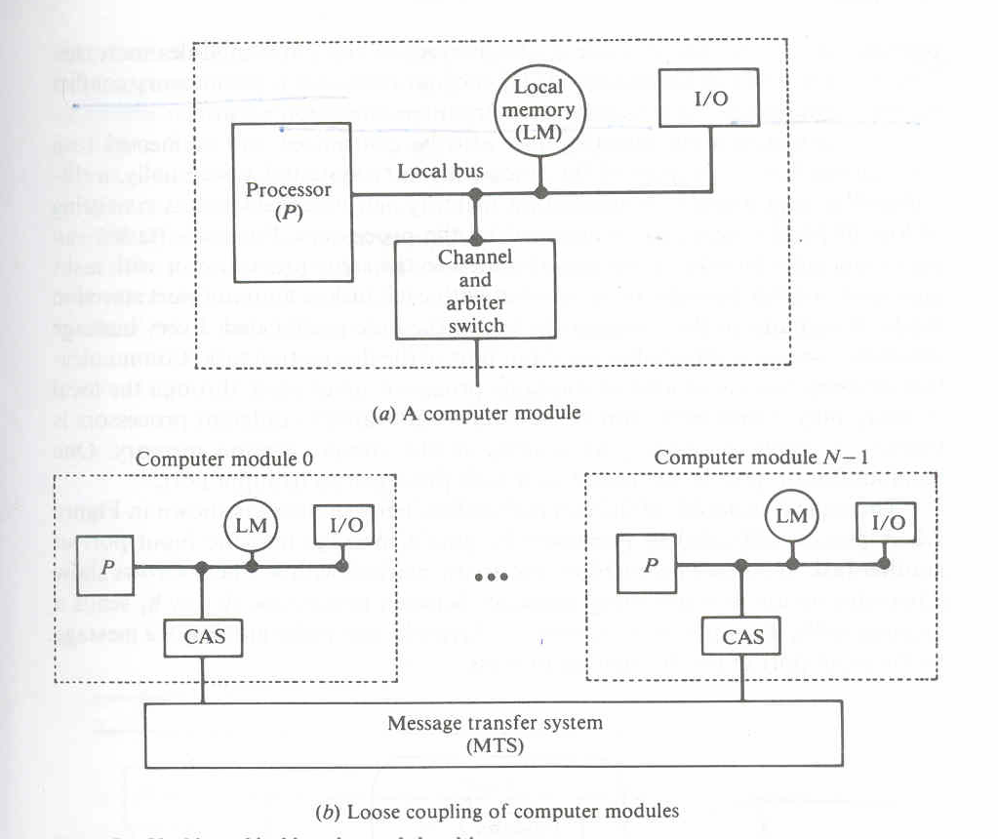

The Cm* architecture

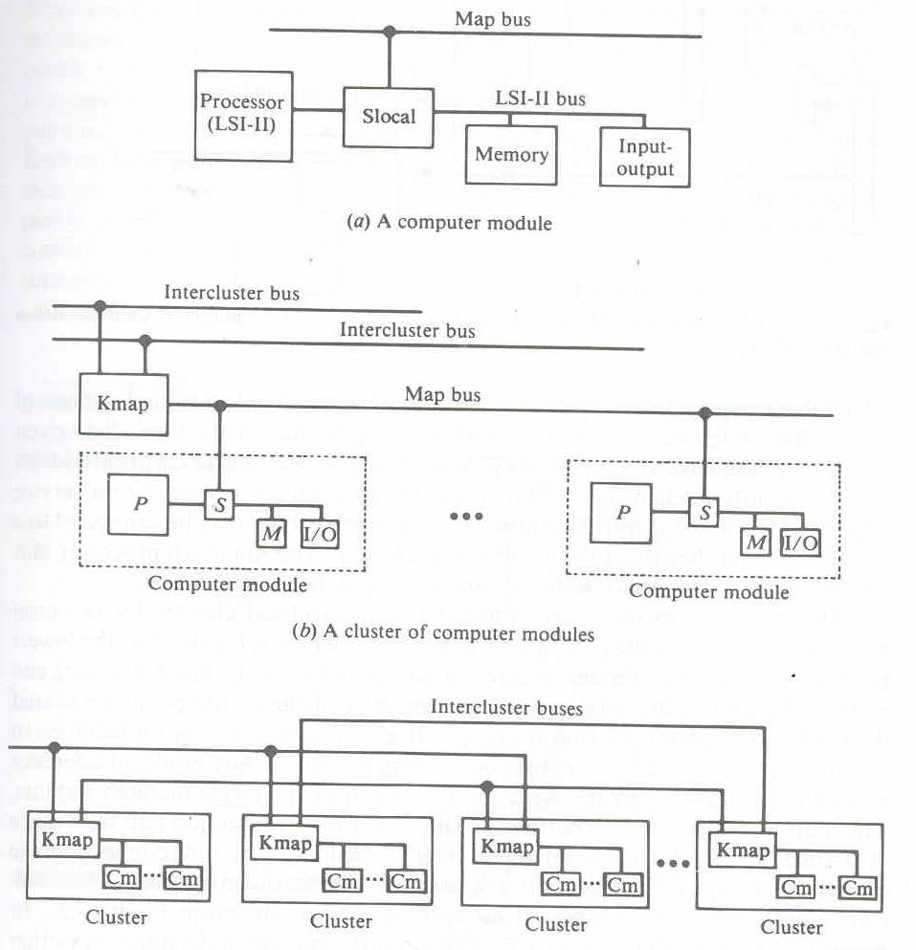

System project at Carnegie Mellon University called the Cm*. Each computer module of the Cm* includes a local switch called the Slocal, as shown in Figure 7.3a. The switch is somewhat similar to the CAS in Figure 7.la. The Slocal intercepts and routes the processor's requests to the memory and I/O devices outside the computer module via a map bus, shown in Figure 7.3b. It also accepts references from other computer modules to its local memory and I/O de- vices. The address translation is shown in Figure 7.4. It uses the four high-order bits of the processor's address along with the current address space, as indicated by the X -bit of the LSI-II processor status word (PSW), to access a mapping table which determines whether the reference is local or nomocal. A virtual address of the nonlocal reference is formed by concatenating the nonlocal address field given by the mapping table and the source processor's identification. This virtual address is subsequently fetched by the Kmap via the map bus in'response to a service request for nonlocal access. A number of computer modules may be connected to a map bus so that they share the use of a single Kmap. The Kmap is a processor that is responsible for mapping addresses and routing data between Slocals.
The computer modules are connected in hierarchical clusters by two-level buses, as shown in Figures 7.3b and 7.3c. A ch,ster, which is regarded as the lowest level. is made up of computer modules, a Kmap and the map bus. Clustering can enhance the cooperative ability of the processors in a cluster to operate on shared data with low communication overhead. It also provides hardware facilities to execute a group of tightly coupled cooperating processes. Any non local reference to memory is handled by the Kmap in the cluster of the target memory mC'dule. The map bus may create a bottleneck since only one transaction can take place at a time. The performance of the system is facilitated by interconnecting the clusters of computer modules in a hierarchy. Clusters communicate via inter- ch,ster buses which are connected between Kmaps, as shown in Figure 7.3c. In general. a cluster need not have a direct intercluster bus connection to every other cluster in the configuration. Hence the complexity of the interconnection network can be simplified.

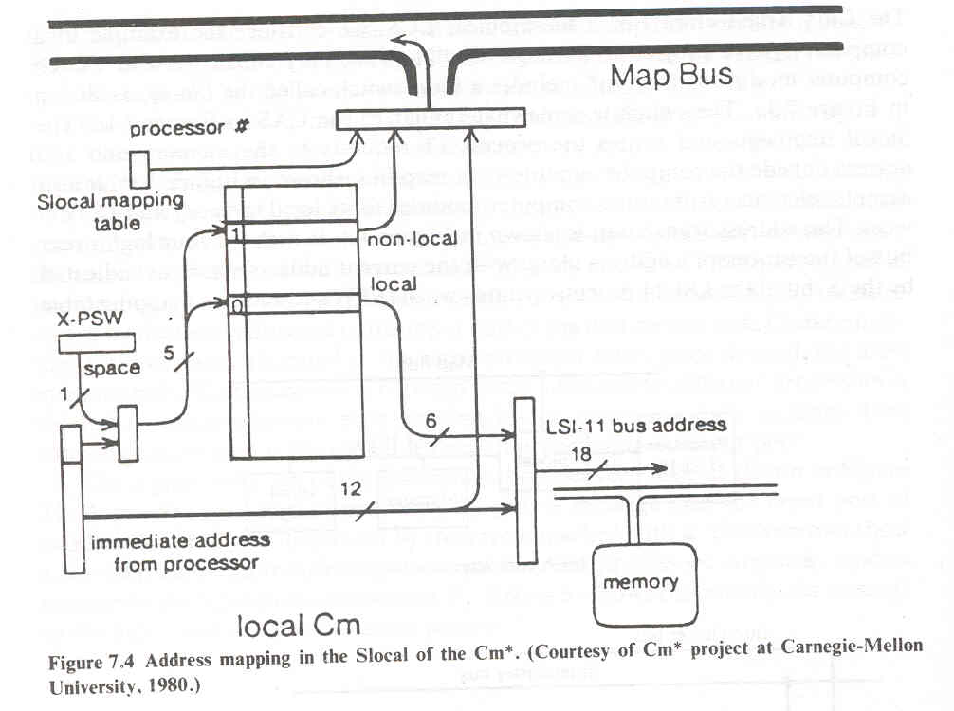

The Kmap is a microprogrammed ,150-ns cycle,three processor complex with a common data memory.The Kmap provides the address mapping,communication,and synchronization functions within the system. The three processors in the Kmap are the Kbus, the Line, and the Pmap, as shown in Figure. The Kbus is the bus controller which arbitrates requests to the map bus. The Linc manages communication between the Kmap and other Kmap. The Pmap is the mapping processor which responds to requests from the Kbus and Linc. It also performs most of the request processing. The Pmap com- municates with the computer modules in its cluster via the map bus which is a packet-switched bus. Three sets of queues provide interfaces between the Kbus, Linc, and the Pmap. Since the Kmap is much faster than the memory in the com- puter modules, it is multiprogrammed to handle up to eight concurrent requests. Each of the eight partitions is called a context and exists in the Pmap. Typically, each context processes one transaction. If one context needs to wait for a message packet to return with the reply to some request, the Pmap switches to another context that is ready to run so that some other transaction can proceed con- currently.

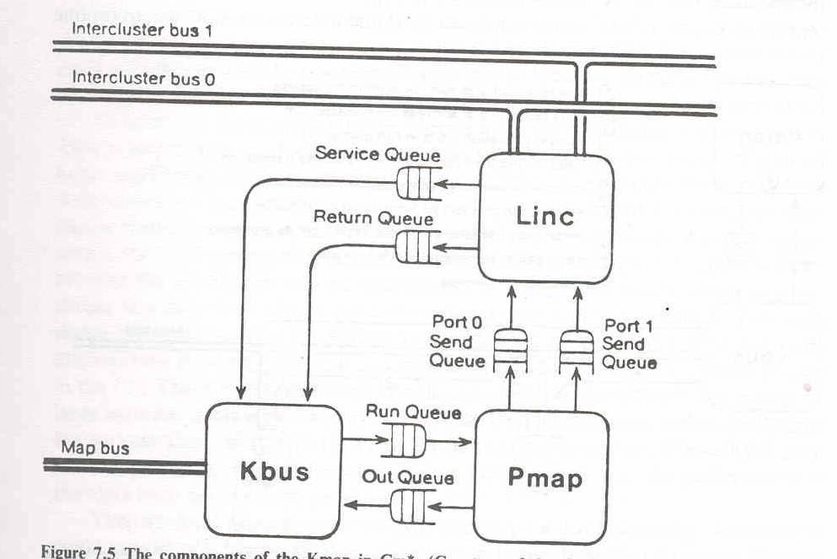

Tightly coupkled Multiprocessors

If high speed or real time processing is desired TCS may be used.Two typical models are there.It consists of p processors,l memory modules,and d input output channels.These units are connected through a set of interconnection networks.They are processor memory interconnection network,I/O processor inter connection network,and interrupt signal interconnection network.

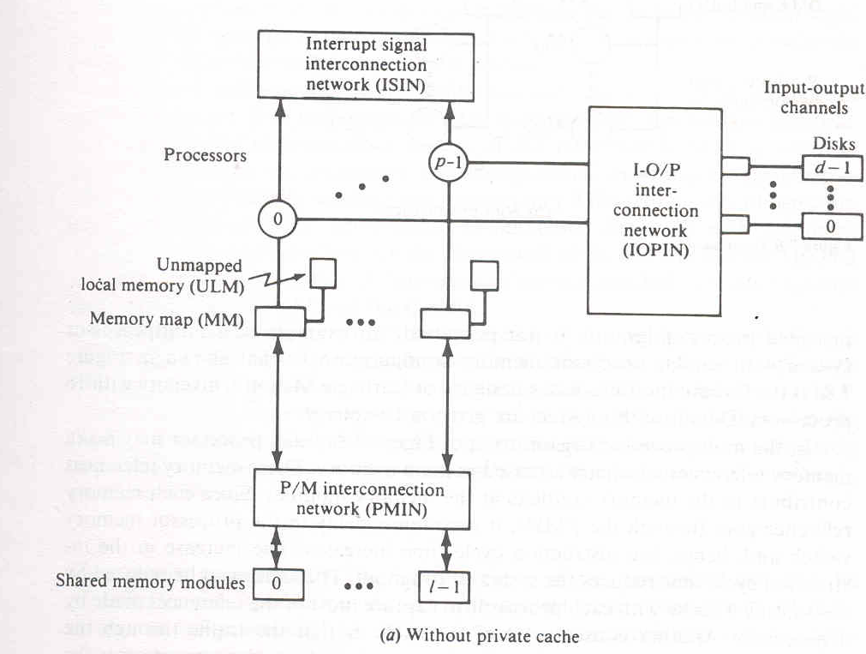

In the first figure each processor may make memory references which are accessed in main memory.Since each memory references go through the PMIN ,it encounters delay in the processor memory switch,and hence instruction cycle time increases,this reduces the system throughput.This can be reduced by associating a cache with each processor to capture most of the references made by a processor.

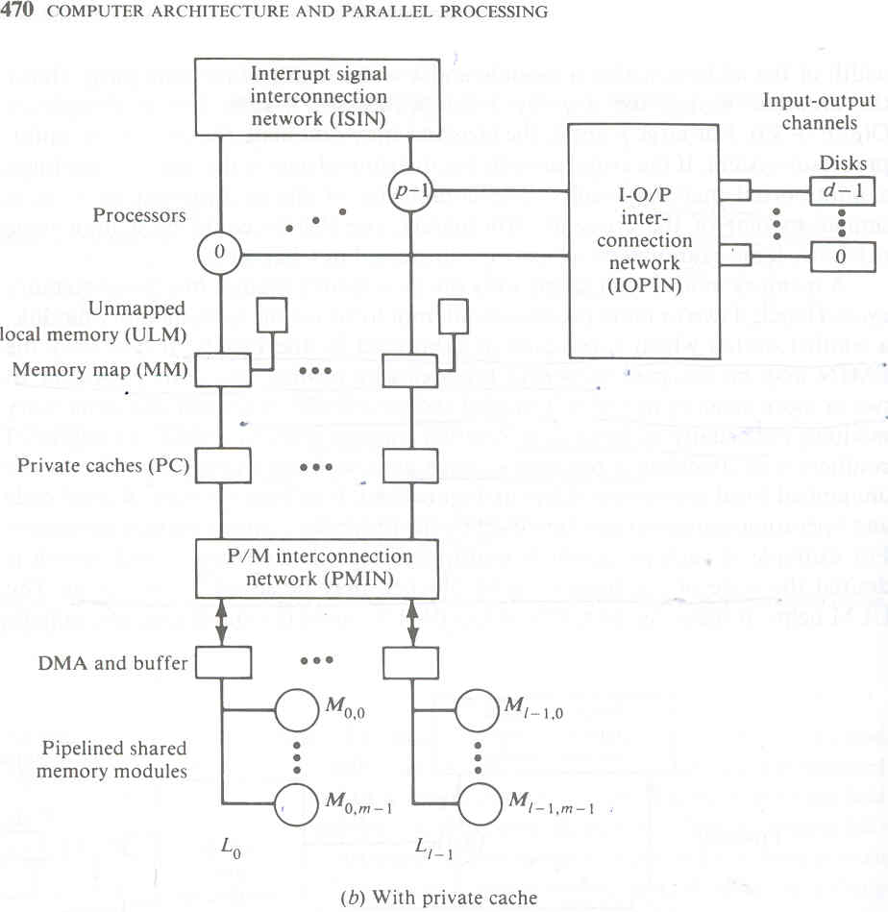

Three examples of a tightly coupled multiprocessor system are the Cyber-170,the Honeywell 60/66 and the PDP-10.

Honeywell 60/66 architecture

In this system every central processor and every I/O multiplexer is connected to every controller(SC).This provides adequate redundancy in paths for high availability.In the event of failure on the SC all IOMs are still accessible by each processor.The system controller acts as a memory controller for its associated pair of memory modules.

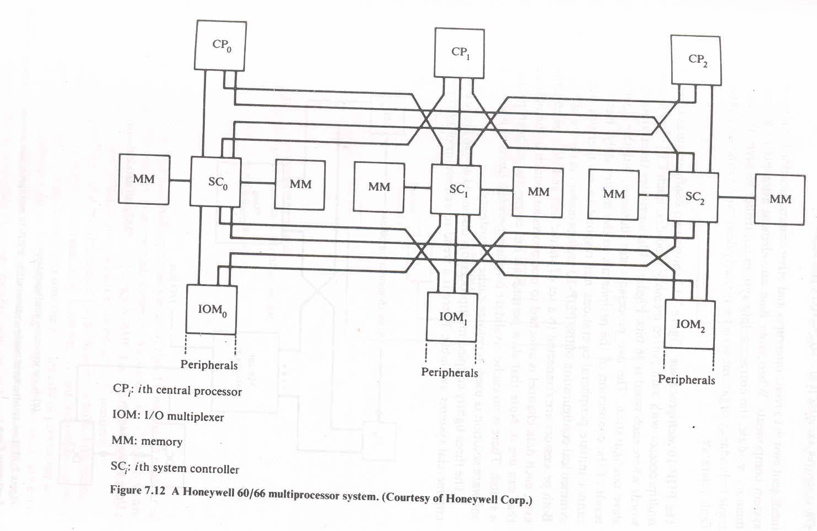

Cyber -170 architecture

This configuration consists of two substsyemscentral processing subsystem and peripheral processing subsystem.
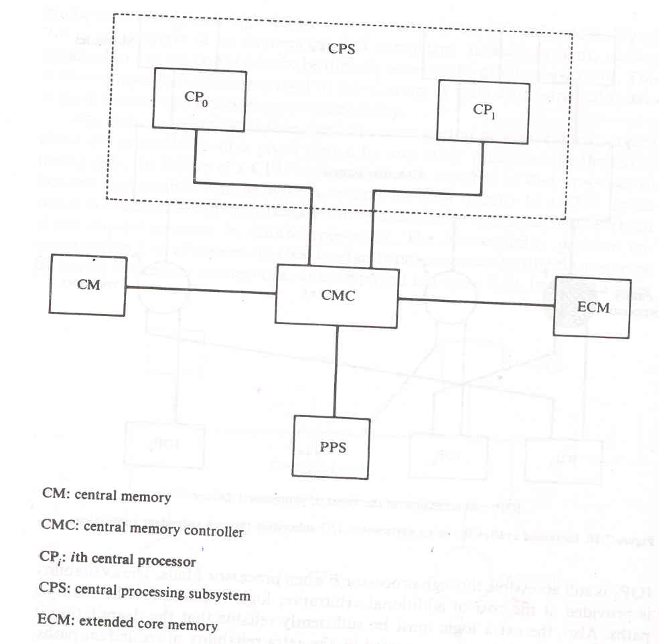

The PDP-10 multiprocessor

Two configurations are there for PDP-10 multiprocessor.Each CPU has a cache of 2K words.First figure illustrates asymmetric master slave configuration.The two processors are dentical,but the asymmetry is a result of the connection of the peripherals to the master only.Hence the slave cannot initiate peripheral operations nor respond to an interrupt directly.

The second figure shows symmetrical configuration of PDP 10 multiprocessor.Both processors are connected to a set of shared fast and slow peripherals.However each data channel is associated to one processor ,which is the only processor that can use it.Slow peripherals are connected to both processors via a switch.There is no cache invalidate interface between them.It is assumed that a software solution is used to enforce cache consistency.

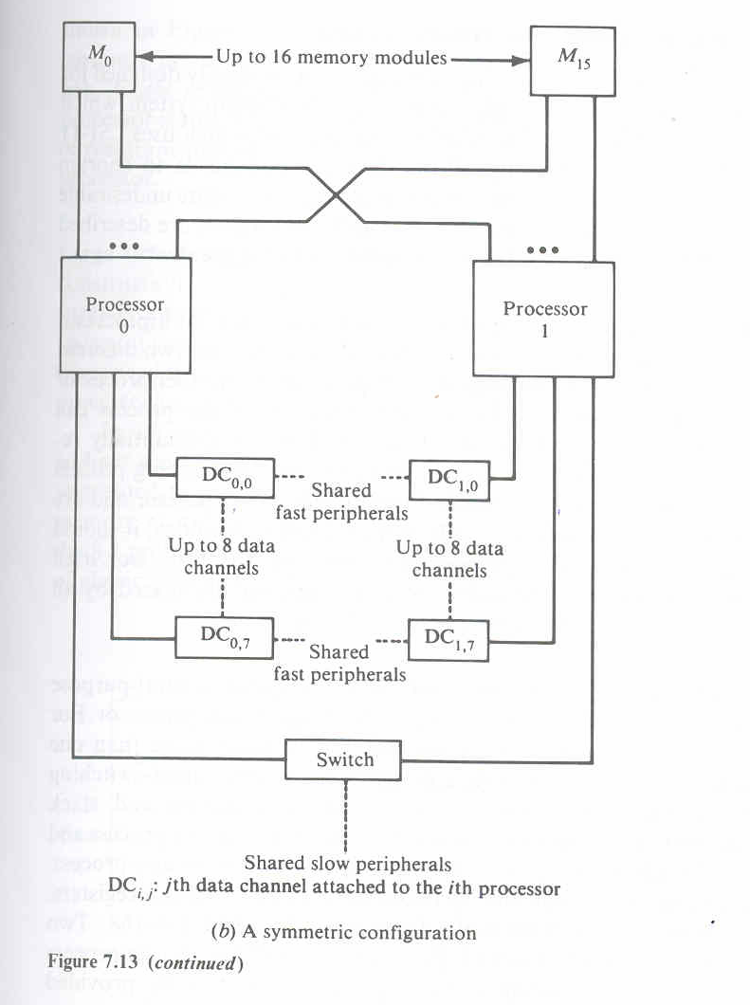

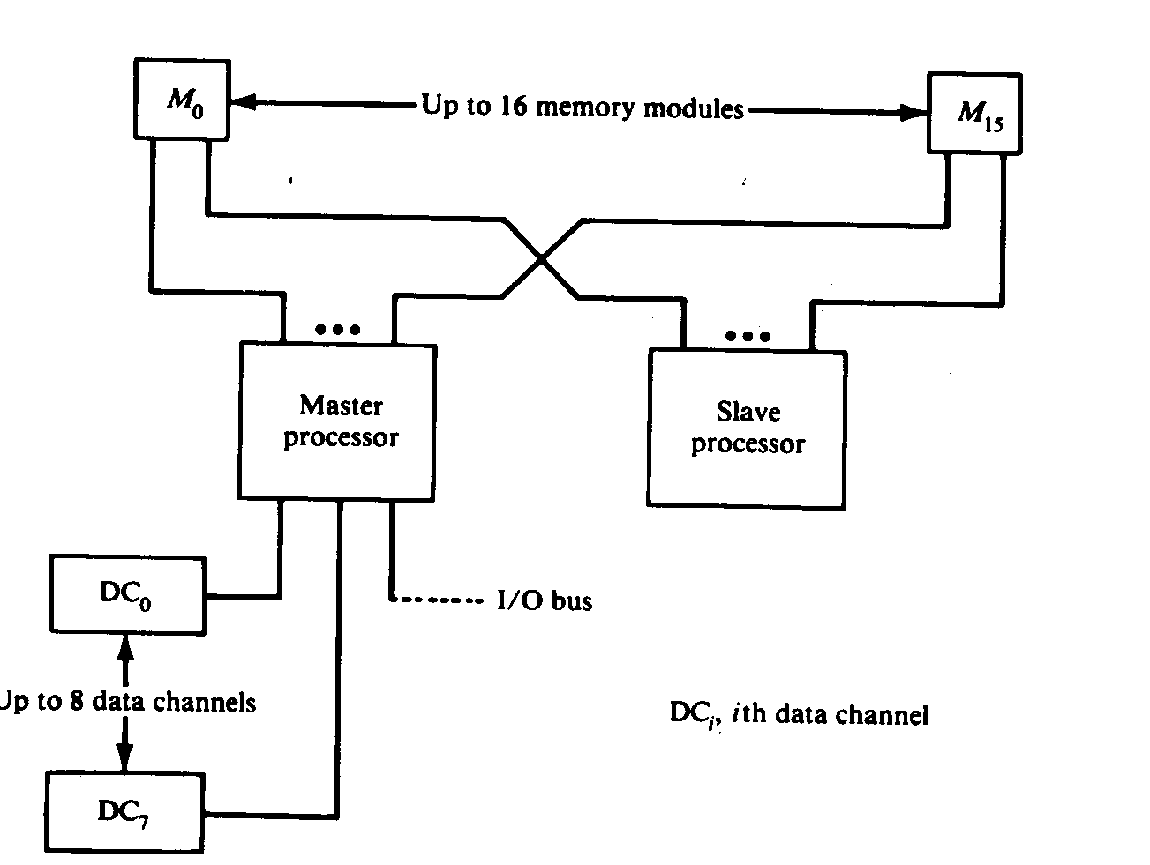

INTERCONNECTION NETWORKS

Time Shared or Common Buses

The simplest interconnection system for multiple processors is a common communication path connecting all of the functional units.The common path is often called a time shared bus or common bus.Since bus is a shared resource a mechanism must be provided to resolve contention.

The conflict resolution methods include Static or fixed priorities,FIFO queues,and daisy chaining.

Static priority algorithm:

When multiple devices concurrently request the use of the bus ,the device with highest priority is granted access to it.This approach is usually implemented using daisy chaining,in which all services are effectively assigned static priorities according to their locations along a bus grant control line.The device closest to a central bus controller is assigned the highest priority.

The fixed time slice algorithm

It divides the available bus bandwidth into fixed length time slices that are then sequentially offered to each device in a round robin fashion.

Dynamic priority algorithm

The devices are assigned uniqueue priorities and compete to access the bus,but the priorities are dynamically changed to give every device an opportunity to access the bus.Two algorithms used are LRU(least recently used)and RDC(rotating daisy chain).

LRU

Gives highest priority to requesting device that has not used the bus for the longest interval.

RDC

In the RDC scheme no central controller exists, and the bus grant line is connected from the last device back to the first in a closed loop. Whichever device is granted access to the bus serves as the bus controller for the following arbitration.

First come first served algorithm.

Requests are simply honored in the order received.

Multistage Networks for multiprocessors

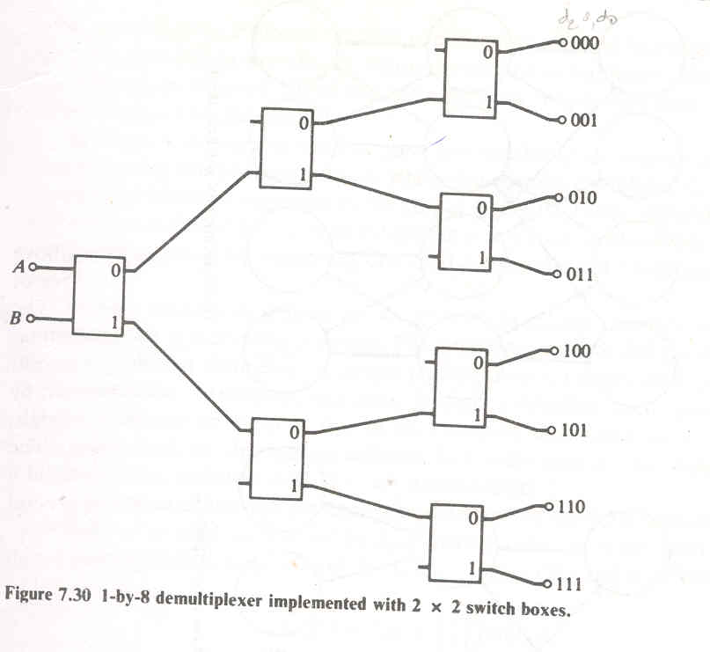

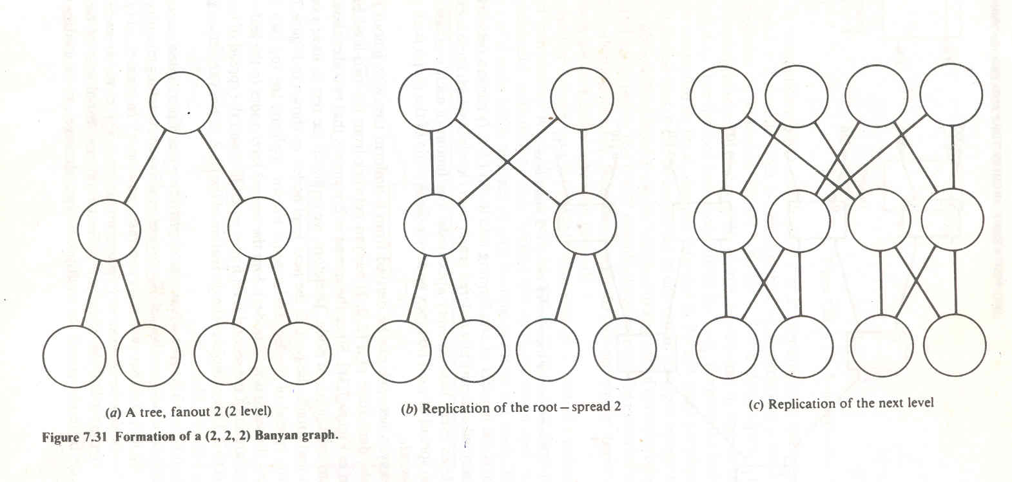

Language features to exploit parallelism

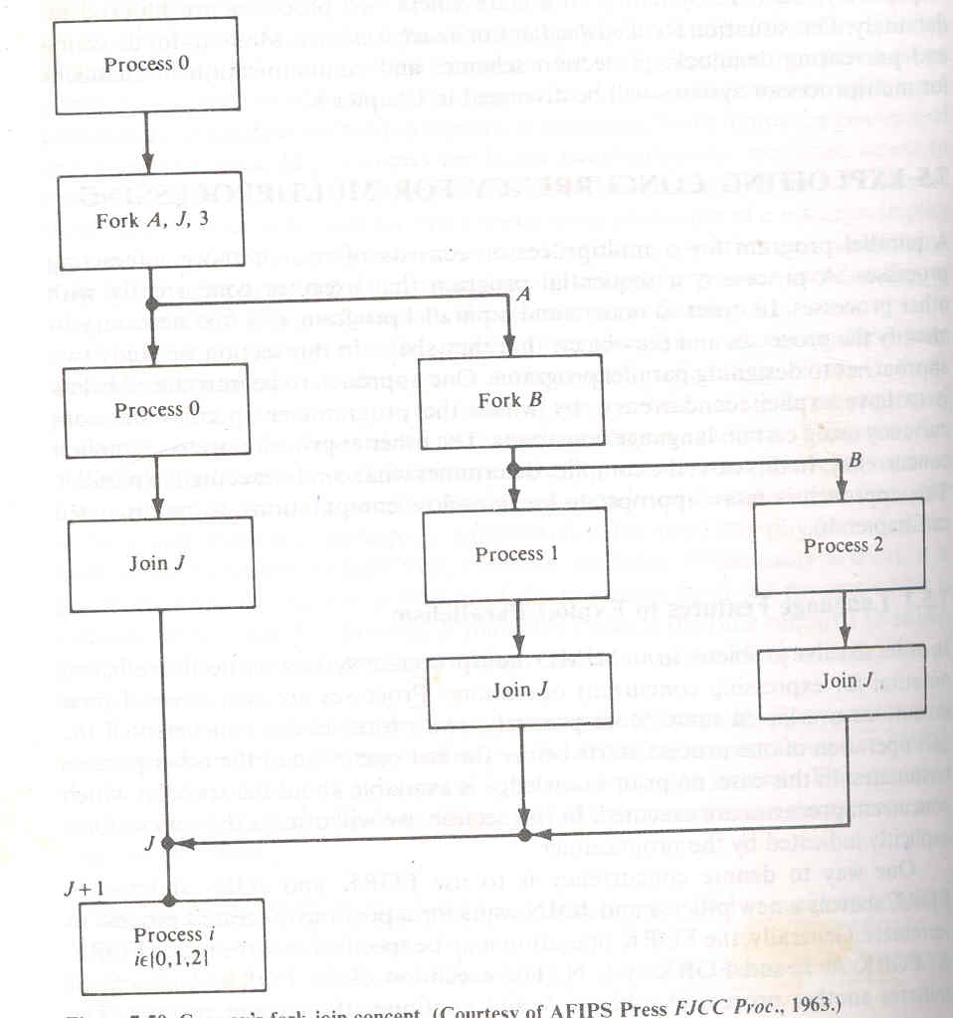

In order to solve problems in an MIMD multiprocessor system, we need an efficient notation for expressing concurrent operations. processes are concurrent if their execution overlap intime.More precisely, two processes are concurrent if the first operation of one process starts before the last operation of the other process terminates. In this case, no prior knowledge is available about the speed.at which concurrent processes are executed. In this section, we will discuss the concurrency explicitly indicated by the programmer.
One way to denote concurrency is to use FORK and JOIN statements. ([ORK spawns a new process and JOIN waits for a previously created process toterminate.. Generally, the FORK operation may be specified in three ways: FORK A; FORK A, J; and FORK A J, N. The execution of the FORK A statement initiates another process at address A and continues the current process.

PROCESS SYNCHRONIZATION MECHANISMS

The set of constraints on the ordering of these events constitutes the set of synchronization required for the operating processes. The synchronization mechanism is used to delay execution of a process in order to satisfy such constraints.

Two types of synchronization are commonly employed when using shared variables . These are mutual exclusion and condition synchronization. We recall mutual exclusion ensures that a physical or virtual resource is held indivisibly. Another situation occurs in a set of cooperating processes when a shared data object is in a state that is inappropriate for executing a given operation. Any: process which attempts such an operation should be delayed until the state of the object changes to the desired value as a result of other processes being executed. This type of synchronization is sometimes called condition synchronization. The mutual-exclusive execution of a critical section, S, whose access is rolled by a variable gate can be enforced by an entry protocol denoted by MUTEXBEGIN (gate) and an exit protocol denoted by. MUTEXEND (gate).Alternatively, the effect of the entry and exit protocols can be expressed as csect gate do S.

There are certain problems associated with implementing the MUTEXBEGIN/ MUTEXEXEND construct. Execution of the MUTEXBEGIN statement should detect the status of the critical section. If it is busy, the process attempting to enter the critical section must wait. This can be done by setting an indicator to show that a process is currently in the critical section. Execution of the MUTEXEND statement should reset the status of the critical section to idle and provide a mechanism to schedule the waiting process to use the critical section (CS). One implementation is the use of the LOCK and UNLOCK operations to respond to MUTEXBEGIN and MUTEXEND respectively. For these, consider that there is a single gate that each process must pass through to enter :S and also leave it. If a process attempting to enter the CS finds the gate unlocked (open) it locks (closes) it as it enters the CS in one indivisible operation so It all other processes attempting to enter the CS will find the gate locked. On completion, the process unlocks the gate and exits from the CS. Assuming that the riable gate ~ O{l) means that the gate is open (closed), the access to a CS controlled by the gate can be written as

LOCK (gate)
execute critical section
UNLOCK (gate)

le LOCK (x) operation may be implemented as follows:

var x: shared integer;
LOCK (x): begin
var y: integer;
y <------- x;
while y = 1 do y ←--- x; II wait until gate is open II
x←----1 ; // set gate to unavailable status //
end

Another instruction used to enforce mutual exclusion of access to a shared variable in memory location m_addr is the compare vand swap instruction(CAS).

(CAS ,r_old, ,r_new, m_addr). The action of the CAS instruction is defined as follows:
var m_addr: shared address;
var r_old, r new: registers;
var z: CAS flag;
CAS: if r _old = m_addr then

{m-.addr ←-- r _new; z ←- 1}
else
{r _old ← m addr; z <- O}
Notice that associated with the CAS instruction is a processor flag z. The flag is set if the comparison indicates equality. Again, the execution of the CAS instruction (that is, the IF statement) is an indivisible operation. We illustrate the use of the
CAS instruction with a shared singly linked queue data structure (Figure 8.1),
which is accessed concurrently by the two processes P 1 and P 2' The two operations which can be performed on the queue are ENQUEUE(X) and DEQUEUE, ENQUEUE(X) adds a node X to the "TAIL" of the queue and DEQUEUE returns a pointer to the deleted "HEAD" of the queue. J-IEAD and TAIL are shared global variables. Assuming that the queue is never empty (for simplicity), the ENQUEUE(X) primitive for a nonconcurrent system can be described as
Procedure ENOUEUE(X);
var P: pointer; / /P is local to each invocation / /
begin
LINK(X) <- ^; / /terminate last node's link/ /
P <- TAIL;
TAIL <- X;
LINK(P) <- X; //attach new node to queue//
end
Suppose process P 1 requests to enqueue node X. While P 1 is executing the primitive, it gets interrupted by P 2' which requests to enqueue node Y to the same queue. , Assume that the interruption occurs at the end of statement P <- TAIL, Figure 8.la illustrates the state of the queue at the time of interruption. If P I executes the procedure to completion after P2 returns control to PI, node X will be attached to the queue. However, node Y, which was added by P 2' would have been detached from the queue unintentionally. This error occurs because pointer P was not updated to point to the last node attached by process P2. We can avoid thD problem by using the CAS instruction to update P to point to the last attacld node. This can be accomplished by replacing the TAIL +- X statement with repeat CAS pP,X,TAIL until TAIL= X”

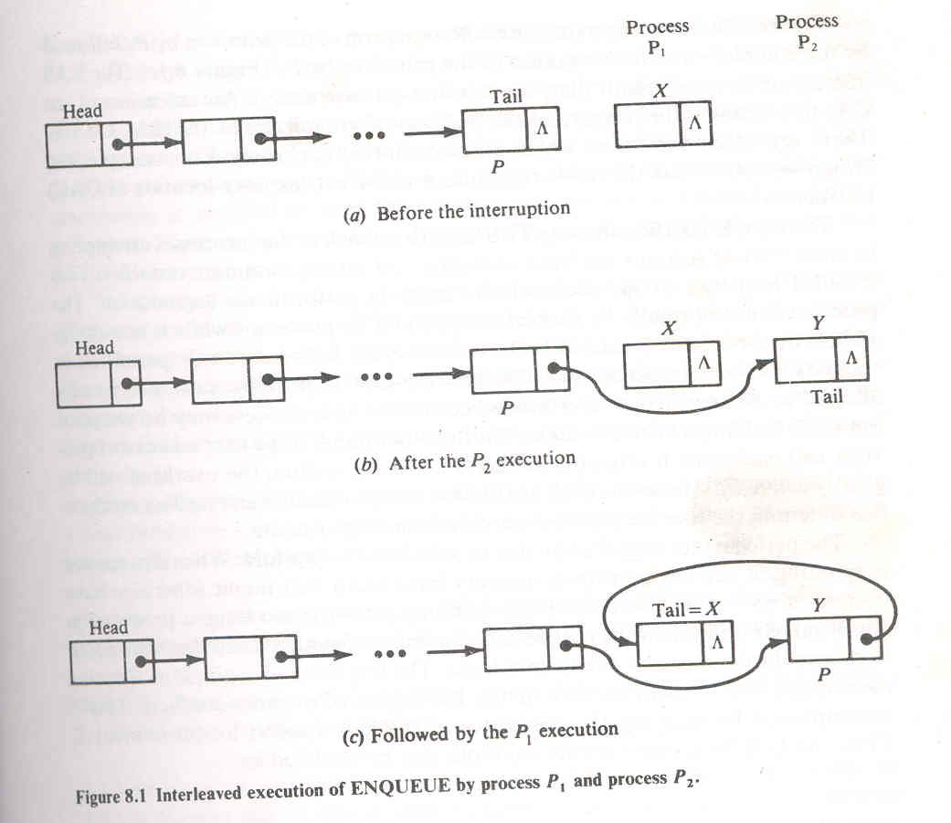

Procedure ENQUEUE(X);
var P: pointer;
begin
LlNK(X) <-A;
P .- TAIL;
repeat CAS P,X,TAIL until TAIL = X;
LlNK(P) <- X; end
The CAS instruction ensures that the logical state (P) of the interrupted IS maintained on resumption of the interrupted program. Otherwise the state P to the most recent value of TAIL.

