MODULE V

DATA-DRIVEN COMPUTING AND LANGUAGES

Data flow computers are based on the concept of data-driven computation, which
is drastically different from the operation of a conventional von Neumann machine. The fundamental difference is that instruction execution in a conventional computer is under program-flow control, whereas that in a data flow computer is driven by the data (operand) availability. We characterize below these two types of computers.

Jack Dennis (1979) of MIT has identified three basic issues towards the
development of an Ideal architecture for future computers. The first is to achieve a high performance/cost ratio; the second is to match the ratio with technological i progress; and the third is to offer better programmability in application areas.

CONTROL FLOW VS DATA FLOW COMPUTERS

The concepts of control flow and data flow computing are distinguished by the control of computation sequences in two distinct program representations.The statement
a = (b + 1). (b - c) is specified by a series of instructions with an explicit flow
of control. Shared memory cells are the means by which data is passed between
instructions. Data (operands) are referenced by their memory addresses (vari- abIes).

In the traditional sequential control flow model (von Neumann), there is a single thread of control, as shown in Figure IO.Ia, which is passed from instruction to instruction. Explicit control transfers are caused by using operators like GO
TO. In the parallel control flow model (Figure 10.lb), special parallel control
operators such as FORK and JOIN are used to explicitly specify parallelism; These operators allow more than one thread of control to be active at an instant and provide means for synchronizing these threads, as demonstrated in Figure 10.lb. All underlined variables refer to addresses of operands and instructions.
Special features are identified below for either the sequential or parallel control
flow model:
- . Data is passed between instructions via references to shared memory cells.
- . Flow of control is implicitly sequential, but special control operators can be used explicitly for parallelism.
- . Program counters are used to sequence the execution of instruction in a
- centralized control environment.
In a data flow computing environment, instructions are activated by the availability of data tokens ~s indicated by the ( ) in Figure 10.2. Data flow pro- grams are represented by directed graphs, which show the flow of data between
instructions. Each instruction consists of an operator, one or two operands,
and one or more destinations to which the result (data token) will be sent. Three snapshots of the data flow graph for a = (b + 1). (b - c) are shown in Figure
10.3. The dots correspond to data tokens being passed between instructions. Listed
below are interesting features in the data flow model:
- Intermediate or final results are passed directly as data token between
instructions.
- There is no concept of shared data storage as embodied in the traditional
notion of a variable.
- Program sequencing is constrained only by data dependency among
instructions.
Control flow computers have a control-driven organization. This means that
the program has complete control over instruction sequencing. Synchronous computations are performed in control flow computers using centralized control.
Data flow computers have a data-driven organization that is characterized by.
passive examine stage. Instructions are examined to reveal the operand availability, upon which they are executed immediately-if the functional units are available.

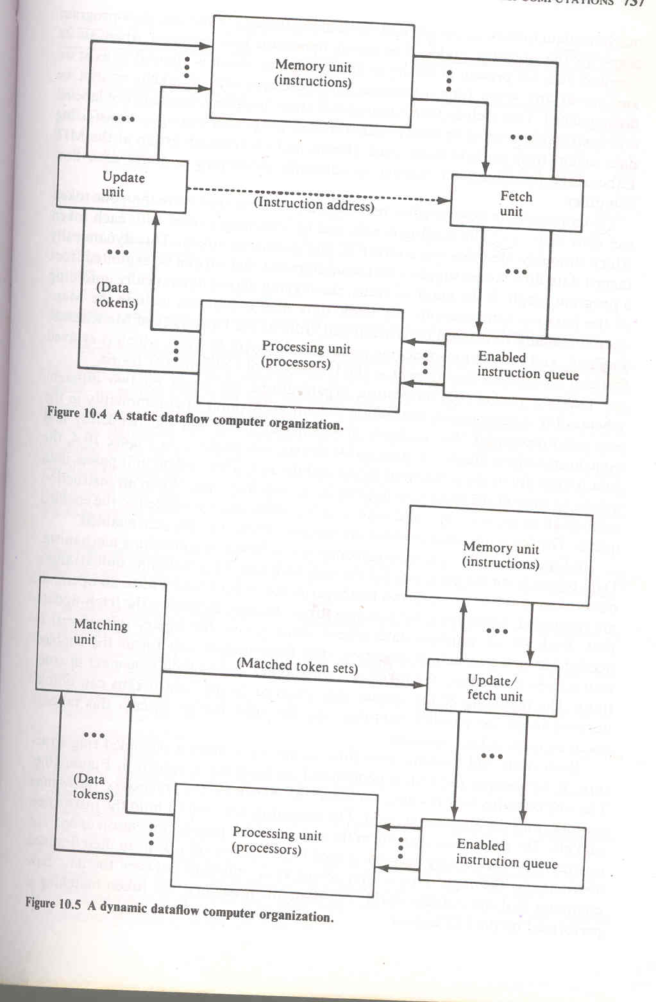

Depending on the way of handling data tokens data flow computers are divided into static model and dynamic model. In a static data flow machine data tokens are assumed to move along the arcs of the data flow program graph to the operator nodes. The nodal operation gets executed when all its operand data are present at the input arcs.Qnly one token is allowed to exist on any arc at any given time, otherwise the successive sets of tokens cannot be distinguished. This architecture is considered static because tokens-are not labeled and control tokens must be used to acknowledge the proper timing in transferring data tokens from node to node. Jack Dennis and his research group at the MIT Laboratory for Computer Science is currently developing a static data flow
Computer.

A dynamic data flow machine uses tagged tokens so that more than one token
can exist in an arc.The tagging is achieved by attaching a label with each token which uniquely identifies the context of that particular token. This dynamically
tagged data flow model suggests that maximum parallelism can be exploited from
a program graph. If the graph is cyclic, the tagging allows dynamically unfolding of the iterative computations. Dynamic data flow computers include the Man- chester machine developed by Watson and Gurd at the University of Manchester, England, and the Arvinds machine under development at MIT, which is evolved from an earlier data flow project at the University of California at Irvine.
The two packet-communication organizations are based on two different schemes for synchro,nizing instruction execution. A point of commonality in the two organizations, is that multiple processing elements can independently and asynchronously evaluate the executable instruction packets. In Figure 10.4, the data tokens are in the input pool of the update unit. This update unit passes data
tokens to their destination instructions in the memory unit. When an instruction receives all its required operand tokens, it is enabled and forwarded to the enabled queue. The fetch unit fetches these instructions when they become enabled.

The system synchronization is based on a matching mechanism .Data tokens form the input pool of the matching unit .This matching unit arranges data tokens in to pairs or sets and temporarily stores token until all operands are compared, whereupon the matched token sets are released to the fetch-update unit. Each set of matched data tokens (usually two for binary operations) is needed for one instruction execution. The fetch-update unit forms the enabled instructions by merging the token sets with copies sent to their consumer instructions. The matching of the special tags attached to the data tokens can unfold iterative loops for parallel computations. We shall further discuss this tagged- token concept in later sections.

Both static and dynamic data flow architectures have a pipelined ring struc.
ture. If we include the I/O, a generalized architecture is shown in Figure 10.6, The ring contains four resource sections: the memories, the processors, the routing network, and the input-output unit. The memories are used to hold the instruction packets. The processing units form the task force for parallel execution of enabled instructions. The routing network is used to pass the result tokens to their destined
instructions. The input-output unit serves as an interface between the data flow
computer and the outside world. For dynamic machines, the token matching is
performed by the I/O section.

Data flow graphs and languages

There is a need to provide a high-level language for data flow computers. The primary goal is to take advantage of implicit parallelism. Data flow computing is compatible with the use of dependence graphs In program analysis for compiling :n a conventional computer. An efficient data flow language should be able to express parallelism in a program more naturally, to promote programming productivity, and to facilitate close interactions between algorithm constructs and nard ware structures. Examples of data flow languages include the Irvine Data- flow language and Value Arithmetic Language (VAL) among several single assignment and functional programming languages that have been proposed by computer researchers

In a maximum parallel program, the sequencing of instructions should be.
constrained only by data dependencies and nothing else. Listed below are useful properties in a data flow language. We shall describe their implications and usages
separately.
- Freedom from side effects based on functional programming .
- Locality of effect without far-reaching data dependencies
- Equivalence of instruction-sequencing constraints with data dependencies .
- Satisfying single-assignment rule with aliasing
- Unfolding of iterative computations into parallelism .
- Lack of “history sensitivity" in procedures calls
Data flow graphs In a conventional computer, program analysis is often performed
at compile time to yield better resource utilization and code optimization and
at run time to reveal concurrent arithmetic logic activities for higher system throughput.

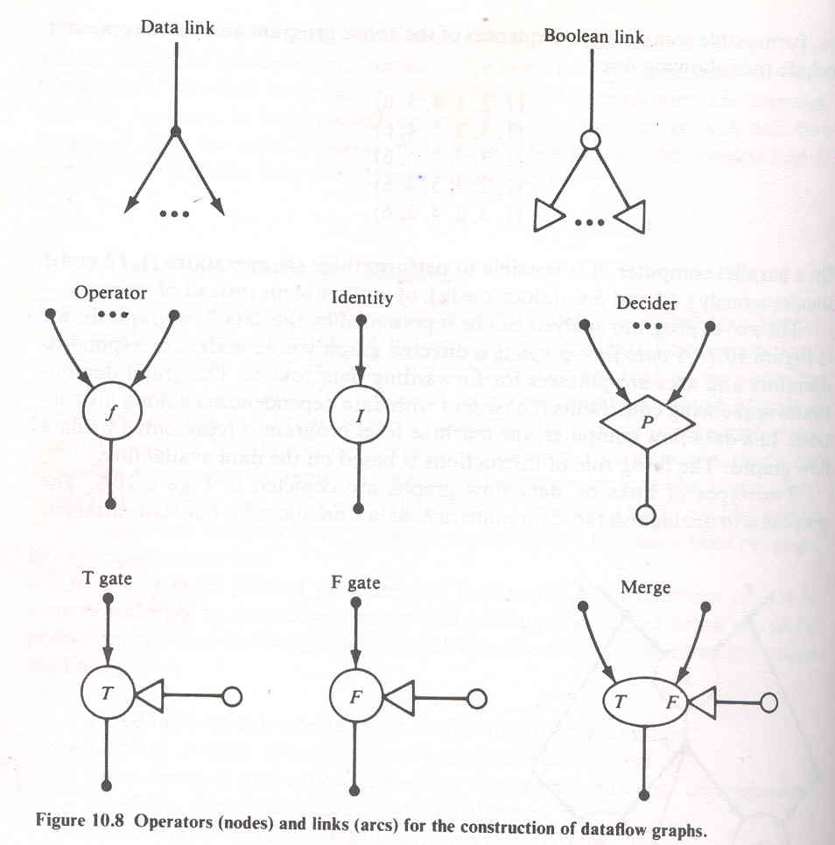

Advantages and Potential Problems
Pros and cons of data flow computers are discussed in this section. Due to their strong appeal to parallelism, data flow techniques have attracted a great deal of attention in recent years. We assess first the advantages and then examine the opposition opinions. The development of data flow computers and languages is still in its infancy stage. The research community is currently divided in opinions. It is too early to draw a final conclusion because the success of data flow computing depends heavily on high technology and its matching with applications. However, it is commonly recognized that more research and development challenges should continue in this area. The idea of data-driven computation is rather old, but only in recent years have architectural models with anticipated performance been developed.

Most advantages are claimed by researchers in this area. The claimed advantages were only partially supported by performance analysis and simulation experiments. Operational statistics are not available from existing prototype data flow machines. Therefore, some of the claimed advantages are still subject to further verification. Data flow computers are advantageous in many respects over the traditional von Neumann machines. These aspects are elaborated below in terms of projected performance, matching technology, and programming productivity. .
Highly concurrent operations:
Parallelism can be easily exposed in a dataflow program graph.The data flow approach offers a possible solution to the problem of efficiently exploiting concurrency of computation on na large scale.It benefits not only regularly structured but also arbitrary parallelism in programs. ", direct use of values instead of names of value containers (addresses) enables pur functional programming without side effects. Asynchronous parallelism can exploited at the instruction level or at the procedure level. Inherently sequent computations can be unfolded to enable parallelism. The data flow approach I applied pipelining, array processing, and multiprocessing techniques discussed previous chapters for control flow computers.

The data flow language does not introduce instruction-sequencing constraiJ1 other than the ones imposed by data dependencies in the algorithm. In theor maximum parallelism can be achieved if sufficient resources are provided. Th approach extends naturally to an arbitrary number of processors in the systen The speedup should be linearly proportional to the increase of processor numbel The high concurrency in a data flow computer is supported by easier prograJ1 verification, better modularity and extendability of hardware, reduced protectiol problems, and superior confinement of software errors.
Matching with VLSI technology
Recall the basic architecture of a data flow computer (Figure 10.6). The memory section contains instruction cells which can bc uniformly structured in large-scale memory arrays. The pool of processing units and the network of packet switches can be each also regularly structured with modular cells. All this homogeneity and modularity in cellular structures contributes to the suitability of VLSI implementation of major components in a data flow computer. As introduced in Chapter I, the impressive progress in microelectronics technology has made it possible to challenge the fabrication of large arrays of processors, memories, and switches on VLSI chips.

The interconnection between chips can be built into highly densed packaging systems. It is fair to say that qata flow machine architecture matches nicely with the technological supports that we anticipate to have. The potential of VLSI and VHSIC technologies can be fully exploited in the development of data flow machines. The operations in a data flow computer may be asynchronous. How- ever, the hardware components can be designed with synchronous functional pipes and clocked memory and switch a.rrays. With more lessons to be learned
and the data flow hardware properly evaluated, it would be appropriate to con-
sider VLSI implementation of some large-scale data flow systems.
Programming productivity
In a control flow vector processor or a multiprocessor system, the percentage of code that can be vectorized ranges from 10 to 90 ' percent across a broad range of scientific applications. The nonvectorizable code (scalar operations) tends to become a bottleneck. Automatic vectorization requires sophisticated data flow analysis, which is difficult in Fortran because of the side effects caused by the global scope and aliasing of variables. A well-designed data flow computer should be able to overcome these difficulties and to remove the bottleneck caused by assorted scalar operations.

Shortcomings of data flow computing

Critics of the data flow approach have pointed out quite a number of potential problems in the development and application of data flow computers at the instruction level. It is instructional to learn n these reserved positions and to explore other alternatives to achieve high performance. In the conventional computer with centralized control hardware, an imperative language such as Fortran is used and an intelligent compiler is needed normalize the program and to generate the dependence graph, which guides vectorization and optimization processes we have studied in previous chapters. h-level use of the dependence graph is practiced here primarily at compile e. The major advantages of this high-level approach are summarized below:
- There is no need to use a new functional programming language, which ordinary programmers may be reluctant to learn.
- Existing software assets for vectorizing,compiling and dedicated application
software can continue to be utilized.
- Data flow analysis at the higher level of procedures and loops will result in
less overhead when averaged over all instructions to be executed.
In the data flow approach, special functional programming languages must used which can be easily compiled into a dependence graph. The object code :enerated to efficiently map the dependence graph onto the data flow machine h distributed control hardware. Some advantages of high-level data flow Ichines become potential shortcomings in the data flow computer, which exploits rallelism at the lowest level of instruction execution. Apparent disadvantages instructional-level data flow computers are summarized below:
The data driven at instruction level causes excessive pipeline overhead per instruction, which may destroy the benefits of parallelism. The long pipeline filling problem is attributed to queueing all enabled instructions at the input ports of every subsystem in the data flow ring. The queue lengths absorb some of the parallelism in a program, thus, performance becomes weak for improper buffering and traffic congestion.
Data flow programs tend to waste memory space for the increased code length due to the single assignment rule and the excessive copying of data arrays. The damaging effects of the memory access conflict problem are so far not well addressed by data flow researchers.
When a data flow computer becomes large with high numbers of instruction cells and processing elements, the packet-switched network used becomes cost-prohibitive and a bottleneck to the entire system.

DATA FLOW COMPUTER ARCHITECTURE
Several interesting data flow computer architectures are studied in this section The intent is to identify related architectural concepts rather than to describe th implementation details. We shall start with static data flow computers represented by the Dennis machine at MIT. Then we describe several ring-structured, dynamic data flow computers, including the original Irvine machine and its successor machine at MIT. the EDDY system in Japan, and the Manchester machine il1 England. Several specially designed data flow systems will be briefly examined, including the Utah machine, the French LAU system, and the Newcastle data. control flow computer. Design alternatives of data flow computers will also be discussed to inspire future development. .
Static Data Flow Computers.

Jack Dennis and his associates at MIT have pioneered the area of data flow research. They have developed a static data flow computing model and the associated language supports. There are two interesting data flow projects at MIT. For identification purpose, we distinguish them by calling them the Dennis machine and the Arvind machine. The Dennis machine has a static architecture, whereas the Arvind machine is dynamic, using tagged tokens and colored activities.
Data flow graphs used in the Dennis machine must follow a static execution rule that only one data token can occupy an arc at an instant. This leads to a static firing rule that an instruction is enabled if a data token is present on each of its input arcs and no token is present on any of its output arcs. Thus. the program graph contains control tokens as well as data tokens, both contributing to the enabling of an instruction. These control tokens act as acknowledge signals when data tokens are removed from output arcs.
The Dennis machine is designed to exploit the concurrency in programs
represented by static data flow graphs. The structure of this data flow computer
it consists of five major sections connected by channels
through which information is sent in the form of discrete tokens (packets):
Memory section consists of instruction cells which hold instructions and their operands.

Processing section consists of processing units that perform functional operations on data tokens.

Arbitration network delivers operation packets from the memory section to the processing section.

Control network delivers a control token from the processing section to the memory section.

Distribution network delivers data tokens from the processing section to the memory section.

Dynamic Data Flow Computers

Three dynamic data flow projects are introduced below. In dynamic machines, data tokens are tagged (labelled or colored) to allow multiple tokens to appear simultaneously on any input arc of an operator node.No control tokens are needed to acknowledge the transfer of data tokens among instructions. Instead, the matching of token tags (labels or colors) is performed to merge them for instructions requiring more than one operand token. Therefore, additional hardware is needed to attach tags onto data tokens and to perform tag matching. We shall first present the Arvind machine, followed by the EDDY system and the Manchester data flow machine.

The development of the Irvine data flow machine was motivated by the desire to exploit the potential of VLSI and to provide a high-level, highly concurrent program organization. This project originated at the University of California at Irvine and now continues at the Massachusetts Institute of Technology by Arvind and his associates.

The Irvine dataflow computer.

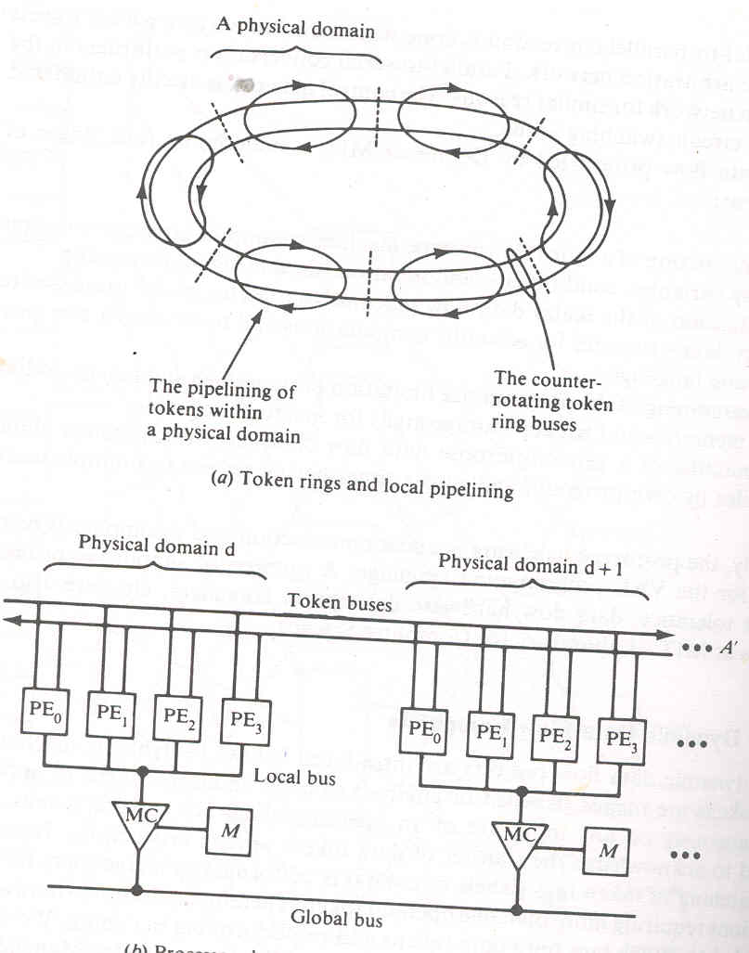

Data Flow Design Alternatives

There are several data flow projects that have special architectural approaches different from the static or dynamic machines described in previous sections.In fact the first operational dataflow machine in the USA is the Data driven machine.The program and machine organization are based on the concept of recursion, markedly different from the previous data flow systems we have examined. The computer is composed of a hierarchy of comput1ng elements (processor-memory pairs), where each element is logically recursive and consists of further offspring elements.

Logically the .DDM architecture is tree structured, with each computing element being connected to a parent element and up to eight offspring elements (below), which it supervises. The DDM project is currently located at the University of Utah. It is operational and communicates with a DEC-20j40, which is used for software support of compilers, simulators, and performance measurement programs.
In Toulouse, France, a data flow system called LAU has been constructed with 32 bit-slice microprocessors interconnected by multiple buses. The LAU programming language is based on single assignment rule, but the computer's program organization is based on control flow concepts. In the computer, data are passed via sharable memory cells that are accessed through addresses embed- ded in instructions. Seperate control signals are used to enable instructions.
Dependence-driven approach
This approach was independently proposed by Gajski et al. (1982), and by Motooka et al. (1981). The idea is to raise the level of parallelism to compound-function (procedure) level at run time.A compound function is a collection of computational tasks that are suitable for parallel processing by multiprocessors:Listed below are six compound functions investigated by the research group at the University of Illinois:
- . array operations
- . Linear recurrence
- . For all loops
- . Pipeline loops
- . Blocks of assignment statements
- . Compound conditional statements
A program is a dependence graph connecting the compound-function nodes. Dependence-driven refers to the application of data flow principles over multiple compound-function nodes. In a sense, it is procedure driven. Instead of using data flow languages, traditional high-level language programs can be used in this depen- dence-driven approach .Additional program transformation packages should be developed to convert ordinary language programs to dependence graphs.. A hardware organ- ization needed for dependence-driven computations .. Such a dependence-driven machine has a global controller for multiple processor clusters and shared memory and other resources, instead of decentralized control as emphasized in a data-driven machine.
Multilevel event-driven approach

The dependence-driven was generalized to an event-driven approach by Hwang and Su (1983c). An event is a logical activity which can be defined at the job (program) level, the procedure level, the task level, or at the instruction level after proper abstraction or enqrossment.. Hierarchical scheduling is needed in this event-driven approach. A mechanism for program abstraction needs to be developed. Such a mechanism must not require high system overhead. It could be implemented partially at compile time and partially at run time. The choice depends on the performance criteria to be used in promoting parallel processing at various levels. Hierarchical scheduling of resources is the most challenging part of research in this approach.

Heuristic algorithms are needed for scheduling multiple events to the available
resources in an event-driven computer. Instead of using the first-in, first-out (FIFO)
scheduling policy on all enabled activities, as in a data-driven computer, this
approach considers the use of priority queues in the event scheduling. The priority is determined by pre-run-time estimating of the time-space complexities of all enabled events.

