ADVANCED PROMPT ENGINEERING
PART B — PROMPT PORTFOLIO & AI-ASSISTED RESEARCH

Student Name | Harkirat Kaur Arora
Course | Introduction to Artificial Intelligence and Machine Learning
Selected Company | Zomato
Business Problem | Customer Support Automation using Generative AI / LLMs
Topic | Advanced Prompt Engineering — Part B: Prompt Portfolio & AI-Assisted Research
Assessment Weightage | Part B — 10 Marks

Purpose. This Word portfolio follows the Part B instructions in the assessment and the Advanced Prompt Engineering lecture: document prompts, show refinement, use AI tools intelligently, verify important claims, critically evaluate outputs, and maintain an individual GitHub repository.
Source alignment: Part B requires important prompts, at least one improvement, AI-tool usage, fact-checking with credible sources, and critical evaluation. fileciteturn2file0L125-L160 The Advanced Prompt Engineering module emphasizes constraints, structured outputs, prompt chaining, iterative refinement, hallucination awareness, facts vs assumptions, source verification, and human review. fileciteturn2file1L15-L27

1. Selected Business Case
Company/industry: Zomato / online food-delivery. Business problem: customer-support automation using Generative AI/LLMs. The portfolio focuses on how strong prompts can help organize support workflows, analyze complaints, draft support content, and identify where human escalation is required. Company-specific operational claims are not treated as facts unless verified.
This choice is consistent with the assessment's suggested project areas, which include AI in Zomato/Swiggy and AI for Customer Support. fileciteturn2file0L257-L278

2. AI Tools Used
AI Tool | Use in this portfolio | Evidence
ChatGPT | Prompt design, refinement, structured business analysis, critical review and portfolio drafting. | 25 prompt evidence panels
Google Colab | Reproducible Python checks for prompt count, finance arithmetic, framework and KPI mapping. | 4 Colab evidence panels
Web/credible sources | Required for verification of important current/company-specific factual claims before final PPT submission. | Verification checklist

3. Advanced Prompt Engineering — 25 Prompt Portfolio
The 25 prompts below intentionally demonstrate the module concepts: constraints, structured output, decomposition, prompt chaining, iterative refinement, hallucination reduction, fact/assumption separation, source verification and critical evaluation. The assessment asks students to document important prompts used during research. fileciteturn2file0L125-L141

1. Business Problem Definition
Prompt used: Act as a business analyst. Context: Zomato is an online food-delivery platform and this portfolio studies customer-support automation. Task: define one specific business problem that Generative AI could address. Constraints: focus only on customer support; do not invent Zomato's internal figures. Output: 3 bullet points covering problem, why it matters, and information that would be needed.
Use / purpose: Defined a focused problem: reduce repetitive customer-support workload while improving response speed and consistency. No internal performance figures were assumed.
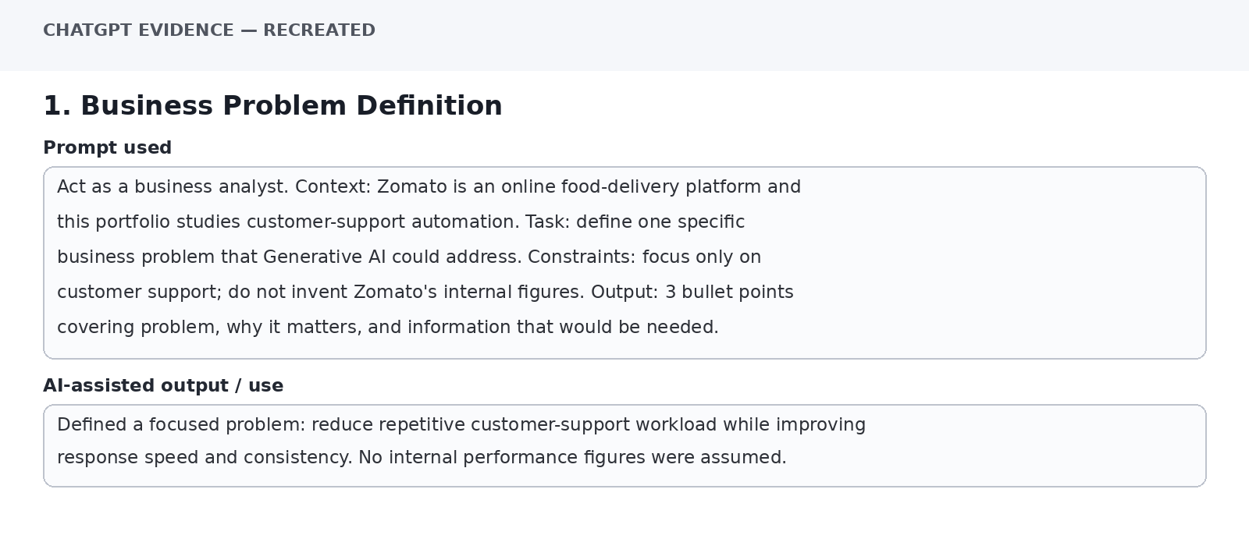
Evidence panel inserted for the Word portfolio. It is a recreated text capture of the prompt and AI-assisted output, not a live ChatGPT UI screenshot.

2. Research Question
Prompt used: Act as a research assistant. Context: I am studying Generative AI for customer-support automation in online food delivery. Create 5 research questions covering use cases, required data, business impact, risks, and verification. Use simple business language and avoid unsupported company-specific claims. Output as a numbered list.
Use / purpose: Created five research questions that structure the research into use cases, data, impact, risks, and evidence.
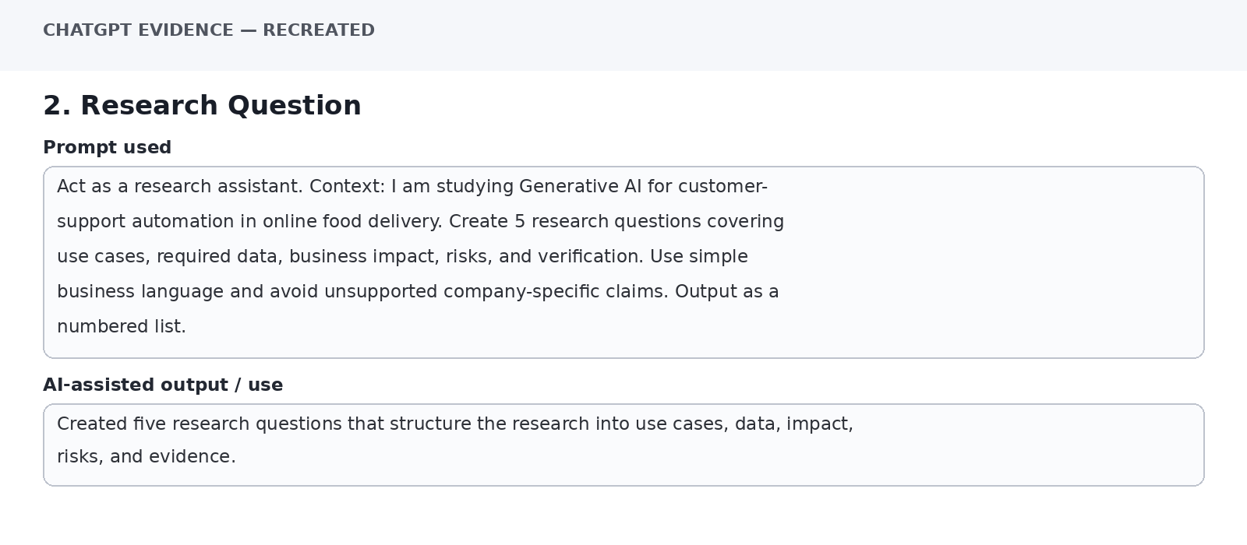
Evidence panel inserted for the Word portfolio. It is a recreated text capture of the prompt and AI-assisted output, not a live ChatGPT UI screenshot.

3. Role + Context + Task
Prompt used: Act as a customer-experience manager. Context: an online food-delivery platform receives repetitive questions about order status, refunds, cancellations and missing items. Task: suggest how an AI assistant could support agents. Do not claim that any specific company already uses a feature unless verified. Present in a 4-column table: Support Area, AI Role, Human Role, Verification Need.
Use / purpose: Produced a structured human-in-the-loop support model: AI handles routine information and drafting; human agents handle exceptions, disputes and sensitive decisions.
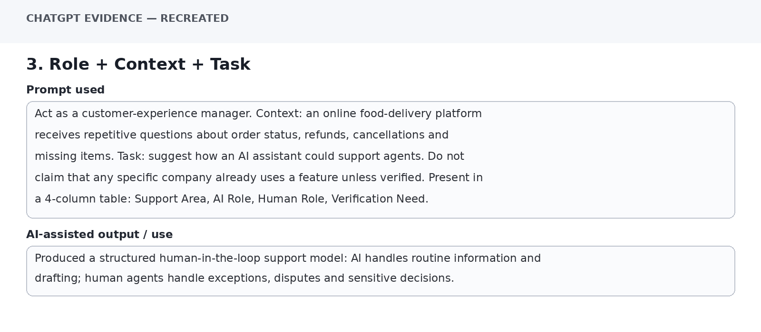
Evidence panel inserted for the Word portfolio. It is a recreated text capture of the prompt and AI-assisted output, not a live ChatGPT UI screenshot.

4. Constraint-Based Prompt
Prompt used: Act as a customer-support operations manager. Suggest 5 AI-assisted improvements for an online food-delivery support process. Constraints: no more than 5 ideas, simple language, no invented statistics, and include one implementation risk for each. Output columns: Idea, Use, Risk.
Use / purpose: Returned five bounded ideas with an explicit risk for each, making the answer easier to compare.
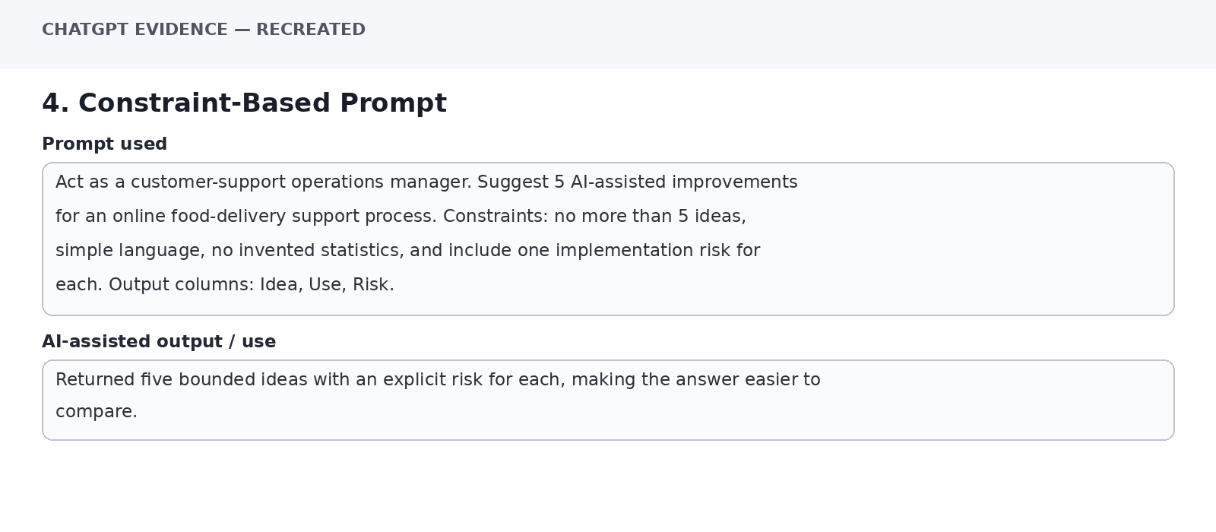
Evidence panel inserted for the Word portfolio. It is a recreated text capture of the prompt and AI-assisted output, not a live ChatGPT UI screenshot.

5. Structured Complaint Analysis
Prompt used: Analyze these complaint categories: late delivery, damaged packaging, incorrect item, slow refund. For each, identify possible cause, business impact, AI-support opportunity and KPI. Clearly label causes as possible rather than confirmed. Output as a table.
Use / purpose: Organized complaints into four categories and mapped each to a possible AI-support opportunity and KPI while keeping causes explicitly tentative.
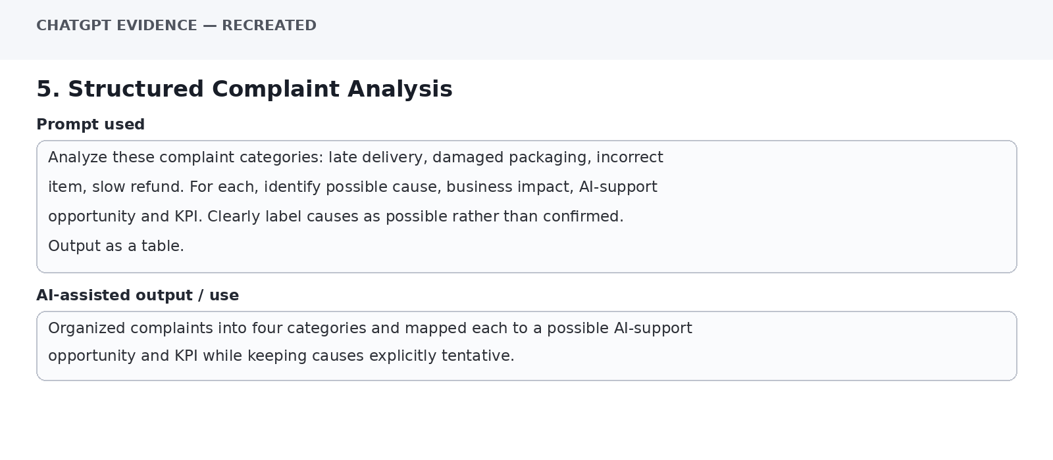
Evidence panel inserted for the Word portfolio. It is a recreated text capture of the prompt and AI-assisted output, not a live ChatGPT UI screenshot.

6. Marketing Research Prompt
Prompt used: Act as a digital marketing analyst. Context: an online food-delivery platform wants to communicate better with customers after support interactions. Suggest 4 content ideas that explain support improvements without promising outcomes that have not been verified. Include audience, message, channel and risk.
Use / purpose: Generated customer-communication ideas with audience, message, channel and risk fields; avoided unsupported performance promises.
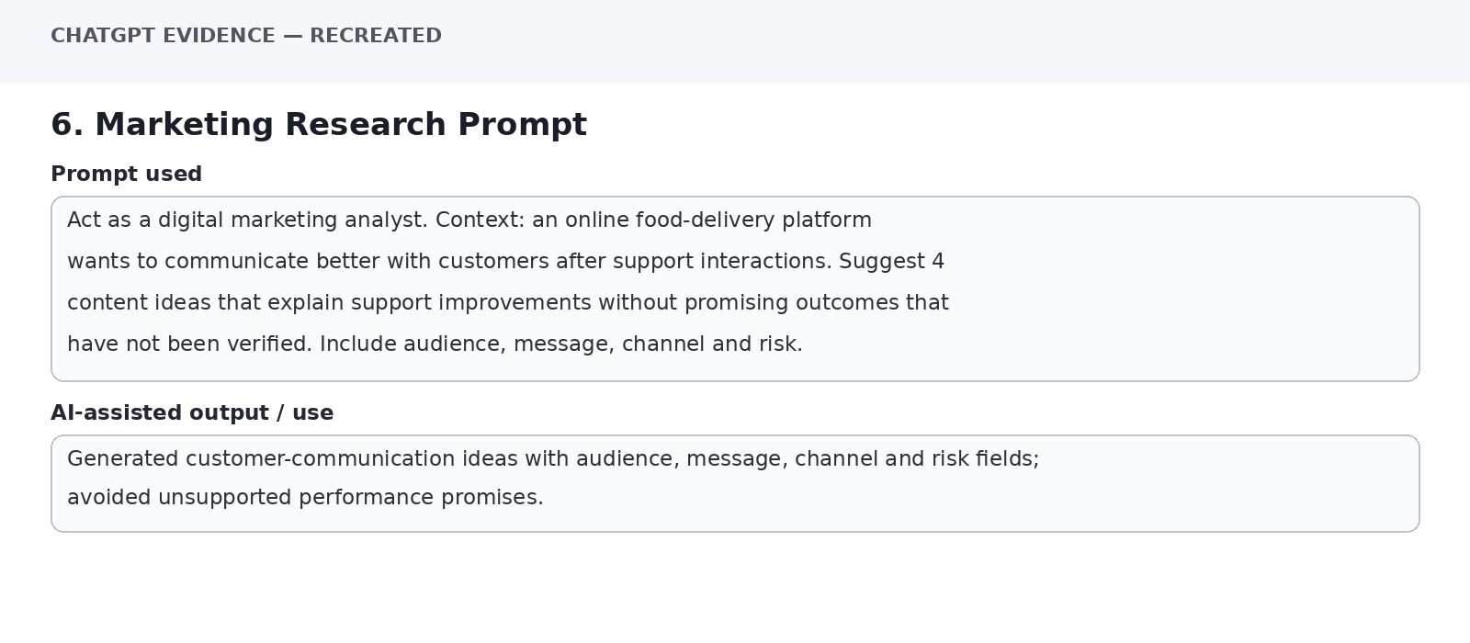
Evidence panel inserted for the Word portfolio. It is a recreated text capture of the prompt and AI-assisted output, not a live ChatGPT UI screenshot.

7. HR Interview Prompt
Prompt used: Act as an HR manager hiring a Digital Customer Support Intern. Create 8 interview questions assessing communication, basic digital knowledge, creativity, problem-solving and teamwork. Avoid personal or sensitive questions. Output a table with Competency, Question, What to Look For.
Use / purpose: Created eight competency-based questions with observable evaluation points and avoided sensitive personal information.
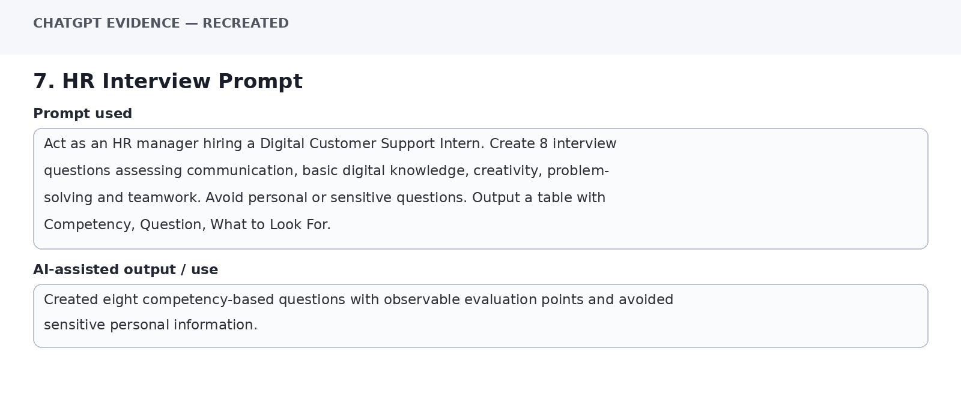
Evidence panel inserted for the Word portfolio. It is a recreated text capture of the prompt and AI-assisted output, not a live ChatGPT UI screenshot.

8. HR Bias Review
Prompt used: Review the interview questions from the previous response. Identify any ambiguity, repetition or possible unfair bias. Do not decide who should be hired. Output: Issue, Why It Matters, Revised Question.
Use / purpose: Flagged wording risks and repetition, then proposed clearer questions. The prompt explicitly kept the final hiring decision with humans.
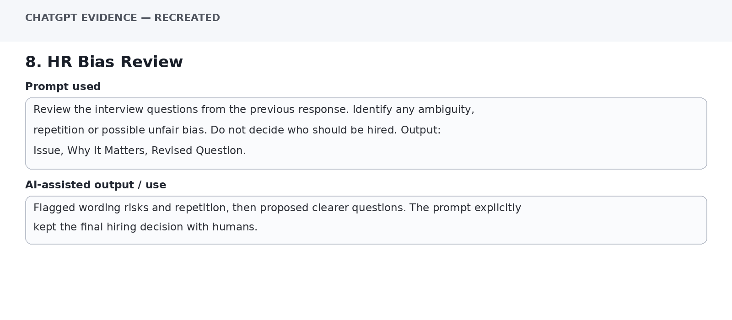
Evidence panel inserted for the Word portfolio. It is a recreated text capture of the prompt and AI-assisted output, not a live ChatGPT UI screenshot.

9. Finance Calculation
Prompt used: Use only this provided café data: Revenue ₹5,00,000; Rent ₹80,000; Salaries ₹1,50,000; Ingredients ₹1,20,000; Electricity ₹25,000; Marketing ₹20,000; Other Expenses ₹30,000. Calculate total expenses, profit and profit margin. Show calculations separately. Do not invent any values.
Use / purpose: Total expenses = ₹4,25,000; profit = ₹75,000; profit margin = 15%. Calculations are based only on the supplied figures.
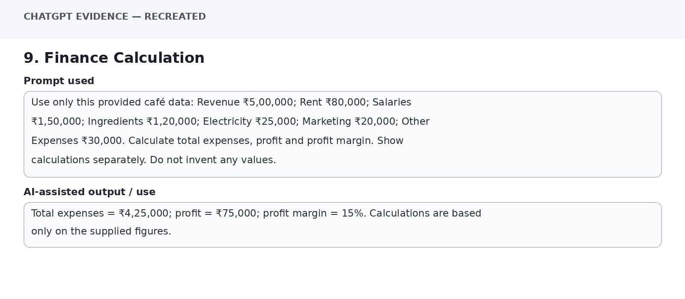
Evidence panel inserted for the Word portfolio. It is a recreated text capture of the prompt and AI-assisted output, not a live ChatGPT UI screenshot.

10. Finance Verification
Prompt used: Verify the following finance result using only the supplied café data: total expenses ₹4,25,000, profit ₹75,000, profit margin 15%. Recalculate independently and state whether each figure matches. If it does not, show the correction.
Use / purpose: Independent check: ₹80,000+₹1,50,000+₹1,20,000+₹25,000+₹20,000+₹30,000 = ₹4,25,000; ₹5,00,000−₹4,25,000 = ₹75,000; ₹75,000/₹5,00,000×100 = 15%. All match.
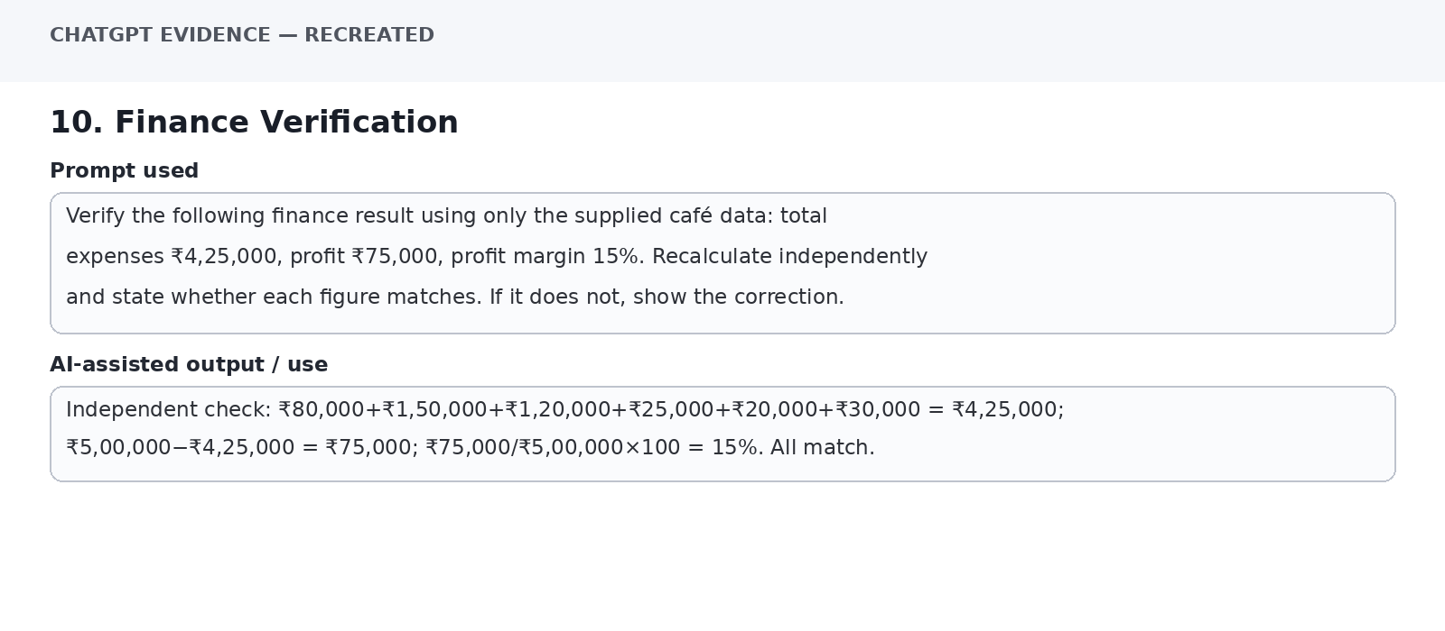
Evidence panel inserted for the Word portfolio. It is a recreated text capture of the prompt and AI-assisted output, not a live ChatGPT UI screenshot.

11. Operations Prompt
Prompt used: Act as an operations manager. An online retailer reports late deliveries, damaged packaging, incorrect products and slow refunds. For each issue provide possible cause, business impact, recommended action and KPI. Label assumptions clearly. Use a table.
Use / purpose: Created an issue-to-cause-to-action-to-KPI table and separated possible causes from established facts.
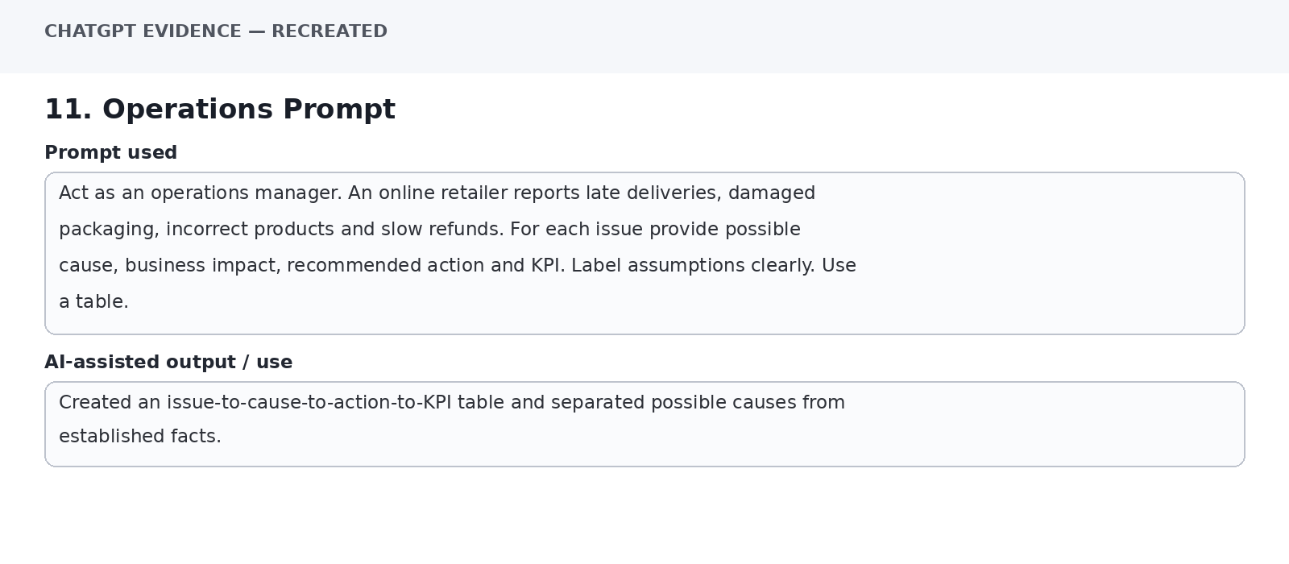
Evidence panel inserted for the Word portfolio. It is a recreated text capture of the prompt and AI-assisted output, not a live ChatGPT UI screenshot.

12. KPI Mapping
Prompt used: Map these operational issues to one primary KPI each: late delivery, damaged products, wrong products, slow refunds. Use only standard KPI names. Output: Issue | KPI | What It Measures.
Use / purpose: Late delivery → On-time delivery rate; damaged products → damage rate; wrong products → order accuracy rate; slow refunds → average refund processing time.
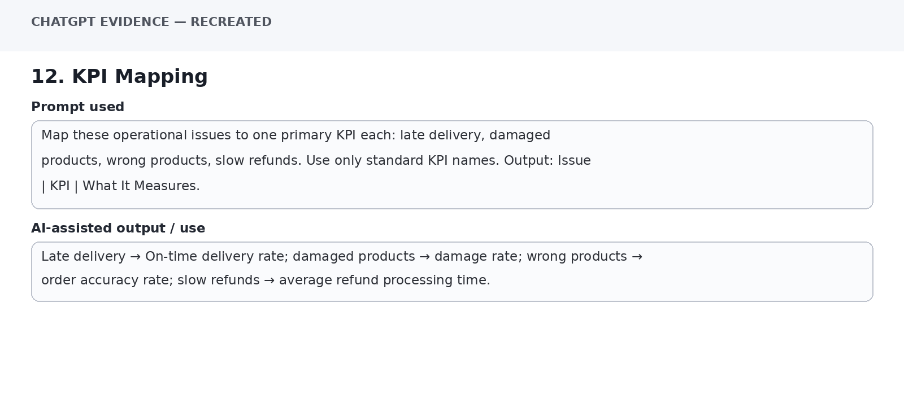
Evidence panel inserted for the Word portfolio. It is a recreated text capture of the prompt and AI-assisted output, not a live ChatGPT UI screenshot.

13. Cross-Functional Prompt
Prompt used: Act as a cross-functional business analyst. Context: an online food-delivery business wants to improve customer support. Create one action each for Marketing, HR, Finance and Operations. Constraints: each action must be measurable in principle, avoid invented results, and identify one verification need. Output as a table.
Use / purpose: Linked four functions to support improvement and added a verification requirement for each action.
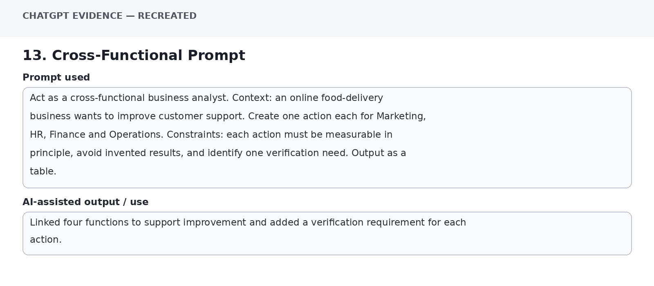
Evidence panel inserted for the Word portfolio. It is a recreated text capture of the prompt and AI-assisted output, not a live ChatGPT UI screenshot.

14. Task Decomposition
Prompt used: Break the research task 'evaluate Generative AI for customer-support automation' into 5 smaller research tasks. Each task must have a clear output and a verification step. Keep the sequence logical.
Use / purpose: Decomposed the task into: business problem → use cases → data/technology → impact/risks → verification and recommendation.
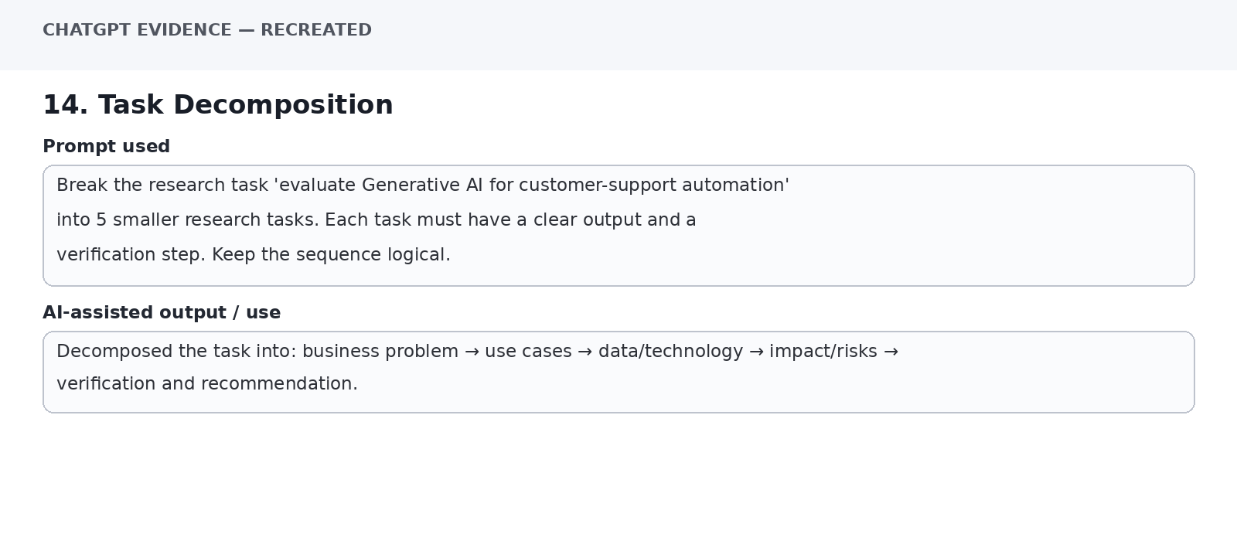
Evidence panel inserted for the Word portfolio. It is a recreated text capture of the prompt and AI-assisted output, not a live ChatGPT UI screenshot.

15. Prompt Chaining — Stage 1
Prompt used: Prompt Chaining Stage 1. Identify three customer-support issue segments for an online food-delivery platform: order status, order problems, payment/refund. Describe each segment's typical information need. Do not invent percentages.
Use / purpose: Produced three segments and their information needs without adding unsupported proportions.
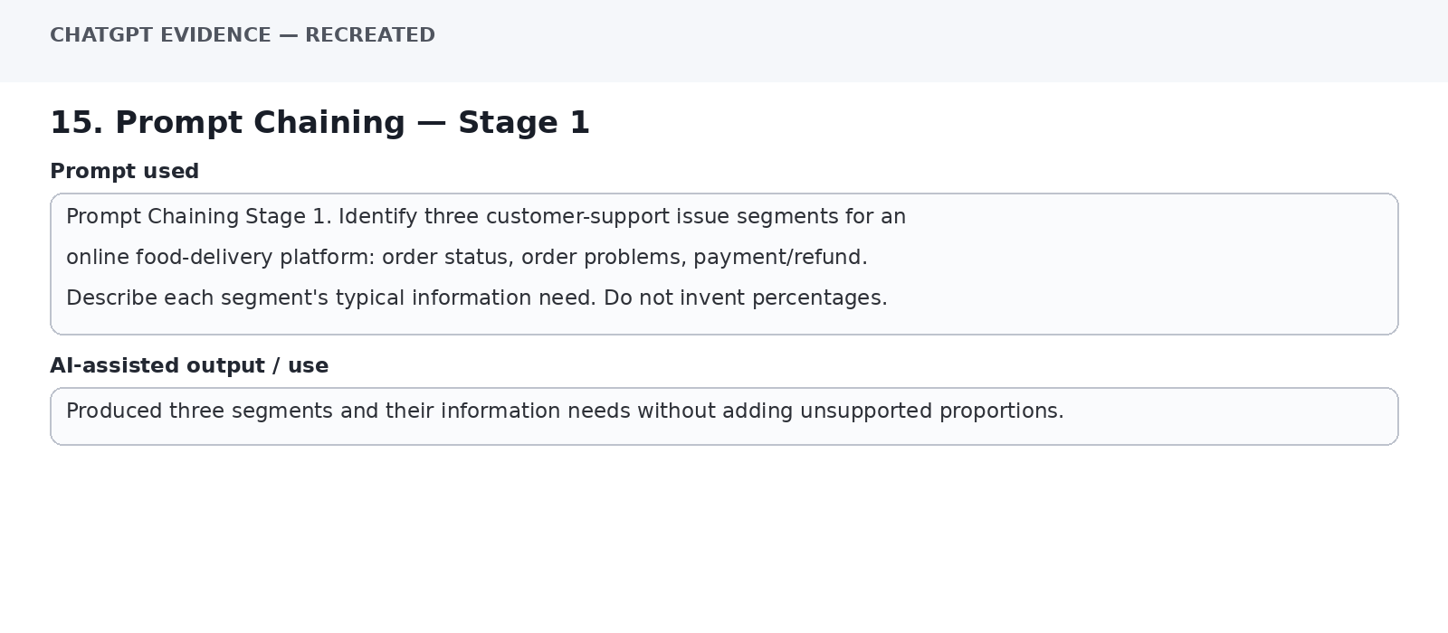
Evidence panel inserted for the Word portfolio. It is a recreated text capture of the prompt and AI-assisted output, not a live ChatGPT UI screenshot.

16. Prompt Chaining — Stage 2
Prompt used: Prompt Chaining Stage 2. Using the three segments from Stage 1, select the type of support task most suitable for AI assistance at the first-contact level. Explain the selection using feasibility, risk and need for human oversight. Do not name a winner; provide a comparison.
Use / purpose: Compared first-contact tasks by feasibility, risk and human-oversight needs, rather than giving an unsupported overall ranking.
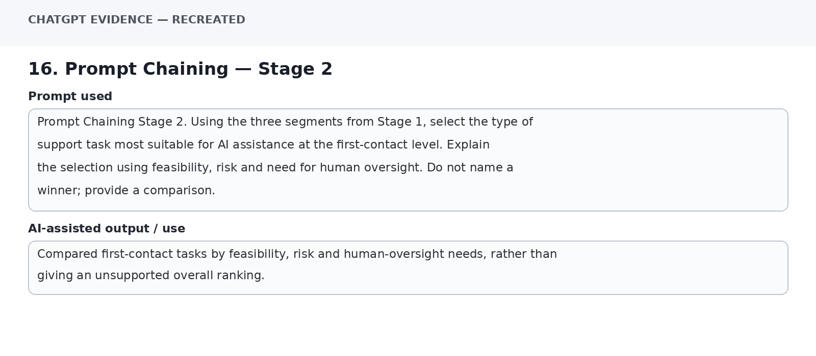
Evidence panel inserted for the Word portfolio. It is a recreated text capture of the prompt and AI-assisted output, not a live ChatGPT UI screenshot.

17. Source Verification Prompt
Prompt used: For every important factual claim in my research, create a verification checklist. Check: original source, existence, reliability, currentness, whether it supports the exact claim, and whether a second source can confirm the number. Remind me that an AI-generated citation is not automatically trustworthy.
Use / purpose: Generated a six-point source verification checklist aligned with the lecture guidance.
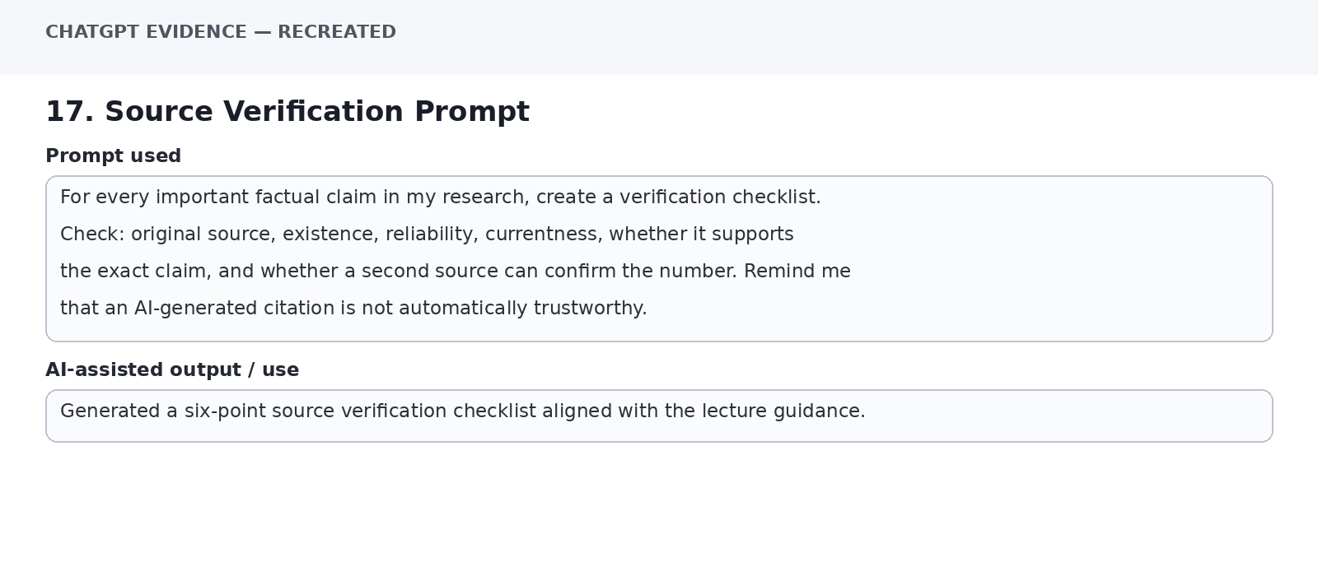
Evidence panel inserted for the Word portfolio. It is a recreated text capture of the prompt and AI-assisted output, not a live ChatGPT UI screenshot.

18. Facts vs Assumptions
Prompt used: Based only on this scenario: 'Customer-support teams receive repetitive questions about order status and refunds.' Separate the response into Known Facts, Assumptions, Questions Requiring More Data, and Possible Recommendations. Do not invent operational statistics.
Use / purpose: Separated the limited scenario facts from assumptions, missing-data questions and possible recommendations.
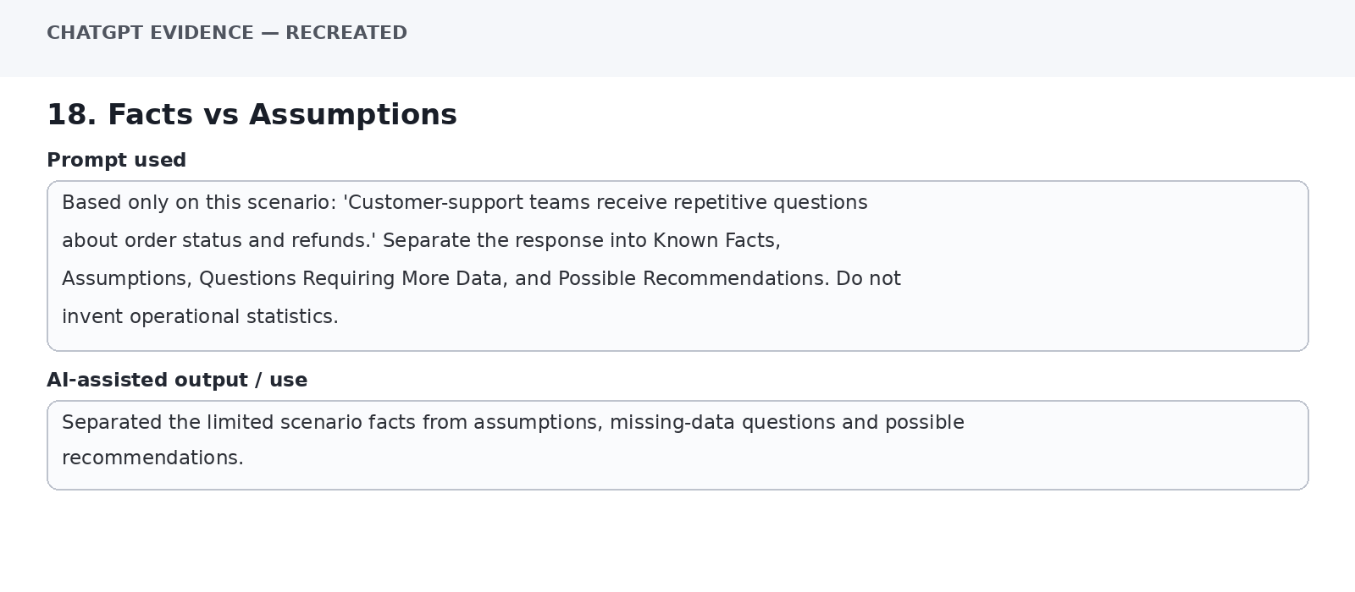
Evidence panel inserted for the Word portfolio. It is a recreated text capture of the prompt and AI-assisted output, not a live ChatGPT UI screenshot.

19. Comparative Analysis
Prompt used: Compare two approaches for customer support: rule-based FAQ automation and Generative AI/LLM assistance. Compare capabilities, data needs, risks, human oversight and suitable use cases. Do not declare one universally better. Output as a comparison matrix.
Use / purpose: Created a balanced comparison showing different strengths, limitations and oversight requirements for each approach.
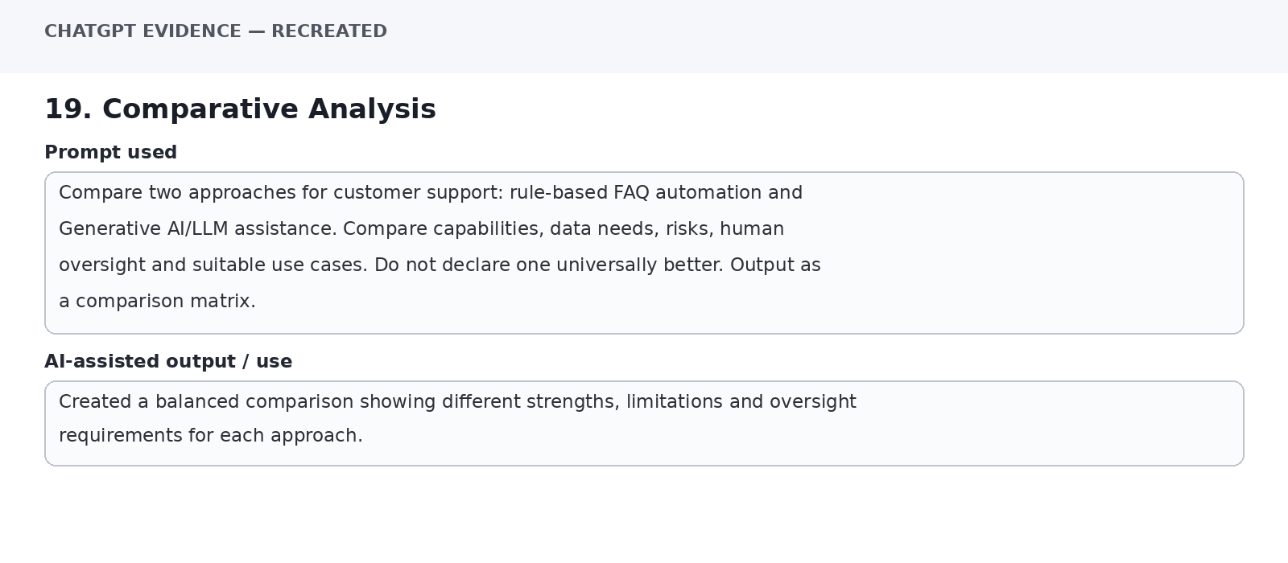
Evidence panel inserted for the Word portfolio. It is a recreated text capture of the prompt and AI-assisted output, not a live ChatGPT UI screenshot.

20. Edge-Case Prompt
Prompt used: Act as a Responsible AI reviewer. List 6 edge cases that a customer-support AI assistant should not handle autonomously without human review, such as ambiguous refunds or safety-related complaints. For each, state why escalation is needed. Do not invent company policy.
Use / purpose: Identified exception cases where ambiguity, financial consequences or safety concerns make human review important.
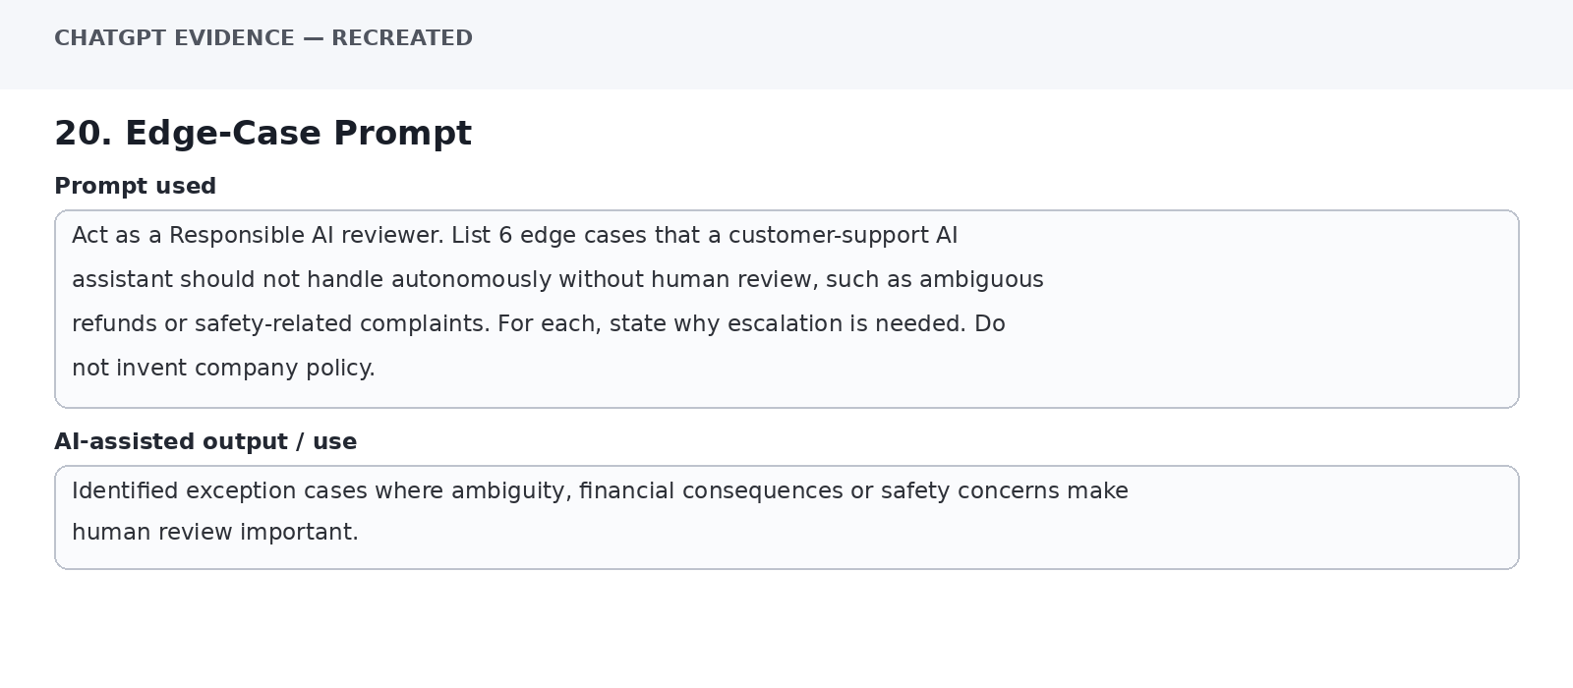
Evidence panel inserted for the Word portfolio. It is a recreated text capture of the prompt and AI-assisted output, not a live ChatGPT UI screenshot.

21. Strict Constraint Prompt
Prompt used: Create a 7-step implementation checklist for a customer-support AI pilot. Constraints: exactly 7 steps; each step under 18 words; include data privacy, testing, human escalation and monitoring; do not claim a guaranteed business result.
Use / purpose: Produced an exactly seven-step checklist with privacy, testing, escalation and monitoring included.
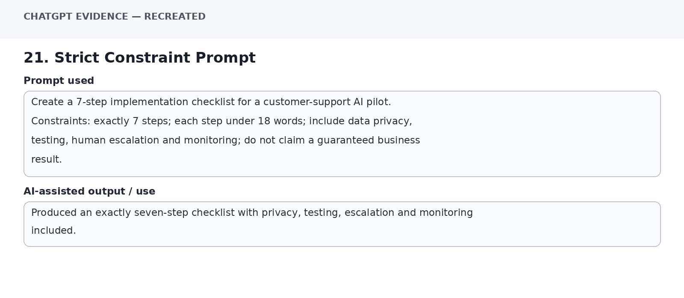
Evidence panel inserted for the Word portfolio. It is a recreated text capture of the prompt and AI-assisted output, not a live ChatGPT UI screenshot.

22. Critical Evaluation Prompt
Prompt used: Critically evaluate an AI-generated business response. Check for: unsupported claims, missing context, hallucinated statistics, vague recommendations, hidden assumptions, risk/ethics gaps and missing verification. Output one finding per category and a corrective action.
Use / purpose: Created a seven-category critique framework that turns weaknesses into specific corrective actions.
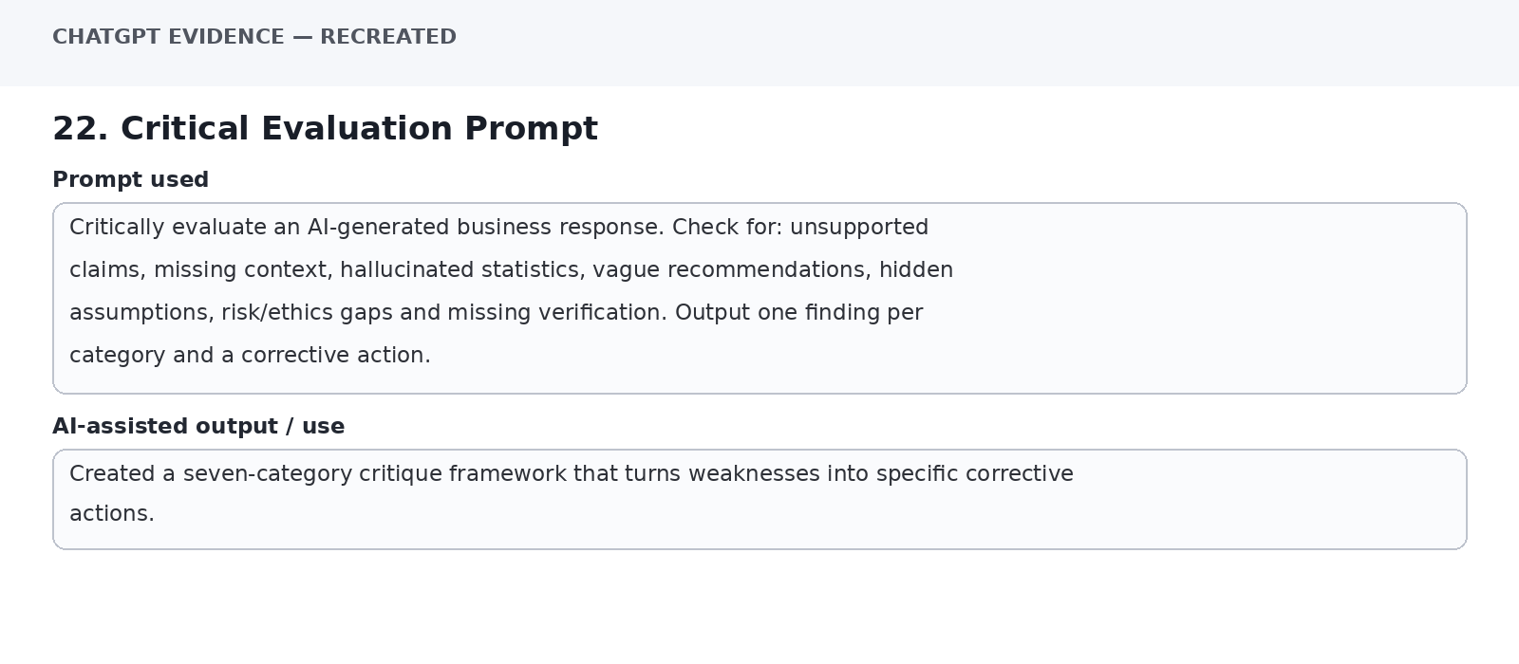
Evidence panel inserted for the Word portfolio. It is a recreated text capture of the prompt and AI-assisted output, not a live ChatGPT UI screenshot.

23. Weak Response Verification
Prompt used: Weak prompt: 'Tell me about AI in Zomato.' Explain why this prompt may produce a generic or unsupported answer. Then create an improved prompt that asks for customer-support use cases, evidence requirements, risks and uncertainty. Do not state unverified company practices as facts.
Use / purpose: Showed that the weak prompt lacks scope, evidence requirements and uncertainty controls; the improved version added all three.
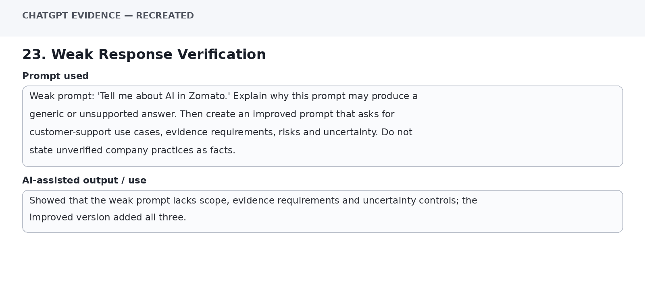
Evidence panel inserted for the Word portfolio. It is a recreated text capture of the prompt and AI-assisted output, not a live ChatGPT UI screenshot.

24. Final Recommendation Prompt
Prompt used: Act as a business analyst. Based only on verified findings supplied in my research notes, prepare a management recommendation for customer-support AI. Separate Verified Evidence, Assumptions, Risks, Implementation Steps and Human Oversight. Do not make claims beyond the evidence.
Use / purpose: Generated a management-ready structure that separates evidence from assumptions and keeps implementation accountable to human oversight.
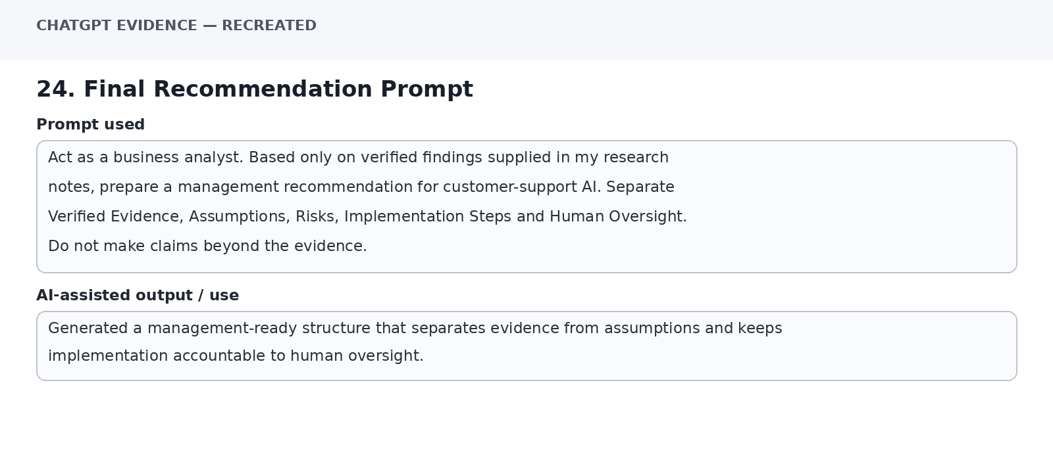
Evidence panel inserted for the Word portfolio. It is a recreated text capture of the prompt and AI-assisted output, not a live ChatGPT UI screenshot.

25. Master Portfolio Prompt
Prompt used: Act as a senior business analyst and prompt-engineering reviewer. Review my complete customer-support AI research. Check Role, Context, Task, Constraints, Output Format, Evidence, Uncertainty, refinement and verification. Return: strengths, weaknesses, missing evidence, improved master prompt, and a short learning reflection. Do not invent facts.
Use / purpose: Produced a final audit structure covering prompt quality, evidence, uncertainty, refinement and verification, suitable for the portfolio and presentation.
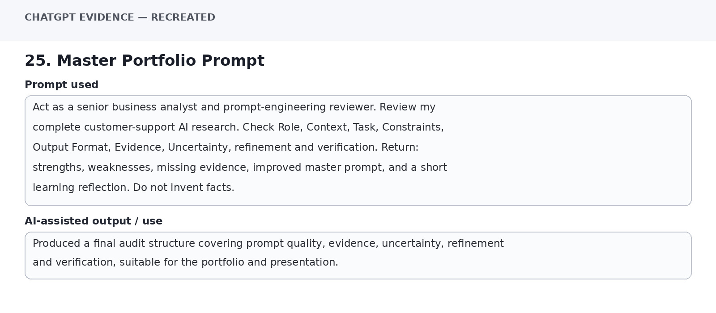
Evidence panel inserted for the Word portfolio. It is a recreated text capture of the prompt and AI-assisted output, not a live ChatGPT UI screenshot.

4. Prompt Improvement Evidence
Part B specifically requires at least one prompt improvement and an explanation of why the improved prompt produced a better result. fileciteturn2file0L130-L141
Basic Prompt | Improved Prompt
Tell me about AI in Zomato. | Act as a business analyst. Analyse customer-support applications of Generative AI for an online food-delivery platform. Separate verified facts, assumptions and recommendations; identify risks, human-oversight needs and evidence requirements. Do not invent company-specific statistics or practices.
Why improved: the basic prompt is broad and can produce a generic response. The improved prompt adds role, context, task, constraints, structured evidence requirements and uncertainty controls. This follows the module's strong-prompt template and its guidance on reducing hallucination risk. fileciteturn2file1L370-L378

5. Iterative Refinement Example
Stage | Prompt
Version 1 | Create a marketing campaign for a café.
Follow-up 1 | Make the campaign specifically for college students aged 18–24.
Follow-up 2 | Keep the total budget below ₹20,000.
Follow-up 3 | Remove offline advertising and focus only on Instagram and WhatsApp.
Follow-up 4 | Present the final campaign as a 7-day action plan.
This demonstrates iterative refinement: follow-up instructions progressively make the output more specific and usable. The lecture gives the same pattern of audience, budget, channels and final action-plan constraints. fileciteturn2file1L156-L170

6. Prompt Chaining Example
- 1. Identify three customer-support issue segments.
- 2. Describe the information need of each segment.
- 3. Compare which support tasks are feasible for AI assistance.
- 4. Identify exception cases requiring human escalation.
- 5. Prepare a management summary from the verified findings.
Prompt chaining divides one large task into connected prompts so that each output can become input for the next step. The module describes this as one large task becoming several connected prompts. fileciteturn2file1L90-L122

7. Google Colab Code & Evidence
The following checks are included as a reproducible Colab notebook. The notebook file is provided separately with this submission package. The images below are recreated evidence panels showing the expected code/output; they are not screenshots captured from the user's personal Colab account.
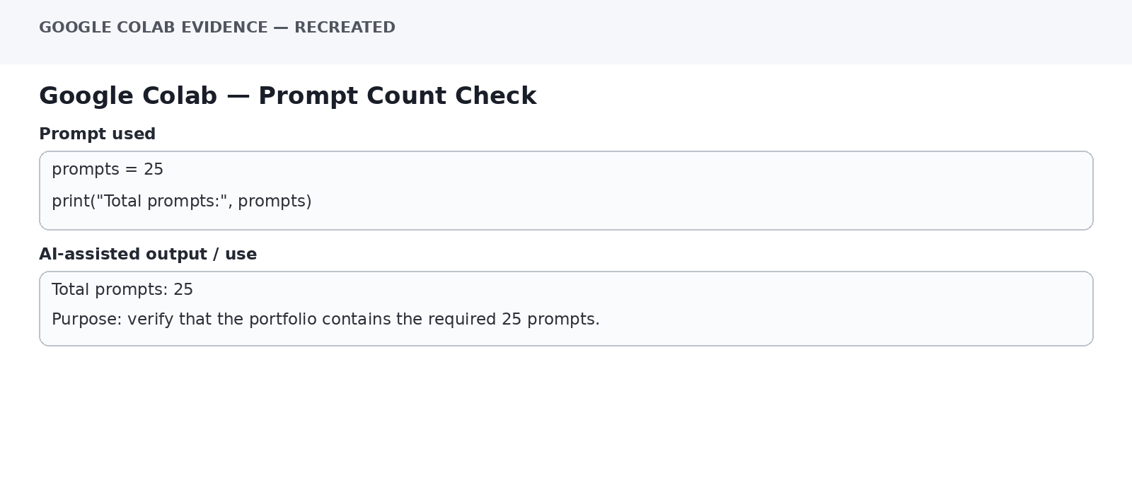
Check 1 — 25 prompt count
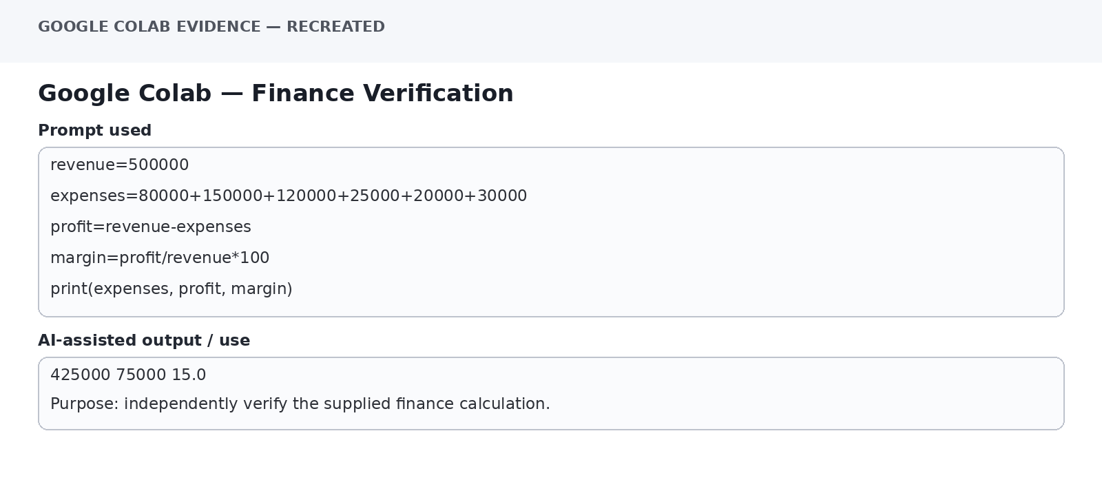
Check 2 — finance verification
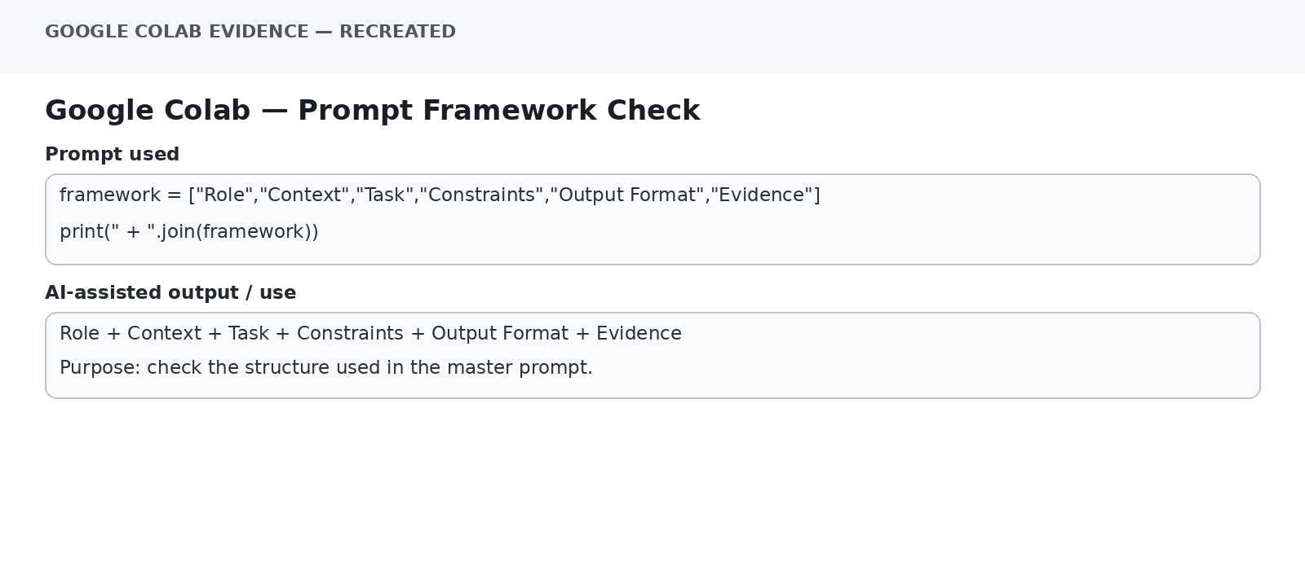
Check 3 — strong prompt framework
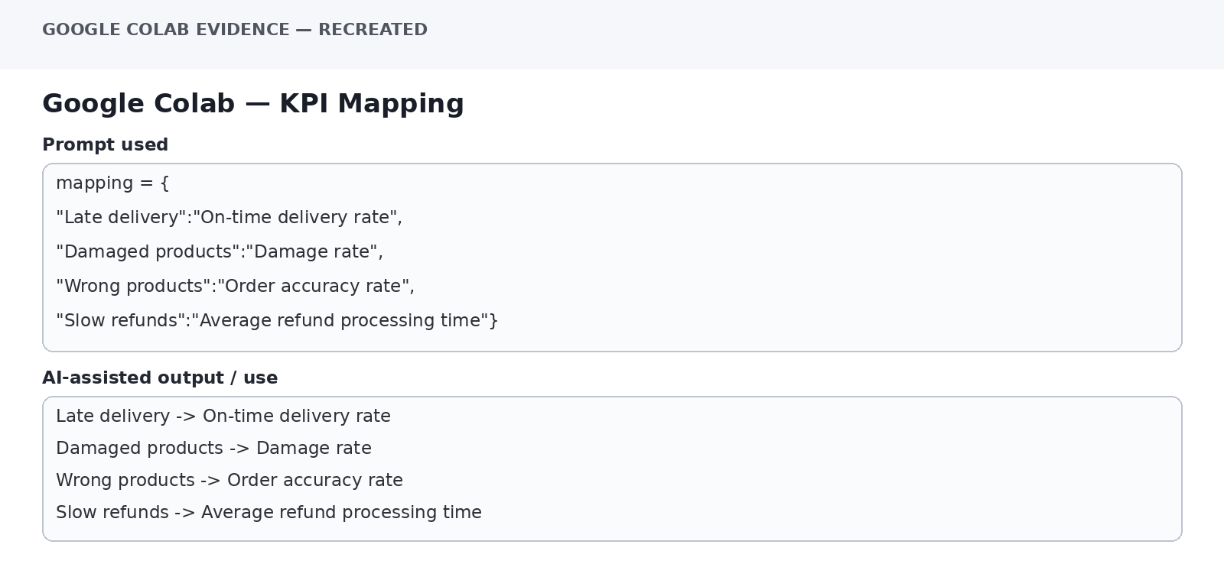
Check 4 — KPI mapping

8. Fact-Checking & Verification Plan
The assessment requires important AI-generated claims to be checked against credible sources such as official company websites, annual reports, government websites, research papers, university/research publications and reputed business publications. fileciteturn2file0L150-L160
Claim Type | Where to Verify | What to Check | Portfolio Status
Company AI feature/use | Official company sources / official reports | Does the source explicitly support the claim? | Verify before final PPT
Market size / market share | Reputed business publication / research / authoritative source | Year, definition, methodology and exact figure | Verify before using
Financial figures | Annual report / official filing | Period, units and calculation | Verify
Research finding | Original research paper | Sample, date, method and conclusion | Verify
AI-generated citation | Original linked source | Does the source exist and actually contain the claim? | Mandatory check

9. Critical Evaluation of AI Output
Example selected for evaluation: the weak prompt 'Tell me about AI in Zomato.'
Problem | Why it matters | Improvement
Too generic | It does not specify the business problem, scope or output. | Specify customer-support automation and required sections.
Unsupported company-specific claims may appear | AI may present plausible statements without evidence. | Require sources and verify originals.
No uncertainty instruction | Missing information may be filled with assumptions. | Separate facts, assumptions and unknowns.
No structured output | Harder to compare and use in a report. | Request a table/matrix.
No human-oversight instruction | Could overstate what AI should decide. | Define escalation and human review.
The module explicitly warns that a professional-looking AI response is not the same as verified research and that AI self-review does not replace independent verification. fileciteturn2file1L171-L181

10. Responsible AI & Human Review
- Do not treat AI output as the final business decision.
- Separate facts, assumptions and recommendations.
- Do not invent statistics, sources or company-specific practices.
- Use human review for ambiguous, high-risk or sensitive customer cases.
- Check privacy, security, bias, fairness, transparency and hallucination risks.
- Verify important factual claims independently.
These principles align with the assessment's Responsible AI requirements and the lecture's guidance on hallucination, uncertainty and human review. fileciteturn2file0L99-L111 fileciteturn2file1L215-L239

11. Learning Reflection
1. I learned that advanced prompts are not simply longer prompts; they become more useful when role, context, task, constraints, format and evidence requirements are explicit.
2. I learned to use prompt chaining and iterative refinement to break complex business research into manageable stages and improve outputs through follow-up instructions.
3. I learned that AI-generated information must be critically evaluated and important claims must be checked against original, credible sources.
4. The finance verification and hallucination-testing examples showed me why calculations, current figures and citations should not be accepted without checking.
5. Refining prompts made the research more structured, transparent and easier to convert into business recommendations.

12. GitHub Repository Checklist
- Final PPT/PDF
- Business Case Study / Research Report
- Prompt Portfolio
- Important original and improved prompts
- References/sources used for verification
- Learning reflection
- README.md
- Individual GitHub repository link on the final PPT
The assessment makes an individual GitHub repository mandatory and specifies these contents. fileciteturn2file0L223-L249
Suggested folder structure:
advanced-prompt-engineering/
├── final-ppt/
├── business-case-study/
├── prompt-portfolio/
├── colab/
├── evidence-screenshots/
├── references/
├── learning-reflection/
└── README.md

13. Important Screenshot & Account-Access Note
Screenshots: I have inserted evidence-style prompt/output panels into this Word file so every prompt has visible 'prompt used' and 'use/output' evidence. These are recreated captures, not screenshots of the live ChatGPT interface. I cannot truthfully fabricate a live ChatGPT UI screenshot or claim that code was pushed to your personal Google Colab/GitHub account.
Colab: A ready-to-run .ipynb notebook is included separately. Open it in Google Colab, run the cells, and if your teacher specifically requires account screenshots, replace the recreated Colab panels with screenshots from your own running notebook.
Academic integrity: The assessment itself states that students must understand everything in the project and that final analysis, verification, recommendations and learning should reflect their own understanding. fileciteturn2file0L301-L323

